Individual academic poster

LECTURER: GILLIAN WEAVER
STUDENT: 2028383/ ZERRON ALEXANDRA WILLIAMS-HANKEY
UNIVERSITY OF WALES TRINITY SAINT DAVID
10/10/2023

Contents
Introduction 4
Functioning of the digestive system 4
Mouth 5
The stomach and small intestine 5
Pancreas 6
Liver 6
Gallbladder 6
The large intestines (colon) rectum, and Anus: 6
Appendix 7
Conclusion 7
Common health conditions 7
References 8

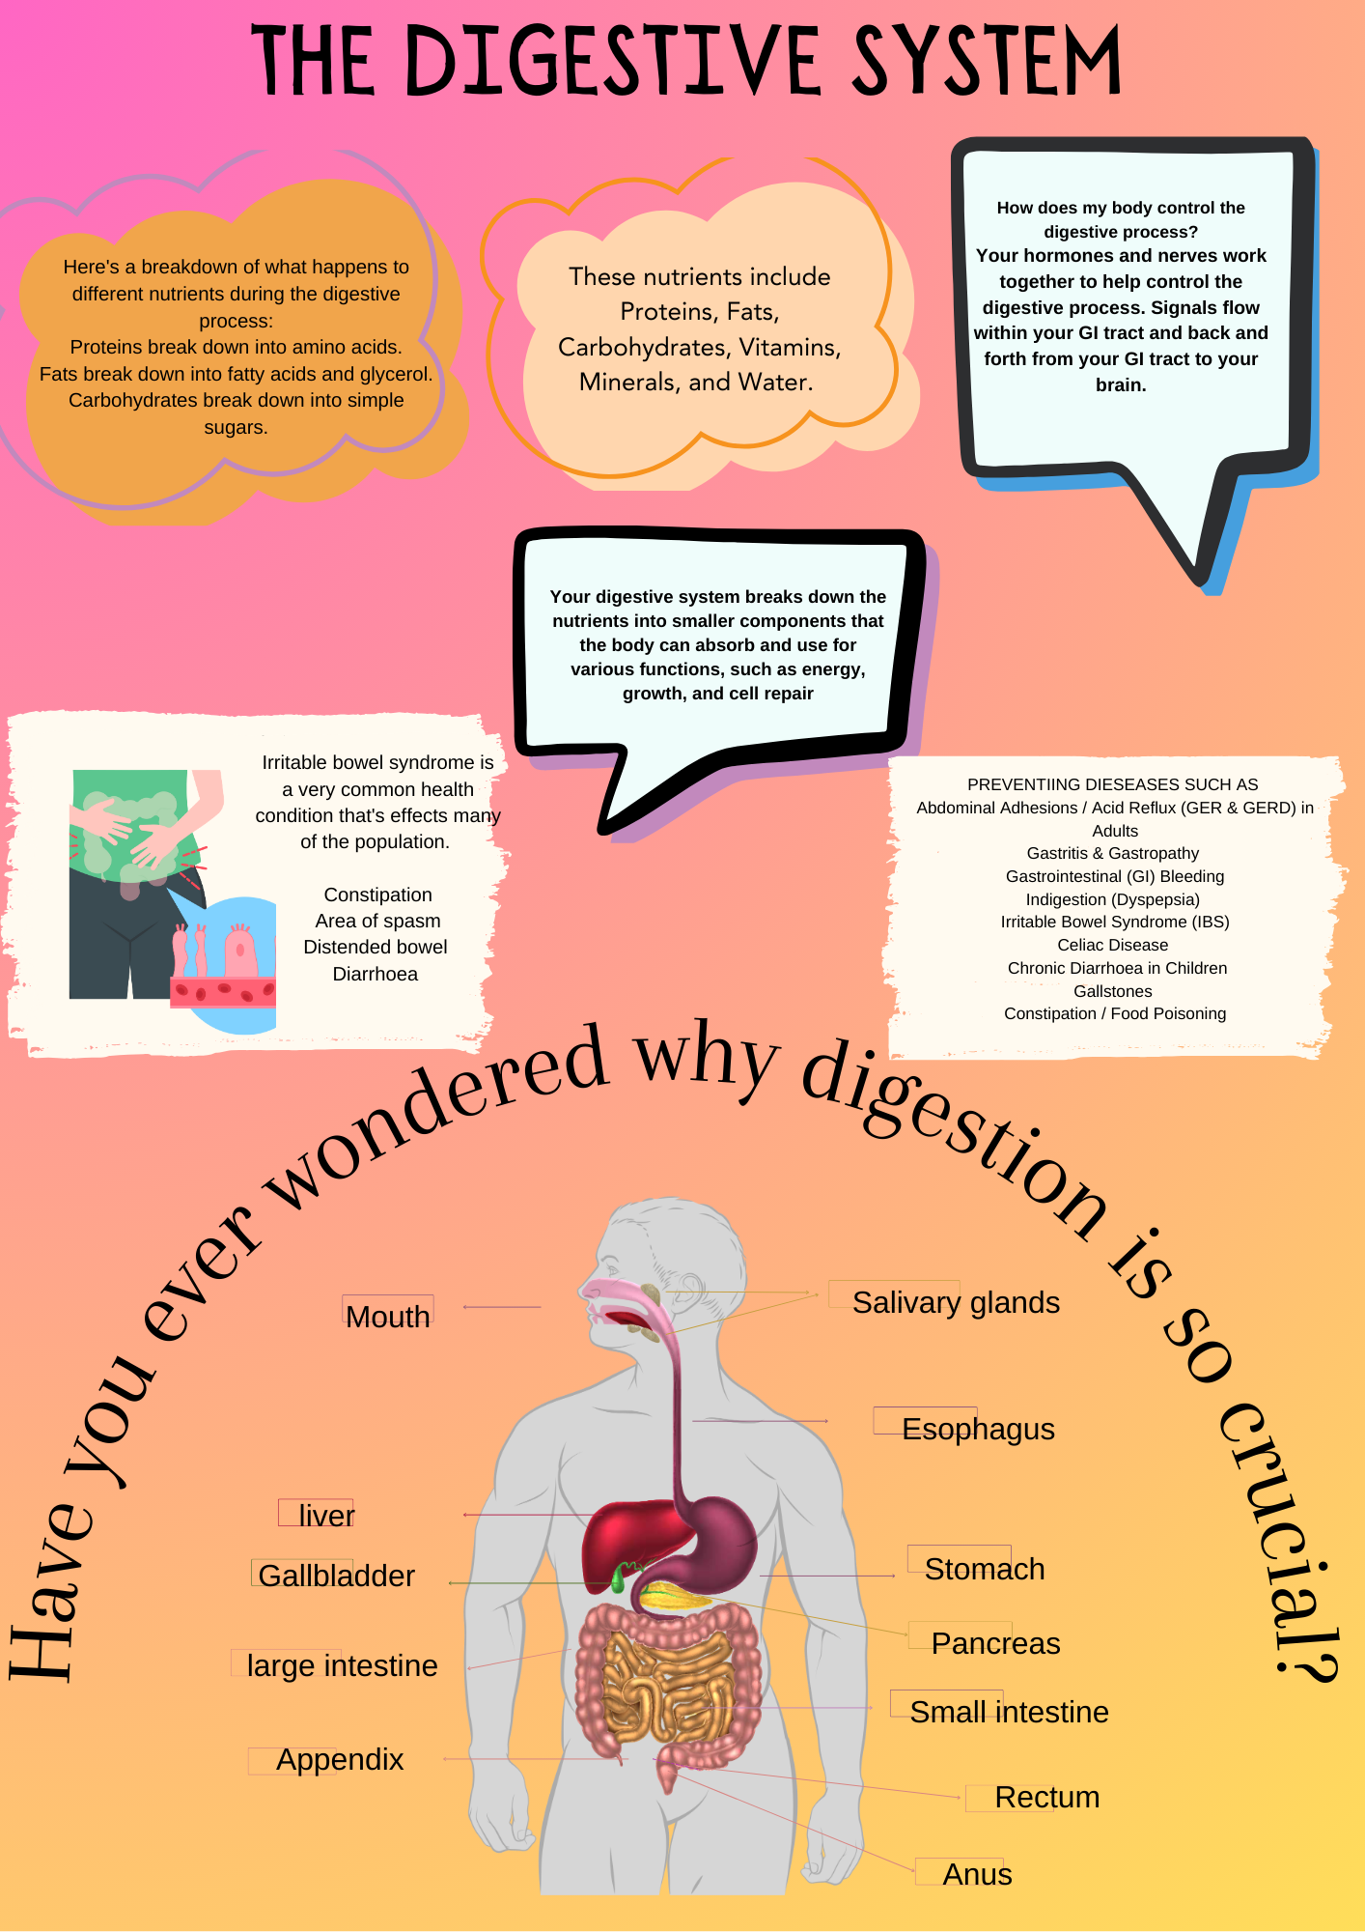

Introduction
THE DIGESTIVE System plays a crucial role in our bodies, allowing us to utilize the energy from the food we consume and eliminate waste products. It is a complex and fascinating process that involves several organs working together to break down food into usable particles and absorb nutrients. In the article. We will explore the anatomy and physiology of the digestive system and understand how it functions in the context of health and social care. The digestive system is a long, tubular structure known as the gastrointestinal tract. It starts with the mouth and ends with the anus. The digestion process involves the breakdown of food into energy and waste products. other organs that support the digestive process include the live gallbladder and pancreas.
The digestive system is important in our body, allowing us to use the energy from the food we eat and eliminate waste products. It is a sophisticated and fascinating process in which multiple organs collaborate to break down food into usable bits and absorb nutrients. In the text. We will investigate the anatomy and physiology of the digestive system, as well as its role in health and social care. The gastrointestinal tract is a long, tubular structure. It begins with the mouth and travels to the anus. The digestion process entails breaking carbohydrates and fats into nutrients and waste products. Other organs that aid in digestion include the living gallbladder and pancreatic.

Functioning of the digestive system
In the context of health and social care, understanding the functioning of the digestive system is crucial for providing appropriate care and support.
some key points to consider are.
Nutritional assessment: health and social care professionals assess individuals’ nutritional status to ensure they receive adequate nutrients for optimal health.
Dietary modifications: based on the individual needs and health conditions, dietary modifications, may be recommended to support digestive health.
Medication management: some medications can affect digestion and require adjustments or monitoring.
Digestive disorders: health and social care professionals play a role in identifying and managing digestive disorders such as a gastroesophageal reflux disease (GERD), irritable bowel syndrome (IBS), and inflammatory bowel disease (IBD).
Supportive care: individuals with digestive disorders may require support with managing symptoms, following dietary guidelines, and accessing appropriate healthcare services.

Mouth
the mouth is the entry point for the food into the digestive system. Before the frostbite, saliva is released by the salivary glands in response to the smell of food. Chewing, or mastication, breaks down the food into smaller particles that can be easily attacked by the enzymes in saliva and helps move it along to the pharynx and esophagus.
The mouth consists of the oral cavity, teeth, tongue, and salivary glands. The oral cavity is lined with mucous membranes and contains the hard and soft palate. Teeth play a crucial role in chewing and breaking down of food. The tongue helps mix food with saliva and aids in swallowing.

The pharynx serves as the transition area from the mouth to the esophagus. During swallowing, the windpipe closes to protect the lungs and food is moved into the esophagus. The esophagus is a muscular tube that contracts in a synchronized fashion, called peristalsis, to move the food towards the stomach. The lower esophageal sphincter, a muscular valve, relaxes to allow the food to pass into the stomach.
The esophagus is responsible for transporting food from the mouth to the stomach through rhythmic contractions known as peristalsis. Additionally, the lower esophageal sphincter prevents food and stomach acid from re-entering the esophagus.

The stomach and small intestine
The stomach is responsible for further breaking down the food we eat with the help of acid and enzymes secreted by glands that line its walls. The muscles in the stomach mix the food, turning it into a thick, creamy fluid called chyme. This chyme is then pushed into the duodenum, which is the first part of the small intestine where further breakdown and nutrient absorption occur. The small intestine is divided into three parts: the duodenum, jejunum, and ileum. The duodenum is mainly involved in breaking down food, while the jejunum and the ileum are responsible for absorbing nutrients into the bloodstream through the walls of the intestine. The stomach is a muscular organ that stores and breaks down food. Gastric glands release acid and enzymes to aid in digestion. The muscles in the stomach mix food with gastric secretions to form chyme. The small intestine consists of the duodenum, jejunum, and ileum. Villi and microvilli in the small intestine increase the surface area for nutrient absorption. Enzymes from the pancreas and bile from the liver assist in digestion and absorption.

Pancreas
The pancreas is a vital organ located behind the stomach in the abdominal cavity. It plays a crucial role in digestion and maintaining blood sugar levels in the body. The pancreas is made up of two types of tissues: endocrine and exocrine. Endocrine cells produce hormones such as insulin and glucagon that regulate blood sugar levels. Insulin helps lower blood sugar levels by allowing cells to take in glucose from the blood, while glucagon raises blood sugar levels by causing the liver to release stored glucose into the bloodstream. Exocrine cells produce digestive enzymes that are released into the small intestine to break down food and aid in digestion. The pancreatic juice containing these enzymes is transported through ducts to the small intestine, where it mixes with the food and helps in the absorption of nutrients. Any dysfunction of the pancreas can lead to serious health problems, such as diabetes and pancreatic cancer.

Liver
The liver is the body's largest internal organ and performs many essential functions. It produces bile, which aids in the digestion of fats. Additionally, the liver plays a crucial role in metabolism, immunity, and detoxification. It eliminates toxins and chemicals from the bloodstream, metabolizes drugs and medications, and stores essential vitamins and minerals. The liver is also responsible for storing nutrients and regulating blood glucose levels, which helps maintain hormonal balance in the body.

Gallbladder
The gallbladder is an essential, pear-shaped organ that plays a vital role in the digestive system. It belongs to the biliary system and links to the liver through ducts called the biliary tract. The primary purpose of the gallbladder is to stockpile and intensify bile, which the liver produces. Upon eating, the gallbladder discharges bile into the small intestine via the cystic duct, facilitating the digestion of fats. Bile works by breaking down fats into smaller molecules, making them more manageable to digest.

The large intestines (colon) rectum, and Anus:
The large intestine, also called the colon, plays a crucial role in the body by absorbing water and solidifying waste products. Comprised of four distinct parts - the ascending, transverse, descending, and sigmoid colon - it uses peristalsis to move stool along its length. The rectum serves as a storage site for stool until it is eliminated through the anus. The large intestine absorbs water and electrolytes from waste material, while the colon's specialized bacteria break down certain substances. The rectum stores stool until elimination through the anus.

Appendix
the appendix has recently been thought to be a safe house for beneficial bacteria, when the body becomes ill and the immune system is being attacked the appendix serves as a reservoir for unwanted bacteria, it then repopulates the intestines with potential helpful microorganisms, adding in the digestion of food to maintain a healthy gut. The appendix s not important for survival and the removal doesn’t consist of long term health issues .

Conclusion
The digestive system is a complex network of organs that collaborate to process food, extract nutrients, and dispose of waste products. Knowing the structure, function, and operations of the digestive system is crucial in the realm of health and social care. By giving adequate attention and assistance, healthcare providers can aid individuals in preserving digestive health and overall well-being.

Common health conditions

Irritable bowel syndrome (IBS) is a chronic gastrointestinal disorder that affects the large intestines or colon. It is characterized by a combination of symptoms, including abdominal pain and discomfort, changes in bowel movement , such as diarrhoea, constipation, bloating and gas, changes of IBS is unknown, but it is believed to involve factors like abdominal muscle contractions, pain sensitivity, inflammation, gut bacteria changes, and issues with the brain-gut communication. Although IBS can cause restrictions to a person’s life, it does not cause permanent damage to the intestines or increase the risk of other serous conditions. Treatment usually involves lifestyle changes, also looking at better dietary options, stress reduction techniques and medication to manage symptoms. It’s important to consult a health are professional for appropriate management some people will experience all the symptoms and others just have mild symptoms
Gallstones are a common health issue associated with the gallbladder. They are hardened deposits that form in the gallbladder and can range in size from tiny grains to larger stones, they can cause blockage in the bile ducts, leading to symptoms such as abdominal pain, nausea, and jaundice, in some cases, gallstones may require surgical intervention to remove the gallbladder or break the stones, its removal can impact digestion, and gallstones can lead to various health complications.

References

Sircus, William , Hightower, Nicholas Carr , Dworken, Harvey J. and Keeton, William T.. "human digestive system". Encyclopedia Britannica, 3 Jul. 2023, https://www.britannica.com/science/human-digestive-system. Accessed 20 October 2023.
Ogobuiro I, Gonzales J, Shumway KR, et al. Physiology, Gastrointestinal. [Updated 2023 Apr 8]. In: StatPearls [Internet]. Treasure Island (FL): StatPearls Publishing; 2023 Jan-. Available from: https://www.ncbi.nlm.nih.gov/books/NBK537103/
Kalra A, Yetiskul E, Wehrle CJ, et al. Physiology, Liver. [Updated 2023 May 1]. In: StatPearls [Internet]. Treasure Island (FL): StatPearls Publishing; 2023 Jan-. Available from: https://www.ncbi.nlm.nih.gov/books/NBK535438/
Svorc P, Bracoková I, Dorko E. Prehĺad regulácií základných funkcií tráviaceho systému [An overview of the regulation of basic functions of the digestive system]. Cesk Fysiol. 2001 Aug;50(3):115-8. Slovak. PMID: 11530723. https://pubmed.ncbi.nlm.nih.gov/11530723/
Saha, L. (2014). Irritable bowel syndrome: Pathogenesis, diagnosis, treatment and evidence-baed medicine. World Journal of Gastroenterolgy, doi: 10.37248/wjg.v20.i22.6759 issue; (4). https://www.ncbi.nlm.nih.gov/pmc/articles/PMC4051916/

https://www.stanfordchildrens.org/en/topic/default?id=anatomy-and-function-of-the-liver-90-P03069
https://www.uhhospitals.org/health-information/health-and-wellness-library/article/adult-diseases-and-conditions-v1/the-digestive-process-how-does-the-gallbladder-aid-in-digestion
https://www.ncbi.nlm.nih.gov/books/NBK482488/
https://www.msdmanuals.com/home/liver-and-gallbladder-disorders/biology-of-the-liver-and-gallbladder/gallbladder-and-biliary-tract
https://www.hopkinsmedicine.org/health/conditions-and-diseases/liver-anatomy-and-functions

