Academic and Employability
Skills (ACE)

Module Code: BMSW4001

Table of Contents
Introduction 1
1. Job adverts 2
2. Personal SWOT analysis 3
3. Significant time management tools to achieve my intended career 5
4. Required skills to get my desired job 6
4.1 Skills I have 6
4.1 Skills I need to obtain 7
5. How I will improve my condition 8
Conclusion 9
Reference 10

Introduction
It is difficult for a student to develop a healthy and secure career in this challenging work environment of the UK (Lucas, 2015). As a candidate, I should have exceptional employability skills to get my dream job in this competitive job market. I would like to join the Culture group as a digital marketing manager. It is my dream job as the digital marketing sector of the UK is very much potential now (Friary, 2020). In this presentation, the required skills and attributes for this job role will be discussed. The skills I have and the skills I need to obtain to get this job will be discussed here. A personal SWOT analysis will be also made in this presentation to address my strengths and vulnerabilities in getting my desired job role. At the same time, how I will obtain the required skills for this post and how I will improve my condition will be demonstrated in this presentation.

1. Job adverts
I would like to join the culture group as a digital marketing manager. The digital marketing sector of the UK is very much potential now (Morris, 2019). The sector is growing day by day and creating new opportunities. Besides, the culture group is one of the most renowned business groups in the UK at present. So I want to get the job of Digital marketer at the culture group. The job advert of this post is attached to the slide.

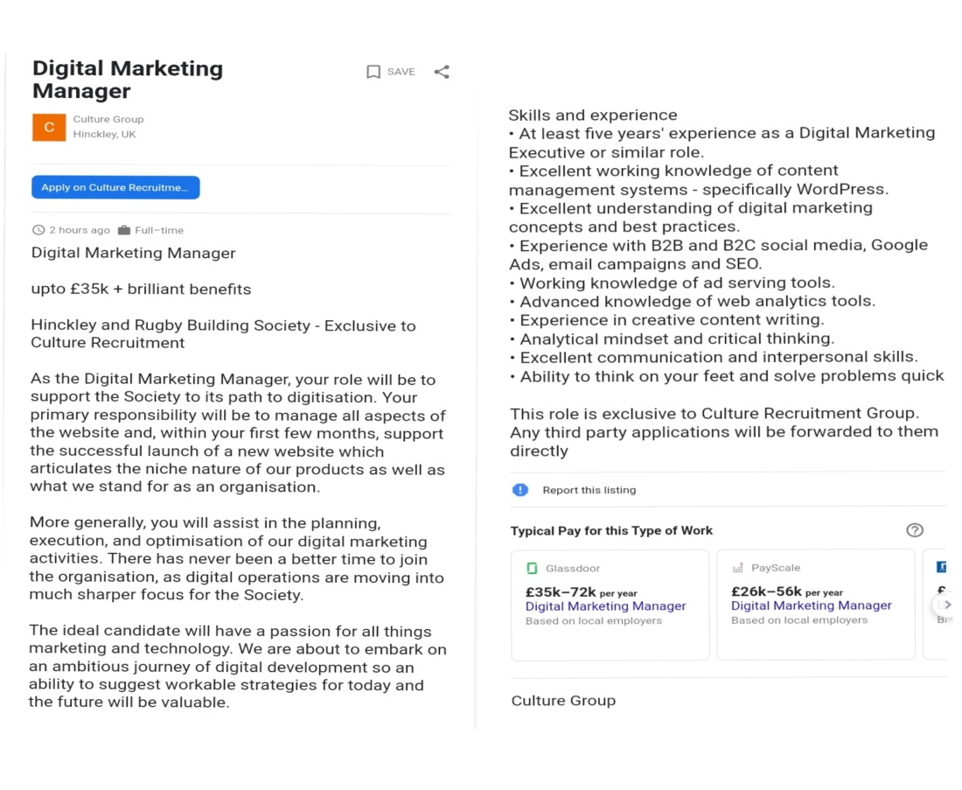

2. Personal SWOT analysis
SWOT analysis is a complete process of identifying the strengths, weaknesses, opportunities, and threats of a particular subject (Mandal, 2017). In this slide, a personal SWOT analysis will be made to address my strengths and vulnerabilities in getting the job of digital marketing manager at the Culture group. This SWOT analysis will help me to trace out the opportunities and threats of this job also.
Strengths
To get the job of digital marketing manager at the Culture group I should have some exceptional employability skills. These skills will help me to accomplish my tasks perfectly at the Culture group. When I can obtain these skills then it will be regarded as a key strength of mine to get this job. In my analysis, I found that I have exceptional communication skills. I can easily interact with others. It will be regarded as a significant skill of mine in getting the job of digital marketing manager at the Culture group as communication skill is one of the most important skills required by successful digital marketers. The level of my Social Media Marketing-SMM skill is also satisfactory. It is another noteworthy strength of mine since having proper social media marketing skills is a prerequisite for being a successful digital marketer (Lucas, 2015). My strong collaboration skills will be regarded as a key strength in getting this job as well. As a digital marketer, I will need to do teamwork at Cultural group. My collaboration skills will help me in this case. I can easily adapt to a new changed situation. My adaptability skill is another important strength of mine according to my selected job role.
Weaknesses
To become a successful digital marketer at the cultural group I should have some exceptional technical skills and knowledge. In my analysis, I found that the level of my technical skills is not satisfactory. It is one of my key weaknesses to get the job of digital marketing manager at the Culture group. For example, my Search Engine Optimization-SEO skill is not satisfactory. But SEO skills are regarded as one of the most digital marketing skills nowadays (Cibrian Barredo, 2018). As a digital marketer of Culture group, I have to do SEO for its websites. My content marketing knowledge is not satisfactory as well. It will be regarded as another weakness of mine is getting my desired job. Besides, I am in lack decision-making also. I will suffer if I fail to ensure quick recovery from here since having proper decision-making skills is a prerequisite of being a successful digital marketer.
Opportunities
The digital marketing sector of the UK is very much potential now. It is growing day by day and taking new dimensions (Garcia Medina, 2019). I have many opportunities to do better in this sector. While working as a digital marketing manager at the Culture group I will be able to obtain exceptional knowledge about interactive technology and artificial intelligence. In this digital business era, it could be a vast opportunity for me. I will get a practical idea about e-commerce and e-business also while working as a digital marketer. It will be regarded as another noteworthy opportunity as all the digital businesses are e-commerce based now.
Threats
The digital marketing sector of the UK is very much complicated and competitive now (Ryan, 2019). I will face some major threats from the other candidates of this post. The complicated work of digital marketing will be another noteworthy threat of mine to get this job. Ensuring data privacy is very tough in this digital business world. Everyone has high technological support. The whole data management system can be attacked by hackers. As a digital marketing manager, I have to ensure the privacy of the Culture group’s data. This difficult task will be regarded as another significant threat of mine in this case.

3. Significant time management tools to achieve my intended career
Time management is a technique that helps an individual to accomplish a task timely and accurately (Cibrian Barredo, 2018). To develop my intended career I should use different time management tools since time management tolls may enhance my punctuality and workability. It will make me prompt and efficient. There are some significant time management tools that I can use to make me a better candidate for the post of digital marketing manager at the Culture group (Culturegroup.co.uk. 2021). Keeping the to-do list is one of them. By using this tool I will be able to accomplish my responsibilities timely as a to-do list shows all the daily tasks and duties on a single page. Besides, I may use time management tools like Scoro. The Scoro provides all the supports an individual requires for effective time management including work reporting, billing, time tracking, and task and project management (Friary, 2020). To get my desired job I must need these supports. Timecamp, Address Book, and task scheduling are some other noteworthy time management tools that I may use to achieve my intended career.

4. Required skills to get my desired job
I have already mentioned that I want to join the Culture group as a digital marketing manager. It is my dream job of mine as digital marketing is my intended career. To get this job I need to have some exceptional employability skills. These skills will make me a better candidate for this post. In this section, I will discuss the required skills that I need to get my desired job. According to my desired job, skills that already I have and skills I need to obtain both will be mentioned in this section.

4.1 Skills I have
According to my desired job, the skills already I have will be mentioned here.
Communication skills
In my analysis, I found that I have exceptional communication skills. I can easily interact with others. According to my desired job, it is an important skill of mine. While working as a digital marketing manager, I have to communicate with numerous audiences, customers, and consumers (Culturegroup.co.uk. 2021). I will need to interact with new unknown people continuously. My exceptional communication skills will help me in this case.
Social Media Marketing-SMM skills
Social Media Marketing-SMM skill is one of the most important digital marketing skills (Bootcampdigital.com. 2021). As a digital marketer, I have to approach potential customers and buyers through different social media platforms. My exceptional SMM skill will help me in this case. Social media is the most appropriate way now to reach out to a customer. To reach out to a customer properly through social media platforms a digital marketer needs high social media marketing skills that is why it is regarded as the most significant digital marketing skill at present.
Collaboration skills
Collaboration skills help an individual to ensure quality teamwork. Having proper collaboration skills is a prerequisite for being a successful digital marketer (Ryan, 2019). As a digital marketing manager, I have to do teamwork. No success will come through individual efforts in this sector. In this case, team efforts will make the work of digital marketing more actuate. So for a digital marketing manager, the importance of collaboration skills is needless to mention.

4.1 Skills I need to obtain
According to my desired job, the skills I need to obtain will be mentioned in this section.
Search Engine Optimization-SEO
Search Engine Optimization-SEO is one of the most significant skills for a digital marketing manager (Moro, 2014). As a digital marketing manager, I have to do SEO for the websites of the Culture group. When proper SEO will be ensured then the website of the Culture group will be showed on the first page of the search engine like Google and Bing. It enhances the possibility of getting new customers.
Content marketing
Content-based marketing helps to gain the faith of the customers (Bootcampdigital.com. 2021). It is an important digital marketing skill also. Quality content like videography, image file, and written content attracts more customers as it provides more precise information. For this reason, content marketing is regarded as a key digital marketing skill. I have to obtain this skill promptly to make me a better candidate for this post.
Decision-making skills
Often a digital marketer needs to make complicated decisions (Fortin, 2020). He needs to make decisions about digital marketing strategy, content marketing process, and social media and search engine marketing techniques, etc. In this case, a digital marketer should have high decision-making skills. It is one of the most significant digital marketing skills which help a digital marketer to make worthy and impactful decisions.

5. How I will improve my condition
To get my desired job as a digital marketing manager I need to have some exceptional employability skills. In this presentation, I have previously mentioned that according to my selected job I already have some skills and I need to obtain some. In this section how I will obtain those required skills and how I will improve the condition of the skills already I have will be discussed.
Joining an internship: I will join an internship program in a renowned digital marketing agency in the UK. It will help me to obtain the required digital marketing skills like SEO, content marketing, and decision-making skills practically.
Doing online courses: I will do online courses on digital marketing from renowned online educational platforms like Udemy and Coursera. It will provide me with more precise information on digital marketing skills (Garcia Medina, 2019).
Taking short-term training: I will take some short-term training on digital marketing skills like communication skills, social media marketing skills, and collaboration skills that I already have. This will increase the quality of my skills.
Focusing on the academic study: Apart from all of these, I will be focused on my academic study more seriously than before to make me a better candidate for the post of Digital marketing manager.

Conclusion
The digital marketing sector of the UK is one of the most fast-paced career opportunities at present. This sector is very dynamic and growing day by day. Consequently, it has become my intended career. But in this time of high competition getting the desired job in this sector is a very difficult task. I need to obtain the required skills and attributes promptly to make me different from other candidates in this sector. At the same time, I need to overcome my weaknesses and vulnerabilities as early as possible to get my desired job as digital marketing manager at the Culture group.

Reference
Lucas, A., 2015. Career Opportunities in Digital marketing. New York, USA: Momentum Press.
Friary, R., 2020. Jobs in the digital marketing industry. San Diego: Academic Press.
Morris, N., 2019. Understanding Digital Marketing: Marketing Strategies for Engaging the Digital Generation. Journal of Direct, Data and Digital Marketing Practice, 10(4), pp.384-387.
Mandal, P., 2017. Understanding Digital Marketing Strategy. International Journal of Scientific
Research and Management.
Bootcampdigital.com. 2021. 12 Most In-Demand Digital Marketing Skills in 2021. [online] Availableat:&lt;https://bootcampdigital.com/blog/12-most-in-demand-digital-marketing skills [Accessed 28 July 2021].
Culturegroup.co.uk. 2021. Culture Group ®. [online] Available at: <http://www.culturegroup.co.uk/> [Accessed 28 July 2021].
Cibrián Barredo, I., 2018. Marketing digital. Madrid: ESIC Editorial.
García Medina, I., Pereira Correia, P. and Alberola Amores, L., 2019. How the digital age has changed the corporate communication world: the case of Digital Marketing in the Fashion Business. IROCAMM-International Review of Communication And Marketing Mix, 2(1), pp.87-94.
Fortin, D., 2020. Global Marketing for the Digital Age20002Bill Bishop. Global Marketing for the Digital Age. Illinois: Lincolnwood 1999. 270pp. $34.95. Journal of Consumer Marketing, 17(4), pp.358-372.
Moro, M. and Rodés Bach, A., 2014. Marketing digital. Madrid: Paraninfo.
Ryan, D., 2019. Understanding digital marketing.

Appendix:


