Takeway Menu For Hotel Trinity
4* hotel restaurant

Starters
- Mexican chilli nachos £4.8
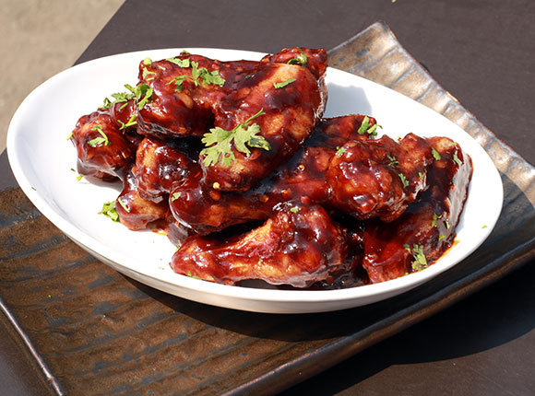
- Chicken bites £4.8
- Mini haggis 4.95
- Garlic Bread £4.85
- Bread garlic mushroom £4.85
- Tomato soup 4.85

Main course (Veg)
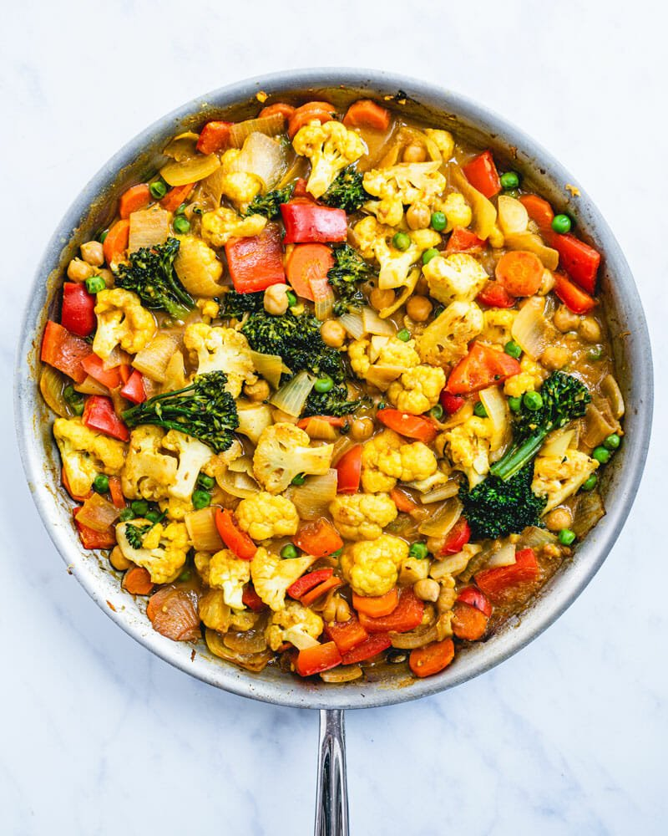
- Vegetable curry £9.85
- Vegetable cheese pasta £8.50

Main Course (Non-veg)
- Breaded haddock or battered Cod £8.95
- Homemade chicken £10.5
- Battered chicken fillets £10.5
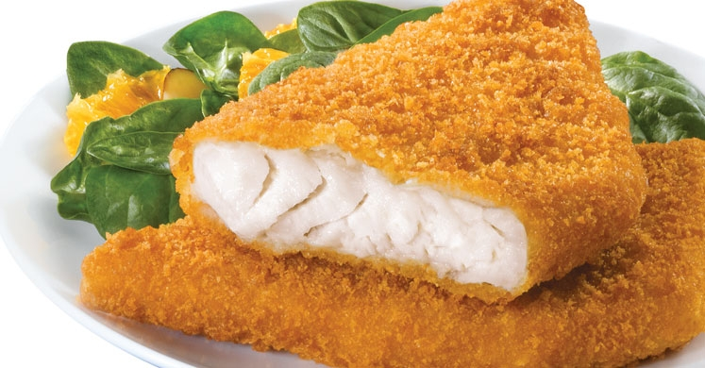
- Breaded scampi £7.95
- Steak pie £9.85
- Venison pie £11.5
- Chicken Ham £8.95
- Macaroni cheese £8.85
- Veal pork £9.15
- Smoked pork £9.85

Beverages
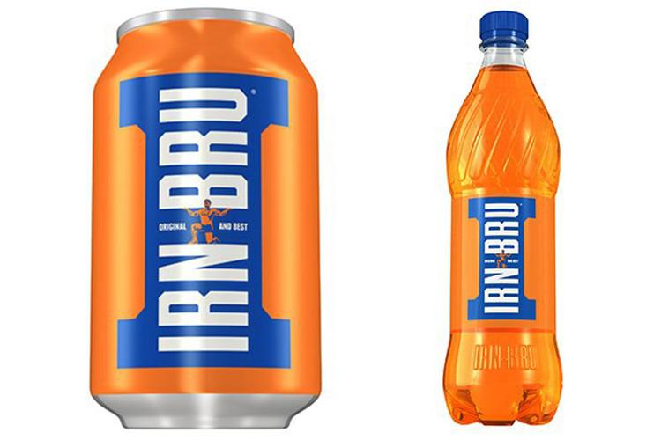
- Can coke £1.00
- Can irn Bru £1.00
- J2D £2.00
- Can Diet Coke £1.00
- Ginger beer £2.00
- Appletise £2.00

Wines
- Pinot Noir £11
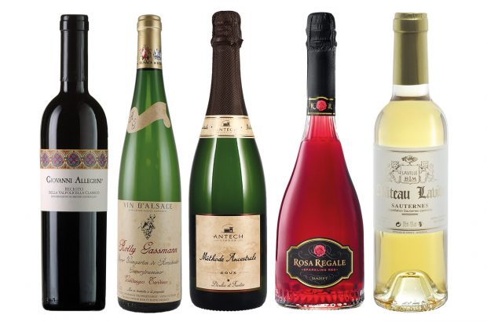
- Saint Laurent £9
- Merlot £13
- Syrah £9
- Cabernet £12
- Chardonnay £12
- Riesling £5

Wine Pairings with dishes
- Chardonnay paired with Veal pork/ Chicken £20
- Riesling paired with Chicken squad duck/ smoked por £13.5


