Student Name: Edgar Lopes Vieira
Student ID: 2438630
Assignment Title: Component 2 – Individual Report: Green Haven Florists Case Study
Module Name: Problem Solving and Decision Making
Module Code: LCLM4004
Programme: Certificate of Higher Education in Business Skills for the Workplace
Module Leader: Richard Ashaye
Submission Date: 16.12.25

Contents
Introduction 3
Alternative Solutions and Evaluation. 4
Alternative 1: Repackaging the Website and Enhancement of Digital Marketing. 4
Alternative 2: Providing Subscription Services and Customized Delivery. 5
Selected Solution and Justification. 6
Chosen Solution: 6
Justification: 6
Risk Analysis 7
Potential Risks: 7
Mitigation Strategies 7
Implementation Plan 8
Phase 1: Website Refurbishment (1-2 months) 8
Phase 2: The Digital Marketing Intensive (1-3 months) 8
Phase 3: New Features integration and Launch (2-3 months) 9
Effectiveness Measurement 9
Conclusion 10
References 11

Introduction
Green Haven Florists is an independent small flower shop at Norwich, UK. The shop was founded by Liam and Priya Patel in 2016 and is recognized because of its environment-friendly floral design and close relations with the community. It serves a wide range of customers, such as individuals, corporate clients, and weddings, and the emphasis on sustainable and bespoke services. In the recent past, Green Haven Florists has experienced a 30 percent decline in in-store sales which is attributed to the decrease in foot traffic, the growth of competition with online florists and the escalated operational expenses. This report will focus on examining the problems of Green Haven Florists, propose two possible solutions, compare them and provide the most appropriate course of action to guarantee the development and viability of the business.
Business Problem, Analysis
- Decline in In-store Sales: Green Haven Florists has recorded a 30 per cent reduction in foot traffic that has greatly impacted on revenue. This has mainly caused the downfall as there are less people in the high street shopping and the surrounding businesses are shutting.
- Increased Competition: The store is experiencing increased competition with a fashionable local florist having a good Instagram following, thus getting younger customers who are more digital. Also, a national chain has made an entry into the market with lower rates and increased delivery services which further strains Green Haven Florists to compete.
- Rising Operational Costs: The price of the flowers particularly those imported such as tulips and orchids have risen because of supply chain interference and the price inflation. The focus on sustainable materials of Green Haven contributes to the financial strain since it is difficult to sustain the profit margins without raising the prices.
- Customer Feedback: Customer review shows that people are not satisfied with the old-fashioned site that is not easy to navigate through. Customers have been interested in improving customer delivery like through same day delivery or subscription services to increase customer convenience.
- Internal Marketing Problems: The store has been relying on word of mouth and infrequent posts on social media as an advertising platform. This narrow-mindedness puts it at a disadvantage to the competitors who have more solid digital marketing plans.

Alternative Solutions and Evaluation.

Alternative 1: Repackaging the Website and Enhancement of Digital Marketing.
Description: One of the ways Green Haven Florists can resolve its existing challenges is to redesign the website and make it easier and more mobile-friendlier to navigate. The new site would be equipped with online ordering, where customers would have access to ordering the flowers online via their gadgets. Also, the store can expand its digital marketing initiatives through better search engine optimization (SEO), specific paid promotions, and collaboration with influencers within the floral and environmentally friendly circles (Etheredge, DelPrince and Waliczek, 2024).
Evaluation using PMI:
- Plus: The refurbished site will result in a massive online presence so that customers can locate and shop conveniently in the store. Online ordering will result in greater customer interaction due to straightforward navigation and simplified online ordering, which will bring in a wider range of customers and notably the younger and more technologically inclined ones (Lee and Lee, 2020).
- Minus: This option will involve large expenses at the beginning to redesign the websites and do marketing. It will also involve constant effort to maintain the site and make it competitive.
- Interesting: The new overhaul of the site will allow distinguishing Green Haven Florists among its competitors, as the site will be more connected to the current trends in consumer shopping experience, which is tied to modern shopping practices and effective utilization of digital means.

Alternative 2: Providing Subscription Services and Customized Delivery.
Description: Green Haven Florists can also offer subscription options, in which the customer is able to subscribe to weekly or monthly deliveries of flowers. As a convenient eco-friendly service, this service might be sold to regular customers. Also, the flexible delivery service, i.e., delivery on the same day or with eco-friendly approaches may be offered to make the delivery convenient to clients (Wangsa et al., 2021).
Evaluation using PMI:
- Plus: A recurring model would open a predictable flow of revenue, and cash flow would be more predictable to the business. Flexibility of delivery would also enhance the customer loyalty by making it easier to shop at Green Haven Florists at regular intervals (Gomes, Pereira and Pinto, 2025).
- Minus: Subscription management is an extra burden in terms of operations and complexity, such as establishing and monitoring repeat deliveries. Also, there will have to be major marketing campaigns to educate and entice customers to the subscription service.
- Interesting: The service would make Green Haven Florists stand out among its national competitors due to personalized and sustainable offers. The emphasis on sustainability and flexibility may appeal to the environmentally conscious customers and offer them a selling point in the competitive business environment (Walsh and Dodds, 2017).

Selected Solution and Justification.

Chosen Solution:
The solution that has been selected is to transform the site and enhance digital marketing. The proposed solution helps tackle the fundamental problem of decreased sales and traffic since it concentrates on increasing the online presence of Green Haven Florists to make it more accessible and attractive to more people.

Justification:
- Long-Term Benefits: The benefits of updating the site and increasing the digital marketing activity will be long-term since they will reach more and more diverse customers (García et al., 2019). With the increasing number of customers shopping online, this solution will assist in attracting customers who might not access the physical store because of its convenience or location.
- Market Trends: Customers are moving to online shopping, which has rapidly grown due to the pandemic, and this trend is specific to the digital-first world. Green Haven should respond to this change in order to be competitive and be able to attract new consumer who appreciate the ease of online ordering (Hu et al., 2019).
- Digital Growth: A contemporary webpage and specific digital promotion is essential in competing with the national chain with lower prices and the boutique florist with vast Instagram development. It will help Green Haven to be unique in the flooded digital environment.
- Sustainability and Innovation: A redesigned site may demonstrate the sustainability of the shop attracting guests to the store through displaying environmentally friendly products and services.
- Feasibility: Digital marketing and revamping of the websites are cheaper to invest in compared to physical operations overhaul and in line with the current trend of online shopping.

Risk Analysis

Potential Risks:
- High Initial Costs: It will incur a large initial cost to develop a new web-site and start a digital marketing program that would demand a lot of money out of the business in the short-term.
- Technical Issues: The shift to a new site might prove to be challenging, particularly when it is worked on by a small group of people who might not be proficient enough in technical skills.
- Customer Adoption: Customers, especially the older ones, might be retarded in adopting the new site and online services (Nunan and Di Domenico, 2019).
- Increased Competition: The online marketplace is very competitive and the outcome of the digital marketing might not show immediately especially where other bigger companies are already operating in the market.

Mitigation Strategies
Invest in Expert Help: Get professionals to design your website and market it online to get the highest quality with no technical problems.
Phased Implementation: Start with the necessary changes on the site and add more functionalities step by step to being economical and causing minimal inconveniences (Anderson, 2020).
Customer Education: Conduct specific campaigns to summarize the advantages and convenience of the new site and internet services and persuade customers to accept the change.
Monitor Performance: Frequently watch essential indicators to measure progress and make necessary changes.

Implementation Plan

Phase 1: Website Refurbishment (1-2 months)
Actions: Hire a team of web designers to remodel the site with user-friendly features e.g. online order, improved navigation, and mobile optimization. It must be designed in the spirit of sustainability of Green Haven and with environmentally friendly images (Ottman, 2017).
Resources required: Web designers, technical support and a budget on the web redesigning.

Phase 2: The Digital Marketing Intensive (1-3 months)
Actions: Plan a social media campaign of such websites as Instagram and Facebook. Collaborate with influencers in the green and flower industry to increase coverage. Optimize search engines and perform specific online advertisements.
Resources Required: Social media managers, advertisement budget and influencing collaborations.

Phase 3: New Features integration and Launch (2-3 months)
- Actions: Test the site extensively to guarantee the smooth running of the site on all devices. Resolve any bugs and make it mobile friendly. Conduct promotional campaigns to publicize the new features on the site and get the customers to interact with the site (Baum et al., 2019).
- Resources Required: Testing crew, marketing crew and customer care department to answer questions and assist customers in making the transition.
Timeline: The entire implementation process will take 4-6 months, and the implementation of each stage will be based on the one that comes before it to ensure that the implementation is smooth.

Effectiveness Measurement
In a bid to gauge the effectiveness of the overhaul and online marketing campaign, the following Key Performance Indicators (KPIs) will be monitored:
- Website Traffic: Measure the traffic of the site including the amount of visitors, the level of bounces and time on the site in order to determine user activity.
- Conversion Rate: Measure the rate of visitors converting to purchase as a measure of how the site is performing in terms of converting traffic into sales (SALEEM, 2019).
- Customer Engagement: Measure social media interaction, e.g. likes, shares and commenting, to understand customer interaction.
- Sales Expansion: Compare the sales of the site prior to and after the revision and determine the direct connection in terms of revenue.
- Customer Satisfaction: Survey and feedbacks on customers should be used to evaluate the level of satisfaction to the new site and services.
- Monitoring Tools: These KPIs will be adequately tracked with the help of Google Analytics and social media insights as well as point-of-sale data.

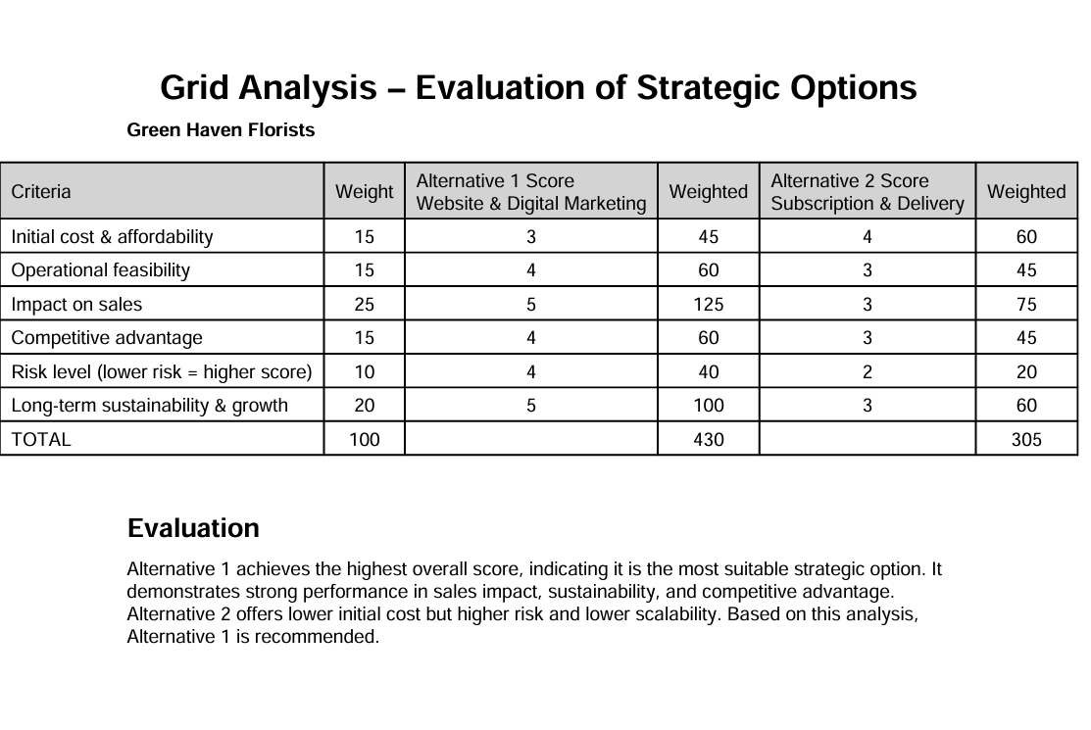

Conclusion
The main challenges of Green Haven Florists include loss in sales and foot traffic because of the growth of competition, the increase in operation costs, and the old-fashioned web site. The solution that is recommended to resolve these issues is complete site redesigning and improved online marketing plan.
The long-term solution that can be offered due to the shift to online shopping is the revamp of the site and investments in digital marketing. It will assist Green Haven Florists in building new clients, reinforcing its brand online and competing efficiently in the digital market that is getting bigger and bigger.

References
Anderson, D.M. (2020). Design for Manufacturability. Second edition. | Boca Raton : Taylor & Francis, 2020.: Productivity Press. doi: https://doi.org/10.4324/9780429285981.
Baum, D., Spann, M., Füller, J. and Thürridl, C. (2019). The impact of social media campaigns on the success of new product introductions. Journal of Retailing and Consumer Services, [online] 50(1), pp.289–297. doi: https://doi.org/10.1016/j.jretconser.2018.07.003.
Etheredge, C.L., DelPrince, J. and Waliczek, T.M. (2024). Perceptions of Environmentalism and the Use of Sustainable Floral Design Practices by Professional Florists. HortTechnology, 34(6), pp.812–818. doi: https://doi.org/10.21273/horttech05546-24.
García, J.J.L., Lizcano, D., Ramos, C.M. and Matos, N. (2019). Digital Marketing Actions That Achieve a Better Attraction and Loyalty of Users: An Analytical Study. Future Internet, 11(6), p.130.
Gomes, Â., Pereira, I.V. and Pinto, S. (2025). Optimizing Social Media Strategies for Enhanced Performance. Advances in marketing, customer relationship management, and e-services book series, [online] pp.273–310. doi: https://doi.org/10.4018/979-8-3693-5395-0.ch009.
Hu, J., Liu, Y.-L., Yuen, T.W.W., Lim, M.K. and Hu, J. (2019). Do green practices really attract customers? The sharing economy from the sustainable supply chain management perspective. Resources, Conservation and Recycling, 149, pp.177–187. doi: https://doi.org/10.1016/j.resconrec.2019.05.042.
Lee, S.M. and Lee, D. (2020). ‘Untact’: a New Customer Service Strategy in the Digital Age. Service Business, [online] 14(1), pp.1–22. Available at: https://link.springer.com/article/10.1007/s11628-019-00408-2.
Nunan, D. and Di Domenico, M. (2019). Older Consumers, Digital Marketing, and Public Policy: A Review and Research Agenda. Journal of Public Policy & Marketing, 38(4), p.074391561985893. doi: https://doi.org/10.1177/0743915619858939.
Ottman, J.A. (2017). The New Rules of Green marketing. Routledge. doi: https://doi.org/10.4324/9781351278683.
SALEEM, H. (2019). Strategic Data Driven Approach to Improve Conversion Rates and Sales Performance of E-Commerce Websites. [online] Academia.edu. Available at: https://www.academia.edu/download/96188065/Strategic-Data-Driven-Approach-to-Improve-Conversion-Rates-and-Sales-Performance-of-E-Commerce-Websites.pdf.
Walsh, P.R. and Dodds, R. (2017). Measuring the Choice of Environmental Sustainability Strategies in Creating a Competitive Advantage. Business Strategy and the Environment, 26(5), pp.672–687. doi: https://doi.org/10.1002/bse.1949.
Wangsa, I.D., Wee, H.M., Hsiao, Y.L. and Rizky, N. (2021). Identifying an effective last-mile customer delivery option with an integrated eco-friendly inventory model. INFOR: Information Systems and Operational Research, pp.1–36. doi: https://doi.org/10.1080/03155986.2021.2012403.

