EFFECTIVE TEAM WORKING & COMMUNICATION

Student name: Andrei Strechie
Student number: 1811974
Module code: BMSK4002
Lecturer: Dr Rexon Nting

TABLE OF CONTENTS
Introduction 1
Effective communication with a group or team 6
Benefits of having effective team working & communication 8
Conclusion 10
References 11

LIST OF FIGURES
Figure 1: Team Dynamics 3
Figure 2: Team Roles 4
Figure 3: Effective team working 9

Introduction
The communication is the key for the success of any project, relationship and of course company as whole. The communication can be said the back bone for any business because if there is no communication there will be no success. For effective team working it is very important that every individual has great listening and communication skills towards the other then only a team work effectively in order to achieve its goals. In this study a case study of company “HR software” is taken. It was the small company which has started its work to provide the payroll software to the big brands but with its effective team working and creative efforts now this company is working very high with the other dealing also. Here a discussion is made upon the ideas which are taken in this organization.

The main theories relating to group dynamics, team working and communication at HR Software Company
The work environment must be in a manner so that every employee and employer can feel their connection with their workplace. There are certain important theories which actually work as in HR Software Company these theories are really helpful to get effective team working.
Recognition of the personalities affects the team dynamic - in a group different kinds of people work together their personalities, their skills and their nature is really different from each other. Recognition of everybody’s style, skills and level of aptitude support to the management or leaders that in which level that person would be fit for the group, apart from that it also helps to design the motivation factors for specific individual. It is also helpful if any gap is found so it can be filled by the corrective actions. Some of the group members can be aggressive personalities who dominates the other members so in these kinds of case where the leaders or a manager knows the personality traits of every members, can react quickly and can take corrective measures. If each of the members within the group feels contributed and valuable he/she can work in better way with very positive effort to achieve the team goal.
Effective leadership theory – the leadership must be strong and effective to handle the team or group. Being strong is not meaning that manager is strong arm for maintaining control. The leader or manager must be true guide for the team development. The manager must show the path to the team so every member along with the group can achieve their goals. The manager or a leader needs to clarify roles and responsibilities to each of the members along with the timeline for the project completion.
Understanding of the group lifecycle – the group dynamics has five steps which describes the whole journey of the group.

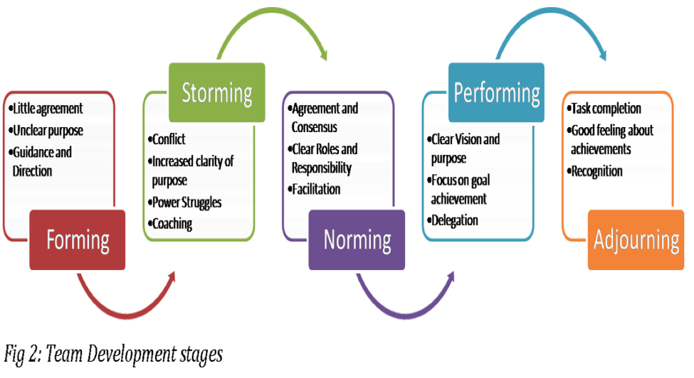
Figure 1: Team dynamics
(Source: www. mspguide.org)

Forming – it is the first stage of the group where all members come together to form a group.
Storming – it is the stage where conflicts can be happen between the group members and sub group may arise.
Norming – in this stage the team became invested in the group as a whole and the common objectives of the group.
Performing – it is the stage where all the team members perform their task with the sense of responsibilities without any issues as in this stage all issues are solved.
Adjourning – if a specific project is designed so after completion the project the other project can be designed
The leaders or the managers must be understood that in which stage, in which manner the team needs support and the leaders must be prepared with the sources in order to helping the team.
Team analyzes – it is very important to analyze the team or group. The team analyze process actually allows to analyze role of every team members. The roles play very important part in team work as according to these roles the team member works.

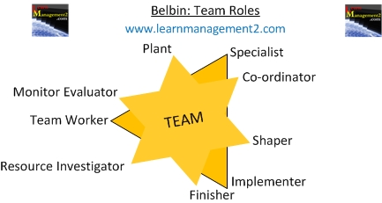
Figure 2: Team roles
(Source: www.learnmanagement2.com)

Action oriented roles – these roles actually turn theories into actions and provide the directions to the projects with the implementation of the plans. These team mates put their efforts for performing things in correct manner. The shaper, implementer and the finisher roles come under this category. These team members actually done or complete the task within time limit.
People oriented roles – these roles helpful to find the resources and tools for the task or project completion. The team worker, coordinator and the resource investigator come under this category as these team members coordinates with the other in order to complete the task. The suitable resource finding, coordination and work are the main attributes of this role category.
Thought oriented roles – these roles are responsible to evaluate the resources and everything and that is why the specialist role comes under this category. These team members are responsible for planting the project. The plant, evaluator and the role of specialist come under this category.
Communication – the group or team members or any employee along with the employers are really gets affected if the communication is not effective. The effective and strong communication is a key to work within a workplace. The communication actually makes task easy and that is why the team can achieve its goal in better way. The techniques, methods and mode of communication are very much advanced nowadays so it can be easily available to every members of a team. The documents, emails, management software, telephonic conference are the major communication tools apart from it the face to face communication as meeting, one to one are the other method that can be used to motivate and to take out the hidden qualities of the individuals. An open and transparent communication is always helpful to build a sense of belongingness and trust level within the group and within the company as well. The IM chat facility also can have by the companies.

The HR Software Company has set some of the indicators that show team working effectively or not, that are as follows;
- All the members have very clear communication
- The organizations have regular brainstorming session or not
- Consensus among team members
- The team has problem solving attitude or not
- The group or team has strong commitment or not
- Regular team meetings inclusive or not
- Timely hand off from team members to others for ensuring the projects is going in right and correct direction
- All the team members
- have supporting, positive relationship.

This organization has also set some characteristics that display the non effective performance of the team. If any team or group shows these kinds of things the leader and manager must involve in that team and help the team to find the solutions. This is the only way to complete the project which is assigned to the specific group or team.
- Lacking in communication within the team
- Unclear responsibilities and roles
- Team members or group is not putting their efforts towards the work completion with no concern or quality work
- Group work alone and not sharing any kind of information and not giving assistance
- Team plays blame game and no one takes responsibilities
- Group members are frequently absent and avoid the work

Effective communication with a group or team
There are some ideas or strategies which have worked very positively for the growth of the HR Software Company in order to have effective communication.
Responsibility – the employer must take the full responsibility for proper communication because being a boss the owner should position himself/herself as the authority and example for which kind of communication must be there within the team.
Preparation – it is very important that boss must make the adjustments on priority basis for the leadership patterns, communication pattern, skills set and etc. the importance of every kind of communication must be clear within employer’s mind then only he/she can give the required picture to the team.
Discussion – it is very important strategy which woks wonder because it opens the door for deep discussion. Discussion of any kind of issue provides opportunity to solve the problem and to have the alternate solutions. It allows understanding every member in deeper sense and it is very helpful to motivate him/her accordingly. It helps to generate the ideas regarding the attributes needed by every individual team member for being a future leader.
One to one – it is the way to communicate effectively. The one to one conversation actually gives hope to those team members who are comparatively reserved in nature and do not share their grievances publically. It also provides opportunity to solve the personal issues if any team members have with the other team member.
Agenda – always set an agenda for the meetings. Meeting can be done at regular interval on a set agenda so the team members get continuous connection with the project. This can be done online, conference, telephonic conference and before that a written copy must circulated within the team members regarding the matter of agenda.
Team leader – appointing a team leader is very good idea to make effective communication as the team leader can communicate the strategies and required behavior to the team. The team leader must be well understood and be able to communicate the day to dy operations and actions strategies to the group.
Feedback – the feedback method works really positive in order to have effective communication within the team and organization. The questions and surveys can be done after every discussion because it provides ideas for the betterment.
Act as mediator – the organization has to play the role of mediator sometimes and solve the issues. If any organization feels that it cannot work as mediator, it can hire a third party which gives unbiased solutions. It happens mostly in big companies.

Benefits of having effective team working & communication
There are lots of benefits to have the effective team working and communication within the organization. The HR Software Company has benefited in lot manner and according to that the given benefits are extracted.

Reachable and clear goals – the effective communication provides the goal clarity and makes it reachable. The team leader or manager usually communicates the requirements, expectations and all other things to the team. The leader provides the information about the team roles, and responsibilities to all the members. The fair distribution of roles and communication helps to have the goals on time basis. Clear communication supports in proper organization and to meet the objectives timely.
Better solutions and efficiency – if the team members are communicated properly for their roles, they put their efforts in correct way. This helps them to serve clients in positive manner. The clear communication helps team members to perform efficiently and that is why both come together. The communication actually supports the maintaining of efficiency in the variety of circumstances and conditions.
Work relationship – the positive communication within the group creates the environment where everybody feels enthusiastic and positive to work. It gives sense of security and belongingness that boost the positive working relationship. When the group members know each other and the leader it becomes easy to work for everyone. This kind of positivity is always helpful to complete the project with satisfaction.
Culture of celebration – the effective team working and communication boost the environment where the celebration is made for everything or every achievement. It boost the energy and enthusiasm of every team member. This kind of environment improves the work potential and satisfaction level. It is the culture where group members feel the growth mindset and then work with positive efforts.
Reduction of conflict – it is the great advantage of effective team working and communication as if disputes or conflicts are solved at very initial phase it cannot be developed further and the peaceful working environment is achieved. The effective communication allows every member to voice out about their problems and achievements. The feeling of free expressions is really good in order to have honesty in work. The conflict must be solved in quick manner and that is why it is very beneficial to have effective team working and communication.
Apart from these there are many others benefits of the effective team working and communication because according to the organization requirements the benefits can be increased.

Conclusion
The study is extracted upon the success of the HR Software Company which has set the example as after becoming a good brand name from the small venture. The above study shows that the effective team working and communication are the pillars of the success of any company. The team working efforts and the communication move together hand in hand and that is why the organization must focus on both the things for the growth. The various team and group dynamic theories must be applied in a suitable manner to boost the effective communication and the effective communication must be there to achieve the set team goals. After gone through this study it is very clear that the effective team working requires some of the applicability such as leadership quality, communication pattern and the kind of project which is assigned.

References
Books and Journals
- Bardach, E. and Patashnik, E.M., 2015. A practical guide for policy analysis: The eightfold path to more effective problem solving. CQ press.
- Boies, K., Fiset, J. and Gill, H., 2015. Communication and trust are key: Unlocking the relationship between leadership and team performance and creativity. The Leadership Quarterly, 26(6), pp.1080-1094.
- Cardon, P.W. and Marshall, B., 2015. The hype and reality of social media use for work collaboration and team communication. International Journal of Business Communication, 52(3), pp.273-293.
- Collet, C., Hine, D. and du Plessis, K., 2015. Employability skills: perspectives from a knowledge-intensive industry. Education+ Training, 57(5), pp.532-559.
- Driskell, T., Salas, E. and Driskell, J.E., 2017. Teams in extreme environments: Alterations in team development and teamwork. Human Resource Management Review.
- Forrier, A. and Sels, L., 2003. The concept employability: A complex mosaic. International journal of human resources development and management, 3(2), pp.102-124.
- Fugate, M. and Kinicki, A.J., 2008. A dispositional approach to employability: Development of a measure and test of implications for employee reactions to organizational change. Journal of Occupational and Organizational Psychology, 81(3), pp.503-527.
- Harris, T.E. and Sherblom, J.C., 2018. Small group and team communication. Waveland Press.
- Hillage, J. and Pollard, E., 1998. Employability: developing a framework for policy analysis. London: DfEE.
- McQuaid, R.W. and Lindsay, C., 2005. The concept of employability. Urban studies, 42(2), pp.197-219.
- Nauta, A., Vianen, A., Heijden, B., Dam, K. and Willemsen, M., 2009. Understanding the factors that promote employability orientation: the impact of employability culture, career satisfaction, and role breadth self‐efficacy. Journal of Occupational and Organizational Psychology, 82(2), pp.233-251.
- Rodell, J.B., Breitsohl, H., Schröder, M. and Keating, D.J., 2016. Employee volunteering: A review and framework for future research. Journal of management, 42(1), pp.55-84.
- Sternberg, R.J. and Frensch, P.A., 2014. Complex problem solving: Principles and mechanisms. Psychology Press.
- Thijssen, J.G., Van der Heijden, B.I. and Rocco, T.S., 2008. Toward the employability—link model: current employment transition to future employment perspectives. Human Resource Development Review, 7(2), pp.165-183.
- Van Aken, J.E. and Berends, H., 2018. Problem solving in organizations. Cambridge University Press.
- Watts, A.G., 2006. Career development learning and employability.
- Woodcock, M., 2017. Team development manual. Routledge.

