BMSK6003: Leading and Implementing Workplace Change
Student Name: Mohammed Nazim Uddin
Student ID: 1606011
Lecturer Name: Dr Rexon Nting

Table of Contents
Introduction 3
Critically analyze the relationship between environmental change and organizational capability 4
Organizational change and culture 4
Environmental change 5
Internal business environment 5
External business environment 6
Responsible parties for change in organization 8
Roles of managers as change agents 9
Critically analyze the nature of change and evaluate complex concepts relating to leadership in relation to change management 9
Forces of change that impact on the organization 9
Nature of the change process 10
Kotter’s 8 step of change model 10
Lewin’s change management model 11
System model of change 12
Explore contemporary issues and their impact on business management 13
Why people resistance to change 13
The way management can handle such resistance and overcome those barriers 14
Hard and soft models of change 15
Analyze and evaluate the relationship between organizational culture and change 16
Trends in organizational change to face 16
Analyzing organizational cultural practices in P&G and their relations with change 16
Analyze the change management model that can be applied by P&G as per their culture 17
Transitional curve to understand relationship between organizational culture and change 17
Conclusion 19
References 20

Introduction
This research has determined and analyzed the way an organization is understanding the environmental changes as well as arranging resources in terms of matching with the changing situations. Here, the relationship between the environmental changes and the capabilities of the organization has explained through explaining different cultural and structural issues of company. It also consists the evaluation of several kinds of business environment that should be known to the company for making better plans and strategies to deal with changes. Though changes are vital for the company to boost the employee’s performance because it contributes in lowering boredom and enabling scopes for the employees to give their best effort in getting desired outcomes. This study has analyzed based on the activities of Procter & Gamble company that is recognized as one of the leading multi-national company around the globe. This company has started their journey in consumer market since 1837 and it has founded by William Procter and James Gamble. The company is producing and delivering products related to the personal care, beauty care, personal healthcare as well as diagnostics products. There are more than 90000 employees who have been continuously trying their best and contributing to the organization through their skills and talents in terms of assuring success.

Critically analyze the relationship between environmental change and organizational capability
In case of managing activities in the company as well as expecting to sustain in the competitive market then there must consider the relationship between environmental change and organizational capabilities. Based on the resources and capabilities of the company like P&G, they are able to cope with different environmental changes.
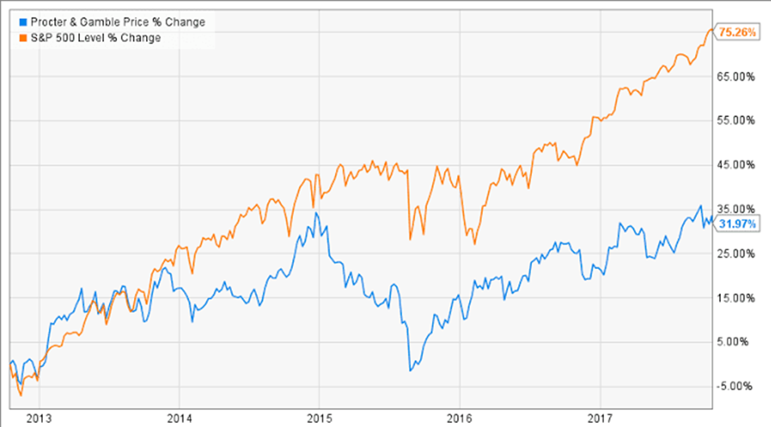

Figure 1 changes in P&G (Catlin-Legutko and Klingler, 2012).
Change has always been considering fact for the company like P&G as they are operating their activities in global world where market demands and conditions are facing the changes constantly. There needs to identify the change in the political and economic conditions so that they can attain desired goals (Catlin-Legutko and Klingler, 2012). In case of understanding change in the company, they require to apply the concept of change management. It determines the process through which the company is able to make the changes in their production and distribution process. Due to the changes in the environmental conditions, the P&G is influenced to enable changes in conducting operations.

Organizational change and culture
When a company is facing the situations where they find difficulties and complexities in running the business then they think about developing their structure and culture (Forsyth, 2012). It would support the company in encouraging the employees in giving best effort as well as managing the resources through following standard process. The P&G has already established their corporate culture whereas the employees are bound to follow the regulations and procedures. If they are not willing to take part in making changes then the employees would get punishment or suspension because of their activities.
There needs to consider various cultural features in the P&G to analyze their capabilities to cope with the changes. These are explained in below:
Innovation: P&G is encouraging their research and Development team to bring new ideas and creativity in terms of making products (Karp and Helg, 2008). It helps the company to reach large amounts of potential customers.
Attention to detail: The authority of the P&G is focusing on the each details of organizational activities such as: gathering materials to the distribution of goods and services to final consumers (Catlin-Legutko and Klingler, 2012).
Expectation: When the company is expecting to attain higher profit then they remain objective as well as concentrating to increase their sales volume. On the other hand, the P&G is people oriented also in terms of reaching goals. As they believe in the concept whereas satisfying employees can motivate them to think about company’s welfare.

Environmental change
To know about required changes in the company, they need evaluate their surrounding environment that impact on making decisions. It consists the examination of several business environment such as: internal and external business environment. These are explained in the following way:

Internal business environment
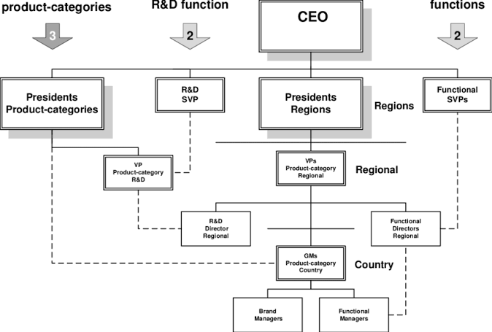

Figure 2 Organogram of P&G (Canaday, 2018).
This business environment is focused on the structure and context of the P&G whereas they have control upon the factors. Through identifying the impact of different factors within the company, they would shape the activities as per required standards. It involves the value system, mission, labor union, technological capabilities and quality human resources of the P&G. These are discussed in below:
Value system: The decisions of P&G are coming from its core values which is integrity among the leaders. When the company has found that the current regulations and values are obsolescence as these should be changed for improving performance (Canaday, 2018). It also influences the mentality and thinking of the employees in terms of working efficiently for the betterment of company.
Mission: It determines the specific objectives of the P&G as management is setting small portion of target for achieving within given time period (Karp and Helg⊘, 2008). They are also able to change their mission if any error or updated information has determined.
Labor union: They would also control the activities of the labor union as it is formed with the employees who are working in the organization (Forsyth, 2012). In case of building better relationship, the P&G can enhance the practice of labor union to know about the demands of employees.
Technological capabilities: If any new technology has innovated for the production and distribution in the company, they should have adopted the updated technology for coping with changing environment (Will, 2015). The P&G organization has applied the ERP technology in the organization for fostering their production and efficiency.
Quality human resources: By improving the HR system within company, they will be able to manage the talents and skilled employees for conducting operations. Due to the changes in recruitment and selection process, there has scope for developing employees. The HR department of the P&G is using the external method such as: online recruitment for hiring quality employees without any biasness.
Business conditions of P&G
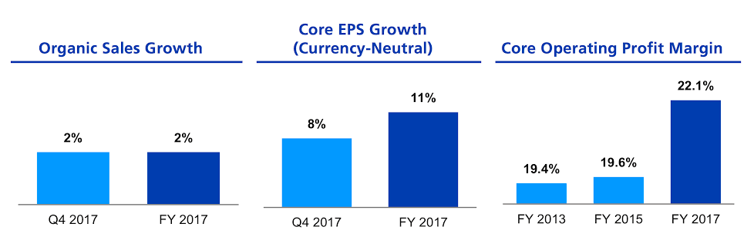
Due to the changes in the business operations as per the global demands and needs, the company has been capable in generating profits higher than previous years. In here, they also increased their core operating margin that determines their level of sustainability in the business operations. It contains the amount of EPS growth in the organization because of their stability in business even after the changing environment.
Figure 3 Business Conditions of P&G (Canaday, 2018).

External business environment
As P&G has been operating functions in different countries, so there are various factors that are out of their control system. They are influenced because of such factors from external environment in terms of setting plans and strategies. To analyze this environment, they need to explore broader perspective so that they take best decisions for enabling the changes.
External factors | Description
Political | In here, the company like P&G needs to change their trading policy in foreign countries like India if the local govt. Increases the tax rate upon the imported products (Canaday, 2018). In that case, the company must look for enhancing collaboration in different countries as well as lowering the production cost for gaining competitive advantages. Due to the corruption level and stability of the govt. the P&G is influenced to invest higher capital.
Economic | As per analyzing economic factors, the P&G has been making their HR policies and business development (Kirst-Ashman, 2008). When a country like India is holding high unemployment rate then they would get advantages to hire employees at lower cost than other countries. They are also affected to implicate labor laws and inflation rate in setting remuneration of employees.
Social | The products and services of P&G need to be conformed with the standards and values that the existing customers hold because the concept and beliefs of individuals living in the social circle are always changing. The changes are generally affecting to the organization from the social conditions such as if the customers are more involved in adopting western culture in India then the company needs to change their production system. In that case, current trends and lifestyle of the customers are influencing the leaders to ensure changing activities (Smith, Farmer and Yellowley, 2013).
Technological | Due to the innovation of new technologies in the market, the company like P&G needs to concentrate on converting obsolete technologies to replace with new ones (Buchanan and Huczynski, 2019). They have to raise awareness among the employees before making changes regarding the technological operations. Such as: If there has increased the availability of automation in the production of goods within P&G then they would not require higher volume of employees to work.
Legal | Based on the implications of laws relating the employment and customers, P&G has to legalize their work by following required conditions. If the govt has increased the minimum rate of employees per hour from $5 to $8, then they are also bound to make the changes. They must avoid materials that are not allowed in a country to produce and sell as per consumer protection law.
Environmental | In case of producing goods and services of the P&G as well as setting prices of the products, they need to depend on the climate changes and environmental policies. In Asian countries like Japan, they are now enabling laws for protecting natural and non-renewable resources. In that case, P&G needs to follow those regulations in manufacturing their goods such as: lowering the wastages and use of plastic in their workplace.

Responsible parties for change in organization
If any kind of updated communication and operational technologies have determined in the global markets then it has been responsibility of the change agents for identifying the ways to adopt those. It contributes in making effective decisions and strategies for dealing with changing environment (Kirst-Ashman, 2008). Due to the changes in business environment, the top management of P&G has also been influencing the change agents to find out better solutions of the problems. They can be from internal employment or hiring external parties to bring out the changes in implementing change. Both managers and employees have to be active in playing role to support the organizational changes, otherwise strategies of the P&G may fail to compete with established companies.

Roles of managers as change agents
In here, the managers are performing various roles as change agents in terms of managing tasks as well as determining the scope for developing conditions. In the P&G, the managers are playing the role as advocate for identifying the problems as well as suggesting the authority of company to make the changes in their procedure (Shani and Noumair, 2019). When there has required of providing information to the employees for bridging the objectives of the company. They consider as counsellor to their subordinates for improving their knowledge regarding the changes and updated information. Managers are playing the role of facilitator by arranging materials and resources to support the employee’s conditions. They would not think about bringing changes without considering the employee’s capabilities and areas of jobs (Sierk, Dvora Yanow and Ida, 2011). The managers have to determine the efficiency level of employees to make the changes as enabling required training to the employees so that they can cope with changing environment. Such as: If the company is thinking about adopting production technology from China that will facilitate the organizational operations then the managers need to introduce their employees with the new technologies.
Managers in the P&G must consist of several skills towards allocating resources and managing those as per required environment. They should have clear vision regarding the adoption of new changes to the company (Buchanan and Huczynski, 2019). There requires to be effective networking between the management and employees for connecting decisions and strategies of the management to the employees. The managers must be proactive like determining the potential outcomes based on the changes in the environmental context of P&G.

Critically analyze the nature of change and evaluate complex concepts relating to leadership in relation to change management

Forces of change that impact on the organization
In case of bringing changes to the company like P&G, they need to identify and analyze the forces for which they are decided to adopt change. It consists of evaluating the elements that drive the company in changing their current situation (Senior, 2006). When they find out that the employees are having low job satisfaction in conducting their tasks then it would impact on the productivity at lower level. In that case, the absenteeism of the employees will arise along with higher turnover. If they determine the fact that employees in P&G are not satisfied with the structure and rules as these are disrespecting their cultural issues like not giving opportunity or time to pray for the employees.

Nature of the change process
To understand changing necessity and activities in the P&G, they have to analyze the perspectives of organizational management body like applying approaches to deal with the situations (Hatch, 2013). There have been explaining different approaches related to the concept and management of changes in handling different situations.

Kotter’s 8 step of change model
If there occur any situations where regarding the for controlling and influencing human behaviour in the company then they must focus on conducting tasks as below process to satisfy them.
Establish sense of urgency: when employees are not satisfied with the current structure of the company and feeling deprivation due to the improper compensation system (Rogala and Białowąs, 2016) . As the company is making biased decisions to deal with employees from different countries such as: prioritizing the employees from Europe other than Asian.
Build guiding team: There needs to make effective team consisting employees from different departments as they focus on determining standard remuneration for the employees (Senior, 2006). They can identify the demands of employees from their department as well as knowing the reasons for thinking about motivation.
Develop vision: After forming team in the P&G, they have to develop their vision such as: identifying desired conditions where the team wants to reach after a particular time period (Czichos, 2014). Such as: In here, the team is focused on finding reasons of deprivation in compensation based on several criteria.
Communicate the change vision: In this stage, the team leader has allocated and organized required elements that will be used for motivating the employees. Like increasing financial inventory and building relationship with employees for encouraging their working behaviour.
Empower broad based action: In case of changing current compensation system like standards for salaries and wages, they can specify broad perspectives where evaluating each employee’s performance and setting standard criteria to give certain amount of payment. In P&G, they have given opportunity to the employees for taking participation in the decision making board.
Generate short-term wins: The team leader can categorize the activities as well as assigning specific goals for the members so that they can ensure short term goal achievement. Through completing short term goals, they can ultimately generate those for attaining ultimate goals of team.
Sustain acceleration: After changing the compensation system like involving hour base pay, performance base, position base and productivity base, the team monitors and controls surrounding for sustaining the change among the employees.
Anchor new approaches in culture: When they apply new approaches within working environment to influence employee’s behavior, they need to focus on converting the applied strategies and techniques as their corporate culture.

Lewin’s change management model
The company like P&G has been following three stages in managing the changing activities whereas it consists unfreeze, change and refreeze. In the organization, it focuses on identification of several criteria that force the company to develop their task completion. Through knowing the necessities of the P&G to bring changes, they can apply those stages to apply in the working environment.
Unfreeze: In this stage, the company is feeling the necessities to improve their current conditions as well as determining what needs to change in the organizational context. They focus on ensuring strong leadership support within the company so that they could enhance efficiency and effectiveness (Johns and Saks, 2007). In that case, they inform the employees along with creating needs for the change in their behavior. After understanding the doubts and concerns, they are capable enough in managing process and activities. It can be described as the situation where the authority find out the requirements for including fingerprint security to ensure employee’s safety and recording information.
Change: The company should analyze the thinking of employees along with determining the factors that can be used for making the changes. It consists of communicating the employee’s interest with their changing environment (Machado and Davim, 2016). The company can survey on the employees through using the questionnaire or observation method for generating information for the changing conditions. In here, they empower the employees for managing activities as well as involving parties who could enhance efficiency towards reaching desired goals in change.

Figure 4: Lewin's change management model
Refreeze: After enabling the changes into organization, they monitor the performance and measure outcomes based on the standards (Pasmore, Woodman and Shani, 2010). It believes in anchoring the changes into the organizational culture whereas it concentrates on the sustaining changes so that they assure consistent services to the customers. It develops the ways in practicing change and allowing various training facilities for the improvement of employees.

System model of change
This system model is used in the company like P&G for describing the processes of making changes in the formal and organized way. It has consisted of several parts such as: inputs, strategic plans, target elements of change and outputs (Czichos, 2014). As per this model, the company needs to give effort on defining vision, mission as well as analyzing the internal capabilities of the company to think about the changes. In that case, when they are done with inputs, they make strategic plans that includes the strategies and goals adopted by P&G for enabling changes in company (Pugh and Mayle, 2009). During the action part like targeting elements of change, they cover the overall structure & culture of the company along with managing employees for performing activities. Through considering the social factors and methods that impact on getting desired outcomes for the P&G and it can be identified at both organizational and individual level for the employees.

Explore contemporary issues and their impact on business management
These issues are directing to the organizational change whereas these are not conducted in the past well as discussing at the present condition (Ashkanasy, Wilderom and Peterson, 2013). Though contemporary issues are not permanent in nature for the company like P&G but it needs to determine and understand by the managers for increasing efficiency. There have discussed several issues that contribute in bringing changes to the organizational operations.
Legal issues: If there has found any conflict regarding trading laws and regulations then it would also impact on P&G’s performance. They must provide facilities and equipment based on the available laws (Hersey, Blanchard and Johnson, 2017). Such as: when the employees are operating their assigned tasks under instruments that would make any harm to employees. In that case, the managers need to follow the labor and safety laws for protecting the employees in the working environment by giving necessary equipment for lowering harms and accidents.
Technological issues: Through specifying required technologies and purchasing those so that they can increase the productivity as well as determining higher profit (Smith, Farmer and Yellowley, 2013). It would facilitate P&G’s production and distribution system because of available new technologies that are used in modern areas by established companies.
Marketing issues: Due to the changes in the trends among the customers regarding the consumption of particular goods and services of P&G then they need to react immediately for capturing higher customer value. In that case, the company pressurises the leaders to influence the employee’s behavior in generating more tasks at low cost so that they can provide more promotional offers and discounts to attract customers.

Why people resistance to change
In the company like P&G, the managers have identified several criteria that helps them to know about the reasons of employee’s disinterest to make changes. Due to the resistance of people regarding changes also impact on the organizational activities and strategies as they may face complexities for not bringing changes in the working condition. These reasons to create barriers for the changes in the organization are explained in the following ways:
Fear of failure: To jump into new environment, the employees get fear of losing their priority as well as incapable to conduct the operations (Van Wormer and Van Wormer, 2007). If there has adopted several equipment related to the advanced technology, the employees face difficulties in operating those and thinking about the outcomes for not completing tasks within proper time.
Loss of job security: Due to the availability of modern technologies in the company, the current employees think that their places can be replaced with those technologies or allocating skilled employees for completing tasks. They feel insecurity regarding their job because fresh employees may have the scope to take risks but aged employees cannot think about switching their job (Pugh and Mayle, 2009).
Peer pressure: In the changing environment, the colleagues may also give pressures to the employees in terms of performing their tasks as per designed way. There has remained less flexibility in doing their jobs (Hatch, 2013).
Past success: When the employees have already achieved recognition because of their past performance in the particular field then they think that those fields would be suitable for them to perform. In that case, they cannot concern about the contribution but focusing on the way to cope with changing environment (Rogala and Białowąs, 2016).
Personality conflicts: The required changing situations may not suit the personality of the employees like some employees prefer in working through flexi time like they are not bound through specific hour to attend but performing overall particular duration in the company. When these employees are facing tight schedule to perform their tasks along within attending to the working environment then they would like to support the changes (Mills, Dye and Mills, 2009).

The way management can handle such resistance and overcome those barriers
When the management of the P&G has been identifying several barriers to make the changes then they would like to follow below activities for ensuring effectiveness.
Creating learning organization: The company must be open for the employees to discuss about the changing conditions as well as educating the employees to learn and adopt the changes (Pasmore, Woodman and Shani, 2010). It remains as continuous process for making the organization learning through changing the mentality of the employees regarding the activities.
Informing employees about change rationale: The employees should be informed about the expected changes in the organization and giving the scope of think rationale about the changes. It would support the employees for finding solutions for their identified problems (Hersey, Blanchard and Johnson, 2017).
Conducting meetings: The leaders should arrange meetings with their subordinates in terms of gathering their view and opinions regarding the changes (Will, 2015). It also helps the company in getting better solutions as well as introducing employees with the changing elements.
Providing opportunities to employees: The existed employees in the organization have the right to get opportunities for coping with the changing environment (Mills, Dye and Mills, 2009). The authority has to ensure required training facilities for overcoming their fear to adopt changes.
Giving information: When employees are able to gather information about the organizational decisions and strategies then they would also capable in relating those issues with their personal interests.

Hard and soft models of change
Based on the various models of change such as: hard and soft approach, the company like P&G is able to measure the conditions and focusing on particular factors for getting the work done. It also specifies the ways to complete tasks as well as determining the acceptance of changing conditions among the employees. When the changes are remained complex and consisting tight schedule for the employees, then hard model is followed whereas they seek for clear goals and objectives. In case of motivating the employees, the outcome of the changes are presented in the quantifiable manner (Johns and Saks, 2007). The implications of power are clear as well as unitary actions are concentrated in the organization so that they can think about attaining goals by supporting each other. On the other hand, soft model has used in the company for developing relationship and considering the organization as social entities. They arrange meeting among members regarding the negotiation of goals as interests and issues of the employees are evaluated against the change adoption. They prefer in appreciating the efforts of the employees regarding to make changes and analyzing particular part of situations for giving solutions (Machado and Davim, 2016). It belongs to the consensus view of organization as they enable constructive conflict among the team members for generating higher outcome at the end of ultimate period.

Analyze and evaluate the relationship between organizational culture and change

Trends in organizational change to face
In case of knowing about the connection between organizational culture and change, there requires to gather information about surrounding trends around the globe that are influencing the company to change their culture.
Globalization: The world is becoming open place for the businesses from any country to conduct their operations in gaining profit. Due to the globalization era, they are dealing with less boundaries as well as performing under single market (Orridge, 2009). The production of the P&G is now influenced by the global trends and demands of the customers in different countries.
Diversity: In P&G, they have allocated talented and skilled employees from different corners of the world in performing tasks. They focus on the diversified employment whereas the color, race, ethnicity and region base of the employees are not used for judging the employees.
Ethical business practice: Customers are preferring to consume their goods and services in where they learn about the ethical business practices (Ulrich, 2014). P&G sets positive view in the customer’s mind along with handling employment issues with ethics.
Technologies: Because of technological era, it has no alternative for the company like P&G to be a part of technological environment for gaining higher profit. They would not be capable to compete with the established companies in the market without developing their technologies and acquiring new technologies to complete tasks.

Analyzing organizational cultural practices in P&G and their relations with change
The cultural practices of the P&G would also impact on developing change and making it as a part of the company’s operations. Through maintaining the cultural issues, they can make the changes within short time. There has analyzed the cultural practices in the P&G in terms of knowing their impact on the organizational change in the following ways:
Flexible: When the leadership policy in the P&G is following the flexibility then it would facilitate the company in coping with any conditions. They would welcome new changes and innovation within organization through influencing the employee’s behavior.
Time management: If the company is good at managing their resources and tasks within specified time period then they would get competitive advantages in the market place (Orridge, 2009). When new changing trends are available in the market then it depends upon the time management quality of company in getting advantages.
Updated technologies: When the company’s management has always been concerning about the use of updated technologies in their business operations then it becomes their advantage to adopt the changes.
Supportive: The nature of organizational authority to care about supporting employees in terms of providing information as well as appraising them for the performance. The employees must be given scope to manage their schedule and mentality to cope with expected changing environment.

Analyze the change management model that can be applied by P&G as per their culture
Among the approaches that are applied in the P&G for handling changes in the company, they would prefer the implications of Kotter's change management model among these models because it is describing the overall process specifically that would help the managers to make better decisions (Will, 2015). They can also categorize the tasks to the employment based on particular part during the change journey. As P&G is a renowned multi-national company around the globe, they must focus on each detail before adopting and sustaining the changes in the company. They would think about relating the changing environment with their culture for making it comfortable to follow by the employees.

Transitional curve to understand relationship between organizational culture and change
During the changing journey of the organization like P&G, the human resources are going through several stages. These stages are related with the determination of employee’s confidence, morale and effectiveness because the changes in the company (Ashkanasy, Wilderom and Peterson, 2013). It can be defined as stages such as: denial, anger, exploring and acceptance.
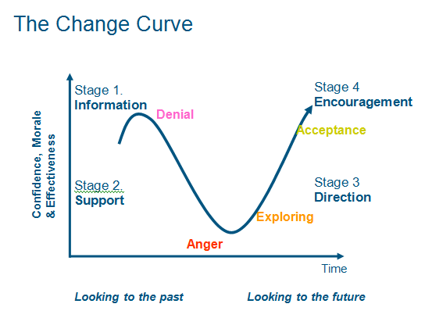
Figure 5: Change transition curve (Ulrich, 2014).
At the initial stage, the employees deny the changing environment as well as organizational policies regarding the changes. They look into the past experiences and conditions that have applied for evaluating and measuring their performance. In here, the management could give required information to their employees for overcoming the stage of denial. In the next level, they may not deny the changes but angry with the authority due to their sudden decisions relating the changes. In that case, the employees seek for support from the authority such as: the top board can assure the employees that they would get proper training as well as their jobs are not at risk due to the changes (Ulrich, 2014). After getting support from the management, they go for exploring the organizational activities during the changing condition whereas it looks for proper guidance in performing tasks. At the last stage, the employees are satisfied with the changing issues as they accept those at the current period whereas they are encouraged for giving their best effort in finishing the tasks.

Conclusion
An organization cannot be able to sustain for long time in a competitive market if it has not focused on determining the factors which are influencing to make changes in the organizational culture and structure. There may face several issues and significance in brining changes to the company whereas it depends on the environmental conditions. Through knowing the depth of environment and its impact upon the organization, then the authority of the company can make effective decisions for developing organizational activities. Due to the innovation in the production and distribution system, the company would bring several changes so that they can keep pace with the updated procedure. When the company’s capabilities would be developed at greater range along with measuring their expected conditions then it can gain higher customer value from the competitive market place. In case of beating the competitors, there have no alternatives other than adopting changes earlier than them to attract customers. It supports the company to stabilize the organizational position at top level for long time. There has examined several theories related to the changes for identifying the suitable process towards managing change in the company. It also includes the analysis of several strategies that have taken for overcoming the barriers that resist in bringing changes within organizational context.

References
Ashkanasy, N., Wilderom, C. and Peterson, M. (2013). The handbook of organizational culture and climate. Thousand Oaks: SAGE.
Buchanan, D. and Huczynski, A. (2019). Organizational behaviour. Harlow, England: Pearson.
Canaday, S. (2018). Organizational Culture. [Erscheinungsort nicht ermittelbar]: lynda.com.
Catlin-Legutko, C. and Klingler, S. (2012). Organizational management. Lanham, Md.: AltaMira Press.
Czichos, R. (2014). Change Management. Freiburg im Breisgau: Haufe-Lexware.
Forsyth, P. (2012) Managing Change. (Online) London; Philadelphia: Kogan Page http://www.tsd.ac.uk/en/lrc/onlineresources/e-books/ (Accessed 26 November 2013)
Hatch, M.J., (2013). The dynamics of organizational culture. Academy of management review, 18(4), pp.657-693.
Hersey, P., Blanchard, K. and Johnson, D. (2017). Management of organizational behavior. New Delhi: Pearson India Education Services.
Johns, G. and Saks, A. (2007). Organizational behaviour. Harlow: Prentice Hall.
Karp, T. and HelgâŠ˜, T. (2008). From Change Management to Change Leadership: Embracing Chaotic Change in Public Service Organizations. Journal of Change Management, 8(1), pp.85-96.
Kirst-Ashman, K. (2008). Human behavior, communities, organizations, and groups in the macro social environment. Belmont, Calif.: Thomson/Brooks/Cole.
Machado, C. and Davim, J. (2016). Organizational management. Basingstoke [etc.]: Palgrave Macmillan.
Mills, J., Dye, K. and Mills, A. (2009). Understanding organizational change. Abingdon, Oxon: Routledge.
Orridge, M. (2009). Change Leadership Developing a Change-Adept Organization. Farnham: Ashgate Publishing.
Pasmore, W., Woodman, R. and Shani, A. (2010). Research in organizational change and development. Bingley, UK: Emerald.
Pugh, D. and Mayle, D. (2009). Change management. London: SAGE.
Rogala, A. and BiaÅ‚owaÌ¨s, S. (2016). Communication in the organizational environment. London: Palgrave Macmillan.
Senior, B. (2006). Organizational change. Harlow: Financial Times Prentice Hall.
Shani, A. and Noumair, D. (2019). Research in Organizational Change and Development. Bingley: Emerald Publishing Limited.
Sierk, Y., Dvora Yanow, Y. and Ida, S. (2011). Organizational Culture. Cheltenham: Edward Elgar Pub.
Smith, P., Farmer, M. and Yellowley, W. (2013). Organizational Behaviour. Hoboken: Taylor and Francis.
Ulrich, D. (2014). The future targets or outcomes of HR work: individuals, organizations and leadership. Human Resource Development International.
Van Wormer, K. and Van Wormer, K. (2007). Human behavior and the social environment, micro level. Oxford: OXford University Press.
Will, M. (2015). Successful organizational change through win-win. Journal of Accounting & Organizational Change, 11(2), pp.193-214.

