

Module: Community Care and Management of Longer-term Conditions

Module code: LCHS7003

Assignment Title: Component 1: Information Booklet of Long-term Condition Management

Lecturer: Dr.Brian Mashumba
Student name: Vaishalikumari Vihar Patel
Student ID number: 2436885

Contents
Introduction 3
Explanation and evaluation of the focused long-term condition and the risk factors of the health condition 3
Definition and prevalence of the long-term condition 3
Evaluation of the implications of the burden 3
Global burden and trends 4
UK prevalence and local burden 4
Risk factor or aetiology of the health condition 5
Impact of the long-term condition with focus on physical, psychological and social implications with suitable evidence-based treatments 5
Physical impact 5
Psychological impacts 6
Social and family implications 6
Evidence-based treatments available through the NHS 6
Theoretical Perspectives and Models for Improved Diabetes Outcomes 7
Critical Examination of Local and National Political Agendas in Type 2 Diabetes Management 11
Recommendations 13
Conclusion 13

Introduction
Type 2 Diabetes mellitus (T2DM) is one of the long-term health conditions that has become a worldwide global public health concern, significantly affecting the quality of life of individuals, and it is placing a major burden on the healthcare systems. Type 2 Diabetes is characterised by impaired glucose metabolism and insulin resistance, which are closely associated with genetic, lifestyle, and environmental factors (Zheng et al., 2018, pp.88-98). The information booklet aims to identify and critically evaluate the prevalence, nature and management type of the disease while analysing the focus on its impact within the context of the UK healthcare system. The work has a purpose to analyse physical, psychological and social implications of the condition along with the effects on families involved in the care provision. The discussion has included the NHS’s evidence-based treatment based on the theoretical framework and models to improve patient outcomes, followed by an examination of social care and political health agendas to reach tailored recommendations.

Explanation and evaluation of the focused long-term condition and the risk factors of the health condition

Definition and prevalence of the long-term condition
Type 2 Diabetes mellitus (T2DM) is one of the chronic metabolic disorders, which is characterised by persistent hyperglycemia, caused by insulin resistance in the peripheral tissues, such as muscle, adipose tissue, together with the progressive pancreatic β-cell dysfunction (Himanshu et al., 2020, pp.1959-1966). Over time, the defects lead to impaired glucose tolerance and fasting hyperglycemia and the complications are mainly driven by metabolic damage and long-term vascular issues such as coronary artery disease, stroke, neuropathy, retinopathy and so on. Aetiology is multifactorial, and genetic predisposition interacts with the behavioural and environmental drivers, including physical inactivity, obesity and poor diet that reduce insulin resistance and also decline the reserve of B-cells. Both ageing and chronic low-grade inflammation also contribute to the disease progression.

Evaluation of the implications of the burden
The burden of T2DM is twofold, including the system impacts and direct clinical harms that affect individuals. As per the clinical perspectives, the persistent hyperglycemia results in increased risk of kidney failure, blindness and lower limb amputation with cardiovascular diseases that raise the complications while reducing the quality of life and life expectancy. From a psychosocial perspective, the people living with diabetes often face self-monitoring, daily treatment regimes, anxiety about the complications, and diet restrictions (Bhat et al., 2020, pp.90-8). This creates a huge demand for managing emotional stress and financial strain as a whole. The situation negatively impacts mental health and includes major adherence to life rules and protocols. At a health system level, diabetes requires high resource use, including specialist clinics, primary care, monitoring, medications, and so on, which often leads to hospital admissions for complications, also imposing major economic cost on organisations such as the NHS. The combination of widening inequalities, rising prevalence, and high-cost complications related to the disease urges priority for prevention with system redesign in the UK.
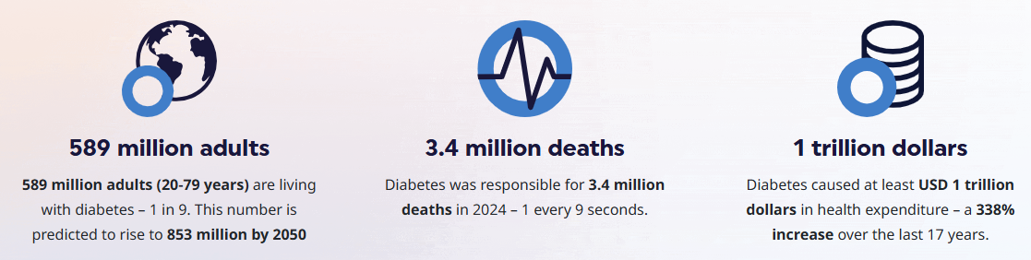
Figure: The growing impact of diabetes across the world
(Source: diabetesatlas.org, 2025)

Global burden and trends
T2DM is a growing global health issue currently. According to the International Diabetes Federation (IDF), it is estimated that roughly 589 million adults aged 20-79 years were struggling with diabetes in 2024, and the projection is rising towards 853 million by 2050 (diabetesatlas.org, 2025). Health issues are associated with high economic costs and life loss across the globe. The World Health Organisation has also declared the risk of living people with the disease is increasing drastically over recent decades. The prevalence of diabetes is rising fast, mainly in low-and middle-income countries. The global rise is mainly driven by issues such as an ageing population, obesity, diet changes, urbanisation, low physical activity and so on. T2DM is evident mainly in the high-income settings, irrespective of age and social groups.

UK prevalence and local burden
The burden of the disease is rising in the UK as the recent Diabetes UK analysis estimated nearly 12.1-12.2 million adults who are suffering due to diabetes and pre-diabetes, which includes nearly 1.3 million undiagnosed people, nearly 4.6 million diagnosed diabetes cases and approximately 6.3 million with pre-diabetes (The Guardian, 2025). The NHS has reported a major prevalence of diabetes among adults, which is increasing year by year, and the rising number of people at risk is significant, underscoring the prevalence and demand for high services with increased GP appointments, medication and complication management, specialist diabetes care and substantial costs to the NHS and social care systems.
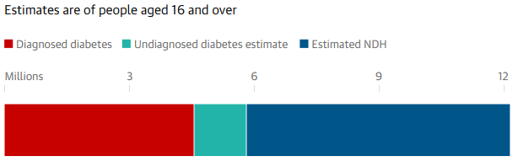
Figure: Estimated diabetes cases in the UK in 2023-24
(Source: The Guardian, 2025)

Risk factor or aetiology of the health condition
The key risk factors include obesity, overweight, sedentary lifestyle and unhealthy diets, which are caused by high-energy processed foods and smoking. The non-modifiable risks include family history and ethnic risks, ethnicity evidenced mainly in the South Asian, Black African or Caribbean people and some other people with a minority background. Over half a million (549,000) more people in England have been identified under the risk factors of diabetes-2, as denoted by the NHS (england.nhs.uk, 2024). Socio-economic determinants for Diabetes 2 include limited access, deprivation, limited access to healthy foods and anogenic environments, which strongly influence the risks and the inequalities observed across the UK.

Impact of the long-term condition with focus on physical, psychological and social implications with suitable evidence-based treatments

Physical impact
T2DM causes chronic hyperglycemia, which leads to well-documented microvascular and macrovascular diseases and various complications such as retinopathy, nephropathy, heart disease, arterial diseases and so on. People face higher risks of cardiovascular mortality, as recent UK analyses have shown a large number of CVD deaths among people who were struggling with diabetes, and nearly 29% of the cardiovascular deaths in England died from this in 2022 (digital.nhs.uk, 2024). Diabetes also resulted in substantiality to hospital admission and long-term disability. As per the NHS National Diabetes Audits and HES dashboards, the rising admission and complication rates for diabetic related issues are vital. These complications are impacting the life span and shortening the life expectancy, while driving high healthcare costs and use of resources. In the UK, diabetes care costs are reported to be in the billions annually.

Psychological impacts
The psychological impacts are also significant as 40% people with the disease struggle due to psychological distress, and the symptoms include anxiety, depression or other diabetes-related issues (diabetes.org.uk, 2025). Mental health disorders are significant in the general population and worsen the glycemic control, worsening self-management and outcomes. The demand of persistent treatment includes diet, monitoring, medication, along with fear of complications and stigma that can produce burnout and reduce engagement with care. NHS and Diabetes UK guidelines highlight that psychological care must be integrated into the diabetes services for a better quality of life and self-care.

Social and family implications
T2DM increases the household burdens for the family members, as informal care is significant for diet, medication and appointments with experienced emotional support that pose a challenge in reduced household income due to the pressure of the illness and caregiving responsibilities. The socio-economic determinants, including environmental deprivation, ethnicity-related, limitations and disparities, increase the risk and access to services which produce unequal outcomes across multiple UK communities. Rising prevalence in working-age adults also affects the economic participation and productivity of the workforce.

Evidence-based treatments available through the NHS
The NHS diabetes prevention programme includes a nine-month evidence-based behavioural programme to reduce the progression to T2DM. The DPP focuses mainly on healthy eating habits, weight loss, and promotion of physical activity, mainly offered to the non-diabetic and hyperglycemic or pre-diabetic people. The recent NHS pilot “Soup and Shake” low-calorie programme has produced remission for a subset of diabetic participants (nhs.uk, 2024). DESMOND and similar types of programmes offer digital education and group education to improve self-efficacy and lifestyle change-related knowledge for people struggling with the disease, with a structured education process that is highly recommended by the NHS and NICE for patients who are newly diagnosed. Annual review process, including food checks, retinopathy screening, CVD risk management, renal monitoring, access to multidisciplinary diabetes teams, along with the programmes, helps to reduce the risk of complications as part of standard NHS care.
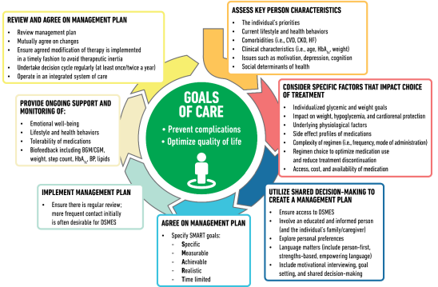
Figure: Decision Cycles for person-centred glycemic management in type 2 diabetes
(Source: nhs.uk, 2024)

Theoretical Perspectives and Models for Improved Diabetes Outcomes
Person-centred, health, social, and community care is essential to the effective long-term management of Type 2 Diabetes (T2DM). Supporting self-management, collective decision-making, and integration on a system-wide basis has been focused through Modern theoretical models. In the UK, another prominent framework that has been employed to guide diabetes care in the country is the House of Care (HoC) model developed by NHS England and The Health Foundation (Alliance Scotland, 2025). The Chronic Care Model (CCM) is among the most powerful international models support the management of long-term conditions (Lall et al., 2018, p.108). Both of the models focus on outcome enhancement but they vary in terms of structural focus, as well as cultural relevance.
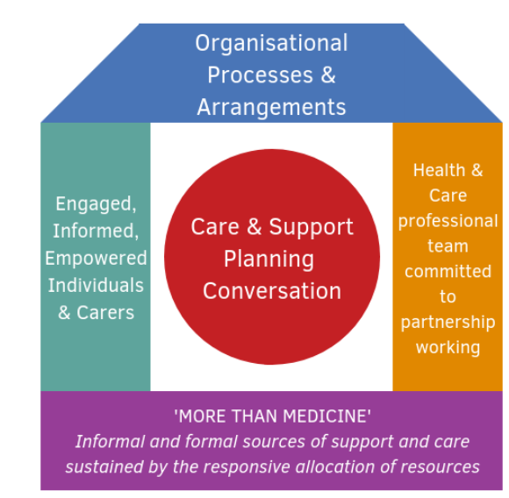
Figure: House of Care (HoC) Model
(Source: Alliance Scotland, 2025)
The House of Care concept puts the individual with the condition at the centre. It is developed on four mutually dependent elements which include engaged and informed people, health and care professionals who are committed to partnership working, organisational processes and system enablers, and commissioning that enables personalised care (Holding et al., 2020, p.493). Instead of relying on episodic treatment the model focuses on care and support planning and promotes shared decision-making in order to assist people in managing their diets, medications, blood glucose monitoring, and lifestyle changes. This is a technique that has demonstrated enhancement of glycaemic control and adherence in T2DM where patients have a sense of empowerment and are aware of their treatment options. The HoC model has a strength in that it is aligned with the UK policy, such as the NHS Long Term Plan, where supported self-management, the use of digital health tools, and systematic education such as DESMOND take the upper hand (GOV.UK, 2025). Nevertheless the implementation of the model is not even across all regions because of the differences in resources, lack of personnel and differences in commissioning priorities. It implies that the model is theoretically sound but its success is determined by the capacity of the system and the willingness of the workforce.
By way of comparison the Chronic Care Model (CCM) provides a more global model. Health system organisation, self-management support, design of delivery, decision support, and information systems, and community resources has been incroporated through it (Goh et al., 2022, p.273). The model is based on the supposition the proactive multidisciplinary team will positively contribute to improving disease outcomes in the long term in cases where patients are constantly assisted instead of being reactive. There is evidence that CCM-based interventions in diabetes result in low HbA1c, less hospitalisation, better medication compliance, and less psychological distress (Williams, 2020). CCM has been extensively used in primary care and in public health programmes in countries like the United States, Canada and the Netherlands.
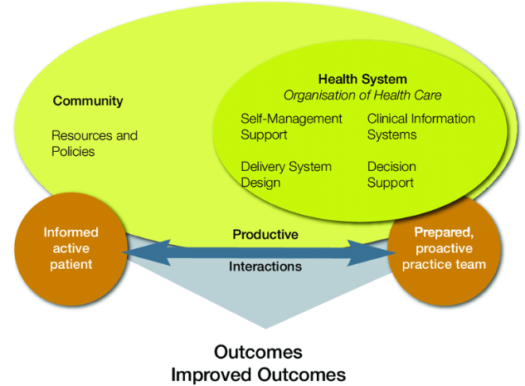
Figure: Chronic Care Model (CCM)
(Source: Parlour and Slater, 2011)
Nonetheless there are difficulties with the use of the CCM. It employs a lot of integration of data systems, community relationships, and coordinated funding- aspects that do not always exist in any healthcare environment. The CCM is partially overlapping with NHS integrated care pathways in the UK although implementation in full may be constrained by inadequately integrated IT systems, burdens on the general practice system and social inequality in access to community support (Hughes et al., 2020, p.452). However the CCM is still useful since it acknowledges that diabetes cannot be determined by clinical variables only but social, behavioural and cultural determinants.
Most importantly both models put self-management in the middle as they realise that people spend most of the time in coping with their condition beyond the clinical setting. However, the HoC is more concerned with the individualised collaborative planning whereas the CCM is more concerned with the system design and professional coordination. Their combination strengths are complementary the HoC supports patient empowerment and shared decision-making whereas the CCM helps organisations prepare and be ready, employ multidisciplinary teams, and provide smooth care pathways. A combination of both views would be of good theoretical contribution in enhancing long-term diabetes results minimising complications and increasing life quality.

Critical Examination of Local and National Political Agendas in Type 2 Diabetes Management
The UK Type 2 Diabetes (T2DM) management is influenced by various national and local political priorities and agendas towards prevention, early diagnosis, integrated care, and lower inequalities. The most significant policy at the national level is the NHS Long Term Plan (2019) which places more emphasis on the prevention of long-term diseases and enhancing access to organised education and online self-management instruments. Its investment in the NHS Diabetes Prevention Programme (NDPP) is an indication of political change which is focused on behavioural prevention as opposed to medical treatment only (NHS, 2025). There is evidence of a positive clinical effect of NDPP which has resulted in reductions of HbA1c and weight among subjects. The uptake has been low among disadvantaged and minority communities, so the programme threatens to increase inequalities in health instead of decreasing them.
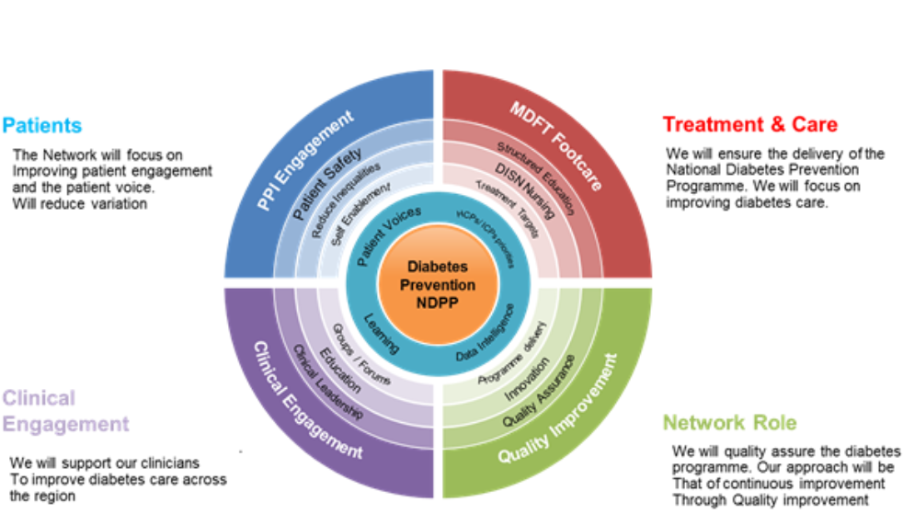
Figure: NHS Diabetes Prevention Programme (NDPP)
(Source: NHS, 2025)
At national level the T2DM care is also affected by funding and commissioning structures. The trend of the Integrated Care Systems (ICS) promotes partnership between hospitals, GPs, public health, and local authorities (Lorne et al., 2019, p.72). This may assist interventions that are holistic in approach to diabetes, a dietary education program, physical activity programmes, smoking cessation and social prescribing. However the implementation of ICS has not been uniform throughout England and much of regions do not have the capacity or digital interoperability especially in the deprived areas, where the prevalence of diabetes is the greatest. Thus the political agenda supports joined-up care, but there are structural and financial constraints that constrain its delivery at the ground level.
The local health strategies in councils and Clinical Commissioning Groups (now within ICSs) have made efforts to lower environmental risk factors, including enhancing access to green areas, controlling fast-food joints around schools, and implementing referral programs (NHS, 2022). These are politically acknowledged as a social-environmental disease. Nevertheless since 2015 the budgets of public health have been drastically reduced, which hinders the ability to carry out health promotion activities (Kingsfund, 2022). The dilemma that arises is that local authorities have more responsibility in terms of prevention while having fewer funds to spend.
Social care agendas also overlap with diabetes especially among the elderly and individuals with disabilities who need diet and medication compliance. The Care Act 2014 puts the focus on person-centred care and autonomy, which is consistent with the principles of diabetes self-management (Legislation.gov.uk, 2023). However, lack of consistent funding of social care makes many people unable to receive any social help resulting in worse glycaemic control and unnecessary hospitalisations.
The broader prevention-oriented policy adopted by the government (mindful of policies like the Soft Drinks Industry Levy (Sugar Tax) and obesity interventions) is an indication that the government is politically inclined to restrict unhealthy surroundings. The presence of low sugar in the drinks and the possibility of long-term effects on obesity and risk of diabetes has been indicated through the initial screening. Nonetheless, critics complain that the top-down policies lack penetration unless there are more extensive measures on poverty, food prices and marketing.

Recommendations
To enhance sustainability in management of Type 2 Diabetes, future solutions should focus on person-centred care in terms of appreciating individual preferences and cultural backgrounds as well as social determinants of health. As much as existing pathways promote shared decision-making, there is still unequal access to structured education. Referrals would be increased and flexible delivery of referrals, including community based, digital and translated resources would be provided to ensure that different populations, especially minority ethnicities, who have higher prevalence and worse outcomes, engage equally (Drewry et al., 2023, p.1142). Care-planning should rely on co-production alongside patients and carers; such that, people can establish meaningful objectives and customize interventions based on lifestyle, employment and family commitments.
Self-management may also be improved with the possibility to increase the access to digital monitoring devices, such as continuous glucose monitoring and diet, exercise, and medication reminder apps. These must be incorporated with primary care records, obliterating the possibility of proactive intervention by clinicians. Isolation and peer-support groups and community-based physical activity programme can be used to decrease isolation and encourage motivational change, especially in individuals with low health literacy levels through social prescribing (Werner et al., 2024, p.72). Furthermore, care coordinators or diabetes specialist nurses are to be available in order to coordinate the complex needs and continuity between primary, community and specialist services.
End-of-life planning is disregarded in the case of people with a complex disease and numerous complications. Previous discussions on the preferences, the ways to manage their symptoms, and care environment are necessary to minimize avoidable hospital admissions and promote dignity. Communication of primary care, palliative teams and families should provide compassionate decision-making, especially on medication rationalisation, foot care, pain management and nutrition assistance.

Conclusion
Thus, it can be concluded that Type 2 Diabetes is a complex long-term condition that seeks person-centred, holistic and system-integrated management. Physical, psychological and social challenges are vital to affect the individuals, families and healthcare systems. The growing prevalence in the UK and across the globe is vital, and evidence-based NHS programmes have played crucial roles in strengthening the care approaches that can reduce the overall burden of the diseases. Both the HOC and CCM highlight the importance of collaboration, self-management and continuous support that differ. Integration with the frameworks can improve the situation with better control, compliance reduction, and enhance the quality of life.
REFERENCE

Alliance Scotland, (2025). The House of Care Model, Health and Social Care Alliance Scotland. Available at: https://www.alliance-scotland.org.uk/past-work-and-projects/scotlands-house-of-care/the-house-of-care-model/ (Accessed: 1 November 2025).
Bhat, N.A., Muliyala, K.P. and Kumar, S., (2020). Psychological aspects of diabetes. Diabetes, 8(1), pp.90-8.
diabetes.org.uk (2025). Depression and diabetes, Diabetes UK. Diabetes UK. Available at: https://www.diabetes.org.uk/living-with-diabetes/emotional-wellbeing/depression (Accessed: 1 November 2025).
diabetesatlas.org, (2025). Diabetes Atlas. Available at: https://diabetesatlas.org/ (Accessed: 1 November 2025).
digital.nhs.uk (2024). Complications and Mortality Outcomes dashboard, 2009-2023. Available at: https://digital.nhs.uk/data-and-information/publications/statistical/national-diabetes-audit/complications-and-mortality-2009-2023 (Accessed: 30 October 2025).
Drewry, M.B., Yanguela, J., Khanna, A., O'Brien, S., Phillips, E., Bevel, M.S., McKinley, M.W., Corbie, G. and Dave, G., (2023). A systematic review of electronic community resource referral systems. American journal of preventive medicine, 65(6), pp.1142-1152.
england.nhs.uk (2024). NHS Choices. NHS. Available at: https://www.england.nhs.uk/2024/06/nhs-identifies-over-half-a-million-more-people-at-risk-of-type-2-diabetes-in-a-year/ (Accessed: 30 October 2025).
england.nhs.uk, (2025). NHS Choices. NHS. Available at: https://www.england.nhs.uk/diabetes/diabetes-prevention/ (Accessed: 29 October 2025).
Goh, L.H., Siah, C.J.R., Tam, W.W.S., Tai, E.S. and Young, D.Y.L., (2022). Effectiveness of the chronic care model for adults with type 2 diabetes in primary care: a systematic review and meta-analysis. Systematic Reviews, 11(1), p.273.
GOV.UK, (2025). 10 Year Health Plan for England: fit for the future. Available at: https://www.gov.uk/government/publications/10-year-health-plan-for-england-fit-for-the-future (Accessed: 1 November 2025).
Himanshu, D., Ali, W. and Wamique, M., (2020). Type 2 diabetes mellitus: pathogenesis and genetic diagnosis. Journal of Diabetes & Metabolic Disorders, 19(2), pp.1959-1966.
Holding, E., Blank, L., Crowder, M. and Goyder, E., (2020). Bridging the gap between the home and the hospital: a qualitative study of partnership working across housing, health and social care. Journal of interprofessional care, 34(4), pp.493-499.
Hughes, G., Shaw, S.E. and Greenhalgh, T., (2020). Rethinking integrated care: a systematic hermeneutic review of the literature on integrated care strategies and concepts. The Milbank Quarterly, 98(2), pp.446-492.
Kingsfund, (2022). The NHS budget and how it has changed. Available at: https://www.kingsfund.org.uk/insight-and-analysis/data-and-charts/nhs-budget-nutshell (Accessed: 1 November 2025).
Lall, D., Engel, N., Devadasan, N., Horstman, K. and Criel, B., (2018). Models of care for chronic conditions in low/middle-income countries: a ‘best fit’framework synthesis. BMJ Global Health, 3(6), p.e001077.
Legislation.gov.uk, (2023). Care Act 2014. Available at: https://www.legislation.gov.uk/ukpga/2014/23/contents (Accessed: 1 November 2025).
Lorne, C., Allen, P., Checkland, K., Osipovic, D., Sanderson, M., Hammond, J. and Peckham, S. (2019). Integrated care systems: What can current reforms learn from past research on regional co-ordination of health and care in England? A literature review, pp.1-84.
NHS, (2022). Integrated care systems (ICSs). Available at: https://www.england.nhs.uk/commissioning/who-commissions-nhs-services/ccg-ics/ (Accessed: 1 November 2025).
NHS, (2024). 10 Year Health Plan for England: fit for the future. Available at: https://www.england.nhs.uk/commissioning/who-commissions-nhs-services/ccg-ics/ (Accessed: 1 November 2025).
NHS, (2024). NHS Diabetes Prevention Programme (NHS DPP). Available at: https://www.england.nhs.uk/diabetes/diabetes-prevention/ (Accessed: 1 November 2025).
NHS, (2025). Workstreams of the NHS. Available at: https://www.england.nhs.uk/north-west/north-west-coast-strategic-clinical-networks/our-networks/diabetes/workstreams/ (Accessed: 1 November 2025).
nhs.uk, (2024). Type 2 Diabetes Mellitus: Guideline for the choice of oral and non-insulin antihyperglycaemic agents for adults Available at: https://www.birminghamandsurroundsformulary.nhs.uk/docs/files/BSol%20IMOC%20anti-hyperglycaemic%20agents%20for%20adults%20with%20type%202%20diabetes%20%20April%202024%20v3%20Final%2024.6%20002. (Accessed: 1 November 2025).
Parlour, R. and Slater, P., (2011). An evaluation of the effectiveness of a self-management programme. Dublin: Health Service Executive, Office of the Nursing and Midwifery Services Director, pp.1-24.
The Guardian, (2025). One in five UK adults have diabetes or pre-diabetes, analysis shows. Guardian News and Media. Available at: https://www.theguardian.com/society/2025/feb/06/one-in-five-uk-adults-have-diabetes-or-pre-diabetes-analysis-shows (Accessed: 1 November 2025).
Werner, J.J., Ufholz, K. and Yamajala, P., (2024). Recent findings on the effectiveness of peer support for patients with type 2 diabetes. Current Cardiovascular Risk Reports, 18(5), pp.65-79.
Williams, C., (2020). The complete care model: improving diabetic patient outcomes in correctional facilities, pp.1-20.
Zheng, Y., Ley, S.H. and Hu, F.B., (2018). Global aetiology and epidemiology of type 2 diabetes mellitus and its complications. Nature reviews endocrinology, 14(2), pp.88-98.

