Emma Cloutman – 1905800 BMSP4004

Essential concepts and principles of modelling and analysing data

Introduction
The following report will have details on concepts and principles of modelling and analysing data. Explaining what data analytics is and why it has impotence. It will also cover all aspects of data visualisation, and how Microsoft Excel is used, with an explanation on the value of a spreadsheet in organisations.

Data analytics
Data analytics is a very broad term that covers many diverse types of data analysis. Data analytics is the ability of analysing raw data in order to come to a conclusion about that information. Many of data analytics techniques have been made into mechanical processes that work over raw material for human consumption. During the process in data analytics there are several different steps involved. These are as follows,
- Grouping the data. Data can may be separated in many ways such as income, outgoing, gender, age and many more. The data could also be grouped by category or its numerical format.
- Process of collecting data. The second step in data analytics would be the collection of data this can be done through various ways such as computers, environmental resources and online.
- Organisation of data collected. It is important when the data is collected it is organised properly. This may take place on a spreadsheet or other form of software.
- Checked before analysis. The final stage is to then clean up and check the data. Ensuring there is no error and that the data in complete. This part of the process with be where any corrections can be made to ensure no errors before the data goes on to be analysed. (Frankenfield 2019)

In organisations data analytics is very important. It gives the organisation a chance to correct any errors in data in order to put the data forward to be analysed. Given a true fair view of the data they are using.

The use of Microsoft Excel
Microsoft Excel spreadsheet software is commonly used in most businesses across the world. This software is used for various purposes by all different business establishments. Some organisations use the software for tracking sales, generating memos, and much more business data. The Microsoft Excel software comes with many rows of data and automate number crunching although this popular software is capable of doing so much more than just figures. Microsoft Excel is fairly simple to use and they make it easy for even a novice user to understand the software in order to preform basic tasks. Even after three decades Microsoft excel is still the most preferred software to use in organisations. One of the major advantages Microsoft excel spreadsheet software is it flexibility feature. This allows the individual to define the structure of their information in order for them to manage is with ease.
There is further training individuals can undergo in order to use Excel to its full potential and gain more hands on experience. (M James2015)

Formulas
In Microsoft excel you can insert formulas. A formula is an expression which calculates the value of a cell. For example to add up the total of a set of data there is a SUM formula see in image bellow.

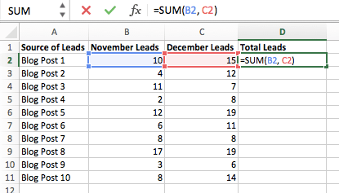

=SUM(B2,C2) This will let excel know you would like to sum up the figures in B2 and C2.

After using this SUM function, it will allow the individual the opportunity to change the contents of the data and the total will automatically recalculate. This is used very often in organisations especially when dealing with many figures that may need to be adjusted.
There are many formulas that can be used in excel for many reasons that will help the organisation hold, receive and organise data more efficiently.

Another formula a lot of organisations use is IF function this function will allow the data to recalculate if there is different figures used often for example on the image bellow. On Sunday the prices are different to the Monday so the formula used is IF its Sunday the prices are £35, giving excel the ability to calculate the correct data.

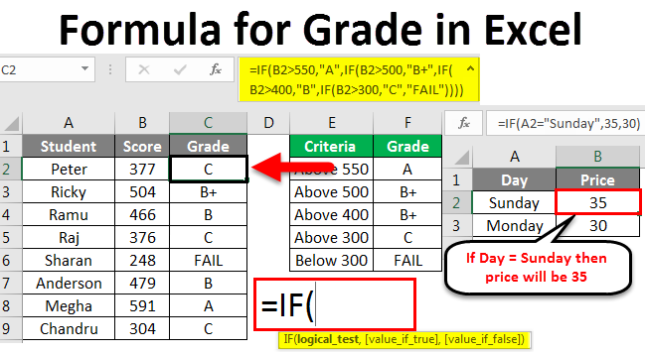

The formulas that are used in every organisation are extremely important. It gives the organisation the opportunity to keep all data organised and in order with an easy way to spot error. It will allow the organisation to see the figures clearly so for example if the company was not meeting targets on profits or their expenses was rising to a cause for concern. There are many different formulas that would benefit an organisation that can be accessed through excel.

Data visualization
Data visualization is where data is put into a graphic format that makes it easier for the viewers to communicate with the data visually to understand. Today data visualization is rapidly evolving using a blend of science and art to visualize data. Computers today has made it possible for individuals to process large amounts of data in seconds being one of the main factors an organisation needs to deal with a huge workload (Sas 2019). In the image bellow demonstrates data in a visual aspect.

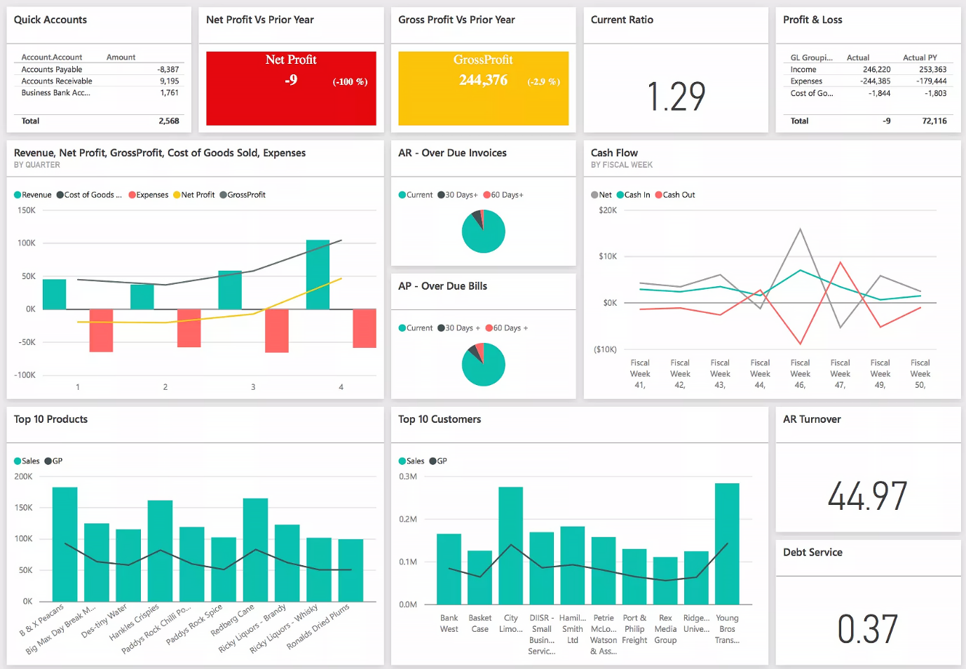

Data visualization is important as it helps individuals understand data quicker and easier. Management can visually see figures and make decisions quicker for example, they can tell if the organisation is at risk from a fall in profits just by glancing at an image instead of looking or hours and in detail at a lot of data.

Value of a spreadsheet to an organisation
A spreadsheet offers many advantages especially in an organisation setting. It allows organisation the opportunity to analyse and visualise data related to numerical, financial, statistical and other information. Not only can you use a spreadsheet for storing data accurately, but you can also use a spreadsheet to manage data and this is a very beneficial way if there is a lot of data to be dealing with.
Spreadsheets when building one will have the data you wish to edit in separate cells. These cells can be written or numerical. The individual can then insert formulas in order to make the cells recalculate if the information needs to be changed. A spreadsheet also gives you the option to add graphical displays of data using charts, diagrams and pivot tables for the individuals to understand the data easily. The value of a spreadsheet to an organisation is of great importance it allows the organisation to hold, edit, understand and use data in a safe and easy way and its easy for individuals to use but also there are training course to be giving to allow staff to use it correctly and to its full potential (smith 2019)

References

(Frankenfield 2019) https://www.investopedia.com/terms/d/data-analytics.asp (Accessed on 11/01/2020)
(M James 2015) https://www.greycampus.com/blog/workplace-tools/why-microsoft-excel-is-important-for-business-organizations (Accessed on 11/01/2020)
(Sas 2019) https://www.sas.com/en_gb/insights/big-data/data-visualization.html (Accessed on 12//01/2020)
(Smith 2019) https://yourbusiness.azcentral.com/advantages-using-spreadsheets-3647.html (Accessed on 14/01/2020)

