Question 2. Within a given time period, select examples of what could be considered high and low cultural artefacts. Discuss these, taking into consideration the surrounding social, political and historical context.

Name: Jeonard John Veloso Cruz

Student Number: 1702794

Course: BA Graphic Design, Year 2

Word Count: 1913

Tutors: Sarah Tombs, Louise Burston

Ever since its discovery, Roman statues of political leaders, warriors, champions and scenes of historical events made of bronze, stone and marble have always been a way to identify power and high culture within our society. Dating all the way back to the Greeks, statues have always been utilised to honour important figures of society. But what if man decides to imitate these objects of high culture and introduce them into low culture and mass produce them, cheaper and far more efficient than the original methods of craftsmanship.
Looking at the statue of Apollo Belvedere, a famous marble statue of a god. It was owned by Cardinal della Rovere who kept it privately in his own garden until 1503 and when he became Pope, only then the Pope moved the statue to the Belvedere where it gained its fame. It is also unknown who sculpted the marble statue for it was discovered in the 15th century in Anzio, 35 miles south of Rome. A German archaeologist by the name of J.J Winckelmann stated that Belvedere Apollo was “the highest ideal of art, of all works of antiquity” (Kuhl et al. 2009, p. 17) but it doesn’t stop there, for there is more to the history of the statue. It seems that this figure of high culture is an imitation created by man. As Kuhl comments:
Its origins are not wholly clear, but the Apollo is presumed to be a Roman copy of a bronze statue by the Greek sculptor Leochares from the 4th century BC. In other words, it is an example of admiration that Rome had for Greek art. (Kuhl, 2009, p. 17)
But why is this statue still considered as an example of a high culture artefact? Even though it is a copy of an original. This blurs the line of high and low culture for it is just an imitation of a missing artefact.
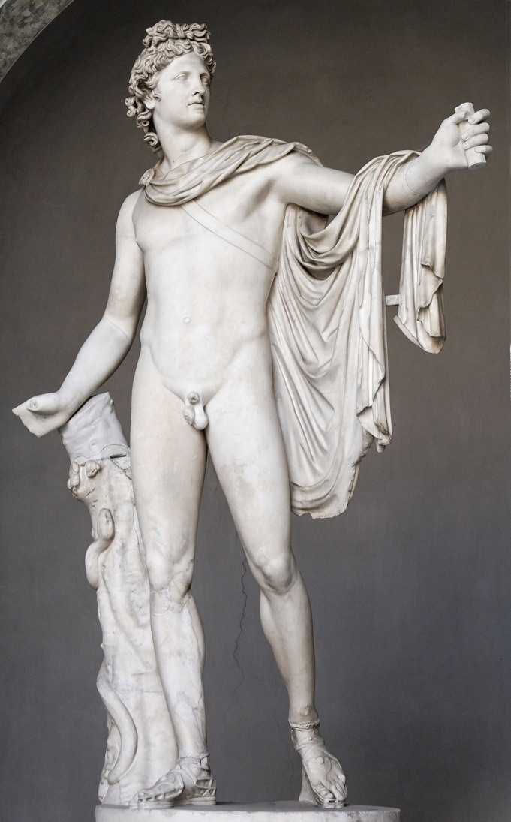

Fig1
Fig. 1: Apollo Belvedere, AD 2, marble copy of a bronze original by Leochares from c. 330/320 BC, h. 224 cm, Museo Pio Clementino, Vatican.
When looking at the authenticity of the Apollo Belvedere, one has to consider the facts of reproduction. Is the quality of the statue still the same? Has it retained its existing value if everyone learns of the origin and history of the artefact? Or will it gain more value if everyone finds out the origin and history of the statue? If this representation of the original bronze statue that was made by the Greek sculptor Leochares is still regarded as part of high culture, then why can’t all copies of Roman and Greek statues today be viewed as high rather than low culture. Is it because of the price? Is it assumed that replicas today are made as souvenirs for tourists? The methods used when it was crafted? The quality of the product? With all of these questions, we can look to the pivotal figure of western philosophy when looking at imitation. Plato’s explanation of why an imitated product cannot hold the same value as the original (360 BC, cited in Beardsley, 1975, pp. 35-36) is quite interesting:
When one knife-maker copies a knife made by another, what produces is not the image of a knife, but another knife; perhaps a little indirectly, but nevertheless genuinely, he is guided by the knife-Form. But a picture of a knife lack the weight, the sharpness, the hardness of the actual knife, and it will not cut—it is an objet manqué. It is both true and untrue, has both being and non being.
Looking at the words used in that quote, there is a phrase that sticks out and that is the phrase ‘objet manqué’ when translated from the French language means ‘object is missing’. Plato’s explanation of what an imitated object is can spark controversy, questions and debates about everything that has ever been made and replicated by man, no matter the quality and where it was created.
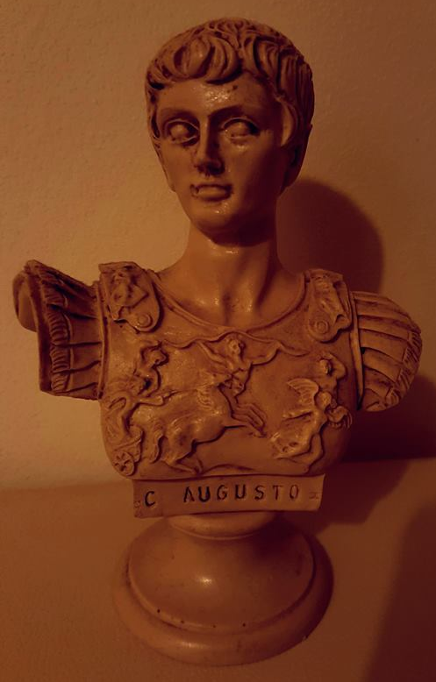
Let us look at a past member of high culture and a piece of artefact which could be considered as part of the great high cultured Roman statues such as Apollo Belvedere, Michelangelo Buonarroti's David, and other statues of powerful Ancient Roman emperors and warriors. This is a bust of a Roman statesman and military leader but also the first Emperor of the Roman Empire, Gaius Octavius Thurinus or simply known as Augustus. Augustus controlled Imperial Rome from 27 BC until 14 AD when he died. And this is a bust of him in Rome, Italy… or is it?

Fig2
Fig. 2: Emperor Augustus, Unknown Year, unknown material copy of Augustus of Primaporta from c. 1st Century AD, h. 16 cm, Swansea, Wales.

This is not made out of marble and it was purchased in Rome, Italy for 25 Euros. I bought this bust of Emperor Augustus during a summer break. Although originally priced at 40 Euros, I had to negotiate with the vendor. Now it is quite obvious that it is only a replica, but the original of this bust is also a copy, a representation of a bronze statue, Zanker talks about the artefact:
This is a marble copy of a bronze statue which must have been made in the years immediately following the victory over the Parthians. This much is clear from the intimate association between the imagery of the breastplate and certain motifs in Horace’s carmen saeculare. (Zanker, 1988, p. 188)
Again this raises the same questions while looking at the Apollo Belvedere. Why can’t this 25 Euro bust replica be honoured and be regarded as part of high culture? And with that, we are lead into the subject of authenticity. Authenticity can mean different things to different types of people and can be affected by various aspects such as race and lifestyle, authenticity can be divergent. Especially in modern society where most members only care about possessing items and objects that are branded, just to be accepted ever so slightly into becoming part of a clique due to the fact that almost everyone has the fear of missing out or being left behind. We live in a society where inadequacy is one of the strongest fears either by being too authentic or not authentic enough to both ourselves and everyone around us, Horning comments:
Why can’t we get rid of the idea of authenticity? It seems as if it settles like a fog, blanketing everything with an amorphous sense of inadequacy. It can feel like it refers to everything and nothing. (Horning, 2017, p. 28)
What Horning stated can be applied onto anything, especially now. But there are certain aspects that the Apollo Belvedere possess that the 25 Euro bust does not. The general aura of Apollo Belvedere captivates its admirers standing at almost 7 and a half feet, this statue of the Greek god Apollo is depicted to be an archer holding a bow and arrow. We can understand why the marble statue is part of high culture, its plain and simple. Time, time is a huge part of why some artefacts are considered to be more precious than others. History is a powerful tool, a tool that can be used in just about anything. Imagine if the Apollo Belvedere and the 25 Euro replica switched places in time, would they switch value as well?
Now let us focus on the 25 Euro replica bust of Emperor Augustus. It has a fine amount of weight, it is of high quality, most likely crafted by hand but the detail on the breastplate does lack in depth compared to the original.
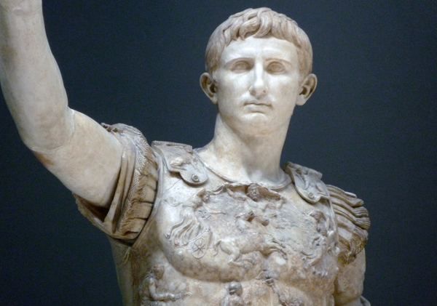

Fig3
Fig. 3: Augustus of Primaporta, c. 1st century C.E, marble, h. 2.03 m, Vatican Museums, Vatican

As stated before, the Augustus of Primaporta is also a representation of a bronze statue. This makes the 25 Euro bust a replica of a replica, could that be the reason why it is not considered to be part of high culture? Augustus of Primaporta is indeed a statue of the first Emperor of the Roman Empire but then again so is the 25 Euro bust, sure it lacks a few aspects of the statue that is currently situated in the Vatican Museums, but both pieces are representations of the same man. Although, the origin of the 25 Euro artefact is quite questionable. It was bought at a stall out in the streets of Rome and there was no clear indication that it was made by hand or machines. Would this affect its value even further? Walter Benjamin states:
Even if the circumstances into which the product of technological reproduction of the work of art may be introduced in no way impair the continued existence of the work otherwise, its here and now will in any case be devalued. (Benjamin, 1936, pp. 6-7)
Another aspect of why the Apollo Belvedere and Augustus of Primaporta are part of high culture may be because of the craftsmanship and time that was applied when creating the artefacts, whereas the 25 Euro bust may have been made by machines in a factory. But technology was also created with time and effort and with the creation of technology some may argue that we have become too lazy and idle because “We often sacrifice real craftsmanship at the altar of expediency.” (Glover, 2010). The matter is still debatable and it depends who answers the question of why certain artefacts are part of high culture and some are part of low culture. Maybe there’s a simple answer and it’s that the 2 artefacts that are being held in the Vatican Museums right now have reputation and we can “Think of reputation as a currency.” (Boag, 2017). Surely an unfair fight for a bust made of unknown materials that was purchased for 25 Euros.
Overall, it may be said that this matter is a one-sided argument but it is completely prejudiced to assume that the bust from the streets of Rome lacks any craftsmanship, and plant its place in low culture due to influences from modern society, and our flaw to appreciate and honour anything no matter how niche or prominent something is, in fear of being shunned by everyone else and that is alright. We can appreciate anything our heart desires and we can absolutely label everything and place them high or low in our culture but it would be way more beautiful if we all just appreciate, adore and respect each other. Especially in modern times where the most common element of politics and society is hatred and division. The Apollo Belvedere and Augustus of Primaporta can be seen as an example of division as it is praised and exhibited as a presentation of wealth, power and class. Comparing the Apollo Belvedere and Augustus of Primaporta to the 25 Euro bust, it is clear why one is regarded are part of the imagery and idea of wealth and power while the other is associated with the notion of low standards and can only be seen as a trinket instead of a piece of art. We may have been shaped to think highly of objects that are being promoted and placed in front of us and to reject things that are tucked and hidden away from the spotlight. But we need to remember that these artefacts exists to be admired and to leave us reminiscing about the history and craftsmanship that went into creating these objects no matter how big and old or small and cheap they are.

Bibliography

Beardsley, M. (1975). Aesthetics from Classical Greece to the Present. Macmillan, New York: University of Alabama Press, pp.35-36.

Benjamin, W. (1936). The Work of Art in the Age of Mechanical Reproduction. London: Penguin Group, pp.6-7.

Boag, P. (2017). Is Success Down To The Quality Of Your Work?. [online] Smashing Magazine. Available at: https://www.smashingmagazine.com/2017/08/success-quality-of-work/ [Accessed 10 Dec. 2018].

Cueto, B., Hendrikx, B., Balsom, E., Berardi, F., Dryhurst, M., Figueroa, J., Herndon, H., Horning, R., Joselit, D., Laric, O., Vermeulen, T., Wagner, B. and Wark, M. (2017). Authenticity? Observations and Artistic Strategies in the Post-Digital Age. Amsterdam: Valiz, p.28.

Glover, R. (2010). Principles of Great Design: Craftsmanship. [online] Smashing Magazine. Available at: https://www.smashingmagazine.com/2010/01/principles-of-great-design-craftsmanship/ [Accessed 10 Dec. 2018].

Kuhl, I., Reichold, K., Lowis, K. and Weidemann, C. (2009). 50 sculptures you should know. New York, NY: Prestel Publishing, p.17.

Zanker, P. (1988). The Power of Images in the Age of Augustus. Ann Arbor: University of Michigan Press, p.188.

