ACCC5000 CLOUD COMPUTING TECHNOLOGIES
Student id: 1813107
Student NAME: ALEKSANDAR IVANOV ANDONOV
2020
Table of Contents
Introduction 2
Background and Terminology for Cloud Computing 2
Characteristics and Benefits of Cloud Computing 4
Service Models and Real-World Models 5
Deployment Models for Cloud Computing Services and Inclusive Recommendations 7
Cloud Computing and Mitigation Strategies of Management and Virtualisation 8
Security Concerns 10
Implementation process of SaaS for London Bikes 13
Recommendations and Conclusion 13
References 14

Introduction
Distributed calculations are growing rapidly as another worldview for conveying the figure as a utility (Ruparelia, 2016). It allows the hiring of IT capacities, whether they are framework, stage, or program applications such as the administration of membership located in administrations, for a fee only if costs are incurred. Its creation depends on various improvements in IT over the last thirty to forty years (Ruparelia, 2016). As new ideas and the progress of innovation have made it even more impressive and engaging in the age of the network, the way in which customers are absorbing and expanding innovation agency agreements has evolved. With model to model based on clouds, the power shifts to buyers. They are approaching more registry power and new applications, with fascinating costs, just as they appreciate the benefits of self-management and self-management conditions.
Distributed computation creates the flexibility and ongoing flexibility of IT assets that are offered to end customers as help through a web medium. Distributed calculations can help efforts to improve the creation and transmission of IT agreements by enabling them to reach administrations in the most financial and adaptive way (Ruparelia, 2016).
The typical understanding of "distributed computing" is constantly evolving, and the phrasing and ideas used to characterize it often need explanation. Inclusion in the press may be unclear or may not fully grasp the extent of what distributed computers include or speak, and in some cases describe in detail how organizations make their responses available in the cloud or how "distributed computing" is the way forward. , however, not to check the qualities, models and administrations involved in understanding what a distributed calculation is and what it can become.

Background and Terminology for Cloud Computing
In the year following the latest state of the cloud survey, we saw a steady development in cross-cloud selection, as open cloud customers included private pools of cloud assets (Baader, Sertkaya and Turhan, 2007). Currently, 77 percent of respondents cover the private cloud compared to 63 percent a year ago. Therefore, the use of cross-cloud situations has developed to 71 percent. A total of 95 percent of respondents currently use the cloud, up from 93 percent in 2015.
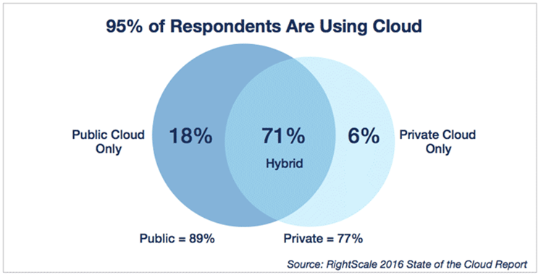
Figure 5. Adaptation of distributed calculations
Users in the cloud
Organizations that use the cloud use 3 open mists and 3 private mists. In total, they perform 1.5 open fog applications and explore different pathways for an additional 1.5 open fogs. They also run 1.7 private fog applications and explore different pathways for an additional 1.3 private fogs.
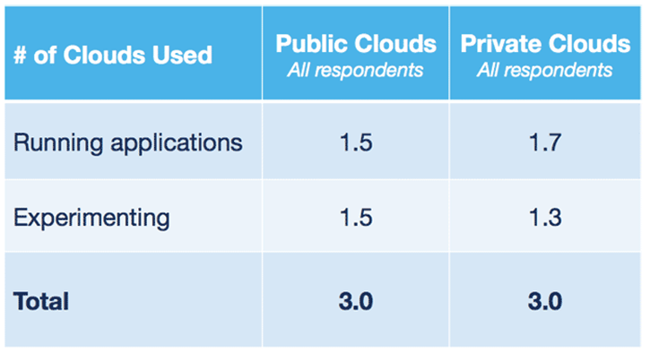
Figure 6. Users in the cloud
The more unresolved tasks undertaken have moved to both open and private coverage in the last year, with the private cloud becoming faster. The number of businesses running more than 1,000 virtual machines (VMs) in the open cloud increased from 13 percent to 17 percent, while those running more than 1,000 VMs in the private cloud grew from 22 to 31 percent. The development of the private cloud in outstanding burdens may further involve long-standing virtualized situations that have been enhanced and appropriated as a private cloud.
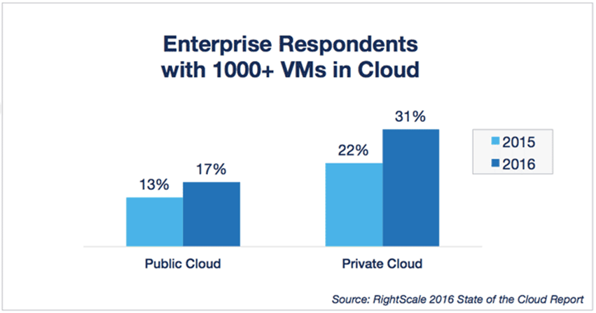
Figure 7. Development of the public and private cloud

Characteristics and Benefits of Cloud Computing
There are five phases in this development, each of which speaks to the alternative design of machining components and frames (Bhowmik, 2017). The five periods are widely useful centralized computer and minicomputer registers, computer computers, client/worker systems, processing, and cloud and multifaceted figuring. Advances that depict one-off can also be used in other time frames for different purposes. For example, several organizations still operate conventional centralized computer frameworks or use centralized server computers as giant workers supporting huge web destinations and enterprise applications.
References: Management Information Systems: Advanced Company Management, Kenneth K. Loden, Jane Price Loden.
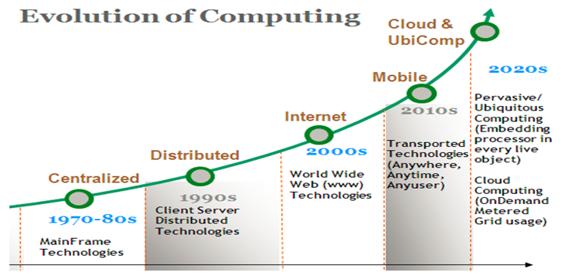
Figure 1. Improving cloud computing
Distributed calculations
In the distributed computational framework, there is a huge exclusive task in motion. Computers no longer have to do all the really hard work of running applications. The system of computers that make up the cloud handles them (Bhowmik, 2017). Requests for equipment and programming by the customer are decreasing. The main thing on which the client's computer should be able to start is the interface programming of the distributed computing framework, which can be just as easy as a web program, and the cloud system does the rest.
The term "cloud" seems to have its starting points in the arrangement of diagrams that spoke on the web or various pieces of it, such as schematic lists. "Distributed computing" was born about what happens when applications and administrations move to the cloud. Cloud mapping hints at the wide range of types of administrations and applications transmitted in the web cloud and the way most of the time the widgets used to reach these administrations and applications do not require any unique applications (Bhowmik, 2017).
Numerous organizations hand over administrations from the cloud. Some striking patterns include the accompanying:
• Google - Has a private cloud that it uses to transmit a wide range of administrations to its customers, including receiving email, recording applications, text interpretations, maps, web surveys and more.
• Microsoft - There is online help for Microsoft Sharepoint that considers substance and business tracking devices that need to be moved to the cloud, and Microsoft is currently making its office applications available in the cloud.
• Salesforce.com - launches its suite of applications for its customers in the cloud, and its elements Force.com and Vmforce.com provide engineers with steps to create cloud administrations.
Attributes
Distributed calculations have an assortment of attributes, the main ones being:
• Shared Infrastructure - Uses a virtualized programming model that allows for capacity sharing for physical administration, warehousing, and system administration. The cloud frame, paying little attention to the stacking model, seems to make the most of the accessible foundation in front of different clients.
• Dynamic provisioning - Allows the arrangement of administrations depending on the current prerequisites of interest. This is done subsequently, using software that allows for the development and contraction of the ability to administer differently. This dynamic scaling must be carried out while maintaining significant levels of unwavering quality and security.
• Network access - It is necessary to access the network from an extended range of widgets, for example, personal computers, workstations, and mobile phones, using APIs based on principles (for example, those that depend on HTTP). Cloud administration organizations include everything from the use of business applications to the latest application on the latest mobile phones.
• Managed measurement - Uses measurement to monitor and optimize administration and to provide detailed and billing data. In this order, customers are charged to administrations according to the amount they actually used during the charging period (Bhowmik, 2017).

Service Models and Real-World Models
Distributed calculations are a model for providing useful, on-demand organization of access to a common pool of configurable processing assets (eg systems, workers, warehousing, applications, and administrations) that can be quickly provided and delivered with little administrative effort or a specialized organization (Khan, 2015).
Programming as a Service (SaaS) - Users purchase the capacity to access and use an application or administration that is facilitated in the cloud.
Stage as a Service (PaaS) - Users purchase access to the stages, authorizing them to send their own product and application to the cloud.
Framework as a Service (IaaS) - Users control and handle frameworks in terms of frameworks, application, storage, and the system network, but do not yet control the cloud base.
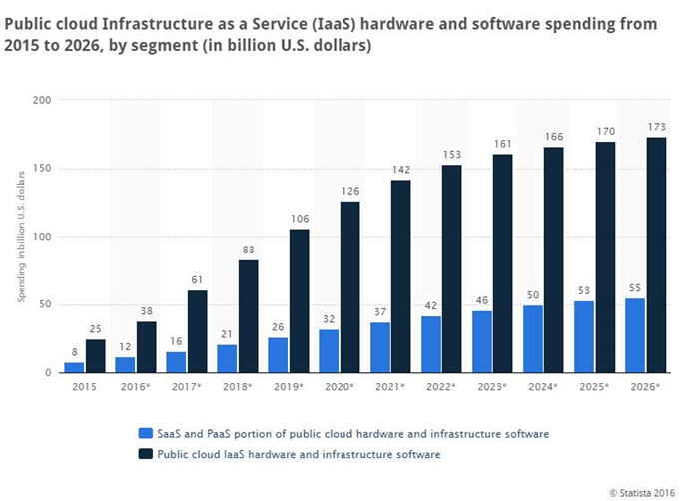
Figure 2. Expected development of an open cloud in 2016
Source: Statistics: Public cloud infrastructures such as service equipment (IaaS) and programming costs from 2015 to 2026 by sections (in billions of USD).
Arrangement models
The transmission of distributed calculations can vary depending on the need and the accompanying four stacking models are distinguished, each with obvious qualities that in a specific way help the requirements of the administrations and customers of the fog.
• Private cloud - The cloud frame is transmitted and maintained and works for a specific association. The activity can be own or with an outside person on site.
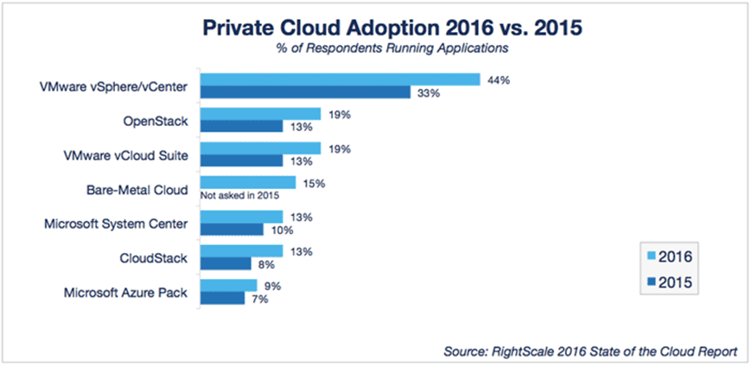
Figure 3. Private cloud reception 2016 compared to 2015
• Public Cloud - The cloud framework is accessible to people in general in business premises by a cloud specialist. This allows the buyer to create and provide help in the cloud, with almost no monetary costs, contrasted with the need to use capital, usually associated with other alternatives to the organization.
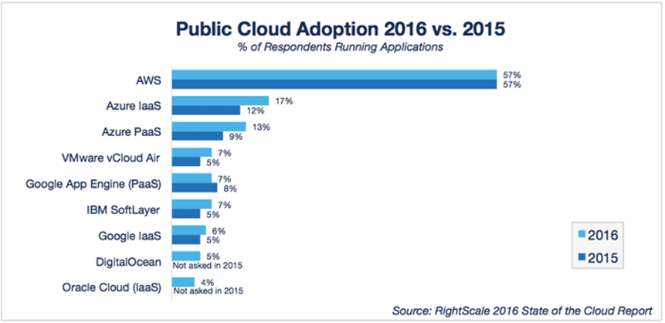
Figure 4. Open cloud reception 2016 compared to 2015
• Hybrid cloud - This can be a mixture of personal and open mists, which help the premise of storing some information in an association and also the need to offer administrations in the cloud.
• Community cloud - the cloud foundation is shared between different associations with comparative interests and needs. This can help limit the cost of using capital to set it up, as costs are shared between associations. The activity can be own or with an outside person on site.

Deployment Models for Cloud Computing Services and Inclusive Recommendations
The forthcoming follow-up is part of the striking difficulties associated with distributed computing, and while some of it may lead to downtime as more administrations are ported to the cloud, it may at most provide openings when properly considered and considered. the stages of the arrangement, including the following aspects (Rountree and Castrillo, 2014):
• Security and privacy - Perhaps two of the more important issues related to "hot trap" involving distributed computers are identified by the removal and provision of information and verification of the use of the cloud by dedicated staff. These problems are largely credited to ease the ordering of cloud administrations. These difficulties can be exacerbated, for example, by transmitting data within the association but allowing its use in the cloud. For this to happen, however, association and cloud security tools need to be strong, and the hybrid cloud can support such an organization.
• Lack of standards - clouds have recorded interfaces; in any case, no instructions are associated with them and it is therefore contrived that most fogs will be interoperable. The Open Grid Forum is building a cloud computing interface to address this issue, and the Open Cloud Consortium is working on distributed computing standards and practices. The findings of these events need to be developed, but it is not known whether they will cope with the requirements of the people sending the administrations and the specific interface that these administrations need. In any case, keeping up with the latest regulations as they progress will allow them to be used if appropriate.
• Continuously evolving - User prerequisites are constantly evolving, similar to the need for interfaces, system administration and capacity. This implies a "cloud", especially open, does not remain static and is also constantly evolving.
• Concerns about law enforcement - The Sarbanes-Oxley Act (SOX) in the US and EU data protection orders are just two of the many consistency issues affecting distributed computers, given the type of information and application it is used for. the cloud. The EU has administrative support for information security in all countries, but in the US, information security is unique and can vary from country to country. Like the aforementioned security and protection, they typically trigger a hybrid cloud-to-cloud transmission by transferring information within the association (Rountree and Castrillo, 2014).

Cloud Computing and Mitigation Strategies of Management and Virtualisation
There is no uncertainty that organizations can receive colossal rewards from distributed computers. In any case, with the numerous focal points, there are some drawbacks (Rountree and Castrillo, 2014).
Focus points on cloud computers
Cost savings - The most critical advantage of distributed calculations is how they are expressed in IT cost reserves. Organizations, regardless of their type or size, exist to raise money while reducing capital and operating costs. With distributed calculations, you can save significant capital costs with zero internal labour stocks and prerequisites for application (Rountree and Castrillo, 2014). The lack of a local framework further evacuates the associated operational costs such as power, cooling, and organization costs. You pay for what is used and separately at any time you want. There is no contribution to cash flow from IT to stress. It is a typical confusion that lone huge organizations can withstand using the cloud when the truth is told, cloud administrations are very moderate for smaller organizations.
Reliability - With a supervisory phase of administration, distributed calculations are significantly more robust and stable than internal IT frameworks. Most providers offer a Service Level Agreement that provides daily access / 365 and 99.99% availability. Your association can benefit from a huge set of recurring IT assets, just like a quick opt-out component - if a worker shows up briefly, simplified applications and administrations can travel to one of the available workers without much of the travel.
Reasonableness - Cloud registration provides improved and disconnected on-board IT and capacity support through a focused asset organization, a foundation that oversees merchants and SLA-sponsored insights. Updates and maintenance of IT foundations are discarded as all assets are maintained by the specialized organization. You value a basic online user interface to access programming, applications, and administrations - no setup requirements - and the SLA ensures the convenient and secure transportation, management, and maintenance of your IT administrations.
Key Edge - constantly growing registration assets give you a serious advantage over competitors, as the time required to acquire IT is virtually zero. Your organization can send strategic applications that bring huge benefits to the business, without real costs and insignificant time to provide. Distributed computing allows you to ignore innovation and spotlight in your key business exercises and destinations. It can also help you reduce the time expected to advertise newer applications and administrations.
Personal Time - As cloud professionals deal with different clients every day, they can become overpowered and even face specialized interruptions. This can quickly stop your business forms. In addition, if your web association is disconnected, you will not be able to access any of your applications, worker or cloud information.
Security - Although cloud specialists follow the best security guidelines and accreditations in the industry, the discarding of information and significant records of external specialized organizations constantly reveals dangers. Using cloud-controlled innovation implies that you need to offer your help provide access to significant business information. At the same time, being open help opens up cloud professionals to security challenges in the normal premise. Immediacy in receiving and receiving cloud administrations can also enable evil customers to check, differentiate, and abuse stipulations and weaknesses within. For example, in a multi-occupant cloud design that makes it easier for different customers to have such a worker, a programmer may try to infiltrate different customers' information and make it easier for a similar worker. However, such adventures and arrangements are not prone to the surface and the likelihood of compromise is not exclusive.
Merchant Lock-In - Although cloud specialists ensure that the cloud will be adapted for use and inclusion, the exchange of cloud administrations is something that is not yet fully developed. Associations may find it difficult to move their administrations, starting with one trader and then the next. Facilitating and integrating ongoing cloud applications at another stage can lead to interoperability and enhancement issues. For example, applications created on the Microsoft Development Framework (.Net) are unlikely to work properly at the Linux stage.
Limited control - Because the cloud base is fully claimed, monitored and verified by the specialized organization, it transfers insignificant control over the client. The client can simply control and handle the applications, information and administrations working on it, not just the foundation. Key regulatory tasks, such as access to employee shells, refreshments and firmware that cannot be passed on to the customer or the end customer (Rountree and Castrillo, 2014).

Security Concerns
Despite the evolving comprehensiveness of distributed computing in the venture, cloud security remains a concern among IT experts. 66% of IT experts at the latest review by Netwrix said that the security and protection of sensitive information is their main concern for the cloud (Hill et al., 2013).
Google applications are the normal and wide application for a huge number of us. They are installed on various protections to guarantee their end customers.
Google's security model is a start-to-finish process based on more than 15 years of experience focused on protecting customers in Google applications such as Gmail, Search, and various applications. With the Google Cloud Platform, your applications and information use a similar security model.
Google is determined to play its part in protecting your tasks, but security is a mutual obligation. They have given us a capacity that we can use to keep your endeavour. Here are some protections and support they gave (Hill et al., 2013).
• Information security team
The focus of Google's security model is the information security team of over 500 top data, application and system security professionals. This group is tasked with maintaining the organization's security frameworks, creating security audit forms, building a secure foundation, and updating Google's security strategies. Their notable accomplishments include finding Heartbleed's weakness, launching a rewards program for reporting programming security issues, and implementing Google's "SSL Naturally" strategy.
• Physical security of the Data Centre
Google's server farms emphasize a layered security model, including shields such as hand-crafted electronic access cards, alerts, obstacle vehicles, edging, metal IDs, and biometrics. The server farm floor highlights the identification of the laser band break. Server farms are inspected day by day by high-quality indoor and outdoor cameras, which can differentiate and follow interconnected. Access logs, action records, and camera movie are checked in case an episode occurs. Similarly, routine farms are monitored by experienced safety personnel who have undergone in-depth individual inspections and training. In addition to those percentages, Googlers will be stepping on one of our server farms at any time (Hill et al., 2013).
• Server and software stack protection
At Google, they manage a huge number of indistinguishable, highly assembled workers. They produced everything from hardware and systems administration to the custom Linux programming stack in the light of security. The homogeneity associated with responsibility for the entire stack significantly reduces our impression of security and allows us to respond more quickly to hazards (Hill et al., 2013).
• Access to data
Google has controls and practices to ensure the security of customer data. The application layers and Google Capacity Stack require that requests originating from different parts be conducted and approved. The access through authoritative architects of the application to the conditions for creation is additionally controlled. The concentrated system for collecting and working managers is used to characterize and control the entry of specialists into the creation administrations, using a security convention that confirms engineers to use short individual open-key declarations; thus, the issuance of individual certifications is protected by a two-factor verification (Hill et al., 2013).
• Data disposal
As soon as it withdraws from Google, hardboards containing customer data are exposed to a process of decimating information before leaving Google's premises. First, the plates are cleaned sequentially by approved people using a procedure approved by the Google security team. At this point, another approved individual conducts a follow-up examination to confirm that the circle has been effectively cleaned. These delete results are saved from the serial number of the device to the next one. Finally, the deleted device is delivered to a warehouse for reuse and redistribution. If there is a chance that the drive cannot be uprooted due to frustration with the equipment, it is safely postponed, while it can very well be really destroyed. Each office is inspected week after week to verify compliance with the circle deletion strategy (Hill et al., 2013).
• Platform security features
All elements in Google, including the Cloud Platform, certainly work as a central structure and need for progress. In addition, Google's site, unwavering quality design teams, administer the tasks of stage frames to ensure high availability and prevent misuse of stage assets. The emphasis on the obvious security of the item is depicted in the documentation of each item, but everyone buys at certain stages (Hill et al., 2013).
• Secure service APIs and authenticated access
All administrations are controlled by making sure of the Global API Door Foundation. This API service framework is only available for encrypted SSL / TLS channels, and each request requires consideration of a period with a limited validation tag created using human input or private key internal facts through the verification framework presented earlier. All-access to Google's cloud platform assets is managed through an equivalent heart-certified framework that entitles other Google administrations. This means you can use existing Google records or set up a controlled Google surveillance space. Highlights available when monitoring customers include a secret phrase strategy, supported 2-factor verification, and a new enhancement to the validation requirement as equipment security keys (Hill et al., 2013).
• Logging
All stage API requirements, such as network requests, retention access storage, and client account, are logged. With Cloud Platform devices, you can understand the activities and log files to access Compute Engine, App Engine, BigQuery, Cloud SQL, Deployment Manager, Cloud VPN, and Cloud Storage.
• Data encryption
The benefits of the cloud platform constantly encode client content that is cancelled very still, without requiring client activity using at least one encryption system, with a few small special cases. For example, any new information placed in industrial circles is encoded under the 256-part extended encryption standard, and each encryption key itself is mixed with a routinely inverted arrangement of ace keys. Similar encryption arrangements and key administrations, cryptographic libraries, and trust trusts used for your information in the Google Cloud platform are used by many people in administrations to create Google, including Gmail and Google's corporate information.
• Secure global network
Google's global system helps improve the security of information on the road by limiting jumps over the open Internet. Cloud interconnection and supervised VPNs allow you to create jumbled channels between your private IP on the premises and the Google system. This allows you to keep cases completely separate from the open network while they are still accessible from your own private frame.
• Security scan
Cloud Security Scanner helps App Engine designers distinguish the best-known vulnerabilities, explicit web page scripting (XSS), and mixed substance in their web applications.
• Conformity and certificates
The Google Cloud Platform and Foundation are guaranteed a growing number of compliance principles and controls and are experiencing several free external reviews to test information security, security, and safety.
• User management and confidential data
The Google Cloud Platform entitles you to set permissions for enterprise-level customers. Give colleagues at least special access.
• Maintain network firewall rules
Of course, all approaching traffic outside the system is blocked and no parcel is allowed on a VM occasion without unambiguous firewall rules. To allow system traffic to approach, you must set up firewalls to enable these associations. This way of dealing with stacking permissions allows you to determine the root and type of traffic, allowing you to come up with examples of your process.
• Penetration test
If there is a chance that you intend to assess the security of your frame in a cloud platform with an infiltration test, you are not required to contact us to begin testing. You must comply with the Cloud Platform Acceptable Use Policy and Terms of Use and ensure that your tests simply affect your tasks (and not other customers' applications).
• Logging and monitoring
The cloud platform provides tools, such as Google Cloud Logging and Google Cloud Monitoring, that make it easier to collect and break down query logs and screen the accessibility of your framework administrations (e.g., virtual help occasions). These devices thus facilitate the production of personalized boards and issue warnings when problems arise.
Security is listed as a top test in the cloud. The lack of assets/capabilities increased from 27% a year ago to 32% this year to displace security as the biggest concern. As more associations put more remaining tasks at hand in the cloud, the skill requirement has evolved. Further training of IT and staff for improvement will be essential to support this test (Cloud computing, 2015).

Implementation process of SaaS for London Bikes
AccessXpert enables fast security experts and improves business efficiency. This is online security on board ISC West 2016. In light of the latest open convention support, AccessXpert rearranges and smoothes on-board security for the current progressive security faculty. The new agreement uses secure cloud-based progress to give building owners, bosses and security officials with any location, whenever portable video surveillance access, interruption location, gain control, watch out for executives and different frameworks. What is more, it combines security with London Bikes SmartStruxure ™, building the on-board framework (BMS) to allow for clearer choices, faster reactions and the most extreme skills in the office (Cloud computing, 2015).

Recommendations and Conclusion
Distributed calculations offer benefits to associations and people. There are also concerns about security and safety. With the chance that you are thinking about cloud administration, you need to consider how individual data and your customers can be best secured. Carefully check the terms of administration or agreement and challenge the vendor to address your issues.
You seamlessly recognize information and prepare tasks that will be submitted for recognition in the cloud: Personal data, sensitive data, strategic company data or data used in business applications. In addition, define your own prerequisites for specialized and legal security.
In general, for a short period of time, the distributed calculations mainly affected the mechanical scene. In the first decade and a half since the cloud became the standard, organizations and people have been drawn to the cost of sparring, the multifaceted benefits that the cloud brings to the table. In the least difficult conditions, the cloud takes into account the reduced costs of equipment and facilities, while helping to increase the flexibility, productivity and accessibility of information. This means that the way business administrations are forwarded and controlled is changing forever, which encourages more remarkable and global development.
As the mechanical scene changes forever from the cloud, notice that we're just starting to scratch the surface. According to Forrester's ongoing study, the distributed computing mall, which is worth $ 40.7 billion since 2011, is expected to grow to $ 241 billion by 2020.
Source: Erin Masterson, creator of trends in cloud computing: The future is bright.

References
Baader, F., Sertkaya, B. and Turhan, A.-Y. (2007). Computing the least common subsumer w.r.t. a background terminology. Journal of Applied Logic, 5(3), pp.392–420.
Bhowmik, S. (2017). Cloud computing. Cambridge New York, Ny Port Melbourne Delhi Cambridge University Press.
Cloud computing. (2015). New Delhi: Astha Publishers & Distributors.
Columbus, L. (2016). Roundup Of Cloud Computing Forecasts And Market Estimates, 2016. [online] Forbes. Available at: http://www.forbes.com/sites/louiscolumbus/2016/03/13/roundup-of-cloud-computing-forecasts-and-market-estimates-2016/#30f603ef74b0 [Accessed 22 Aug. 2020].
Electric, S. (2016). Schneider Electric Introduces Cloud-Based Integrated Security Management System. [online] www.prnewswire.com. Available at: http://www.prnewswire.com/news-releases/schneider-electric-introduces-cloud-based-integrated-security-management-system-300246783.html [Accessed 22 Aug. 2020].
Expedient. (2012). Cloud Computing Trends: The Future is Bright. [online] Available at: https://www.expedient.com/blog/cloud-computing-trends-the-future-is-bright/ [Accessed 22 Aug. 2020].
Forum Info-Tech. (2020). About Us | Forum Info-Tech IT Solutions. [online] Available at: http://www.levelcloud.net/why-levelcloud/cloud-education-center/advantages-and-disadvantages-of-cloud-computing/ [Accessed 22 Aug. 2020].
Hill, R., Hirsch, L., Lake, P. and Siavash Moshiri (2013). Guide to cloud computing : principles and practice. London ; New York: Springer.
Khan, M. (2015). The Value of Theoretical Models for Real-World Market Analysis. SSRN Electronic Journal. [online] Available at: https://works.bepress.com/michael_andersons/6/download/ [Accessed 22 Aug. 2020].
Rountree, D. and Castrillo, I. (2014). The basics of cloud computing : understanding the fundamentals of cloud computing in theory and practice. Amsterdam ; Boston: Elsevier/Syngress.
Ruparelia, N.B. (2016). Cloud computing. Cambridge, Massachusetts ; London, England: The Mit Press.

