

MBA- Masters of Business Administration
Marketing Management – Assessment 2 (LCMB7001)

Title: Analysis for Premier Inn

Student ID: 2223911
Student Name: Priyanka Myadari
Word Count: 2573

Table of Contents
Introduction 3
Analysis of the firm 4
PESTLE 4
Porter's Five Forces 6
SWOT Analysis 7
Advantages and Disadvantages of SWOT 8
Appraisal of the marketing management 9
Segmentation , Targeting and positioning for Premier Inn 9
Segmentation 9
Marketing Mix strategy 10
Conclusion 11
Recommendations for future 11
References 13

Introduction
The business enterprise chosen for the task is Premier Inn which is one of the largest hospitality brands in the UK. WhiteBread is the owner or parent company to Premier Inn. It is a limited enterprise which has its headquarters in Dunstable in the United Kingdom. The brand operates in varied locations across England including suburban areas, city centres and airports (Premier.com 2023). It has more than 800 hotels across the UK, where all operate with diligence and fervour. Premier Inn operates in several other countries as well such as Qatar, Germany, Isle of Man, United Arab Emirates and others. The Premier Inn group has acquired great performances and market reputation through the years and acquired a significant base of loyal consumers.
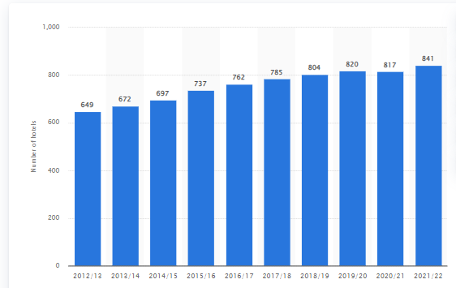
Figure 1: Premier Inn hotels UK
(Source: Statista 2023)
The Parent company Whitbread which has long-term network targets and has around 17% market share in the UK. In 2022, Premier Inn reported pre-tax profits of 307 .4 million Euros on revenues and revived from losses that it faced during pandemic years from 2020-2021 (thecaterer.com 2023).
The report elucidates the role as a consultant for Premier Inn to construct the marketing analysis for the firm involving both external and internal environmental analysis and also depicts the appraisal of the marketing management. The viable recommendations for the firm Premier Inn have been reported in order to bring better performances in the future.

Analysis of the firm
The internal and external analysis of Premier Inn has been elucidated in the section using the PESTEL framework, the Porter's Five Forces model and conducting the SWOT analysis for the firm.

PESTLE
According to the view of Nandonde (2019), the PESTEL framework is a strategic tool used to review the external conditions that have implications on the business operations. The tool has been applied to Premier Inn:
Political
Premier Inn is a UK based brand and operates mainly in England. The Government after the Brexit referendum has increased security with longer wait times and increased fees which has reduced travel inbound to the UK and can have an impact on occupancy rate of Premier Inn. The pandemic impacted overseas to the UK though it has increased in 2021 to 2023 but the levels are yet below the pre-pandemic levels. Hence, these have implications on lowered occupancy in the hospitality sector like the popular brand Premier Inn.
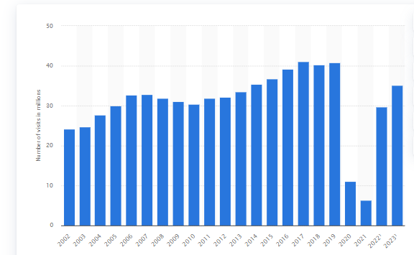

Figure 2: Overseas visits to UK
(Source: Statista 2023)

The United Government has increased corporation taxation upon the business profits from 19% to 25% Hence it has added additional burden on the hotel profits like Premier Inn (costar.com 2023).
Economic
There has been a hike in the utility pricing in the UK and it poses a threat to the hotel sector as they face rising operational costs. Hence, it affects the operations of Premier Inn declining its profit margins with increased operations costs (boutiquehotelier.com 2023).
The economic health of the country affects the hotel industry in significant ways. It has affected the United Kingdom and the performance of the hotel is yet to return to pre-pandemic levels. The GDP of the UK has been low and it affects the sales to Premier Inn.
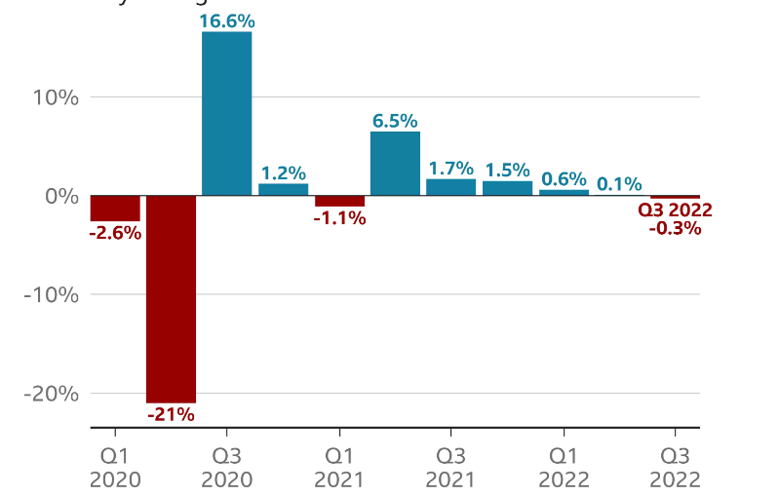
Figure 3: GDP decline in UK
(Source:bbc.com 2023)

The inflation rate in the UK has been soaring due to increased energy costs, impact of the pandemic. Hence, it has forced several hotels to face an increase in its operations costs and it has applied it to the consumers by increment of pricing by 10% (harpers.co.uk 2023). This will have negative implications on Premier Inn as most consumers' purchase decisions would be impacted in negative ways as people would rather spend during inflation in necessity than on vacations for leisure hotels.
Social
Social factors relate to consumers' needs and services by Premier Inn. The main focus of Premier Inn has been the satisfaction of consumers and offers money-back guarantee money but the consumers are not satisfied with the friendly and comfortable services. They ensure to cater to customers’ needs with value-based pricing and also have several promotions on offer in order to cater to consumers’ needs.
Technological
Premier Inn uses technology to bring improvement in its consumer services and reduce cost of operations. Premier Inn has widespread usage of the mobile applications, websites and social media portals in order to create wider brand awareness and engage its target audiences. Premier Inn initiated the first automated self-checkout kicks at St Mary Gate Sheffield location (futr.ai 2022). It has cut down the time needed for check-in and check-out significantly. Moreover, it has initiated the usage of mobile apps for controlling room amenities as well. Hence, these technological advancements have increased engagement of Premier Inn hotels.
Legal
This refers to equal opportunities for employment and complying to all employees related regulations and legislations in the UK. There has been an increase in UK minimum wages and hence it has led to increase in operational cost of the hotel chain as well (gov.uk 2023).
Environmental
Premier Inn has pledged to attain net-zero carbon emissions by 2040 and reduce the usage of the gas and install solar panels in its hotels along with electric vehicles fleet as part of sustainability. Premier Inn has already installed 88 solar arrays across the UK for the hotel needs as part of its environmental sustainability initiative (saurenergy.com 2023).

Porter's Five Forces
As per the view of Isabelle et al., (2020), the Porter's Five Forces is a strategic tool to understand the attractiveness of the industry. The tool has been applied in the context of Premier Inn.
Bargaining power of suppliers - The bargaining power of the suppliers is mainly the manpower which provides productivity to the firm. Premier Inn faced high suppliers force with the labour shortages increasing but the firm has got them down to low force in bargaining power of suppliers as it has spent more than 23 million Euros on engaging and retaining employees at Premier Hotel chains (Hancock 2021).
Bargaining power of consumers - The bargaining power of consumers is high as there are several competing firms like Hyatt Hotels, Kew Green, Travelodge hotels and others. Hence, lowered pricing or promotional offers by competing brands can lower the demands for Premier Inn.
Competitive Threat - There is high competition from brands like Holiday Inn and Travelodge. Premier Inn has been able to sustain a highly competitive edge owing to its brand name, quality of hospitality services and loyalty of the consumers.
Threat of new entry - The threat of new entry is low as there is large investments in setting the hotel sectors and the time to create brand awareness. Hence, the threat of new entry is low in this context.
Substitute threat - There can be low substitute threat as the only substitutes can be motels and accommodation at family and friends’ houses.

SWOT Analysis
According to the view of Benzaghta et al., (2021) , the strategic planning investigates the position of the organisation and develops right strategies.

Strengths | It has an occupancy rate of more than 68.3% and holds a favourable position in the industry (statista.com 2023).  It has a large presence in the UK with more than 800 hotels.  It has several hotels near tourist attractions and airports which are a great advantage to the firm to draw a large base of consumers.  It has a high brand image in the UK. It is popular for being a kid-friendly hotel as well.It offers 24/7 wi-fi services and voted as the best hotel brand. It has won the Best Budget Hotel Brand Award in 2019.
Weaknesses | Limited global presence is a major weakness of Premier Inn. Premier Inn operates in limited countries.  Premier Inn has been subjected to issues relating to several reports having undercover reporting which revealed the housekeeping has been using the same guest towels for cleaning the entire bathroom. This raised concerns on the brand's reputation (www.news. 2023).
Opportunities | It can expand to other countries.  Can invest in digital marketing for wider reach.
Threat | The biggest threat can be the competition of Premier Hotels where several hotels like Holiday Inn, Easy Hotel, and others as budget hotels stand as strong competitors.

Advantages and Disadvantages of SWOT
The usage of SWOT as the tool has several pros and cons associated with it. The first advantage of using SWOT is that it is a simple process easily applicable by all, and second it gives a wide range of vital information needed to attain the goals for firms like Premier Inn. The disadvantage of using SWOT for analysis is that it is a time-consuming process and cannot be applied as Premier Inn needs quick decisions. Another disadvantage is that Premier Inn may be relying upon too subjective analyses drawn from employees' analysis and bias or opinions of team members can have influence interfering with facts.

Appraisal of the marketing management

Segmentation , Targeting and positioning for Premier Inn

Segmentation
According to the view of Kalam (2020) segmentation refers to division of the marketplace in specific segments. The following segments are classified for Premier Inn.
Geographic segmentation- It caters to all target audiences in the UK and Scotland having diverse locations from near airports and business centres to convenient market and tourist attractions places.
Demographic segmentation- Caters to all males and females and to all ages specially the families with kids as it is known as one of the best kid friendly places.
Psychographic segmentation- It targets all these long for complete modern amenities at affordable pricing.
Target market
The target market for Premier Inn is a wide range of consumers from leisure travellers to travellers of business looking for convenient and affordable stay.
Positioning of Premier Inn
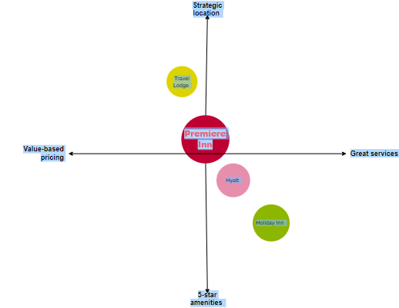

Figure 4: Perceptual Map for Premier Inn
(Source: Self-Developed)

Marketing Mix strategy
Product
Premier Inn has varied types of rooms for different consumers. The family size rooms have large king size rooms and sofa beds. The hotel has interconnecting rooms as well. The rooms have categorisation as single, double and accessibility which has wheelchair access for senior citizens and physically disabled. It has luxury rooms as well. The hotel offers 24.7 wi-fi services and team and coffee facilities for guests. It has a bar and restaurant in-house as well with daily cleaning to ensure safety, and cleanliness for all guest’s well-being. Premier Inn has mixed reviews both positive and few negative on travel websites.
Price
Pricing plays a key role in marketing and Premier Inn has varied pricing strategies especially value-based pricing. It has several pricing strategies which are Flexible pricing, semi-flexible, Advance, and Non-Flex rates. The flex rates provide consumers the ability to amend or cancel booking for the same day. It has value-based pricing aiming to provide consumers with great value and offers promotional discounts throughout the year through varied travel sites as well.
Promotion
In terms of promotion, the hotel invests largely in marketing mix and advertises through radio, print advertisement and recently leveraged digital social media in order to promote the brand. A drawback is that it has less followers and activity on social media which needs to be revived to increase the presence.
Place
It has a large presence in the UK and over 840 hotels. The rooms can be booked directly through the hotel website or app. The third-party apps such as booking.com, Lastminute.com and others can be used as well. Phone bookings are viable as well.

Conclusion
In a nutshell, it can be stated that Premier Inn is a popular brand and the report has elucidated its internal and external environmental analysis. Keeping few drawbacks to Premier Inn it can implement certain recommended actions for better growth in future.

Recommendations for future
With increased pet-friendly tourism hotels, Premier Inn can plan to have pet-friendly facilities at the hotel available.
Secondly it can create effective campaigns through social media in order to promote the brand and target larger audiences. It can use techniques like story-telling in order to reach consumers drawing their attention. It must ensure SEO optimization for all the content its uploads on websites and social media portals.
Premier Inn can inculcate new innovations in its operations such as introducing robot-based restaurants or cafes. It can be an attraction to the consumers and draw better revenues. Moreover, it can offer special packages with food, and stay for newlyweds , or weddings or business conferences. Moreover, it must bring a few renowned brands of UK such as Starbucks, Pret-Manger, or Costa coffee to open their outlets within hotels to act as an attraction to consumers. The firm can bring a few activities such as games room, and bowling activities along with gaming arcades in order to attract the audiences. These innovations and changes can create great attraction to engage target audiences.

References
Benzaghta, M.A., Elwalda, A., Mousa, M.M., Erkan, I. and Rahman, M., 2021. SWOT analysis applications: An integrative literature review. Journal of Global Business Insights, 6(1), pp.55-73.[Available at: https://digitalcommons.usf.edu/cgi/viewcontent.cgi?article=1148&context=globe]
Bureau, S.N. (2016) Whitbread completes installation of 88 Solar Arrays at Premier Inn sites across UK, Saur Energy International. Available at: https://www.saurenergy.com/solar-energy-news/whitbread-completes-installation-88-solar-arrays-premier-inn-sites-across-uk (Accessed: May 2, 2023).
Hancock, A. (2021) Premier Inn owner Whitbread spends £23m to retain staff, Subscribe to read | Financial Times. Financial Times. Available at: https://www.ft.com/content/b2b6c145-f0ab-4fdd-a711-909ccffccf5f (Accessed: May 2, 2023).
Isabelle, D., Horak, K., McKinnon, S. and Palumbo, C., 2020. Is Porter's Five Forces Framework Still Relevant? A study of the capital/labour intensity continuum via mining and IT industries. Technology Innovation Management Review, 10(6).[Available at: https://www.timreview.ca/article/1366]
Kalam, K.K., 2020. Market segmentation, targeting and positioning strategy adaptation for the global business of Vodafone Telecommunication Company. International Journal of Research and Innovation in Social Science, 4(6), pp.427-430.[Available at: https://www.researchgate.net/profile/Khaled-Kalam-2/publication/342881199_Market_Segmentation_Targeting_and_Positioning_Strategy_Adaptation_for_the_Global_Business_of_Vodafone_Telecommunication_Company/links/5f0b33114585155050a04318/Market-Segmentation-Targeting-and-Positioning-Strategy-Adaptation-for-the-Global-Business-of-Vodafone-Telecommunication-Company.pdf]
Millions get pay rise as National Minimum Wage and national living wage increase (no date) GOV.UK. Available at: https://www.gov.uk/government/news/millions-get-pay-rise-as-national-minimum-wage-and-national-living-wage-increase#:~:text=The%20full%20increases%20from%201,%C2%A36.83%20to%20%C2%A37.49 (Accessed: May 2, 2023).
Nandonde, F.A., 2019. A PESTLE analysis of international retailing in the East African Community. Global Business and Organizational Excellence, 38(4), pp.54-61.[Available at: http://41.73.194.142/bitstream/handle/123456789/3290/Felix%20GBOE.pdf?sequence=1&isAllowed=y]
Premier Inn Hotels: Book Direct (no date) Premier Inn hotels | Book direct. Available at: https://www.premierinn.com/gb/en/home.html (Accessed: May 2, 2023).
Price, K. (2022) Premier Inn owner Whitbread returns to Profit, The Caterer. The Caterer. Available at: https://www.thecaterer.com/news/premier-inn-owner-whitbread-returns-profit-h1-2022 (Accessed: May 2, 2023).
Published by Statista Research Department and 15, J. (2022) Premier Inn Hotel Numbers 2022, Statista. Available at: https://www.statista.com/statistics/739855/whitbread-premier-inn-hotels/ (Accessed: May 2, 2023).
Published by Statista Research Department and 15, J. (2022) Premier Inn Hotel Occupancy Rates 2022, Statista. Available at: https://www.statista.com/statistics/739831/premier-inn-hotel-occupancy-rates/ (Accessed: May 2, 2023).
Published by Statista Research Department and 2, J. (2023) Inbound visits to the UK 2023, Statista. Available at: https://www.statista.com/statistics/287133/annual-number-of-overseas-visits-to-the-united-kingdom-uk/ (Accessed: May 2, 2023).
Rising utility costs: How hoteliers are tackling the problem (no date). Available at: https://www.boutiquehotelier.com/rising-utility-costs-uk-hotelier-advice/ (Accessed: May 2, 2023).
Thomas, D. (2022) UK economy shrank more than previously thought, BBC News. BBC. Available at: https://www.bbc.com/news/business-64062548 (Accessed: May 2, 2023).
UK hoteliers brace to feel pinch of Higher Corporation tax (no date) CoStar. Available at: https://www.costar.com/article/356349250/uk-hoteliers-brace-to-feel-pinch-of-higher-corporation-tax#:~:text=New%206%25%20Tax%20Increase%20Takes%20Effect%20April%201&text=The%20rate%20of%20United%20Kingdom,profit%2Dand%2Dloss%20accounts. (Accessed: May 2, 2023).
Web-Designer (2022) Ai in hotels: Transforming the guest experience, Futr. Available at: https://futr.ai/ai-in-hotels-how-tech-is-transforming-the-guest-experience/ (Accessed: May 2, 2023).

