2
Nour Jahan Begum
Student Number: 1814937

BMSK 4006
Professional Career Development
Lecturer: Dr. Buddhi Pathak

Table of Content
Part 1
Introduction……………………………………………………………………………………..page 1
Defining Self Awareness……………………………………………………………………….page2
Importance of Self Awareness………………………………………………………………..page 2
Defining Johari Windows……………………………………………………………………...page 2
Johari Windows on Myself………………………………………………………………….page 3-4
Results from Career Motivation Test………………………………………………………page 5-6
Results from MBTI Test……………………………………………………………………...page6-7
Defining a Protagonist………………………………………………………………………….page7
Impact of results………………………………………………………………………………..page 8
Part 2
30 Second CV Scan…………………………………………………………………………...page 8
Defining a CV…………………………………………………………………………………..page 9
The Importance of a CV…………………………………………………………………...page 9-10
The Importance of a Cover Letter…………………………………………………………...page10
The Importance of a Job Advert/Job Description/Person Specification…………….page 10-11
The Interview…………………………………………………………………………………..page11
Preparations Steps before an Interview………………………………………………..page 11-12
Results from Interview……………………………………………………………………….page 12
Feedback from Interviewer 1&2……………………………………………………………..page13
Key Learnings from Interview…………………………………………………………..page 13-14
Conclusion…………………………………………………………………………………….page 15
References………………..……………………………………………………………….page 16-19
Appendix…………………………………………........................................................page 20-38

Introduction
Definition of Professional Career Development
Career advancement is a procedure that structures ones work personality. This is an important piece of human advancement (Mc Kay, 2019).
Addressing your guiding principle, your strengths, weaknesses and your future goal can be a very good step to take to Improve and understand your professional career development (Indeed.com, 2019).
My short term career target is to achieve my Teaching Assistant Level 2 qualification and pursue that level of work, while I’m in that job to continue with my Teaching Assistant Level 3 qualification and then pursue a job at that level.
My long term goal is to do a Teaching degree and become a Qualified Teacher.
There is two parts to this report, Part one is where I will be discussing about self-awareness and how important it is and how Johari windows as a self-awareness tool helped me to identify myself and what I have learnt.
Then I will be discussing all the other various tests we have taken and how these tests are linked to my career progression and whether those tests were useful or not and how?
Part two of this report is discussing about the in class recruitment, who I chose and why? We will be focusing on the importance of a CV, job advert, job description, cover letter and person specification also how these will help me prepare for an interview.
Finally, I will analyse the feedback from the interview and how I could have improved myself and what impact it has had on my career development.

1
Defining Self-Awareness
Self-awareness is a familiarity within yourself, with the self being what makes one’s personality remarkable. These interesting segments incorporate contemplations, experiences and capabilities. Analysts Shelley Duval and Robert Wicklunds hypothesis to self-awareness was that “when I focus on myself, I survey and balance my present lead with my internal principles and attribute, (such as my strengths and weaknesses) I hesitate as target evaluators of myself”.
Importance of Self-Awareness
Self-awareness is the key component to passionate knowledge. The capacity to screen our feelings and contemplations from minute to minute is vital to comprehend ourselves better. Various researches have given self-awareness as a basic characteristics of effective business pioneers (Zhu, 2020).
There are various tools you could use to gain self-awareness, in this case I have chosen Johari windows as a tool to explore my self-awareness.
Defining Johari Windows
Johari Windows was developed by Joseph Luft and Harry Ingham in 1950’s they were American psychologists, who combined both their names and came up with the name Johari. Johari windows is a very common tool that is used as a self-awareness training, character advancement, relational correspondence, group improvement. This device allows us to research how we see ourselves and how the world see us. It is known as a model of opening the different lines of communication. It brings out an approach to show how we become progressively open to others as we become closer (Saxena, P, 2015).

2

Johari Windows on myself
Open Area (Known to yourself and others) | Blind Area (Unknown to you but known to others)
- Good Communicator  - Very approachable  - Cordial  - Supportive  - In-depth writing, never short of words.  - Good team player  - Can work on my own initiative as well as in groups.  - Patient | - Very funny  - Hardworking  - Can get on with work in a noisy atmosphere.  - Can get carried away in conversations, not letting anyone speak.
Hidden Area (Known to you but unknown to others) | Unknown Area (Unknown to you and others)
- Very competitive  - Can get effectively emotional.  - Can easily hide how I’m feeling. | - Have the ability to become team leader.  - Powerful

To get the above outcome I had asked my fellow peers to help me complete Johari windows on myself. My fellow peers helped me complete the open area, blind area and unknown area, and I had to complete hidden area by myself.
At the time when my peers were helping me complete the blind area and open area, I was feeling very over whelmed by what they were saying eg: they thought I was hard working, can get my task done even in a noisy atmosphere and that they thought I was very supportive etc. This feeling has made me feel more empowering to achieve my goals.
What I thought was good about this tool is:
- Knowing the open area increases mutual concern, respect and co-operation.
- Knowing my blind area is like a feedback so I could improve and learn and when I overcome them changes, they could go into the open area.
- Letting my peers know my hidden area so they could encourage me to overcome and learn how to take this positively and bring this information into the open area.

3
- Having my unknown area revealed that I may have potential to be a leader will encourage me to push my boundaries (Luft, J. and Ingham, H., 1961).

What I do not like about this tool is some people may misuse this information or use it in a negative way (Self Awareness, 2013).
The Johari windows (self-awareness tool) that I did on myself has helped me analyse and will assist me with dealing with my blind area, unknown area and hidden area by shrinking the size of theses windows this will then expand the size of my open area, this will put me on a way towards developing myself (Douglas, D.H. and Willis, D.G., 2005).

What I have found challenging in this tool was the blind area, I did not think anyone thought I spoke over them, not letting them speak, failing to listen to others this is something that is completely oblivious to me. If I was to continue to do this my colleagues/friends may lose focus on what I am saying and it may cause miscommunication. To overcome this challenge, I have decided to set a time limit of 6 months to see if I could actually change that about myself. I will try to talk less and listens to others more. After six months I will get constructive feedback from friends and colleagues to see if there has been any improvement
What I have learnt from Johari Windows is that by disclosing some information about my abilities is a good way for others to help me achieve my objectives, it makes me communicate with others better which is the key to success, having common understanding where trust manufactures great relational connections and can be connected to improve my performance (Nofriza, F., 2017). Trying out new experiences pushing myself for greater outcomes. It also allows me to get constructive feedback from others this will give me an insight of my behaviour towards others and myself. Great input brings out common understanding, joint agreement and good participation (Mulder, 2017).

This self-awareness tool has had a great impact on my life where it has given me a better understanding to where I am right now to where I would want to be in the next couple of years. It has made me see things about my personality that I would not have seen by myself. By highlighting my good points, it has also highlighted what more I have to learn. To do this I have to take on board all the constructive feedback I have received from peers and work on them effectively (Newstrom, J.W. and Rubenfeld, S.A., 1983, March).
4

Results from Career Motivation Test (123 Test)
This test can assist you with picking up knowledge into the professions that best fit your character. It will enable you to realize what sort of workplaces and occupations suit you best (Doyle, 2019).
Below is a pie chart showing my personalities in percentages.

My list of occupations from this test were:
Medical Records Clerk- 77%
Tutor- 73%
Nurse responsible for general care- 71%
Community Health Worker- 68%
Corporate Trainer- 62%
Legal Assistant- 63%
Health and Safety Officer- 66%
Occupational Therapist- 69%
5
Librarian- 68%
Archive Manager- 68%
Pharmacist- 66%
E-Learning Developer-62%
After taking this test I feel as though it has given me something to consider, I have significantly more alternative of employment decisions that would suit my personality. I feel as though I need to do some research on the above jobs recorded before I arrive at any conclusion.
The good thing about this test is that, it can detect my personality and give me indications of what changes I should consider so that I am in the right direction of achieving my set goal, eg: need to complete a Health and Social Care course if I am thinking of working in that field. What I do not like about this test is that it may not be able to measure all areas such as musical intelligence and artistic capabilities. No guarantees the jobs listed would in reality be ideal for me (Barrett, J., 2009).

My key learnings from this test is that, it has broadened my career options matching to my job preference’s and personality. This test determines what jobs I am best suited to and by what percentage. I can see there is pattern between all the jobs listed from the aptitude test which is general care whether it is for adults or children. This test has also indicated what qualifications I need to gain before I could apply for the job (Mjåtveit, 2018).
This test has helped me immensely in my career progression because career aptitude test discovers my character type and what jobs are the correct occupations that I should pursue, as character influences an individual’s frame of mind, relational abilities, initiative aptitudes and teamwork qualities. By matching my character to an occupation will build the opportunity for me to have work achievement (Bimrose, J., Barnes, S.A. and Hughes, D., 2008).
Results from MBTI Test (Myers-Briggs Type Indicator)
Psychometric tests help you distinguish your own strengths and weaknesses, it helps build up a profile for your characteristic’s and personality (Carter, P.J., 2004).
In this test you are asked several questions about yourself and about how you would react in certain situations and you have to be completely honest otherwise the test would not work accurately (Cherry, 2019).
6

Outcome to my results
After I had completed the test, the results were that my personality type was a protagonist and my individual attributes were:
Outgoing- 89% Intuitive- 55% Feeling- 61% Judging- 75% Decisive- 51%
Role: Diplomat
Strategy: People Mastery.
Defining a Protagonist?
This is a person who is a natural born leader, who is not afraid to speak up or defend someone when they are right. Determined and full of charisma, someone who can inspire people to do their best in the world, someone who can be a teacher and guide people to go on the right path and do things for the community. A Protagonist is a firm believer that can radiate validness, concern and unselfishness, they also can communicate with people very easily (Frohock, R., 2004).
I am feeling very proud of the outcome of the results, I believe it is so accurate I could not have described myself any better and in so much depth.
What I believe that was acceptable about the test was by responding to every one of the inquiries it can recognise your qualities and shortcomings and indicate what your personality attributes are in a very supportive way (Ganapathy, 2014).
What I do no not like about the test is that it does not indicate how unique I am and this could result in many individuals having the same traits and applying for similar jobs (McDonald, J.D., 2008).
From the Myers Briggs Indicator test what I have educated is that I am a lot more grounded individual than I suspected, I am capable of being a teacher and guiding everyone. This test has told me some true facts about my personality which I was oblivious too, for me to know myself through these test has given me an understanding on how to cultivate my strengths at my current job which is a senior play leader, I have also learnt that I need to put my needs first before my colleagues and push them effectively so that they can exceed in their job roles, without anyone getting offended. It has given me a better insight of better career choices, it has broadened my career paths.
7
To foster my strengths within all my personality traits will prompt more noteworthy variety of thoughts which will make a result with inventive arrangement. This result has motivated me even more to go out there and achieve my set goal (Barrett, J., 2009).

These results have definitely had a great impact on my career progression by listing a few of my strengths and weaknesses according to my personality, it has given me a chance to reflect on these and make appropriate changes. It will help me to accomplish personal and professional objectives and it gives me a clear direction to where I want to go with my career.
Part 2
In this part of the report I would be focusing on the in class recruitment, importance of CV writing, cover letter, job advert, the preparation before an interview, my feedback from the interview and how it will influence my career development.
30 Sec CV Scan
At the start of this module I was told to create my own CV, I really did not give it much thought and consideration I just went and handed in my CV that I had produced 10years ago and presented it to my lecturer for feedback. We then went onto to do a task in class where we were told to read 10 individuals CVs given a time scale of 30 seconds for each CV and come up with who might be the best person to recruit for the managerial position. After I had scan read all the CVs I think Ann J. Morgan would be the ideal candidate to recruit for the job because she has several years of experience in this role and has shown constant career progression, starting from an assistant store manager to a store manager then a project manager and then a customer service manager and now currently working as a senior operational manager. She has had many high demanding projects dealing with 16,000 internal and external customers, dealing with motivating and developing staff and continuously achieving and exceeding Key Performance Indicator. Ann has retail Level 1,2 and 3, she has A levels in mathematics which helps her when it comes to managing accounts in her current role.
What I have achieved from this process is how to search for a job vacancy online, how to apply for the post according to my qualifications and skills, to understand the requirements on the job description/person specification clearly so I could highlight my abilities and skills on the cover letter accordingly.
8
After reading Ann Morgans CV these are the changes I made to my CV and cover letter:
- Highlighted my strengths and weaknesses according to the teaching assistant person specification.
- Highlighted what work experience I have done relating to the job description.
- Displayed what trainings I have completed.
- Highlighted why I am the best person for the job and what sort of attitude I will bring with me.
By making all the above changes to my CV, illustrating the key concepts of my experiences on my cover letter gives me a better opportunity to get selected for the Teaching Assistant job.
Defining Curriculum Vitae (CV)?
CV is a Latin phrase (Curriculum Vitae) which means course of life. It is a well elaborated document about your present and past professions and academic history. CVs incorporate data such as work duties, grants and awards achieved, your hobbies and interests. A CV diagram is utilised for impressing recruiters when applying for jobs (Harzallah, M., Leclère, M. and Trichet, F., 2002, July).

The importance of a CV
CV is a device of accomplishment, it is your attempt to sell yourself to an organization. Well written CVs can open doors to the interview room. The chance of you getting an interview or getting rejected is all based on the strengths of your CV (Bennett, J.B., 1992).
It is very crucial that I spend quality time on the data and the presentation of my CV, making sure the data you are providing is accurate and to tailor my cv specifically to the job I am applying for (Legalsecretaryjournal.com, 2007).
Things to remember when writing a CV:
- Any unique projects you may have handled and then on a later date credited for
(Morgan, 2016).
- Be clear and concise
- Highlight Heading so its distinctive
- Check for spelling errors
- Use positive language
9
- Don’t lie.
- Try not to leave gaps in your employment history (if you do, you may need to be prepared to answer questions as to why that may be) (Parry, 2018).
The importance of a cover letter
Not many individuals put their time in preparing for their cover letter this piece of document has significant effect whether it is negative or positive on my employers, this will give employers initial impressions about myself. If my cover letter is elegantly composed it can open doors for a meeting with associations. The cover letter features my relational abilities, associations aptitudes, social abilities, sense of focus and priorities also technical knowledge in a way that my CV does not do (Beatty, R.H., 2004).
The Importance of the Job Advert/Job Description/Person Specification
Job Advert
The fundamental motivation behind an occupation advert is to attract the correct contender for the vacant position (Walker, H.J., Feild, H.S., Giles, W.F. and Bernerth, J.B., 2008).
As an occupation searcher I should depend on my job advert to set me up for an interview after all it is the only piece of data I have on what recruiters are searching for. On my job advert I should have information on what aptitudes are required for the job so I could prepare responses for questions that may be asked in the interview (Haer, 2015).
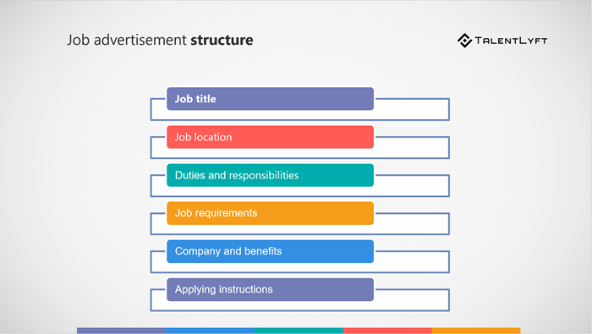
(Recruiting and Hiring Resources, n.d.). 10
Job Description
Job description is a composed explanation that portrays a job that may involve a separate group of organizational roles. The description includes: Obligations, duties, extent of work and working conditions.
Person Specification
The significance of a person’s specification is to comprehend the specific details of an occupation. My person specification gives me significant details of a job eg: Education, skills, work experience and any other abilities that may help me to get the job. This will enable me to achieve my goals, Job specification can be used for screening of resumes and shortlisting candidate who best fit the job (El-Hajji, M.A., 2011).
Interview
One of the important ways I have prepared for my interview is by gathering foundation data about the organization and the employment. Getting ready for the prospective employee meeting is significant for acquiring exact data about the activity just as separating myself from different applicants and for articulating my aptitudes and capabilities will fit the activity necessities (Caldwell & O’Reilly, 1985).

Being interviewed is a critical part of the procuring procedure. This is where I will have a face to face collaboration with my potential employer. The interviewer at this point knows about my achievement from my CV and cover letter, now this is an opportunity to show them my character and how I can deal with their working environment.
Preparation Steps Before my Interview on Performance
- To do research on the organization, the company’s recent achievements. (Lack of knowlegement on the company shows that I do not have much interest).
- Research on any values the company may have so I could align it with my values.
- Have well prepared answers according to my Job advert/Job specification.
- Prepared some questions for the interviewer (Van De Voort, D.M. and Whelan, T.J., 2012).
- Rehearse/Partner Interviewing, I practised with my partner so that I can get constructive feedback and then I could go through to find answers on how I could improve.

11
- Record stories that I could incorporate with my job specification, by making it personal it will draw the attention of the recruiter (Hansen, K., Oliphant, G.C., Oliphant, B.J. and Hansen, R.S., 2009).
Before my interview I was feeling very nervous and panicking just in case I could not answer a question, but once I entered the interview room all my nerves had disappeared and I was feeling very confident.

Results from My Interview
Score: 5 = Excellent 4 = Very Good 3 = Good/Average 2 = Poor 1 = Very Poor

12
Feedback from Interviewer 1:
- Ensure that I remain constant eye contact.
- Good demonstration of knowledge about the school
- Ensure that I relate my answers to my achievement mentioned in my CV.
- I answered questions in good depth.
With a Score of 77% They Might Have Hired Me for the Job.
Feedback from Interviewer 2:
- Audible and confidence.
- Demonstrated well by talking about my strengths.
- Avoid too much elaboration on questions
- Good by asking specific related questions.
With a Score of 86% They Are Considering Me for the Job.
I was quite shocked by the outcomes as I thought I would have achieved much better results, the feedback from both the interviewers were quite different from each other, but that was maybe because I managed to engage one of the interviewers in my conversation more than the other. I achieved the highest score in class but it is still crucial to take on board what the interviewers have said, I think the feedback is constructive and manageable.
I could have improved my interview, if I practised more on my nonverbal communication, I should have related my answers more to my achievements mentioned on my resume, and controlled on how much an interviewer needs to know (Sternberg, K.J., Lamb, M.E., Esplin, P.W., Orbach, Y. and Hershkowitz, I., 2002).
What I have learnt from the interview is:
- To be myself, recruiters are wise enough to make sense of whether I am fit for the job.
- Be confident, being confident attracts employers, for an organisation to believe in my capabilities I have to believe in myself.
- Distinguishing my shortcoming is a quality and having the patient and assurance to transform those shortcomings into my strengths.
- Getting feedback from interviews and taking it in a positive way and working on improving those areas, this could work in my favour for myself to arrive at my future goals.

13
- Show the person behind the resume, by showing my personality, the aptitudes and the hard working attitude is the way forward to winning the position.
- To use SMART model when explaining a situation that way I am not elaborating to much unnecessarily, smart is very specific and to the point its very measurable (Schildhouse, J., 2006).

The mock interviews will have a great impact on my career development because it allows me to get back constructive feedback on where I went wrong, this will increase my confidence and a higher chance for future employment (Yates, S.M., 2008).

14
Conclusion

The main objective of this report in part A, is about professional career development, identifying my short term and long term career goals. Defining self-awareness and why it is important and how Johari windows as a self-awareness tool has help me analyse and reflect on my feelings and thoughts and also how the world perceive me as.
In the next section I used aptitude test and 16 personality test to help research on my characteristics and figure out what job best suits my personality. The outcomes to the test were surprisingly good, the results described my personality so well to who I really am. These results will help guide me towards my path to become a teacher or work in social care.
In part B where the mock interviews took place, the incredible feedback I got back from the Interviewers helped me make changes in my CV and cover letter to improve my chances of successful interviews. I was really pleased with my scoring, especially when I found out that I scored the highest in the class this has given me the boost I needed to go out there and apply for jobs.

15
Reference

(Barrett, J., 2009). Career Aptitude and Selection Tests: Match Your IQ Personality and Abilities to Your Ideal Career. Kogan Page Publishers.
Barrett, J., 2009. Aptitude Personality and Motivation Tests: Analyse Your Talents and Personality and Plan Your Career. Kogan Page Publishers.
Beatty, R. (2004). The perfect cover letter (eBook, 2004) [WorldCat.org]. [online] Worldcat.org. Available at: https://www.worldcat.org/title/perfect-cover-letter/oclc/54750890 [Accessed 29 Jan. 2020].
Bennett, J.B., 1992. The Curriculum Vitae An Imperfect Mirror. College Teaching, 40(4), pp.155-156.
Bimrose, J., Barnes, S.A. and Hughes, D., 2008. Adult career progression and advancement: A five year study of the effectiveness of guidance. Coventry: Warwick Institute for Employment Research and the Department for Innovation, Universities and Skills.
Caldwell, D.F. and Burger, J.M., 1998. Personality characteristics of job applicants and
Carter, P.J., 2004. IQ and psychometric tests: Assess your personality, aptitude and intelligence. Kogan Page Publishers.
Cherry, K. (2019). Myers-Briggs Type Indicator: The 16 Personality Types. [online] Verywell Mind. Available at: https://www.verywellmind.com/the-myers-briggs-type-indicator-2795583 [Accessed 29 Jan. 2020].
Douglas, D.H. and Willis, D.G., 2005. Care for professional self. Role development in professional nursing practice, pp.129-133.
Doyle, A. (2019). Free Career Aptitude and Career Assessment Tests. [online] The Balance Careers. Available at: https://www.thebalancecareers.com/free-career-aptitude-tests-2059813 [Accessed 29 Jan. 2020].
El-Hajji, M.A., 2011. Some recent trends in writing job description for the purpose of job evaluation: A reflective view. American International Journal of Contemporary Research, 1(3), pp.6-14.
Frohock, R., 2004. Heroes of Empire: The British Imperial Protagonist in America, 1596-1764. University of Delaware Press.
16
Ganapathy, V. (2014). Myers Briggs Type Indicators: The Pros & Cons of the same. [online] Linkedin.com. Available at: https://www.linkedin.com/pulse/20141012165626-20365684-myers-briggs-type-indicators-the-pros-cons-of-the-same [Accessed 29 Jan. 2020].
Haer, S. (2015). Preparing for an Interview? Use the Job Description - Jobscan Blog. [online] Jobscan Blog. Available at: https://www.jobscan.co/blog/preparing-for-an-interview-use-the-job-description/ [Accessed 29 Jan. 2020].
Hansen, K., Oliphant, G.C., Oliphant, B.J. and Hansen, R.S., 2009. Best practices in preparing students for mock interviews. Business Communication Quarterly, 72(3), pp.318-327.
Harzallah, M., Leclère, M. and Trichet, F., 2002, July. CommOnCV: modelling the competencies underlying a curriculum vitae. In Proceedings of the 14th international conference on Software engineering and knowledge engineering (pp. 65-71).
Indeed.com. (2019). Career Development Theory: Definition and Examples | Indeed.com. [online] Available at: https://www.indeed.com/career-advice/career-development/career-development-theory [Accessed 23 Jan. 2020].
Legalsecretaryjournal.com. (2007). The Importance of a Good CV | DEDICATED. [online] Available at: https://www.legalsecretaryjournal.com/the_importance_of_a_good_cv [Accessed 29 Jan. 2020].
Luft, J. and Ingham, H., 1961. The johari window. Human relations training news, 5(1), pp.6-7.
MC KAY, D. (2019). What Is Career Development, and What Factors Influence Growth?. [online] The Balance Careers. Available at: https://www.thebalancecareers.com/what-is-career-development-525496 [Accessed 23 Jan. 2020].
McDonald, J.D., 2008. Measuring personality constructs: The advantages and disadvantages of self-reports, informant reports and behavioural assessments. Enquire, 1(1), pp.1-19.
Mjåtveit, S. (2018). Pilot Aptitude Test - What is it and why do you need one?. [online] Osmaviationacademy.com. Available at: https://www.osmaviationacademy.com/blog/pilot-aptitude-test-what-is-it-and-why-do-you-need-one [Accessed 29 Jan. 2020].

17

Morgan, P. (2016). The Business Student’s Guide to Study and Employability | SAGE Companion. [online] Study.sagepub.com. Available at: https://study.sagepub.com/morgan [Accessed 30 Jan. 2020].

Mulder, P. (2017). What is the Johari Window Model? Definition, example, template | toolshero. [online] toolshero. Available at: https://www.toolshero.com/communication-skills/johari-window-model/ [Accessed 23 Jan. 2020].
Newstrom, J.W. and Rubenfeld, S.A., 1983, March. The johari window: A reconceptualization. In Developments in Business Simulation and Experiential Learning: Proceedings of the Annual ABSEL conference (Vol. 10).
Nofriza, F., 2017. Development of training guide johari windows in improving student self-disclosure. SCHOULID: Indonesian Journal of School Counseling, 2(1), pp.41-47.
Parry, K. (2018). [online] Kensingtonparry.com. Available at: https://www.kensingtonparry.com/single-post/2018/03/29/9-Things-to-remember-when-writing-your-Cv [Accessed 29 Jan. 2020].
Recruiting and Hiring Resources. (n.d.). What is Job Advertisement ?. [online] Available at: https://www.talentlyft.com/en/resources/what-is-job-advertisement [Accessed 29 Jan. 2020].
Saxena, P. (2015). Johari Window: An effective model for improving interpersonal communication and managerial effectiveness. SIT Journal of Management, 5(2), pp.134-146.
Schildhouse, J., 2006. One on one: an interview with Lori Vegso. Journal of Supply Chain Management, 42(3), pp.2-4.
Self Awareness. (2013). Self Awareness. [online] Available at: https://www.selfawareness.org.uk/news/understanding-the-johari-window-model [Accessed 23 Jan. 2020].
Self Awareness. (2013). Self Awareness. [online] Available at: https://www.selfawareness.org.uk/news/understanding-the-johari-window-model [Accessed 23 Jan. 2020].
Sternberg, K.J., Lamb, M.E., Esplin, P.W., Orbach, Y. and Hershkowitz, I., 2002. Using a structure interview protocol to improve the quality of investigative interviews
18

Success in screening interviews. Personnel Psychology, 51(1), pp.119-136.
Van De Voort, D.M. and Whelan, T.J., 2012. Work analysis questionnaires and app interviews. The handbook of work analysis. Methods, systems, applications and science of work measurement in organizations, pp.41-80.

Walker, H.J., Feild, H.S., Giles, W.F. and Bernerth, J.B., 2008. The interactive effects of job advertisement characteristics and applicant experience on reactions to recruitment messages. Journal of Occupational and Organizational Psychology, 81(4), pp.619-638.
Yates, S.M., 2008. The Career Development of a Senior Woman Athletic Administrator.
Zhu, J. (2020). What is Self-Awareness and Why is it Important? [+5 Ways to Increase It]. [online] PositivePsychology.com. Available at: https://positivepsychology.com/self-awareness-matters-how-you-can-be-more-self-aware/ [Accessed 23 Jan. 2020].

19
Appendix

Career test result
Share this test:

In this test you had to choose between pictures showing specific work activities. Each picture depicted work associated with a specific type of personality. These types are derived from Dr. John Holland's theory of careers and vocational choice, known as Holland Codes.
There are six personality types in Holland's model:
- Realistic: practical, physical, concrete, hands-on, machine, and tool-oriented
- Investigative: analytical, intellectual, scientific, explorative, thinker
- Artistic: creative, original, independent, chaotic, inventive, media, graphics, and text
- Social: cooperative, supporting, helping, healing/nurturing, teaching
- Enterprising: competitive environments, leadership, persuading, status
- Conventional: detail-oriented, organizing, clerical

Personality types and Holland Codes
Dr. Holland did not say that a person is just one of these types. Then there would be only six types of people in the world. Instead, any one person can have interests associated with all of the six types. When you rank the types, starting with those you have the most interest in to those you have the least interest in, you get your specific Holland Code. There are some 720 different combinations possible, like ISERAC, AIRSEC, or CSERIA. Generally, however, only two or three letters are necessary to create a useful description, such as SC, IRC, or AIC. Such a description may apply to both a person and a work environment. By typifying both people and work environments with Holland Codes, we can calculate matches between them. This helps you assess a potential career or vocational choice.
20

Your personality type
You preferred 'Social' the most, followed by 'Conventional' and 'Investigative'. Your six letter personality type is 'SCIEAR'. Your personal preference is also shown in a graph below.
PIE CHARTFig. 1FAVORITE TYPES OF W
ORKGENDER: FEMALEAGE: 36YOUYOUSOCIAL23%CONVENTIONAL23%INVESTIGATIVE23%ENTERPRISING13%ARTISTIC8%REALISTIC8%

Your personal Holland Code
Depending on how strongly you favor any specific type you can compose your own personal Holland Code. You do this by taking the first letters of the types you favor most. In your case, this is the letters S, C and I Your personal Holland Code then becomes either SCI, SC, CS or even CSI.

Your jobs
Here is a list of jobs that fit your Holland code SCIEAR. The list is only part of all jobs that fit your personality. You should use this list of occupations as prototypical examples. A total of 20 occupations are suggested based on your score.

21

Your list of suggested occupations
Medical records clerk
77%
Medical records clerks organise, keep up-to-date and archive patients` records for medical staff availability. They transfer medical information from a patient’s paper records to an electronic template.
Education level: Vocational school or associate's degree required
Read more: Medical records clerk
Tutor
73%
Tutors provide personalised education to the children of employers or to adults, in addition to the main education system. They help students improve their knowledge and competence of a specific subject, at their own pace. Tutors will teach their students study techniques and strategies in order to ensure their academic development and will assess the student's progress throughout the tutoring sessions.
Education level: Bachelor's degree or higher usually required
Read more: Tutor
Nurse responsible for general care
71%
Nurses responsible for general care are in charge of promoting and restoring patients` health by providing physical and psychological support to patients, friends, and families. They also supervise assigned team members.
Education level: Bachelor's degree or higher usually required
Read more: Nurse responsible for general care
Occupational therapist
69%
Librarian
68%
Community health worker
68%
Archivist
68%
Archive manager
68%
Audiologist 22
66%
Health and safety officer
66%
Pharmacist
66%
Podiatry assistant
64%
Legal assistant
63%
Speech and language therapist
63%
Physiotherapist
62%
Corporate trainer
62%
E-learning architect
62%
E-learning developer
62%
Montessori school teacher
58%
Dental hygienist
58%

WORKGENDER: FEMALEAGE: 36YOUYOUSOCIAL23%CONVENTIONAL23%INVESTIGATIVE23%ENTERPRISING13%ARTISTIC8%REALISTIC8%

23

16 Personality Test

AnonymousProtagonist
What about you?
Take the test

TYPE: | Assertive Protagonist | ?
CODE: | ENFJ-A | ?
ROLE: | Diplomat | ?
STRATEGY: | People Mastery | ?

24
Personality Traits

Mind
89%
EXTRAVERTED
Energy
55%
INTUITIVE
Nature
61%
FEELING
Tactics
75%
JUDGING
Identity
51%
ASSERTIVE

ProtagonistPersonality
ENFJ-A / ENFJ-T
(WHAT’S THE DIFFERENCE?)

25
Introduction
Everything you do right now ripples outward and affects everyone. Your posture can shine your heart or transmit anxiety. Your breath can radiate love or muddy the room in depression. Your glance can awaken joy. Your words can inspire freedom. Your every act can open hearts and minds.
DAVID DEIDA
Protagonists are natural-born leaders, full of passion and charisma. Forming around two percent of the population, they are oftentimes our politicians, our coaches and our teachers, reaching out and inspiring others to achieve and to do good in the world. With a natural confidence that begets influence, Protagonists take a great deal of pride and joy in guiding others to work together to improve themselves and their community.

Firm Believers in the People
People are drawn to strong personalities, and Protagonists radiate authenticity, concern and altruism, unafraid to stand up and speak when they feel something needs to be said. They find it natural and easy to communicate with others, especially in person, and their Intuitive (N) trait helps people with the Protagonist personality type to reach every mind, be it through facts and logic or raw emotion. Protagonists easily see people’s motivations and seemingly disconnected events, and are able to bring these ideas together and communicate them as a common goal with an eloquence that is nothing short of mesmerizing.
The interest Protagonists have in others is genuine, almost to a fault – when they believe in someone, they can become too involved in the other person’s problems, place too much trust in them. Luckily, this trust tends to be a self-fulfilling prophecy, as Protagonists’ altruism and authenticity inspire those they care about to become better themselves. But if they aren’t careful, they can overextend their optimism, sometimes pushing others further than they’re ready or willing to go.

26
Protagonists are vulnerable to another snare as well: they have a tremendous capacity for reflecting on and analyzing their own feelings, but if they get too caught up in another person’s plight, they can develop a sort of emotional hypochondria, seeing other people’s problems in themselves, trying to fix something in themselves that isn’t wrong. If they get to a point where they are held back by limitations someone else is experiencing, it can hinder Protagonists’ ability to see past the dilemma and be of any help at all. When this happens, it’s important for Protagonists to pull back and use that self-reflection to distinguish between what they really feel, and what is a separate issue that needs to be looked at from another perspective.
...The Struggle Ought Not to Deter Us From the Support of a Cause We Believe to Be Just
Protagonists are genuine, caring people who talk the talk and walk the walk, and nothing makes them happier than leading the charge, uniting and motivating their team with infectious enthusiasm.
People with the Protagonist personality type are passionate altruists, sometimes even to a fault, and they are unlikely to be afraid to take the slings and arrows while standing up for the people and ideas they believe in. It is no wonder that many famous Protagonists are cultural or political icons – this personality type wants to lead the way to a brighter future, whether it’s by leading a nation to prosperity, or leading their little league softball team to a hard-fought victory.

Diplomats – Advocates, Mediators, Protagonists, and Campaigners – tend to be warm, caring, and generous individuals, shining in diplomacy and counselling. These personality types promote cooperation and harmony, tolerating discord only as a step towards positive change. Their perceptive abilities seemingly go deeper than the traditional senses – it’s as if they have a full set of tuning forks in their hearts that can resonate with people’s emotional states, and this empathetic sensitivity creates deep connections with others.
This is not as mystical as it can seem. Diplomat personalities deeply value understanding, and a lifetime of self-reflection grants them insights into others’ motivations that they might not even understand themselves. Diplomats can use this to shape the way others feel, but it would be out of character for them to use this for ill.

27
Diplomats’ people skills nurture friendship and healing with pure, genuine empathy. Causing distress feels to them like wounding their own psyche, so they prefer to gently nudge loved ones and strangers alike in a positive direction. Diplomats find the ideals of humanism rewarding: kindness, understanding, altruism, and growth warm them like a bonfire on a chilly autumn day. These personality types envision a prismatic, kind world.
The Intuitive trait plays a big part in this optimism, but it also makes Diplomats sensitive to injustices that would jeopardize that ideal world. They can be aggressive against forces they perceive as evil, and are capable of steely action when they feel they have moral high ground. Diplomats’ sensitive emotions may flare to outright combativeness if provoked; with self-righteous momentum and weighty ideals, these personality types can steamroll others. If they let inspiration trump rationality unchecked, they can sometimes go too far, damaging the very causes they hold dear, however justified the outrage.
Tempering this passion with cold practicality is a challenge for Diplomats. They are often reluctant to make and carry out tough decisions or plans lacking in empathy, and often struggle with carrying out a plan at all. They find greater satisfaction in abstract self-exploration and understanding the issues that affect those least able to defend themselves than mundane accomplishments and day-to-day tasks. Diplomats emphasize experience and understanding rather than calculable achievement.
People Masters are highly stress-resistant, maintaining confidence through life’s challenges, social pressures, and any questions of their capabilities. These personality types seek social contact and have solid communication skills, feeling at ease when relying on or directing other people. People Masters’ mantra is fearless engagement – to be is to do. This is not a group known for its timid opinions or idleness.
People Masters feel rewarded by stimulation and challenging experiences. They like travelling to see things, people, and places, where they can experience a richer understanding of the world around them. These personalities like sampling new foods, lifestyles, and cultures; even things they don’t end up liking can be entertaining excitement for them.
Sometimes, though, People Masters are too confident. Insulated against self-doubt and the need to prove themselves, they don’t always test, or even consider, their own limits or ambitions. They can slip into a pattern of endless fun and comfort-seeking, rolling their eyes at those who press themselves towards more intimidating goals.

28
Cover Letter and CV
Nour Jahan Begum
31 Weatheroak Road
Sparkhill
Birmingham
B11 4RE
Email Address: nourbegum@hotmail.com
18th November 2019
Goodway Road Nursery School
Goodway Road
Birmingham
B44 8RL
To whom it may concern,
I am writing to you in regards to the job advertisement, Teaching assistant level 2. I am currently studying Certificate in Higher Education of skills in a workplace level 4 at University of Wales Trinity Saint Davids. I am also studying Teaching Assistant Level 2 at Adult education centre that will be completed by 21st November 2019.
My placement for STL training is at English Martyrs School, where I have worked with special need children in key stage 1, I have helped teachers with planning and assessment and planned activities for children outdoors.
I am also currently working at English Martyrs School as a play leader and team leader for key stage 1 staff. I currently hold a dbs certificate and have been working with key stage 1 and 2 children for 7 years. I have also had safeguarding training, positive play training and have completed first aid training. I have 3 children of my own, and I love working with children.

I am a hardworking, positive and enthusiastic person with a keen interest in working with children, and have a passion to progress in this field. I would be grateful to be considered for an opportunity at your school.
Thank you for reading my letter, I look forward to hearing from you soon.
Yours faithfully,

Nour Jahan Begum
29

NOUR JAHAN BEGUM
31 WEATHEROAK ROAD, SPARKHILL, BIRMINGHAM, B11 4RE
nourbegum@hotmail.com/07852138547

Professional Summary
I am an enthusiastic, responsible, patient individual. Throughout my past and present experiences, I have gained excellent interpersonal and communication skills. I am a well-motivated professional with a proven track record of exceeding set targets. In addition to this, I am confident with working individually, as well as in groups. I have a passion for working with children.
KEY SKILLS
Communication skills
Good level of communication skills gained from past experiences in life and at work. As well as communicating with staff, customers, children and also suppliers, both over the phone and face to face basis. I have always maintained a friendly and approachable manner.
Teamwork
During the course of work, I have had the opportunity to work as part of a team as well as a team leader, on major projects with various roles. This involved setting deadlines that required planning, organisation as well as hard work and commitment. I have the confidence to lead, support and develop others as well as working efficiently using my own initiative.
Computing
I have a very good working knowledge of Word processing packages including Microsoft Word, Excel spreadsheets, PowerPoint as well as the internet. I always try to further develop my computing skills by keeping up to date with new packages and software.
PROFESSIONAL EXPERIENCES
English Martyrs Catholic School Dec 2012-Present
Play Leader/Lunchtime Supervisor
- Overseeing children in the playground or during wet play, and monitoring the safety and suitability of activities.
- Supervising pupils at mealtimes- encouraging children to eat healthily, helping infants to open packaging or cut up food, and providing some social and educational training, such as good table manners.
- Caring for the personal cleanliness of children.
- Maintaining order, cautioning children who misbehave and reporting unresolved problems to the duty teacher or head teacher.
- Making sure children who are ill or injured receive appropriate medical attention, and reporting any serious accidents.
30

Sandwell Metropolitan Borough Council 2001-2004
Departments Included: LEA {sen section}, housing rebates, social inclusion, elections, planning and development.
- create and revises systems and proceeding by analysing operating practices, record keeping systems, forms control, office layout, personal requirements, implementing changes.
- ensure operations of equipment by completing preventive maintenance requirements, calling for repairs, maintaining equipment inventories, evaluating new equipment and techniques.
- provide information by answering questions and requests promptly.
- Complete operational requirements by scheduling and assigning administrative projects, expediting work results. Contributing to team effort by accomplishing related results as needed.

Education
Adult Education Centre
Teaching Assistant Level 2 Present

University of Wales Trinity St Davids
Certificate of Higher Education of Skills in a Workplace Level 4 Present
Training Present
English Martyrs Catholic School
At my work placement my responsibilities are to supervise and provide particular support for pupils, including those with special needs, ensuring their safety and access to learning activities, promote self-esteem and independence, establish constructive relationships with pupils and interact with them, promote good behaviour, storytelling, administer routine tests and undertake routine marking of pupil’s work.
Holly Lodge High School 1995-2000
G.C.S.E- 6 A/C’s including child care
Hobbies and Interest
I enjoy organising events and activities, I have organised many team outings and social events during my past employment history. During my leisure time I enjoy spending time with my children and family, as well as going swimming, bowling and taking my children and other family friends to activity centres. I also regularly attend the gym in order to stay active and healthy.
Reference Available Upon Requests
31

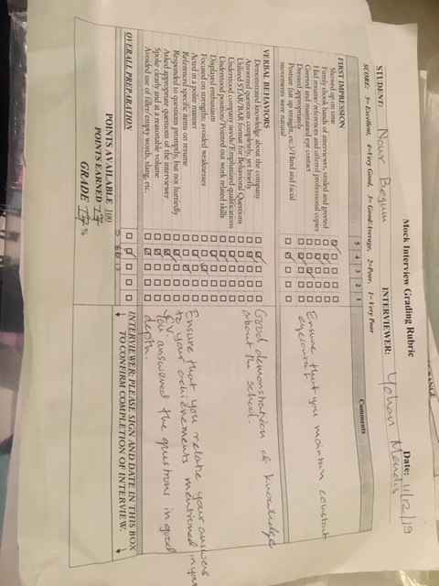

32
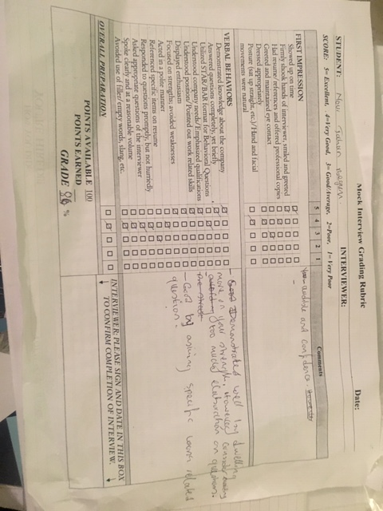

33

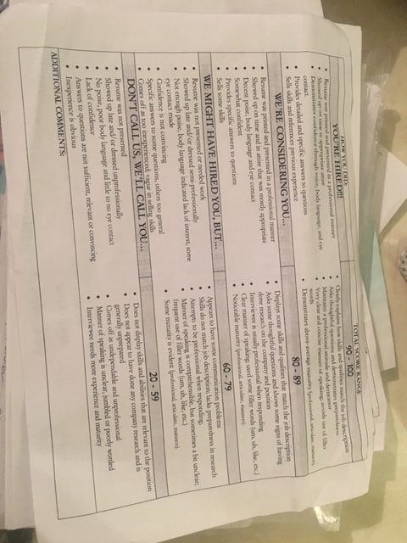

34

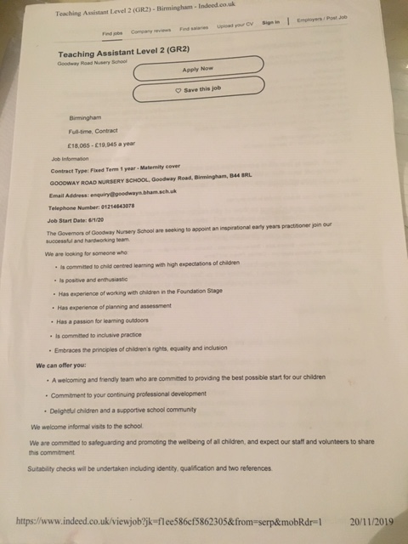

35

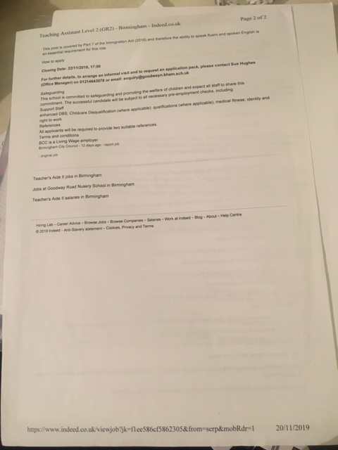

36

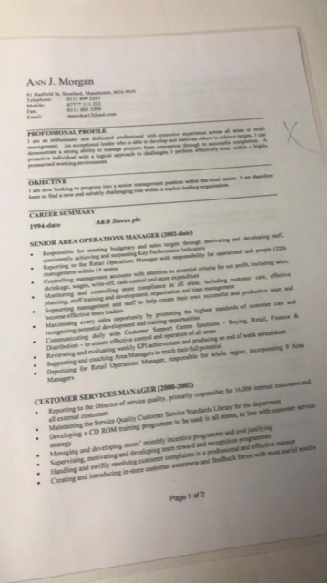

37

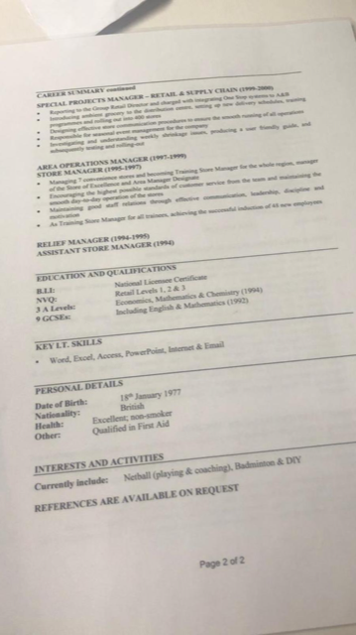
38

