Design and Evaluation of Wireless Sensor Networks

Student Name: Lloyd Johnson
Student No. 1802820
Module: Wireless Networks and Simulation ACCB5004
Lecturer: Dr Carlene Campbell

Contents
Introduction 3
Modulation 3
Simulation 3
QPSK 4
Advantages and Disadvantages 4
Implementations 4
Pros and Cons of Simulation 5
Wireless Networks and Communication Systems 5
LoRA 5
WLAN, ZigBee and WI-FI 5
Satellite Communication Systems 6
Cellular Communication Systems 6
Internet of Things and Smart City 6
Security and Imaging Technology 6
Farm Design 6
Conclusion 8

Introduction
The first part of this report will be including research into the modulation scheme QPSK. The research will include the function of the scheme. The advantages and disadvantages of using the scheme in different communication systems. The fundamentals of how the scheme works in communications system then examples of communications systems that use QPSK will be listed. In addition, the research will document will outline the benefits and drawbacks of using simulation versus using other methods.
The next part of this report will include research into these nest following topics, wireless communications systems such as long and short range, low power systems this includes WLAN, WI-FI and LoRa. Research into satellite and cellular systems will be discussed. Internet of Things and Smart city ideas will be outlined and analysed in this section along with how security image can be used to benefit high risk areas by identifying concealed weapons on personnel.
The final section of this report will include a design of a wireless monitoring system for a farm in the Caribbean Islands. The design will have to include features that are specified in the brief such as using sensors to alert local police, the features that are included in the design must be justified as stick within the limits of the brief.

Modulation
Modulation is used in communication to create a signal for a transmission channel. Modulation converts digital data into radio waves that can be carried using antennas and radio towers. There are many types of modulation. Frequency modulation(FM), a FM carrier wave is reflected by changes in the frequency of the data. Phase modulation(PM) works by modulating the signal to change the phase. This is done by changing the frequency of the signal briefly, this changes the phase of the data across the wave briefly meaning FM And PM are very similar. [1]When phase modulation is used for digital modulation it is known as Phase Shift Keying, some examples of PSK are Binary Phase Shift Keying, Quadrature Phase Shift Keying and Offset Phase Shift Keying. Amplitude modulation (AM) is when the carrier wave is shaped according to the data that is sent. Quadrature amplitude modulation (QAM) two AM signals are used this allows the carrier wave to use two bits rather than one bit every transmission. [2]

Simulation
Simulations are used at the start of creating communications systems in the real world. This is done before any other planning of the system is in place. Simulations allow a network designer to run tests on digital prototype systems, in these tests the designer can research how the communication system will perform in different conditions. These conditions will include channel characteristics such as noise, pathloss, shadowing and fading. These tests also can check the communication systems for the effectiveness of the hardware. It is important to simulate these characteristics as it is cheaper and more cost-effective then creating the system then testing for noise or pathloss in the system, in addition there is no consequences for errors in the system. Simulation models are used to complete these tests, two different types of models could be used. A Physical model is created smaller to show larger systems or created bigger to outline much smaller systems. Mathematical systems use formulas to show the how the system functions.

QPSK
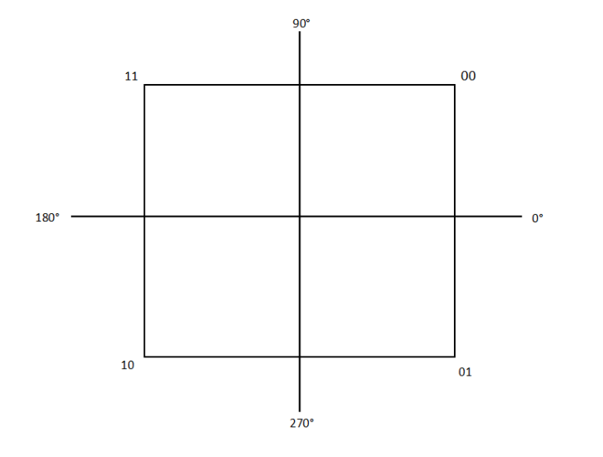
Quadrature Phase Shift Keying also known as QPSK is a digital modulation scheme that uses four states, it uses phase modulation to determine the carrier wave [3].This form of modulation is similar to 4PSK however, QPSK transmits two bits per state instead of one bit like 4PSK, the symbols QPSK represents is 00, 01, 10, 11 because of the ability to transmit two bits per symbol it increases the data rate carried across the signal bandwidth [4]. QSK is used more in communication systems where high transmission rate and bit transfer speeds are required examples of these will be discussed later. These symbols represent phases and each phase has an angle at which it travels along the signal. The diagram below shows the angles for each phase.

Advantages and Disadvantages
Depending on where QPSK is implemented into a communication system there will be advantages and disadvantages to using this type of modulation. The first advantage to using a QPSK based system is as mentioned above it can transmit two bits per symbol making it twice as efficient as systems that only transmit one bit such as BPSK. Thus, making the bandwidth more efficient so engineers using QPSK will not need to purchase more bandwidth for the system. In addition, transmitting two bits rather than one, it will increase the transmission rate within the communication system [5]. Another advantage is QPSK provides the carrier signal with noise immunity, reducing the interference in the signal makes it easier to obtain all the data in the signal [6]. The next advantage of QPSK is because it is phase modulation which is digital this allows the noise or interference within a signal can be removed from the original carrier wave. Another advantage to using QPSK rather than other modulation such as BPSK is it has a higher spectrum efficiency because of the two-bit transmission. [7]
One disadvantage of using QPSK is it has poor power efficiency as the modulation transmits two bits per symbol it uses more power to transmit these signals, other methods of modulation such as BPSK. Another disadvantage for QPSK is it is much more complicated to use within a communication system because of the circuit complexity. [6] The next disadvantaged to using QPSK rather than other forms of modulation is even though it has good noise immunity it hasn’t got the best noise immunity for the carrier wave, A QAM signal has much better noise resistance.

Implementations
QPSK is the mainstream way of modulation used. QPSK is used in wireless communication this is because of the high bandwidth which allows more users to communicate and the low error rate makes it reliable enough to use in this system. QPSK is used in mobile communications, a low error rate is important for this as users do not want to lose connection briefly as this will cause the signal to stutter. Another area where QPSK is used is in satellite communications, satellites need to transfer lots of data so QPSKs high transmission rate is suitable for this communication system. [8]

Pros and Cons of Simulation
One of the first advantages to using simulation as a method of testing rather than mathematical is properties can be quickly changed and altered to then analyse what property would be best for the wireless system, with mathematical tests full equations and calculation will have to be redone rather than using computer simulation software which allows quick changes. This leads to the next advantage, if a person is creating all the equations and calculations for a proposed wireless system then the finished equations are prone to human error which could have an effect on the final system functioning properly, using a computer programmed system such as NetSim and Packet Tracer will eliminate any mistakes found in personally doing equations. Another benefit of using simulators rather than other methods is the simulation can be repeated to test the systems reliability, it can be harder to do this using mathematical testing as the same output will be produced when repeating the testing.
One disadvantage of using simulations rather than using methods such as test-bed experiments and mathematical testing is, simulation usually does not include important factors such as signal propagation or need it needs to be specified when carrying out the testing , signal propagation can greatly affect the strength and distance of a signal wave. Another drawback of using a simulation system is many of the simulation applications available for use do not have up-to-date technology to use in testing. With Mathematical experimenting new technologies can be tested almost immediately as they are created, whereas the new technology must be programmed into the simulation program leaving it impossible to use simulation to quickly test and deliver new wireless system that include new technology . [9]

Wireless Networks and Communication Systems

LoRA
LoRa is a low powered wide area network, this style of communication system is used in Natural Disaster Detection [10], Smart Fire Alarms and Fire detection and finally it is used in many Internet of Things networks in countries like Argentina and Brazil. [11] LoRa uses the unlicensed spectrum in order to communicate through long distances it also helps devices connect to the cloud. An advantage of using LoRa is that it uses the frequencies 868 and 915 MHZ ISM bands these frequencies are free to use worldwide for any organisation. Also as mentioned before it has a low power consumption and a very far travel distance [12]. A disadvantage of using LoRa however is it is not a best suit for real-time systems as it is prone to a have poor latency when used in this system.

WLAN, ZigBee and WI-FI
All these systems are examples of short range, low power connections WLAN is a wireless local area network this can be created either using ZigBee or WI-FI, these two systems both use the 2.4GHz band so usually one is picked to be used in a WLAN. They can be used together however must be configured to not interfere with each other. An advantage of using this type of system is it has a low start-up cost it also allows for a flexible network structure. [13] A disadvantage of using WLAN is the short travel distance of the signal which if used within a business can slow expanding.

Satellite Communication Systems
Satellite communication systems use outer space transponders called satellites that send signals to the earth from the satellite outer space location. The satellites have antenna that can receive the signals from earth then use the transponders to redirect the signal to the receiver. [14] An advantage of satellite systems is that they can cover massive amounts of land as long as the sender and receiver have clear vision to space. A disadvantage to satellite communication is that it can be greatly affected by the weather and its surroundings such as building or mountains. [15]

Cellular Communication Systems
This type of communication refers to the use of mobile phones. Mobile Phones are bi-directional radios that allow sending and receiving signals. This system divides and area into cells that allow phones to use a specific frequency to communicate to one another. An advantage of this is the ability for many users to transmit and receive at the same time because of the frequency division. A disadvantage to cellular systems is the costly new mobile phones that are used to use this type of communication.

Internet of Things and Smart City
Using IOT can help to cut traffic, pollution, and crime rate within cities. Recently IoT has been used in the coronavirus pandemic to track coronavirus patients using face recognition to trace their movements to develop an understanding on who may have been infected by the virus.

Security and Imaging Technology
This technology will help to detect concealed weapons on people in public spaces. This is important technology for public areas such as airports, government buildings and for public events. Using this technology can lower the amount of armed crime in these areas by deterring potential suspects from carrying out crimes or locating suspects before the crime has been committed. This type of technology is expensive to be implemented into these areas and are not 100% accurate in locating potential suspects. [16]

Farm Design
Below is a design for the Caribbean Island Farm that has asked to install new security features to prevent the farms crops and livestock being stolen. The farms are targeted during the harvesting season meaning include any extra security features during this time.
The circles included on the diagram are motion sensors and have a larger range than the circle areas show. The cone shows the viewpoint of the cameras but also when installed the cameras may have a wider viewpoint then the diagram displays.
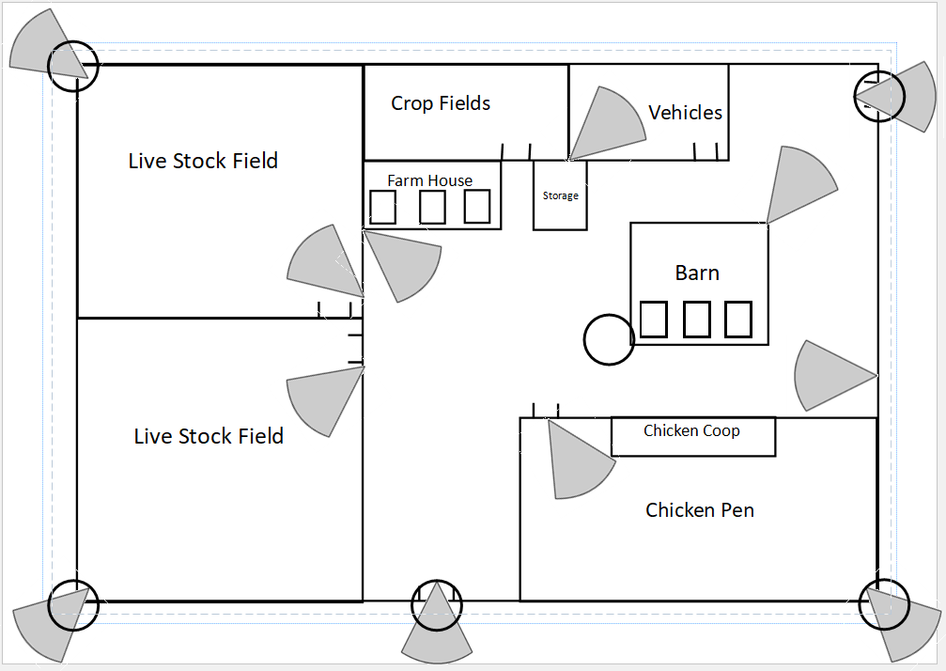

One security feature that is not installed on the system is a security guard will be hired during the harvesting season as the farmer will have an increased income to afford a guard to patrol the farm and its perimeter.
The Farm is a 300m by 300m this is an assumption made on the design. All buildings and sections included on the diagram have been assumed to be in the farm property.
Surrounding the perimeter will be a 3m tall fence this is to stop potential thieves from entering the farm compound in areas where there is low level security such as the crop and livestock fields. There are cameras included on all entrances, these cameras will constantly be on to record any personnel entering and exiting the farm. Included just inside the farm fence near the entrances will be motion sensors if these are activated outside of the working hours of the farm then the local police will be alerted to travel to the farm and access the situation. Included on the entrances to the farm security and imaging technology will be installed to alert local authorities if anyone enters the farm during and out of hours. This is important as any threats of robbery with weapons will be stopped.
On the Farm fence corners cameras connecting to motion sensors will be installed to only start recording when the motion sensor has been activated. This will be the case as to save power on the rest of the system plus outside of the farm is not the main concern for the farmer, but it may help to deter potential thieves.
Within the farm compound all the cameras will continuously be recording this because inside is the main threat area. During the harvesting season a guard will constantly monitor this area from the local police station to assess potential threats to the farm. The cameras cover all the yard areas including the buildings and the livestock fields and pens. During the farm season the cameras will still be recording to deter potential thieves however will not be monitored.
Solar Panels will be installed on the Barn and Farmhouse roofs to help to power the security devices on the farm, however the devices will still be connected to the farm generator as in the winter the solar panels may not generate enough power for all the devices. Any excess power generated will be used in the normal electricity grid on the farm or sold to the local electricity board for money.
The security devices will be connected by a WLAN network, the wireless devices will cost more however cabling does not have to be installed around the farm. The control system for the devices will be included in the Farmhouse the devices surrounding the close area of the farmhouse will connect straight to the farmhouse. For the devices on the perimeter and chicken pen wireless signal boosters will be installed to connect these devices to the farmhouse. The camera feed in the farmhouse and the local police station will have to be secured by passwords and firewalls to stop potential thieves gaining access to the camera feed.

Conclusion
Concluding the research into QPSK modulation scheme it is a very efficient modulation scheme compared to BPSK as it can transmit two bits per symbol compared to a single bit. Therefore, it will be a scheme that should be used to transmit data quickly such as in real-time systems.
Concluding the research into wireless communication systems different systems have advantages and disadvantages to each and have scenarios where they are best used. Internet of Things and Smart City is most likely the way forward in running cities using connected devices to manage traffic and crime. Security and Imaging technology should be included as an extra security feature in public areas to decrease the crime rate in those areas.
Concluding the Security Farm design using cameras and motion sensors to help deter and alert local authorities will help to lower the amount of thefts the farm will experience. Changing the security levels during peak times will help to save the farm money and lower crimes in these peak times.

Bibliography

[1] | “modulation,” https://searchnetworking.techtarget.com/, October 2018. [Online]. Available: https://searchnetworking.techtarget.com/definition/modulation. [Accessed 1 April 2020].
[2] | L. Teschler, “QPSK modulation and generating signals,” TestandMeasurmentTips.com, 4 April 2017. [Online]. Available: https://www.testandmeasurementtips.com/basics-qpsk-modulation-display-qpsk-signals/. [Accessed 2 April 2020].
[3] | Mathuranathan, “QPSK modulation and Demodulation,” https://www.gaussianwaves.com/, 20 January 2020. [Online]. Available: https://www.gaussianwaves.com/2010/10/qpsk-modulation-and-demodulation-2/. [Accessed 2 April 2020].
[4] | R. Keim, “Understanding Quadrature Phase Shift Keying (QPSK) Modulation,” allaboutcircuits.com, 17 August 2016. [Online]. Available: https://www.allaboutcircuits.com/technical-articles/quadrature-phase-shift-keying-qpsk-modulation/. [Accessed 1 April 2020].
[5] | “Quadrature Phase Shift Keying : Waveform and Its Advantages,” elprocus.com, 2018. [Online]. Available: https://www.elprocus.com/quadrature-phase-shift-keying-definition-with-circuit-diagram/. [Accessed 3 April 2020].
[6] | “Advantages and disadvantages of QPSK,” https://www.ecstuff4u.com/, 2018. [Online]. Available: https://www.ecstuff4u.com/2019/02/advantages-and-disadvantages-of-qpsk.html. [Accessed 4 April 2020].
[7] | Y. Li, M. Li, Y. Poo, J. Ding, M. Tang and Y. Lu, “Performance analysis of OOK, BPSK, QPSK modulation schemes in uplink of ground-to-satellite laser communication system under atmospheric fluctuation,” OPtics Communications, vol. 317, no. 1, pp. 57-63, 2014.
[8] | N. Birla, N. Gautam, J. Patel and P. Balaji, “A novel QPSK Modulator,” 2014 IEEE International Conference on Advanced Communications, Control and Computing Technologies, pp. 653-656, 2014.
[9] | G. Nychis and G. Sardesai, “Network Simulators, Emulators and Test Beds,” [Online]. Available: http://www.cs.cmu.edu/~srini/15-849/S06/lectures/05-tools-student.pdf. [Accessed 1 May 2020].
[10] | V. Mohan, “IoT is revolutionizing natural disaster prediction,” TechTarget, 6 February 2018. [Online]. Available: https://internetofthingsagenda.techtarget.com/blog/IoT-Agenda/IoT-is-revolutionizing-natural-disaster-prediction. [Accessed 2 May 2020].
[11] | “Kerlink and YEAP! to Collaborate on the Rollout of First LoRaWAN IoT Network in Argentina,” IoT Buiness News, 5 September 2017. [Online]. Available: https://iotbusinessnews.com/2017/09/05/47979-kerlink-yeap-collaborate-rollout-first-lorawan-iot-network-argentina/. [Accessed 1 May 2020].
[12] | N. Medi, “LORA TECHNOLOGY, ITS ADVANTAGES OVER OTHER NETWORKING PROTOCOLS,” Mechanical, Electrical, Electronics Engineers, 18 December 2019. [Online]. Available: https://www.meee-services.com/lora-technology-its-advantages-over-other-networking-protocols/. [Accessed 2 May 2020].
[13] | R. Singh, P. Singh and K. Yadav, “Experiment Findings,” 1 August 2014. [Online]. Available: https://www.researchgate.net/publication/304805032_Wireless_Communications_Enlargement_A_Review_of_Advancement_in_Technologies/citation/download. [Accessed 2 May 2020].
[14] | V. Labrador, “How Satellites Work,” Britannica, [Online]. Available: https://www.britannica.com/technology/satellite-communication/Satellite-applications#. [Accessed 2 May 2020].
[15] | M. Marius, “SATELLITE COMMUNICATION: PROS AND CONS,” ICT Pulse, 28 September 2016. [Online]. Available: https://www.ict-pulse.com/2016/09/satellite-communication-pros-cons/#. [Accessed 2 May 2020].
[16] | H.-m. Chen, R. Rao, S. Lee and A. Slamani, Imaging for concealed weapon detection - A tutorial overview of development in imaging sensors and processing, vol. 22, no. 2, pp. 52-61, 2005.

