

Strategic Management (LCMB7003)

Report on Strategic Analysis of Delicious



Student name: Sathwik Ramadugu
Student Number: 2223934
Lecturer: Jayalakshmi Gopal Krishnan & Gladius Kulothungan
Word count: 5000
Submission Date: 19th December 2023

Table of Contents
Introduction 2
Delicious Background 2
Delicious Mission and Objectives 3
Macro-Environment Analysis 4
PESTEL Analysis 5
Micro-Environment Analysis 6
Industry Life Cycle 6
Porter’s Industry Five Forces Analysis 7
Internal Analysis 9
Strategic Resources and Capabilities 9
Value Chain Analysis 11
Primary Activities 11
Secondary Activities 12
VRIO Analysis of Distinctive Resources and Capabilities 13
SWOT Analysis 15
Strategies to Sustain Competitive Advantage 16
Growth Strategies 18
Green Strategy and CSR 20
Conclusion 21
Recommendation 22
References 23

Introduction
The report outlines a strategic plan for Delicious, a small fast-food restaurant in London aiming to grow its business across the United Kingdom. The objective is to develop an effective expansion strategy that leverages Delicious' strengths and competitive advantages (Hitt & Ireland, 2009). A vision, mission and goals will first be defined to provide strategic direction for Delicious. Subsequently, utilising key strategic management concepts and theories, a systematic analysis of the restaurant's external and internal environments will be conducted. The external analysis will assess the broad macroeconomic, political, social, technological and industry forces that may impact Delicious' strategy using a PESTEL framework. It will also examine the competitive landscape of the UK fast food market through Porter's Five Forces model. Internally, Delicious’ strategic capabilities and resources will be appraised alongside an evaluation of its value chain. By synthesising the findings from these external and internal analyses, the critical strengths, weaknesses, opportunities, and threats confronting the restaurant will be identified via a SWOT analysis. This will inform the formulation of strategies to sustain Delicious’ competitive edge along with approaches to support its UK growth ambitions (Hitt & Ireland, 2009). Implementation and monitoring mechanisms will also be recommended to help successfully execute the expansion strategy. The plan leverages relevant strategic planning models and concepts covered in this module with the goal of charting a path for Delicious to profitably extend its foothold in the competitive UK fast food industry. The focus is on crafting strategies that utilise the restaurant's strengths to develop sustainable competitive advantages.

Delicious Background
In today's highly dynamic business environment, strategic management plays a crucial role in developing effective strategies suited to the situation (Hitt & Ireland, 2009). The fast-food industry is extremely competitive with many uncertainties and challenges. Devising an expansion strategy for Delicious - a small-scale fast-food restaurant based in London. Delicious aims to leverage strategic management concepts to support its growth plans within the UK. The restaurant serves burgers, sandwiches, fries, and beverages and has developed a reputation for quality, customized fast food over its operations. While Delicious has slowly grown its customer base, revenue growth has stagnated recently due to market saturation. As such, the owners wish to expand across the UK. Funding for growth will come from a small business loan and investors. The objective is to craft a suitable competitive strategy that establishes a sustainable competitive advantage for Delicious as it scales up national operations. This strategic plan will analyse external market and internal capabilities, formulate an expansion strategy, provide implementation guidance, and outline performance monitoring mechanisms - ultimately charting a path for profitable growth. The focus is on leveraging Delicious' strengths to expand within the turbulent UK fast food industry.

Delicious Mission and Objectives

Mission
Delicious is on a mission to build meaningful connections that nourish relationships. We strive to create warmer, kinder communities by serving fresh, wholesome meals prepared with love. Our food philosophy focuses on seasonal ingredients from ethical suppliers to support local economies. We believe that hospitality starts from within, by cultivating motivated teams that treat customers like their own. Our promise is to forge lifelong bonds over the shared joy of food, one tasty meal at a time. The expanded vision statement adds details on the attributes of food quality, nutrition, sustainability, diversity and memories that the brand aspires to be known for. The mission statement dives deeper into the underlying philosophy around food sourcing, team culture and promising hospitality through a people-centric approach. Let me know if you need any other changes.
Objectives
Growth Objectives: Delicious aims to expand from 1 to 5 company-owned restaurants over the next 3 years by 2026. The target cities for new outlets include Manchester, Birmingham, and Leeds. By increasing customer access across geographies, the goal is to achieve £5 million in annual sales revenue through organic growth efforts by 2025. Additionally, Delicious plans to build a loyal customer base of 50,000 members by 2025 through personalized promotions and its membership program.
Product Objectives: On the product side, the focus will be on curating menus that offer a balance of both popular as well as innovative food offerings to cater to evolving customer preferences. As part of its commitment to serve fresh and sustainable food, Delicious plans on sourcing at least 60% ingredients locally through partnerships with community suppliers. It also aims to maintain its existing 4-star food safety rating through stringent quality control practices across its growing outlet network.
Customer Objectives: By providing superior, customized dining experiences, delicious looks to attain a net promoter score of 60 by 2025. It also aims to actively engage with customers via multiple feedback channels and customize up to 15 ingredient options in its burger, sandwich and salad offerings based on local tastes and preferences.
Financial Objectives: Financially, Delicious will aim to optimize its cost structure to target a 15-18% operating profit margin by 2024 despite expansion costs. The company has set an ROI target of 20% for its growth investments into new outlets and technologies. It will also raise additional funding from angel investors to fuel the intended pan-UK growth.

Macro-Environment Analysis
The macro-environment consists of broad conditions and forces that generally impact many organizations across sectors (Whittington, et al., 2020). An analysis of the external macro-environment is crucial to understand opportunities and threats which can strategically impact Delicious' expansion plans. This analysis will focus on key factors under the PESTEL framework encompassing political, economic, socio-cultural, technological, environmental, and legal dimensions. Each component under PESTEL exert external influences that Delicious would need to evaluate and respond to as part of its strategy formulation. By analysing relevant macro-environmental factors using the PESTEL model, Delicious can identify favourable opportunities like government incentives as well as potential threats such as restrictive F&B regulations. The strategic insight derived would enable Delicious to design a robust expansion strategy supported through required adaptations to its operations, marketing, and locational needs within the UK.
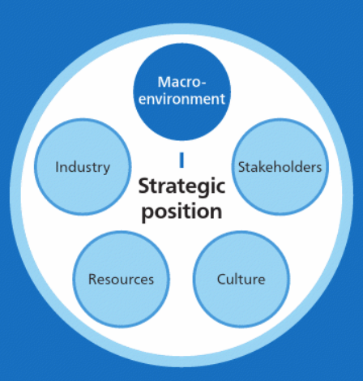
Figure 1: Macro-Environment Analysis (Whittington, et al., 2020)

PESTEL Analysis
A PESTLE analysis involves systematically identifying and assessing the external influences in an organization's operating environment that are relevant from a strategic perspective. By gaining a comprehensive picture of the key external drivers, an organization can leverage favourable opportunities as well as plan mitigation measures for significant threats through its strategic decisions (Whittington, et al., 2020).
Political Factors: The UK government has implemented favourable policies for the food and beverage (F&B) industry such as tax reliefs and incentives for new businesses (Whittington et al., 2019). This presents an opportunity for Delicious to obtain financial support as it looks to expand. However, stringent food standards and safety regulations need to be adhered to, requiring investments into quality control systems. Policies around ecological sustainability and local sourcing also need to be considered for ingredient supply chains (Wondershare EdrawMax, 2023).
Economic Factors: Rising inflation and cost of living in the UK could negatively impact discretionary spending on dining out (Whittington et al., 2019). Delicious needs to closely analyse demographic trends and optimize its pricing model to ensure affordability amidst the uncertain economic climate. However, the steady rise of the fast casual dining segment signals an appetite for affordable quality food that Delicious could leverage during its expansion by emphasizing value propositions.
Sociocultural Factors: Increasing health consciousness and preference for fresh, nutritious meals in UK presents an opportunity for Delicious to differentiate itself on food quality (Whittington et al., 2019). Additionally, high consciousness around sustainability and local sourcing means Delicious needs to highlight its use of seasonal, locally ingredients. Vegetarianism and veganism trends also indicate a requirement to diversify menu choices to cater to changing preferences.
Technological Factors: Digital platforms and online food delivery services are key channels that need focus, considering rising digital lifestyles (Whittington et al., 2019). Investment into digital capabilities for taking customer orders and managing loyalty programs would be vital. Emerging technologies around supply chain such as inventory management systems could also aid Delicious enhance quality, sustainability, and cost efficiency.
Environmental Factors: Stricter regulations around ecological sustainability require Delicious to ensure responsible sourcing, sustainable ingredient supply chains and food waste reduction through portion control and inventory management technologies (Whittington et al., 2019). Commitments to environmental standards could also be promoted to customers as a differentiation.
Legal Factors: Compliance with employment, food hygiene and safety laws is mandatory for Delicious, requiring investments into health checks, quality control systems and training programs (Whittington et al., 2019). Additionally robust customer data privacy measures would need implementation with digital systems to ensure compliance with UK data protection regulations.

Micro-Environment Analysis
The micro-environment includes stakeholders and forces close to a business which directly impact its ability to serve customers and operate effectively. Assessing the key actors and dynamics in the competitive space around Delicious is crucial when expanding nationally (Learn Marketing, 2020).

Industry Life Cycle
The concept of industry lifecycle (ILC) demonstrates that market conditions evolve systematically over time for a given industry, requiring strategists to track patterns for informed decisions (Johnson, 2017). Evaluating ILC also enables identification of growth opportunities or potential threats depending on the stage.
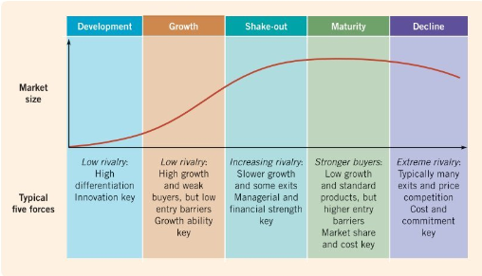
Figure 2: Industry Lifecycle (Johnson, 2017)
Development Stage: The UK fast casual dining industry in the development stage with competing chains, niche consumer segments and highly differentiated offerings as players experimented with the model of quality affordable meals (Johnson, 2017). Delicious has already seen growth beyond start-up by validating fast casual dining's potential.
Growth Stages: Delicious operates in is currently in a high growth stage, evidenced by rising consumer demand for affordable quality meals supporting increasing competition amongst existing and new entrants aiming for market share growth through physical and digital channel expansion (Johnson, 2017). First mover advantage for outlets in potential cities and differentiated offerings would enable Delicious to establish itself before saturation and to increase market share through innovation (Abdul, 2022).
Shakeout Stage: The industry is expected to eventually enter the shakeout phase as market gets saturated with more players leading to eroding margins, requiring competitive differentiation to standout while high operating costs force weaker players to exit (Johnson, 2017). Delicious would need accelerated growth during present growth stage to build scale, optimize supply chains and develop loyalty to gain competitive advantage for outperforming rival chains entering shakeout.
Maturity Stage: At maturity increased barriers to expansion are expected through market stabilisation from established national chains controlling distribution channels and consumers through higher brand loyalty (Johnson, 2017). By optimizing product experience, service operations and marketing ecosystem in current growth stage, at maturity Delicious can be positioned to leverage market opportunities through new innovative offerings retained consumers provide.
Decline Stage: Eventual commoditization triggering the decline stage seems less likely unless disrupted radically by change in consumer preferences, technologies, or regulations. Managing costs, differentiating strongly via unique food experiences, and pivoting strategically during growth and maturity would enable delicious counter decline forces by sustaining loyal niche (Johnson, 2017).

Porter’s Industry Five Forces Analysis
Porter's Five Forces framework analysis the competitive landscape shaping profitability for players within an industry based on five key forces (Porter, 1989). Evaluating the external ecosystem is crucial for Delicious to make informed strategic decisions as a fast casual dining chain expanding across the UK.

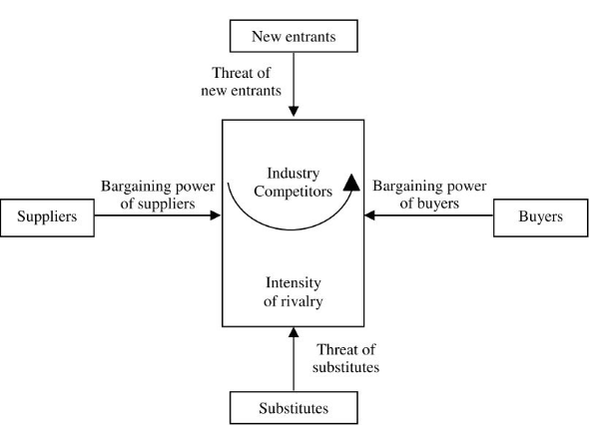

Figure 3: Porter’s Five Forces analysis (Morden, 2016)
Competitive Rivalry: The UK fast casual segment has highly competitive rivalry fuelled by increasing saturation from rapidly expanding national chains attempting to tap changing consumer preferences for quality affordable dining (Valentin, 2015). With low product differentiation, delicious needs first mover advantage in target cities to establish footprint before competition intensifies triggering price wars that erode margins (Abdul, 2022).
Supplier Power: Input suppliers like local food producers have moderate bargaining power to influence procurement terms for ingredients like fresh produce based on partnerships built through volumes and sustainability commitments (Valentin, 2015). Building trusted relationships with community suppliers through multi-year contracts can offset risks of input cost inflation for Delicious.
Buyer Power: Consumers have rising options for quality meal replacements from expanding chains and delivery apps, heightening buyer power amidst low switching costs (Valentin, 2015). Delicious can counter through customer loyalty programs, personalized online ordering and emphasizing unique value on custom, nutritious offerings.
Threat of Substitutes: While the threat of food delivery apps is increasing, dine-in chains still have strong differentiation potential on overall experience comprising ambience and personalized hospitality (Abdul, 2022). By focusing on total customer engagement, Delicious can mitigate substitution risks.
Threat of New Entrants: The UK fast casual space has moderate barriers to expansion with rising real estate, food and labour costs offset by government incentives, keeping new entrant threats moderate (Abdul, 2022). Delicious would need accelerated time-to-market and locational advantages in target cities to offset risks before low-differentiation chains saturate those markets (Valentin, 2015).
Managing competitive forces would require a smart expansion strategy for Delicious leveraging internal capabilities like flexible custom offerings, ethical sourcing and loyalty ecosystem against market-based risks.

Internal Analysis
A crucial aspect of internal analysis is assessing the strategic resources and capabilities which are the building blocks that enable an organization to achieve competitive advantages (Barney & Hesterly, 2019). Resources refer to financial, physical, human, and organizational assets controlled by a firm, while capabilities relate to the capacity to leverage resources through organizational skills and processes. By identifying its strategic resources and capabilities, Delicious can determine strengths that can be leveraged for its expansion strategy (Lynch, 2018). This section evaluates Delicious’ key resources comprising its physical, human, and organizational assets alongside capabilities like custom food preparation, supply chain relationships and customer engagement processes.

Strategic Resources and Capabilities
Key Resources
Financial Resources:
- Moderate capital from founding entrepreneurs to fund opening 1-2 new outlets (Abdul, 2022).
- Potential to unlock external debt and equity funding for accelerated expansion by demonstrating consistent sales growth across initial outlets (Barney & Hesterly, 2019).
Physical Resources:
- Existing restaurant located in prime high footfall location in London.
- Needs identification and acquisition of suitable restaurant sites across target cities like Manchester, Birmingham etc based on pedestrian traffic, visibility, accessibility, and local competition (Abdul, 2022).
- Takeout/delivery infrastructure needs development across new outlets
Human Resources:
- Founders contribute hospitality domain expertise and culinary skills (Abdul, 2022).
- Requires onboarding finance/accounting, supply chain, marketing, and real estate expansion talent through senior management hires (Barney & Hesterly, 2019).
- Lack capabilities around national-level retail expansion project execution (Abdul, 2022).
Organizational Resources
- Supply agreements with network of local farms, food producers and ingredient suppliers in London to source fresh, seasonal ingredients (Abdul, 2022).
- Needs establishment of new local supplier ecosystem across expanded location (Barney & Hesterly, 2019).
- Positive brand perception (4-star rating) and customer loyalty metrics (60+ NPS) based on quality, custom experience in London (Abdul, 2022).
- Operational capabilities around flexible custom meal prep, inventory management etc enables consistent food quality across outlets (Abdul, 2022).
Capabilities
Delicious has strong capabilities around customized meal preparation allowing menu innovations and preparation flexibility. Its customer engagement and service capabilities also represent a competitive edge reinforced through customer loyalty and brand net promoter scores (Barney & Hesterly, 2019). However, Delicious needs to develop capabilities around national outlet expansion project management encompassing market entry, real estate, localization and maximizing synergies across functions.
Delicious has moderate resources and strong capabilities that lend competitive differentiation. Scalability of its resources and expansion capabilities would shape speed and success as Delicious extends footprint across the UK.

Value Chain Analysis
The value chain concept describes the key categories of interlinked activities that create value for customers (Johnson et al., 2012). Assessing the strategic value chain is crucial to identify capabilities that lend competitive advantage to Delicious or areas needing improvement.
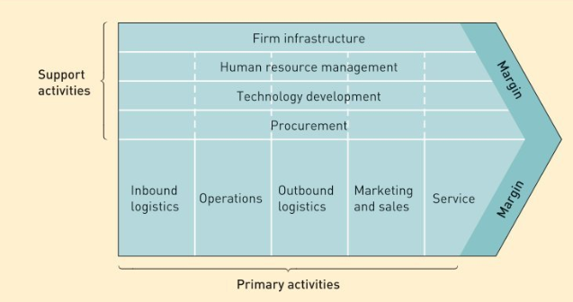
Figure 4: Value chain (Johnson, et al., 2012)

Primary Activities
Inbound Logistics: Delicious has developed capabilities for sourcing fresh, seasonal ingredients through long-term contracts with local London suppliers (Johnson et al., 2012). However, an area needing improvement is expanding its ingredient supply and inventory ecosystem across targeted cities as Delicious grows outlet footprint. Centralized, transparent inventory management technologies can enhance perishables visibility and quality controls across locations.
Operations: A key capability lending competitive advantage is Delicious’ customized burger and salad preparation allowing high flexibility in product offerings for customers (Johnson et al., 2012). Integrating complementary digital tools such as mobile apps for order taking and kitchen display systems would further augment operational efficiency.
Outbound Logistics: Streamlining front-end order fulfilment and packaging processes through workflow optimization and potential automation can minimize customer wait times during peak hours (Whittington et al., 2020). Location evaluation and advantages of new outlets pertaining to high foot traffic, parking access etc. would additionally improve customer convenience.
Marketing & Sales: While Delicious has effectively developed a loyal community in London through personalized loyalty programs and social media engagement, national expansion requires honing analytics capabilities to gain sharper insight on local customer preferences and demographics to run targeted promotions and campaigns (Whittington et al., 2020).
Service: A stellar hospitality-focused service culture clearly differentiates Delicious’ overall customer experience as evident through feedback reviews and brand strength metrics (Johnson et al., 2012). Further augmenting digital channels for two-way communications on obtaining customer inputs around product improvements areas can aid service enhancement.

Secondary Activities
Procurement: Centralized procurement capabilities for ingredient supplies, restaurant equipment etc. can improve economies of scale for Delicious as it expands across UK (Whittington et al., 2020).
Technology Development: Inventory management, online ordering, loyalty program and data analytics technologies would enable process improvements and customer insight across the value chain (Whittington et al., 2020).
Human Resource Management: Structured training programs focused on hospitality and customer service consistency across employee base and new outlets would be vital as Delicious scales up UK operations (Johnson et al., 2012).
Infrastructure: Formalizing planning systems for new market entry, outlet opening checklists and KPI dashboards would lend robustness as Delicious transitions from a single to multi-location chain. Enhancing finance functions is also vital for efficiently managing the growth stage funding requirements.

VRIO Analysis of Distinctive Resources and Capabilities
The VRIO framework analyzes the competitive potential of an organization's resources and capabilities as sources of sustained competitive edge. VRIO is an acronym for four key criteria - Value, Rarity, Inimitability and Organization. By examining if a resource or capability satisfies each criterion, strategists can determine whether it truly lends strategic value (Barney & Hesterly, 2019). The aim is to identify the distinctive competencies possessed by an organization which are valuable to customers, not commonly implemented by rivals, and difficult to imitate. When complemented by organizational mechanisms to extract full utility, such differentiating proprietary resources and capabilities can become platforms for consistent value creation and competitive moves that rivals cannot easily match.
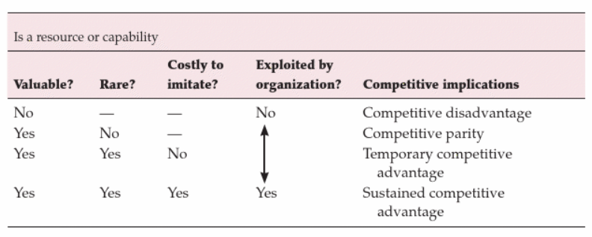
Figure 5: VRIO Framework (Barney & Hesterly, 2019)
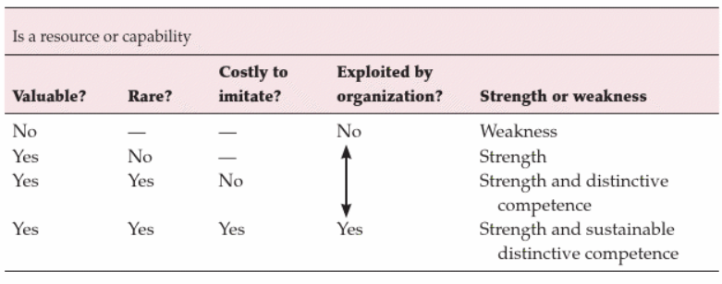
Figure 6: VRIO Framework with Strengths or Weakness (Barney & Hesterly, 2019)

Resource/Capability | Value | Rarity | Inimitability | Organization | VRIO Status
Customized Food Preparation | Yes | Yes | No | Yes | Competitive Parity
Hospitality Focused Culture | Yes | No | No | No | Competitive Disadvantage
Ethical Local Sourcing | Yes | Yes | Yes | No | Temporary Competitive Advantage
Customer Loyalty & Brand Perception | Yes | No | Yes | Yes | Sustained Competitive Advantage
Site Selection Capabilities | Yes | No | No | No | Competitive Disadvantage

Delicious’, customized meal preparation model allows flexibility in offerings, however several competing chains have now adopted customization capabilities limiting the differentiation value. Though locally sourced ingredients provide uniqueness currently, the supply partnerships depend on Delicious' ability to scale up operations across new locations. A major competitive disadvantage is Delicious' lack of structured site selection capabilities vital for expanding outlets nationally, posing significant risks. On the positive side, strong brand perception and customer loyalty metrics reinforce brand strength across locations over long-term, lending potential sustainability. However, the hospitality culture centred around customer relationships has not permeated organization wide. Training programs and coordination mechanisms are necessitated for transferring these soft, experience-based capabilities across an increasing employee base during rapid growth. While customization and ethical sourcing practices may offer temporary differentiation, scale dependent, Delicious needs urgent capability building for new market entry site selection and hospitality culture dissemination to mitigate expansion risks. Meanwhile, reinforcing the brand salience and loyal community bridges the short term to long term.

SWOT Analysis
SWOT analysis assesses the key internal strengths and weaknesses of a firm alongside the external opportunities and threats based on accompanying environmental analyses to determine strategic implications (Johnson, 2017). The aim is to evaluate the level to which Delicious' capabilities can capitalize on emerging industry opportunities or counter potential risks.
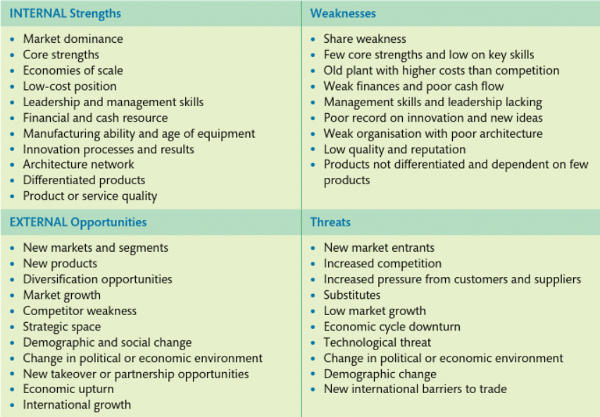
Figure 7: Possible factors for SWOT Analysis (Lynch, 2018)
Strengths
- Established brand presence and loyal community in London.
- Ability to offer customized meals lending product differentiation.
- Supplier relationships supporting farm-to-table positioning.
Weaknesses
- Limited management bandwidth to scale up operations.
- Lack of structured capabilities around national expansion site selection
Opportunities
- Changing consumer preference for fresh, healthy meal options
- Government incentives and policies supporting new food retail businesses.
- Increasing adoption of food ordering technologies
Threats
- Expanding competitive intensity from wider chains competing on pricing
- Rising real estate and ingredient input costs putting pressure on unit economics
- Talent acquisition challenges with hospitality workforce supply crunch
The analysis indicates that while Delicious possesses strengths around its brand and customization abilities to tap into rising consumer demand, capability constraints around scalability and looming competitive threats during rapid expansion would need to be addressed through the strategic choices made.

Strategies to Sustain Competitive Advantage
Porter's generic strategies provide fundamental strategic positioning options based on firms adopting either cost leadership, differentiation, or a focused scope along these dimensions in relation to competitors (Johnson et al., 2017). Evaluating these choice sets would enable Delicious to determine an optimal competitive approach during its expansion.
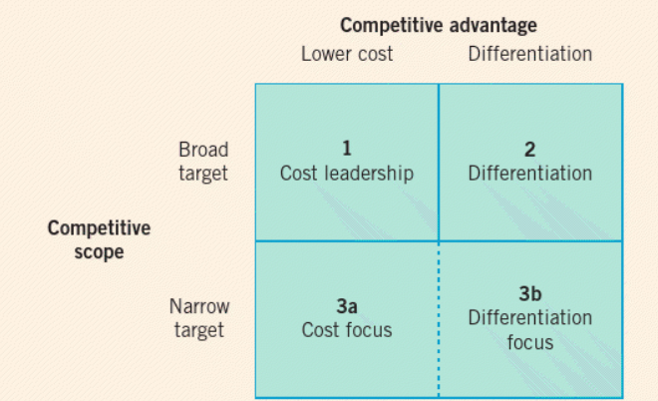
Figure 8: Porter’s Generic Strategy (Johnson, 2017)
Cost Leadership: Pursuing a cost leadership-driven expansion strategy would involve aggressively minimizing operating overheads across all facets of Delicious' operating model including ingredient sourcing, meal preparation processes, inventory management, outlet rentals and staffing. The aim would be to translate the cost efficiencies gained into everyday low pricing that undercuts competing offerings in the affordable meal segments, therefore driving market share growth through price competitiveness. However, the inherent capabilities needed for structural cost advantages around supply chain scale, centralized procurement leverage and process standardization are still evolving for a relatively young, small restaurant chain like Delicious. Implementing drastic cost prioritization measures also risks diluting specialized differentiation areas like ethical sourcing partnerships and hospitality-focused dine-in service which provide foundational brand relevance currently (Management Technology Policy, 2023). Thereby, adopting an overall low-cost expansion strategy appears less aligned and feasible at this stage for Delicious.
Differentiation: Leveraging product and service specialization advantages nurtured over time forms a natural strategic direction for expansion. Delicious has steadily built uniqueness around tailored food offerings prepared from locally grown ingredients complemented by warm, personalized hospitality. These differentiated attributes satisfy demand for fresh, customized eating options with intimate dine-in ambience. During growth phases, reinforcing brand messaging and customer experiences centred on specialization excellence in ethical sourcing, meal customization flexibility alongside memorable occasion-based dining would amplify non-replicable points-of-difference justifying premium value perception that unlocks growth potential across wider target markets (Management Technology Policy, 2023). Thereby, expansion fuelled by sharpening differentiation forms an optimal path aligning inherent strengths with target consumer appetite.
Focused Differentiation: This expansion approach would concentrate early efforts on establishing differentiated advantages around supply relationships, community connections and food localization benefits in selected neighbourhoods and cities where preference indications for fresh, sustainable eats are relatively higher. The aim is prudent incubation of sourcing and culinary capabilities tailored to local tastes before expanding footprint towards a broader nationwide presence. It allows optimizing unique specialization areas deeply attuned to needs of focus demographic clusters (Management Technology Policy, 2023). As Delicious proves the niche models, it can then broaden targeted segments systematically thereby retaining differentiation advantages. Risks of uncontrolled expansion dilution before capabilities are market-proven also get mitigated through this selective stores-driven growth. Thereby, the focused pathway centres on harnessing differentiation potential thoroughly within strategic geographic strongholds before scaling further.

Growth Strategies
The Ansoff Matrix is a strategic planning tool that provides guidance on potential growth pathways based on market and product dimensions (Lynch, 2018). As Delicious looks to expand from its single London restaurant to a multi-location chain across the UK, assessing options to enter new markets with existing or new offerings would be valuable.

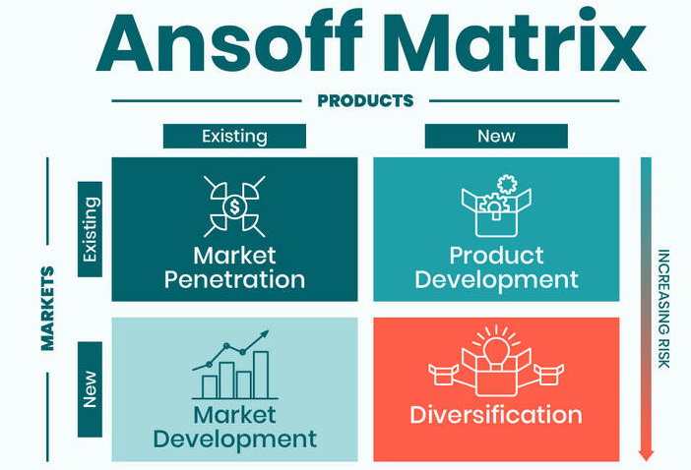
Figure 9: Ansoff Matrix (Peter Booklah, 2022)
Market Penetration: Delicious has established strong brand recognition and customer loyalty within its neighbourhood consumer base in London. Further penetrating this existing market would involve tactics to drive higher repeat purchase frequency through targeted promotions and bundling deals. Enhancing convenience levers for ordering and meal customization access through digital channels can also increase share of wallet. However, saturation risks from high local competition necessitate balancing penetration with geographic expansion.
Product Development: Introducing more vegetarian, vegan and gluten-free menu options align with shifting preferences among Delicious' core patron demographics for fresh, healthy meal choices. Special seasonal offerings also catalyse purchase occasions. However, customization flexibility mitigates risks of menu innovation failures somewhat by retaining select niche preparations basis customer votes.
Market Development: Delicious intends fuelling growth by foraying into UK cities like Manchester, Birmingham etc. Transporting existing brand identity and product strengths rooted in ethical sourcing and hospitable dine-in service holds relevance in similar urban clusters aligned to sustainability values. Localizing elements like regional cuisine influences and community engagement initiatives aids marketability.
Diversification: Diversifying into retail merchandise, at-home ingredient kits or specialty condiments provides tangential growth opportunities. However, priority is expanding core dining operations over next 3 years before stretching focus areas. Potential franchising of brand for geo-expansion also offers lever while retaining organizational oversight.
Balanced focus between increasing London loyalty and replicating existing product-market rocks in new regions is optimal currently for Delicious rather than over-diversification.2
Expansion and Entry mode Strategies
Franchising: One approach is to expand by franchising the Delicious brand to strategic partners who open and operate new outlets leveraging Delicious' brand name, operating model and food quality standards. This requires developing the capability to identify capable franchisees, provide training and build consistency systems. However, it enables relatively capital efficient growth (Valentin, 2015).
Company-Owned Outlets: Alternately, Delicious could self-fund opening and operating company-owned outlets across cities like Manchester, Birmingham etc. This allows better control on customer experience consistency but has higher capital requirements to set up and run each location. Delicious aims to establish an initial footprint through this route before potentially transitioning to a franchise-focused structure (Valentin, 2015)..
Joint Ventures: Exploring joint ventures with established dining or hospitality players who have market familiarity, real estate and operations infrastructure across large UK cities provides another pathway. Delicious would need to evaluate synergy fit, partner capabilities and economic arrangements to ensure brand values preservation alongside accelerated growth (Valentin, 2015)..
Hub-and-Spoke: Rather than large restaurant outlets, smaller kiosks, pick-up stations and ghost kitchens focused mainly on delivery could act as access points in newer regions. Once brand recognition builds through such models, larger experience-oriented dine-in outlets can be added. This potentially accelerates market access more affordably (Valentin, 2015).

Green Strategy and CSR
Delicious aims to build environmental and social responsibility into its organizational culture to promote sustainability both internally within its operating practices as well as through external community partnerships.
Green Strategies
To minimize the ecological impact from its restaurant operations and supply chains, delicious plans implementation of measures focused on four key areas:
- Responsible Sourcing: Committing to source 70% ingredients through local farmer partnerships not only aids freshness but reduces emissions associated with transportation miles. Annual audits of supplier sustainability standards aids compliance (Aptean, 2022).
- Energy Conservation: Transitioning outlet lighting to LED along with optimal HVAC management techniques during low-traffic hours can efficiently cut energy consumption per square foot by 20% over the next 2 years. Integrating in-kitchen heat recovery systems to repurpose cooking exhausts for water heating also holds high potential (Aptean, 2022).
- Waste Minimization: Delicious strives to achieve over 80% recycling, composting or reuse of restaurant operational waste within 2025. Packaging reduction, optimized ingredient procurement and donations of surplus edible food to hunger relief agencies like Food Banks also progress its footprint lowering mission (Aptean, 2022).
- Water Preservation: Low-flow fixtures and tap aerators aid lowering water utilization up to 30% alongside systematic leak inspection across sinks and plumbing equipment maintenance. Progress tracking on key metrics helps reinforce sustainability focus for employees too.
CSR Initiatives
- Nutrition Partnerships: Collaborating with schools and community nutritionists on healthy eating awareness camps educates the next generation on balanced diets while positioning Delicious' wholesome, made-to-order fare.
- Fundraising Drives: In-restaurant and digital customer engagement providing options to contribute financially towards organizations addressing food security and environmental conservation symbolizes care beyond great service.
- Employment Inclusion: Hiring team members facing barriers to traditional work settings and focusing manager energy on nurturing their success aids display social conscience while benefiting operations through lower attrition and higher dedication.
The three-pronged green plus CSR agenda aims firmly embed community and ecological wellbeing into the core values framework that steers decision-making as Delicious prepares for ambitious growth plans in the years ahead while retaining its founding purpose.

Conclusion
In conclusion, this report has presented a comprehensive strategic expansion plan for the fast-casual dining restaurant - Delicious. Leveraging key strategic analysis models, the current situation facing Delicious was systematically evaluated. While Delicious enjoys a niche presence in London, ambitions to scale operations face several external hurdles from intensifying competition to rising real estate and talent costs during the high growth phase of the UK industry life cycle. Still, emerging preferences for fresh, customizable and affordable meals lend continued expansion opportunities. Internally, Delicious boasts strengths around its brand equity, hospitality model and sourcing relationships but needs capability enhancement for multi-location coordination.
Considering these factors, the recommended strategy focuses differentiation based on customization flexibility, ethical sourcing as well as service excellence. This leverages Delicious' inherent brand qualities that satisfy consumer demand for unique dining experiences. A prudent initial pathway plots concentrating differentiation efforts through localized incubation across neighbourhood in targeted cities displaying affinity for such positioning. As niche presence and capabilities scale, expansion into additional regions follows. Delivering tailored meal customization and hospitality training standardization organization-wide fosters long-term advantage sustainability. Concurrently, green operations and CSR initiatives aid embedding higher purpose values among stakeholders.

In terms of growth approaches, penetration within London is balanced through new market forays starting Manchester and Birmingham via an asset-light licensing model, before transitioning to company-owned outlets. Innovation investments also concentrate on digital platforms and emerging technologies to enable an integrated customer experience across in-store, takeaway/delivery and off-premise channels.
With execution coordination around the recommended market-centric differentiation strategy complemented by capability and locality enhancement in phases, Delicious can profitably navigate external dynamics to systematically quadrupled its outlet presence over 5 years. The focus remains rooted in the core promise of creating joyful food experiences connecting communities.

Recommendation
- Pursue a differentiated growth strategy leveraging core strengths around customization flexibility, ethical sourcing and hospitality service excellence. Concentrate on establishing competitive advantages through localized incubation across target neighbourhoods before scaling wider.
- Prioritize capability building for new market/site selection and hospitality culture dissemination across outlets through structured training programs and coordination processes as key expansion success factors.
- Balanced focus between penetrating existing London consumer base deeper via digital channels while extending current product strengths into new regional markets like Manchester, Birmingham etc. through company owned outlets.
- Initially license brand assets to strategic restaurant partners as affordable rapid market entry option across regions before transitioning to self-owned units. Evaluate joint ventures for accelerating footprint supported by partner complementary competencies too.
- Commit significant innovation investments into digital platforms for customer engagement/convenience spanning customized ordering apps, delivery management systems and CRM analytics.

References
Abdul, M., 2022. Fast Food Industry Analysis. [Online]
Available at: https://pestleanalysis.com/fast-food-industry-analysis/#Fast_Food_Industry_Life_Cycle
[Accessed 08 December 2023].
Aptean, 2022. Responsible Sourcing in Food and Beverage: Compelling Reasons and Useful Strategies for Working with Sustainable Suppliers. [Online]
Available at: https://www.aptean.com/en-GB/insights/blog/responsible-sourcing-in-food-and-beverage
[Accessed 09 Deember 2023].
Barney, J. & Hesterly, S. W., 2019. Strategic management and competitive advantage : concepts and cases .. 6 ed. Harlow: Pearson.
Hitt, M. & Ireland, R., 2009. Strategic Management: Concepts & Cases Competitiveness and Globalization. 8 ed. South-western: Cangage Learning.
Johnson, G., 2017. Exploring strategy : text and cases. 11 ed. Harlow: Pearson.
Johnson, G., Whittington, R. & Scholes, K., 2012. Fundamentals of Strategy. 2 ed. Harlow: Pearson Prentice Hall.
Learn Marketing, 2020. Micro Environment. [Online]
Available at: https://www.learnmarketing.net/microenvironment.htm
[Accessed 2023 December 2023].
Lynch, R., 2018. Strategic Management. 8 ed. Harlow: Pearson Education.
Management Technology Policy, 2023. Porter's Generic Competitive Strategies. [Online]
Available at: https://www.ifm.eng.cam.ac.uk/research/dstools/porters-generic-competitive-strategies/
[Accessed 02 December 2023].
Morden, T., 2016. Principles of strategic management. 3 ed. New York: Routledge.
Peter Booklah, 2022. Ansoff Matrix: What Is It And How To Use It?. [Online]
Available at: https://boolkah.com/ansoff-matrix/
[Accessed 10 December 2023].
Porter, M., 1989. How competitive forces shape strategy. UK: Macmillan Education UK.
Valentin, E., 2015. Business planning and market strategy. Los Angeles: SAGE.
Whittington, R., Patrick , R. & Gerry, J., 2020. Exploring Strategy, Text and Cases. 12 ed. Harlow: Pearson Higher Education & Professional Group.
Wondershare EdrawMax, 2023. Detailed PESTEL Analysis of Restaurant Industry. [Online]
Available at: https://www.edrawmax.com/article/restaurant-industry-pestel-analysis.html
[Accessed 04 December 2023].

