Physical landscapes and conservation in your local area- The River Ely

Table of contents

1 Introduction 2
2 The Evolution of the River Ely 3
2.1 The geomorphology of Wales - Fluvial landforms and processes in Wales 3
2.2 How are rivers formed in Wales? 3
2.3 Rock samples from the River Ely 4
2.4 What type of River is the River Ely 5
3 How does the River Ely influence its environmental conservation? 6
3.1 The pollution of the River Ely 6
3.2 The wildlife and vegetation that can be found in lowland rivers such as the River Ely 7
4 Conclusion 7
5 References 13

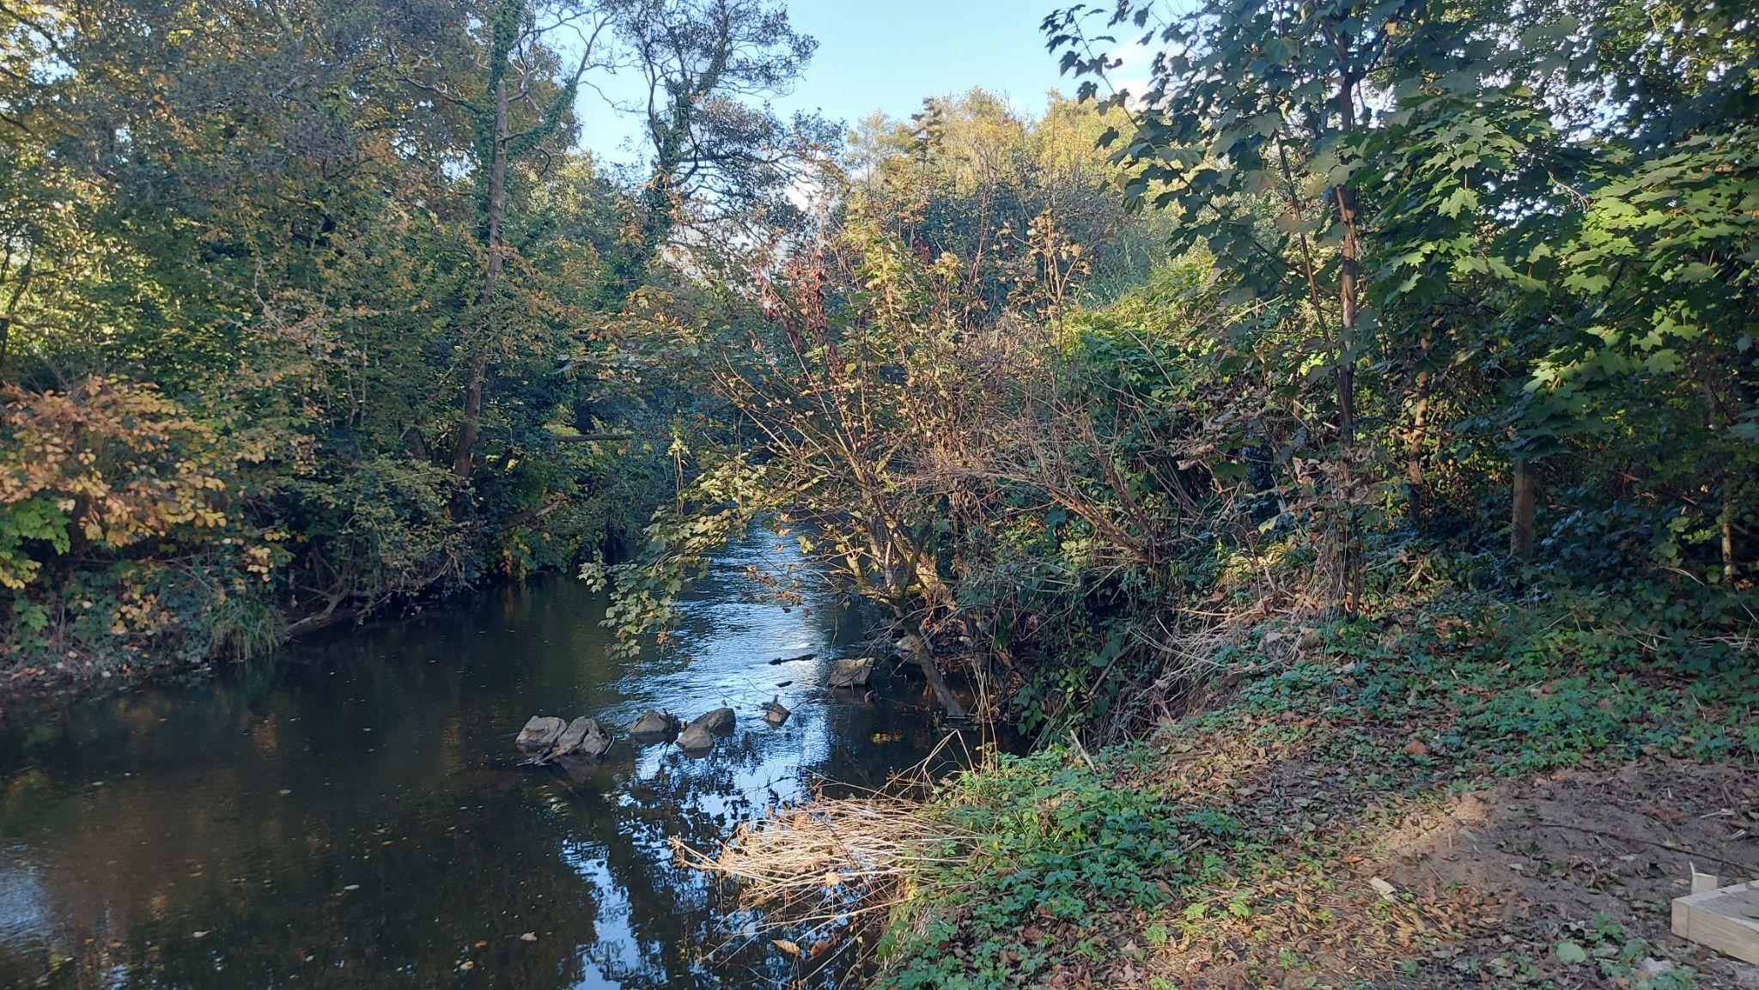
Authors Own (2024) Picture of the River Ely

1 Introduction
The River Ely is 39km from start to end and is a short and largely urban river. Unusually, it does not have a reservoir common for rivers in Wales but instead starts from the mountains North of Tonyrefail called Mynydd Penygraig Mynydd y Gilfach and the slopes of Mynydd Dinas. The river flows southeast towards Cardiff and through Pontyclun, Llantrisant, St Fagans and Cardiff Bay. Afonydd Cymru (2023) Below is a map of Cardiff showing the River Ely flowing through it, the River Ely ends at Cardiff Bay where it meets with the Celtic Sea.

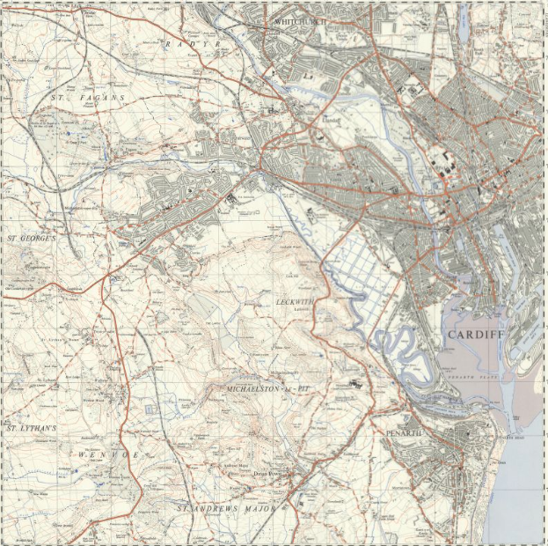

National Library of Scotland (1956). Location Map of the River Ely. Available at: https://maps.nls.uk/view/95749520 [Accessed 11 Dec. 2024]

2 The Evolution of the River Ely

2.1 The geomorphology of Wales - Fluvial landforms and processes in Wales
There are many fluvial systems in Wales and they all have these three characteristics which are they have an extended evolutionary history such as phases of rejuvenation and glaciation and these two phases have formed the landscapes of rivers in Wales that are seen today such as waterfalls, gorges, flat-bottomed valleys and much more Gregory et al. (1999). Due to fluvial processes in Wales, this has created a wide range of different river types such as upland source area streams, meandering and also braided reaches. The final characteristic would be that there have been large amounts of studies and research into the rivers of Wales this means that they are internationally known due to the high amounts of academic interest. The impacts of environmental issues such as afforestation or river channelization have been affecting fluvial features in Wales. Also, Quaternary glaciation has added trough-like valleys and a widespread veneer of glacial sediments in Wales.

2.2 How are rivers formed in Wales?
The rivers in Wales usually form from upland areas, especially from Wales’s highest peak, Snowdonia. They are typically small and can be as long as 20km; however, some rivers, like the River Wye, reach up to about 250km from source to mouth Duigan, (2009). These longer rivers typically run through big floodplains as they are very slow and have lots of meanders within the river. These rivers flow through acidic soils often in places such as farms, forests and tourism ventures. This addition of acidic soil can largely affect the chemical properties of the river water.
The River Ely was formed from the mountains North of Tonyrefail and the river then started to meander around rocks, and hills until it reached another body of water in Cardiff Bay where the Celtic Sea is. As the River Ely flowed it started to erode the land around the river which is called the banks of the river, as this process happens it can create valleys or gorges if the river is strong enough to around the rock. (BBC Bitesize 2019) During erosion, the river takes the eroded sediment, carries it along with it, and deposits it into the sea. The River Ely is vital for wildlife living around the river as it is a good source of water, shelter and much more. Sadly, the river Ely can become badly polluted which can then decrease the amount of wildlife found around the river as wildlife can not drink or use polluted waters.

2.3 Rock samples from the River Ely
A grab sample was collected from the banks of the River Ely in Pontyclun there were a few different rock types that were found next to the river and they were very diverse and quite surprising. A few notable rocks that were found on the beaches of the River Ely was calcite shown in Figure 5, calcite is carbonated and is the most common form of natural calcium carbonate and it is also polymorphous and could have minerals present such as aragonite and vaterite. (Dietrich, R.V. 2024) A few other rocks found on the beaches of the River Ely had some sulphur present in the rock. Most of the rocks found were fine-grained and had a present of sand in the rocks. The range of different rocks found on the beaches of the River Ely shows that the river has picked up sediment from different areas on its path through villages and towns.

2.4 What type of River is the River Ely
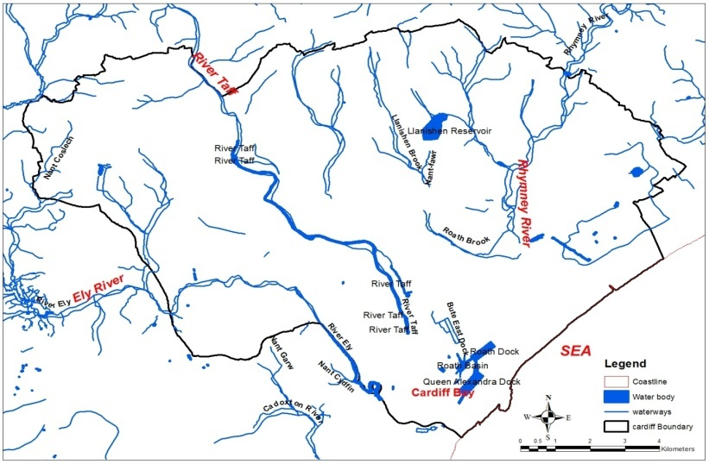
Ismail Usman Kaoje (n/d) Hydrological map of Cardiff

Figure 8 shows the different rivers that can be found around Cardiff, this is a map that is used to determine what can happen in a flood and the aftermath of it. There is software that is used to analyze rivers like the River Ely to predict what could happen if it floods and what can be done to stop the flooding from happening. The River Ely is a lowland, meandering river which means that the river flow is slow and this results in slow erosion on the river banks.

With lowland rivers such as the River Ely, there are low-slope environments with high discharge due to the river being wider and bigger than a highland river which is thinner and can carry less discharge. Lowland rivers have a shallower gradient than highland rivers and lowland rivers can be referred to as a depositional zone in the rivers cycle. The river planform of the River Ely is all determined by boundary conditions which are all internal variables such as soil vegetation and also controlling variables such as sediment supply and water. A river planform looks at the sediment load, sediment grain size, how stable the banks are, how variable the discharge is and how low or high gradient the system is. The River Ely is a meandering river so therefore the sediment load would be more suspended, its sediment grain size would be finer-grained, its bank stability would be very good, the river discharge variability would be low and finally, the channel would be low-sloped. (Rob, n/d)

3 How does the River Ely influence its environmental conservation?

3.1 The pollution of the River Ely
The River Ely has faced many issues in the past century as it is one of the most polluted rivers in Wales and the water quality around 150 years ago was catastrophic. It is said by Rivers Trust (2024) that the River Ely has undergone huge environmental changes over the years. During the Industrial Revolution, the upper and lower catchments were transformed by coal mining which then reduced the wildlife around the river due to the coal pollution. There was a mix of coal, metal and paper that was being deposited into the river which was destroying the river fauna and flora. Afonydd Cymru states that in the early 1870s, there was an Ely paper mill that was discharging hundreds of tonnes of chloride of lime which is a bleaching agent and up to 1884, the river was said to turn a reddish colour due to the amount of sulphuric acid that was being put into it. Due to the River Ely being lower gradient and having a slower flow, this meant that it was not able to deal with the amount of pollution that it was getting. Also, Afonydd Cymru says that during the 1860s there was a push to try and clean the River Ely as the local villages and towns were reliant on the water from the River Ely for drinking water. One way in which they tested how badly polluted the river was, was to put some minnows in a jar and put it into the river and see how long they would survive in the polluted River Ely. Even though the River Ely was badly polluted, the wildlife in the river was still hanging on and this could be due to the efforts to help the river to get clean. Afonydd Cymru explains that there were indications that the water quality in the river was improving as they were now allowing baptisms to happen using the water from the River Ely. Even though there was a lot of effort to try and restore the river water quality the river still stayed heavily polluted for many decades. Finally, as the heavy industry started to disappear the water quality in the River Ely started to improve and this brought along some new wildlife carp, eels and brown trout with many more to go alongside them. Even though the pollution has improved there is still a threat of pollution in the river due to wastewater treatment works from industries around the River Ely as shown in Figure 4 it is clear that the river is still not in good condition and it needs more treatment right away.

3.2 The debris in the River Ely

The river is prone to flooding with heavy rain, especially by Cowbridge Road West under the A48 bridge. When there are storms the debris can get blocked up underneath the bridge and cause a blockage for any water trying to get through this then can result in serious flooding over the bridge and around the surrounding areas. As shown in Figure 2 and Figure 6 we can see a large amount of Debris in the River Ely. Teams of people can't remove the debris during the storm as it is too dangerous so there is no way of stopping the flooding from happening during storms however, there have been plans to create a solution for this problem. A solution for the flooding problems is to build a tree catcher upstream to collect any debris and trees before they reach the bridge, it is then easier for teams of people to collect and take out any trees that may cause a blockage further upstream. (Natural Resources Wales 2022)

3.3 The wildlife and vegetation that can be found in lowland rivers such as the River Ely
The wildlife that can be found in lowland rivers is very similar to wildlife that can be found in lakes and ponds due to the slow flow of the river. However, the difference is that there is still some flow in rivers and there is no flow in lakes or ponds therefore animals such as fish can lay their eggs in lowland rivers like the River Ely as it is similar to a lake or a pond. It is easier for wildlife to find food in a lowland river because it is always moving therefore they can move up or down the stream to find more food however they can not do that in lakes or ponds. There is certain wildlife that is present in lakes and ponds but not in lowland rivers this is mostly due to the river flow for example, plankton and floating plants can not be present in a lowland river as the current will take them away and they will not be able to survive Better Planet Education (2024). Also, a way that water creatures have adapted to lowland rivers is that they deposit their eggs under the gravel and stone that is found at the bottom of the river to stop their eggs from being taken downstream. Also, some species use the flow of the river to disperse which helps them go downstream and colonise a different section of the river. Certain species drift downstream on purpose at different times of the year as certain parts of the river might be calmer than others which can help with the breeding season. Finally, some species find it easier to find food from a lowland river, this is because small animals are easily brought downstream where predators are waiting and they can easily catch the small animals that are stuck in the river as the river is slow moving enough to allow predators to easily catch their food.

The River Ely has a wide range of vegetation around its banks such as Alder trees, (Alnus.spp) Bluebells, (Hyacinthoides.spp) Bramble, (Rubus.spp) Common spotted orchids and (Dactylorhiza fuchsii) reedbeds. (Phragmites australis) There are a few more vegetation that can be found on the beds of the River Ely however, these are some of the main ones that can be spotted. However, there are a few invasive species that can be found on the River Ely such as Himalayan Balsam as shown in Figure 6 (Impatiens glandulifera) and Japanese Knotweed. (Reynoutria japonica) These invasive species can out-compete native species and this can cause severe erosion issues. The invasive species is making it more difficult for other species to grow around the banks of the River Ely, certain plants are a source of food and shelter for different animals and if they do not have these plants to protect them and keep them alive they will move to a different area, this lowers the amount of wildlife that can be seen around the River Ely.

4 Conclusion
In conclusion, the River Ely is a small 39km river starting the from mountains North of Tonyrefail and ending in Cardiff Bay and running through various villages and towns. The river is a lowland river and it is meandering as well meaning that the flow of the river is slow. The river carries large amounts of fine-grained sediment that is deposited onto beaches of the River Ely as found from a grab sample taken from the beach near the River Ely. Furthermore, the River Ely was known for the large amounts of pollution that it faced in the 1800s from coal pollution and factories near the river during the Industrial Revolution, this changed the amount of wildlife found in the river and there was a big project to restore the water quality of the River Ely. Finally, the River Ely has a range of different wildlife found within and around the river however, there is concern about the invasive species found around the river as it is causing erosion and loss of wildlife.

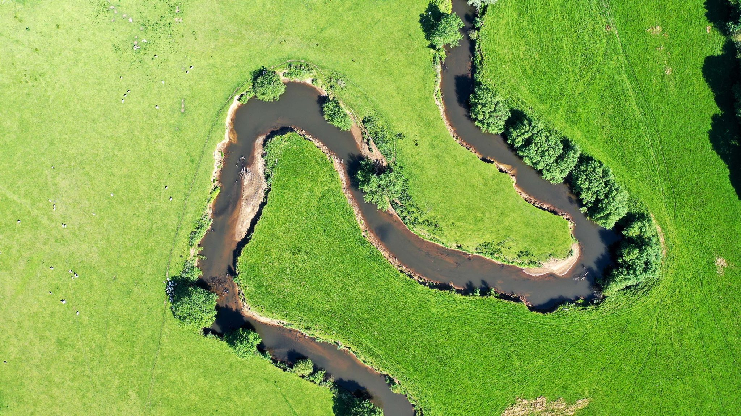
Figure 1: Nick Russill (2020) River Ely flowing through farmland

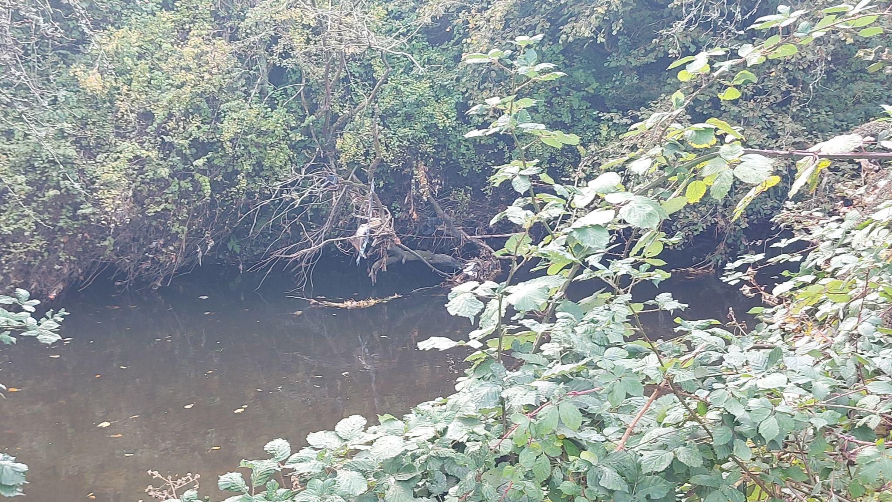
Figure 2: Authors own (2024) Tree debris in the River Ely

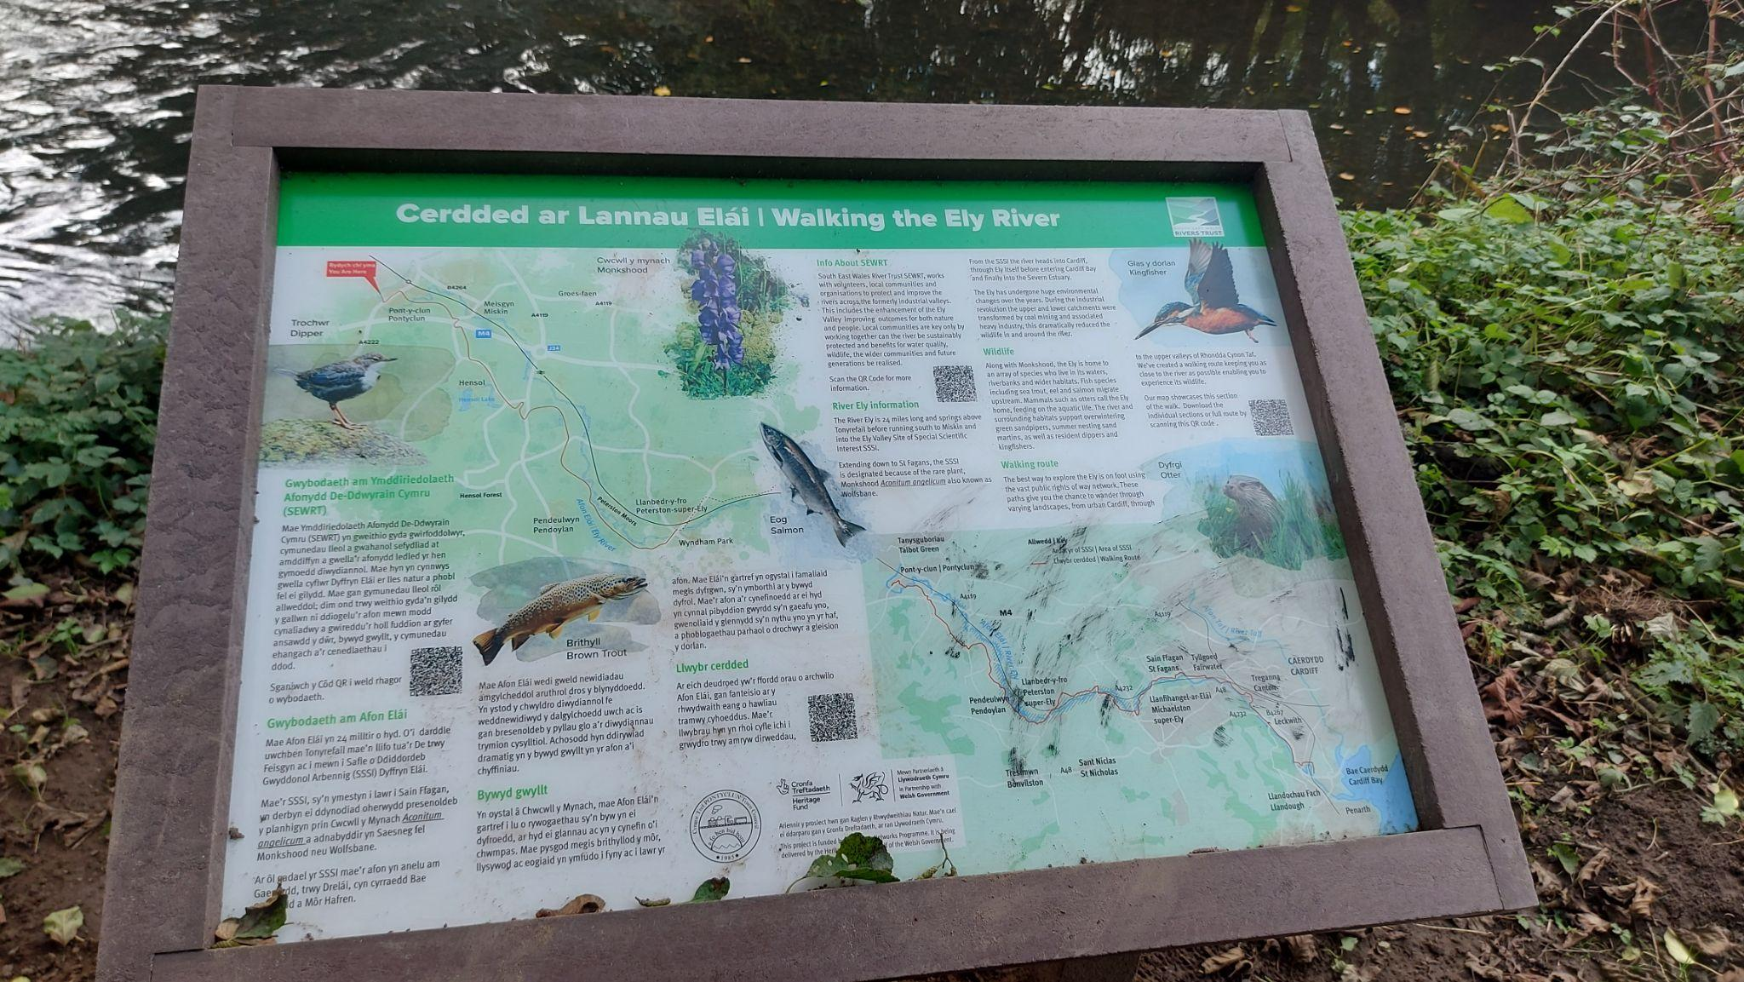
Figure 3: Rivers Trust (2024) Walking the River Ely information board

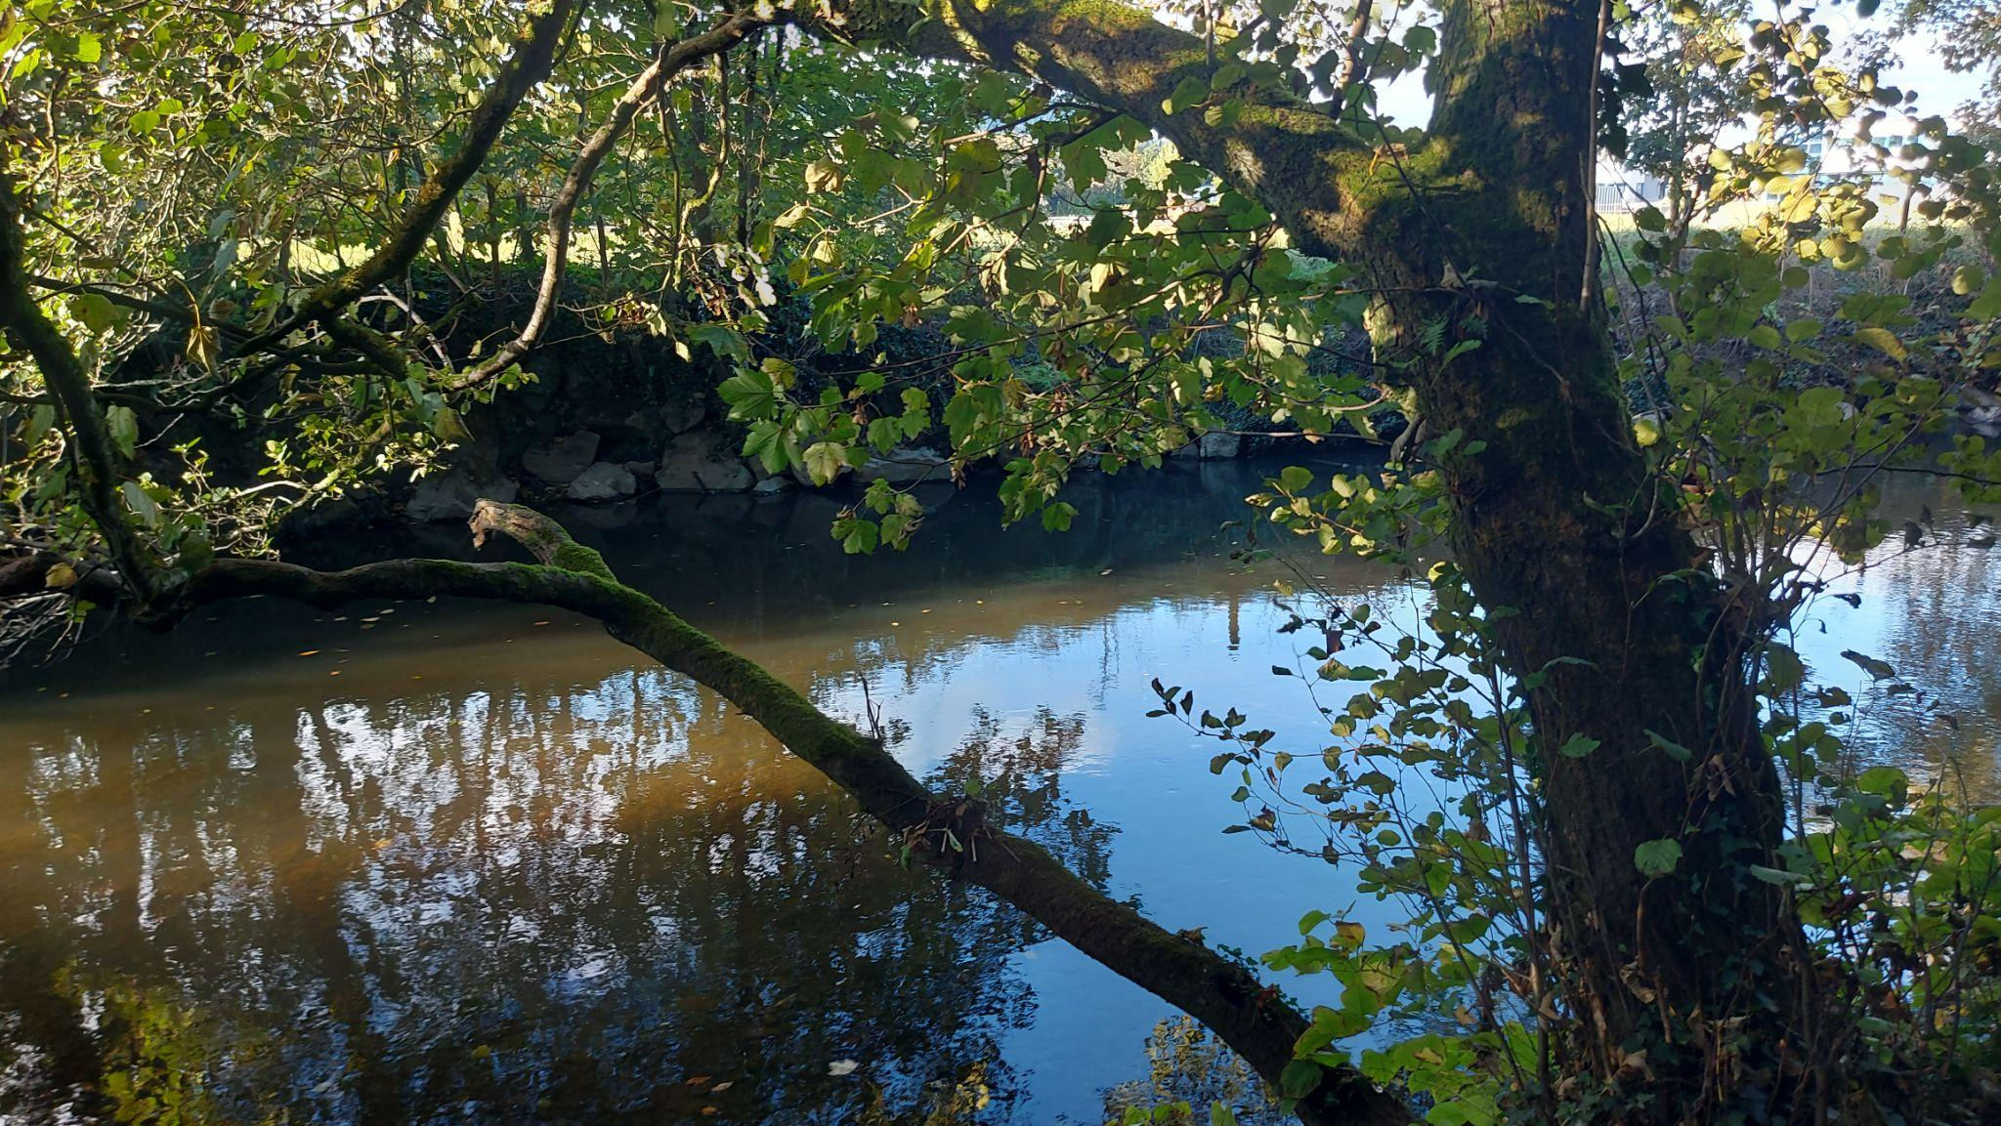
Figure 4: Authors own (2024) Area of polluted water on the River Ely

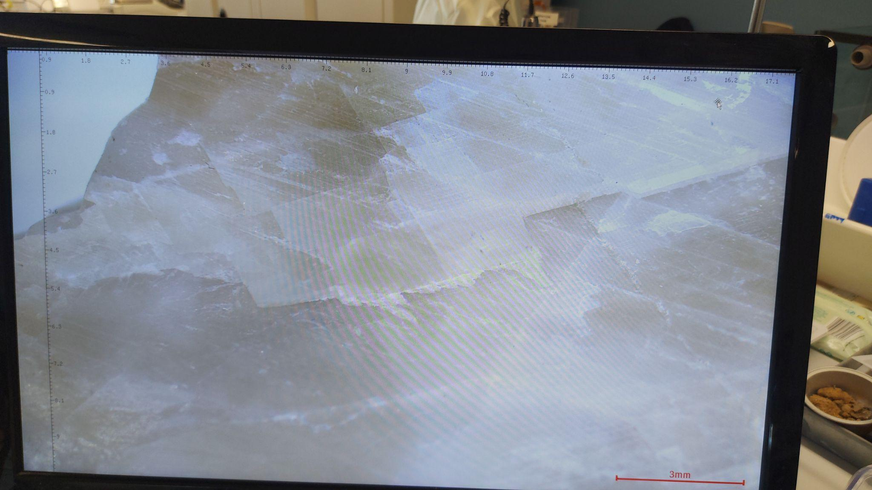
Figure 5: Authors own (2024) Close up of calcite rock found on the bank of River Ely

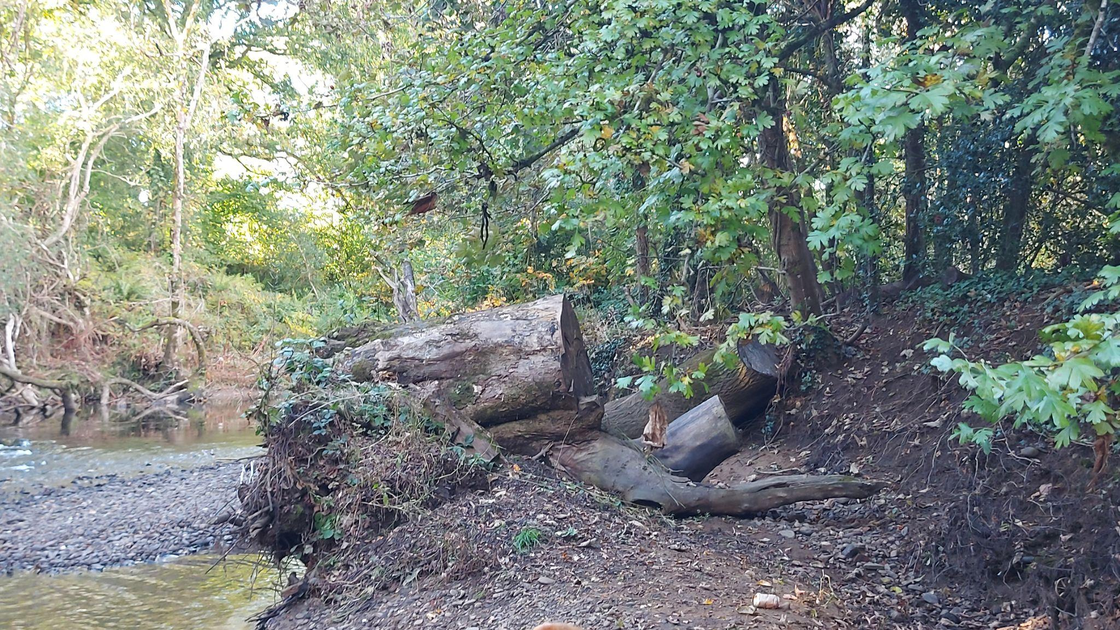
Figure 6: Authors own (2024) Washed up tree debris on the riverbed of the River Ely

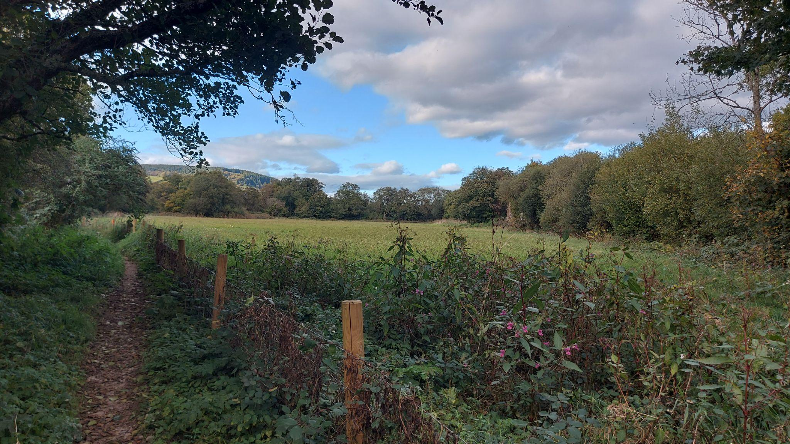
Figure 7: Authors own (2024) Field close to the River Ely with invasive species, Himalayan Balsam

Figure 8: Application of Geographical Information System Techniques in Urban Flood Risk Assessment and Vulnerability Mapping 'A Case Study of Cardiff, Wales' - Scientific Figure on ResearchGateAvailable from: https://www.researchgate.net/figure/Hydrological-map-of-Cardiff_fig1_317561780 [accessed 10 Dec 2024]

5 References

Afonydd Cymru (2023). River Ely | Afonydd Cymru. [online] Afonydd Cymru. Available at: https://afonyddcymru.org/ely/ [Accessed 6 Dec. 2024].

BBC Bitesize (2019). Explore rivers - BBC Bitesize. [online] BBC Bitesize. Available at: https://www.bbc.co.uk/bitesize/articles/z7w8pg8#zccw7yc [Accessed 8 Dec. 2024].

Better Planet Education (2024). Life in a Lowland River. [online] Betterplaneteducation.org.uk. Available at: https://betterplaneteducation.org.uk/factsheets/rivers-life-in-a-lowland-river [Accessed 10 Dec. 2024].

Dietrich, R.V. (2024). Calcite | mineral. In: Encyclopædia Britannica. [online] Available at: https://www.britannica.com/science/calcite [Accessed 7 Dec. 2024].

Duigan, C. (2009). Rivers in the Welsh physical and cultural landscape. [online] Backhuys Publishers, Leiden Margraf Publishers. Available at: https://catherineduigan.co.uk/riversofwales/chapter_02.PDF [Accessed 8 Dec. 2024].

Gregory, K.J., Lewin, J., Harvey, A.M., Macklin, M.G. and Werritty, A. (1999). Fluvial Geomorphology of Great Britain. The Geographical Journal, [online] 165(3), p.336. doi:https://doi.org/10.2307/3060466.

Natural Resources Wales (2022). Ely Bridge Flood Risk Management Scheme - Natural Resources Wales Citizen Space - Citizen Space. [online] Cyfoethnaturiol.cymru. Available at: https://ymgynghori.cyfoethnaturiol.cymru/south-central-wales/ely-bridge-flood-scheme/ [Accessed 6 Dec. 2024].

Outdoor Cardiff (n/d) Wildlife of the Ely Trail- Outdoor Cardiff. [online] Available at: https://www.outdoorcardiff.com/wp-content/uploads/Wildlife-of-The-Ely-Trail.pdf [Accessed 10 Dec. 2024]

