Student Name: Augusta-Roxana Toth  Student ID: 2226559  Module Title: Foreign Languages & Cultural Awareness  Module Code: BMIH5003  Lecturer: Lisa Bassler  Date: 15.01.2024 | 
ASSIGNMENT 1: PORTFOLIO
(4 Components)

Component 1: Professional Reflection (500 words +/- 10%)

Weighting: 25%
Due to the increasing number of people from diverse backgrounds in the world, the hospitality industry is no longer immune to cultural diversity. As a result, restaurant staff members must be trained to recognise and interpret cultural differences. Misunderstandings about other cultures can lead to conflicts and confusion, which can affect an organization's productivity and efficiency (LGS, 2022).
Based on the experience I had during my internship at the hotel, I found that I lacked detailed attention and communication. According to 2024, this skill is very important to have, as it can prevent some cultural misunderstandings. When I was in the bar department, there was confusion based on culture and religion due to a lack of communication, in which two guests asked for a drink containing alcohol without knowing what exactly that drink contained. This led her to a major discomfort for both the barmaid and the guests. The department manager had to intervene to remedy the situation with a discount for customers.

This scenario prompted me to reflect on the importance of cultural awareness and its implications for guest interactions. The incident highlighted the importance of being culturally sensitive in the hospitality industry. Understanding that cultural norms and preferences vary helps in providing a more personalized and comfortable experience for guests.

I realised the need to adapt my communication style based on the guest's cultural background. While some guests appreciate friendly conversations, others may prefer a more formal and reserved interaction (Hastings, 2023). Flexibility in communication is crucial for accommodating diverse preferences.

The hospitality industry is dynamic, with guests from various cultural backgrounds. Embracing a mindset of continuous learning about different cultures, customs, and communication styles is essential for delivering exceptional service.

Discussing cultural nuances with colleagues from diverse backgrounds can offer valuable insights. In this case, learning from a colleague about clients who are part of a Muslim religion, who have different traditions from our culture, helped me to look at their culture from another perspective, to understand the preservation of certain customs and beliefs, and to adapt according to their requirements (Buckley, 2023).
Developing empathy towards guests from diverse cultures is crucial. This involves putting myself in their shoes and considering how my actions and words may be perceived from their cultural perspective.
To prevent cultural misunderstandings in the future, I need to develop better cross-cultural communication skills. This involves being more aware of different communication styles and adjusting my approach accordingly. Taking the time to educate myself about the cultural norms and communication styles of guests from diverse backgrounds to better understand their expectations (Montanino, 2023).
Recognises that people from different cultures may have varying preferences in communication styles. While some may appreciate indirectness, others may prefer direct and clear communication.
Establishing effective feedback channels, both for guests and among team members, can contribute to a more informed and culturally aware work environment. Encouraging open communication about cultural differences fosters a supportive atmosphere for learning and growth (LinkedIn, 2023).

In conclusion, this experience underscored the significance of cultural competence in the hospitality industry. It reinforced the idea that recognizing and respecting diverse cultural perspectives not only enhances guest satisfaction but also contributes to a more inclusive and harmonious workplace. By reflecting on such encounters, I can continuously refine their skills and create positive experiences for guests from all walks of life.
Cultural misunderstandings can occur in such situations due to differences in communication styles, social norms, and expectations. In this case, the guest might have expected me to be more direct and ask for their preferences, while I assumed that being suggestive would be a more considerate approach.

References:
- Buckley F. (2023). Empowering Your Team: The Benefits of Cross-Cultural Training in the Hospitality Industry. Available at: https://www.linkedin.com/pulse/cultural-training-hospitality-industry-finbarr-buckley/ (Accessed 15 January 2024).
- Hastings D. (2023). Training Restaurant Staff to Understand Cultural Differences through the Foods We Consume. Available at: https://www.andreykolchurin.com/p/training-restaurant-staff-to-understand/ (Accessed 15 January 2024).
- LinkedIn (2023). How do you adjust your customer service to different cultures in F&B? Available at: https://www.linkedin.com/advice/0/how-do-you-adjust-your-customer-service-different/ (Accessed 15 January 2024).
- LGS (2022). Cross-Cultural Communication: Meaning | Importance | Barriers. Available at: https://www.linkedin.com/pulse/cross-cultural-communication-meaning-importance-/ (Accessed 31 January 2024).
- Montanino S. (2023). Navigating Cultural Differences in a Diverse Workplace. Available at: https://factorialhr.co.uk/blog/navigating-cultural-differences-diverse-workplace/ (Accessed 31 January 2024).

Component 2: Training Plan (500 words +/- 10%)

Weighting: 25%

Identified cultural misunderstanding (in a few words) :
Cultural misunderstanding refers to a situation where people from diverse cultural backgrounds interpret or perceive things in a way that leads to confusion, miscommunication, or misinterpretation. It occurs when individuals make assumptions or judgments based on their cultural norms and values, without considering the perspectives of others from diverse cultural backgrounds. Cultural misunderstandings can arise in various contexts, such as interpersonal relationships, business dealings, or social interactions (Varga, 2023).
Training plan (Why/What//Who/Where/When):
- Why:
The purpose of the cultural misunderstanding training plan is to address and mitigate challenges arising from cultural differences within the workplace. The primary objectives include promoting cultural awareness. Increase employees' understanding of diverse cultures and backgrounds. Foster an inclusive environment by acknowledging and appreciating cultural differences (CN, 2023). Improving Communication enhances communication skills to minimize misunderstandings caused by cultural nuances. Encourage open dialogue and active listening among team members.

- What:
Through cultural awareness and sensitivity training, participants can develop empathy for others from varying backgrounds. It can also help them identify biases and stereotypes (Lacalle, 2021).
Non-verbal and verbal communication styles are often misunderstood. This course aims to help participants develop effective strategies for cross-cultural communication. We will learn how to identify language barriers and find solutions to common communication issues.

- Who:
The training program's target audience should be broad enough to include people from different departments and roles within the company. The objective is to promote an inclusive and culturally competent culture within the organization.
People who work on projects with coworkers from varying divisions. Those involved in cross-departmental collaborations should have the necessary expertise and skills.
Employees who work from various time zones and geographical locations. They interact with clients, colleagues, and partners from varying cultural backgrounds.
Sales and marketing teams that are focused on international markets have to deal with a diverse client base. HR and diversity teams are also involved.
The HR professionals are responsible for hiring and onboarding new employees. The diversity and inclusion teams are also responsible for developing an inclusive work environment.

- Where:
Having a neutral environment can also help reduce the biases that people may have about a certain location. It can create a focused learning space that is away from the distractions of the office. It can encourage employers to explore new areas and feel like they are stepping out of their comfort zone. Some of the factors that can affect the planning of a training program include the size of the group and the cultural activities that are being conducted (Talespin, 2023).

- When:
During off-peak hours, such as those when the company is not as busy or experiencing reduced workloads, the training should be conducted. This ensures that participants can complete the program without affecting their regular duties.
The training should also be integrated during scheduled breaks or downtime, such as during lunch periods or when there are lighter workloads.

- How:
By conducting interviews, surveys, and focus groups, you can gather employee input on the training program's goals. We must define the objectives and ensure that the training addresses cultural misunderstandings.
To inform workers about an upcoming training session on cultural misunderstandings, a communication strategy must be developed. This can be accomplished by utilizing various channels, such as emails, and meetings.

The goal of our training program is to improve the understanding of people from diverse backgrounds in the workplace. It is also important to note that cultural competence is not a one-off process. It requires continuous improvement and dedication.
These principles can help us create a culture that values cultural differences and acknowledges them, encouraging innovation, improved employee satisfaction, and increased collaboration. We must also recognize that diversity serves as a powerful force that drives us toward success (Swain, 2024).

References:
- CN (2023). WHY IS CULTURAL SENSITIVITY IN THE WORKPLACE IMPORTANT? Available at: https://www.countrynavigator.com/blog/why-is-cultural-sensitivity-in-the-workplace-important/ (Accessed 31 January 2024).
- GDI (2023). The Significance of Cultural Sensitivity and Diverse Guest Satisfaction. Available at: https://www.linkedin.com/pulse/significance-cultural-sensitivity-diverse/ (Accessed 15 January 2024).
- Lacalle E. (2021). What is cultural diversity and why is it important in the hospitality industry? Available at: https://www.mews.com/en/blog/cultural-diversity-in-hospitality-industry/ (Accessed 15 January 2024).
- Varga P. (2023). Valuing cultural differences: Why it matters and how to do it right. Available at: https://hospitalityinsights.ehl.edu/cultural-differences-why-it-matters/ (Accessed 16 January 2024).
- Swain E. (2024). 30 best hospitality courses to train your staff. Available at: https://www.lingio.com/blog/best-hospitality-courses/ (Accessed 31 January 2024).
- Talespin Team (2023). MAXIMIZING YOUR HOSPITALITY TRAINING PROGRAMS. Available at: https://www.talespin.com/reading/maximizing-your-hospitality-training-programs/ (Accessed 31 January 2024).

Component 3: Student Self-Reflection (500 words +/- 10%)

Weighting: 25%
Cultural awareness within the hospitality industry is crucial for several reasons. Over time, my understanding of its importance has evolved as I have processed a diverse range of information (Wisner, 2023).
Initially, I recognised cultural awareness as a means to enhance customer service in the hospitality sector. It was about understanding and respecting different customs, languages, and preferences to ensure a positive experience for guests.
As I processed more data, I realized that cultural awareness goes beyond mere customer service. It is integral to creating an inclusive and welcoming environment for both guests and employees (Somji, 2022). Acknowledging and appreciating diverse backgrounds fosters a sense of belonging, contributing to a positive workplace culture.
I consider ways to build bridges and foster a more inclusive and culturally aware environment. I reflect on how I can contribute to promoting cross-cultural understanding in my personal and professional life.
Cultural misunderstandings provide opportunities for growth and learning. By reflecting on these experiences, I can develop greater cultural awareness, sensitivity, and adaptability, contributing to more effective and harmonious cross-cultural interactions.
By focusing on these skills, I can enhance my ability to navigate cultural differences effectively, creating a more inclusive and welcoming experience for all guests.

Numerous real-world examples highlighted the impact of cultural awareness on the success of hospitality businesses. Instances where cultural insensitivity led to negative publicity or customer dissatisfaction underscored the need for initiative-taking measures to promote cultural competence.
The hospitality industry is inherently global, with people from various cultures traveling and working in diverse locations. Understanding cultural nuances is not just a courtesy but a strategic advantage (Carl, 2023). It helps in tailoring services, marketing strategies, and overall business operations to cater to a broad and varied clientele.
Recognising and adapting to cultural differences is crucial for innovation in the hospitality industry. This adaptability can lead to the development of unique and personalized services that appeal to a wide range of customers, contributing to the success and competitiveness of a business.
Cultural awareness is not only external facing but also internally relevant. It contributes to effective communication and collaboration among a diverse workforce. When employees feel understood and respected, it positively influences their job satisfaction, performance, and overall engagement.
This reflective process has reinforced my understanding of the vital role cultural awareness plays in the hospitality industry. It has become an ongoing journey of self-development, contributing to both personal and professional growth (Safonov, Jenson 2022).
Actively participated in team discussions about cultural diversity, sharing insights from my learning journey, and encouraging others to do the same.
Over time, my increased awareness of cultural differences positively influenced my interactions with guests. I found that being attuned to cultural nuances not only improved guest satisfaction but also created a more inclusive and welcoming atmosphere.

In conclusion, my understanding of the importance of cultural awareness in the hospitality industry has deepened over time. It is not merely a customer service tactic but a fundamental aspect that shapes organizational culture, influences business strategies, and contributes to the industry's overall success and sustainability (Nallalingham, 2023). The experiences and examples encountered during data processing have reinforced the significance of cultural awareness as a multifaceted and dynamic element within the hospitality sector.

References:
- Carl C. (2023). How can you use self-reflection to advance your career in hospitality management? Available at: https://www.linkedin.com/advice/0/how-can-you-use-self-reflection-advance-8qcjc/ (Accessed 15 January 2024).
- Nallalingham L. (2023). Building Cultural Awareness: A Practical Approach. Available at: https://www.linkedin.com/pulse/building-cultural-awareness-practical-approach-lee-nallalingham/ (Accessed 31 January 2024).
- Somji A. (2020). It's time for self-reflection, hotel brands. Available at: https://www.linkedin.com/pulse/its-time-self-reflection-hotel-brands-alim-nizar-somji/ (Accessed 16 January 2024).
- Safonov A. and Jenson M. (2022). TIPS FOR HOTELIERS TO IMPROVE EQ SKILLS FOR BETTER LEADERSHIP AND GUEST RELATIONS. Available at: https://www.todayshotelier.com/2023/10/04/the-power-of-emotional-intelligence/ (Accessed 16 January 2024).
- Wisner W. (2023). Cultural Awareness—How to Be More Culturally Aware & Improve Your Relationships. Available at: https://www.verywellmind.com/cultural-awareness-importance-how-to-develop-it-7500316/ (Accessed 31 January 2024).

Component 4: Training Presentation (6 Slides)

Weighting: 25%
[Introduction 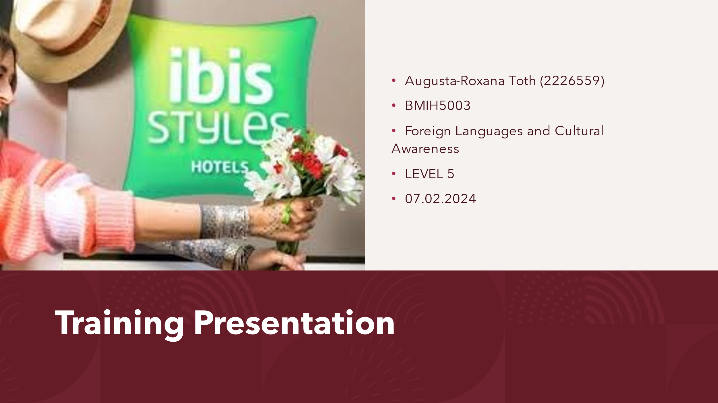n slide, e.g., assignment title, student name/ID, module title/code, date, hotel logo]
[Content Slide 1]
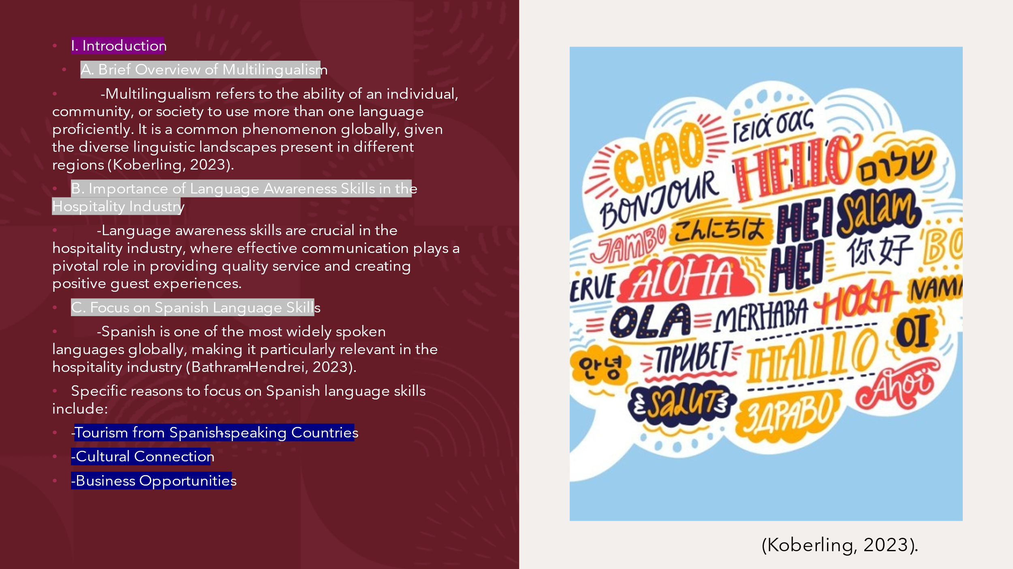
[Content Slide 2]
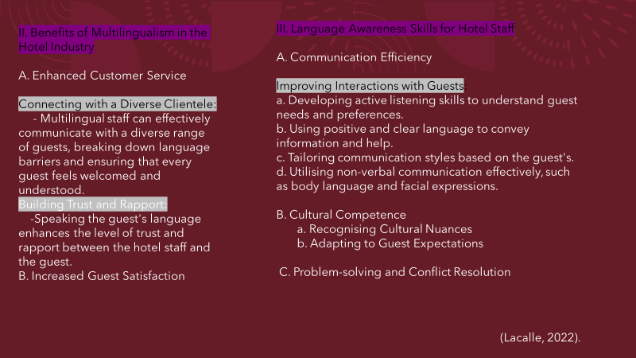
[Content Slide 3]
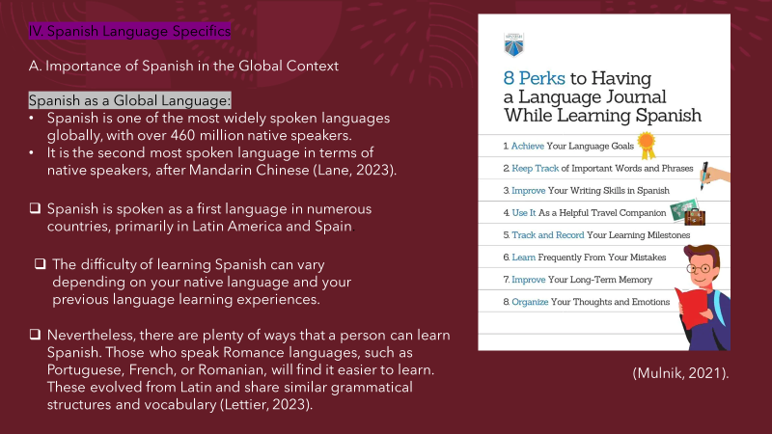
[Content Slide 4]
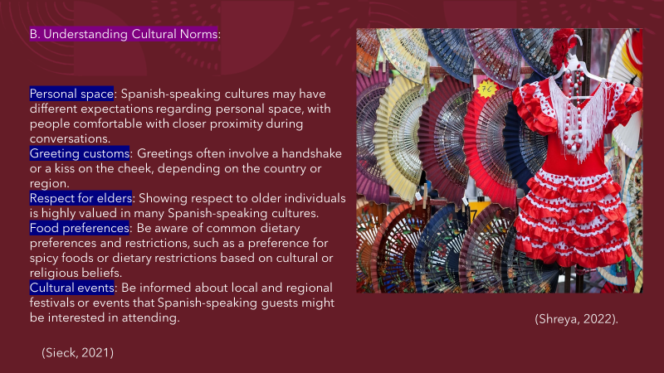
[Content Slide 5]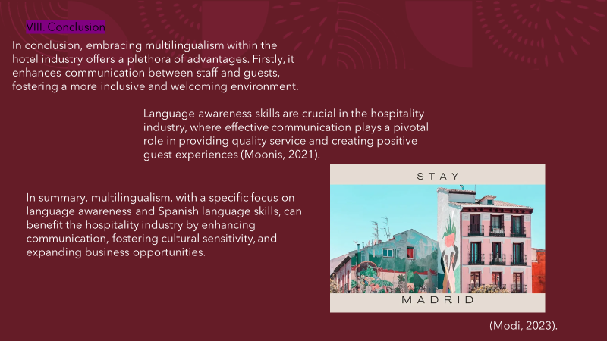
References (no screenshots):

- Batham-Hendrei O. (2023). 8 key benefits of multilingualism in today’s workplace. Available at: https://preply.com/en/blog/b2b-multilingual-workforce/ (Accessed 23 January 2024).
- Koberling L. (2023). The Connection Between Multilingualism and Business Success. Available at: https://www.speexx.com/speexx-blog/multilingualism-and-business-success/ (Accessed 30 January 2024).
- Lane J. (2023). The 10 Most Spoken Languages In The World. Available at: https://www.babbel.com/en/magazine/the-10-most-spoken-languages-in-the-world/ (Accessed 31 January 2024).
- Lacalle E. (2022). Six ways to improve hotel guest communication. Available at: https://www.mews.com/en/blog/hotel-guest-communication/ (Accessed 31 January 2024).
- Lettier M. (2023). Is Spanish Hard to Learn? An Honest Analysis. Available at: https://www.clozemaster.com/blog/is-spanish-hard-to-learn/ (Accessed 31 January 2024).
- Moonis M. (2021). 4 Benefits of Multilingual Service at your Hotel. Available at: https://blog.trip-kit.com/4-benefits-of-multilingual-service-at-your-hotel/ (Accessed 30 January 2024).
- Mulnik F. (2021). 8 Perks to Having a Language Journal While Learning Spanish. Available at: https://www.spanish.academy/blog/8-perks-to-having-a-language-journal-while-learning-spanish/ (Accessed 31 January 2024).
- Penty C. (2018). Thailand's Minor to Bid for All of Spain's NH Hotel Group. Available at: https://www.bloomberg.com/news/articles/2018-06-05/minor-international-to-bid-for-all-of-spain-s-nh-hotel-group?leadSource=uverify%20wall/ (Accessed 30 January 2024).
- Sieck W. (2021). Cultural Norms: Do they Matter? Available at: https://www.globalcognition.org/cultural-norms/ (Accessed 31 January 2024).
- Shreya (2022). Expat guide to Spanish culture and traditions. Available at: https://housinganywhere.com/Spain/spanish-culture-and-traditions/ (Accessed 31 January 2024).

