STUDENT NAME: Juliet Nazareth
STUDENT NUMBER: 1909020
MODULE NAME: Effective Teamwork and Communication.
MODULE NUMBER: BMSK 4002ETW1
LECTURERS NAME: Tim Hopkins
DUE DATE: 06 January 2020

INTRODUCTION
In my report I will explain about Communication and why it is important.
There are three (3) different types of Communication Theories. They are Shannon and Weaver, Berlo’s and Schramm and how they are effective in a business organization and the importance effective communication.
I will also be talking about the Role of Culture in Communication and how does communication work between Management and Employees and their purpose.
I will also talk about effective communication strategies such as Keys, Soler and the 7 c’s.

Why is Communication important in Management
This skill is very important for every Managers. Very good communication skills help managers to do their roles more efficiently. In any work relate roles managers must communicate with their team, to their suppliers and their financiers about the business.
My report will show how Communication is effective in any business organisation.
The relevant Theories which is Shannon and Weaver, Schramm and Berlo.
The Importance of effective Communication and the different methods of Communications and how does Communication work between Management and Employees.

- How Communication can be made effective in a business organisation?
This can be achieved by developing strategies in the workplace by
- Put in place a communication strategy
- Create a Communication process
- Always listen
- Providing important feedback and passing on important information.
2.The Relevant Theories:
(a) Shannon and Weaver Model is designed to develop communication between sender and receiver. This helps with different information source, transmitter, noise channel, message, receiver and channels information to destinations. This model of communication can be divided in 6 Keys concepts which are sender, encoder, channel, noise, decoder and receiver.

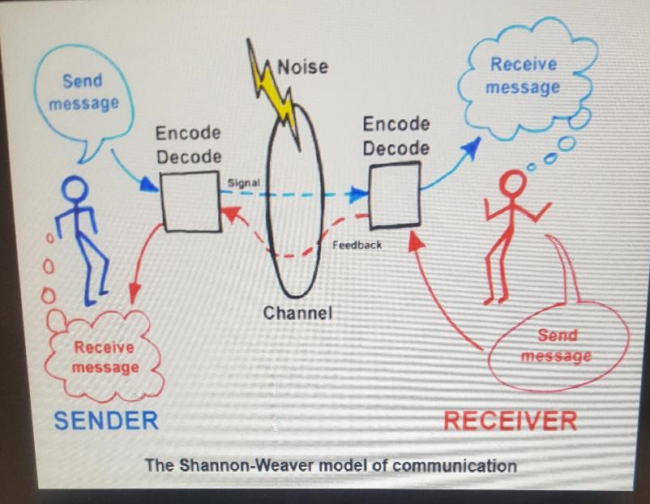
(b) Schramm is a method of communication that takes place between a sender and a receiver.
© Berlo is a method of communication which is made up of four components, which are sender, message, channel and receiver.
3.The importance of effective Communication is very important in our day to day lives more so in the workplace. When relaying information we have to make sure it is clear, precise and the person receiver the information can understand what is being said or written down.
4. Methods of communications are verbal, nonverbal, written and visual.
Verbal communication can be used when doing a presentation in a group, a phone call and meetings.
Nonverbal communication is using body languages, gestures and facial expression to relay messages.
Written communication is writing, typing or using symbols to pass on information. Email and chats are the most common forms of written communication used in our everyday activities.
Visual communication is using photographs, drawings, and graphs to pass on information.

5. Communication between management and employees are very effective . Managers should be accessible at all times meaning set aside time to answer phone calls, answer emails, give feedback, and be available to staff to answer any queries.
CONCLUSION
In concluding this I have talked about different communication skills used in our every day lives and in the workplace. How they are effective and how Managers relate to employees.
REFERENCES
- Https://www. Communication theory. Org
- https://www.indeed.com
- Https://work.chron.com
- Google



