Multi-stakeholder working - Identifying stakeholders
Effective stakeholder engagement within multi-disciplinary and inter-disciplinary projects will build partnerships and is critical to achieving organisational aims. It should also be undertaken by all staff, not just a communications team, but care should be taken not to overlap or create gaps.
Stakeholder categorisation
Stakeholders and their categorisation may be revised throughout the project, some exiting and others getting involved, each requiring a range of communication strategies.
One common method of division is CPIG (Figure 1) (Customers, Providers, Influencers and Governance) (Smith, King, Sidhu, Skelsey, & The APM Group Limited, 2014).
- Customers: The service-user
- Providers (or suppliers): The project doers/enablers
- Influencers: Anyone who may have a major influence on the overall impact of the project
- Governance: Help decide whether the change can be made and meets the required standards or protocols
Figure 1 – CPIG model (Smith, King, Sidhu, Skelsey, & The APM Group Limited, 2014, p. 179).
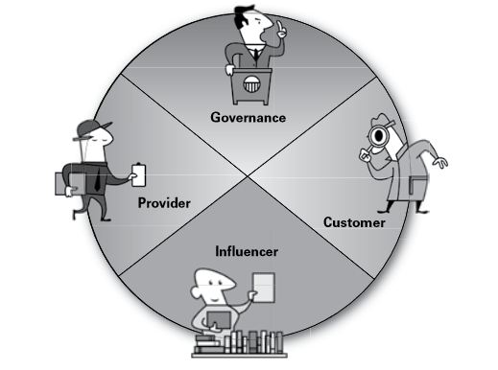
Identifying stakeholders may be achieved using rapid listing, individuals forming a list, group thinking or mind mapping.
Table 1 shows an individual’s categorised list of stakeholders who may be involved in the enabler from previous coursework submitted.

Table 1 – A categorised stakeholder matrix drawn from previous coursework
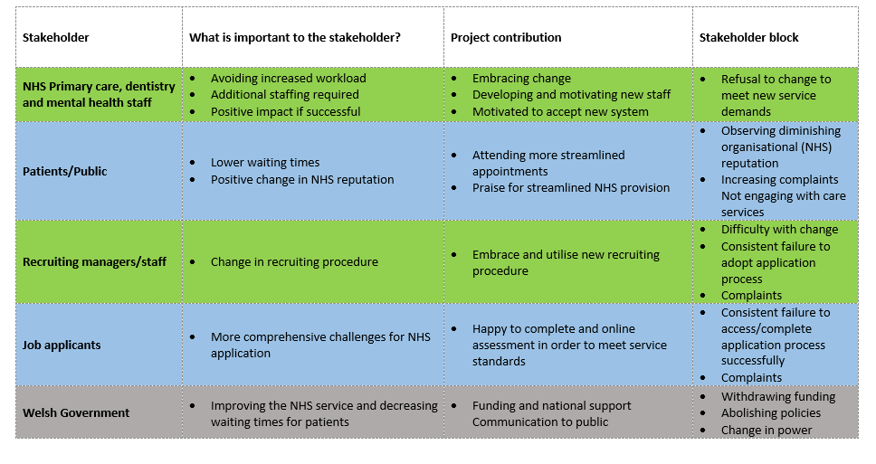
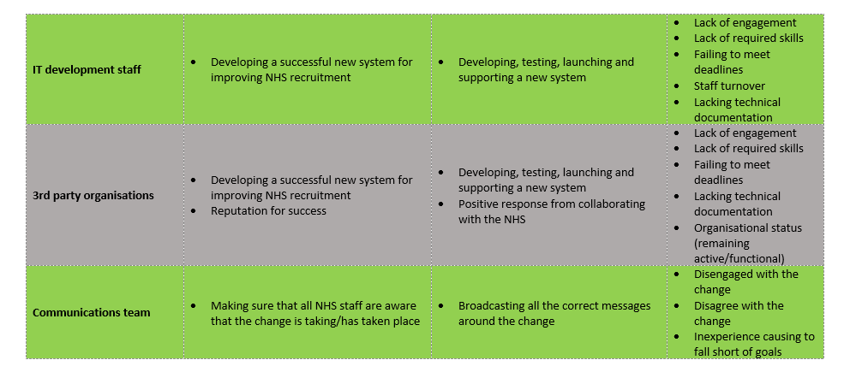

Stakeholder engagement
Stakeholders will carry a range of differing interest in any change and may therefore be categorised according so that an appropriate level of involvement and communication may be employed.
Stakeholder sets should be identified with a clear goal for each group, taking into account what is trying to be achieved and how we wish to influence them.
Cyclical evaluations of stakeholder relationships need to take place, with ways to measure whether the relationship is/has changed.
“Stakeholder engagement is pivotal to the whole process of effective change” (Smith, King, Sidhu, Skelsey, & The APM Group Limited, 2014, p. 172).
Convincing others plays a major part of stakeholder engagement and regular success in this area will result in more effective leadership (Smith, King, Sidhu, Skelsey, & The APM Group Limited, 2014).
Mayfield illustrated (Figure 2) how adding a second layer of engagement in addition to the traditional aspects allowed for human beings to be considered so, incorporating emotional states, influenceable by motivation (Mayfield, 2013).
Figure 2 – Illustration of Mayfield’s two layers of engagement (Mayfield, 2013).
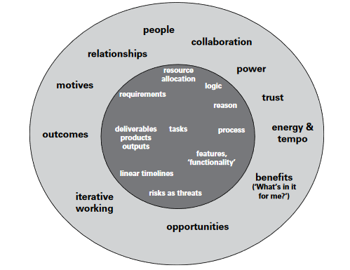
The outer circle highlights what needs to include in their focus for effective change, leading to improved staff engagement.
Power and interest
A power/interest matrix (Figure 3) is another very common, two-dimensional, tool for establishing the level of engagement required with particular stakeholders.
It measures a stakeholder’s influence over a project against their interest, mapping them into one of four categories.
Figure 3 – A power/interest matrix (Smith, King, Sidhu, Skelsey, & The APM Group Limited, 2014, p. 197), classifying the level of engagement required with a stakeholder.
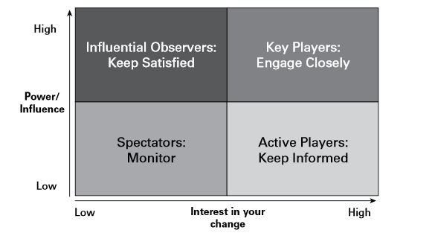
Table 2 – A power/interest matrix for stakeholders identified in section 1 (Identifying stakeholders)
Stakeholder | Power (1-10) | Interest (1-10) | Overall impact/  Engagement level
NHS Primary care, dentistry and mental health staff | 2 | 9 | 18
Patients/Public | 2 | 9 | 18
Recruiting managers/staff | 5 | 8 | 40
Job applicants | 5 | 3 | 15
Welsh Government | 10 | 9 | 90
IT development staff | 9 | 5 | 45
3rd party organisations/suppliers (if used) | 7 | 2 | 14
Communications team | 4 | 4 | 16

Stakeholder engagement plan
Stakeholder engagement is an iterative process, whereby behaviours need to be encouraging, interactive and inclusive, with a readiness for change.

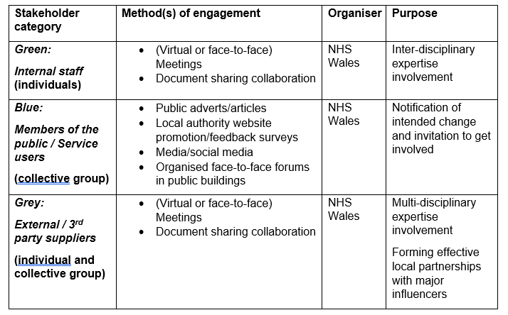
Table 3 - Stakeholder engagement plan

Critical reflection on personal experiences
Throughout my two decades of working in the health sector, I’ve held both website development and information technology (IT) support roles, which required liaising with numerous stakeholders in order to convey information or make changes.
Figure 4 illustrates a six-part framework tool (Gibbs, 1988) to reflect on the teaching and learning from situations or experiences, particularly repetitive ones.
(Figure 4) – 6-Part Reflective Cycle Framework (Gibbs, 1988)
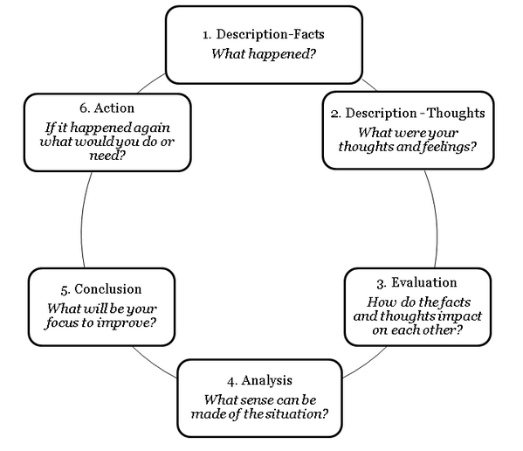
Example 1: Web development
- Description (Facts)
A vaccination department had brought information which they needed changing on their website. An approach from this team was a daily occurrence and I added it to my workload which, without reason, I tended to action in chronological request order.
A few days later, I tried to contact the team to clarify some detail, but there was no-one available.
Eventually, one of the team contacted me, asking why the information hadn’t been updated, stating that it was “clearly” time-sensitive, relating to changes to attendance details of the conference.
In view of this, I clarified and made the necessary changes, but some delegates didn’t receive the updated information in time, so failed to attend.
- Description (Thoughts)
My workload was constantly heavy at this particular time, so I was feeling overwhelmed as a result.
I also felt the conference organiser or programme head would likely challenge me on what happened at some stage.
- Evaluation
Other conference changes took place after this and I made sure they were uploaded promptly.
The conference went ahead as planned, was a resounding success, with only a few delegates missing.
- Analysis

Things concluded well due to the repetitive nature of the event since most delegates were regularly in touch with the programme and inconsequentially learned of the changes.
- Conclusion
Nobody engaged in conversation with me around this, but I couldn’t help thinking my prioritisation was lacking detail.
Usually, requests for this type of work would come with a highlight for any specific deadline requirements. This one didn’t, but I still felt I could have perused the content, which would have notified me of timeliness.
I also felt that the teams shouldn’t have left no-one available for query at such a critical time of the year for the programme, heading into flu season.

- Action

For all future website changes brought to me, I learned that a conversation of sometimes just a few sentences clarified prioritisation and resulted in a better experience from the programme, me and all stakeholders and conference attendees.
Example 2: IT Support
- Description (Facts)
An all-staff message needed to go out to the organisation around an unexpected outage during the migration of a service to a cloud-based equivalent.
As one of only a few users authorised to address the entire staff en masse, it was within my remit to communicate with other stakeholders using the Company Communicator application.
The notification was delivered via the Company Communicator application as intended.
I didn’t expect any response from other staff, and I kept updates regular, with sufficient detail.
The following day, I was contacted by the communications team, who asked me to engage with them prior to sending out such technical messages. They weren’t keen on my use of the word “Azure.”
- Description (Thoughts)
Having got my message to stakeholders very promptly with accurate detail, I felt my opening gambit was controlled and had clearly set my intention of handling the outage.
- Evaluation
Historically, the communications team already had a reputation of steering away from technical messages, but I considered this to be a balanced effort to convey relevant information.

No other staff contacted me to query the message, so the communications team approach felt a little unjust.
- Analysis

I was very surprised to be approached with a view to naively ‘dumbing down’ important technical information, which was appropriate for some staff, but just awareness of the outage enough for others.
- Conclusion
On reflection, if I’d engaged with the communications team beforehand, I could have stressed that the technical terminology in the message was required by some, highlighting that the rest of the message was sufficient for the less technical.
- Action

In future, maybe I should consider offering only the communications team and other critical technical stakeholders the information, for them to apply their expertise in taking any appropriate follow-up action.

Making the right decision
The main identifier of Groupthink (Janis, 1972) is when groups of decision-makers remain loyal to previous policies and norms in order to maintain morale, usually foregoing any critical thinking procedures which may reveal “…alternative courses of action” (Janis, 1972, p. 84).
Groupthink is often present when a strong and persuasive group leader may, convince a selection of loyal group members that a collective decision they are making is correct, despite there being evidence to the contrary.
Groupthink may also be recognised by some of the following symptoms (Smith, King, Sidhu, Skelsey, & The APM Group Limited, 2014):
- Losing sight of potential failure
- Ignoring opposing arguments
- Ignoring ethical consideration
- Labelling anyone who opposes a viewpoint as weak
- Accusing challengers of being disloyal
- Suppressing any doubts around consensus
- Silence is seen as agreement
- Group affiliates defend other group members from information which may challenge the consensus
Counter-acting consensus via Groupthink:
Employing critical evaluation skills
Develop an ability to observe, analyse, communicate and problem-solve.
Opinion of new group members
Seek the opinion of junior members of a group ahead of those of established members.
Expert or specialist
Consider the viewpoints of an expert/specialist in appropriate the field.
Alternative viewpoint
Identify a group member whose role it may be to develop and present an argument for an opposing viewpoint.

References
Tanguay, E., Hanratty, P., & Martin, B. (2020). Reflective Writing for Nursing, Health and Social Work. London: Bloomsbury Publishing Plc.
Cottrell, S. (2005). Critical thinking skills : developing effective analysis and argument. Palgrave Macmillan.
Dewey, J. (1910). How We Think.
Fook, J. (2007). Reflective practice and critical reflection.
Gibbs, G. (1988). Learning by Doing: A guide to teaching and learning methods.
Griffin, E. (1991). A First Look at Communication Theory.
Janis, I. (1972). Victims of Groupthink.
Mayfield. (2013). The task perspective and the change manager’s perspective.
OFCOM. (2018). Communications Market Report 2018.
Smith, R., King, D., Sidhu, R., Skelsey, D., & The APM Group Limited. (2014). The Effective Change Manager's Handbook: Essential Guidance to the Change Management Body of Knowledge.

