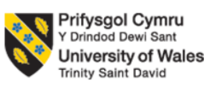

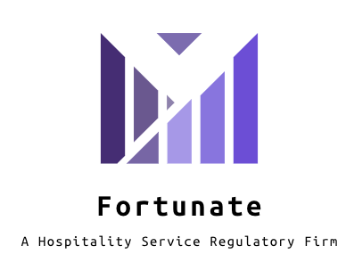
Programme: BA(Hons) International Hotel Management
Module code: BMIH6005
Module: Organisational Consultancy
Assignment Title: Consultancy Report
Lecturer: Emily Williams
Student name: Simona-Ancuta Stefan
Student number: 1817699
Consultancy report for Fortunate - A hospitality service regulatory firm
Name of the company: Fortunate - A hospitality service regulatory firm
Name of the client: XYZ Consultancy
Executive Summary
The following report had focused on the aspect of organisational consultancy. The report firstly had demonstrated the importance of the topic and had discussed how it helps in betterment of a company. Then the report discussed the Fortunate - A hospitality service regulatory firm. The report then went on to identify the scope and analyse it correctly. It then went on to perform a SWOT and PESTEL analysis on the mentioned company. It identified all the problems in the place and discussed the strengths that are present there.
From the SWOT as well as PESTLE analysis the different positive, as well as negative aspects of the business operations of the Fortunate - A hospitality service regulatory firm can be found out. It had been found out that the hotel had a strong brand image and it focused on the creation of its business policy by taking into consideration of the improvement of the level of satisfaction of the customers. Moreover, the quality of the food, as well as the beverages supplied by the hotel, were of good quality. It can improve its overall business revenue by implementation of Artificial intelligence as well as focussing on customer values. The report discussed certain theoretical aspects of management that could be used to put forth an improvement in the operations that are maintained by Fortunate - A hospitality service regulatory firm.
The action plan section had elaborately design the organizational action stating the problem and mitigation process. In the same section of the paper the discussion related to the potential outcome had emphasised in well manner. In regards to perform so the organization might take some time and expense that had mentioned through proper assessments. Apart from this, in the recommendation section the recommendation respecting on the organizational issues and shortcomings had advised. The recommendation might ensure the organization to operate the organization effective way.
The section of findings and analysis focused on the outcomes of the research on the hotel Hilton on food and beverages, staffing, accommodation, rooms, venue design and environment. The section dealt with the Hilton hotel organization that is public limited and private sector company that makes profit by selling certain things like room services, foods or meals and is also into expanding the business to maximize the customers and sales potential. The number of employees are also calculated around 173 thousand with specific reference to various departments starting from the bottom of the vertical line to the top.
Table of Contents
Introduction 5
Company Overview 5
Scope and Analysis 6
SWOT Analysis 6
Strengths 6
Weaknesses 7
Opportunities 7
Threats 8
PESTEL Analysis 8
Political 8
Economical 8
Social 9
Technological 9
Environmental 9
Legal 9
Discussion 9
Analysis of hotel operations – positive and negative aspects 9
Management Techniques by Which Hotel Operations Can Be Improved 12
Two factor theory 12
Expectancy Theory 14
Action plan 20
Recommendations 24
Recommendation 1: Creative and unique service approach 24
Recommendation 2: Implementation of AI for hotel management 24
Recommendation 3: Employee training and retention 24
Recommendation 4: Effective market practice 25
Conclusion 25
Reference list 26

Introduction
Organizations these days need to keep on bettering themselves and they can do this very thing by hiring professional consultants. The organisations often fail to utilize the maximum of their capabilities and impose risks upon themselves of declining. The consultancy agencies often help the businesses identify their true potential and help them to come up with strategies that will help them rightly to get to their goals. The businesses can jump back to earning profit from their respective operations and these agencies can do that.
The following report will focus towards creating a consultancy report for the Fortunate - A hospitality service regulatory firm in Boston. The report will focus towards identifying the problems the start-up is having and then it will perform a SWOT and PESTEL analysis on the mentioned business (TAKACS and VADUVA, 2017). The two selected methods will greatly help in understanding the hotel in discussion. Upon doing all of these, the report will suggest the hotel ways in which it can improve its operations in a right way. Then the report will list down the findings and provide a thorough analysis of the findings. Lastly, it will create an action plan along with providing recommendations.

Company Overview
The “Fortunate - A hospitality service regulatory firm” is a luxury hotel service situated at 878 Lyon Avenue in Boston. It is a beautiful hotel built in central Boston on 0.5 acres of land. It is a new hotel that has started its journey very recently and it is looking to attract customers who are looking for luxury services. It has a total of fifty rooms and a hundred employees work in the hotel. Mr. Z has established the hotel very recently and is looking to establish the business in a prominent way among the luxury customers of Boston.

Scope and Analysis

SWOT Analysis
Strengths | Weaknesses
Customers are looking for homelike experience away from home  The exploring options in local economy (El-Sawalhy and Farid, 2017)  Higher Profit  Huge number of employees | Expensive industry  High taxes  Existence of other prominent hotels in the area
Opportunities | Threats
Providing Unique services to its customers  Offering its customers with dynamic prices  Local and international tourists | The ongoing pandemic  Economic meltdowns

Strengths
The customers who avail hotel services are looking for home like experiences away from home. The customers who avail luxury hotels look for hotels that can provide them with best services in different areas. The “Fortunate - A hospitality service regulatory firm” can use that to their advantage and provide great services to their customers (Titomir and Danylova, 2018). They could provide their customers with right services like bed, washroom, electricity, built-in wifi, automated heating system, excellent food services and others to give them a good luxurious feeling.
The economy of the United States is blooming and the hotel could rightly use that to their very advantage. The country has a lot of hotels and restaurants and the number of incoming tourists in the industry is very high. The hotel could definitely explore the local economy and profit from that hugely.
The hotel in order to function needs a huge base of employees. A hotel usually has many operations within its system and that is why it needs many employees. The employee base in the USA is huge and the company could definitely benefit from that.
The hotel business is well known for the amount of profit it generates. It is a kind of business where one would get the right profit in connection to their investment.

Weaknesses
The company will be starting luxury hotel services and it will be expected to spend a lot of money on it (Kuo, Chen and Tseng, 2017). The investment for the company will be huge and as it is indulging into making a luxury hotel, it will only attract a certain kind of customer base.
The taxes on the hotel industry is usually very large and the hotel will be struggling in this department as it will have to pay a huge amount of money from its revenues.
There are other prominent hotels that have been serving a different range of customers over the years. The hotel will struggle to make a mark for itself among the other hotels that have been present there for long enough.

Opportunities
The hotel industry is very competitive and to stay relevant in it the company in discussion could dabble in certain unique prospects. The company could attract its customers by providing unique services.
The company could offer the same services as a luxury hotel at a different price. It will be able to attract new customers based on their unique prices.
The local and international tourists are always visiting the place and the hotel woulsd definitely benefit from that.

Threats
The ongoing pandemic has largely affected the hotel industry. International travel has been restricted and controlled largely. Different tourist attractions are locked to stop the contamination from happening. The people in this situation are not working and they have to rely on their savings. They are not travelling at the moment.
If an economic meltdown takes place in the country, the business will be affected negatively.

PESTEL Analysis
Political | - Government regulations
Economical | - Economic changes  - Change in foreign exchange rates
Social | - Social trend of travelling  - Reduction of discrimination
Technological | - Hotel industry is bettering itself with technological services
Environmental | - Weather condition of the country
Legal | - Legal environment of the country

Political
The “Fortunate - A hospitality service regulatory firm” is largely dependent on the tourism of the country and that is highly dependent on the government regulations of the countries in which it operates. If a country is very open about its tourism laws, it will take a huge amount of taxes from the hotel industry. In countries where a political strife is going on, there the Hilton Hotels will not perform rightly.

Economical
Any major change that will take place in the economy will affect the hotel industry largely. The hospitality industry has many luxury hotels in it and different economic fallouts such as recessions, inflations will affect the business wrongly (Cetin, Ultav and Funda, 2019). A sudden change in the rates of foreign exchange will affect the company directly as it will directly affect the ability of foreign customers to employ the hotel services.

Social
The newer generation is highly focused on the aspect of travelling and has turned into a trend. As in the social media platforms, people often indulge in the aspect of showing off about their lives, the trend of travelling has increased only. The hotel industry has become more accepting about people and discrimination has been put out of the view.

Technological
The hotel industry in recent times has used many kinds of technologies. The use of CCTV cameras for security or the feature of Wi-Fi intercoms are quite famous.

Environmental
The countries that do not have a favourable weather condition, will not experience large profits in the hotel industry. The company will be affected massively as the country bad weather conditions will not have enough tourists to entertain.

Legal
The legal environment of a country is extremely important for a hotel business to flourish. If the country does not have a stable condition, the business will be highly affected.

Discussion

Analysis of hotel operations – positive and negative aspects
From the SWOT and PESTLE analysis of the Fortunate hotel of Massachusetts different positive and negative impacts of the hotel, operations have been found out. It has been found out that the brand reputation of this hotel is very good and it focusses on the improvement of the satisfaction level of the customers. From the analysis of the business reports of Fortunate hotel of USA it has been found out that the organisation focusses on recruiting high quality staffs as well as improving its business strategy by focussing on creation of customer centric business model. This organisation focusses on improving the business strategy by providing the customers the full right to companions well as providing feedback (Madar, 2014). The organisation focusses on improving the reputation of the business and for this reason, it focusses on providing good quality products. One of the important business strategy of the Fortunate hotel is to become one of the best hotels of USA and that is why it focusses on creation of cross sectional team for achieving the cost efficiencies as well as improve the overall streamline process of business. This organisation focusses on the implementation of innovative technologies in the business process for improving the satisfaction level of the customers and the managers of this hotel take full responsibility in solving major complaints of the customers. The rooms of the major hotels of the organisation are highly decorated and the rooms have proper internet access. (Cetin, Ultav and Funda, 2019). The organisation shall focus on providing proper trainings to its staffs to cope up with the problem as well as improving the major problems related to review sites. The hotel has the opportunity to improve its overall business revenue of the organisation by implementation of innovative technologies. From the understanding of the strengths of the strengths as well as weaknesses in the business structure of the hotel it has been found out that the hotel faces severe competition from many of the competitor companies in the Hospitality industry of Boston and it shall focus on the creation of effective business strategy based on customer satisfaction.
From the analysis of the vision statement of the organisation, it has been found out that the Fortunate hotel is to make the everyday life of the customers better and for this reason it focusses on creation of improving the quick service restaurant experience of the customers. From the analysis of the financial reports of this organisation, it has been found out that the Fortunate hotel has created a positive impact on the lives of the customers. (Cetin, Ultav and Funda, 2019).
However different negative aspects can be found out from the analysis of the staffs of this hotel sometimes feels demotivated when the customers of this hotel complain to the manager about the quality of the products and services. It has been found out from the reports that the managers focus on providing a lot of pressure on the staffs for providing good services to the customers and that is why they fear of job losses. The different Government policies of the country namely USA have a significant impact on the operations of the organisation and that is why it can affect its overall business revenue. From the analysis of the reports as well as the webpages, it has been found out that the customers of this hotel faces different problems in the hotels related to the designs of the rooms as well as the quality of the foods provided (Sourvinou and Filimonau, 2018). It has been found out that the mangers of the hotel shall focus on motivating the employees from time to time to achieve the business objectives as well as distribute the tasks among them based on their capability.
Moreover, the organisation has a limited Market share and that is why it can affect the overall brand reputation of the organisation. The company is facing major problems in management techniques as the supply chain management process is not proper. The Fortunate hotel faces the problems related to the increase in the supply chain process costs as well as lack of maintaining security as well as the quality of the products it offers to its customers. As per the opinion of Kim et al., (2019), the supply chain management of the Fortunate hotel takes into consideration of the purchasing process, production schedule as well as inventory management. Moreover, the cost of transportation increases in the supply chain management process of the hotel as it faces problems in the operation as well as the distribution of the products (Ma and Qu, 2011). The Fortunate Hotel of Massachusetts shall focus on the change in the market requirements as well as the other factors that can hamper the overall business revenue of the hotel. It has been found out that the main weakness that the hotel has been facing in its business process is the high cost structure of the business process as it can increase the overall costs of the business.
The organisation shall focus on reducing the negative comments from the customers of the hotel as the negative comments can have a significant impact on the overall brand image. The organisation shall focus on providing staff training programmes as it can help them to serve the customers in a better way. From the financial reports, it has been found out that the organisation is facing major problems related to staff management as staff retention (Pham, Tučková and Jabbour, 2019). Moreover, it has been facing problems related to the guest expectations as the expectations of the guests are improving the quality of food and beverages as well as improving the right conditions of the hotel rooms. The other problems that the hotel has been facing arte related to the environment as well as venue design process of the hotel rooms as most of the customer’s complaints about the designing process of the rooms. Moreover, the Fortunate hotels are facing the problems related to environmental regulations and it has a plan of reduction of the net carbon footprints. (Elziny, 2019). Thus the Fortunate hotel shall focus on providing proper training to its employees to boost their motivation level.

Management Techniques by Which Hotel Operations Can Be Improved
The Fortunate - A hospitality service regulatory firm is a start-up organisation active across the hospitality sector. The concern should employ the following factors in order to improve operations.

Two factor theory
Two factor theory is propounded by Frederick Hertzberg in 1950. According to Two Factor Theory of Hertzberg, there are two motivational factors which have a role-play behind the satisfaction and motivation of employees. According to Holmberg (2018), motivational factors such as carer progress, enjoyment of their work and feeling acknowledged inspire the employees effectively. The other is hygiene factor and their absence makes the workers feel demotivated. It includes increase of wages, good relation between managers and workers, improvement of company policies and so on Thus, for the productive workforce the presence of these two factors are required.
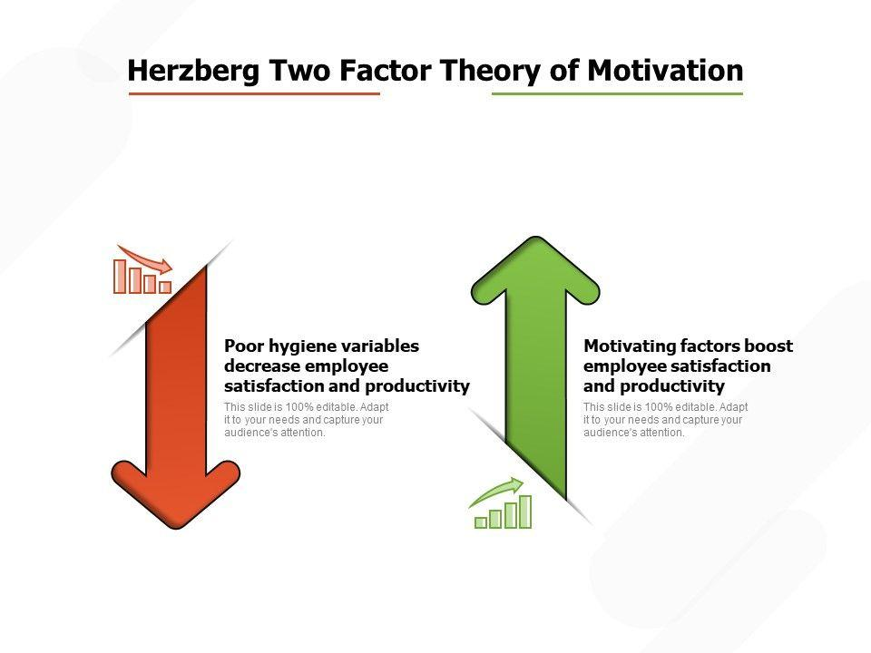
Figure 1: Two factor theory by Hertzberg
(Source: Alshmemri, Shahwan-Akl and Maude, 2017)
On the basis of this above mentioned theory Fortunate - A hospitality service regulatory firm can improve their operations. When the employees are motivated they feel encouraged and appreciated. The authority of Fortunate - A hospitality service regulatory firm should give their valuable feedback to the employees and accordingly they have to understand how the workers progress in their career by fulfilling organisational objectives. Hygiene factors can be utilised well by the authority of Fortunate - A hospitality service regulatory firm by paying the employees their desired salary and as well as creation of a comfortable work environment enhance their intuition (Harris et al., 2017). There should be a supportive relationship between the manger and the employees to improve the operation techniques of Fortunate - A hospitality service regulatory firm. Encouragement toward the employees can be shown by rewarding them through increased wages (Susilo, 2020). Inspirational keys help the staff to satisfy the customers well. The staff should talk to the customers politely and they should greet them heartily.
Moreover, the function of an employee is to satisfy the customers and for the smooth functioning of this criteria an employee has to be motivated and encouraged by the motivational factors as mentioned above. Gratitude towards the customers makes them feel valuable and appreciation of their concern through the management is a technique through which a hotel operates. Therefore, for the successful employment of this theory in the management principles of Fortunate - A hospitality service regulatory firm the authority has to prevent the dissatisfaction first and then focus on the individual preferences. Guest satisfaction is one of the major functions that a hotel authority has to fulfil (Baumann, and Bonner, 2017). The employees should learn the management skills through internships and participation in various events make them gain real life experiences. Recollection of the customers’ names and having an appropriate body language to communicate with customers is the other essential skill for any hotel worker. Verbal communication such as telephonic conversation is an appreciative move for systemising the hospitality industry (Lee, 2019). Therefore, politeness during a telephonic conversation is an essential part of management techniques. Proper care of the pets can be an important method of management and customer service. The arrangement for recreational games for the kids prevents their boredom and make their stay livelier.
Apart from this, regular guests can be offered with discounts or surprise gifts and it ensures their arrival in the hotel effectively. A record of the guests’ preferences such as their favourite food, room and other amenity choices should be there and celebration of special occasions such as birthdays, anniversaries make the customer service better (Alfayad and Arif, 2017). Cleanliness of the entire hotel premises including rooms, corridors, elevators should be maintained. Delegation is the other key factor in management principles of a hotel as if there is any big conference and the staff should be aware of the criteria for maintenance of customer service well. Hiring right employees for the right work becomes impactful when it comes to the matter of hospitality sector.

Expectancy Theory
The Expectancy Theory has been proposed by Victor Vroom. As per the Expectancy Theory, people decide to behave accordingly according to the outcome they achieve in the process. Thus, employees decide to work for long hours only when they get a higher pay. The theory is based on three components such as expectancy, instrumentality and valence. Expectancy denotes when there is a belief within the employee to achieve desired goals due to his effort (Hur, 2018). Instrumentality means the self-confidence to achieve reward if they can meet their objectives. Valence is when the employees put a value on the expected reward. Thus, according to this theory employee are motivated when the get a desired result.
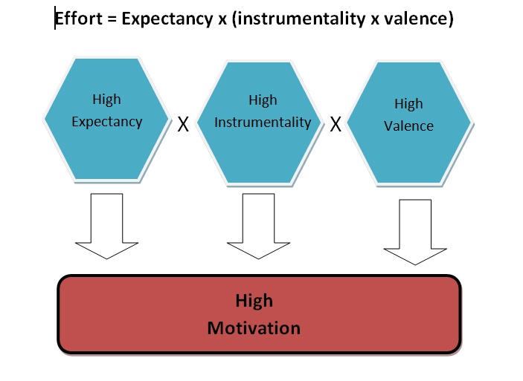
Figure 2: Expectancy Theory
(Source: Lloyd and Mertens, 2018)
Fortunate - A hospitality service regulatory firm can improve their management techniques by rewarding properly to their employees when they meet their target. Many times rewards don’t come in the form of rise of income or increasing bonuses. A hotel like Fortunate - A hospitality service regulatory firm can motivate their staff by the creation of opportunities of progress or by praising them or to create a style of “employee of the month” as such.
Maslow’s Hierarchy of Needs
The theory of Hierarchy of Needs is propounded by Abraham Maslow in 1943. According to this theory, the needs of individual must be fulfilled before they become motivated. According to (Hopper, 2019), the first requirement is psychological where a person should get his primary needs such as food, shelter and water. Next is ensuring of safety and security of a person mostly financial and physical. The feeling of love mostly centred in family and friends should be encouraged. Esteem is another need for employees and they should feel respected. The other is the need of self- actualization where one can feel that he can achieve something if motivated.
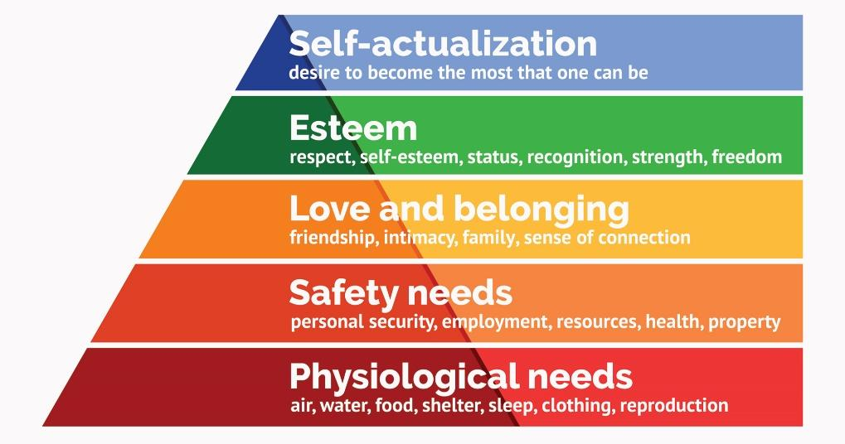
Figure 3: Maslow’s Hierarchy of Need theory
(Source: Hale et al., 2019)
Fortunate - A hospitality service regulatory firm might improve their management skills by following this theory. The staff has to understand the importance of the people they serve and by the display of the value of their function they feel motivated and can understand the job role they have to perform. The hotel authority should ensure the other psychological factors, safety issues of the staff (Rao, Kulshrestha and Ramakrishnan, 2019). They should chalk out a flexible work schedule so that the staff could spend a quality time with their family members. Their wage should be increase according to their ability and performance. The increase of income surely motivates them and if they get fair pay then their financial condition improves accordingly.
Findings and Results
The Fortunate - A hospitality service regulatory firm provides full service to the travelers from all over the world. The Fortunate hotel organization is the public limited and private sector company that makes profit by selling certain things like room services, foods or meals and is also into expanding the business to maximize the customers and sales potential. The hotel provides different services to the guests arriving at the hotel for availing their rooms.
Food and Beverage
Food and beverage being an important part of any stay offers a wide variety range of drinks and food even after being a start-up hotel. Customers have the choice of having dinner and relaxing in the only restaurant present in the hotel itself and have almost four variety of breakfast options for satisfying the customers (Serafim et al. 2018). Serviced accommodation is provided by the hotel along with accommodation facilities for different types of people. Various different kinds of services will be provided soon by the hotel for meeting the needs of the customers like that of relaxing spa and gym which is still under construction. The hotel provides facilities to both the business as well as leisure travelers. The portfolio of beverage and food in the hotel is truly encompassing. The hotel industry provides a prototype restaurant concept that is understandable on the universal basis. The hotel does not have the option of food takeaway but they are trying to setup a takeaway facility.
Accommodation
The hotel provides two buildings with thirty-two rooms for accommodating the travelers or guests for stay. This is one of the most important aspect for people who are on a trip or want to travel from one destination to another (Mody et al. 2017). The hotel is planning to change the accommodation in the hotel to split into different parts: Serviced accommodation and non-serviced accommodation. For now, the serviced accommodation is provided with maid services such as room cleaners who have the work of changing towels, bedsheets, serving food, drinks and beverages and more. The Non-serviced accommodation which will be provided by the hotel is like the stays in camping holiday, cottages, caravanning and more.
Rooms
The Fortunate hotel provides a number of suitable hotel rooms with perfect ambience where the rooms are categorised into three different kinds. There is availability of guest rooms, suits and executive rooms as well. King sized guest rooms are provided with the accommodation of two people having floor to ceiling windows, air conditioner, Wi-Fi, LED TV (Prabowo et al. 2019). The main highlights of the room accounts to the availability of mini bar, hair dryer, hand held shower, alarm radio clock and much more. A king deluxe room is also available with a perfect park view from the room itself. There is also availability of twin rooms of one is a guest room and the other is a deluxe room where four people could be accommodated.
Environment and venue design
The delivery and design of the properties are truly exceptional that rewards the partners of the hotel and also delights the travelers or consumers. The environment also reflects a unique culture of their geographic locations. The creative companies provide exceptionally varied designed properties that include operational relationships and also optimization of requirements that are spatial (Pennay et al. 2020). The operational relations are maintained in both the front house and back house areas of the hotel. The standards of construction and design is ensured for the operation of the property efficiently and economically.
The hotel aims to be environment friendly and introduced with the electricity facility that is carbon free. They have a further goal of reducing 20% of the energy consumption, waste output and carbon dioxide emissions. The strategy of waste reduction is evolved continuously for reinforcement and will be minimized in terms of waste according to the needs of the community.
Staffing and employee roles
The hotel has approximately 100 employees working on the floor in different departments. Fortunate is till now specifically referred to as one of the best place in the area to work with outstanding culture within the organization. The hotel provides both professional and personal growth with meaningful opportunities and is becoming competitive with other major hospitality industries. The possible number of languages, local challenges or countries are taken into consideration for keeping the best culture of having the feel like a family (Safavi and Karatepe, 2018). Team members are of central importance to everything that provides a lot of programs or ecosystem of programs for supporting the members of the team from the initial stage to the end. The employees are trained with programs starting from the date of joining till the employee is in work. The organization is always responsible to the shareholders, stakeholders and most importantly the employees. The employees are ensured with security in their job with good payment policies and a better working environment. The hotel is both horizontally and vertically integrated with a good number of facilities, rewards and offers. The sales of their hotel is on the verge of maximization by offering services that are additional or extra like breakfast, extra bed, fun packages of family along with conference facilities as well.
Regulations and Contribution to economy
The Fortunate hotel complies with the regulations of safety and health policies in the workplace. Not only to the employees but safety and health is also ensured to the guests as well. The hotel also complies with the act of Discrimination Disability that has convenient facilities for the disabled persons who are accumulated in lifts, toilets and rooms for their easy accessibility. The hotel has also started contributing to the GDP of the specific country in which it is located as well.
The hotel rooms are found to be clean with zero disturbances of cockroaches, bed bugs or other related insects (Petropoulos, 2017). People often have the wish for taking long and hot showers after travelling for so long. The hotel has got good ratings on the availability of hot water facilities in the washroom attached to the rooms. Even if there is no available facility of hot water services or geysers, the guests are shifted or transferred to better rooms with the same facility if available. The hotel consists of a number of employees in different departments for the ease of getting work done in an effective manner. There is a General Manager of the hotel who is involved or has the responsibility of the financial and operational result of the hotel or property. The manager also creates standards for the administration of personnel and performance, room rates, services to the patrons, publicity, food selection and advertising. There are hotel clerks who actually perform ample number of service giving tasks for the guests arriving at the hotel such as the check-in and check-out of the guests, assignment of various rooms to the guests and also answering the different questions, queries and inquiries of the customers to hotel services.
There are Bellhops who escort the guests into the hotels to the rooms and also assist with the luggage of the guests. They also have the responsibility of informing the guests about the services available for providing to the guests along with the other entertainment and hotel attractions. Bellhops also inspect the rooms of the guests to make sure on the point that all the things are present to satisfy the customers with the accommodation or not (Arsawan et al. 2018). There is also a planner for convention and meeting who will further plan for special events and meetings of different sizes. They also coordinate among the logistics like that of speakers, transportation, tickets, technology, facilities, equipment, printing and many more. The employees are trained with programs starting from the date of joining till the employee is in work. The organization is always responsible to the shareholders, stakeholders and most importantly the employees. The hotel provides facilities to both the business as well as leisure travelers. The portfolio of beverage and food in the hotel is truly encompassing with a prototype restaurant. The sales of their hotel is maximising by offering services that are additional or extra like breakfast, extra bed, fun packages of family along with conference facilities as well. The beverage and food department of the hotel has the responsibility or duties of producing or making, selling and serving food to the guests arriving at the hotel. The hotel has got good ratings on the availability of hot water facilities in the washroom attached to the rooms. Even if there is no available facility of hot water services or geysers, the guests are shifted or transferred to better rooms with the same facility.

Action plan
Serial no. | Problem | Solution | Desired outcome | Time scale | Completion Date | Planned Budget
 | Digital deployment | Fortunate being one of the start-up business organization, may face issues regarding digital deployment (AYHÜN, 2019). in order to work on it, the organization may implement different digital equipment for better management of the organization. Related organizational gadgets and other application may get implemented over here. | Processing with the system, the organisation may get customer response and can set target markets. Apart from this, employee and customer details with organizational record can be easily handle (OFORI, 2019).  . | 2 months | 21-03-2021 | £ 256.00
2. | Recruitment and retention | The organization, Fortunate may face issue related to employee engagement and their performance. Addressing this particular issues, the organization have to arrange proper training as well as advanced training for guest handling or hospitality and many more (Yeswa and Ombui, 2019). | The organization may successfully depict the organizational portfolio or reputation. With advanced technical training the organizational staffs may able to maintain different organizational function whether its related to the operational or house department (Septiant, 2020). | 6 months | 05.08.2021 | £ 785.30
3. | Increasing productivity | Fortunate being one of the start- up may get advice from XYZ consultancy for betterment of the organization. In that part the organization may implement advanced strategy to enhance their productivity that may have impartial impact over organizational reputation (Varelas and Georgopoulos, 2017). | The organization may get benefits with the development of the organizational productivity. In case the organization incorporate different organizational strategy and train their employee in better way, the organization may experience more response as well (Hanif, Rakhman and Nurkholis, 2018). | 5 months | 23-06.2021 | £ 823.20
4. | Branding and new market creating | Fortunate may get more opportunities to introduce their brand in market as the location of the organization is tourist hub. The organization initially can be branding their organization through infusing different marketing mix with the help of XYZ consultancy. Here, the organization may incorporate marketing mix, value proposition  customer demography  target market for better outcomes (Mykola et al., 2020). | The organization must target specific number of audience as well as market to establish their reputation. In that part the strategies and other marketing tools may help the organization to get extension (Nourlette and Hati,2017). With the advisory of XYZ consultancy the organization may get assumed benefits and organizational value as well. | 4 months | 31-06-2021 | £ 6548.35
5. | Decreasing cost | The organization is unable to bare huge expansion to operate different organizational operation and other management (Bacik, 2019). in time of implementing different organizational tools and techniques the organization have to maintain the cost through cost benefits analysis,  budget planning,  waste maintenance may practice. | In case the organization control the organizational expenses, it can practice different necessary performance such as brand promotion, advertisement and other organizational tools implantation. | 5 months | 25-06-2021 | £ 586.30

Recommendations
The organization, Fortunate being a start-up organization needs to perform a lot related for better management as well as to establish the organizational image in the particular industry. The intersection or the department of Fortunate needs to be organised enough and it needs to or to follow different international strategy for organizational expansion. Addressing the organizational requirements, the organization may get some specific recommendation for organizational management are following;

Recommendation 1: Creative and unique service approach
Being one of the start-up hotel organization, the particular have to be focused enough on organizational service and approaches. At the very first, the organization have to assess used tools or strategy and based on the concept the organization needs to have some unique approach for further development. Fortunate has to mould their service techniques and quality to get unique strategy for more customer response. It may help the organization to receive customer response and organizational value.

Recommendation 2: Implementation of AI for hotel management
The organization has to implement relevant AI system over the organization form the very early to support the organizational actions (Huynh, 2018). Most importantly, the organization is supposed to manage organizational network for customer interaction and industrial communication and to do so, the organization may adopt such advanced AI tools.

Recommendation 3: Employee training and retention
The organization, Fortunate may not get such experienced or skilled employee as per their wages policy. In regards, the organization have to employ candidate for serving their guest effectively. In that part the organization have to implement different organizational policies related to employee training. Even as per the requirement and growth the organizational authority have to focus on employee retention.

Recommendation 4: Effective market practice
The organization has to implement different marketing tools and techniques for getting more impartial outcome. Diplomatically, the organization has to assess the market scenario and company status for better management. to increase the organizational market and value the organization may get practice marketing mix, customer interaction and other to get reach to the customers.

Conclusion
The present study had critically evaluated the portfolio of and start-up hotel organization, Fortunate. The different section of the paper had explored the organizational information related to its strength, weakness and opportunity as well. The bottom line of the research study was to focus on the organizational assessment of Fortunate start- up brand and to advocate the present organization XYZ consultancy might advocate in effective way. In the early section, the present paper had reflected the necessary organizational values such as accommodation potentially, number of room and employee, beverage and housekeeping service of the organization. Even the particular paper had elaborated the other aspect that have to follow is, cost budget estimation, venue development and others. the concluding statement of the paper may state as, the entire study had coherently planed for an organization in order to development and others.

Reference list
Alfayad, Z. and Arif, L.S.M., (2017). Employee voice and job satisfaction: An application of Herzberg two-factor theory. International Review of Management and Marketing, 7(1), pp.150-156.
Ali, S., Md, I.M. and Mutsumi, T., (2019). Using SERVQUAL to determine Generation Y's satisfaction towards hoteling industry in Malaysia. Journal of Tourism Futures, 5(1), pp.62-74.
Alshmemri, M., Shahwan-Akl, L. and Maude, P., (2017). Herzberg’s two-factor theory. Life Science Journal, 14(5), pp.12-16.
Antwi, C.O., Fan, C.J., Aboagye, M.O., Brobbey, P., Jababu, Y., Affum-Osei, E. and Avornyo, P., (2019). Job demand stressors and employees’ creativity: a within-person approach to dealing with hindrance and challenge stressors at the airport environment. The Service Industries Journal, 39(3-4), pp.250-278.
Arsawan, I.W.E., Rajiani, I. and Suryantini, S.P., (2018). Investigating knowledge transfer mechanism in five star hotels. Polish Journal of Management Studies, 18.
AYHÜN, S.E., (2019). Strategic Management Tools: A Qualitative Research on Hotel Enterprises. Journal of Current Researches on Social Sciences, 9(1), pp.125-142.
Bacik, R., Kmeco, L., Richard, F., Olearova, M. and Rigelsky, M., (2019). Marketing instrument of improving hotel management service: Evidence of Visegrad group countries. Маркетинг і менеджмент інновацій, (1), pp.208-220.
Baumann, M.R. and Bonner, B.L., (2017). An expectancy theory approach to group coordination: Expertise, task features, and member behavior. Journal of Behavioral Decision Making, 30(2), pp.407-419.
Bismala, L., Tanjung, H. and Andriany, D., (2019, March). SWOT Analysis of Halal Destinations in North Sumatra. In Multi-Disciplinary International Conference University of Asahan (No. 1).
Bisoi, S., Mou Roy, D. and Samal, A., (2020). Impact of Artificial Intelligence in the Hospitality Industry.
Bushi, T. and Kumar, S., (2019) Promises and Challenges of Kaffa as Tourist Destination: SWOT Analysis.
Cetin, H.A., Ultav, Z.T. and Funda, U.Z., (2019). Reflections of the İstanbul Hilton Hotel on Mid-century Hotel Buildings in Turkey. Art-Sanat Dergisi, (12), pp.57-88.
El-Sawalhy, H. and Farid, M.B., (2017). Hospitality Industry Development via Scientific Research: SWOT analysis. Journal of Association of Arab Universities for Tourism and Hospitality, 14(2), pp.133-139.
Elziny, M., (2019). The Impact of Green Human Resource Management on Hotel Employees’ Eco-Friendly Behavior. International Academic Journal Faculty of Tourism and Hotel Management, 5(1), pp.107-126.
Felin, T., Gambardella, A., Stern, S. and Zenger, T., (2019). Lean startup and the business model: Experimentation revisited. Forthcoming in Long Range Planning (Open Access).
Gaafar, H.A.A.S.M., (2020). Artificial Intelligence in Egyptian Tourism Companies: Implementation and Perception. Journal of Association of Arab Universities for Tourism and Hospitality, 18(1), pp.66-78.
Gür, Z., (2019). Parallels between Two Identity Searching Nations in the 20th Century through the Museum and Exhibition Buildings. Periodica Polytechnica. Architecture, 50(1), p.67.
Hale, A.J., Ricotta, D.N., Freed, J., Smith, C.C. and Huang, G.C., (2019). Adapting Maslow's hierarchy of needs as a framework for resident wellness. Teaching and learning in medicine, 31(1), pp.109-118.
Hanif, H., Rakhman, A. and Nurkholis, M., (2018). New Productivity Concept Based on Local Wisdom: Lessons from Indonesia. J. Mgt. Mkt. Review, 3(3), pp.96-103.
Harris, K.J., Murphy, K.S., DiPietro, R.B. and Line, N.D., (2017). The antecedents and outcomes of food safety motivators for restaurant workers: An expectancy framework. International Journal of Hospitality Management, 63, pp.53-62.
Holmberg, C., Caro, J. and Sobis, I., (2018). Job satisfaction among Swedish mental health nursing personnel: Revisiting the two‐factor theory. International journal of mental health nursing, 27(2), pp.581-592.
Hopper, E., (2019). Maslow's hierarchy of needs explained. Viitattu, 12, p.2019.
Hur, Y. (2018) Testing Herzberg’s two-factor theory of motivation in the public sector: is it applicable to public managers?. Public Organization Review, 18(3), pp.329-343.
Huynh, N., 2018. Revenue Management for Small an Independent Hotel: An Action Plan for Hotel.
Jiang, R., Mao, C., Hou, L., Wu, C. and Tan, J., (2018). A SWOT analysis for promoting off-site construction under the backdrop of China’s new urbanisation. Journal of Cleaner Production, 173, pp.225-234.
Kim, Y.J., Kim, W.G., Choi, H.M. and Phetvaroon, K., (2019). The effect of green human resource management on hotel employees’ eco-friendly behavior and environmental performance. International Journal of Hospitality Management, 76, pp.83-93.
Kuo, C.M., Chen, L.C. and Tseng, C.Y., (2017). Investigating an innovative service with hospitality robots. International Journal of Contemporary Hospitality Management.
Lee, H.W., (2019). Moderators of the motivational effects of performance management: A comprehensive exploration based on expectancy theory. Public Personnel Management, 48(1), pp.27-55.
Lloyd, R. and Mertens, D., (2018). Expecting more out of expectancy theory: History urges inclusion of the social context. International Management Review, 14(1), pp.28-43.
Ma, E., Qu, H., Wei, X. and Hsiao, A., (2018). Conceptualization and operationalization of an altruistic and egoistic continuum of organizational citizenship behavior motivations. Journal of Hospitality & Tourism Research, 42(5), pp.740-771.
Martinez, B., 2017. A SWOT analysis on Millennials in the workplace: Increasing manager success with Millennial employees in the hotel industry (Doctoral dissertation, California State Polytechnic University, Pomona).
Mody, M.A., Suess, C. and Lehto, X., (2017). The accommodation experiencescape: a comparative assessment of hotels and Airbnb. International Journal of Contemporary Hospitality Management.
Mykola, I., Vadym, A., Lokutova, O., Anatoliy, P. and Romaniuk, I., (2020). Ways to develop brands and pr management of tourism enterprises with a focus on national markets. International Journal of Management, 11(5).
Nikolić, D. and Nikolić, J. (2020), The sceptical analysis of the marketing environment in the hospitality industry.
Nourlette, R.R. and Hati, S.W., (2017). Penentuan Strategi Dengan Pendekatan Analisis SWOT Pada Hotel Nongsa Point Marina & Resort Dalam Menghadapi Persaingan Bisnis. Inovbiz: Jurnal Inovasi Bisnis, 5(1), pp.82-102.
OFORI, E., (2019). Deployment of learning management system to promote an enhanced learning in higher education. Journal of Basic and Applied Research International, 25(4), pp.158-167.
Pascual-Fernández, P., Santos-Vijande, M.L., López-Sánchez, J.Á. and Molina, A., (2021). Key drivers of innovation capability in hotels: implications on performance. International Journal of Hospitality Management, 94, p.102825.
Pennay, A., Livingston, M., Cook, M., Room, R., Dwyer, R., MacLean, S., O’Brien, N., Nicholson, M. and Kuntsche, E., (2020). Sports bars: environmental design, drinking, and sports betting. Addiction Research & Theory, pp.1-11.
Petropoulos, G., (2017). An economic review of the collaborative economy (No. 2017/5). Bruegel Policy Contribution.
Pham, N.T., Tučková, Z. and Jabbour, C.J.C., (2019). Greening the hospitality industry: How do green human resource management practices influence organizational citizenship behavior in hotels? A mixed-methods study. Tourism Management, 72, pp.386-399.
Prabowo, H., Astuti, W. and Respati, H., (2019). Effect of Service Quality and Brand Image on Repurchase Intention through Word of Mouth at Budget Hotels Airy Rooms. Open Journal of Business and Management, 8(01), p.194.
Raharja, S.U.J. and Arifianti, R., (2018). Competitive Strategy In" XYZ" Four-Star Hotel Company in Tangerang City, Indonesia. Review of Integrative Business and Economics Research, 7, pp.117-126.
Rahman, M., Islam, R., Husain, W.R.W. and Ahmad, K., (2019). Developing a hierarchical model to enhance business excellence in hotel industry of Bangladesh. Management, 31(4), pp.1836-1856.
Rao, A.L., Kulshrestha, N. and Ramakrishnan, G., (2019). Adaptability and applicability of need hierarchy theory in assessing employee satisfaction with special reference to EPC company of UAE. International Journal of Business Excellence, 19(1), pp.1-15.
Romero, I. and Tejada, P., (2020). Tourism intermediaries and innovation in the hotel industry. Current Issues in Tourism, 23(5), pp.641-653.
Safavi, H.P. and Karatepe, O.M., (2018). High-performance work practices and hotel employee outcomes. International Journal of Contemporary Hospitality Management.
Sarker, T.R. and Al Saeed, L.S.L.A., (2020). Benchmarking Marketing and Business Strategy of UNIQLO to Start-up a Retail Shop in Bangladesh. Benchmarking, 12(2).
Seffar, O., (2020). Challenges of scaling a small business in the hospitality industry: implications for boutique hotels.
Septiant, A., (2020). Proposed Business Strategy for Hotel in Airport City (Case Study: Kualanamu International Airport). Research, Society and Development, 9(1), pp.e98911671-e98911671.
Serafim, A.L., Stangarlin‐Fiori, L. and Hecktheuer, L.H.R., (2018). Good handling practices in food and beverage areas of hotels: Evaluation of improvements achieved versus financial investments. Journal of Food Safety, 38(6), p.e12543.
Singh, N., 2018. SWOT Analysis of a Boutique and Lifestyle Hotel-Uncle Ming Retreat.
Sourvinou, A. and Filimonau, V., (2018). Planning for an environmental management programme in a luxury hotel and its perceived impact on staff: an exploratory case study. Journal of Sustainable Tourism, 26(4), pp.649-667.
Stevens, B., (2011). Hotel managers identify ethical problems: A survey of their concerns. Hospitality Review, 29(2), p.2.
Susilo, D., (2020). Macro-Regional Analysis of Tourism Entrepreneurship Environment in Bali: A Descriptive Study. International Journal of Economics, Business, and Entrepreneurship (IJEBE), 3(1), pp.1-13.
TAKACS, J. and VADUVA, S.A., (2017). A swot analysis of the global hospitality industry. Revista Economica, 69(6).
Thant, Z.M. and Chang, Y., (2020). Determinants of Public Employee Job Satisfaction in Myanmar: Focus on Herzberg’s Two Factor Theory. Public Organization Review, pp.1-19.
Varelas, S. and Georgopoulos, N., (2017). Competition as a critical factor of the strategic planning of hotel businesses. J Hotel Bus Manag, 6(167), p.17.
Velmurugan, T.A. and Sankar, J.G., (2017). A comparative study on motivation theory with Maslow’s hierarchy theory and two factor theory in organization. Indo-Iranian Journal of Scientific Research, 1(1), pp.204-208.
Werdani, R.E., Kurniawati, N.I., Pradhana, G.A. and Ginting, T.P.H., (2019, October). Promotion Strategy in Grand Mercure Medan Angkasa Hotel by SWOT Analysis. In International Conference on Maritime and Archipelago (ICoMA 2018) (pp. 380-383). Atlantis Press.
Yeswa, L.S. and Ombui, K., (2019). Influence of talent management strategies on employee retention in hotel industry in Kenya. International Academic Journal of Human Resource and Business Administration, 3(7), pp.83-103.

