Caerleon Roman Barracks (Castra)

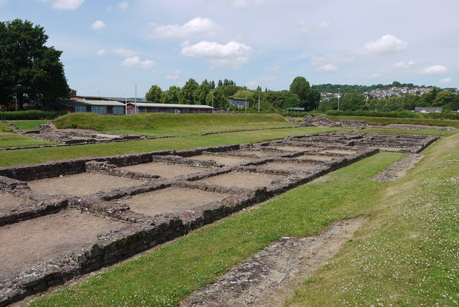

Founded in 74 AD by the Legion II Augusta as a fort at Isca (now Caerleon). This fortress would remain occupied until the end of the 3rd century. The fortress was founded so that Legio II Augusta were able to watch over the dominant South Wales tribe called the Silures.

Each “column” shown above would have been the quarters for a Roman Cohort (the picture above shows what was probably the Tenth Cohorts quarters). A Cohort numbered around 480 legionnaires or six centuries worth (excluding the 120 or so slaves that were assigned to the unit). The legionnaires were quartered in the square remains that you can see in the “columns”. These rooms were no larger than the standard marching tent. The men slept in one room with the other members of their Contubernium. The men would also eat with the members of their Contubernium in the other room where their armour was also stored.
The remains in the top right hand corner are that of the toilet facilities of the fortress, it is unknown how water was provided to them although it was likely hauled up as part of punishment duty.
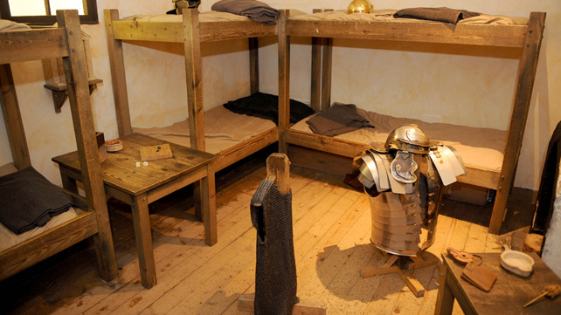

The picture above is what the sleeping quarters of the barracks likely looked like and show that they were surprisingly comfortable for the men. They are surprisingly reminiscent of modern military barracks today.

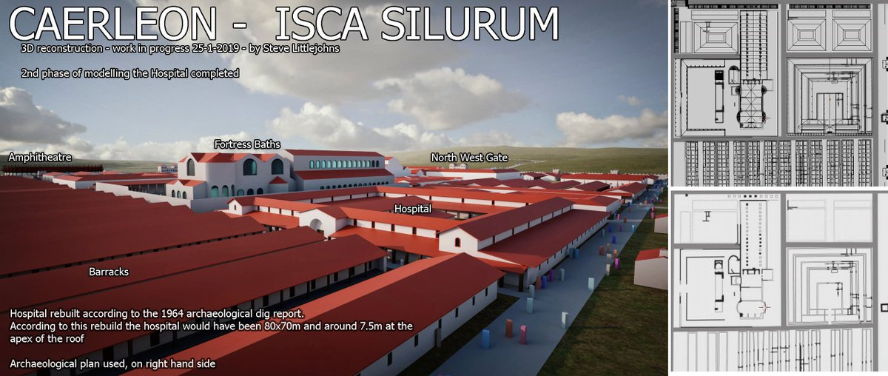

The image above shows what the fortress may have looked like whilst it was in use. It is unlikely that entire legion would be present at any one time and in fact it is known that during the fort’s history detachments of Legio II Augusta helped to build Hadrian’s Wall far to the north and served in Gaul as well at various points.

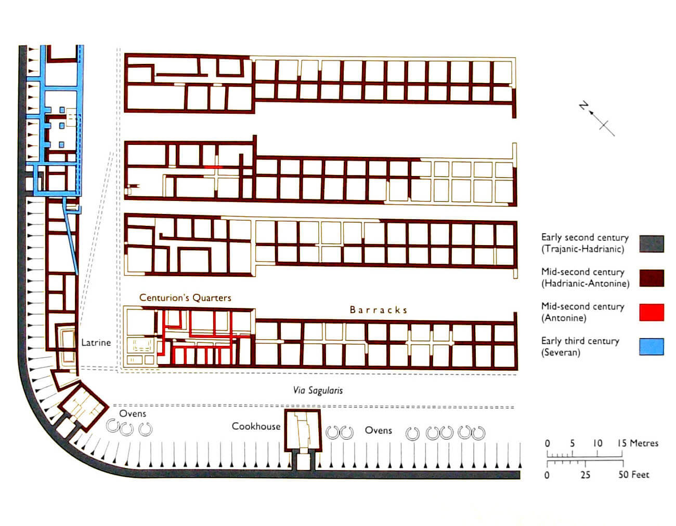
Above is a map of the ruins showing when the gradual changes and additions made to the fort throughout its service, an example of this would be that when the fort was founded it had a wooden wall built on an earthen rise with a ditch in front of it but by the forts closing it had a defensive stone wall built around it.

