Module Title: | Effective Team-working and Communication
Student Name: | Juned Ahmed
Student ID: | 2016399
Date of Submission: | 16th December 2022
Word Count: | 2187

Table of Contents
Introduction 4
Section 1: How to use teamwork theories to improve teamwork inside the organisation? 5
1. Tuckman's theory 5
2. Belbin's theory 6
Section 2 8
1. Issues and challenges faced within the case study. 8
2.Communication theories 8
2.1 Shannon Weaver Model 8
2.2 Schramm's Model of Communication 10
2.3 Berlo's Model of Communication 10
3. Recommendations 12
Conclusion 13
References 14

Figure 1: Shannon–Weaver model 9
Figure 2:Schramm's Model of Communication 10
Figure 3:Berlo's Model of communication 11

Executive Summary
Andrea Jones is the new local Council Social Services Head. Andrea replaced the departing Head of Service. Due to high employee turnover and absenteeism, team managers faced recruitment and staff shortages. Teams frequently failed. Staff shortages increased absenteeism. They also showed that teams have different standards and practices, so one social worker may decide a kid is in danger while another may disagree. Because they spent most of their time with families, social workers had awful connections, but when they returned to the office, there were so many new faces that they put their heads down, did their job, and left. When they were busy and needed help, they didn't know who to trust, so they did everything themselves, resulting in poorly written reports and cases being open longer than necessary. Firefighting prevented management from addressing underperformance. Verbal instructions are occasionally confusing and erred. Performance and concerns were seldom discussed. Due to workload, recruits received high caseloads without enough training. They fled feeling unsupported. The last Head of Service was uninvolved. He liked contacting colleagues at his workplace, but he was typically too busy to respond. His bosses heard his concerns in one-way discussions. Team managers heard from employees that they had great performance-improvement ideas but no mechanism to share them with senior management. Team managers also felt disrespected. Andrea and HR resolved concerns swiftly. First, they filled all team manager positions. Filling all social worker positions stabilized teams. The teams needed encouragement. This report attempts to identify Andrea's and her team's issues and provide corresponding recommendations.

Terms of Reference

16th December 2022
Melanie Squire
University of Wales Trinity Saint David
College St, Lampeter SA48 7ED, United Kingdom

Dear Teacher,
This report on team working and communication within the workplace was requested by ( ) as a part of the programme of Certificate in Higher Education – Skills for the Workplace. I would like to thank my course teacher for this opportunity, and all the people who helped me complete this report.

Sincerely,
Juned Ahmed
Student ID: 2016399

Introduction
The goal of any communication is to ensure that both parties involved are on the same page. When communicating, data must go from a sender to a recipient or recipient. The technique may be done through speaking, reading, listening, or writing (Gan, 2017). As a result, encoding and decoding are often used to transfer information that is based on ideas, emotions, or thoughts. Furthermore, the ability to communicate with others is crucial since it facilitates the sharing of knowledge and the attainment of mutual understanding. For instance, professional life often necessitates interacting with individuals who are culturally and linguistically dissimilar from one another. Effective encoding and decoding in the workplace allow for clearer communication and a deeper understanding among colleagues. Another key component is collaboration. The term "teamwork" is used to describe a collection of coordinated efforts toward a shared objective (Frazer and Oswald, 2019). Collaboration fosters teamwork since it is commonly accepted that combined efforts are more likely to succeed than those of individual members. Case analysis reveals ineffective methods of communication and teamwork inside the organization. This portfolio is dedicated to examining and critiquing the many ideas and methods of communication and teamwork to enhance the existing work culture of the office of the local council of social services.

Section 1
The case study makes it quite clear that the teams that Andrea oversees do not participate in productive forms of teamwork. They are faced with several challenges, many of which might be conquered by working together more effectively. The idea presented by Tuckman and Belbin illustrates an alternate path that might lead to enhanced teamwork.

1. Tuckman's theory
The psychologist Bruce Tuckman initially put forward Tuckman's idea back in 1965. In it, the five phases of a team's evolution—forming, storming, norming, performance, and adjourning—were outlined. These phases are meant to begin when the team first gets together and continue right up until the project is completed (Badalov, 2017). Here are the 5 Steps:
The forming
The formation phase is the initial step in a team's evolution. A new team has just been formed, and roles have been assigned. It's a fascinating psychological moment because individuals on the team are acting more autonomously than they have up to this point. There may be goodwill and purpose, but trust won't follow (Russ and Dickinson, 2019).
Storming
When the initial enthusiasm and good grace have worn off, the situation is said to be storming. The whole scope and pressure of finishing the project have probably finally struck at this point. At this point, pride may begin to surface, and tempers may flare. There may be disagreements or concerns raised by the team while they work to finish a job. The presence of a capable leader is crucial at this time (Lewis, 2018).
Norming
At this point, things have begun to stabilise. A rhythm of working together toward the same objective may be established on your team. There may be some overlap between the storming and norming phases during the norming phase. There may yet be disagreements when new jobs emerge. It may be simpler to resolve these differences now that you've passed the hardest portion (Cresswell-Yeager, 2020).
Performing
The group will find its stride once it takes the stage. The team members know each other well enough and are acquainted enough with one another's abilities and shortcomings to provide effective support. Members, at this point, are fully invested and eager to go on. This is also where they have the most freedom to do their work without fear of being caught. It's quite a feat since several teams never even make it this far. This is the point when all groups will be hoping to perform at their absolute peak. Creativity flourishes and morale soars when people are part of a close-knit group working toward a common goal.
Adjourning
Tuckman didn't finish his Model until 1977 when he included stage five. The group will break up after the project is complete. If they've become close by the time they're ready to perform, there may be a feeling of loss. Working with some of these folks again may be simpler if you have had pleasant shared experiences.

2. Belbin's theory
This strategy was introduced by a British psychiatrist named Dr R. Meredith Belbin, who also defined "team roles" as the propensity for individuals to exhibit certain behaviours, make particular contributions, and interact in particular ways with one another.
(A) Action Oriented Roles
Shapers - These individuals have the will and will to succeed despite the challenges they face. They are full of life and challenge, causing impatience in others while revelling in the thrill of working under pressure.
Implementers - The folks that fit this profile are often inflexible and set in their ways. They aren't able to see the future's potential. These people are effective, self-disciplined, and dependable, and they have a knack for making plans that can be implemented (Nanay, 2013).
Completers - These folks always keep things moving forward and make sure the team meets its deadlines. They worry easily and are very thorough. No amount of carelessness, whether intentional or accidental, is tolerated.
(B) People Oriented Roles
Coordinators - Since they dictate the team's next steps, these folks give off an air of manipulation. Despite their self-assurance, maturity, and ability to delegate, they lack the intellectual rigour and creativity of true leaders.
Team-workers - People with such sensitivity tend to avoid making tough choices. They have a knack for diplomacy, keep their cool under pressure, and can prevent fights from breaking out (Dexter and Franco, 2014).
Resource Investigator - These folks are very receptive to novel ideas and chances. However, when not under duress, they are easily bored and unmotivated.
(C) Cerebral Roles
Plant creative - They see the broad picture and don't get bogged down in the details. They understand the material, have good ideas, and can solve problems.
Monitors-Evaluator - These individuals make good decisions and pay attention to all relevant factors. Since they are also stubborn and unfeeling, they are not effective leaders.
Specialists - Professionals that are enthusiastic about their job make up this team. Nonetheless, they can't step back and look at the broader picture. Thus disagreements arise about little issues.

Section 2

1. Issues and challenges faced within the case study.
There are several issues and major challenges that are obvious from the case study. These concerns are presented in bullet point form below.
- High rates of employee absence and departure meant that the team constantly had to adapt to new faces and cover for absent members.
- Constantly establishing teams resulted in poor performance.
- Poor relationships exist among social workers.
- Management is too preoccupied with responding to emergencies to notice the team's lacklustre performance.
- Frequently, instructions were provided orally and informally, resulting in muddled signals and errors.
- Team meetings were infrequent thus there was little opportunity for feedback or complaints.
- The former manager's interactions with you were mostly nonverbal and unidirectional.
- Team leaders often heard complaints from staff members that they had many suggestions for increasing productivity but no way to relay them to higher-ups.

2. Communication Theories

2.1 Shannon Weaver Model
The Shannon–Weaver Model of Communication was developed in 1949 by Claude E. Shannon and Warren Weaver (Al-Fedaghi, 2018). This Model is sometimes referred to as the "mother of all models."

Figure 1: Shannon–Weaver model
Image Source: (Al-Fedaghi, 2018)
- The originator of communication (the "Sender") is the one who generates it and chooses the medium for transmission.
- A sender who employs an encoding technique to convert text into a signal or binary data is known as a transmitter (encoder).
- The Channel is the communication system that is used for sending out messages.
- A receiver, sometimes known as a decoder, is either the device or the human being that converts binary data or signals into messages.
- "Receiver" (or "Destination") may refer to either the person or the location where the communication has been sent. Depending on the content of the communication, the receiver responds accordingly.
- Noise is the natural interruption, such as people and environment, that inhibits the message reaches the recipient precisely.
The sender is the one responsible for translating their ideas and thoughts into a code that can be sent through a technological medium like a telephone. The message will be received and then decoded by the recipient into ideas and thoughts. It's possible. However, that interference from noise on the Channel may disturb the transmission process and interrupt the conversation.

2.2 Schramm's Model of Communication
Schramm's Model, developed by Wilber Schramm and influenced by the work of Shannon and Weaver, was first presented in 1954.
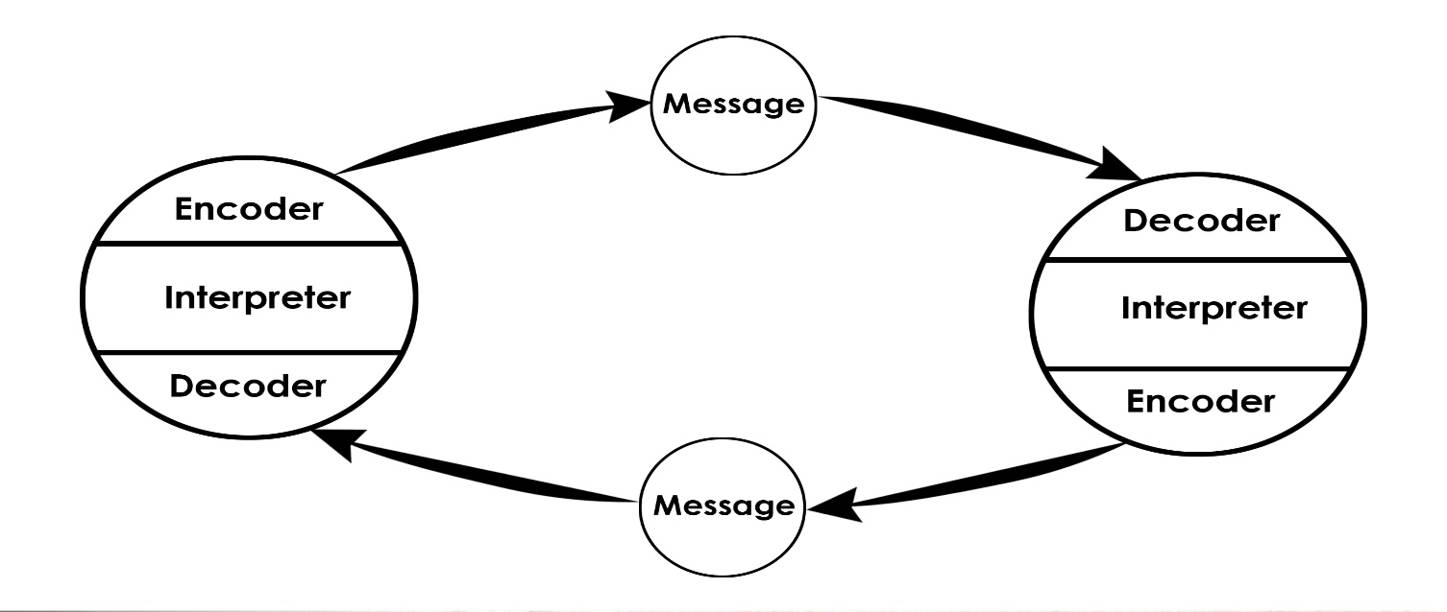
Figure 2:Schramm's Model of Communication
Image Source: (Nelson, 2020)

To begin the communication process, it is necessary to translate ideas and thoughts into messages, making encoding an essential aspect. An individual's first instinct upon seeing a message is to attempt to decipher it. Thus, encoding and decoding are crucial to effective communication since, without them, information would never be communicated (Nelson, 2020). Schramm maintains that a successful communication system requires two-way interaction between the sender and the recipient. Schramm's approach emphasises the need to take into account a person's knowledge, experiences, and cultural background while communicating with them since persons from different religious and cultural origins may have different perspectives.

2.3 Berlo's Model of Communication
To improve communication, David Berlo developed a new framework he calls the SMCR Model of Communication. Again, the Model by Shannon and Weaver from 1949 served as an inspiration. Berlo found what makes people's communication more successful, and it's a mix of factors. Berlo's methodology relies heavily on encoding and decoding, much as Schramm's.
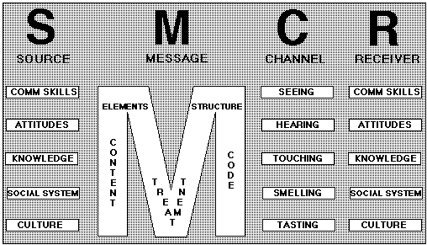
Figure 3:Berlo's Model of communication
Image Source: (Miller, 2016)
Berlo's Model consists of the "Sender," "Message," "Channel," and "Receiver" (SMCR) to facilitate comprehension. Several elements might affect each of them. The sender initiates the message's transmission and is hence the message's communication origin.
The recipient may be influenced by the sender's communication abilities, both positively and negatively. Not only do societal structures and cultural norms have an impact on communication, but so does the sender's attitude. Considerations such as the recipient's worldview, religious upbringing, and cultural norms might affect how they receive and respond to the message (Miller, 2016).
The sender's message is the information they've created just for the recipient. Various forms of communication, such as words, pictures, and texts, might be used. What's said in the message, how it's said, who says it, how it's said, how it's spoken, how it's structured, and how it's conveyed all have an impact on the message's reception.
How the message is sent is called "the Channel." In this context, "distance communication" might include everything from telephones to letters to the internet. A human's senses, however, also function as a communication channel, and this reduces the Channel's effectiveness. The five senses are auditory, visual, olfactory, gustatory, and tactile.
The recipient is the intended reader of the communication. According to Berlo's approach, for two people to communicate effectively, their mental abilities must be on par with one another. Otherwise, the intended meaning of the communication may be lost in translation. Communicative abilities, attitudes, knowledge, social systems, and cultural background should all be at the same level as the sender.
Communication obstacles like noise and the lack of a feedback mechanism are not taken into account by the Shannon–Weaver–Schramm model. Since the transmitter and the recipient must be on the same conformity level, this connection is unidirectional.

3. Recommendations
The two key problems in the case studies are concerns with teamwork and communication. Many issues have arisen as a result of social workers' failure to communicate with one another and with team supervisors and employers. Similar to how improper teamwork completely impedes the process. The previously discussed philosophies of teamwork and communication will be useful in resolving this. Additionally, the following suggestions are provided.
- Using Tuckman's approach to establish and grow motivated teams will minimise absenteeism and employee turnover.
- Establish permanent teams with space for substitution.
- Improve relationships among social workers
- Management should respond to crises while also monitoring performance.
- Instructions should be provided in a written format that is clear and easy to comprehend.
- Team meetings should be frequent and allow for two-way communication.
- Andrea should not communicate with her team infrequently.
- Members of the team should be able to propose and convey ideas to higher-ups.

Conclusion
The findings of the case study indicate that there is a significant breakdown in communication as well as cooperation throughout the firm as a whole. The verbal, nonverbal, visual, and kinesthetic modalities of communication were highlighted to a significant extent throughout the presentation of the portfolio. In addition to the significance of the value that can be derived from working together in business, there is also a need for communication that is both verbal and written to be crystal clear. This study examined Shannon-Weaver's, Schramm's, and Berlo's communication theories. There is additional consideration given to Tuckman and Belbin's perspectives on the nature of collaboration.

References
Al-Fedaghi, S. (2018). A Conceptual Foundation for the Shannon-Weaver Model of Communication. International Journal of Soft Computing, 7(1), pp.12–19.
Badalov, D. (2017). Personality Structure, Group Composition, and Group Functioning. Sociometry, 27(4), p.469.
Cresswell-Yeager, T. (2020). Forming, storming, norming, and performing: Using a semester-long problem-based learning project to apply small-group communication principles. Communication Teacher, 35(2), pp.1–11.
Dexter, B.P. and Franco, G. (2014). Team performance in ‘leading management’ – a ‘storming’ success?. Team Performance Management: An International Journal, 12(3/4), pp.115–120.
Frazer, R. and Oswald, P. (2019). Teamwork. New York: Simon Spotlight.
Gan, G. (2017). Communication. Philadelphia: Chelsea House Publishers.
Lewis, J. (2018). Review essay. Forming, storming, norming, reforming. Social Science Japan Journal, 1(2), pp.281–284.
Miller, G.R. (2016). The Process of Communication. College Composition and Communication, 11(4), p.250.
Nanay, B. (2013). Action-oriented Roles. European Journal of Philosophy, 20(3), pp.430–446.
Nelson, L. (2020). The Unique Perspective of Communication: A Retrospective View. Journal of Communication, 33(3), pp.6–17.
Russ, R. and Dickinson, J. (2019). Collaborative Design: ‘Forming, Storming, and Norming’. Journal of Psychology, 25(2), pp.52–58.

