University of Wales Trinity Saint David
School of Engineering

Hybrid Powertrain and Control
Module Code: ACEA7007

Zachary Church
1700054

Contents
1 Introduction 1
2 Drive Cycle 2
3 Buggy Specifications and Assumptions 3
3.1 Aero Assumptions 3
3.1.1 Frontal Area 3
3.1.2 Coefficient of Drag 4
3.2 Gear Ratios 4
3.3 Masses 5
3.4 Corner Assumptions 6
4 Forces 6
4.1 Acceleration 6
4.2 Equivalent mass 6
4.3 Resistive Forces 7
4.3.1 Aero Resistance 7
4.3.2 Rolling Resistance 7
4.3.3 Resistance Due to Gradient 7
4.4 Power, Torque, and Fuel Consumption 8
4.4.1 Power and Torque 8
4.4.2 Driving Force 8
4.4.3 Fuel Consumption 9
4.4.4 BSFC 9
4.4.5 Total Consumption 10
5 Graphs 11
5.1 Velocity and Aero Resistance 11
5.2 Acceleration 12
5.3 Gradient Change 12
5.4 Power and Gear 13
5.5 Resistive Forces 14
5.6 BSFC 14
5.7 Total Fuel Usage 15
6 Conclusion 16
7 References 17
8 Appendix 18
8.1 Matlab Code 18

Figure 1. Drive Cycle 2
Figure 2. Blitzworld Renegade DX-10c 300cc. 4
Figure 3. Rolling Resistance Coefficients. 7
Figure 4. BSFC Table. 9
Figure 5. Velocity and Aero Resistance Graph 10
Figure 6. Acceleration over the Lap. 11
Figure 7. Elevation Change Over the Lap. 11
Figure 8. Power and Gear Selection. 12
Figure 9. Resistive Forces. 13
Figure 10. BSFC Values. 13
Figure 11. Total Fuel Usage. 14

Equation 1. Fuel Mass. 5
Equation 2. Acceleration. 6
Equation 3. Equivalent Mass. 6
Equation 4. Aerodynamic Resistance. 7
Equation 5. Rolling Resistance. 7
Equation 6. Gradient Resistance. 8
Equation 7. Torque. 8
Equation 8. Drive Torque at Shaft. 8
Equation 9. Drive Force at Wheels 9
Equation 10. Driving Force. 9
Equation 11. Fuel Used. 9

Table 1. Buggy Specifications. 3
Table 2. Tire Specifications 4
Table 3. Gearing Specifications. 4
Table 4. Wheel Masses 5
Table 5. Fuel Weight. 5
Table 6. Total Weight of the Buggy 6
Table 7. Equivalent Mass per Gear. 7
Table 8. Power and Torque from Specification Table. 8
Table 9. Fuel usage and Laps per Tank. 10

Introduction
Outlined in this report is the calculating on forces and fuel consumption over a lap of a course at a corporate entertainment event. The course was made to be safe but entertaining for the employees. The buggy used was the Blitzworld Renegade DX-10c 300cc Corporate buggy.

Drive Cycle
The drive cycle for this report was derived from an imaginary track that might resemble a corporate event that would allow employees a chance to experience off-road buggies. The track itself was comprised of 4 corners making a loop that brings drivers back to the starting line. The track is 1,484 meters long. The track surface consists of a grassy field and a sandy section giving drivers a tricky change of terrain to deal with. There is a total of 20 meters of elevation change. There is a 10 meter downhill at a constant slope followed by an uphill further down the track that is 10 meters in height with a constant slope. The reason for the constant slope is that the track was assumed to be perfectly groomed and the down hills to be graded to the specified gradient to reduce risk of employees crashing.

Figure 1. Drive Cycle

Buggy Specifications and Assumptions
The off-road buggy detailed in this report is Blitz Worlds Renegade DX-10c Corporate 300cc model. The following important specifications are detailed in the spec sheet (Blitzworld, n.d.):
Table 1. Buggy Specifications.
Engine cc | 278
Power (hp) | 18
Torque (Nm) | 22
Top Speed (mph) | 30
Length (mm) | 2620
Width (mm) | 1650
Height (mm) | 1620
Wheelbase (mm) | 1440
Ground Clearance (mm) | 300
Weight (Car) (kg) | 365

Aero Assumptions

Frontal Area
The frontal area of the buggy had to be assumed to be 1.5m^2 because of the lack of actual data. The given overall height and width are given in Table 1. The overall width is listed as being 1,650mm but as shown in the picture the wheels stick out past the main body, so using the front wheel width the actual body can be assumed to be around 1200mm wide. The overall height is listed ad 1,620mm but the buggy has 300mm of ground clearance which means that the height of the main body is around 1,320mm. This means that the main body has an area of around 1.58m^2, including the wheels the frontal area can be assumed as being 1.6m^2.
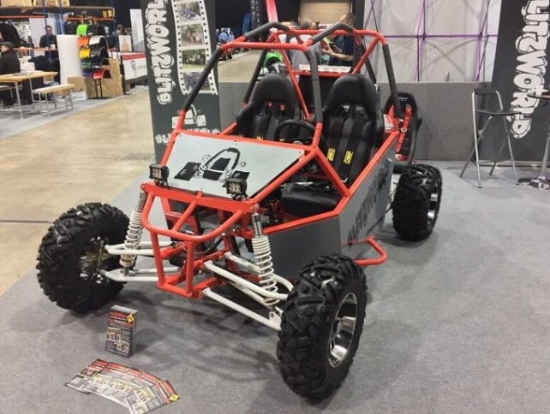
Figure 2. Blitzworld Renegade DX-10c 300cc. (Blitzworld, 2019)

Table 2. Tire Specifications
Front Tires | 24x8x12
Rear Tires | 23x10.5x12

Coefficient of Drag
The coefficient of drag was assumed to be around 0.6 because of the buggies open wheel and open cockpit layout. The tube chassis also contributes to this high number. A typical low drag road car has a Cd of around 0.3 so a Cd of 0.6 for an open wheel, open cockpit, tube chassis buggy with minimal body work appears to be a reasonable assumption.

Gear Ratios
For this particular report the buggy was assumed to have a 3-speed transmission was randomly chosen gear ratios that would produce a top speed just over 30 mile per hour as the buggy is electronically limited to 30 mph according to the specification sheet. This would give higher acceleration capabilities and more excitement for the pilot. The gear ratios are defined in Table 3.
Table 3. Gearing Specifications.
Gearbox A | Potential Road Speed From Gear Ratios
Selected Gear | Gear Teeth 1 | Gear Teeth 2 |  | Gear Ratio |  | Overall Ratio | Top Speed (km/h) | Top Speed (m/s)
Primary Drive Gear | 64 | 19 |  | 3.368421053 |  | N/A | N/A | N/A
1st | 29 | 14 |  | 2.071428571 |  | 23.9226638 | 34.52323767 | 9.589788242
2nd | 27 | 16 |  | 1.6875 |  | 19.4887218 | 42.3777309 | 11.77159192
3rd | 26 | 18 |  | 1.444444444 |  | 16.68170426 | 49.50859908 | 13.75238863
Engine RPM | 7500
Front Sprocket |  |  | 14
Rear Sprocket |  |  | 48
Final Drive |  |  | 0.291666667

A primary drive ratio, three gear ratios, and a front and rear sprocket. The primary drive is assumed to be from the crankshaft to the drive gear of the input gear shaft. The final drive of the buggy is chain drive according to the original specification sheet. The 3-speed transmission replaces the buggies original CVT style transmission.

Masses
The masses of the wheels needed to be defined for the calculation of the equivalent masses and the inertia of the mass of the rim and tire were looked at separately. From prior experience the entire bundle will weigh somewhere in the vicinity of 35 pounds. The Masses are displayed in Table 4.
Table 4. Wheel Masses
Rear Tire mass (kg) | 9
Front Tire mass (kg) | 8
Front Rim mass (kg) | 7
Rear Rim mass (kg) | 6

The weight of the buggy was defined in the spec sheet but for the calculations the weight of the fuel and the weight of the driver need to be added to the weight of the buggy. The weight of the fuel was calculated using the volume of the fuel tank which was 29 liters. The density of fuel is 0.75 kg/l (The Engineering Toolbox, 2003).
Equation 1. Fuel Mass.
$$Fuel Mass=Volume*Density of Fuel$$
The mass of the fuel was calculated to be:
Table 5. Fuel Weight.
Fuel Weight | 21.75

The weight of a driver and passenger were added to the buggy weight. An average weight of the driver and passenger with a driving suit and helmet was assumed to be 90kg multiplied by two to get total passenger weight.
The total weight of the buggy was then calculated to be:
Table 6. Total Weight of the Buggy
Weight Combined with Fuel (kg) | 566.75

Corner Assumptions
Corners in this report are not considered to be steady state like a motorcycle cornering model. From experience the corporate off-road buggies are driven a certain way, and that way would be with no mechanical sympathy as employees try to set the fastest lap times. The brakes and throttle are operated with the left and right feet respectively. This allows the driver to quickly transition from the throttle and brakes and back to the throttle. Coupled with the low speed and knobby tires there is no need for coasting anywhere on the course.

Forces

Acceleration
The acceleration was calculated with Equation 2. Acceleration. Deceleration was calculated using the same equation. Due to the surface and the track the deceleration was assumed to be 1.5 times greater than the acceleration ability.
Equation 2. Acceleration.
$$Acceleration=\frac{Force}{Equivalent Mass}$$

Equivalent mass
The equivalent mass is needed to calculate the acceleration values. The equivalent mass was calculated using Equation 3. Equivalent Mass.
Equation 3. Equivalent Mass.
$$Equivalent Mass=Total Mass+4*\frac{Wheel Inertia}{{Rolling Radius}^{2}}+Engine Inertia*\frac{Overall Gear Ratio}{{Rolling Radius}^{2}}$$
The equivalent mass reduces as the gear ratios get taller so that gives us the table below:
Table 7. Equivalent Mass per Gear.
Equivalent Mass
1st Gear | 631.7297767
2nd Gear | 628.6938698
3rd Gear | 626.7719132

The reduction is slight but noticeable in the data.

Resistive Forces

Aero Resistance
Aero dynamic resistance was calculated using Equation 4. Aerodynamic Resistance.
Equation 4. Aerodynamic Resistance.
$$Aerodynamic Resistance=0.5*CD*Frontal Area*Air Density*{Velocity}^{2}$$

Rolling Resistance
The rolling resistance in this report was calculated using Equation 5. Rolling Resistance.
Equation 5. Rolling Resistance.
$$Rolling Resistance=Mass*Gravity*Rolling Resistance Coefficient$$
The rolling resistance coefficient is a coefficient that changes with different surfaces. The rolling resistances for this report were based on the figure below. The “field” figure is what the rolling resistance coefficients are based off of. Included is a sandier surface with a slightly higher value than the grassy field section.
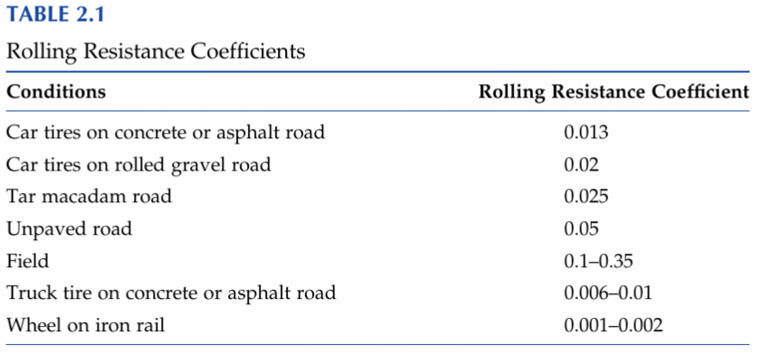
Figure 3. Rolling Resistance Coefficients. (Ehsani, 2019)

Resistance Due to Gradient
Moving resistance changes with gradient and is calculated using Equation 6. Gradient Resistance.
Equation 6. Gradient Resistance.
$$Gradient Resistance=Mass*Gravity*\sin{θ}$$
Where Theta is the incline angle of the hill. Most hills do not have a constant gradient, although the inclines of this particular track are assumed to have rapid transitions and graded to have a constant slope.

Power, Torque, and Fuel Consumption

Power and Torque
For this report power and torque figures were supplied with the original specification sheet, Table 8. Power and Torque from Specification Table.
Table 8. Power and Torque from Specification Table.
Power HP @ 6500 rpm | 18
Torque Nm @ 5500 rpm | 22

This only supplied the maximum values for the mechanical horsepower and torque but an entire power curve was needed for a lap simulation as the buggy does not operate at constant rpm at maximum power and torque values. To get the required dyno graphs, other dyno graphs from similar engines were examined and some values were selected for major RPM values. Then values in between were then interpolated using Matlab. Using the interpolated values the torque was calculated using Equation 7. Torque.
Equation 7. Torque.
$$Torque=\frac{(Power*7127)}{RPM}$$

Driving Force
Driving force was needed to calculate acceleration. Drive torque at the output shaft was calculated using Equation 8. Drive Torque at Shaft.
Equation 8. Drive Torque at Shaft.
$$Drive Torque at Shaft=Torque*Gear Ratio*Efficiency$$
Drive torque at the shaft changes with each gear.
Equation 9. Drive Force at Wheels
$$Drive Force at Wheels=Drive Torque at Shaft*Final Drive Ratio*Efficiency$$
Where efficiency in each of the equations above accounts for the loss in power through the drivetrain. For this simulation the total loss was estimated to be 6% at the wheel and 2% from drive shaft to the transmission (Wong, 2001).
Driving Force was calculated using Equation 10. Driving Force.
Equation 10. Driving Force.
$$Driving Force=\frac{Driving Force at Wheels}{Rolling Radius at Wheels}$$

Fuel Consumption
Total fuel consumption was calculated using Equation 11. Fuel Used.
Equation 11. Fuel Used.
$$Fuel Used=\frac{\frac{BSFC*KWH}{1000}}{Density of Fuel}$$

BSFC
The BSFC or brake specific fuel consumption is the fuel mass flow rate divided by the power output of the engine (X-Engineer, n.d.). To get the BSFC chart for this report a chart was provided to the students (Sanford, 2021). That chart was digitized and a new chart was created to match the torque output and RPM range of the engine.
Figure 4. BSFC Table.

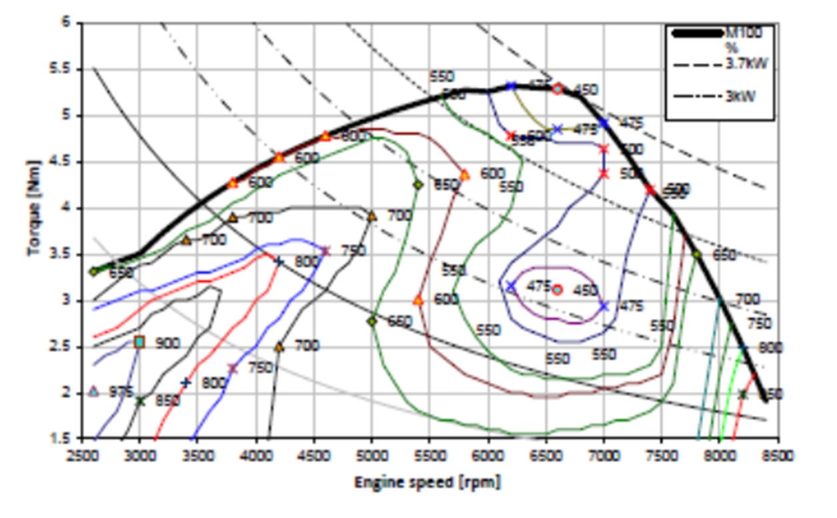
Figure 5. BSFC (Sanford, 2021)

Total Consumption
Fuel consumption was calculated over each meter of the track using the equations previously mentioned., then summed to get the total amount of fuel used per lap as shown in Table 9. Fuel usage and Laps per Tank.
Table 9. Fuel usage and Laps per Tank.
Total Fuel Usage (L) | 0.228100364
Laps Per Tank | 127.1370179

Dividing the total fuel used by the volume of the fuel tank which was advertised as being 29 liters. This tells us that the buggy can do 127 laps per tank. A company could give rides to 254 employees before having to refuel. The fuel economy of the buggy comes out to be 6.49km/l. Assuming to be carbureted and running poor quality fuel as an abused corporate entertainment buggy this value seems reasonable.

Graphs

Velocity and Aero Resistance

Figure 6. Velocity and Aero Resistance Graph
The Figure above shows both vehicle velocity and aero dynamic resistance the buggy experiences over the lap. This shows that as the velocity increases the aero dynamic resistance goes up exponentially.

Acceleration

Figure 7. Acceleration over the Lap.
Shows the acceleration values over the course of the lap some acceleration changes are quite dramatic.

Gradient Change

Figure 8. Elevation Change Over the Lap.
Shows the gradient change over the lap. The total elevation change is equivalent to 20 meters.

Power and Gear

Figure 9. Power and Gear Selection.
Shows the power output and the gear selection of the buggy over the lap.

Resistive Forces

Figure 10. Resistive Forces.
Shows the total resistive forces on the buggy.

BSFC

Figure 11. BSFC Values.
Shows the BSFC value selected over the lap

Total Fuel Usage

Figure 12. Total Fuel Usage.
This shows the total fuel usage as the lap went on.

Conclusion
Outlined in this report is power usage and fuel consumption for a Blitzworld corporate entertainment buggy. Through this report the driving forces and rolling resistance along with power output, were used to calculate the fuel consumption over the lap. The company using the buggy would not have to refuel the buggy until 127 laps in. At 2 minutes a lap it would take around 4 hours to drain the fuel tank. If the event takes the entire corporate workday, say 8 hours the company would only need to refuel the buggy once.

References
Blitzworld, 2019. https://twitter.com/blitzworldbuggy. [Online]
Available at: https://twitter.com/blitzworldbuggy?lang=it
[Accessed 28 November 2021].
Blitzworld, n.d. About Renegade DX10-C (Auto) Corporate 300cc Specification Sheet. s.l.:s.n.
Cossalter, V., 2006. Motorcycle Dynamics. s.l.:Lulu.
Ehsani, G. Y. L. S. &. E. K. M., 2019. Modern electric, hybrid electric, and fuel cell vehicles (Third edition, International student edition). s.l.:CRC Press, an imprint of Taylor & Francis Group..
Sanford, M., 2021. BSFC Information. s.l.:s.n.
Wong, J. Y., 2001. Theory of ground vehicles. 3rd ed. s.l.:John Wiley and Sons, New York.
X-Engineer, n.d. X-Engineer. [Online]
Available at: https://x-engineer.org/brake-specific-fuel-consumption-bsfc/
[Accessed 25 November 2021].

Appendix

Matlab Code
clc
clear all
power=xlsread('DiveCycelHYBRID.xlsx', 'BSFC', 'AC11 : AC25');
Powerinterp = fillmissing(Hp,'spline');
power= fillmissing( transpose(Hp), 'spline');
power= transpose(Hp2);

