Dissertation Proposal

Student Name – Chloe Willis
Student Number – 1700449
Student Course – BA Graphic Design

Word Count: 2272

Dissertation Proposal
How has LEGO and the way that children play and use their imagination changed throughout the years?

In my dissertation I decided that I wanted to look at Lego as I am a huge fan. I am going to look at Lego and how it has changed over the years. In the opinion of a lot of adults now think that children don’t know how to “play” anymore, this goes for Lego also, this is because of the shift from using your imagination to modem Lego sets where you have to use the instructions provided. When Lego first started the company was very imagination driven but now anyone can pick up a set and follow the instructions, it isn’t rocket science.
I think throughout the years Lego has gotten easier in the fact that you no longer need imagination to be able to build a Lego set.

My first key word I have chosen to unpack during my writing is imagination. The definition of Imagination is “the ability to form pictures in the mind” (Cambridge Dictionary, 2019) A huge part of the way that we learn and grow as people is through our imaginations. When children are young before they learn about the world around them, the way in which they interact with the world is through their imaginations. I want to look at weather since the start of Lego becoming the number one toy in the world has the way that it is used been changed since the beginning because children don’t use their imaginations the same as children used to when Lego began. Some children like to play through imagination and some don’t, I feel that children learn by imagination less and less as time goes on and technology gets more of an importance in their lives. When playing with Lego the goal has always been to be creative because you are creating something from plastic blocks in to anything you want and can imagine. I want to look at whether it is still possible to be creative while we are using instructions, rather than children using their imaginations. Are children’s creativity skills now being threated because of them copying an idea that already exists rather than using the ideas that they come up with, this is what I want to look at. In the image below is a image of two Lego bricks with the shadow of an aeroplane this is an example of how children show be playing with Lego, it doesn’t matter how good of a builder you are it matters that you can imagine what you want to make. Lego have recently started a project called The Lego Imagination Factory, this is an event that has been popping up around the UK to try and show children and adult fans alike how to use their imaginations when playing with Lego. Everyone involved will be made to wear a builder’s outfit and they are transported into the world of the imagination factory, this is where the building begins. I think it is very important that Lego themselves are going back to their roots and showing that imagination is at the root of their company. When Lego first became popular you would get a huge box of plastic bricks and that was it, sometimes if you were lucky there would be a few pictures on the box to follow, once your build was finished you would play with it for hours and ever changing it because you made it up in your imagination you made the rules. Now people buy a Lego set and follow the instructions then it will just sit on a shelf gathering dust. During my dissertation I want to look more into by being creative and using your imagination is less of a trend now how will children learn to think of their own if they are always falling instructions. Also, when children are using instructions for their Lego builds it sort of makes the experience a one person play because only one person can be following the instructions at a time, this could be harmful for the child’s development because they are learning to play alone rather than at a team.


My Second key word that I have chosen is play. as Lego is a toy first and foremost the most important part of the company is the play factor. The product could be the coolest most detailed pieces of art ever made out of plastic but it all come back to was it fun to build? Can It be played with now it is built? Lego fans range from ages 3 who play with Duplo to 60 year olds who have been playing with Lego since the start. Lego has also been a company that makes products suitable for 0 – 99-year olds that has been a running joke in the adult fan community for many years of what happens when you get to 100. I think Lego is a great bonding tool, because Lego has been around for so long it is very likely that if children are fans it’s because their parents are too. In the picture below, you can see a boy playing Lego with father, I think that this is a very interesting dynamic because the father is probably in the generation who think that Lego should be built with the imagination whereas the boy is in the generation that most of the time he would use instructions. The Lego group are a part of the Lego company that focus on the children and finding new ways for them to learn and play. “for the Lego group, play is a serious business, and a great deal of thought goes into making every Lego experience as enriching as it is exciting.” (Lipkowitz, 2018 p. 20) this quote is so important to remember because most people will think that Lego is just a massive company that is good at making a lot of money, which they are but it is important to remember that at the root of the company is still with play and teaching children new skills. I think Lego is a great tool to use to teach children so many skills in life some examples are when you knock a build over it is teaching them about gravity, there is a Duplo Train that teaches you to count, it teaches children how to share and one of the newest learning product they have is a Lego robot that teaches you how to code and all of this is being done through the method of play. Part of the reason I have chosen the work play as one of my key words is because I want to look at weather as time goes on are children forgetting how to play, are they too focused of IPad and technology that they just don’t know how to play with actual toys anymore. I want to look at play in my dissertation because I think that it is extremely important for children to learn how to play because it teaches them so many life skills such as problem solving and sharing, these are skills they will use for the rest of their lives. I also think it is important because as you grow older adults always want to go back to be a child and playing again, I think this is why there are so many adult Lego fans. If children don’t really play anymore then we will have a generation of adults who don’t have a good imagination or creative skills.
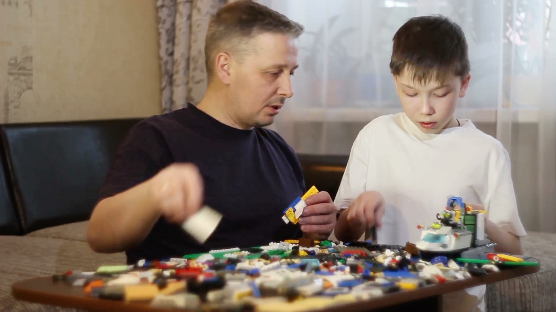

My final key word I have chosen is history. I have chosen this as my final word because Lego are a company who have been around since 1932, they are a company that is full of history that most people don’t even know about. Most of us have grown up with Lego and have seen it change into the amazing product we love today. Before Lego made the product that we now know they first started by making wooden toys such as Lego’s alphabet blocks and a pull along duck which was their best seller. In 1955 Lego introduced the System brick these were described as “the Simple but innovative idea that every plastic LEGO element should be part of a wider ‘system’ is still at the heart of LEGO building today” (Hugo, 2017, p. 10) I think its really important that the system brick which is a huge part of Lego’s story is still a massive part of the product today. In the picture below, you will see one of the first Lego sets that was ever made, this is a box a Lego bricks in the five original colours which were Red, Blue, Yellow, Green and White. I think its important to also note that over the 63 years since the launch of the system brick they have added 46 new colours which means we have 51 colours of Lego brick today, this is one of the small changes to the company has made to make Lego the brand we know now. Although a lot has changed since the system brick was launched there is one important thing that Lego fans are happy about, if you happen to have one of the first Lego bricks made in the 1950s they will fit perfectly with any bricks you by today. The three main types of Lego are System, Technic and Duplo these are the three main pillars for the Lego brand. System being where it all began, technic being the more modern kind of Lego building, technic is where mechanics and moving parts are used in the build. The final type of Lego is Duplo this is where the love of Lego normally begins as this is the Lego for younger children. Lego have come so far in the years they have been around, and I don’t think they are going to stop any time soon. I wanted to write about the history of Lego in my dissertation because I think it is something that people tend to miss when they think about the company. Not many people will know that Lego were first a company that made only wooden toys as of now where they don’t make any at all. Lego is a huge brand in the world and no one looks at the small details that makes them so successful.
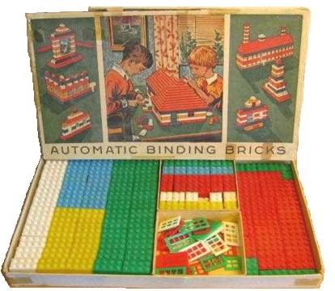
All of my key words are helped me come to the question “How has LEGO and the way that children play and use their imagination changed throughout the years?” during my dissertation I want to look into weather children’s creativity and imagination has been threatened by todays society and the rise of technology. I want to look at how child play now and what they would do if someone took the instructions away when playing with Lego. I want to look at how children solve problems now compared to how they used to when Lego first started. I also want to look at Lego as a company and how they have changed over the years, from system brick to the new product they are making today. I will also end of with looking at what Lego have in store for its future of the company. I think that is it going to be interesting to see where Lego has come from and Where it is going. I want to see how the future of Lego can affect children and how they play, weather Lego will ever be enough or weather they need more technology within the Lego brand. Lego have already started along the way of using technology within their company, this year they brought out Lego’s first remote-control car that you build all out on Lego bricks. If you look how far Lego have come, all the way from wooden blocks to remote control cars if blows the minds of Lego fans everywhere. If this is how far they have come so far, I can’t wait to see what comes next.

In conclusion I am very much looking forward to looking more into the world of Lego and how it affects and has affected children all over the world. I think that it is and will always be a very important part of history. Part of the reason that I wanted to do this topic for my dissertation was because of something my dad said when I brought a new Lego set. He said, “that’s not real Lego, you shouldn’t need instructions, I never did when I was a kid.” What he said painting the whole topic in my head. I wanted to write about Lego because it is something that I am very passionate about and I think the more you care about a topic the more you will connect with it. I want to look into the good things that Lego is doing for children all around the world whether that be with the sets they make or with the Lego foundation. I want to show people that Lego isn’t just a toy or isn’t just for children. Lego is a company that has changed so many people’s lives for the better. If you ask anyone if they have ever played with help the answer is probably yes. I think it is amazing how a company that started with 5 colours of 2x4 pegs bricks is now the biggest too companies to ever exist they have taken and will ever hold a spot in history for the innovation and genius that is Lego. Lego as a company should be the inspiration to toy companies all over the world, to be going for over 60 years they defiantly are doing something right.

Reference List

S Hugo (2017) Absolutely Everything You Need To Know London: DK

Cambridge Dictionary (2019) Imagination available at: https://dictionary.cambridge.org/dictionary/english/imagination

Behance (2019) Lego Imagination Factory available at: https://www.behance.net/gallery/66675707/LEGO-Imagination-Factory

D Lipkowitz (2018) The Lego Book London: DK

