Description | Physical Address
PC-A | 00D0.FFA6.A8BB
PC-B | 00D0.FFA6.A8BB
I discovered two MAC addresses one for each computer in my topology.

Pinging PC-B (192.168.1.11) from PC-A (192.168.1.10). Ping was successful with no dropped packets.

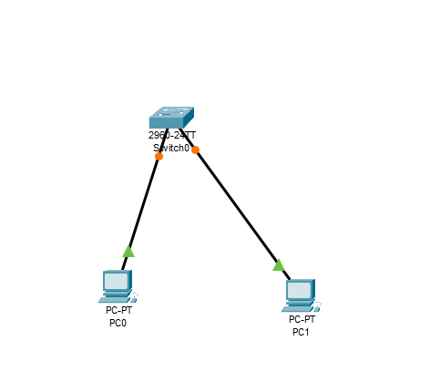

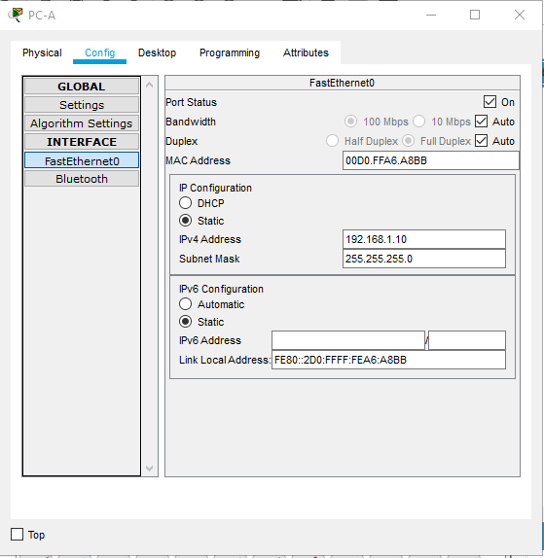
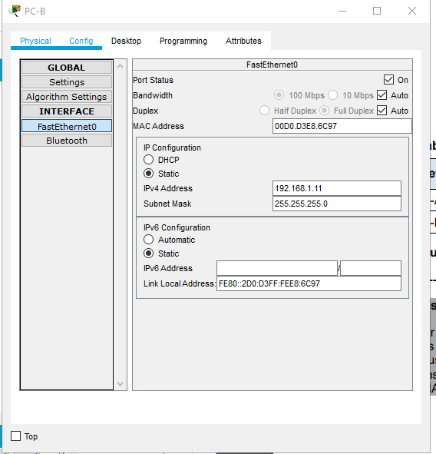

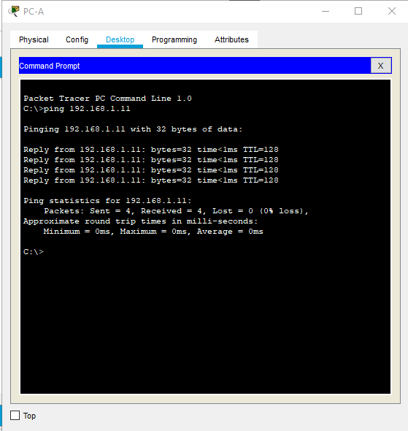

Manufactory OUI | Unique Identifier for the Interface | Vendor Name
00-D0-FF | 0-208- 255 | Unable to locate
00-D0-FF | 0-208- 255 | Unable to locate
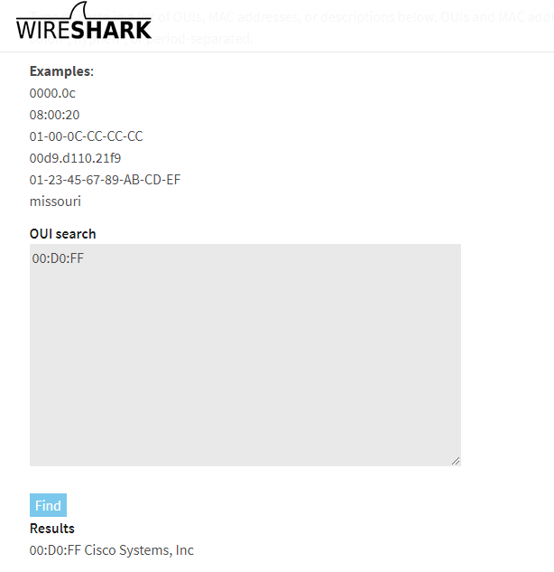

A computer may have more then one mac address if it contains more then NIC e.g. has two ethernet ports, has wi-fi adapter and ethernet adapter on the same machine.
No, the MAC address does not change as the MAC address is physical layer and does not change at any point regardless of if you have internet connectivity or not. The MAC address will always be displayed when using the ipconfig /all command regardless of the network connection.
MAC address can also be called the following names: Ethernet hardware address, hardware address, or physical address
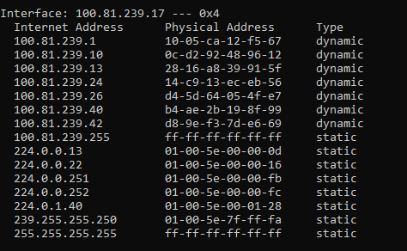
Arp -d is used to delete an arp entry
If the arp -d command is wildcarded with “*” it will delete all hosts.
The benefit of using an ARP cache on the machine is that the machine can recall IP addresses and MAC address from locations that data has previously been sent meaning that an ARP broadcast does not need to be done once the information is stored on the cache.
The target mac address will be the machine that is being communicated with e.g another desktop or laptop on your network that it is attempting to broadcast to via the ARP broadcast.

The source MAC address does match in Wireshark in comparison to the information provided via the ipconfig /all command.
Arp – a results:
Unable to complete the wireless adapter information task due to using a desktop that only contains an ethernet adapter and does not have a wi-fi adapter available.
You would activate one NIC at time if you were using a laptop and would be switching between using wireless interface when on the move but when at home you might be using the ethernet connection for a more consistent connection.
Y

