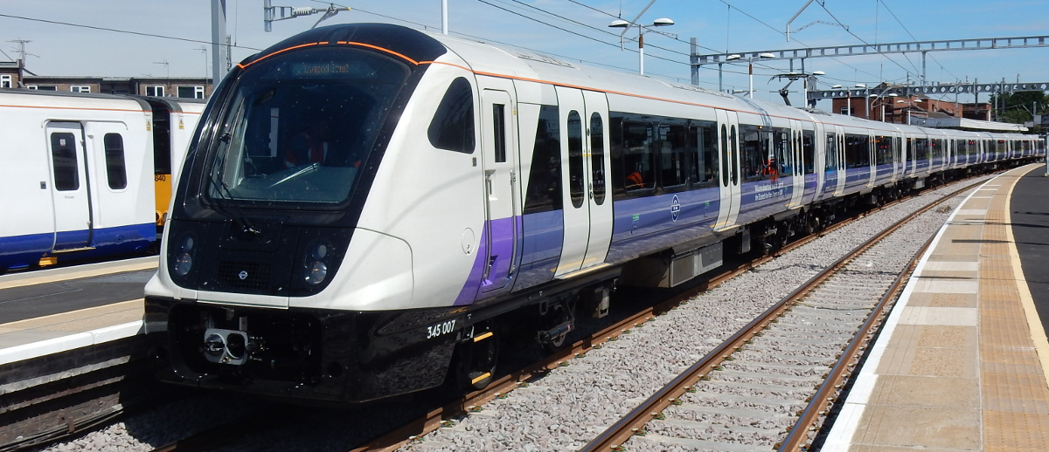
Project Management A2

Submitted by
Name Nikola Nikolov
ID 2014060
Date of Submission:16/01/2023

Contents
Introduction 3
A narrative on the Cross-Rail project 3
Success of the Cross-rail project 6
Lessons learnt from the cross-rail project 8
Recommendations 9
Conclusion 9
References 10

Introduction
Project management involves applying processes, methods, different skills, knowledge, and experiences gained to achieve specific project aims according to the project acceptance that has been agreed upon within the parameters (Larsson and Larsson, 2020). Project management is essential since it helps to effectively plan and manage a project to be successful in its listed objectives and deliverables. Furthermore, it is vital to ensure that every project is managed well since it involves identifying and managing risks, smart budgeting and transparent communication across multiple teams and stakeholders (Elia, Margherita and Secundo, 2020).
The Elizabeth Line is an East-West railway running through central London constructed as part of the cross-rail. This Cross-rail project has been aimed at increasing transportation and efficiency through an effective design of railways in the U.K.
This case study discusses the Cross-Rail project (Elizabeth Line) in applying effective project management. The essay gives a detailed narrative of the Crossrail project understanding and justifies why it is considered a success. The description also discusses the lessons I learned from the project and makes recommendations for a similar project.

A narrative on the Cross-Rail project
The Elizabeth line project is a practical project developed over the past 20 years with specific aims to help the government and the population. The main objectives of this project are to shorten the travel times for the public, decrease congestion and give passengers different options for their routes efficiently. This project is essential as it will promote population expansion within the U.K. and enhance transport connectivity within London. Furthermore, the project has aimed at ensuring that it improves accessibility for the population and increases travel safety through the reduction of traffic accidents that have been occurring over the past years due to traffic congestion and poor transportation systems utilizing transport (Zhang et al, 2020).
First, this project is essential since it will help increase commuting in Great Britain. It is crucial to undertake this project due to different reasons and aims established in this project's research proposals. This development will be helpful as it will increase the transportation of many people from one city to another. This project will help increase employment opportunities for the people within the U.K. as it will be essential to employ people to help in the labour works required within the project.
Additionally, this will promote job opportunities for unemployed persons (Anderson, 2022). For example, at the beginning of the Cross rail project, it was able to train more ta n 1000 people through apprenticeship, which has enabled individuals to gain employment opportunities in the construction industry. Furthermore, the project has also increased the number of women joining the industry as it trained more women to gain more experience in the project.
The development also helps to enhance the transportation system within the U.K. as it will lead to the construction of flyovers that will improve travelling time while going to or coming from Heathrow. This project will also be helpful as it will benefit the government to enact over 70km of tracks, leading to improved trans' reliability. The project will help to transport more people who will be travelling to different parts of the United Kingdom, including travellers from central London who can travel within approx. Forty-five minutes to their destinations (Williams and Black, 2018). This project is an example of improving transportation infrastructure throughout the whole U.K. However, this is important as it will increase the transport used in London, leading to rail transport being faster.
Furthermore, the enhancement of this development will improve the reliability of the transportation system since the project aims to use a shorter time for people to be at their destinations. According to Whyte and Nussbaum (2020), the Elizabeth line will be necessary for the community as it will increase people's connectivity to other places. In addition, this will be enhanced by cutting down the journey time people will spend travelling using the Elizabeth rail project.
The project will be practical and helpful since it will lead to installing the CCTVs, which will mean that security will be assured to the residents using it to travel. Installation of the CCTVs will entail proper management of the people as they will effectively monitor their travelling, their waiting and the railway system itself. Furthermore, this will expand the number of people using the cross-rail system. This development will also provide public transport to everyone within London city. Hence it will improve the reliability and availability of central London transport. Working on this project will also be essential since it will be easier to access the mode of transport, and people will be reliable while using it. I also think that the project will be practical as it will help to improve the U. K's rail capacity since it will be able to increase it by about 10% capacity, according to Chodorowski et al, (2021).
The project should also be given maximum time and concentration in order to ensure that it completes within the specified period. Different challenges have been experienced, which have led to the project being delayed. However, this completion allowed the construction of the cross rails to run smoothly without any complexity, as everything was undertaken effectively and efficiently. The project should also be given maximum planning which will enable it to avoid issues related to reviewing the budget and pushing away the proposed plans. It will be essential to ensure that the project runs as expected to ensure that the commuters can easily access the transport system. In addition, this project's stakeholders should also be trained and briefed about how the project should run.
Moreover, this will help increase the allocation of the responsibilities that are supposed to be undertaken by the stakeholders. The project should also ensure that it has enough materials to help it run more effectively without a stop. Different challenges like political factors and delays due to bonds street experienced in 2019 should not be a big deal to stop the project's operation. The project should be given maximum attention and reduced challenges to complete it and start operating.
However, the development is also likely to face different challenges. For instance, there were issues with underground tunnelling due to the already constructed houses and massive buildings, which have occupied the area that is entailed to be for the construction of the cross-rail project. The project is also likely to face lack of enough funds to support the construction project as the budget of the Elizabeth line project keeps on being reviewed from time to time making it to be reduced due to various factors including political and the recent pandemic. The project is also likely to face more time consuming due to different challenges being faced thus it should be allocated enough time to increase efficiency in working on the construction of the cross-rail project effectively.

Success of the Cross-rail project
I consider the cross-rail project to be a success since it will be able to be completed and will help to reduce the traffic congestion and pollution that is being faced currently in the U.K. This cross-rail project will be able to bring more benefits as it will be able to reduce the fatal accidents that keep on happening thus it will lead to zero damages as the people will be using it. Another reason for considering this project to be successful is because it will be aimed to be completed by the constructors since it can carry over 1.5 million travellers to central London in under 45 minutes. Therefore, the project will be completed to ease transportation and save time for transporting people. Although the project has been facing different challenges like coalition delayed the cross rail from being constructed in October 2010 due to the occurrence of politics, additional notices that led to the cross-rail holding up due to the schedule not being followed as stipulated and the occurrence of the global pandemic that led to the project being stopped for sometimes, this challenges will not hinder the project from being successful as plans have made on tackling the issue hence the construction of the cross rail project is still being carried out hence considering it is being successful.
The project will also be successful as the budget has been reviewed and it has been approved. Hence here are enough funds to ensure that the project runs to the end and gets completed within the estimated time. There have been optimistic forecasts, as seen in April 2021 when the government gave more time for the construction project cross rail; hence this can be considered a successful project. More time was given to the project to get completed to help people get a reliable and accessible transport system that will use a shorter time to transport people within various destinations. The cross-rail project has a transparent project management scope which will help guide the project to completion. Thus, this will increase the project to be more success. The cross-rail project has also increased its costs to be sufficient to run the project. Thus, this will help the project to get completed as enough funds help to run the project without facing delays in finance planning.
According to (Bal et al, 2013), quality stakeholders are essential in every project as they help to achieve success by coming up with rational and well-thought-of outcomes. For example, the cross-rail project has outlined that it has quality stakeholders who will help ensure that the project runs continuously and achieves the best outcomes, contributing to its success.
The quality and assurance participants create the consideration that the Elizabeth lines will be a successful project,since the quality stakeholders will be able to help in dealing with the different emerging challenges that might be associated in the development of the project as well as they will make critical decisions which will help the project to get completed in time thus being successful. The cross-rail project will have a good team working with each other in ensuring that everything that is required within the project is of quality and meets the needs thus this will contribute the project being successful.

Lessons learnt from the cross-rail project
From the Cross-rail project/Elizabeth line, I have learned different lessons from this project's formulation. First, it is vital to ensure that every project has effective management planning, which helps to execute different plans at every stage when carrying out the project. Project planning is crucial as it helps to outline the processes that will be entailed when carrying out the project (Harrison and Lock, 2017). It is also essential to have a project budget since it helps to give an overview of the amount of funds required to run and complete the project.The finance of every project should be carefully planned to estimate the amount required to complete the project. Additionally, this helps to avoid reviewing and reducing the project funds from time to time; hence, having an adequate budget will help strategically plan and manage the funds. I have also learned that it is important for project managers to ensure that they have quality stakeholders for the project to run well since they help make critical decisions concerning the ongoing project.
Another lesson picked from the cross-rail project is that it is essential to seek extra funds from private bodies to help run the project well apart from the funds received from government bodies, as it may not be enough to complete the project. It is also essential to ensure that every project has a scope that will guide it on how to carry out the construction of the project since the Cross-rail project had its scope, which helps it to be able to know the procedures and processes that should be carried after each other. Project scope management is essential to every project since it helps clearly define the project's aims, objectives, and requirements (Kerzner, 2017). Additionally, another lesson I gained from the cross-rail project was that it is important to ensure that every project has a project time management. According to Hornstein, (2015) project time management helps to develop schedules for the project tasks to be covered during the occurrence of the project. This was an essential lesson since I was able to learn on how to formulate project time management and how to assign a duration to the project activities.

Recommendations
Every project must have project management planning that will help it to effectively plan and place the strategic decision on the processes that should take place within the project. It is also important for every project to ensure that it plans an effective budget to help run and complete the project efficiently without disturbance. In order to ensure that funds have been planned effectively, every project should have a project financial planning which will help to execute the funds required to carry out the project in order to be successful. It will also be necessary for every project to have adequate time management, which will help the project to plan and schedule different activities against the required duration adequately. Furthermore, this will help the project to be able to carry out the tasks required and complete the project within the estimated time of the project. Finally, every project should also ensure that it formulates project quality management which will help projects to be able to fulfil the requirements of the projects.

Conclusion
The cross-rail project is a project that is being carried out within U.K in order to help ease and reduce the traffic congestion, and polution that is being experienced. This project is essential as it will help to transport over 1.5 million travellers to central London. However, this makes the project itself a valuable asset for the government. The development will improve the traffic capacity to about 10%. The project has faced different challenges but has managed to continue being carried out through engaging in different planning and reviews. The project will be successful as it has plans of getting it completed. There are different lessons that I have gained from this project. Recommendations have also been made to help similar projects that may be planning to take place just as cross rail project.

References
Anderson, M. (2022). Earthing Design and Installation for the Elizabeth Line. In Crossrail Project: Infrastructure Design and Construction (pp. 145-155). ICE Publishing.
Bal, M., Bryde, D., Fearon, D. and Ochieng, E. (2013). Stakeholder engagement: Achieving sustainability in the construction sector. Sustainability, 5(2), pp.695-710.
Chodorowski, A., Ingram, P. and Black, M. (2021). Crossrail project: the impact of 4–18 Bishop's Bridge Road on the new Elizabeth line, London, UK. Proceedings of the Institution of Civil Engineers-Geotechnical Engineering, 174(1), pp.83-90.
Elia, G., Margherita, A. and Secundo, G. (2020). Project management canvas: a system thinking framework to address project complexity. International Journal of Managing Projects in Business.
Harrison, F. and Lock, D. (2017). Advanced project management: a structured approach. Routledge.
Hornstein, H.A. (2015). The integration of project management and organizational change management is now a necessity. International journal of project management, 33(2), pp.291-298.
Kerzner, H. (2017). Project management: a systems approach to planning, scheduling, and controlling. John Wiley & Sons.
Mair, R. (2013), March. Tunnelling and deep excavations: Ground movements and their effects. In Proceedings of the 15th European Conference on Soil Mechanics and Geotechnical Engineering–Geotechnics of Hard Soils–Weak Rocks (Part 4). IOS Press, Amsterdam, the Netherlands (pp. 39-70).
Larsson, J. and Larsson, L. (2020). Integration, application and importance of collaboration in sustainable project management. Sustainability, 12(2), p.585.
Whyte, J. and Nussbaum, T. (2020). Transition and temporalities: spanning temporal boundaries as projects end and operations begin. Project Management Journal, 51(5), pp.505-521.
Williams, R.V. and Black, M. eds. (2018). Crossrail Project: Infrastructure design and construction. ICE Publishing.
Zhang, N., Hwang, B.G., Deng, X. and Ning, Y. (2020). Achieving transient competitive advantage in high‐speed rail projects bidding: Sustainable development perspective. Sustainable Development, 28(6), pp.1738-1754.

