10/08/2026

Configure and manage the Virtualised Enterprise network

ASSESSMENT 2
screenshots

University of Wales Trinity Saint David
LONDON CAMPUS

Module Name: Network Operating Systems and Services Module No: ACCA5023_LON)
Student Name: Azubuike Orizu
Student ID: 2440637
Group: 1
Lecturer’s Name: MD Sadeque Imam Shaikh

Table of Contents
Contents 1
Introduction: 2
Task 1 2
1.Routing 2
1a. Path Selection 2
1b. Packet Forwarding 2
1c. Network Segmentation 3
Purpose of RRAS & IP Forwarding 3
2. Domain Server 7
2.1. Forest 8
2.2 A record 10
2.3 Reverse lookup 11
3. Encrypted Connection between Birmingham and London 14
3.1. VPN 14
4. Users 16
5. Domain Membership 17
5.1. Domain set up 17
6. DHCP 20
6.1 Definition of DHCP 20
7. Test and Troubleshoot 22
8. Disk Drive 23
8.1. Shared Drive 23
9. IIS Server 26
9.1. 26
10. Remote Desktop Services. 28
10.1. Remote access 28
Conclusion. 30
References 30

Introduction:
Modern enterprise networks rely on a combination of routing, directory services, secure communication, and server based resource management to deliver reliable and scalable IT infrastructure[1]. This report documents the complete design, configuration, and deployment of a multi site Windows Server environment spanning the Birmingham and London networks. The solution integrates essential services including Routing and Remote Access (RRAS), Domain Services, DNS, DHCP, VPN connectivity, user and group management, shared storage, IIS web hosting, and Remote Desktop Services (RDS), all of which are foundational components in contemporary distributed systems[2].
The report begins by examining routing fundamentals such as path selection, packet forwarding, and network segmentation, which are critical for efficient data movement across interconnected networks[3]. This is followed by an explanation of RRAS and IP forwarding as the foundation for inter site communication. It then explores the structure of the domain environment, including forest creation, A records, and reverse lookup zones that support name resolution across Birmingham and London—key mechanisms for ensuring Active Directory functionality and service discovery[4].
Secure connectivity between the two sites is achieved through an encrypted VPN tunnel, enabling seamless resource access for authorised users while maintaining confidentiality and integrity of transmitted data[5]. Subsequent sections detail user account creation, domain membership, and DHCP configuration to automate IP allocation. The report also covers shared disk drives, network file access, IIS web server deployment, and Remote Desktop Services for remote application delivery—technologies widely used in enterprise environments to centralise management and improve scalability [6].
Finally, testing and troubleshooting procedures validate the functionality and resilience of the entire system. Together, these components form a fully operational, secure, and scalable Windows Server infrastructure suitable for enterprise use.
Below are the screenshots.

Task 1

1.Routing

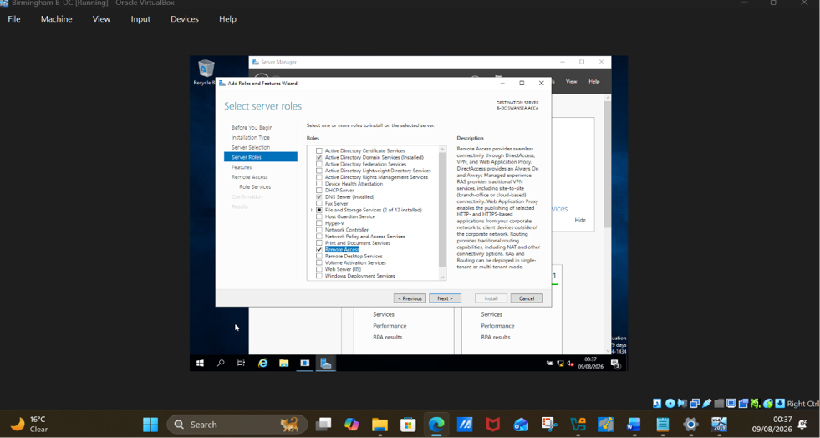
Fig 1. tick on remote access (routing is included in remote access)

- Under Role Services, tick direct access & VPN and also tick Routing
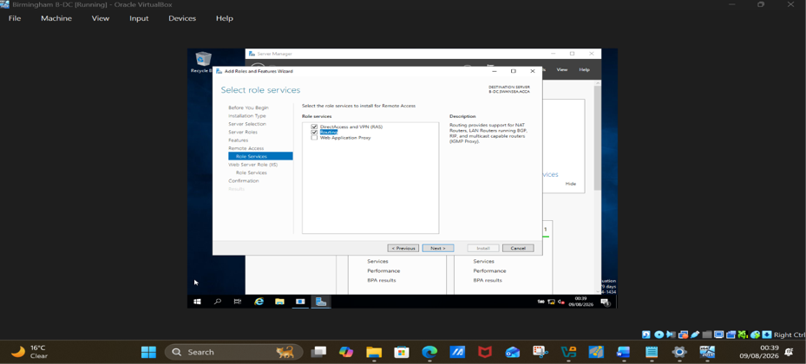 Fig 2. Installing VPN and Routing.
- Complete installation
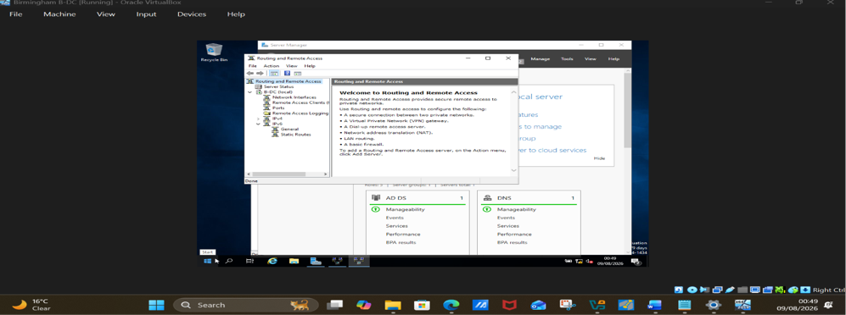
Fig 3, Routing remote access configured.

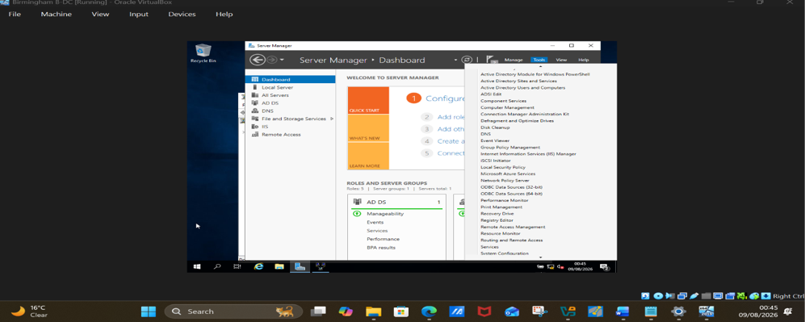
Fig 4, routing and remote access as shown in tools.

1.1b Modify firewall rules to allow ICMP traffic.
Goto tool and click on routing remote access, click on IPV4, click on general
And then ethernet.

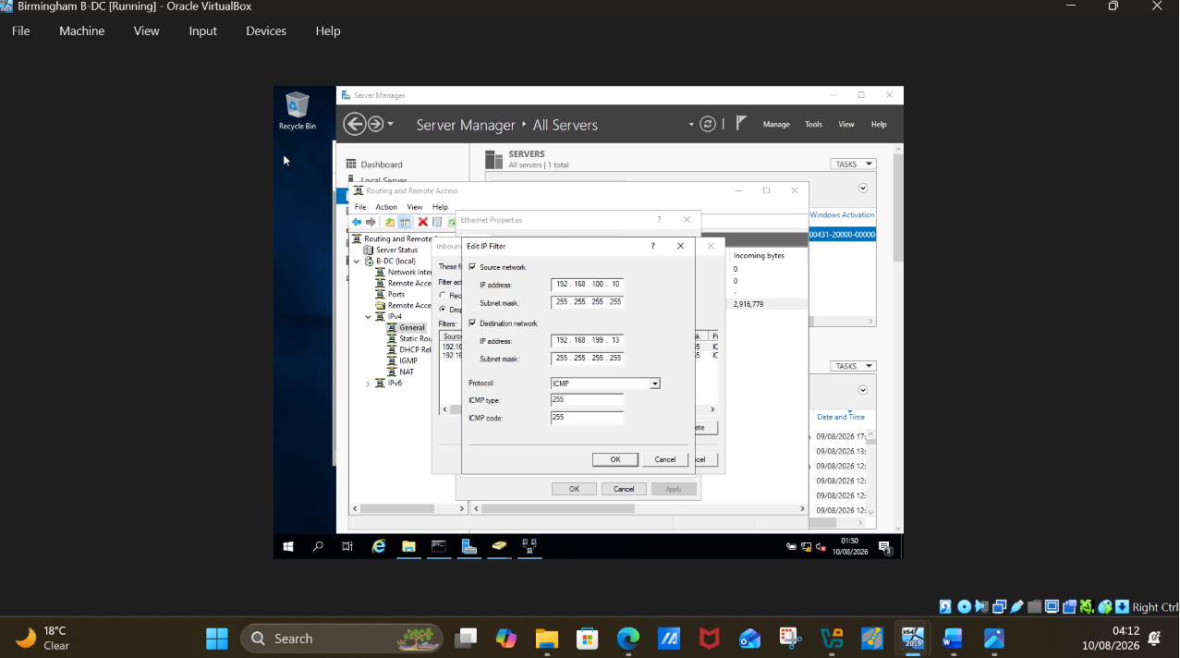
Fig 5. Inbound firewall rules modified to allow ICMP traffic.

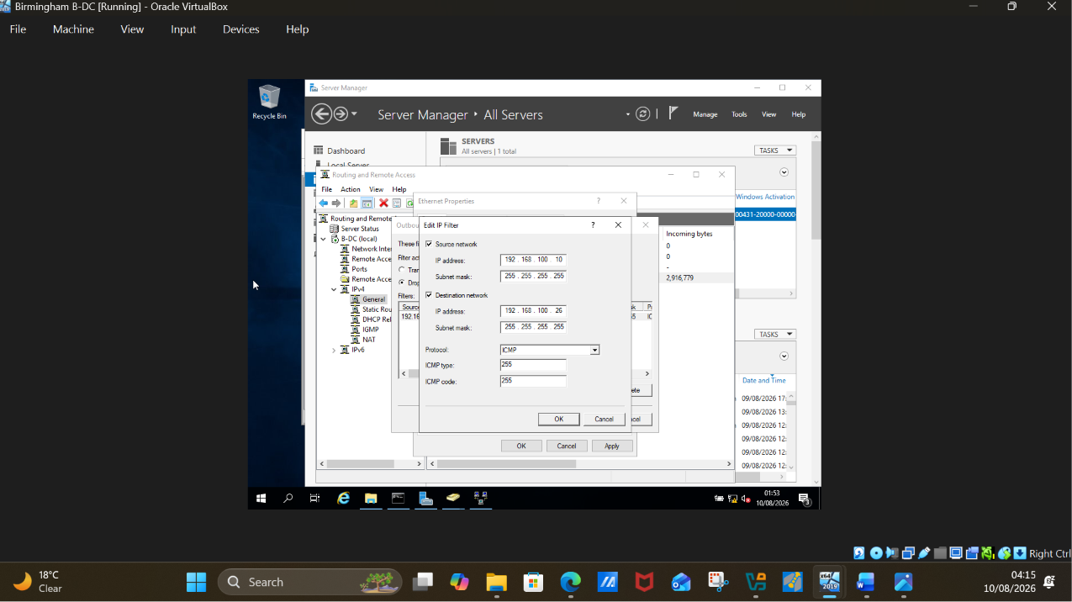
Fig 6. Outbound firewall rules modified to allow ICMP traffic.

1.2 IP forwarding and Routing

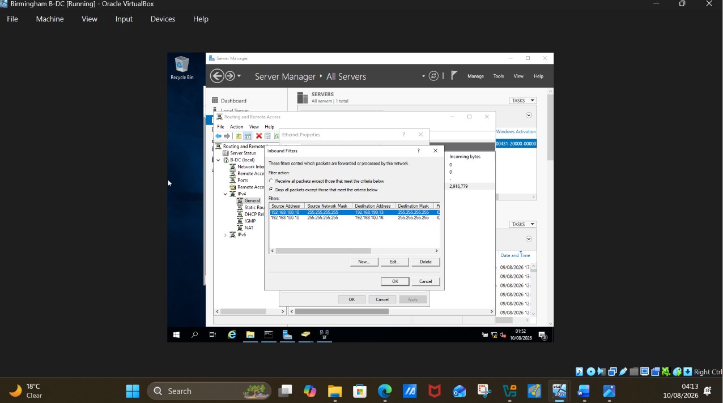
Fig 7. Inbound Ip configured

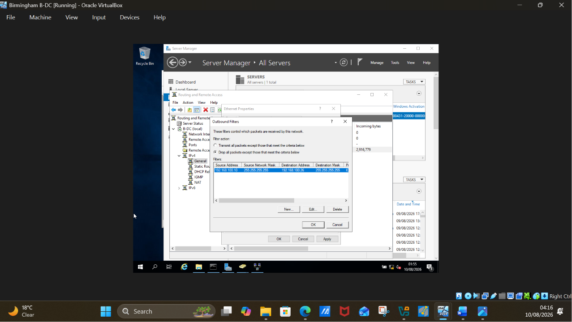 fig 8. Outbound Ip forwarding configured

2. Domain Server

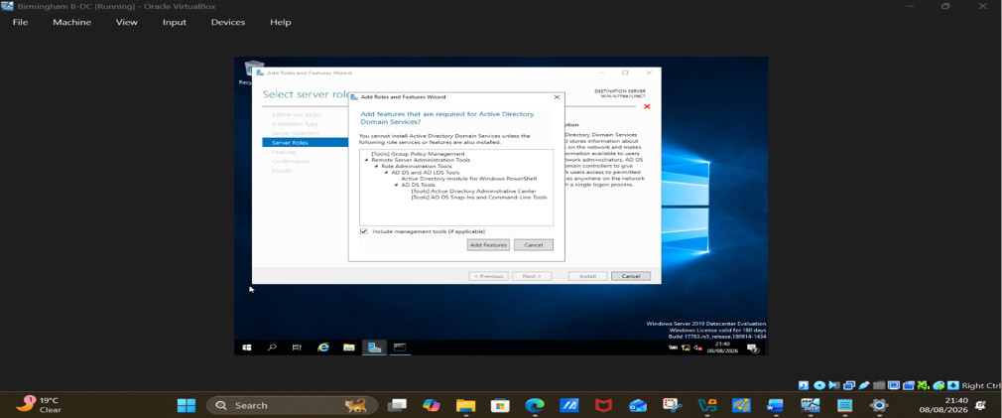
Fig 9. Creation of active directory services.

2.1. Forest

Forest creation

Add a new forest
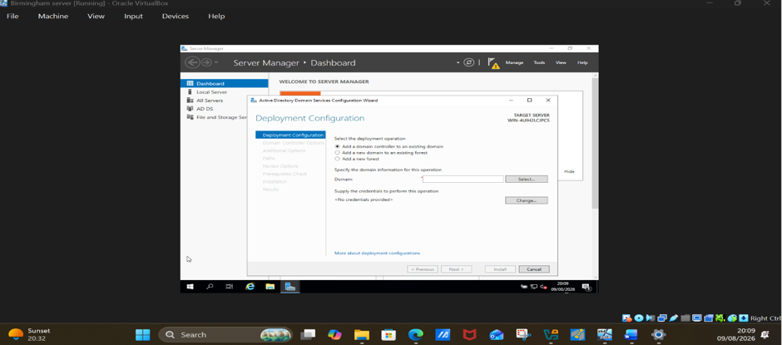
Fig 11. Adding a forest

Enter your forest root domain:
yourname.acca (in this case, swansea.acca) as instructed in the assessment.
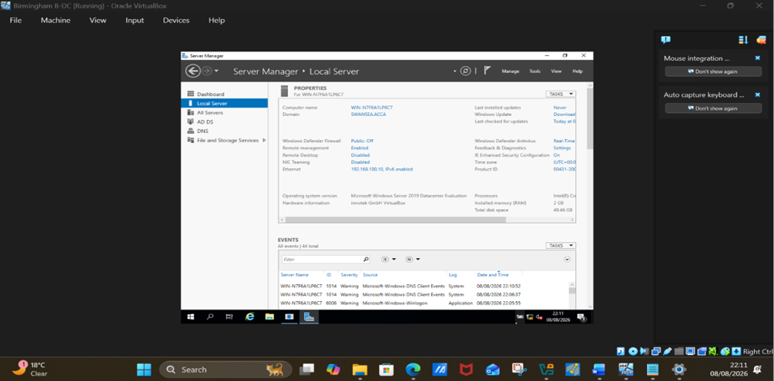
Fig 12. Domain created as SWANSEA.ACCA.

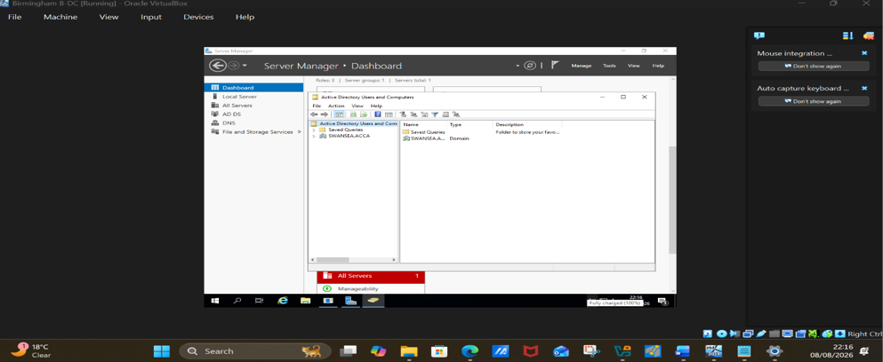
Fig 13. Domain shown from tools

2.2 A record

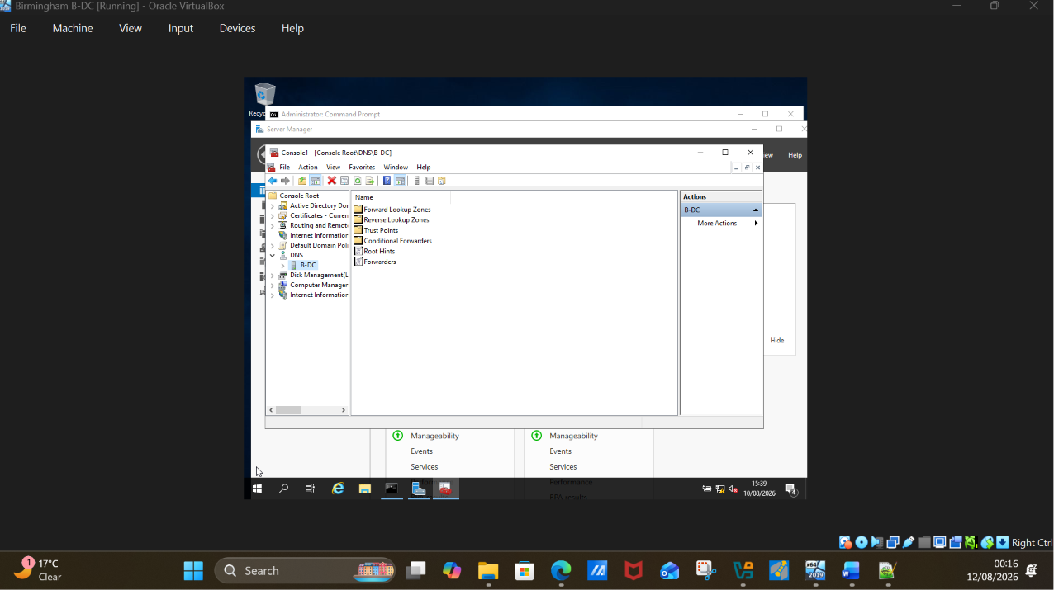
Fig 14. DNS

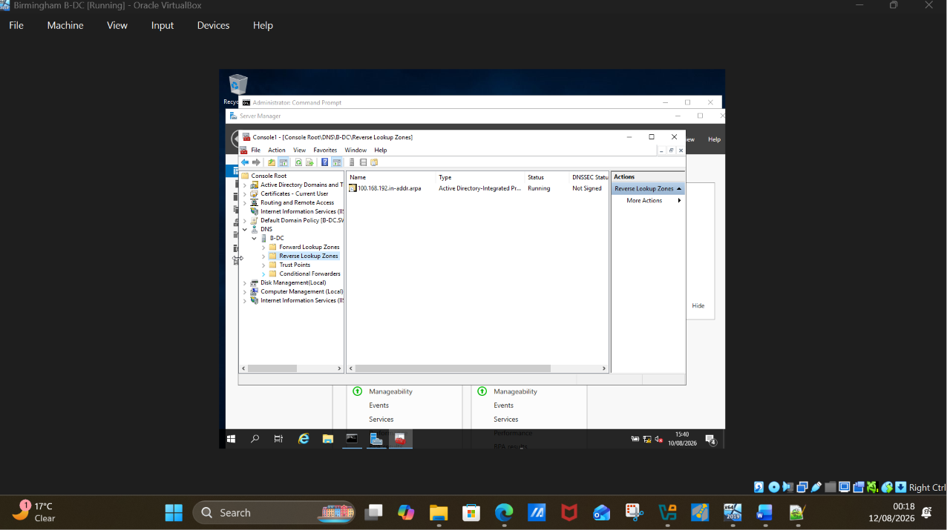
Fig 15. Expand DNS to get forward lookup zone

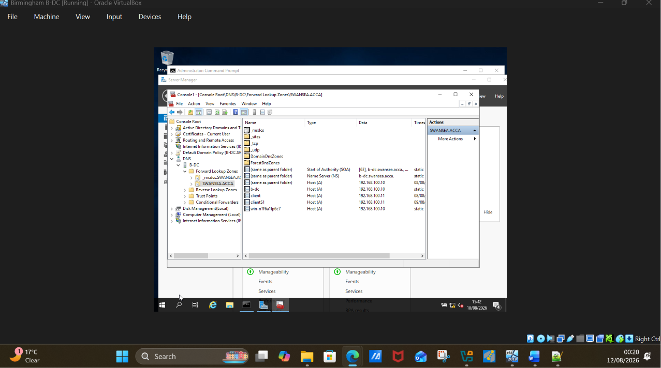
Fig 16. Creating a record.

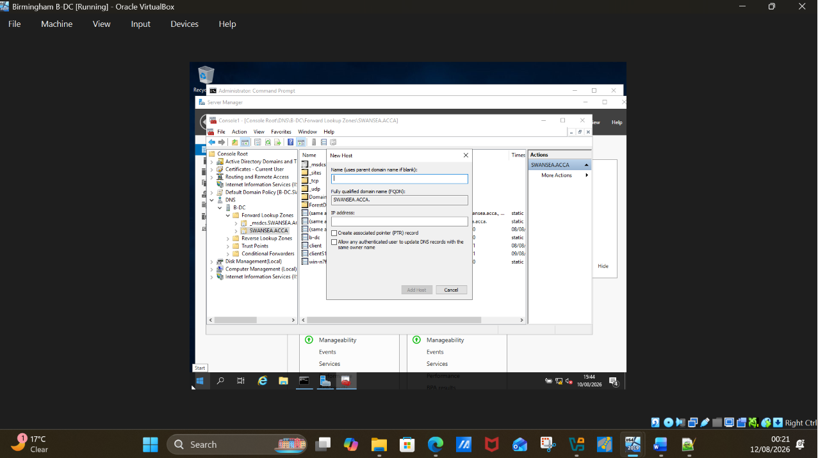
Fig 17. Saved webpage copied and pasted on the provide space.

Insert the target IP address on the space provided and click ok.

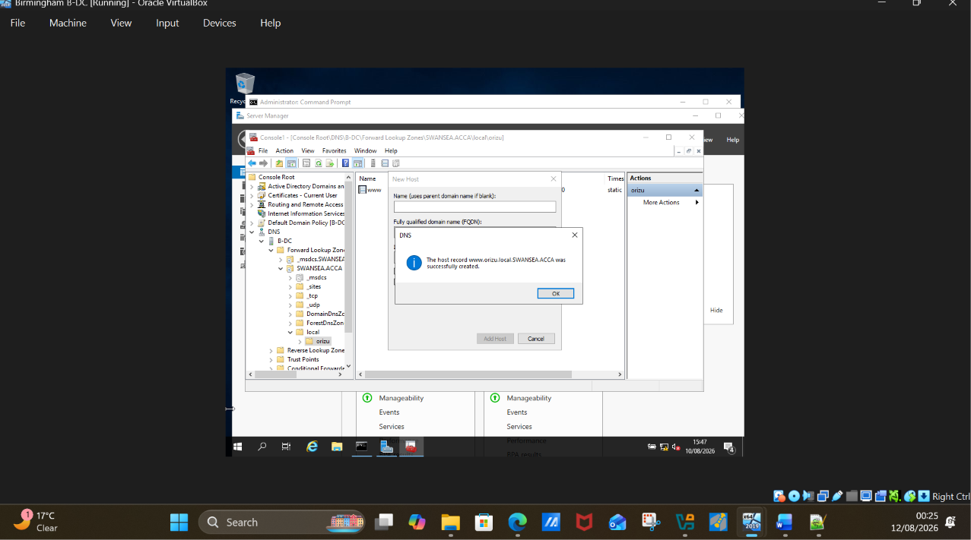
Fig 18. Host successfully created.

2.3 Reverse lookup

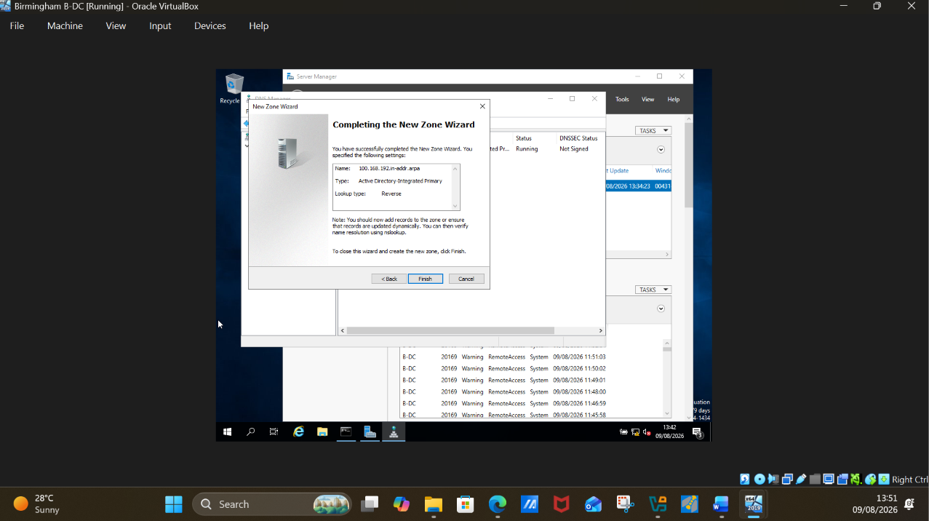
Fig 19. Completing new zone

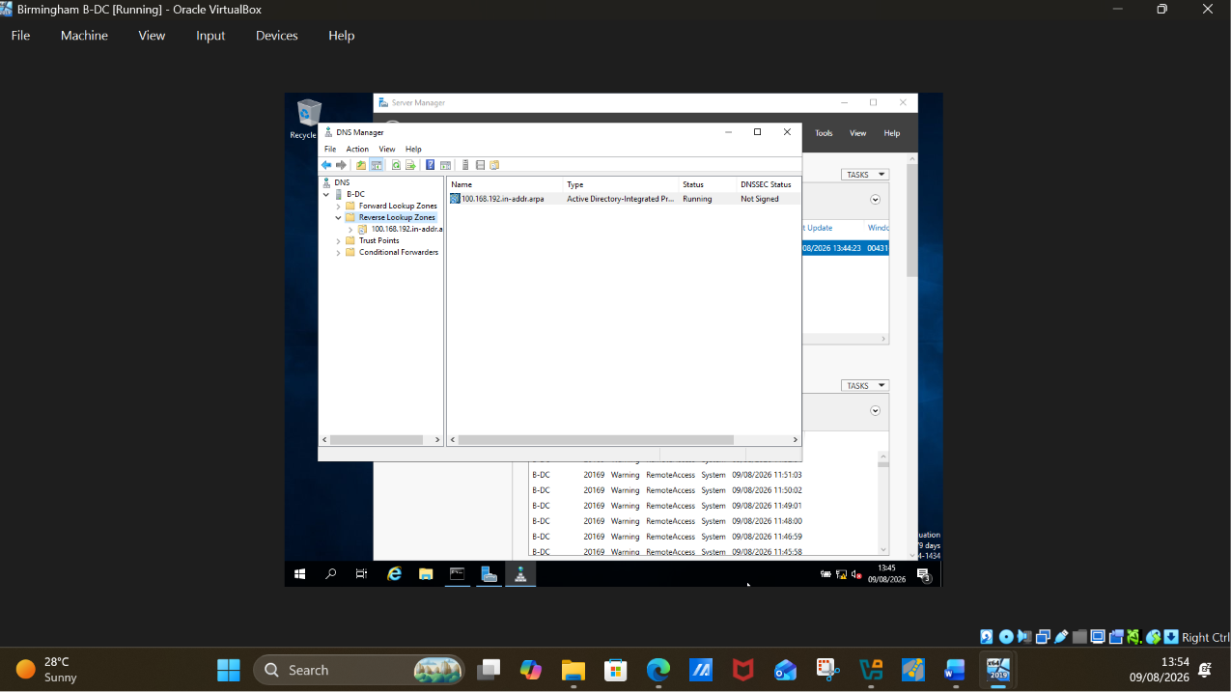
Fig 20. Reverse look up created.

3. Encrypted Connection between Birmingham and London

3.1. VPN

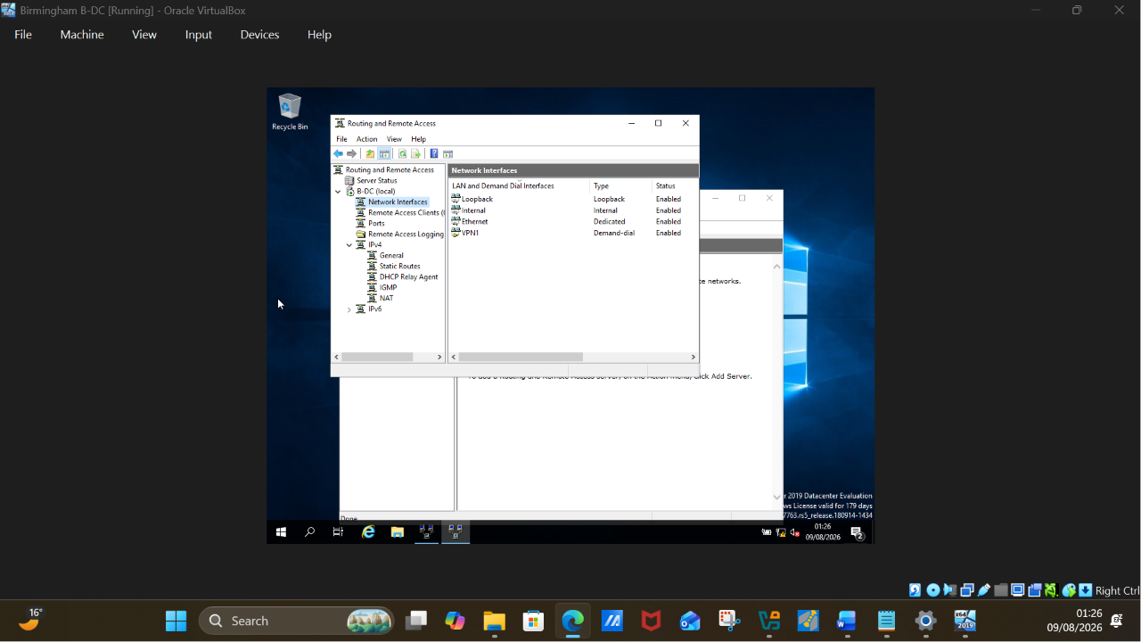
Fig 21. VPN installed after installation of Routing and Remote access service.

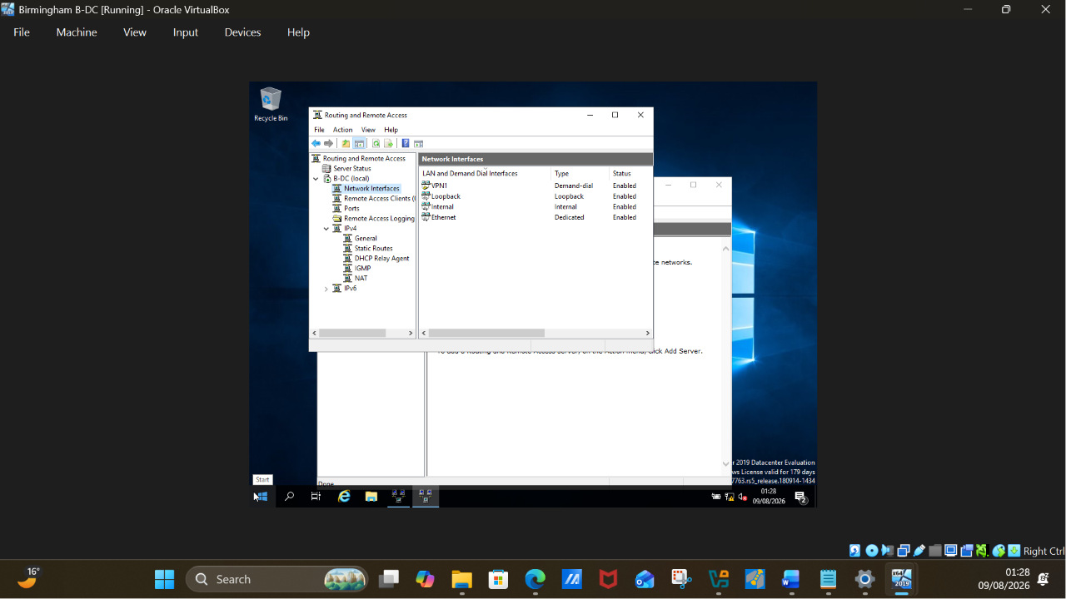
Fig 22. Installed VPN showing from network interface.

4. Users

User account creation for Swansea.acca domain

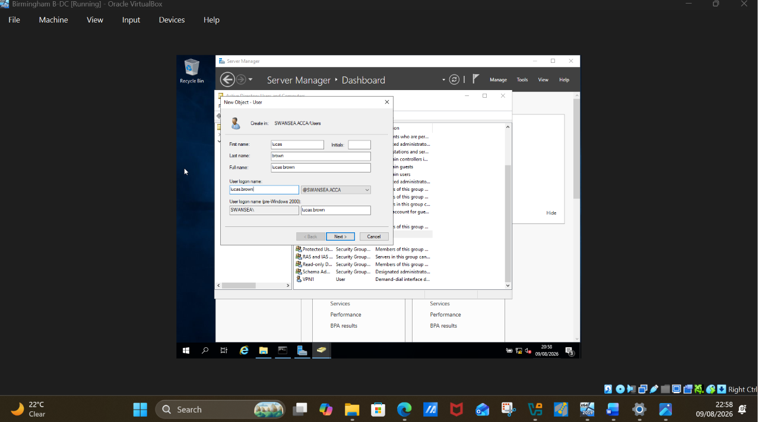
Fig 25. User name added (lucas.brown@Swansea.acca)

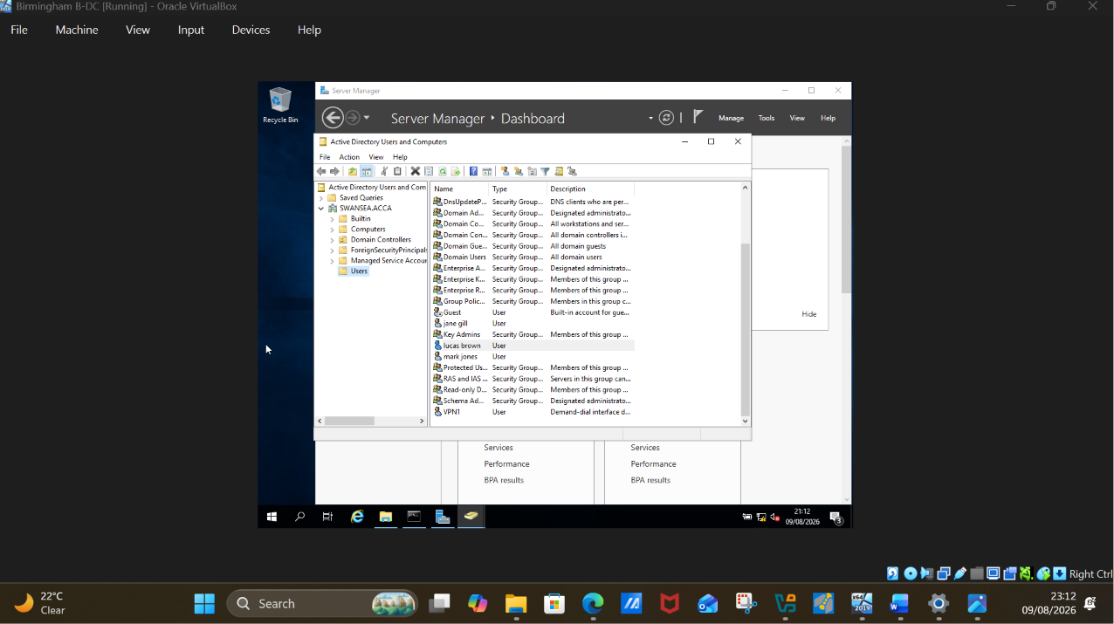
Fig 26. List of users accounts created

5. Domain Membership

5.1. Domain set up
In Client click on workgroup, on the new window , click on domain and write in your chosen domain name (Swansea.acca)
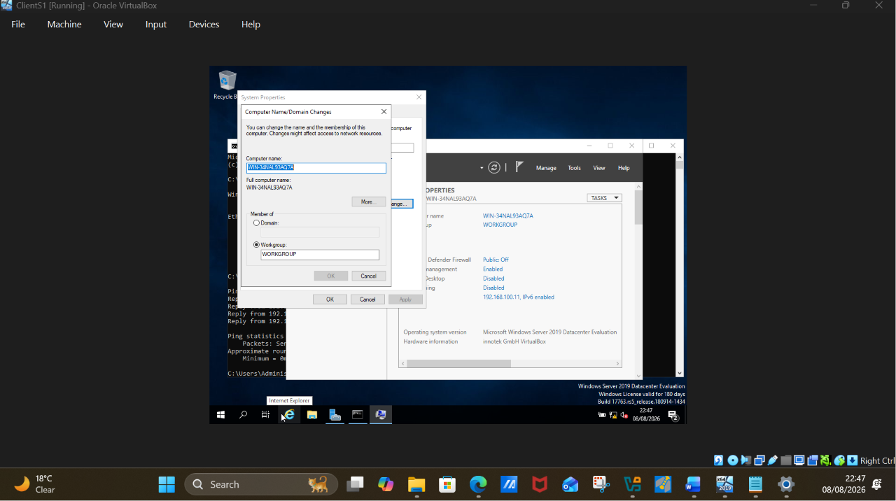
Fig 27. Workgroup

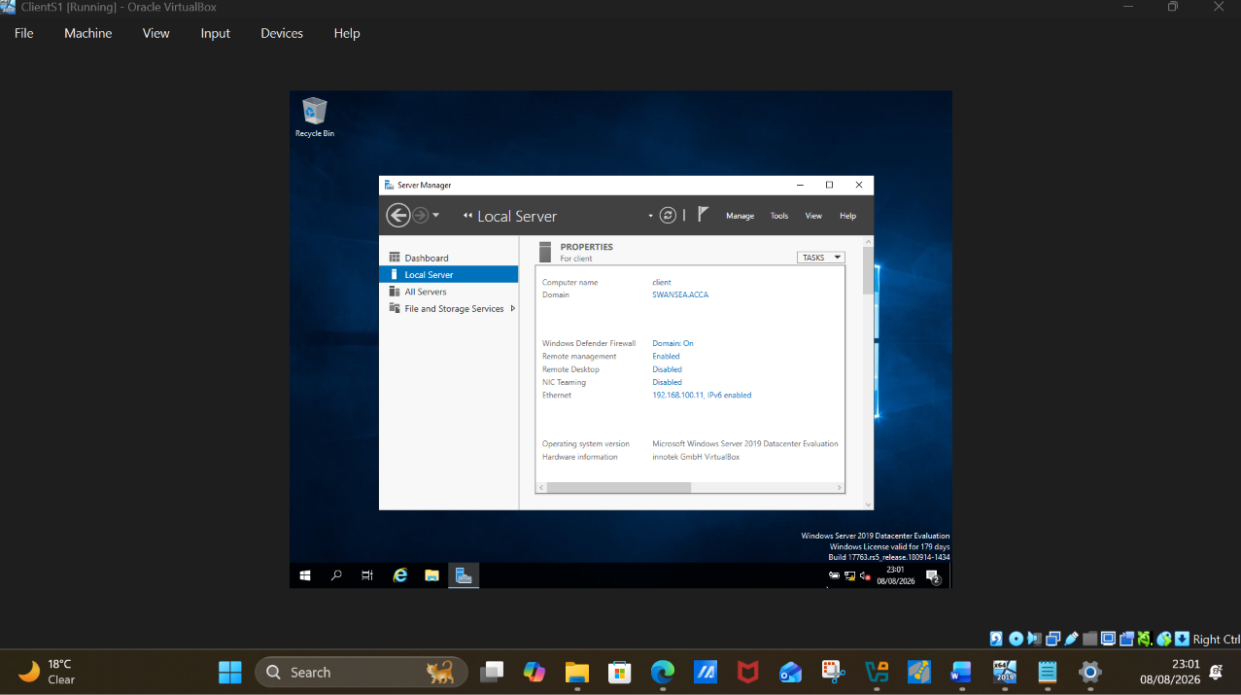
Fig 28. Workgroup changed to Swansea.acca

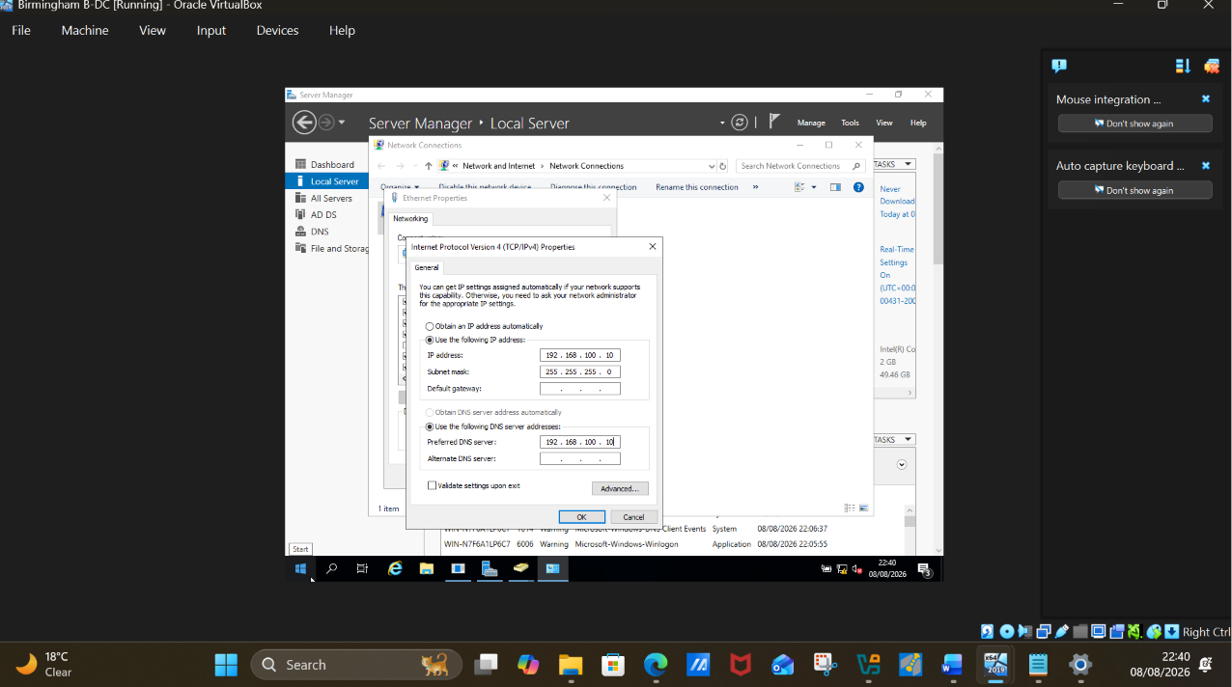
Fig 29. Assigning Ip address to DNS Server

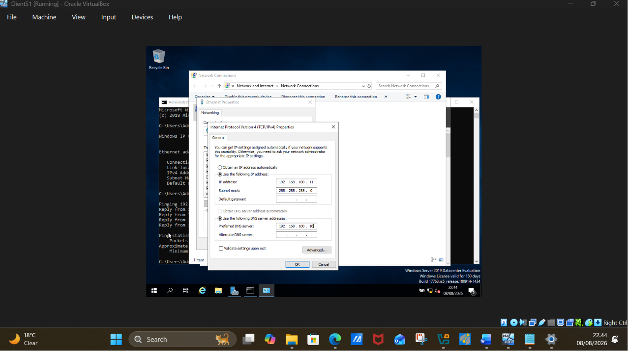
Fig 30. IP address assigned to DNS server ClientS1

IP address properties of client gateway address is the IP address of the target machine.

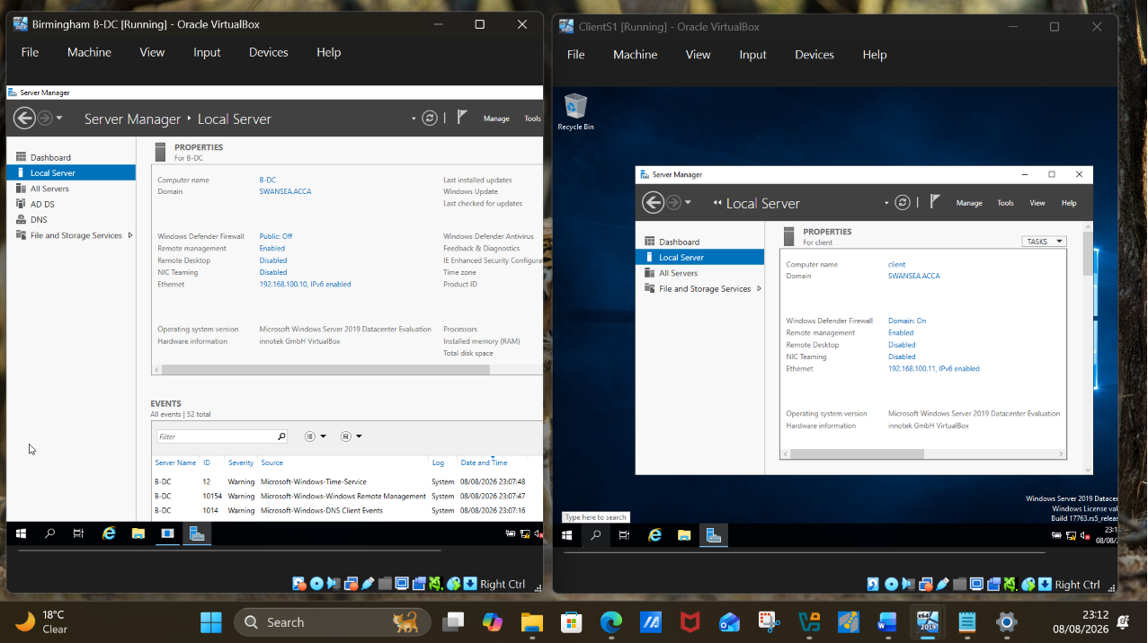
Fig 31. Server and client set up.

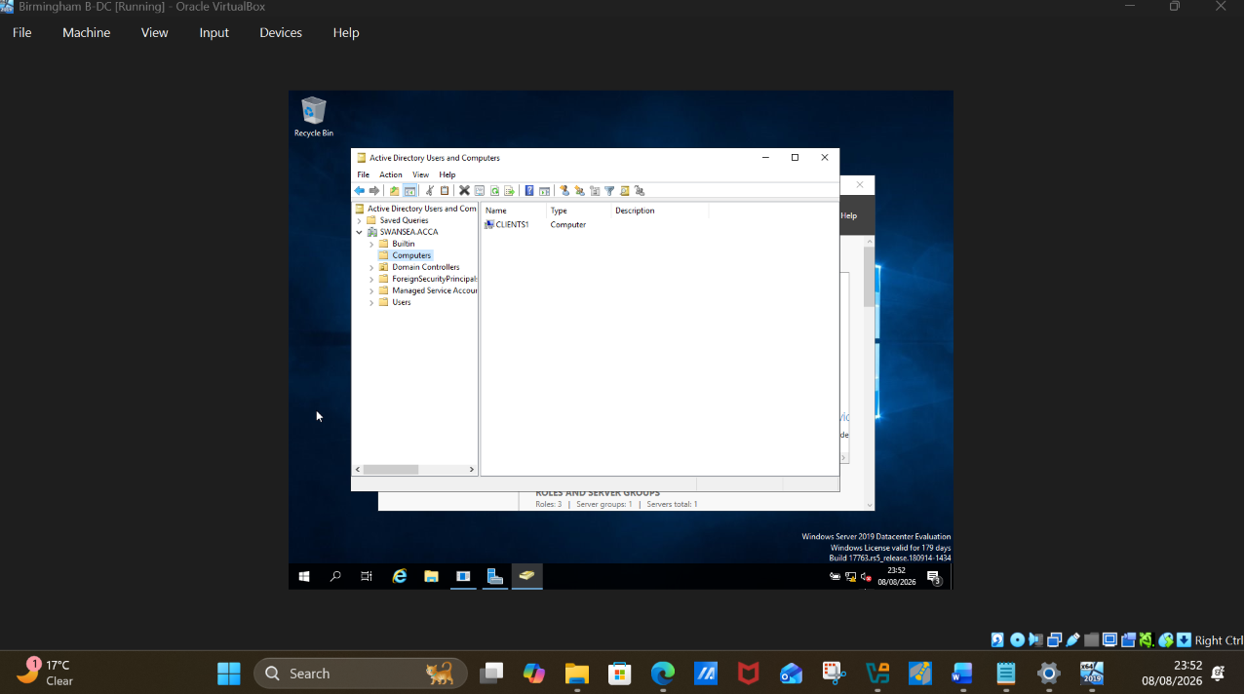
Fig 32. ClientS1 successfully added to the server B-DC as shown above

7. Test and Troubleshoot

7.1. Testing the network connectivity

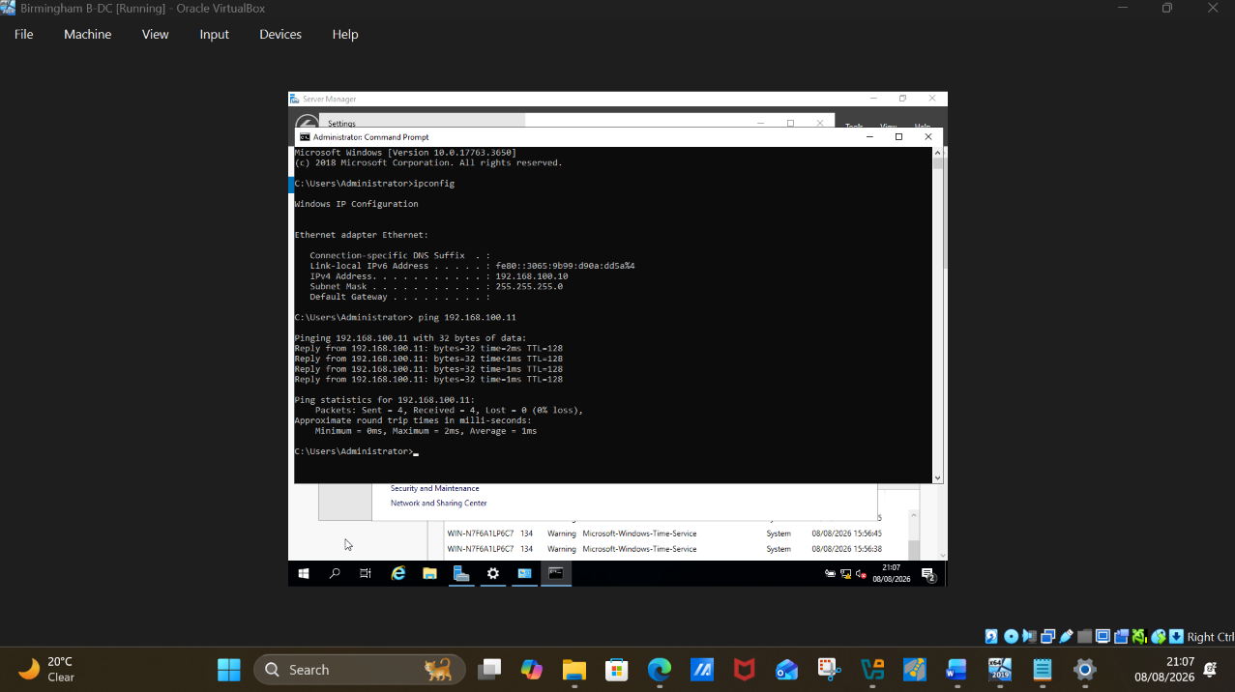
Fig 34. Ping from Birmingham server B-DC to ClientS1 successful.

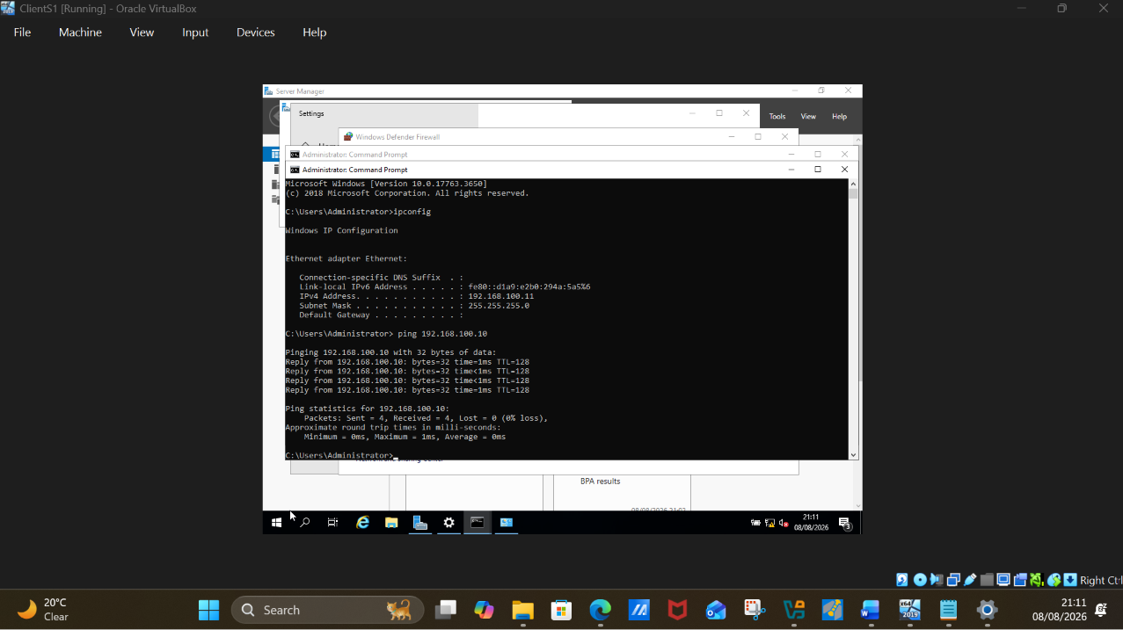
Fig 35. Ping from ClientS1 to Birmingham Server B-DC successful.

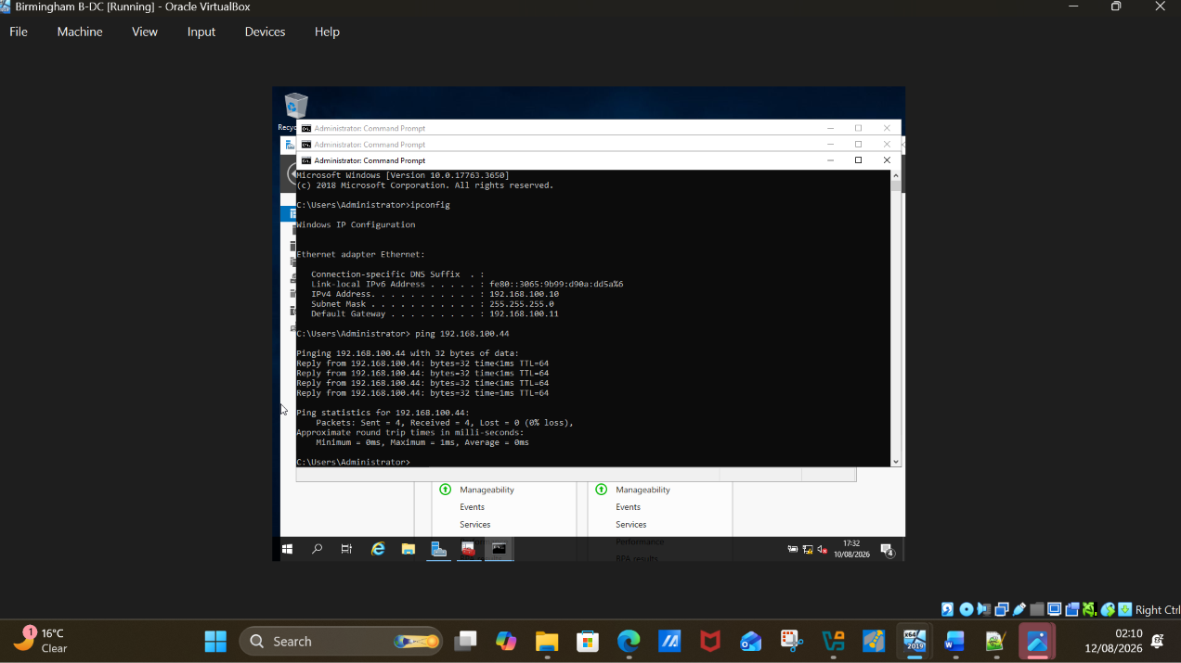
Fig 36. Ping from Birmingham windows server B-DC (192.168.100.10) TO London linux server D4 (192.168.100.44) Result – Successful.

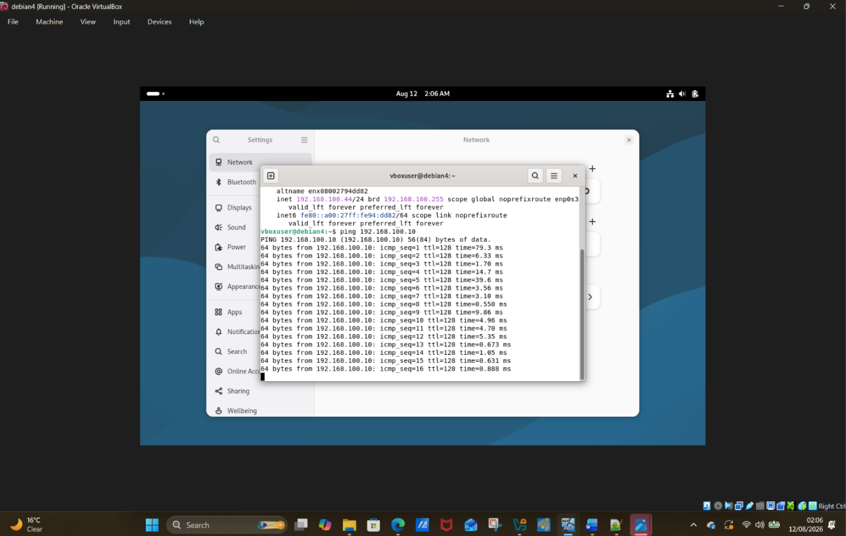
Fig 37. Ping from London linux server D4 (192.168.100.44) to Birmingham server B-DC (192.168.100.10) Result – successful.

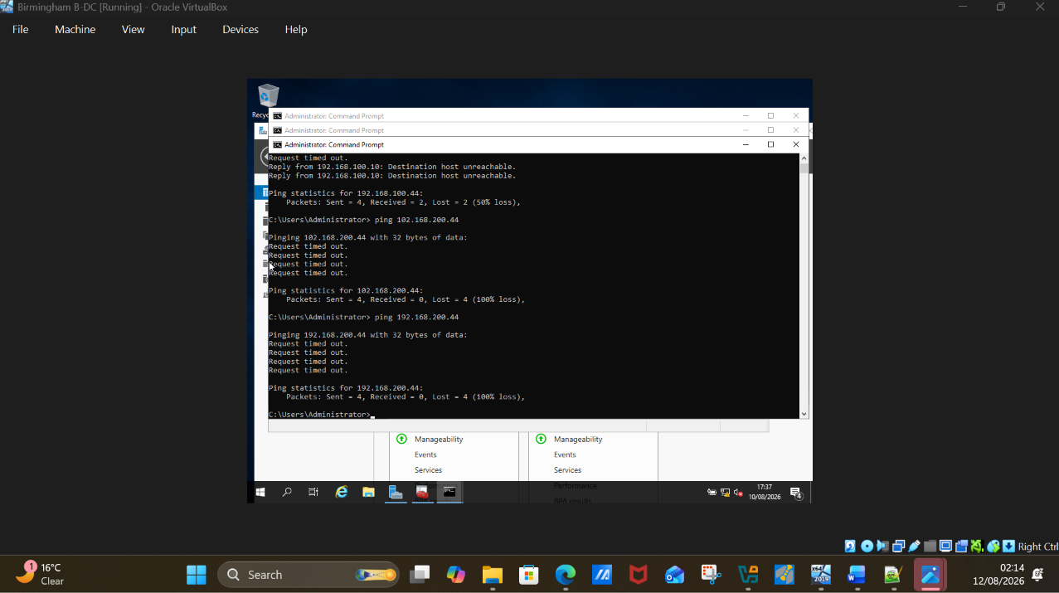
Fig 38. Ping from Birmingham windows server B-DC (192.168.100.10) TO London linux server D4 (192.168.200.44) Result – Unsuccessful.

The two server are on different network -thus connection was unsuccessful.

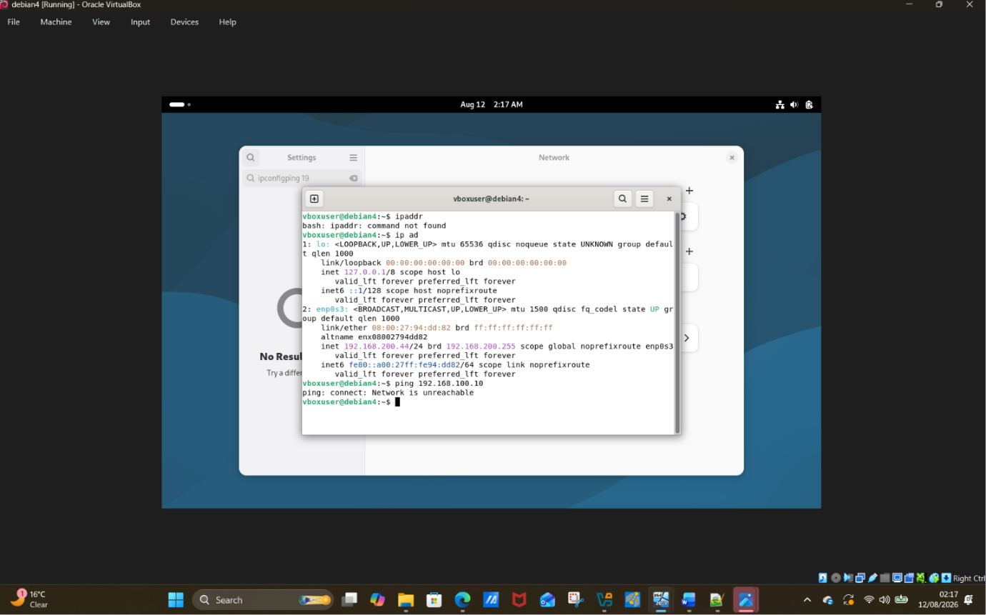
Fig 39. Ping from London linux server D4 (192.168.200.44) to Birmingham server B-DC (192.168.100.10) Result – Unsuccessful.
Same here, the to networks are on different networks (192.168.100.10 and 192.168.200.44) result is unsuccessful as well.

8. Disk Drive

8.1. Shared Drive
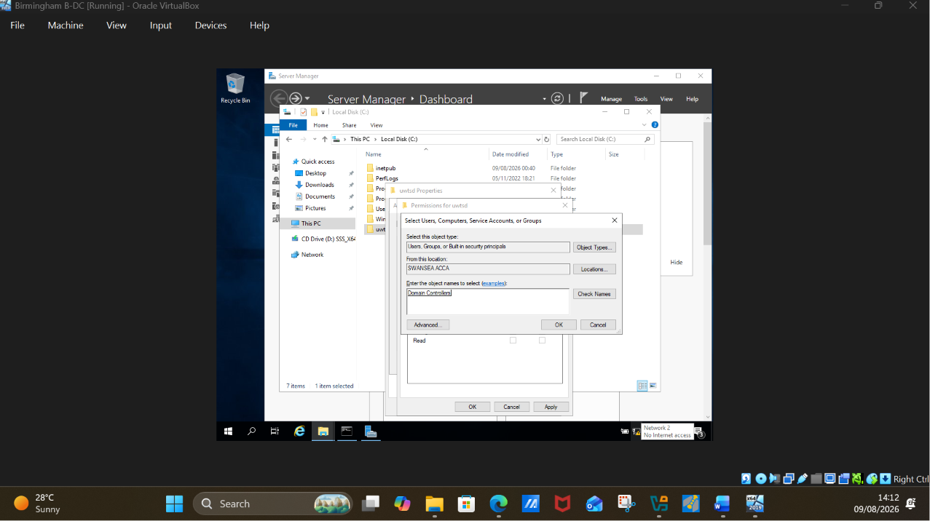
Fig 40. Domain controller

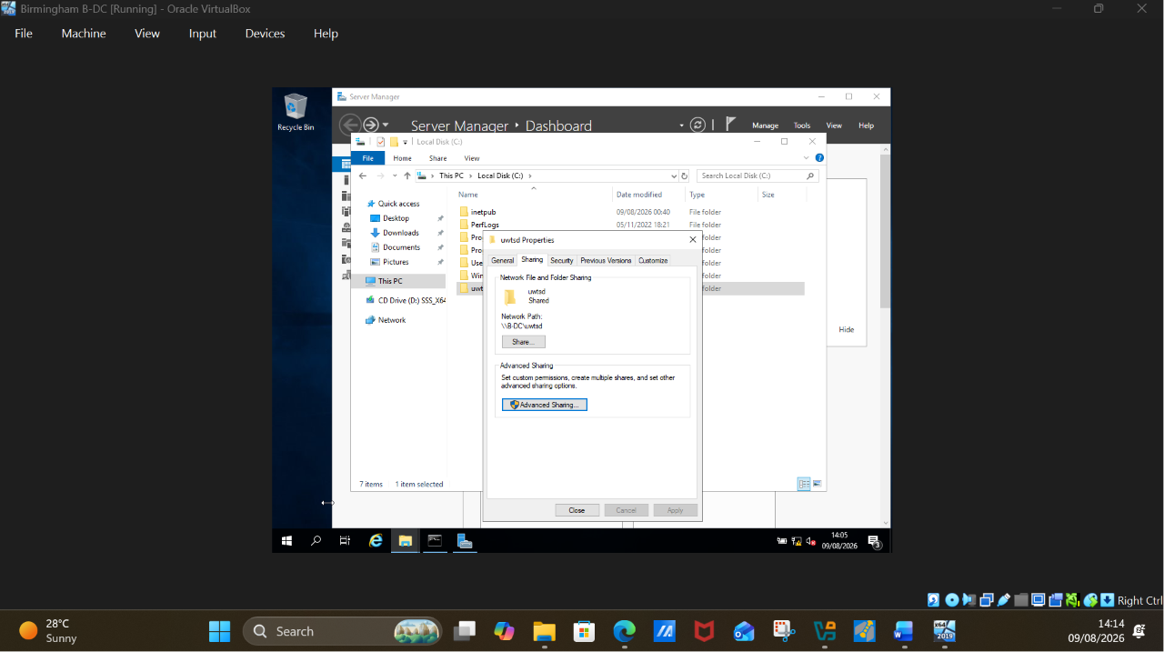

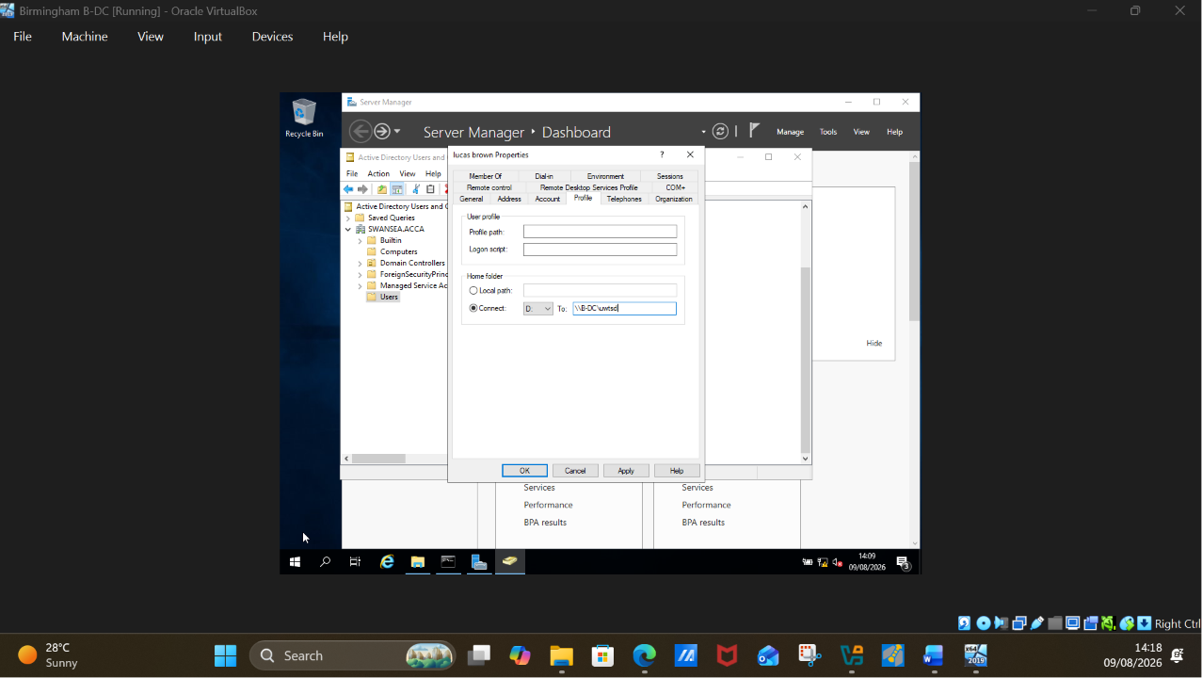
Fig 42. Drive shared to a user ( lucas brown)

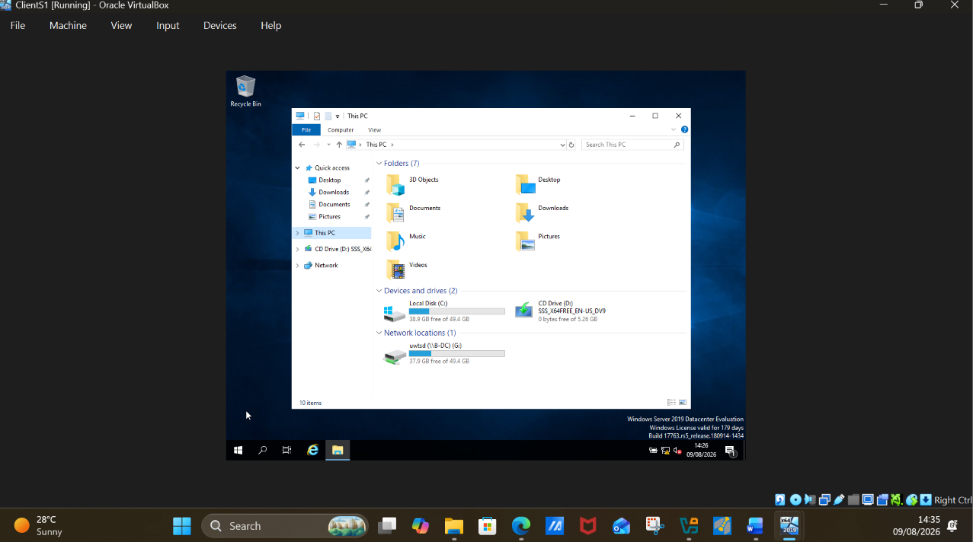
Fig 43. New shared drive showing from clientS1 Pc

9. IIS Server

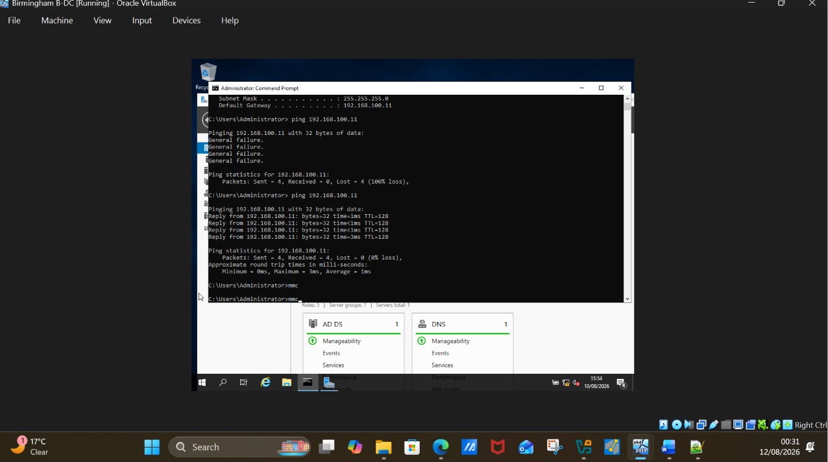
Fig 44. Mmc command in command prompt

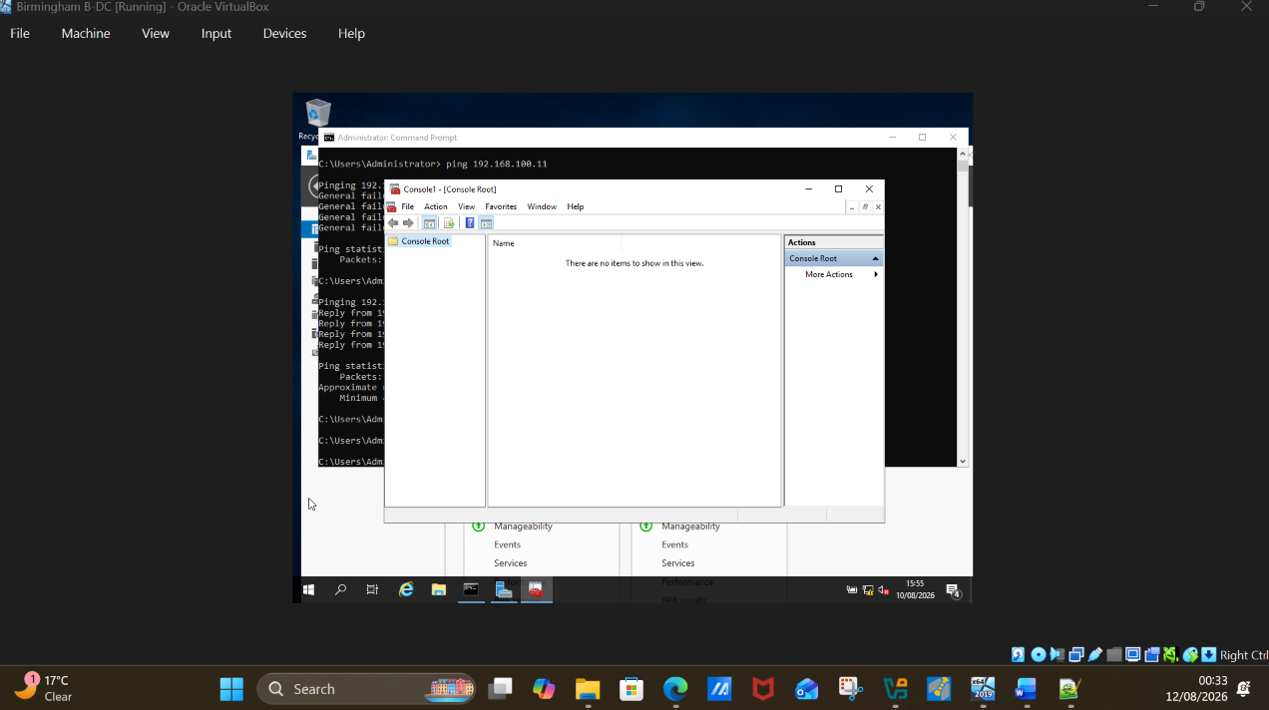
Fig 45. Mmc console open

Click on file to expand

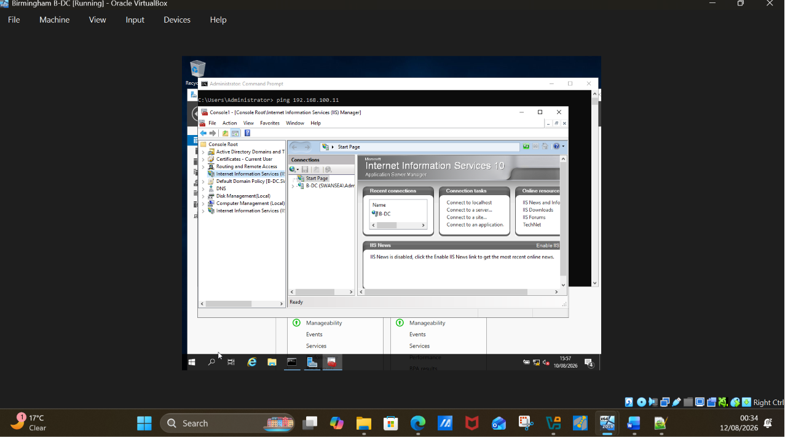

Fig 46. Add IIS to the console root and then click on IIS to expand.

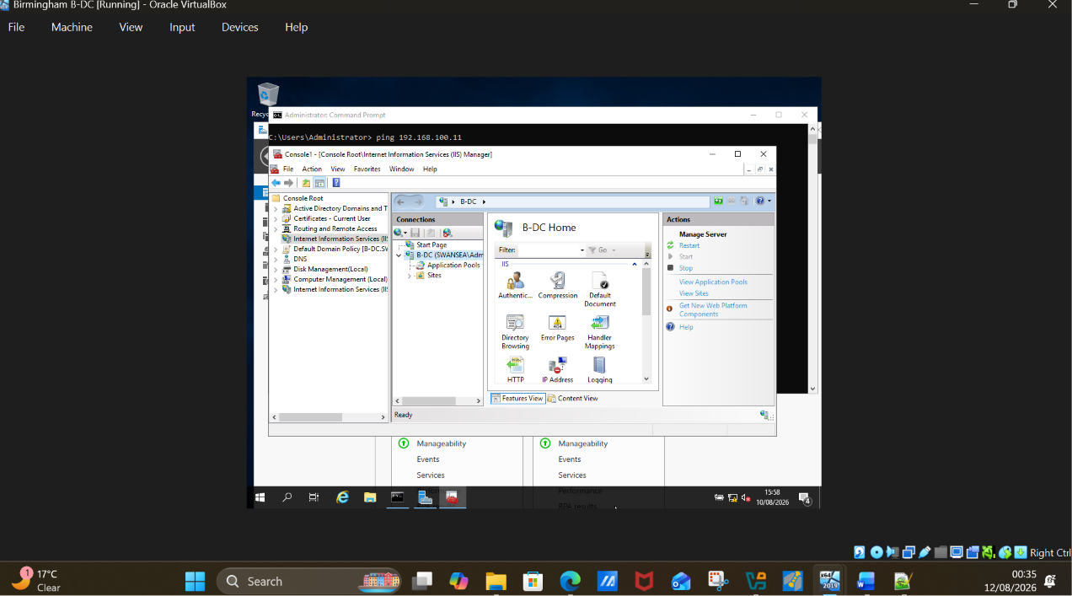
Fig 47. Expand Birmingham server B-DC

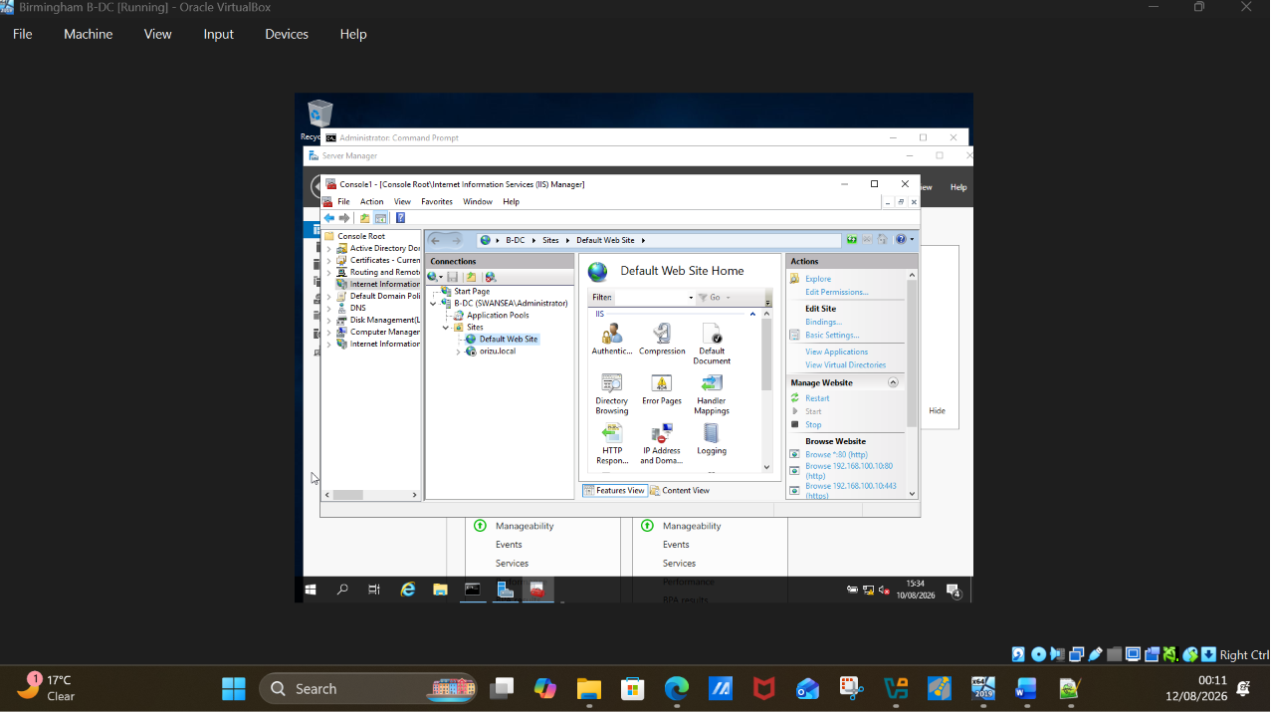
Fig 48. Creating Orizu.local

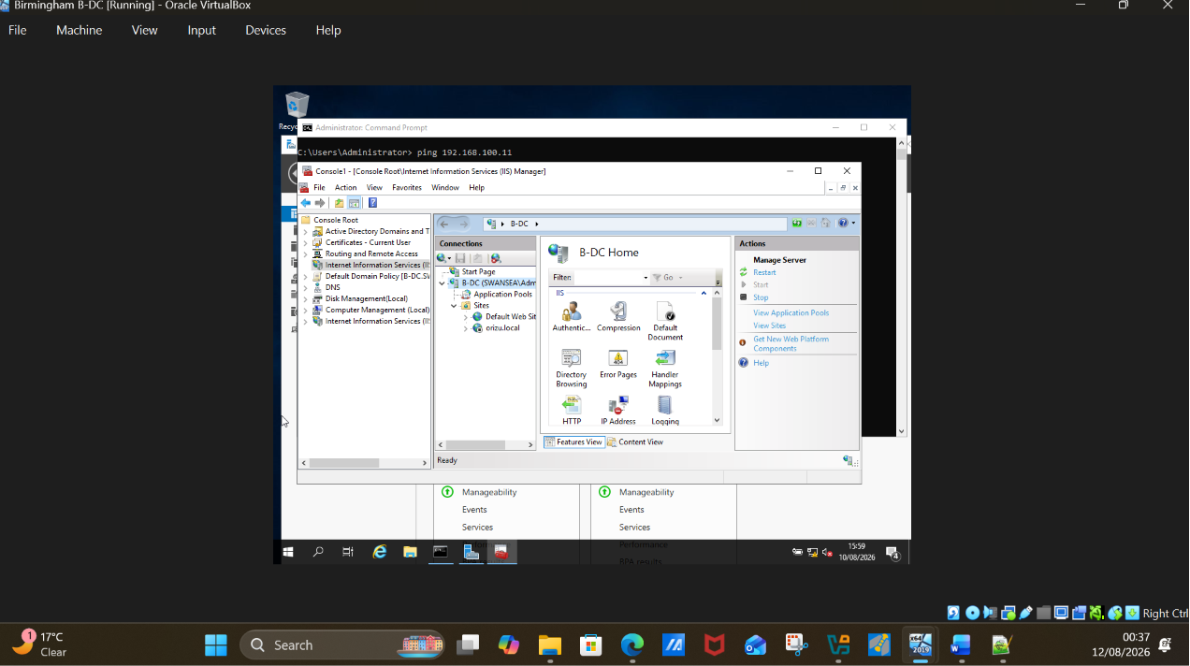
Fig 49. Right click on site to add webpage

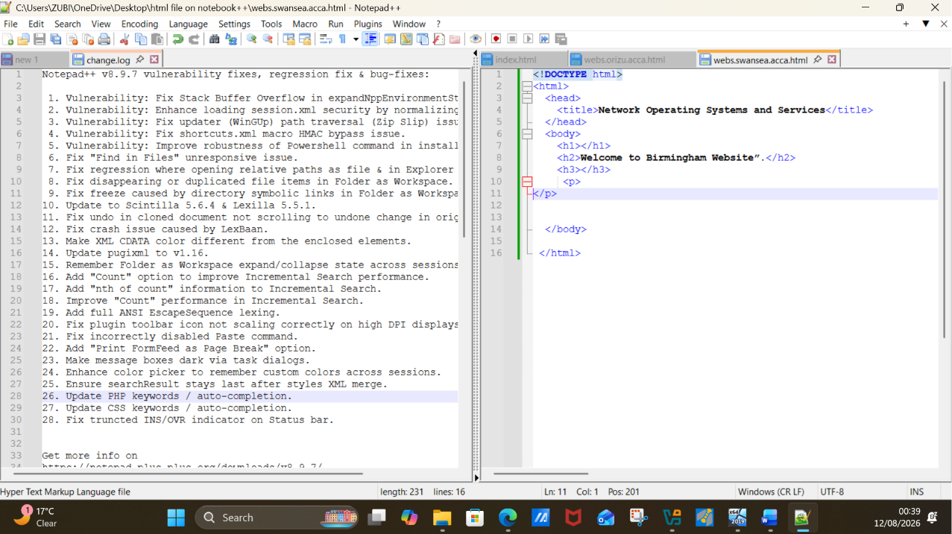
Fig 50. Webpage created on notepad++ and saved.

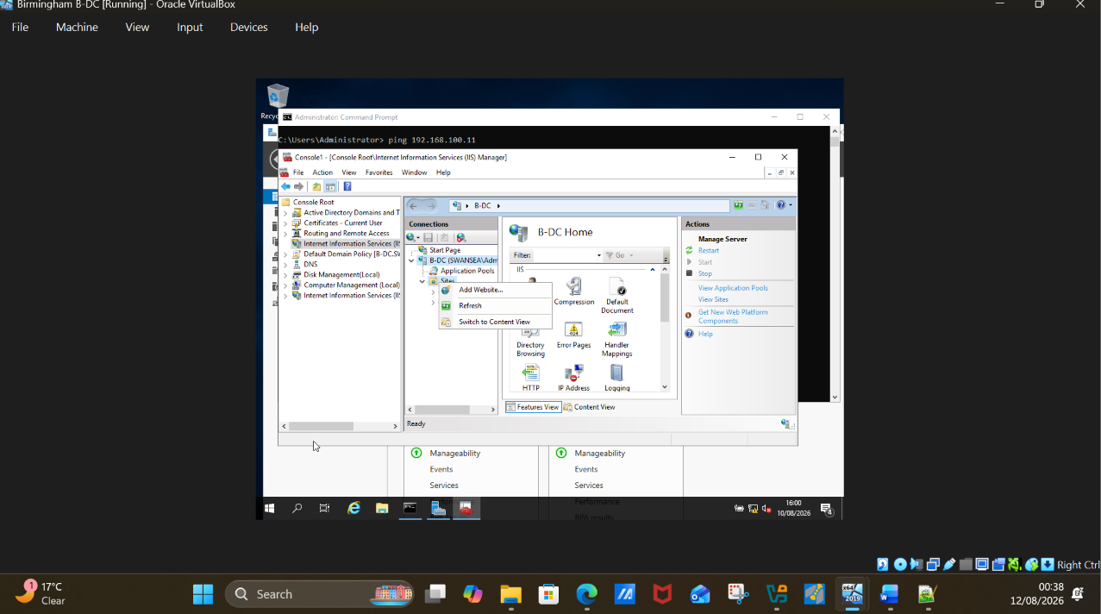
Fig 51. Click on add website.

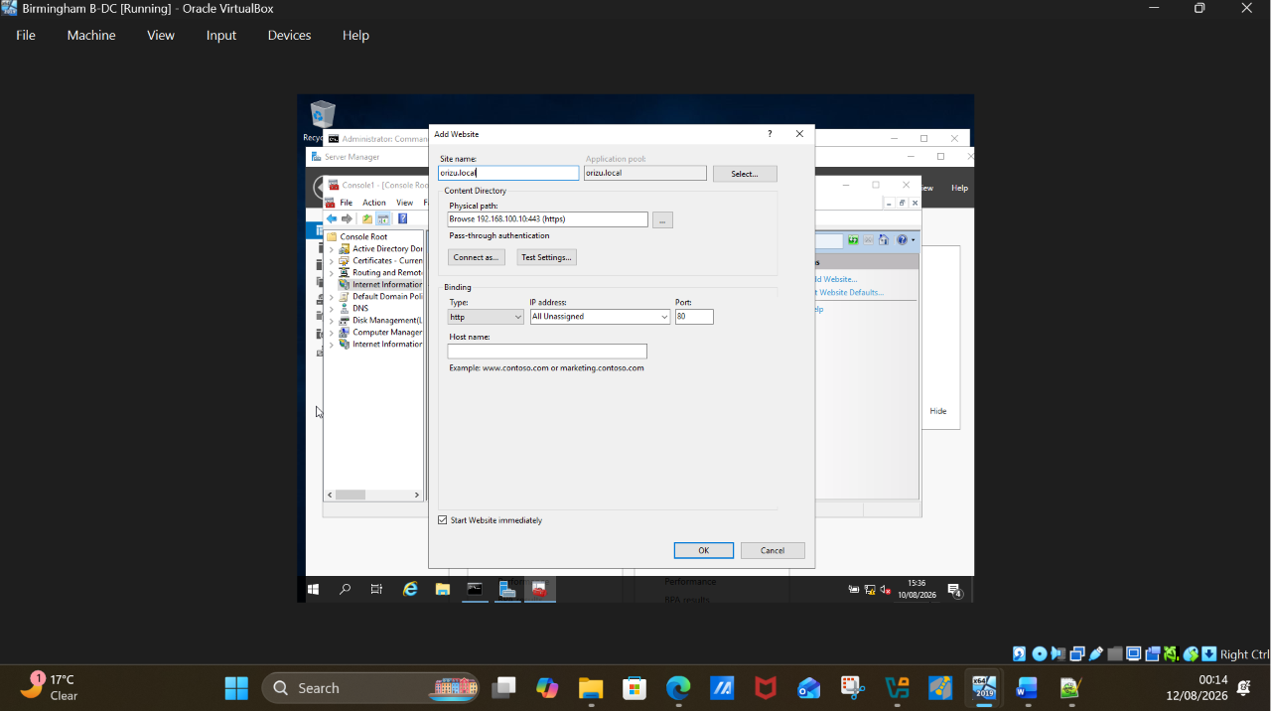
Fig 52. Copy and add created webpage

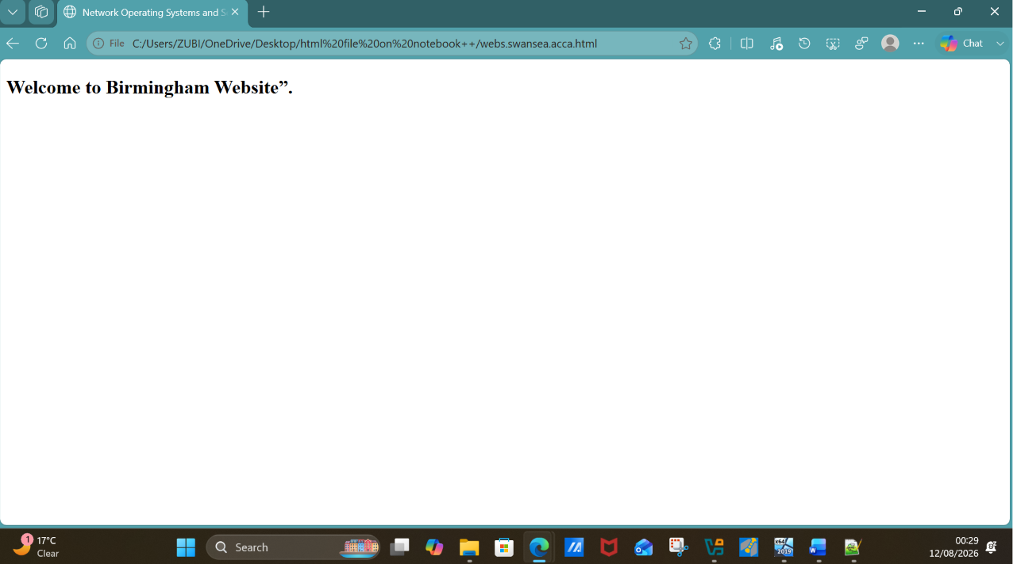
Fig 53. Webpage display “Welcome to Birmingham Website”

Fig 54. Webpage icon

10. Remote Desktop Services.

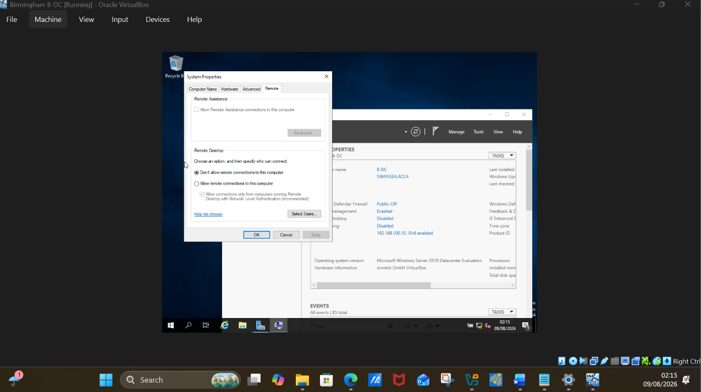
Fig 55. To enable remote access on the desktop, click on disabled to be enabled.
On the pop up wizard, change to allow and ok.

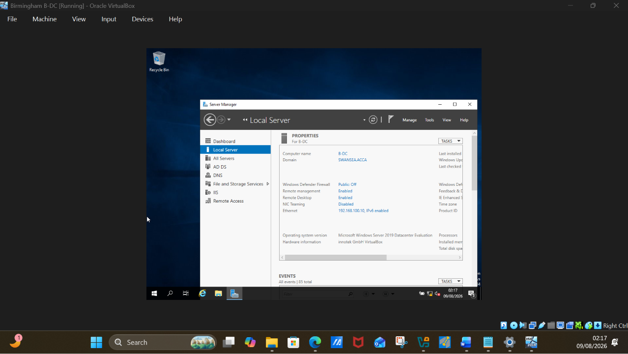
Fig 56. Remote desktop enabled on Birmingham server B-DC

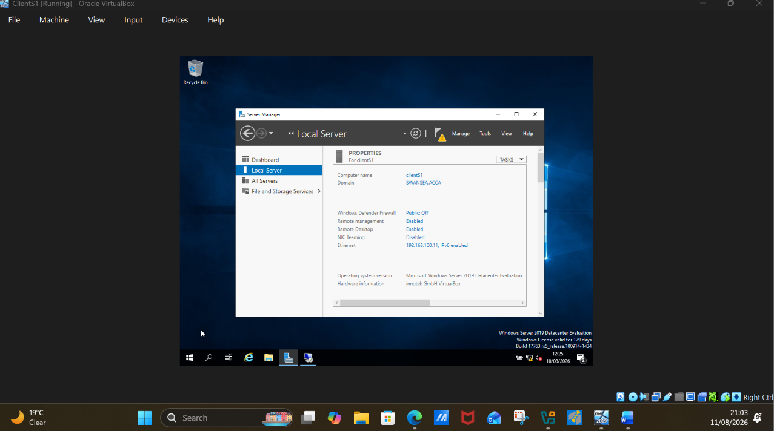
Fig 57. Remote desktop enabled on ClientS1

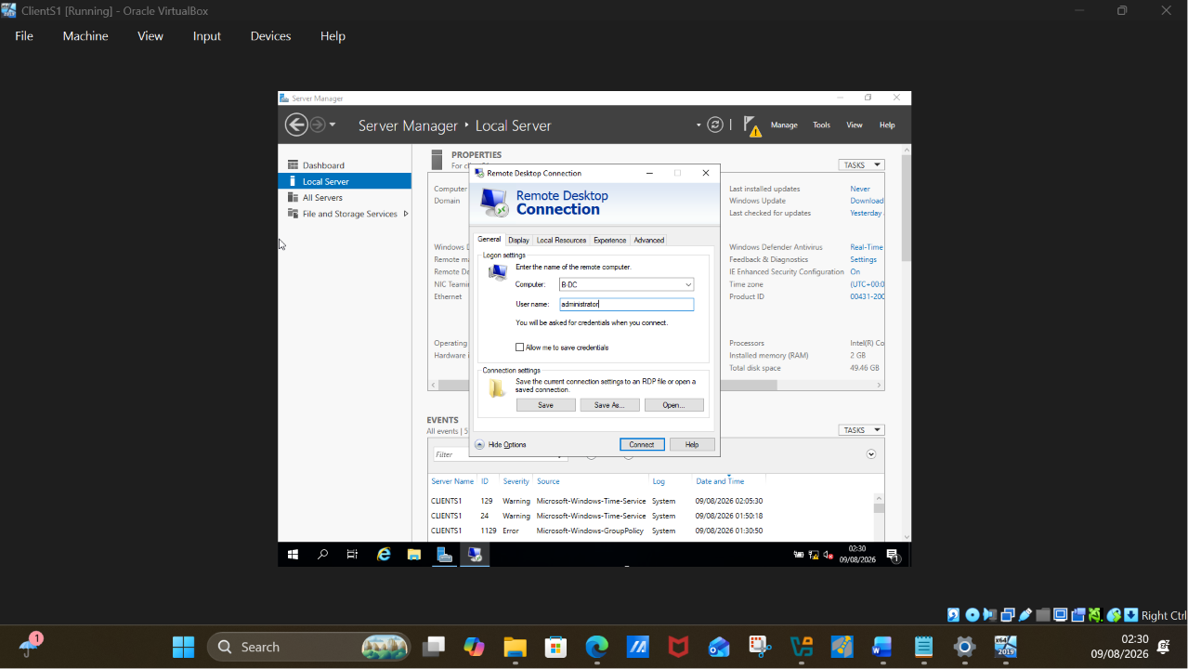
Fig 58. User -Lucas brown successfully logged into Birmingham server B-DC from ClientS1.

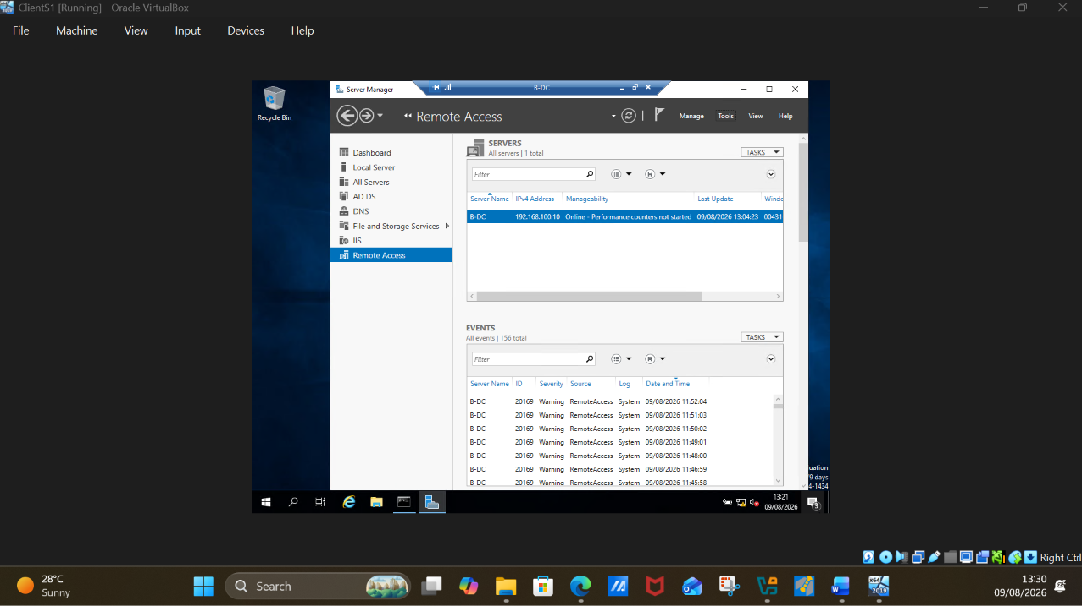
Fig 59. Birmingham server B-DC showing on clientS1 Pc.

