AHHI6012 Imagining the City: The Urban Experience, c. 1851–Present
Week 4. Shanghai: The Pearl of the Orient
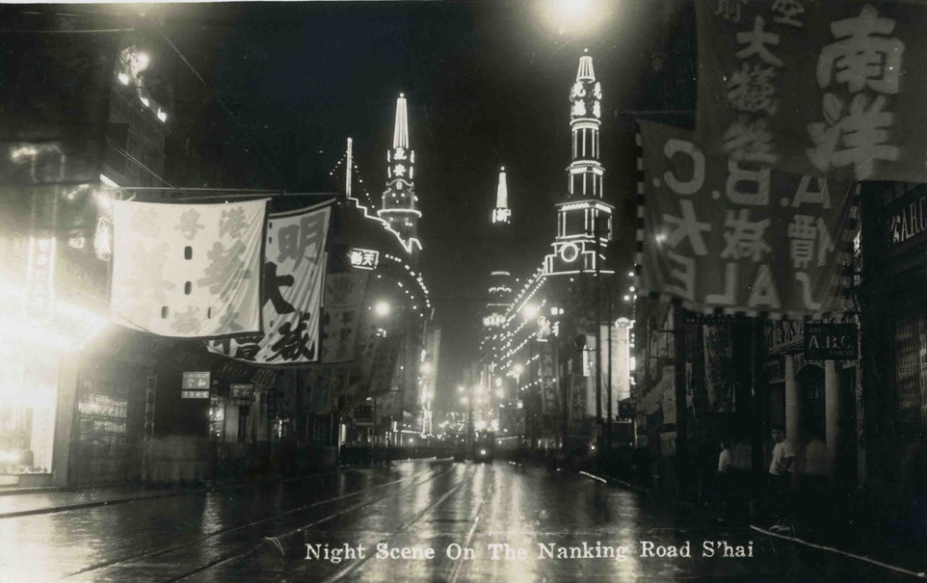
Night view of Nanking Road, 1930s
Lectures summary:
This week counterpoises previous lectures’ focus on Western cities by concentrating on Shanghai, China. While the city’s history will be situated within both long-term and contemporary perspectives, our primary emphasis is on cultural phenomena which characterised Shanghai during the era of the Chinese Republic, 1912–1949 (particularly prior to the outbreak of World War Two). The varying experiences of Chinese and European residents of Shanghai will be foregrounded.
The first lecture approaches the history of Shanghai ‘backwards.’ It begins by discussing present-day Shanghai, and its status as perhaps the twenty-first-century metropolis, before contextualising this in relation to a longer chronology. We shall see how Shanghai assumed particular prominence as a consequence of European imperialism (and the Opium Wars especially) during the nineteenth century, and how this gave rise to its reputation as a cosmopolitan city in the early decades of the twentieth century. Here, we will discuss Eileen Chang’s writings on fashion as evidence of, in Leo Ou-fan Lee’s terms, the flowering of modern urban culture in Shanghai. From there, attention shifts to the city’s relationship to broader political movements in Chinese history: its status in the founding of a Chinese republic in 1911 and during the upheavals of the 1930s and 40s; its role in the origins of Chinese communism; and how Shanghai was treated by the Maoist Cultural Revolution of 1966–1976. Our narrative is brought up to date with a discussion of how the skyline of the eastern shore of central Shanghai (Pudong) has been transformed after the liberalisation of China’s economy in the 1980s and 1990s.
The second lecture offers an in-depth case study of Shanghai during the first four decades of the twentieth century. Running through the lecture is an idea that the varying experiences of different Shanghainese open a window onto multiple versions of the city, telling stories about it which do not necessarily fit neatly alongside European imperialist discourse of time – nor the historical narratives espoused more latterly by the Chinese state. Students will be tasked with assembling narratives about Shanghai from a set of images made available to them via Moodle, while also trying to map pre-WWII Shanghai. Throughout, emphasis is placed on understanding Chinese residents of Shanghai as modern urbanites, and as agents of and in modernity and modernism.

Required reading and other preparation:
Tuesday
- Eileen Chang, ‘A Chronicle of Changing Clothes’ (first published 1943), Positions: East Asia Critique, Vol. 11 No. 2 (Fall 2003), pp. 427–441.
- Timeline of Modern Chinese History
Friday
- Leo Ou-fan Lee, ‘Shanghai Modern: Reflections on Urban Culture in China in the 1930s,’ Public Culture: Bulletin of the Project for Transnational Cultural Studies, Vol. 11, No. 1 (January 1999), pp. 76–107.
Recommended background reading:
- Paul Pickowicz, Kuiyi Shen and Yingjin Zhang, ‘Liangyou, Popular Print Media and Visual Culture in Republican Shanghai,’ in Pickowicz, Shen and Zhang eds. Liangyou: Kaleidoscopic Modernity and the Shanghai Global Metropolis, 1926–1945 (Leiden: Brill, 2013), pp. 1–13.
- Images from Liangyou
- Mapping Shanghai (all available via Moodle)

Preparing for the lectures:
Before doing any of the longer reading for the lectures, students should familiarise themselves with the timeline of modern Chinese history that is available on Moodle. It is not exhaustive and will not give students a comprehensive understanding of modern Chinese history, but will at least convey a general sense of its important themes and events. These will be elaborated on and further contextualised during the lectures. The other assigned readings focus on Shanghai in the 1920s and 1930s. On Tuesday, we will think about Eileen Chang’s discussion of fashions, with references to images from the magazine Liangyou (The Young Companion). Complementary background materials relevant to this reading are available on Moodle; biographical details about Chang can be found here: http://www.oxfordreference.com/view/10.1093/acref/9780195066081.001.0001/acref-9780195066081-e-0141.
For Friday’s class, students should read Leo Ou-fan Lee’s essay ‘Shanghai Modern,’ which covers a variety of relevant themes. One of Lee’s aspirations is to construct “a cultural map” of early-twentieth-century Shanghai: in the lecture, we will attempt to do something similar, using photographs and other images to gain a sense of the geography and social milieu of pre-WWII Shanghai. The questions below should prove as an aid to your understanding of Lee’s essay and act as preparation for the in-class task.
Hard copies of the photographs will be distributed in class but are also available in the file entitled ‘Mapping Shanghai.’

Questions to consider:
Chang, ‘A Chronicle of Changing Clothes’
- Chang’s essay focuses on the history of fashion in China, focusing on women’s clothes in particular. Her illustrations show styles dating from various eras. What changes in fashion can you note from the images and what significance does Chang draw from these changes in the essays’ text? For instance, what does Chang say about fashion in:
- the late imperial era (c. 1890–1911)
- the era of the Republican revolution (c.1911–1916)
- the Warlord Era (c. 1916–1928)
- the 1930s?
- the 1940s?

- The qipao is a recurrent focus in Chang’s essay. What is the qipao and what significance does Chang derive from it?

- ‘A Chronicle of Changing Clothes’ covers similar topics to aspects of ‘The Painter of Modern Life.’ What comparisons and contrasts can be drawn between Chang’s essay and Baudelaire’s? Does Chang’s status as a women mean her perspective on fashions and modern urban life deviates from Baudelaire’s, and if so how? What ‘gender politics’ are at play in the essay?

- What further insights might the background materials on Liangyou shed on Chang’s essay?

Lee, ‘Shanghai Modern’
- Lee begins by listing some of the cultural stereotypes associated with Shanghai in the West. What are some of these stereotypes, and why might they be significant? What does the verb ‘shanghai’ mean for instance?

- What arguments and interpretations does Lee forward about the Shanghai cityscape in the 1930s. For instance, what does he say about the following:
  - Architecture (e.g. Art Deco style) and urban space (e.g. public parks, streets)
  - Department stores
  - Magazines (e.g. Liangyou) and other print media
  - Coffee houses and dance halls
  - Shanghai Race course?

- Lee discusses competing interpretations of Shanghainese culture of the 1920s and 1930s as having embodied a sense of Chinese nationhood (pp. 98–101) versus being exemplary of ‘a colonial condition’ (pp. 101–104). What do you make of these debates? How valid is it to interpret Shanghai as having been a European colony, for instance?

- In the section headed ‘The City and the Flaneur,’ Lee discusses Baudelaire’s ideas in relation (pp. 94–97). What application does Lee make of Baudelairian theories of the city, and how useful do you think they are for understanding modern urban culture in 1920s–1930s Shanghai?

Further reading:
Select bibliography
Ballard, JG. Empire of the Sun (London: Panther, 1984).
Bangqing Han. The Sing-Song Girls of Shanghai (New York: Columbia University Press, 2005 [1892]).
Bickers, Robert A. The Scramble for China: Foreign Devils in the Qing Empire, 1832–1914 (London: Allen Lane, 2011).
—. ‘Shanghailanders: The Formation and Identity of the British Settler Community in Shanghai 1843–1937,’ Past and Present, No. 159 (May 1998), pp. 161–211.
—. ‘Shanghailanders and Others: British Communities in China, 1843–1957’ in Bickers, ed. Settlers and Expatriates: Britons Over the Seas (Oxford: Oxford University Press, 2010).
Chang, Eileen. ‘A Chronicle of Changing Clothes’ (first published 1943), Positions: East Asia Critique, Vol. 11 No. 2 (Fall 2003), pp. 427–441.
Foreign Languages Press. Shanghai Down the Centuries (Beijing: Foreign Languages Press, 2006).
Goodman, Bryna and David SG Goodman, eds. Twentieth-Century Colonialism and China: Localities, the Everyday and the World (Abingdon, Oxfordshire: Routledge, 2012).
Goodman, Bryna. Native Place, City and Nation: Regional Networks and Identities in Shanghai, 1853–1937 (Berkeley, California: University of California Press, 1995) Available via University of California Press: http://publishing.cdlib.org/ucpressebooks/view?docId=ft0m3nb066;query=shanghai;brand=ucpress)
Grieder Jerome B. Hu Shih and the Chinese Renaissance: Liberalism in the Chinese Revolution, 1917–1937 (Cambridge, Massachusetts: Harvard University Press, 1970).
Harris, Kristine. ‘The New Woman Incident: Cinema, Scandal and Spectacle in 1935 Shanghai,’ in Sheldon H Lu, ed., Transnational Chinese Cinemas: Identity, Nationhood, Gender (Honolulu: University of Hawaii Press, 1997).
Hershatter, Gail. Dangerous Pleasures: Prostitution and Modernity in Twentieth-Century Shanghai (Berkeley: University of California Press, 1997).
Hong, Guo-Juin. ‘Framing Time: New Women and the Cinematic Representation of Colonial Modernity in 1930s Shanghai,’ positions: east asia cultures critique Vol. 55, No. 3 (Winter 2007), pp. 553–579.
Hung, Chang-tai. War and Popular Culture: Resistance in Modern China, 1937–1945 (Berkeley: University of California Press, 1994). Available via University of California Press: http://publishing.cdlib.org/ucpressebooks/view?docId=ft829008m5;brand=ucpress.
Ishiguro, Kazuo. When We Were Orphans (London: Faber, 2001).
Lee, Leo Ou-fan. Shanghai Modern: The Flowering of a New Urban Culture in China, 1930–1945 (Cambridge, Massachusetts: Harvard University Press, 1999).
—. ‘Shanghai Modern: Reflections on Urban Culture in China in the 1930s,’ Public Culture: Bulletin of the Project for Transnational Cultural Studies, Vol. 11, No. 1 (January 1999), pp. 76–107.
Lee, Tahirih V, ed. Coping with Shanghai: Means to Survival and Success in the Early Twentieth Century – A Symposium, series of essays in special edition of The Journal of Asian Studies, Vol. 54: No. 1 (February 1995), pp. 3–123.
Liang Wu. Old Shanghai: A Lost Age (Beijing: Jiangsu Fine Arts, 2003).
Mitter, Rana. A Bitter Revolution: China’s Struggle with the Modern World (Oxford: Oxford University Press, 2005).
Nishimura, Shizuya. ‘The Hongkong and Shanghai Banking Corporation, 1870–1913,’ in Nishimura, Toshio Suzuki and Ranald C Michiee, eds., The Origins of International Banking in Asia: The Nineteenth and Twentieth Centuries (Oxford: Oxford University Press, 2012).
Perry, Elizabeth J. Shanghai on Strike: The Politics of Chinese Labor (Stanford, California: Stanford University Press, 1993).
Pickowicz, Paul, Kuiyi Shen and Yingjin Zhang, eds. Liangyou: Kaleidoscopic Modernity and the Shanghai Global Metropolis, 1926–1945 (Leiden: Brill, 2013).
Ristaino, Marcia Reynders. Port of Last Resort: The Diaspora Communities of Shanghai (Stanford, California: Stanford University Press, 2001).
Tianshu Pan, ‘Historical Memory, Community-Building and Place-Making in Neighborhood Shanghai,’ in Laurence JC Ma and Fulong Wu, eds., Restructuring the Chinese City: Changing Society, Economy and Space (London: Routledge, 2005).
University of Bristol. Historical Photographs of China collection (http://hpc.vcea.net/).
Warr, Anne. Shanghai Architecture (Sydney: Watermark Press, 2007).
Wen-Hsin Yeh, ed. Becoming Chinese: Passages to Modernity and Beyond (Berkeley, California: University of California Press, 2000) Available via University of California Press: http://publishing.cdlib.org/ucpressebooks/view?docId=kt5j49q621;brand=ucpress).
Wen-Hsin Yeh. Shanghai Splendor: A Cultural History, 1843–1945 (Berkeley, California: University of California Press, 2008).
Wu Liang. Old Shanghai: A Lost Age (Beijing: Foreign Languages Press, 2003)>
Yingjin Zhang. The City in Modern Chinese Literature and Film: Configurations of Space, Time and Gender (Stanford, California: Stanford University Press, 1996).
Zamperini, Paola. ‘On Their Dress They Wore a Body: Fashion and Identity in Late Qing Shanghai,’ Positions: East Asia Critique, Vol. 11 No. 2 (Fall 2003), pp. 301–330.
Select Filmography
In the Mood for Love. Directed by Wong Kar-wai (Hong Kong, 2000).
2046. Directed by Wong Kar-wai (Hong Kong, 2006).

