THE IMPACT OF CORONAVIRUS TO MARRIOTT HOTELS IN UNITED KINGDOM

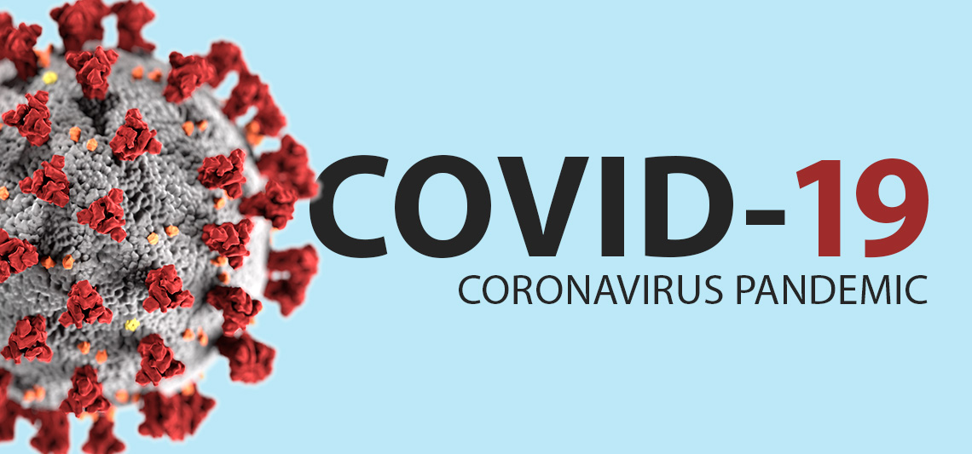

Module: Academic and Industry Skills
Module code: M4X02101
Name: Stanislav Kim
Student number: 1807730
Word Count: 2375
The Impact of Coronavirus to Marriott Hotels in the United Kingdom

Introduction

The main of this assignment its to demonstrate a clear understanding how the global epidemic covind19 impact the Marriott hotels in the United Kingdom. The project will focus to follow the organization over three months from 25th of March. How the global epidemic impact the businesses, what does the organization’s management react? Has the approach to marketing changed? Why will an agency of hospitality continue to function? Then, what do they do? Why does the Guest Service impact the pandemic? Also, will be a conclusion towards the end to summarizing essay as whole.

History of Marriott hotels.
Willard Marriott founded Marriott hotels in the United States, where the first hotel was found in 1927 (Marriott International 2018). The hotel becomes a Hot Shoppes restaurant chain from a nine-stool root beer stand. Through its successful operations, the restaurant chain developed to what is today exist as the Marriott International hotel company. The company is built through specific guiding principles, which is firmly rooted in the company’s culture. In 2016, the company obtained Starwood Hotels and Resorts that make it the world’s largest travel company (Marriott International 2018).
Consequently, the hotels offer a variety of services and accommodation to its guests. It provides an unmatched choice for its customers and generates unrivaled value for stakeholders. Today the company has expanded across the globe since its establishment. Currently, the company owns 270 properties in 30 countries and territories across the world, with over 60 000 rooms (Marriott International 2020). With the marketing platform and dynamic sales, an expansive portfolio of the brand, and the global scale that drive its efficiency, the company owner’s gains from a clear competitive advantage. Moreover, the company has also acquired an opportunity to increase its investments. For example, the company has expanded and opened new locations in the United Kingdom. In London, the wood-paneled chambers, and vaulted ceilings of County Hall, which has experienced historic London moments today, stand as an iconic luxury hotel (London Marriot County Hall 2019). The hotel is completely refurbished along with its incredible view of the riverside, which provides spacious guest rooms in the central part of London.
Nonetheless, the London Marriott Hotel County Hall launch was in 1998. J.W.Marriot, junior as the president and chairperson of Marriott International Inc., performed the grand opening of the hotel in 1998. The company provides many services and opportunities to the UK residents and its international guests. The company has health club facilities, wedding and meeting facilities, a library and restaurants within its premises. Consequently, there are 77 Marriott hotels in the entire United Kingdom with a head office in Luton (Druce 2019). The paper examines the impact of Coronavirus to Marriott hotels in the UK. However, with the global pandemic from the outbreak of Covid-19, it continues to experience significant implications for its operations. The management has developed various coping strategies, including delaying regular cycle renovations, and cutting off its operating costs and closing hotels and furloughing employees.

The Impact of Coronavirus to Marriott Hotels
Every business has a corporate strategy that includes its plan of operation. These strategies drive all its activities carried out daily. According to Marriott hotels, the main aim is to focus on achieving a competitive advantage over its rivals in the hotel industry in every state. The strategic plans help the company develop better measures to utilize its resources and handle its operation during recessions in a challenging business environment. With the outbreak of coronavirus pandemic across the globe, the hotel industry in the UK continues to experience downturns and losses in their operations, as most states are in lockdown procedures (Marriott 2020). Marriott hotels are not exempted from the adverse changes experienced in the industry as they record a significant decline of visitors in their facilities.
Most companies in the tourism, events, and hospitality sector are currently employing new innovative approaches in their operations as well as new methods to respond to the global pandemic. However, some reduce the number of their employees as a method of cutting short their operation costs while some are sending their employees home with unpaid leave (Baskas 2020). The outbreak of coronavirus will make other companies cease to exist because of the massive impact on their businesses. Consequently, Marriott hotels also have several approaches in responding to the global pandemic. The hotels continue to closely monitor the World Health Organization's, Centers for Disease Control and Prevention statements regarding the novel coronavirus cases and following procedures from these agencies and the local health departments.
The management Marriott hotels in the UK view the wellbeing of their visitors and associates with utmost importance. In response to the changing market environment and conditions in the UK hotel industry, Marriott International is dedicated to ensuring that their guests' experiences flexibility as the crisis continues to exist. In every Marriott International, hotels across the United Kingdom are extending their flexible reservation policies (Marriott 2020). Customers with the existing reservation, their reservations continue to be honored for future arrival date based on the strategies that were in place at the time before the pandemic.
The coronavirus outbreak has led to massive termination of corporate events, sports, and social events along with cancellations of international congress meetings. The hospitality industry in the UK is expected to experience severe impact due to global travel bans, lockdown, and social distancing practices, according to the data and analytics company in the United Kingdom. From the United Kingdom Hospitality data, the leisure and hospitality industry contribute about 5% national GDP and represents 10% of employment in the entire region (Partt 2020). At the beginning of the pandemic outbreak, Marriott International hotels closed most of their facilities and started furloughing its employees. However, currently, the company is implementing new strategies to support the hotel owners and ways to respond and prepare for the aftermath.
To assist Marriott owners and stakeholders through the business recession, the company has adopted strategic approaches that focus on reducing its expenditures. These approaches include postponing all regular cycle renovations for the year 2020 and deferring reserves funding for six months. Marriott International hotels have adopted measures to minimize operation costs, along with expenses relating to services and programs reimbursed by the hotels in the UK (Marriott International 2020). For example, the company has reduced its marketing costs to be in-line with the projected decline in funding and changes in the global marketplace, which is likely due to reductions in revenues.
Major Marriott International hotel chains in the UK temporarily close due to the declining occupancy rates in the region. The occupancy rates in major international hotels tumble as travelers are forced to stay at home during the coronavirus spread. Marriot International hotels in the UK are pre-emptive about sharing specifics concerning their cleaning efforts in the surrounding environment and the community. Besides disinfection and cleaning measures, Marriott hotels guarantee that guests have a clean and hospitable environment in the guest rooms and public places. With the growing alteration of businesses due to coronavirus outbreak and community responses, several hotels emulate the airline's responses by regularly updating their refund policies and cancelations based on various cases extending the applied dates.
Currently, there is a trending news feed concerning the UK government's job retention scheme. The hospitality management of Marriott International hotels in the UK has placed about 1500 of its casual employees on the government's Covid-19 job retention scheme. However, the administration continues to examine whether the employees could be furloughed, considering the cash flow concerns in the industry. According to the company reports, the organization is working effectively with its groups in 60 managed hotels in the United Kingdom to assess the existing funds in every hotel daily. Most of the hotels have recorded zero revenues daily as the UK properties continue closing. Today, about 500 casual employees in the United Kingdom have been requested to sign the agreement to be furloughed based on the scheme as the remaining employees await letters in the coming days (Pratt 2020).
The coronavirus outbreak has had a massive and general impact on the hotel industry everywhere in the world. Therefore, every hospitality sector is focusing on preparing post-Covid-19 operation and strategies to continue with service locally as the international airlines are still excluded from operations by the government. For example, in the UK, the Marriot International hotels in Both London boroughs and other regions within the United Kingdom focus on resumption on some of the areas following the governmental measures. Sanitization and cleaning have become an essential part of operating hotels in the country amid Covid-19 (Marriott International 2020). The management at Marriot international hotels in the UK has set measures to ensure the guest's safety by cleaning not only guests' rooms, doorknobs, and counter tables but also the public environment to reduce possible contact with the virus.
Furthermore, Marriot international Hotels are implementing new strategies to prepare for the reopening of some of its significant hotels in different regions in the UK. The management is setting aside new principles based on the government updates on Covid-19 in the country. For example, they are examining ways of maintaining environmental cleaning and sanitization, re-thinking furnishing procedures, monitoring air conditioning systems in their facilities, optimizing space for social distancing in their premises, and providing adequate information to their guests and adopting digital processes in their operations (Murphy 2020). However, most of the hotels in specific locations are temporarily closing for further notice as they are regarded as the hotspots to the spread of coronavirus in the country. Nonetheless, the hospitality industry, in general, will demand several new changes in operation among the hotels in the country. The industry will require new protocols to minimize the risks as most of the operating businesses in the sector adopt personal protective equipment (PPEs) for their employees as they continue to operate to local customers.
Currently, the UK hospitality industry continues to reopen partially to its local customers. However, the operation is based on the government's stringent measures to combat the spread of coronavirus. This is evident as many restaurants and pubs open their doors for customers following closely the strict measures set side by the state. Conversely, the industry is still experiencing slow attendance, as many customers remain cautious with the fear of a second spike in coronavirus cases in the country (Murphy 2020). Consequently, it is critical for restaurants to open for the industry to survive. The United Kingdom has faced a decline in its revenue from the hospitality and tourism industry since the outbreak of Covid-19 in the country. The coronavirus's impact has led to several shutdowns in many international hotels that are the leading revenue generator for the industry, such as Marriott International hotels.
The outbreak of Coronavirus (Covid-19) has a significant impact on the guest service provision in the UK hospitality industry. The hospitality sector continues to experience workforce implications as many employees are furloughed to minimize costs of operation in major international hotels with massive employment rates such as Marriot Internationals. Many employees in the hospitality and tourism sector have lost their jobs following the government order on closure hotels, caravan parks, campsites, and commercial boarding houses in the country to control the spread of the novel coronavirus (Smith 2020). Services rendered to customers in several international hotels in the UK have been significantly affected as most of the employees are requested to accept the furloughed agreement in order for the company to survive.
Most employers in the hospitality industry today require a significant number of employees to continue working. However, most workforce services are no longer needed following the decline of visitors in the industry, which has implicated the hospitality sector's revenue flow. Following the ongoing lockdown in some parts of the United Kingdom, there are cautious indications of the possible reopening of specific regions in the hospitality industry Today (Lexology 2020). However, the employers require reconsideration for the long-term effects of pandemic and any alterations to their initial coronavirus response strategies.

Conclusion
Willard Marriott founded Marriott hotels in the United States in 1927. Marriott International hotels offer a variety of services and accommodation to its guests. The hotel offers an unmatched choice for its customers and generates unrivaled value for its stakeholders. The company also acquired an opportunity to increase its investments over the years, leading to the opening of new regions. For example, the company has expanded and opened new locations in the United Kingdom. With the outbreak of the novel coronavirus, the company continues to experience significant impacts on its operations.
The management, however, has developed various coping strategies, including delaying regular cycle renovations, and cutting off its operating costs as well as closing hotels and furloughing employees. Furthermore, Marriot international Hotels are implementing new strategies as they prepare for the reopening of some of its significant hotels in different regions in the UK. For example, they are examining ways of maintaining environmental cleaning and sanitization, re-thinking furnishing procedures, monitoring air conditioning systems in their facilities, optimizing space for social distancing in their premise as well as providing adequate information to their guests and adopting digital processes in their operations.

Reference List:

Baskas, H., 2020. Hotels Face Drop in Occupancy, Revenue Amid Coronavirus Outbreak. [Online] Available from:
https://www.cnbc.com/2020/03/18/coronavirus-hotels-face-drop-in-occupancy-revenue-amid-outbreak.html>. [27th July 2020].

Druce, C. 2019, Marriot Launches First New-Look-Courtyard Hotel in sUK. (Online) The Caterer. Available from https://www.thecaterer.com/news/hotel/marriott-launches-first-new-look-courtyard-hotel-in-uk>. [27th July 2020].

Lexology. 2020. UK: Hotels & COVID-19: Q&A for UK employers. [Online] Available from:https://www.lexology.com/library/detail.aspx?g=c84a41a7-1bbd-4cd1-9e4b-3c805237cd55. [ 27th July 2020].

London Marriot County Hall 2019, History of Our Hotel. Available from: https://modules.marriott.com/hotel-info/lonch-london-marriott-hotel-county-hall/history-of-london-county-hall/scqlhdm/history-of-hotel>. [27th July 2020].

Marriot 2020, Travel Information: COVID-19 Update. Available from https://marriott-re-2019ncovc.com/>. [27th July 2020].

Marriot International 2018, Hotel Development. Available from: https://hotel-development.marriott.com/>. [27th July 2020].

Marriot International 2020, Our Story. Available from:
https://www.marriott.co.uk/about/culture-and-values/history.mi>. [27th July 2020].

Murphy, D. 2020. How Hotels Can Prepare For Hospitality after COVID-19. Available from: https://www.businesswest.co.uk/blog/how-hotels-can-prepare-hospitality-20-after-covid-19>. [28th July 2020].

Pratt, L. 2020. 1500 Marriott Casual Workers to Receive Furlough Pay. Available from:https://employeebenefits.co.uk/1500-marriott-casual-workers-to-receive-furlough-pay/>. [28th July 2020].

Smith, S. 2020. Live Blog: Coronavirus Briefing for the Hospitality Industry. Available from:https://virtual-solutions.co.uk/coronavirus-briefing-for-the-hospitality-industry/>. [28th July 2020].

