A Critical Examination of the Sky in Relation to Material Culture

Introduction
This essay compares two primary images of the same celestial phenomenon: both a digital and personal photograph of the Milky Way, taken in Michigan in 2024 (Fig. 1), and Peter Paul Rubens’s The Birth of the Milky Way (c. 1636-38) (Fig. 2), associated with the mythological programme, comprised of over 60 paintings commissioned by Philip IV from Rubens for the Torre de la Parada (“Tower of the Halt”), a 16th-century Spanish royal hunting lodge near Madrid. The paper investigates how these two works represent the Milky Way differently–through their respective media–what those differences disclose about the subject matter, and the cultural meanings attached to the heavens in their varying contexts. One image belongs to the present twenty-first century and records the night sky and the Milky Way through a handheld technological device, while the other, a seventeenth-century painting, depicts the Milky Way in the classical myth of Juno and Hercules. Their subject matter is the same; yet their dissimilar media, periods, and cultural horizons are what set them apart.
The comparison is developed through three themes; the first looks at medium and visual perception by comparing a digital photograph taken during a direct encounter with the night sky with an oil painting shaped by artistic invention, workshop practice, and courtly patronage. The second examines how the Milky Way is treated in each image: in the photograph as a visible milky gas formation in the night sky, and in Rubens’s painting as a celestial event depicted through myth. The third decodes cultural meaning and intended viewing, comparing a contemporary phenomenological experience of looking up into the night sky with an early modern visual culture in which celestial imagery carries mythological, courtly, and cosmological significance at once.
The essay’s core finding is that both images present the Milky Way as visually arresting and culturally meaningful, though they do so through very different material practices and visual languages. My photograph approaches the Milky Way as something directly encountered while gazing upon the night sky under dark conditions, while also belonging to a contemporary culture of mobile photography, visual preservation, and a reinvigorated awareness of what artificial light often obscures, preserved through a personal act of documenting my experience. While Rubens’s painting depicts the same phenomenon using mythological painting, within a courtly and learned world where celestial imagery could be embodied, narrated, and interpreted through classical story. Examining the two together reveals two representations of the same sky, each employing an entirely different way of constructing meaning from it.

Approach and Primary Sources
My approach is not to produce an overly focused mythological theory-based comparison, nor to force either image into a single interpretive scheme. Regarding Rubens’s work, art historian Marcia Pointon’s account of The Birth of the Milky Way is valuable because it contextualises the painting within the fields of astronomy, astrology, mythology, fertility, and abundance in early modern Europe. While the Museo del Prado’s cosmology material describes the painting through the myth in which Juno’s milk becomes the Milky Way, it also prompts the viewer to consider the painting in relation to a post-Galilean understanding of the Milky Way as a multitude of stars. Lastly, Frances Huemer’s work situates Rubens’s painting within a broader discussion of art, nature, and astronomy in the early modern period.

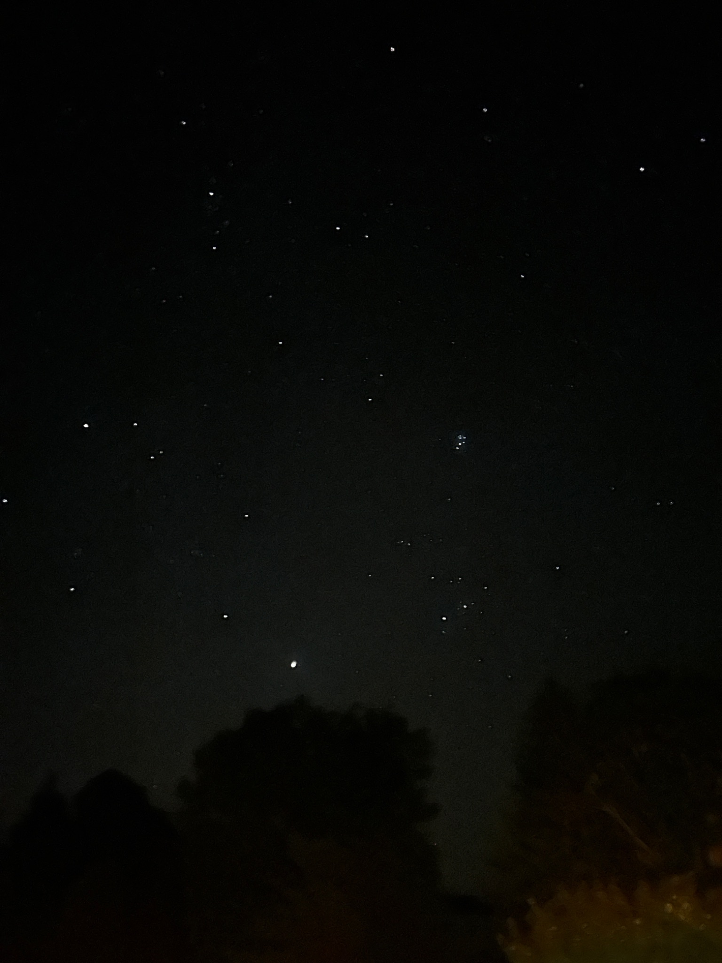
Figure 1. Milky Way, Northern Michigan, 2024. Photograph by author.

Figure 1 is my photograph of the Milky Way, taken in Northern Michigan with an iPhone. It is a digital image, but it doesn’t capture the full extent of the Milky Way’s visibility; how the concentration of stars was framed by the milky-white gaseous clouds that surrounded them. The Milky Way appears as a starry concentration swept over the dark night sky: granular in places, diffused in others, though bright enough to notice it. The horizon below was stark in contrast to the sky, and the little light pollution present made the horizon and sky stand out even more. I felt moved to take the photograph as a way to preserve my time and place at that moment, as a time stamp; similarly, Rubens’s painting is a time stamp of the world in which he lived.

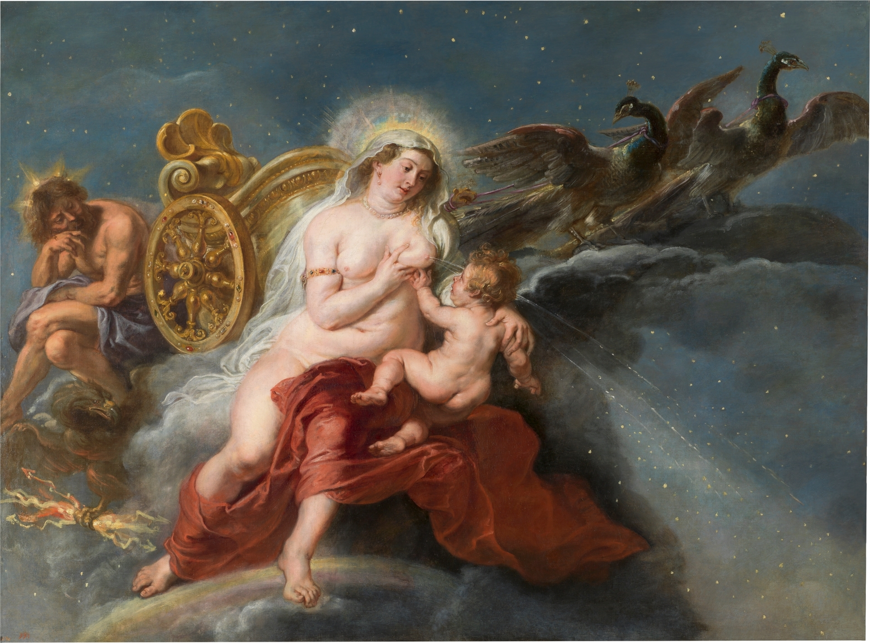
Figure 2. Peter Paul Rubens (1577-1640), The Birth of the Milky Way, c. 1636-38, oil on canvas, Museo Nacional del Prado, Madrid. Image and Copyright ©Museo Nacional del Prado

Figure 2 is Peter Paul Rubens’s The Birth of the Milky Way, painted around 1636-38 and now in the Gemäldegalerie Alte Meister, Dresden, though it is typically located at the Museo del Prado in Madrid, Spain. The work depicts the familiar myth in which Juno, startled while nursing Hercules, spills milk into the heavens, creating the Milky Way. Prado documents the painting in relation to mythology and early modern cosmological thought.
Medium and Visual Perception
The first and most obvious difference between the two works is their medium. My photograph was digitally captured from a live encounter with the night sky and made on an iPhone; Rubens’s work is from his primary and recurring medium: oil on canvas. Each piece is visually distinguishable and showcases a different relationship to light. In the photograph, the image depends on the conditions of a particular night—darkness, exposure, and the atmosphere’s clarity. In Rubens’s painting, by contrast, light is planned and intentional, formed by his hand through his choice of colour, symbolism, and signature diagonal composition.
My photograph is a direct observation, preserving a version of what I witnessed. The photo was shaped by exposure, framing, and the digital processing that instantaneously formed the final image. I was not staging a photoshoot, constructing a narrative, or observing the sky through a telescope, nor was the image edited afterwards. I was responding to a live encounter with the sky—an ancient source of fascination—though the image is not as organised or planned as Rubens’s painting. Rubens’s use of oil paint allows him to transcribe his vision into a world where a starry night sky and a mythological scene can coexist.
The photograph of the Milky Way seems to say, “This was a single vantage point, and I gazed above right beneath it.” It’s what captivated me in a contemporary context. The phone is an everyday object associated with speed, convenience, messaging, and interruption. In this instance, it became a tool for prolonged looking. The act of making the photograph allowed me to pause and choose which part of the Milky Way to capture, yet still, I had to let the scene settle and accept that the image would remain partial. The photograph does not capture the full experience of the Milky Way’s brightness, but it does document an eternal sky. The iPhone files the image with its timestamp, allowing me to immediately share and revisit anytime images, yet it also reminds the viewer that no digital image can capture the scale or depth of the night in which it was made.
Rubens’s use of oil as a medium in The Birth of the Milky Way does not depict a single personal encounter with the Milky Way, but rather a mythological understanding, as well as astronomical depictions and sketches. Pointon, in her article, ‘On “The Origin of the Milky Way” by Peter Paul Rubens: Astronomy, Astrology and Mythology in Early Modern Europe’, discusses Rubens’s knowledge of astronomical and astrological debates but argues that he translated them materially through paint. She describes the sky in The Origin of the Milky Way as a ‘complex material equivalent of the experience of looking at the Milky Way’, built through transparent layers, varied tones, and stars of differing scale and intensity. Unlike my photograph, which depends on the actual light conditions of a particular night, Rubens’s image mindfully constructs light by hand. She describes how richly this medium serves Rubens’s subject and how it emphasises that the painting draws together mythology, astrology, astronomy, and ideas of abundance and fecundity.
Huemer’s discussion of Rubens and Galileo suggests that Rubens worked within an early modern world in which art, nature, and astronomical thought could remain in close conversation. Rubens worked in a period when artistic practice and astronomical thought were not sealed off from one another. This does not mean that every celestial detail in the painting should be read as a coded reference to scientific discovery. It does suggest, however, that early modern painting could absorb changing ideas about the natural world without giving up classical or mythological forms. Rubens was able to paint the Milky Way as a mythological event without being disconnected from the astronomical interests of his time.
By contrast, the two works belong to very different media and ways of picturing the sky. My photograph depends on a contemporary, technologically mediated sky encounter. Rubens’s painting depends on composition, artistic invention, and a mythological approach shaped by early modern painting. Both use contrast to draw the eye towards the Milky Way against the darkness, but they do so in different ways. The photograph presents the sky as an observation and asks the viewer to accept and trust that it was seen, whereas Rubens’s medium is a traditional narrative means of painting, asking the viewer to enter a world shaped by myth. He constructs a mythological image through composition, bodily form, and painterly invention. While the photograph preserves a direct and personal encounter with the sky, it is still mediated by a device and by the ordinary contemporary habit of using photography to hold on to fleeting experience. It is immediate, close at hand, and made in seconds; very different from Rubens’s painting, which is shaped through a slower, more deliberate process and is not tied to a single moment of observation in the same way. Both are visual responses to the Milky Way, yet they belong to different conditions of seeing and to different expectations of what an image of the sky should do in each medium.

II Treatment of the Milky Way as Subject Matter

Beyond questions of medium and authorship, the Milky Way remains the central subject of both works. In my photograph, the Milky Way appears as a barely visible celestial band overhead. It is obvious, not evident, and there’s no intriguing story to go along with it; it’s not personified, narrated, or explained. It remains straightforward: a concentration of light and star density stretching across the night sky overhead, yet my subjective experience of it was not. What moved me most at the time was that the Milky Way is so concentrated and distinct from the scattered stars of the night sky; it altered the whole scale overhead. The darkness around it was not empty space waiting to be filled, but innately active. The Milky Way emerged with an extraordinary presence. The photograph is as much about the conditions of visibility as about the visible object. The Milky Way always exists, but amongst the sun-saturated sky, its apparent visibility is nonexistent to us on Earth. The only way we can see the Milky Way with the naked eye is because darkness makes it more visible.
As subject matter, the photograph presents the night sky through visible scattered stellar patterning rather than narrative or allegory. It does not present itself as a clearly visible or even identifiable structure, but as a dispersed field of stars against a darkened night sky. The image offers no immediate constellation patterns or recognisable celestial markers to orient the viewer. Instead, the stars appear scattered, with only a faint vertical lightening of the sky suggesting the possible presence of the Milky Way. Because this band is neither clearly defined nor easily separated from the surrounding darkness, it could just as easily be an effect of low-light and atmospheric conditions. Recognition by the viewer depends not only on what is visible, but also on prior knowledge and expectations and asks the viewer to remain with what is uncertain and only partially seen.
At the same time, the photograph is not culturally empty. I cannot look at what may be the Milky Way without bringing some modern understanding to it. I know I may be looking at a galaxy from within, and that its visibility depends on the absence of artificial light. The Milky Way, if present, is faint and without emphasis. The photograph does not use visual narrative to clarify it and offers no story to contain the sky.
The photograph does not use visual narrative to clarify it and offers no story to contain the sky. Rubens’s painting operates in the opposite direction. It belongs to an early modern mythological tradition in which the aim was not to reproduce physical reality in a strictly observational sense. Instead, it reshapes celestial subject matter through myth, composition, and pictorial invention.¹ His treatment of the Milky Way is the reverse. In The Birth of the Milky Way, the celestial band does not remain a stellar formation suspended in darkness. It is given a mythological origin through the body of Juno and the infant Hercules. According to the myth, Hercules needed Juno’s milk to secure immortality; when she pushed him away, the milk scattered across the heavens and formed the Milky Way. Yet, Prado details a slightly different version: “When, in his enthusiasm, Hercules bites her, Juno awakens and brusquely pulls him away from her. The milk spilling out of her breast turned into the Milky Way.” Rubens depicts the Milky Way through a Greco-Roman myth in which Juno’s spilt milk becomes a celestial formation. Although the Torre de la Parada cycle as a whole drew heavily on Ovid’s Metamorphoses, the specific story behind The Birth of the Milky Way appears to depend more directly on other classical mythographic sources, especially Hyginus. This distinction places the painting within a broader early modern classical culture rather than tying it too narrowly to one Ovidian text.
The Birth of the Milky Way provocatively stimulates our perception of the celestial feature through myth, the body, and early modern cosmological thought. As Marcia Pointon details, the painting brings together mythology, astronomy, astrology, and ideas of fertility and abundance within a single visual field. The Milky Way is rendered as an astronomical structure, but depicted as a stream of milk spilling across the night sky, showing the Milky Way as something continuous with the body rather than separate from it. The heavens are vibrant and active, and painted as something animate and generative. The sky emerges through movement and divine intervention.
Pointon emphasises that this particular work of Rubens should be understood within a wider network of early modern meanings, in which the celestial, the mythological, and the reproductive are deeply entangled. The Milky Way is the central site through which these ideas converge. Rather than leaving the sky open or indeterminate, as in the photograph, Rubens gives it form, narrative, and cultural relevance. The heavens are made legible through the figure of Juno and the maternal symbolism of lactation, offering a visual storytelling way to understand the cosmos grounded in myth, embodiment, and early modern cosmology rather than detached observation.
Prado's cosmology material adds another level and dimension to Rubens’s work by framing the painting within post-Galilean thought about the Milky Way as a mass of stars. This context is key to understanding the subject matter fully, given Rubens’s known engagement with contemporary intellectual and scientific culture. As Frances Huemer has shown, Rubens was working at a moment when new astronomical ideas—circulating in the wake of Galileo’s observations—were beginning to reshape how the heavens were understood. The painting does not attempt to visualise these developments directly. Instead, it renders the sky through myth, allowing different ways of knowing the cosmos to remain in dialogue with one another. What appears as a mythological scene can also be read as a work produced within a culture in which astronomical inquiry and symbolic interpretation were not yet fully separated. The origin of the Milky Way is expressed through Juno’s milk, as part of a culture increasingly aware of new ways to understand the heavens.
Art historian Michael Jaffé’s account of Rubens’s engagement with Italian artistic traditions and earlier masters helps contextualise how such mythological subject matter could be developed through study, adaptation, and reinterpretation. The painting brings this connection into view through its visual language. The Milky Way is rendered as a white, dispersed, living substance; it doesn’t appear as a strange astronomical object detached from the figures. It is physically a part of them. Rubens makes the celestial intimate without making it small. The sky enters the register of the body, and the body enters the register of the sky. In art-historical terms, that is one of the painting’s most remarkable achievements. It converts the heavens into a matter of touch, flow, and generation.
My photograph keeps the Milky Way at a distance, even as it draws the viewer into the act of looking. There is no figure to guide the eye, to tell a story through which the sky is explained, and no narrative to shape what is seen. Instead, the image offers a very human, not mythologised, view from the ground: a field of stars, faint and uncertain, that has to be taken in slowly, if at all.
Each presents the same subject through a different mode of representation. In the photograph, the stars remain simply there, barely registered at all, a subtle depiction of the sky, from a very human vantage point, the ground, gazing up. In Rubens’s painting, the sky is heavenly, epic, and drawn into the body, shaped by narrative. In both images, the Milky Way is treated as the primary subject rather than a background element.

Section Conclusion
Both images are looking at the same thing, but they show it in very different ways. In my photograph, the Milky Way feels and is visually distant, faint, and only partially grasped, encountered from the ground without a narrative or figure to guide interpretation. In Rubens’s painting, it is grandiose, shaped through the body, visually articulated through myth. Their subject matter, The Milky Way, is not something that takes on different meanings depending on how it is rendered, perceived, contextualised, and understood.

III Cultural Meaning and Intended Viewership
Who are these images for, and how do they ask to be looked at? What habits of looking do they cultivate?
My photograph comes from direct observation of the night sky, but it also belongs to a time when seeing the Milky Way is no longer guaranteed. In most urban and suburban settings, artificial light washes it out completely. Many people know it more as an idea than as something they have actually seen. As a result, a clear sighting indicates that the viewer is present, connected to nature, and likely in a remote, light-pollution-free location. What I captured with the phone was not only the sky, but a way of being with it that is easy to lose: standing in darkness long enough for your sense of scale to shift and to look up and notice. Through this lens of presence, the photograph holds onto that moment, allowing it to be visually documented in a digital library that can be referenced and revisited at any time, in line with Susan Sontag’s description of photography’s ability to hold experience beyond the instant in which it occurs.
Rubens’s painting was made for a different audience and time. The work belongs to Rubens’s mythological production and, as the Prado notes, is connected to the commission Rubens received at the Torre de la Parada, a courtly context tied to Philip IV., which places the painting within royal patronage and elite visual culture. Its viewers were not random onlookers but select members of a cultivated milieu familiar with classical story, allegorical painting, and the pleasures of erudite display. As historian Peter Sutton outlines, Rubens’s mythological paintings were made for aristocratic contexts in which classical subject matter formed part of a broader visual and literary culture. This positions The Birth of the Milky Way within a setting where such imagery would have been recognised and understood rather than encountered as unfamiliar.
Culturally, the Milky Way was a subject through which learning, sensuality, and visual splendour could be joined through Rubens. The painting was made for a very different setting and audience than my photograph, which was made with no audience in mind other than myself. The Birth of the Milky Way formed part of the decorative programme for the Torre de la Parada, whose origins lay in the mid-sixteenth century but which was extensively remodelled and redecorated under Philip IV in the 1630s. In 1636, Philip IV commissioned Rubens to produce around sixty mythological scenes for the site, most of them which were based on Ovid’s Metamorphoses, with many of the final canvases executed in Antwerp after Rubens’s oil sketches. This context supports that the painting was intended for an intimate courtly audience designed for elite viewing rather than public display. An audience that would have already been familiar with classical mythology and responsive to the pleasures of learned, decorative painting. As Svetlana Alpers has shown, early modern painting often assumes an active, informed viewer, for whom looking involves recognition and interpretation rather than passive reception. In this context, the Milky Way was entertaining and intriguing, depicted as an astronomical phenomenon through a mythological subject that aligned celestial imagery with aristocratic taste, classical learning, and the culture of the Habsburg court.
Pointon’s interpretation presents the painting as intellectually dense, bringing together mythology, astronomy, and broader cosmological ideas within a single image that reaffirms the audience already accustomed to this subject matter. Rubens’s audience is expected to read, and beyond feeling its awe and large scale, the painting rewards visual literacy. It asks the viewer to recognise the myth, to appreciate the pictorial intelligence of the composition, and to inhabit a world in which celestial phenomena are given form through classical narrative. Huemer’s work further supports this setting by showing that Rubens operates within a broader early modern culture where art and astronomy are in active conversation.
While there is no known statement by Rubens on this painting in particular, his correspondence—such as his letter to Nicolas-Claude Fabri de Peiresc—reveals an artist deeply engaged with learned patrons and classical subject matter. This exchange shows a painter capable of discussing the meaning and appropriateness of his subjects with clarity. This does not provide a direct interpretative key by the painter himself on The Birth of the Milky Way, but it does support the broader claim that Rubens worked within a highly articulate visual culture in which complex mythological imagery was both possible and purposeful.
Rubens’s broader career is also key; the Prado’s artist biography, as the Prado notes in his biography, his success at the major European courts and his high social standing were as important as his artistic talent in establishing his influence, which gave access to his suitability for an elite royal patronage. The biography emphasises that he was not only a major Flemish painter but a figure shaped by Italian art, humanist learning, and diplomatic service at European courts, all of which help explain his suitability for an elite mythological commission.
The contrast between the way my iPhone photo of the Milky Way leaves perhaps less to the imagination. The age, high-definition, is realistic yet doesn’t capture the nuances of the milky white, hazy cloudlike Milky Way encompassing the pathway of stars that I witnessed with my naked eye; therefore, my depiction invites more reflection and a deeper visual understanding and literacy of both what an iPhone is capable of capturing and the night sky and astronomical landscape understanding, required when using technology to capture the Milky Way. My photograph is shaped by a modern phenomenological relation to the heavens: personal and environmental, marked by the rarity of dark-sky visibility. Whereas Rubens’s painting asks for context when not viewed by its intended audience, it can still be recognised more broadly as celestial imagery. Viewers without specific knowledge may still respond to its scale, movement, and sense of awe, even if its full meaning remains out of reach. As Michael Baxandall has shown, acts of looking are shaped by historically specific habits of seeing, meaning that interpretation depends in part on what a viewer has learned to recognise. Rubens’s painting is therefore shaped by an early modern courtly relation to the heavens: learned, mythological, and tied to the pleasures of elite representation, though still enjoyed by the majority of the modern collective, whether elite or not, as contested by its usual placement at the Museo Nacional del Prado points to a broader appeal that extends beyond its original audience.
Yet, once again, a shared feature remains. Both images assume that the Milky Way deserves extended attention. Both treat the sky as meaningful. Both invite the viewer to look upward and to remain there. The difference lies in how that upward looking is culturally organised. My photograph invites the viewer to feel the force of direct encounter. Rubens invites the viewer to enter a symbolic and mythological world through which the heavens can be understood.

Section Conclusion
These two works prompt the viewer differently, and in doing so shape different ways of relating to the sky. First, their intended audiences have shifted: my photograph is reserved for those whom I choose to share it with, while Rubens is now on view in an international museum for a broader public. My photograph is beholden to the conditions of viewing a technologically mediated image and is shaped by what is no longer easily seen, pointing to a larger condition shaped by artificial light, population density, and technological advancement. By contrast, Rubens’s painting reflects a world in which the heavens were already given form through shared knowledge and narrative. The Milky Way, untouched directly by either myself or Rubens, remains the same; what changes is how we are asked to see it.

Conclusion
This comparative essay brings together two different ways of portraying the same sky. The Milky Way remains culturally significant because it has been observed for centuries, and it continues to be seen and understood differently over time. My photograph and Rubens’s painting differ in every way except their subject matter; they reflect different ways of making sense of what a sky phenomenon is. And, while his painting comes from a world in which myth, science, and visual culture were closely connected, he poetically invoked the sky, shaped through story and shared knowledge. He held the Milky Way in a way that could be explored and elucidated within a broader understanding of the cosmos that has endured for centuries.
By contrast, my photograph captures a celestial moment when seeing the night sky is no longer guaranteed. Technology is continuing to advance, and while it makes it easier to capture moments and share what is actually visible, it also introduces a certain distance between the experience and the image. Photography depends on the atmosphere, timing of darkness, and the device’s limits, and is only part of the experience. It does not explain the sky so much as mark a moment of encountering it.
Together, these works show a shift in how the sky is experienced and held onto. What was once understood through shared stories is now often felt as something fleeting and more personal. The Milky Way has been ever-present, but how we come to know it—and what we make of it—continues to change.

Bibliography
Alpers, Svetlana, The Art of Describing: Dutch Art in the Seventeenth Century (Chicago:
University of Chicago Press, 1983)
Baxandall, Michael, Painting and Experience in Fifteenth-Century Italy (Oxford: Oxford
University Press, 1972)

Huemer, Frances, ‘Rubens and Galileo 1604: Nature, Art, and Poetry’,
Wallraf-Richartz-Jahrbuch, 44 (1983), 175–96

Jaffé, Michael, ‘Rubens as a Collector of Drawings. Part Three’, Master Drawings, 4.2 (1966),
127–48

Museo Nacional del Prado, ‘Reflections of the Cosmos’, https://www.museodelprado.es
[accessed 24 April 2026]
———, ‘The Birth of the Milky Way’, https://www.museodelprado.es [accessed 24 April 2026]
Pointon, Marcia, ‘On “The Origin of the Milky Way” by Peter Paul Rubens: Astronomy,
Astrology and Mythology in Early Modern Europe’, Zeitschrift für Kunstgeschichte, 84.4
(2021), 451–82
Sontag, Susan, On Photography (New York: Farrar, Straus and Giroux, 1977)
Sutton, Peter C., Rubens (New York: Harry N. Abrams, 1997)
Villar Martín, Montserrat, Reflections of the Cosmos in the Museo del Prado (Madrid: Museo
Nacional del Prado, 2022)

Peter C. Sutton, Rubens (New York: Harry N. Abrams, 1997); Museo Nacional del Prado, Reflections of the Cosmos.
Marcia Pointon, ‘On “The Origin of the Milky Way” by Peter Paul Rubens: Astronomy, Astrology and Mythology in Early Modern Europe’, Zeitschrift für Kunstgeschichte, 84.4 (2021), 451–82.
Museo Nacional del Prado, Reflections of the Cosmos.
Frances Huemer, ‘Rubens and Galileo 1604: Nature, Art, and Poetry’, Wallraf-Richartz-Jahrbuch, 44 (1983), 175–96.
Museo Nacional del Prado, ‘The Birth of the Milky Way’, collection entry.
Museo Nacional del Prado, Reflections of the Cosmos.
Marcia Pointon, ‘On “The Origin of the Milky Way” by Peter Paul Rubens: Astronomy, Astrology and Mythology in Early Modern Europe’, Zeitschrift für Kunstgeschichte, 84.4 (2021), 451–82.
Frances Huemer, ‘Rubens and Galileo 1604: Nature, Art, and Poetry’, Wallraf-Richartz-Jahrbuch, 44 (1983), 175–96.
Museo Nacional del Prado, ‘The Birth of the Milky Way’, collection entry.
Museo Nacional del Prado, ‘The Birth of the Milky Way’.
Pointon, ‘On “The Origin of the Milky Way”’, pp. 460–66.
Pointon, ‘On “The Origin of the Milky Way”’, pp. 460–66.
Museo Nacional del Prado, Reflections of the Cosmos.
Frances Huemer, ‘Rubens and Galileo 1604: Nature, Art, and Poetry’, Wallraf-Richartz-Jahrbuch, 44 (1983), 175–96.
Michael Jaffé, ‘Rubens as a Collector of Drawings. Part Three’, Master Drawings, 4.2 (1966), 127–48 (p. 127).
Susan Sontag, On Photography (London: Penguin, 1979), p. 4.
Prado, ‘The Birth of the Milky Way’.
Peter C. Sutton, Rubens (London: Phaidon, 1997).
Museo Nacional del Prado, Reflections of the Cosmos.
Svetlana Alpers, The Art of Describing: Dutch Art in the Seventeenth Century (Chicago: University of Chicago Press, 1983).
Pointon, ‘On “The Origin of the Milky Way”’, pp. 464–65.
Huemer, ‘Rubens and Galileo 1604: Nature, Art, and Poetry’, pp. 184–86.
Rubens to Nicolas-Claude Fabri de Peiresc, 16 March 1636, quoted in Marcia Pointon, ‘On “The Origin of the Milky Way” by Peter Paul Rubens’, Zeitschrift für Kunstgeschichte, 84.4 (2021), 451–82 (p. 452).
Museo Nacional del Prado, ‘Peter Paul Rubens’, https://www.museodelprado.es [accessed 24 April 2026].
Baxandall, Michael, Painting and Experience in Fifteenth-Century Italy (Oxford: Oxford University Press, 1972).
Museo Nacional del Prado, ‘The Birth of the Milky Way’, collection entry.

