University of Wales Trinity Saint David
LONDON CAMPUS
Individual Report
Module Name: Digital Skills and Research Methods
Module Code: LCHS 4007
Student name: Vilma Martinez
Student ID:2509208
Lecturer’s Name: Dr. Sadeque Iman Shaikh

Table of Contents
Research Topic: <Insert Research Topic Here> 2
Introduction 2
Problem Statement 2
Justification 2
Information Sources and Justification 2
Task 2: Research Methodologies 2
Give a brief overview of quantitative and qualitative research. 2
What type of research methodology will you use for your research and why? 3
Task 3: Data Collection 3
Overview of primary and secondary data collection 3
What form of data will be used to address your research problem, and why? 3
Conclusion 3
References 3

Aging Population and Elderly Care

Introduction

The United Kingdom is experiencing significant demographic change as the proportion of older adults steadily increases, presenting both challenges and opportunities for health and social care. The NHS is strengthening services by promoting independence, healthy living, and early frailty detection to prevent long-term conditions. The BMA highlights the importance of recognising older adults as active contributors rather than passive recipients of care, while also addressing workplace challenges linked to caregiving responsibilities. Globally, the WHO advocates focusing on frailty and wellbeing rather than age alone. A comprehensive approach combining healthcare, social support, and policy reform ensures older adults age with dignity.

Problem Statement
The United Kingdom is undergoing a profound demographic transition, marked by a rapid increase in the proportion of older adults. Projections write down that by the mid-2040s, approximately 22 million individuals will be aged over 50, being nearly 40% of the national population. This demographic is expected to expand by 19.3% within the next two decades, with the most significant growth occurring among those aged 85 and above. The population aged 65 and older has already risen substantially, with an estimated 2 million people lacking adequate care and support. Furthermore, the 65–79 age group is forecast to grow by nearly one-third, while the number of centenarians has doubled since 2004. These demographic shifts are expected to place considerable strain on public services, particularly the National Health Service (NHS), social care systems, and wider public finances.
Globally, similar challenges are clear. By 2050, it is projected that 80% of older adults will exist in low- and middle-income countries, with the global population aged 60 and above nearly doubling. This expansion is accompanied by a rise in age-related health conditions such as dementia, diabetes, cardiovascular disease, and chronic pain, all of which contribute to increasingly complex healthcare demands. Within the UK, the prevalence of these conditions is intensifying the need for medical services, long-term care, and specialist interventions. Healthcare costs inevitably rise with age, and the NHS is already under significant pressure due to escalating demand, workforce shortages, and financial constraints.
Beyond healthcare, older adults meet substantial social and economic challenges. Employment barriers, particularly those associated with balancing work and caregiving responsibilities, negatively affect household income and national productivity. Weak or insufficient support systems worsen these difficulties, leaving many older individuals vulnerable to poverty, social isolation, and diminished quality of life. Housing, pensions, and community support structures require urgent reform to address the evolving needs of this demographic.
Another pressing issue is the persistence of ageism within UK society. Advocates for older people’s rights emphasize that ageism stays harmful yet widely “normalised.” Even individuals who consider themselves socially progressive may express derogatory views about older adults, reinforcing stereotypes that depict them as passive recipients of care rather than active contributors to society. Such attitudes undermine initiatives aimed at promoting healthy aging and discourage older adults from fully taking part in social, economic, and civic life.
Addressing these challenges requires a comprehensive and multi-faceted response. Policies must strengthen healthcare and social care provision while simultaneously promoting independence, resilience, and inclusion among older adults. Preventive measures such as frailty case finding, wellness checks, and community-based interventions can show those most at risk and provide tailored support. At the same time, broader reforms are necessary to challenge ageism, enhance employment opportunities, and ensure adequate housing and pension systems. By integrating healthcare, social support, and policy innovation, the UK can more effectively respond to the needs of its aging population, ensuring that older adults are respected, supported, and empowered to age with dignity and resilience.

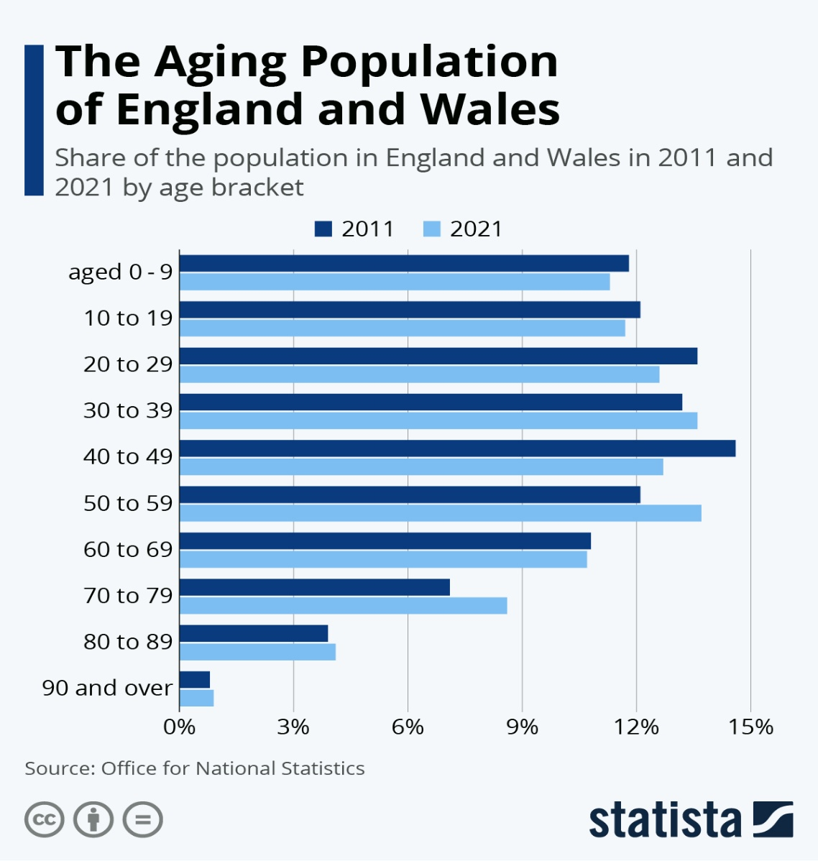

1.A comprehensive social policy framework is urgently needed to emphasize active aging and preventive measures that mitigate later-life risks. Grounded in a life-course perspective, such an approach must recognize the diverse trajectories and varied experiences of aging, ensuring inclusive strategies that promote resilience and wellbeing.
By implementing this approach, policymakers can substantiate the necessity of addressing demographic challenges linked to the United Kingdom’s aging population, thereby emphasizing adaptation and ensuring sustained support mechanisms for an increasingly older society within evolving social and healthcare contexts.
London: Government Office for Science. Available at: https://assets.publishing.service.gov.uk/media/5d273adce5274a5862768ff9/future-of-an-ageing-population.pdf (Accessed: 7 December 2025).
2. In 2024, England records 22 million individuals aged over 50, standing for approximately 40% of the population. This demographic is projected to rise by 19.3% between 2024 and 2044, equating to an added 4.3 million people. Notably, the cohort aged 85 and above is expanding at the most accelerated rate, underscoring significant implications for health and social care provision.
Age UK (2024) State of Health and Care of Older People in England 2024. Available at: https://www.ageuk.org.uk/discover/2024/september/state-of-health-and-care-of-older-people-in-england-2024/ (Accessed: 2 December 2025).
3. In 2021, the United Kingdom recorded approximately 13 million individuals aged 65 and over, a figure predicted to surpass 15 million by 2030. This demographic shift implies that nearly one-fifth of the national population will be of retirement age. As advancing age is often associated with increased healthcare requirements, residential care has become a critical part of the UK’s healthcare system. Provision of residential care encompasses two principal forms: nursing homes, formally chosen as care homes with nursing, and standard residential homes, commonly referred to simply as care homes.
https://www.statista.com/topics/7908/residential-care-in-the-uk/ (Accessed: 4 December 2025)

Research Methodologies
Quantitative Research Focuses on gathering numerical data and applying statistical techniques to interpret results. Its central aim is to generate goal, measurable evidence that can be quantified and systematically analysed. This method is commonly employed to evaluate hypotheses, find relationships, and reveal patterns across large datasets. Using tools such as surveys, experiments, and statistical modelling, researchers can produce generalizable findings and forecast future outcomes. Quantitative approaches are especially significant in disciplines like healthcare, education, and social sciences, where evidence-based decision-making relies on precise measurement, statistical rigor, and validated results to ensure reliability, accuracy, and practical relevance.
McLeod, S.A., 2023. Qualitative vs quantitative research. Simply Psychology. Available at: https://www.simplypsychology.org/qualitative-quantitative (Accessed 30 Nov. 2025).
Qualitative Research Is an investigative approach designed to gain a deep understanding of human experiences, behaviours, and social interactions. Unlike quantitative methods that emphasize numerical measurement, qualitative research explores meanings, emotions, and subjective perspectives to capture the richness of lived experiences. It relies on techniques such as interviews, focus groups, and observations to uncover insights that numbers alone cannot reveal. This approach is widely applied in disciplines including sociology, psychology, education, healthcare, and business, where understanding context, personal narratives, and complex social dynamics is essential. Ultimately, qualitative research provides nuanced evidence that informs theory, practice, and policy development.
researchmethod.net (n.d.) Qualitative Research. Available at: https://researchmethod.net/qualitative (Accessed: 30 November 2025).
I chose quantitative research method because it shows measurable, generalizable, and statistically validated evidence rather than subjective insights, making it the most proper approach.

Primary Data Collection Primary data is information collected directly from original sources for a specific research purpose, using methods such as surveys, interviews, observations, or experiments. Its main advantages include relevance, accuracy, and strong quality control, as researchers oversee the entire process. However, it can be costly, time-consuming, and resource-intensive, requiring careful planning and ethical implementation to ensure reliable results.
Interviews: Conversations, either individual or collective, designed to explore and understand people’s perspectives, experiences, and behaviours.
Observations: Systematically recording behaviours and events as they occur within authentic contexts.
Experiments: Controlled investigations conducted
under structured conditions to assess theories and prove causal relationships between variables.
Focus Groups: Organized interviews with selected participants designed to explore perspectives and beliefs.
Primary data collection offers significant advantages, providing researchers with information tailored to specific goals, ensuring relevance and timeliness. Direct control over the process enhances data quality and accuracy. However, this approach is resource-intensive, demanding considerable time, funding, and personnel, while requiring meticulous planning and ethical execution to guarantee reliable outcomes.

Secondary Data Collection Secondary data is information that has already been gathered, structured, and made available by other researchers or organizations for purposes different from the current study. It often comes from existing research projects, official reports, surveys, or administrative records. Unlike primary data, which is collected firsthand by the researcher, secondary data can be revisited and adapted to address new research questions.

Conclusion
In conclusion, the challenges associated with an aging global population require integrated and coordinated strategies across healthcare, social policy, and research. By 2050, most older adults will live in low- and middle-income countries, intensifying the demand for fair and sustainable care systems. Addressing ageism, strengthening residential and community-based care, and prioritising well-being over chronological age are critical steps toward improving outcomes for older individuals. Research methods such as secondary data analysis and quantitative approaches offer valuable insights into demographic trends and health patterns, though they must be applied with caution to account for limitations in accuracy and contextual relevance. A holistic response that combines compassionate practice, evidence-based policymaking, and rigorous research is essential to ensure older adults are supported, valued, and empowered. Such an approach will help societies adapt effectively to demographic change, promoting dignity, resilience, and inclusion in elderly care.

References

World Health Organization (WHO). (2022) Ageing and health. Available at: https://www.who.int/news-room/fact-sheets/detail/ageing-and-health
(Accessed: 23 November 2025).

UK Parliament (2015) Ageing population. Available at: https://www.parliament.uk/business/publications/research/key-issues-parliament-2015/social-change/ageing-population/ (Accessed: 23 November 2025).

NHS England. (n.d.) Improving care for older people. Available at: https://www.england.nhs.uk/ourwork/clinical-policy/older-people/improving-care-for-older-people/ (Accessed: 23 November 2025).

UK Parliament. (2015). Challenges of an ageing population. (online)UK Parliament. Available at: https://www.parliament.uk/business/publications/research/key-issues-parliament-2015/social-change/ageing-population/ (Accessed 23 Nov. 2025).

Public Health England (2019) A consensus on healthy ageing. (online) GOV.UK. Available at: https://www.gov.uk/government/publications/healthy-ageing-consensus-statement/a-consensus-on-healthy-ageing (Accessed: 23 November 2025).

Oxford Academic. (n.d.) Clinical research methods Age and Ageing. Oxford University Press. Available at:
https://academic.oup.com/ageing/pages/clinical_research_methods (Accessed: 30 November 2025).

GeeksforGeeks, 2025. Data Collection Methods Primary and Secondary Data. [online]
GeeksforGeeks. Available at: https://www.geeksforgeeks.org/data-analysis/methods-of-data-collection/ (Accessed 3 Dec. 2025).

Research-Methodology, 2025. Data Collection Methods. (online) Available at: https://researchmethodology.org/data-collection/ (Accessed 3 Dec. 2025).

Age UK (n.d.) Care and support for the elderly. Available at: https://www.ageuk.org.uk/information-advice/care/ (Accessed: 7 December 2025).

