

Assessment 1 – Reading Task Template
Upload your photo of your A3 in-class notes here:
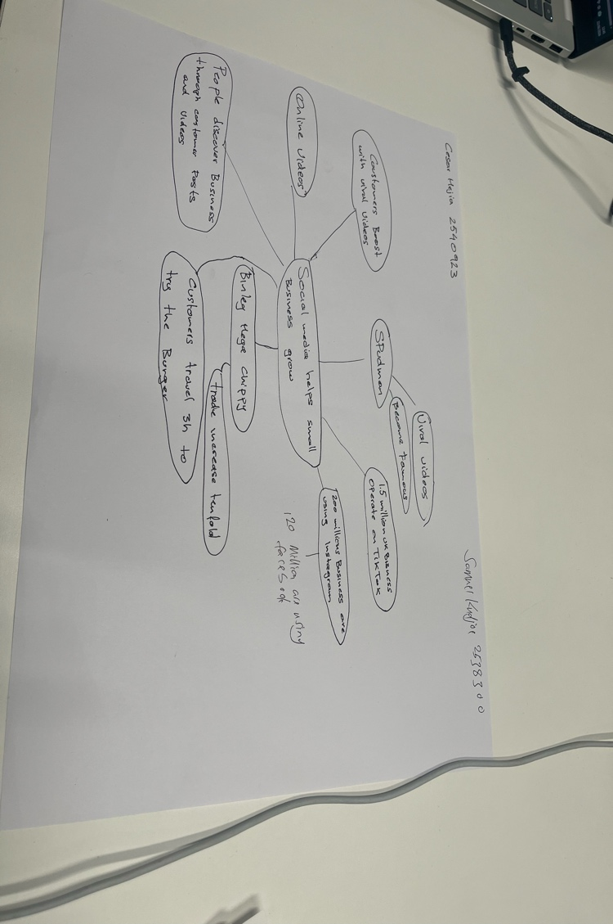

1. Answer these questions using the sentence starters below
a. What is the main idea of the text?
The main idea is that social media platforms make small businesses grow
b. What are two key points?
One key point is about 1.5 million business used TikTok in 2025

Another key point is more than 200 million are using Instagram
c. What part of the text did you find most important? Why?
The most important part is the businesses are making online videos to promote their business
d. Was anything unclear or difficult to understand?
I was not sure about how satisfying customers are
e. How did your group help you understand the text better?
My group helped me by helping me find the key the key points
2. One sentence reflection
Question: What did you find challenging about this task?
The hardest part was how 62 years of age has relocated businesses online

