Changemakers
Assignment 1: E-Portfolio
Jacob Smelt (2215291) – Beng2-PT embedded electronics systems

Contents
E-Portfolio 2
Link 2
Home Page 2
How innovation shapes the world Mind Map (Task 1) 2
Task 2 3
Task 3 3
References 4
Screenshots of unit completion 4

E-Portfolio

Link
https://sites.google.com/view/changemakers-assignment1/home

Home Page
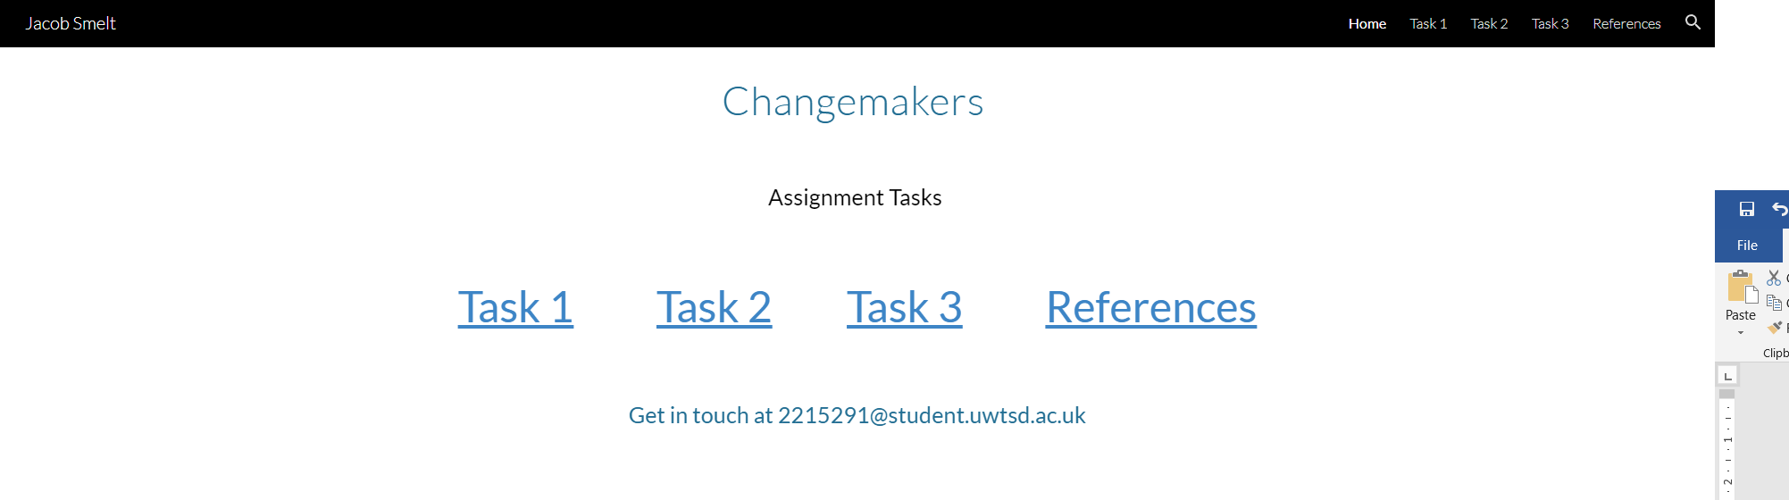

How innovation shapes the world Mind Map (Task 1)

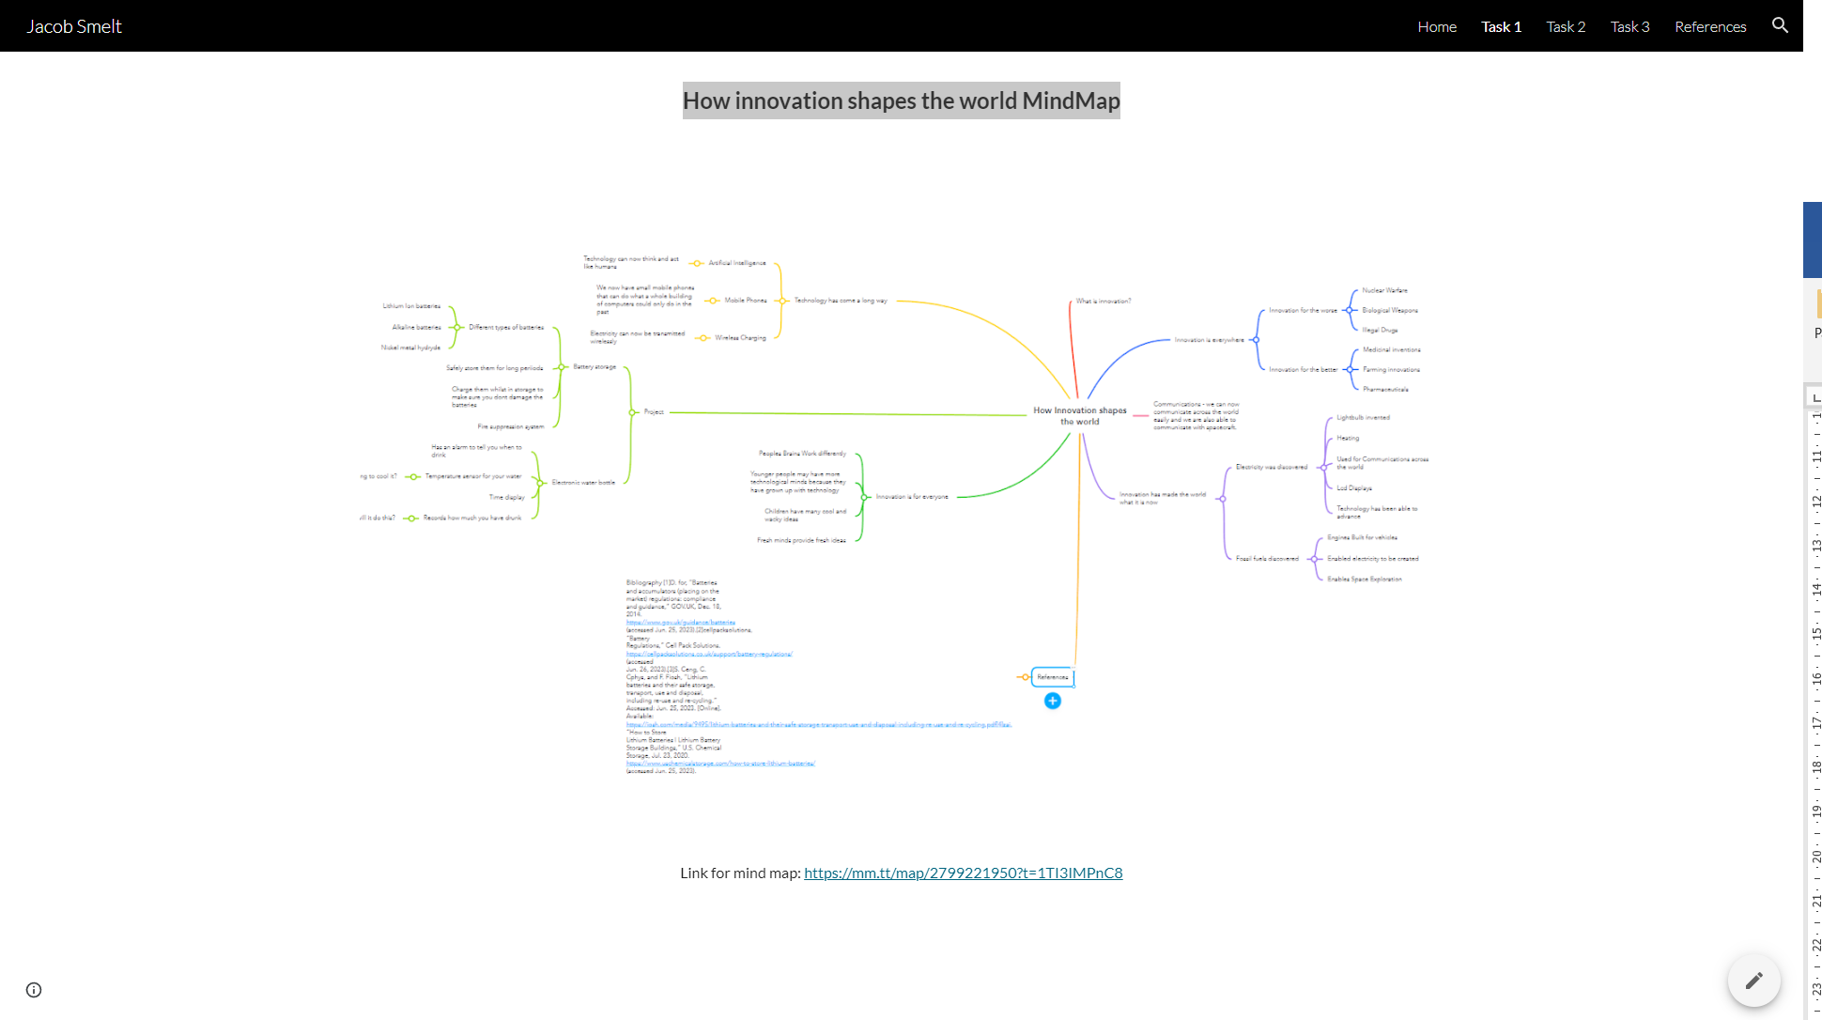

Task 2
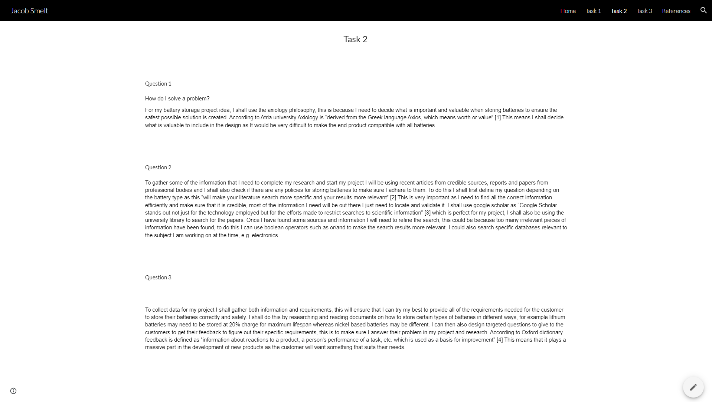

Task 3
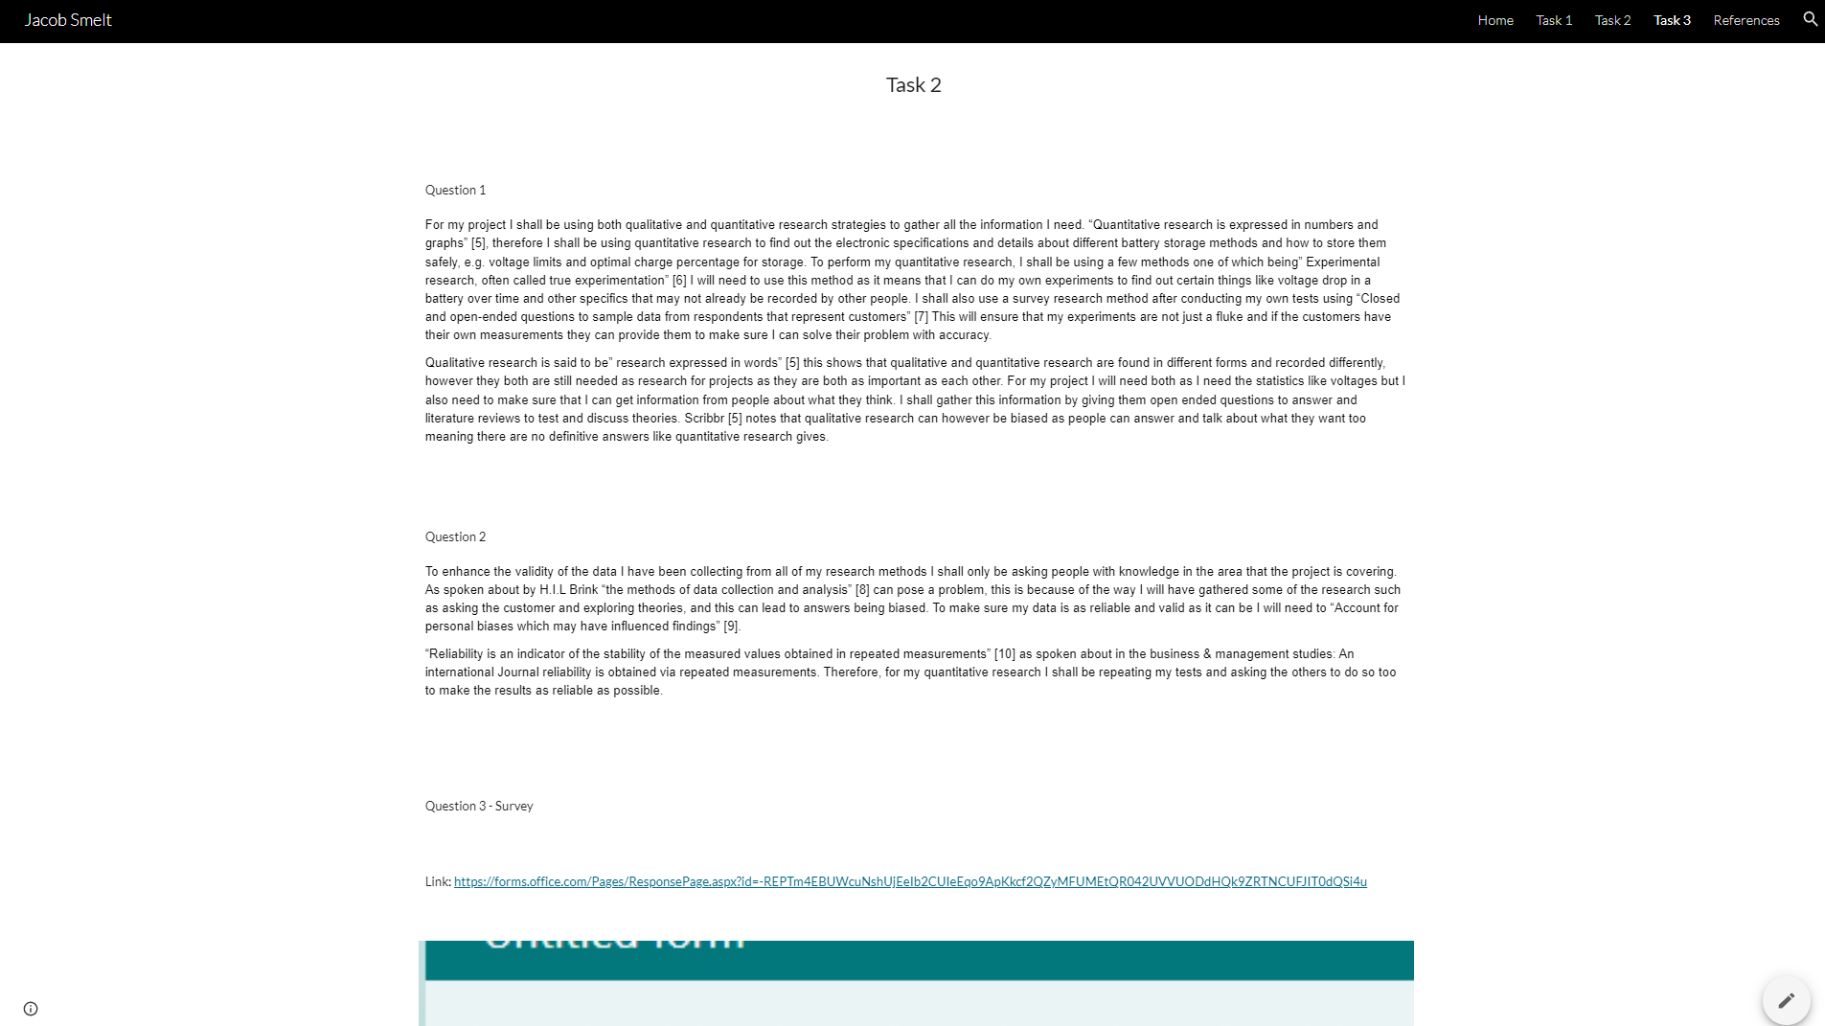

References
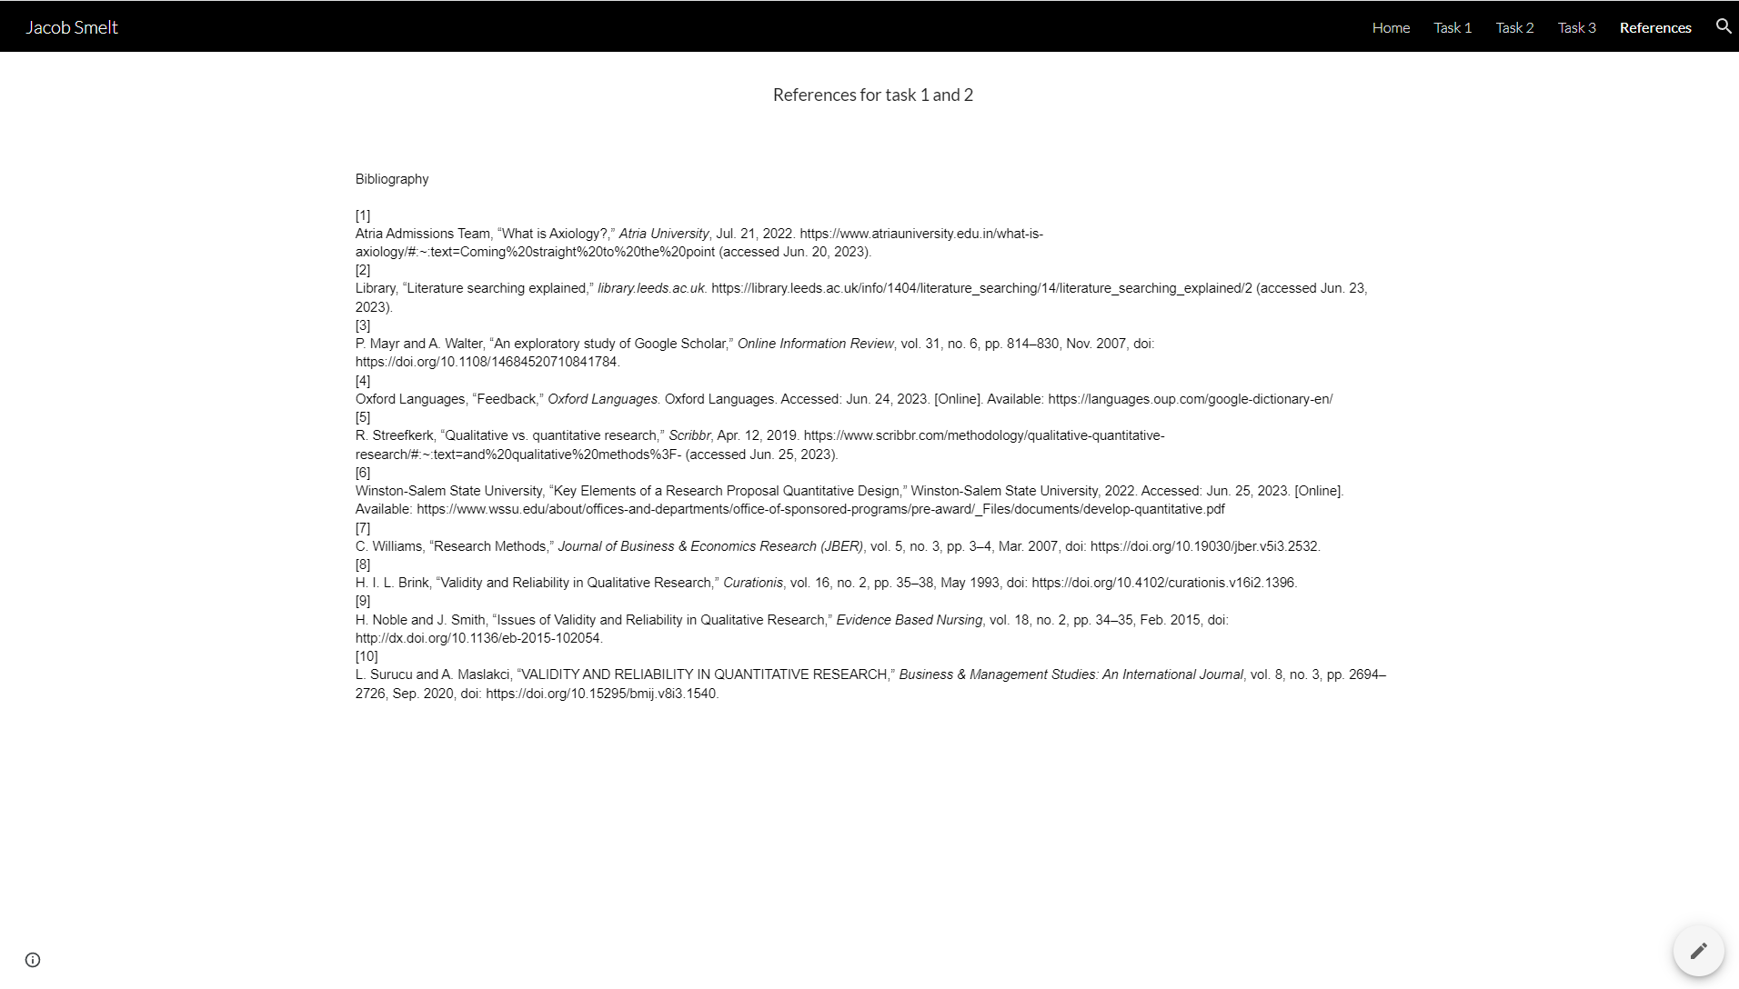

Screenshots of unit completion


