
Data Handling and Business Intelligence
Project Report

Ionela filip-datcu
id :1922490
LECTURER NAME: Dr Md Nazmul Hasan

Table of Contents
Introduction: 2
Data 3
Objective: 4
Data Preprocessing 4
Exploratory analysis: 4
The second part of the analysis: 6
The fourth part of the analysis: Is to analyze sums of discounts money for each category. 9
The fifth part of the analysis: Is to analyze the percentages of sales of each ship mode. 9
Dashboard: 11
Recommendations: 12
a) Answer: 17
b) Answer: 18
What is Text Mining? 18
c)Answer: 21
SPSS Vs EXCEL: The Key Differences 21
SPSS Vs EXCEL: In Tabular Form 22
References: 24

Part 1 –

Introduction:
The Superstores (Alauddin, 2015) comprises companies that operate by having huge spaces that store and supply large amounts of goods. The super store is comprised of extensive stores that sell a typical product line of grocery items and merchandise products, such as pharmaceuticals , cosmetics items, food, and personal care items, health related products, games and toys, furniture, and many appliances. Superstore provides a membership fee for consumers to shop within the store and once a member, and the superstore provides consumers with a broad array of products for discounted costs. The superstore industry is part of the retail trade market. Most of the products bought at superstores(Ghosh, 2019) are used by wholesalers and smaller retail businesses for their own companies. There is constant competition between the superstores and supercenters with many merchandisers, department stores, wholesalers, and grocery stores. Large superstores and superstore chains are predominant in this market because of their economics of scale in the financing, purchasing, and distributing. To analyze such an industry is of great importance and induced us as it gives insights into the sales and profits of various products. Our analysis is based on global superstore data where the products are ordered between the years 2009-2012. Here, in this superstore data, we analyze and discover various aspects that determine the profit of superstore(Merrilees,2001) based on some parameters like region, products, and sales. The idea is to attempt to find new ways to improve efficiency with regard to logistics and shipping. Improving these areas will, in turn, reduce the amount of time between initial customer order and delivery. Companies that sell merchandise online need to have distribution centres where their merchandise is kept and shipped from. When an order is placed, the distribution centre receives the order and then sends that product to the appropriate place via a shipping method. This is what we will focus on in this analysis.

Data
The data contains information about online orders from a superstore (e.g. something like Amazon). Our analysis is based on a retail dataset of a global superstore from the year 2009 – 2012 (4 years), and the dataset belongs to the retail domain with 8400 observations.
The exchange of a commodity for money like clothes, furniture for the money, the action of selling something is called Sales and data is the quantities, characters on which operations are performed by a computer, which may be stored and transmitted in the form of electrical signals and recorded on magnetic etc. There are mainly two types of data:
Categorical data: It is divided into two types
• Dichotomous: Dichotomous variables are nominal variables that have only two categories (Binary) or levels. For example, if looking at gender feature , would probably categorize somebody as either "male" or "female".
• Non-Dichotomous: Non-Dichotomous are nominal variables that have more than two categories or levels. For example, if have looked at grades in a semester, would categorize many grades.
Numeric data: Numeric data is data that is measurable, such as time, weight, money, and so on. The Sales data can assume the facts for making few computations and predictions, also reduce the relation between feature and parameters that leads to higher turnover of the Super Store. Our data is consistent of both Categorical and Numerical. Here, our aim is to drop all the unnecessary features, assign numerical equivalence to categorical features, and perform analysis to get insights of the company's Profits and sales.

Objective:
The store owner notes that there was a sales drop in 2012. So he wants to make good decisions in order to increase sales once again. Whether changing the policy of the store, changing the prices range, or increase discounts. So goal is to support them to make his decision. KPIs will use that are sales, profit, and discount.

Data Preprocessing
It is a data mining technique that use to transform raw data into an understandable format. This process has four main stages – data cleaning, data integration, data transformation, and data reduction. In this case, there may be noises of impossible and extreme values and outliers, and missing values. The errors may include inconsistent data and redundant attributes and data. As the first step, null values within the dataset will be identified and appropriately replaced if possible. Throgh analysis found that there are no null values present in the dataset. The RowID column can be deleted because it has no meaningful information.

Exploratory analysis:

The first part of the analysis: is to analyze the growth of sales through 4 years. By excel tool have created line chart to analysis the sales growth.

Row Labels | Sum of Sales
2009
Qtr1 | 1257938.596
Qtr2 | 874888.8235
Qtr3 | 1015021.013
Qtr4 | 1021476.374
2010
Qtr1 | 816978.8345
Qtr2 | 873806.447
Qtr3 | 813463.4785
Qtr4 | 1047393.622
2011
Qtr1 | 880759.168
Qtr2 | 731884.988
Qtr3 | 844334.31
Qtr4 | 998473.5945
2012
Qtr1 | 949217.6185
Qtr2 | 933881.6935
Qtr3 | 879267.807
Qtr4 | 976814.457
Grand Total | 14,915600.82

To see the behaviour of sales growth from 2009 to 2012. We note the line has shown increasing trend behaviour from the year 2010 till the year 2011. But, from the year 2011 till 2012 the line has shown an increasing trend. In 2009 sales was 4,168.324.806$ while the lowest sales were recorded in 2010 with 3,551.642.382$

The second part of the analysis:
It is to analyze the sales profits in that period from 2009 to 2012. Here line chart created to analysis the profit growth.

By pivot table:
Row Labels | Sum of Profit
2009
Qtr1 | 115941.46
Qtr2 | 89088.81
Qtr3 | 96344.57
Qtr4 | 120139.44
2010
Qtr1 | 84186.27
Qtr2 | 97387.04
Qtr3 | 71747.15
Qtr4 | 117538.63
2011
Qtr1 | 86928.23
Qtr2 | 80097.28
Qtr3 | 93043.41
Qtr4 | 124219.31
2012
Qtr1 | 110927.85
Qtr2 | 85146.97
Qtr3 | 76638.13
Qtr4 | 72393.43
Grand Total | 1521767.98
The data is available for four years, 2009 - 2012. 2009 is the most profitable year, and 2012 is the least profitable. There was no significant change in these over the years, which could indicate a drop in profit for 2012. This analysis note that the line is climbing from the year 2010 to the year 2011. In the period from 2011 to 2012, the line is falling the same as the first part of the analysis. In 2009 profit was more as like sales than other three years.
The third part of the analysis: is to determine sales percentages of each product category. We have created piechart to analysis the sales percentages of each product category.

We note that we have three categories those are:
Furniture, Office Supplies, and Technology. The technology category has the highest percentage in sales with 40%. The next category is furniture with 35%. And the lowest percentage is office supplier's category.

The fourth part of the analysis: Is to analyze sums of discounts money for each category.

By analysis note that the office supplier's category has the highest sum of discounts money while the furniture category has the highest sum of discounts money.

The fifth part of the analysis: Is to analyze the percentages of sales of each ship mode.

As we know that the sales of each ship mode are different, Here this chart showing that the Express Airship mode has the lowest percentage in sales while Regular airship mode has the highest percentage (50%) in sales.
Sixth part of the analysis: Sales distribution by Product category and Customer Segment:

By this bar chart, through analysis conclude that corporate customer segments are important for the company and mostly focus on the technical product category, so the company should target corporate segments to increase sales and revenue.
Sales distribution by Region

From this chart, conclude that Ontario and the west region are the best places for sales because sales distribution is more in this region. In the North Carolina and Northwest Territories region, sales are not good, so this business idea required a warehouse, on-time delivery, etc.
Avg Shipping cost by Region:

By this chart can see in Northwest average shipping charge is more than other regions, while in this region sales distribution is less so can recommend in this region shipping cost should be decreased.

Dashboard:
In last combined all worksheet and created a dashboard for interactive visualization (Oike, 2019) to see the overall analysis of superstore:
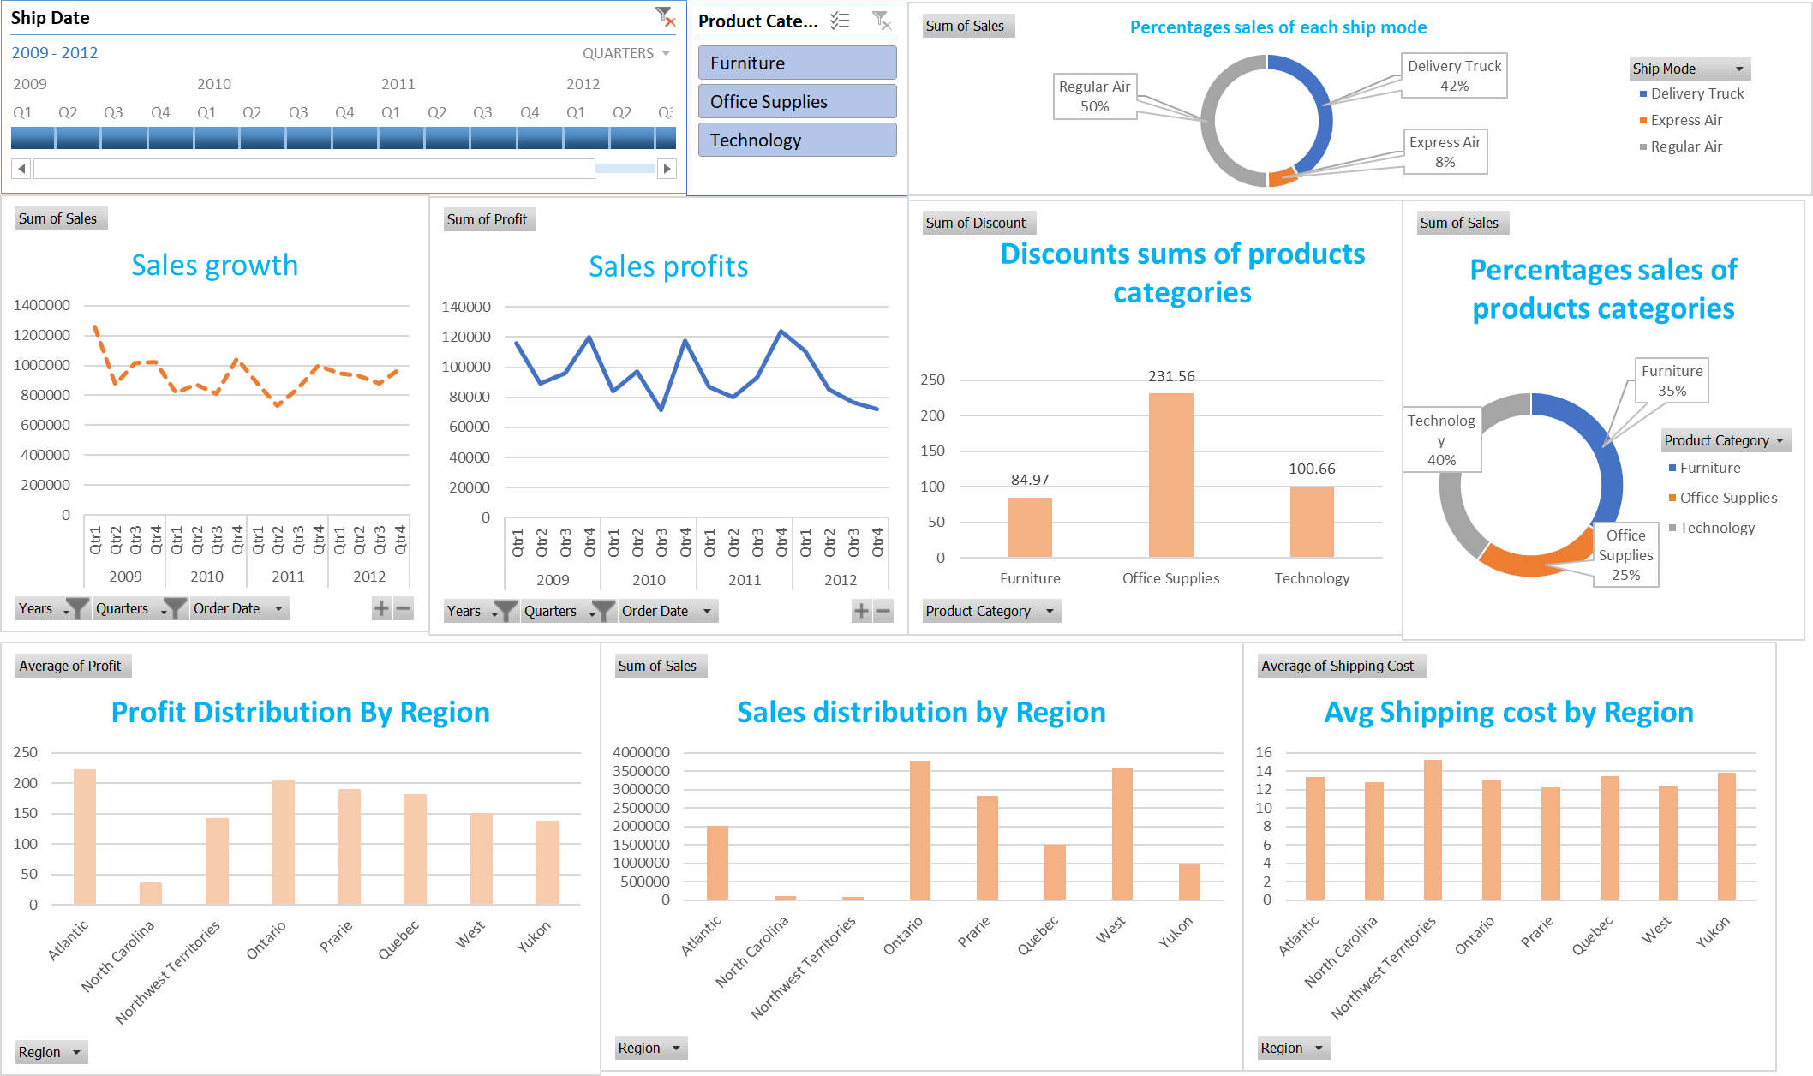

Recommendations:
According to the previous parts of analysis we observe that the store owner should:
- Decrease the shipping price for Express air and delivery truck ship mode. And does not ignore to decrease the shipping price for Regular airship modes.
- Increase offers for customers.
- Make an effort to attract more sales in states that have the growth potential.
- Increase more different ship modes with different prices.

Discounts should be given thoughtfully; unnecessary discounts witness low profit.

Discounts on Furniture Supplies should be kept low, as we are facing more loss here.

Super store should concentrate on Technology Sales because have low Sales in it.
- From the above inferences, conclude that most of the values are negative i.e. the company's profits are negative, which means the company is running in losses due to orders from specific postal codes and types of shipping modes, as well as the discounts offered on the products, are high.
- The superstore should stop providing high discounts at specific postal codes and also in should increase the charges of the shipping modes.
- In the category of furniture sales, more sales are happening in the month of September. So during this month demand for these products are higher.
- In the category of furniture sales, fewer sales are happening in the month of February. So the manager should adopt any new business approaches to increase the sales during these months.
- In the category of furniture sales, super store can expect the demand for furniture products will increase in the next two years. In the category of technology product sales, more sales are happening in the month of September. So during this month demand for these products are higher.
- In the category of technology product sales, fewer sales are happening in the month of February. So the manager should adopt any new business approaches to increase the sales during these months.
- In the category of technology product sales, super store can expect the demand for technology products will increase in the next two years.

Part 2
Now on SPSS tool use the 'Smile clinic', data that define who has been tasked to analyze customers data to see whether they eat rice in their daily meal from a healthy diet point of view. Has been perform analysis on this dataset by using the SPSS.
How many customers of the Smile Clinic do eat rice?
- Answer: In SPSS (Levesque, 2007) tool dataset has been imported, below can view:
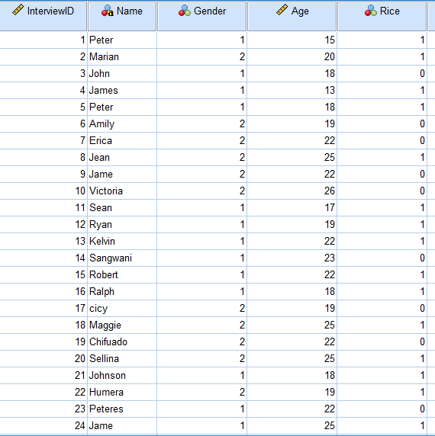

Rice
0 | 1
Count | Count
40 | 60

So there are Eat rice 1: 60% while not eating rice are 40% of customers.
How many customers are Male and Female?
Answer: Have been crated count table by SPSS to check the how many customers are male and female
Gender
1 | 2
Count | Count
50 | 50

So here 1 represent Male, and 2 represent female, so both are 50-50 customers.
What are the Mean and Median of the ages in the data?
Answer:
Descriptive Statistics
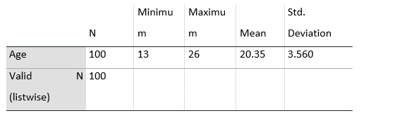
So by output of descriptive analysis have got mean value 20.35 and medium value 19 of the ages in the data.
What are the Mean and Median of participants who eat rice?
Answer:
Descriptive Statistics
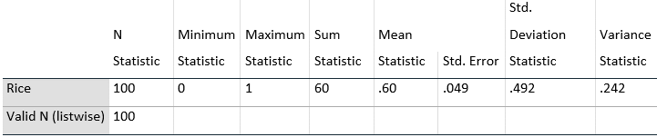
Have got Mean value have got .6 and the median 1 of participants who eat rice.
Findings on Pie, Bar or Histogram can be seen below. Have seen below the distribution of gender: both count value is 50.
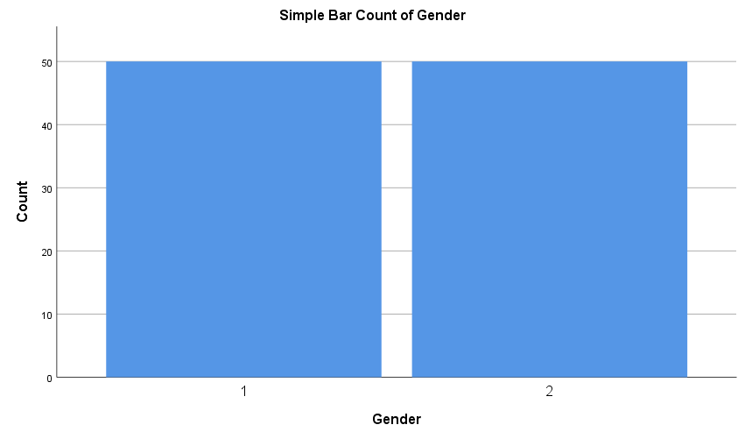
Who eats rice, or not distributed by a pie chart?
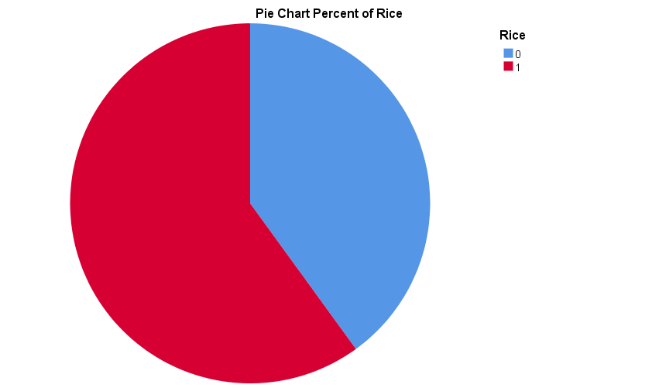
Here 1= yes eat rice, 0= no eat rice, so have seen the most of the customers are eating rice.

Answer:
Now, has created clustering by the SPSS tool (Kent, 2014):
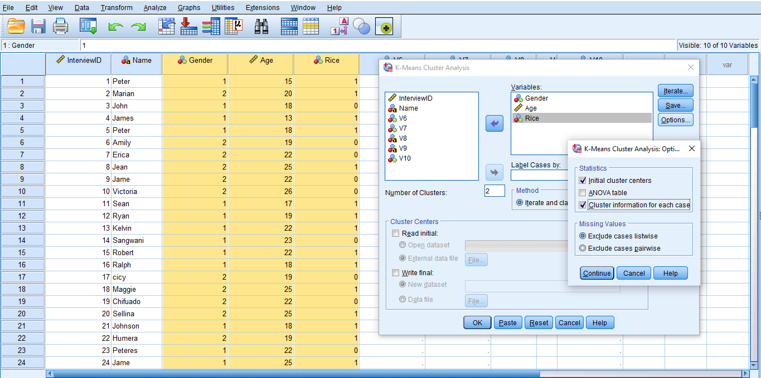
Have perform clustering on numerical features and selected 2 clusters (Baizyldayeva,2013) that output can see below :
Final Cluster Centers
 | Cluster
 | 1 | 2
Gender | 1 | 2
Age | 18 | 24
Rice | 1 | 1

In cluster 1st, Gender 1 and gender two are distributed, and age 18 or less than age comes under cluster 1 and other in cluster 2. These 2 clusters have different properties, but both clusters have similar instances.

Answer:

What is Text Mining?
Text Mining (Hearst, 2003) is the automated process of translating large volumes of unstructured text into quantitative data to discover information, trends and patterns. By text mining can analyze text data using advanced data science techniques. Textual data reveals customer feelings on topics or unearths other information. There are two ways to use text mining:
• The first method is to analyze existing text, such as customer reviews, to gain valuable information.
• The second method is to structure the text to be used in machine learning models to predict future events.
How the Text Mining Used in Business?
In the below image, here are a few examples that are the application of text analytics:
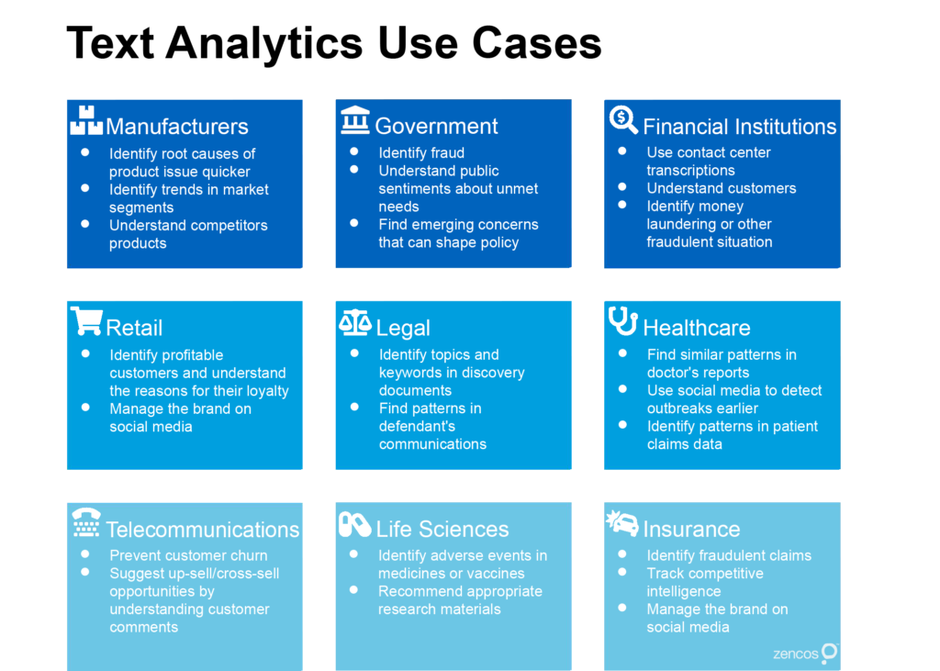
Applications of Text Mining
Below are text mining applications (Gupta, 2009) that used in business :
Risk Management:
A major cause of bankruptcy in the corporate sector is the lack of adequate or insufficient risk analyzes. Adopting and integrating risk management software based on text mining technologies such as SAS Text Miner (Segall,2009) can help companies stay abreast of all current business market trends and increase their capabilities to mitigate potential risks. As text mining tools and technologies can collect relevant information from thousands of textual data sources and create links between the extracted information, they enable businesses to access the right information at the right time, thereby improving the 'entire risk management process.
Customer Care Service
Text mining techniques, especially NLP (Berry, 2010), are gaining increasing importance in the field of customer support. Businesses invest in text analytics software to improve their overall customer experience by accessing textual data from various sources such as surveys, customer reviews and calls, etc. Text analysis aims to reduce business response times and help deal with customer complaints quickly and efficiently.
Business Intelligence
Organizations and businesses have started to take advantage of text mining techniques as part of their business intelligence. In addition to providing insight into customer behaviour and trends. Text mining tools like Cogito Intelligence Platform and IBM text analytics provide insight into marketing strategy performance, latest customer and market trends, and more. Organization use BI techniques in Bigdata (Jo,2019)to enhance revenue, figure out segemts, get isnghts from the data, and based on that take proper business solution.
Fraud Detection
In banking, Insurance and finance companies are facing Fraud by customers. By combining the outcomes of text mining (Govindarajan,2007) with relevant dataset, these companies can now process claims swiftly and detect and prevent fraud.
Social Media Analysis
The text mining tools can effectively analyze the number of our brand's social media posts, likes and followers, tweets text emotions (Wikarsa,2015) allowing us to understand the reaction of people interacting with our brand and online content. The analysis will allow us to understand "what's hot and what's not" for our target audience. By using text analytics, can perform sentiment analysis.

c)Answer:

SPSS is better than MS Excel(Barreto, H., 2015)when it comes to data analysis because it is specifically created for statistics. SPSS and Microsoft Excel have a similar look and feel, with menus, spreadsheets, and built-in statistical functions. But when we compared SPSS to Microsoft Excel(Proctor,2002),SPSS has:
1.Basic functions, such as descriptive statistics, are easier and faster to reach with pull-down menus.
2.There are many different charts and graphs to pick from.
3. Statistical tests can be accessed more quickly.

SPSS Vs EXCEL: The Key Differences
By these following points, we can understand the key differences of SPSS vs EXCEL (Pfister,2013):
- SPSS provides us with clear information or insight about the computing storage's utilization and the memory system's efficiency. Excel shows how to extract the information as well as knowledge from data in a variety of formats.
- SPSS shows us how to build processes in batches and work and how to manage memory in programming. Excel provides a view of how data can be used to study how data will be stored, processed, and manipulated to avoid redundancy and for future use to make data relevant.
- SPSS is a tool that is used for computing that includes subjects like Data Storages and Data Formats, whereas Excel includes mathematics concepts like Statistics, Calculus, Algebra, and Advanced Statistics, etc.
- Computations, probabilistic theories, reasoning, discrete structures, and databases are all included in the SPSS sub-areas. Excel has a lot more mathematical operations and analytics that are more simple.
- SPSS is all about using the techniques of manipulation of data efficiently to fetch good results, and Excel is all about correctly processing and storing data.
- SPSS (Cleff, T., 2019) is evolving with concepts that are advanced one's, and IBM is developing more efficient and advanced algorithms. Excel is becoming more complex to operate and maintain on a daily basis, but it still needs improvements.
- By focusing on the manipulation of data, SPSS deals with statistical algorithms. Excel is a combination of data storage and mathematics in a variety of forms.
- In SPSS tool can build many machine learning like desion tree , svm model etc, while in Excel tool we have only Regression model. So it’s a biggest and important difference when we solve a case study that time have to choose a tool Excel or SPSS.

SPSS Vs EXCEL: In Tabular Form

Terms for comparison | SPSS | EXCEL
Definition or Meaning | SPSS is a tool that is formulated for the statistical analysis of data. | Microsoft's product is used for manipulation of data and for data entry to save some data.
Tool | SPSS is a statistical tool for batch processing. | Excel is a data manipulation tool.
Objective | It is used in data manipulation procedures to produce accurate results. | It is used to save the information and study it properly.
Benefits | Performance and speed. | Information redundancy is decreasing.
Usages | It is used for statistical computations and data usage in accordance with IBM standards. | It is used to manage and store data using Microsoft defined methods.
Real-time usages | It is used to develop ultra-fast and advanced technologies such as supercomputers and other advanced devices. | It maintains and manages a vast amount of clients data.
Field | It involves the full technological field, which is defined as a superset of Data Science. | It is a subset of networkability in which information knowledge is gained via the use of various technologies and methodologies.
Applications | It applies to all professional activities and large-scale businesses. | It applies to businesses where sensitive large-scale data must be processed.
Industry | After obtaining a degree in this profession, you can work as a data analyst or scientist. | After obtaining a degree in this profession, you can work as a data analyst or scientist.
Academics | It has existed for several years under SPSS, which is now owned by IBM. | It exists and has grown with the beginnings of technology and science.

References:
Alauddin, M., Hossain, M.M., Ibrahim, M. and Hoque, M.A., 2015. Perceptions of consumer impulse buying behavior in the super store: A case study of some selected super store in Bangladesh. Asian Social Science, 11(9), p.68.
Ghosh, S. and Neha, K., 2019, December. Sales Analysis and Performance of Super Store Using Qlik GeoAnalytics. In International Conference on Advances in Computational Intelligence and Informatics (pp. 151-157). Springer, Singapore.
Merrilees, B. and Miller, D., 2001. Superstore interactivity: a new self‐service paradigm of retail service?. International journal of retail & distribution management.
Barreto, H., 2015. Why Excel?. The Journal of Economic Education, 46(3), pp.300-309.
Oike, H., Ogawa, Y. and Oishi, K., 2019. Simple and quick visualization of periodical data using microsoft excel. Methods and protocols, 2(4), p.81.
Levesque, R., 2007. SPSS programming and data management. A guide for SPSS and SAS Users.
Pfister, R., Schwarz, K., Carson, R. and Jancyzk, M., 2013. Easy methods for extracting individual regression slopes: Comparing SPSS, R, and Excel. Tutorials in Quantitative Methods for Psychology, 9(2), pp.72-78.
Kent, P., Jensen, R.K. and Kongsted, A., 2014. A comparison of three clustering methods for finding subgroups in MRI, SMS or clinical data: SPSS TwoStep Cluster analysis, Latent Gold and SNOB. BMC medical research methodology, 14(1), pp.1-14.
Baizyldayeva, U.B., Uskenbayeva, R.K. and Amanzholova, S.T., 2013. Decision making procedure: applications of IBM SPSS cluster analysis and decision tree. World Applied Sciences Journal, 21(8), pp.1207-1212.
Kim, D.H., 2009. A practical application of cluster analysis using SPSS. Journal of the Korean Data and Information Science Society, 20(6), pp.1207-1212.
Hearst, M., 2003. What is text mining. SIMS, UC Berkeley, 5.
Gupta, V. and Lehal, G.S., 2009. A survey of text mining techniques and applications. Journal of emerging technologies in web intelligence, 1(1), pp.60-76.
Jo, T., 2019. Text mining. Studies in Big Data. Cham: Springer International Publishing.
Berry, M.W. and Kogan, J. eds., 2010. Text mining: applications and theory. John Wiley & Sons.
Govindarajan, M., 2007, December. Text mining technique for data mining application. In Proceedings of world academy of science, engineering and technology (Vol. 26, No. 104, pp. 544-549).
Wikarsa, L. and Thahir, S.N., 2015, November. A text mining application of emotion classifications of Twitter's users using Naive Bayes method. In 2015 1st International Conference on Wireless and Telematics (ICWT) (pp. 1-6). IEEE.
Dang, S. and Ahmad, P.H., 2014. Text mining: Techniques and its application. International Journal of Engineering & Technology Innovations, 1(4), pp.22-25.
Inzalkar, S. and Sharma, J., 2015. A survey on text mining-techniques and application. International Journal of Research In Science & Engineering, 24, pp.1-14.
Proctor, J.L., 2002. SPSS vs. Excel: Computing software, criminal justice students, and statistics. Journal of Criminal Justice Education, 13(2), pp.433-442.
Lee, N. and Peters, M., 2015. Business statistics using EXCEL and SPSS. Sage.
Cleff, T., 2019. Applied statistics and multivariate data analysis for business and economics: A modern approach using SPSS, Stata, and Excel. Springer.
Admin, W 2020, WHICH SOFTWARE IS BETTER FOR RESEARCH? SPSS or MS-EXCEL, writeneed-, viewed 9 November 2021, <https://www.writeneed.com/post/which-software-is-better-for-reasearch-spss-or-ms-excel>.
Differences between Excel and SPSS 2020, www.ibm.com, viewed 9 November 2021, <https://www.ibm.com/support/pages/differences-between-excel-and-spss>.
SPSS vs EXCEL - 8 Most Important Differences You Should Know 2018, EDUCBA.
Segall, R.S., Zhang, Q. and Cao, M., 2009. Web-based text mining of hotel customer comments using SAS® text miner and megaputer polyanalyst®. SWDSI 2009, pp.141-152.

