Student number- 2013746
BA illustration and graphic design
Alice Samual
• Question 2: Analyse the work of illustrators and,
particularly, author illustrators who tackle difficult, sensitive
and sometimes shocking themes.
In this essay will be discussing the topic of difficult subject matter or shocking themes within the medium of comic books and graphic novels specifically, and how these themes correlate to the material and how it is displayed via using illustrative techniques. The two images that I have chosen to discuss will be from the “Watchmen” by Alen Moore and “the walking dead” by Robert Kirkman, both being very popular adult centred graphic novels that both deal with sensitive topics throughout and would not be suitable for younger or less mature readers. Although a percentage of viewers are not suitable for the content does not mean the content itself isn’t desirable, quite the opposite as it allows deeper level of thought or detail to appear which in turn, allows for a better quality of story and design for the viewer to experience.
The watchman, is a graphic novel series, written in the late 1980’s by author Allen Moore and illustrated by Dave Gibbons. A satire of the superhero genre, it examines a large variety of difficult topics which at the time were deemed socially inappropriate to discuss in the medium of comics and graphic novels, however the level of detailed applied by both Moore and Gibbons in terms of author and illustrator to fulfilling an interesting narrative but with simplistic yet eye grabbing designs. One of the most dramatic panels is the accidental fatality of the character Jon Osterman, (see figure 1) being accidentally annihilated by an atomic device and reborn as the prominent alter ego Dr Manhattan; a near God like being with an endless number of powers and abilities who can experience past, present, and future at the same time.
The loss of humanity and morality within the character, Jon Osterman, is depicted through a massive explosion whereby the character is reduced to a skeleton. The skeleton is drawn using only black, conveying death and sadness, with the black shooting backwards away from the skeleton with his bones appearing to ‘melt’. The use of white in the background contrasts against the skeleton making it more prominent for the viewer and is a visual depiction of the visceral and violent nature of the explosion happening upon Jon as his flesh is being stripped from his bones. The viewer is drawn to the bright white ‘flash’ in the middle of the skeleton where the centre of the chair and the character’s pelvic bone are also situated; the lines travelling outwards from this area again serve to draw the viewer in. The accentuated black skeleton and melting exploding bones can arguably be symbolically reminiscent of Hiroshima, whereby the atomic bomb hit Japan after the second world war. “Over two-thirds of Hiroshima's buildings were demolished. The hundreds of fires, ignited by the thermal pulse, combined to produce a firestorm that had incinerated everything within about 4.4 miles of ground zero.” Within the image the viewer may feel connection to the Hiroshima bombings through a bastardises version of the real event within panel. The blackened bones of the character “Jon” can be reminiscent of death and sickness which can be related to those who were affected by the bombings being surround dead bodies and other dying from radiation sickness. These attributes help define what is happening in the Image a depressing event depicting a gruesome transformation of the physical self via the use of black line work contrasting the white background to emphasise the violent reaction taking place.
Symbolically black is used to create authority within an image and the skeleton becomes the central figure. The black absorbs all other colour from the image however combined with the yellow and white creates energy surrounding the skeleton making the viewer feel the force and energies generated by the explosion again drawing the focus towards the blackened bones being eviscerated. “Black absorbs all light, so it’s a low-energy color. Though black used in contrast–particularly with white or yellow–does create energy, black on its own can be depressing and can dampen the mood. Black lines on white paper are stark, definite marks–bearing huge communicative potential for transmitting information.” Within the image the black skeleton is being used to communicate the idea that the character is succumbing to the accidental explosion it being out of his control, a depressing feeling being unable to control your own fate another attribute that black represents.
The loss of morality and humanity through an explosion of a human being can be parallel to a metamorphosis, a change from physical to metaphysical, transformation of the character “Jon Osterman” into “Dr Manhattan”. An excruciating process as described with blackened bones protruding outwardly as the blistering white light with a blue hue consumes the flesh. This seemingly random event, against the will of “Jon” as well as mother nature itself, producing a god like being capable of doing anything he desires, manifesting or destroying all things on top of being able to perceive time all at once, past present and future, which implicates all decisions. However, with this new level of power his morality as well as his humanity starts to slowly dissipate throughout the story chapter by chapter, paralleling the accident, like his body being stripped from his bones, such as “Jons” consciousness to his soul, atom by atom.
The slight hue of blue within the background of the image can represent the slow decline in “Dr Manhattan” morality throughout the story. The blue hue is depicted towards the edge of the image, spreading outwards in an hourglass shape. An illustrative technique used to describe the situation the character finds himself in, being unable to control time yet experience all of time all at once. This must feel extremely saddening to experience, being a near god like being but the only one of his kind, a loneliness that only he can experience a sadness that no other living being can comprehend. These emotions as well as “Dr Manhattan” himself represent as the colour blue, a colour that holds a lot of feelings that represent themselves through the colour, “Overuse of blue can feel cold and impersonal, and even unfriendly. Blue’s association with depression and sadness are also pervasive.” The reason the colour blue is used in the panel negatively is because the situation as well as the tone of the graphic novel itself is dark and grounded to reality, which unfortunately has some associations to real life, with most people suffering the effects of depression, sadness and loneliness this represented in the slight hue of blue surrounding the image, indicating that the overall event leads to a pinacol of upset and unhappiness throughout the full story, expanding outwards like a visual metaphor to what is going to happen in the story, again paralleling the event of the creation of “Dr Manhattan” a tragic event followed by events of sadness and turmoil expanding on further as you read into the story.
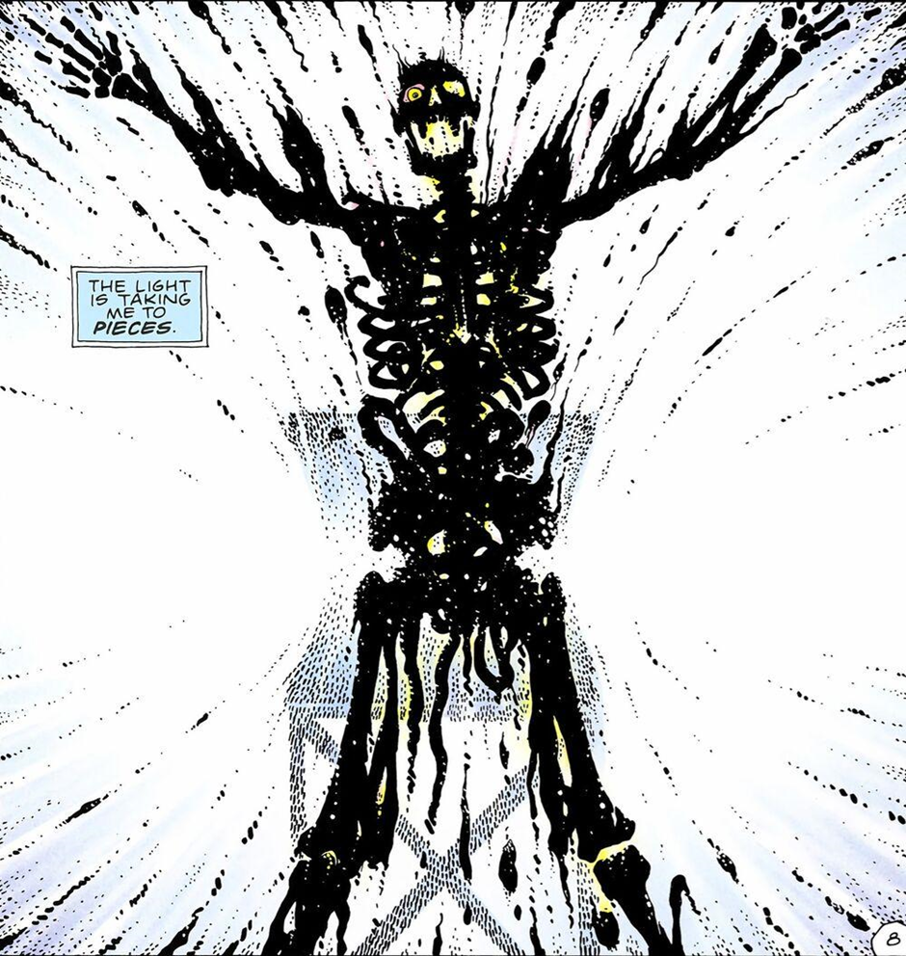

The Walking Dead depicts a situation of emotional turmoil and graphic violence throughout, a grim depiction of life after a plague of zombies destroys the town; graphic violence and emotional turmoil are key themes and depicted through the stark use of black and white imagery. This is a consistent troupe throughout the 193 issue run of the series, this dedication to keeping the constant tonality throughout the series is partly the reason why it is so successful. The black and white colourization helps emersed the viewer easier Into illustrations and dialog with monochromatic aesthetic, not being distracted by flashy hyper colourful action scenes as well as the intense amount of blood and gore that is featured heavily throughout the series. This would be tedious to read through if it had been fully colourized, as half of their series would be the colour red which would quickly become uninteresting and repetitive which has many limitations in terms of fresh and bold designs.
Artistically there is a benefit to using a monochromatic colour printing techniques, like less time or resources being spent on needing to complete the work as all saturations and hues would be some form of black, white or grey. As the detail of colour is not the significant factor of the story, as it focus more on character development, landscape, facial expressions and positioning the lack of colour just enhances the details of those factors. “That actually came from our original idea because [co-creator Tony Moore and I] believed Night of the Living Dead was in public domain. We thought it would be neat to just go out and do a comic book series that takes place in that world, and do it in black and white. In the end, we decided to do something completely different, but to keep the black-white thing because you could get away with more gore. It’s not all bloody and violent with red all over the page, so it seems a little less offensive. It’s also a little cheaper to print.” This shows how a subtle creative illustrative techniques can be an effective ways of enhancing imagery and also dialog using a minimalist pallet of black and white to convey details outlined by black to create depth using shadows and white is used to separate by predominantly being used in the foreground. This technique when applied correctly can appear multi-layered using text such as onomatopoeia to break up panels using negative space to bring forward the boldness in character especially in close ups scenes when the atmosphere of the story comes to a pineal and important parts of the narrative unfold are increased because of monochromatic pallet the viewers attentions is completely zoned into the pages allowing continued enjoyment of the material.
The use of onomatopoeia within the “the walking dead” is cleverly used throughout the series, this illustrative technique that utilises sounds effects to further improve the quality of an illustration by pairing it to a noise or sound effect. This technique when applied properly makes it more comprehensible to the reader the situation or object that is producing the noise, further giving depth and context to what is happening as sound is not a visual sense it is dependent on the illustrator to fill in the gaps and apply onomatopoeia properly. Onomatopoeia can be applied in many different ways being comprised of letters that culminate to make sound effects, the level of application is endless and the amount of sounds that can be translated into a words to punctuate a situation or object. The use of font size and placement of onomatopoeia can be used in different ways to convey sounds, like big bold black lettering can signify a loud bellowing or an explosion, where as a small hollow font can describe a soft or quiet sound by the use of placement within the panels to achieve another level of depth. “ln terms of the comic, the font, colouring, and sizing of these words depend on the genre of the comic, and creators style their onomatopoeia to be in alignment with these genres. For instance, a large, flashy, and brightly coloured “POW” would feel out of place in a monochromatic noir comic.” Without the use of onomatopoeia within the medium of comic books and graphic novels it would be difficult to express sounds and noises through a purely visual medium, it is critical to include onomatopoeia within comics, as a visual medium that requires illustration to support it as a concept that further drives the narrative filling the space of the panel visually or can be used for dramatic effect in a stylized way to emphasise an action or notion within the story. It is important and needed technique that can be used to express a range of different outcomes like objects that make or produce sounds and our ability to connect that sound to a words to express a different type of visual communication

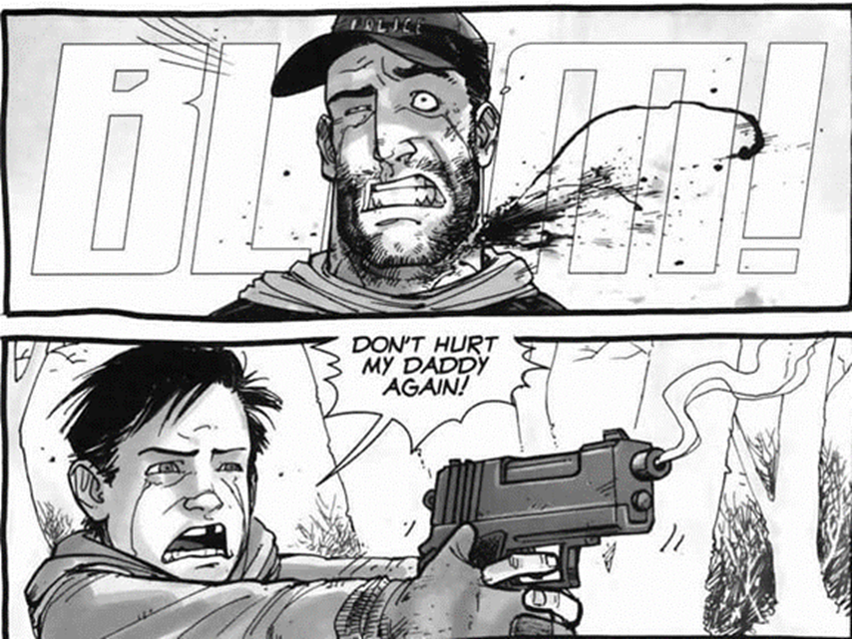

In conclusion I think that the images I have chosen to use for this essay depict difficult and sensitive subject matter and use multiple different techniques to achieve these effects, dramatically changing the way you understand the image. For example the use of minimalist colours to convey emotions like the use of blue, black and white within the first image (figure1) the use of colour within the panel give a subtle idea to what is happening to the character emotionally while being unrelated to what is actually happening during a dramatic explosion scene. These details combined with the shocking image of a skeleton being exploded culminates in an images with a subtle complexity leaving the viewer with a contrast in beautiful illustrative artwork that has a dark undertones to keep viewer engaged with the story and the characters. I also believe that the use of colour throughout the image especially the colour black is important as it is used prominently in the image and is the main focus, using the negative space to give the illusion of something extremely bright using the white space as a background complemented by black line spreading outwards giving the appearance of motion, all of these techniques are properly utilised and executed.
Furthermore I think the use of black and white printing within “the walking dead” series (figure 2) is a clever uses of design, although less vibrant and eye catching at first glance, this is made up for in terms of quality character and landscape design. I feel like the monochrome aesthetic holds a lot of tonality within giving the impression that the world is quite bleak and future is left to be decided, matching the black and white ideals. I have also found that “the walking dead” uses negative space as well as onomatopoeia too fill in blank spaces which normally would be in colour, however the application of these techniques is used perfectly filling all spaces with interesting designs that don’t take away from the character focused narrative. The onomatopoeia is also used effectively being appropriately used to convey dramatic or important sounds that are created within the comics themselves, onomatopoeia words have different methods of application each being used subtly within panels to fill space as well as making the overall panel look interesting or dynamic especially with high action sequences or tense silence being broken within the story. Overall the techniques used by these illustrators is what helps convey the idea of them being shocking or disturbing, these subtle additions compliment the idea of difficult topics to discuss, like the blue hue being featured in the “Watchmen” (figure1) image can represent sadness, depression and loneliness which are all emotions that require a deeper level of understanding and emotional thinking than the average weekly issue of a generic superhero comics that the general public is used too.

References
Hibakusha Stories - Atomic Archive
The following "Voice of Hibakusha" eyewitness accounts of the bombing of Hiroshima are from the program HIROSHIMA WITNESS produced by the Hiroshima Peace Cultural Center and NHK, the public broadcasting company of Japan. Mr. Akihiro Takahashi was 14 years old, when the bomb was dropped.
https://www.atomicarchive.com/history/atomic-bombing/hiroshima/page-14.html

Meaning Of Black: Color Psychology And Symbolism - Sensational Color
Black represents evil, darkness, night, and despair. It’s the color used to convey certainty and authority, and when used in opposition with white, it’s a symbol of the eternal struggle between day and night, good and evil, and right and wrong. Positive Associations We think of black as sophisticated and serious Finally, COLOR EXPLAINED by an expert in a way that everyone can understand
https://www.sensationalcolor.com/meaning-of-black/
Sensational Color
https://www.sensationalcolour.com/meaning-of-black
The Color Blue: Meaning and Color Psychology - Verywell Mind Finally, COLOR EXPLAINED by an expert in a way that everyone can understand
Sensational Color
(https://www.sensationalcolor.com/meaning-of-blue/)
The Walking Dead Comic Will Be Re-Released in Color
Bojalad The Walking Dead Comic Will Be Re-Released in Color
July 19, 2020
https://www.denofgeek.com/comics/the-walking-dead-comic-returns-in-
Sound Effects
deVega Sound Effects
https://soundofcomics.sdsu.edu/sound-
Sound of Comics
November 27, 2022
https://soundofcomics.sdsu.edu/sound-
Sound Effects
https://soundofcomics.sdsu.edu/sound-
Sound of Comics
November 27, 202
The end of Watchmen and Before Watchmen: Ozymandias/Crimson Corsair (4 of 4)
https://www.avclub.com/the-end-of-watchmen-and-before-watchmen-ozymandias-cri-1798240678
The A.V. Club
August 05, 2013
The Walking Dead: 10 Comic Moments That Went Too Far
URL
https://whatculture.com/comics/the-walking-dead-10-comic-moments-that-went-too-far?page=4
WhatCulture.com
Date accessed

July 31, 2020

