Blog 1-
Climate change? Is it not time that we change!
What do you consider to be the biggest threat to human kind and why ?

(United Nations,2022)
Climate Change is an ever expanding threat to human kind, potentially leading to a life ending disaster.
Dore(2005) mentions the idea that climate change is already having a negative impact on our planet, there has been a decrease in the amount of snow converges and the melting of ice caps, averaging at approximately 10% since the 1960s.Beck(2016) states that climate change is a metamorphosis, impacting our lives and how we live in this world. One of the major impacts that Beck(2016) picks up on is the rising sea levels and the inequalities they are already causing within the different nations of the world.
Some of the most severe impacts of climate change include, increasing temperatures,severe storms,droughts,rising oceans and loss of species(united nations,2022).These are all being caused by humans,generation of power,transportation,deforestation and manufacturing goods.One of the largest contributors to these changes are fossil fuels,as they account for over 75% of greenhouse gas emissions,these gases are heating up our planet by trapping the sun's heat.It is now stated that “The world is now warming faster than at any point in recorded history”(united nations,2022).
Since this large increase in Greenhouse gas emissions,global warming has become an imminent problem that needs to be solved,as Greta Thunberg(2018 )stated,“So, we can’t save the world by playing by the rules, because the rules have to be changed. Everything needs to change and it has to start today.”Pencheon(2009) discusses the changes that hospitals and medical services can put in place to aid climate change,firstly discussing the reduction of carbon production from things like heating and air conditioning,transporting patients and producing medical goods,by creating low energy and low carbon buildings from the early stages of building them.They also talk about all medical interventions being assessed to ensure that they are at their most efficient state of cost and not only benefit for the patient but also the environment.Another was how 20% of the health services carbon footprint was patients,staff and visitors transport,and in an attempt to reduce this can be using public transport,cycling or walking.Lastly,they mention the power that the service have and they would be able to implement more sustainable and environmentally safe products and actions.With an enormous "national targets such as a 80% reduction on Greenhouse gas emissions by 2050”(Pencheon,2009)something needs to be done about this ever growing issue.
Keen(2022)discusses the drastic impacts of climate change on the world and the rising problems that come with global warming,even stating that “the economic damages from climate change are at least an order of magnitude worse than forecast by economists, and may be so great as to threaten the survival of human civilization.” Is it not time that now we take into consideration the intensity of the destruction we have caused our planet,are we not causing more problems for the future generations.It is becoming a major threat to human kind,creating issues from temperature change leading all the way to extinction of species.

References-
Beck,U (2016)The metamorphosis of the world:How Climate Change is Transforming Our Concept of the World.London:John Wiley & Sons.(Accessed:February 06,2023)
Dore, M (2005) Climate change and changes in global precipitation patterns: What do we know?, Environment International. Pergamon. Available at: https://www.sciencedirect.com/science/article/pii/S0160412005000553?casa_token=z7xYCjQyHEAAAAAA%3AnAzdWD1iKd-HbP3J6ijg6f7kLXfHleUNyvP0k8wkMh6l_qUwxfBpAXOLVE1nQXnKaExcA8CMdXo (Accessed: February 06, 2023).
Keen, S (2022) “The appallingly bad neoclassical economics of climate change,” Economics and Climate Emergency, pp. 79–107. Available at: https://www.tandfonline.com/doi/abs/10.1080/14747731.2020.1807856 (Accessed:February 12,2023)
Pencheon, D (2009) “Health Services and climate change: What can be done?,” Journal of Health Services Research & Policy, 14(1), pp. 2–4. Available at: ttps://journals.sagepub.com/doi/pdf/10.1258/jhsrp.2008.008147?casa_token=nJYMBCmk8BcAAAAA:D2h7dv-T54E-BHG0z5zZOZT-lobLiAid9vJkUwMW7leK6sVVc3T58o3u3KFSX6Clv6LFlFzSXQHf
Thunberg,G(2018)School strike for climate-save the world by changing the rules.Available at:https://youtu.be/EAmmUIEsN9A (Accessed: February 14,2023)
United Nations (2022) Causes and effects of climate change, United Nations. United Nations. Available at: https://www.un.org/en/climatechange/science/causes-effects-climate-change (Accessed: February 12, 2023).
United Nations,overheating planet (2022) What is climate change ? United nations . Available at: https://www.un.org/en/climatechange/what-is-climate-change (Accessed: February 12, 2023)

Blog 2-
What do we need to be successful ?
Evaluate the skills you will need to be successful in your chosen field.
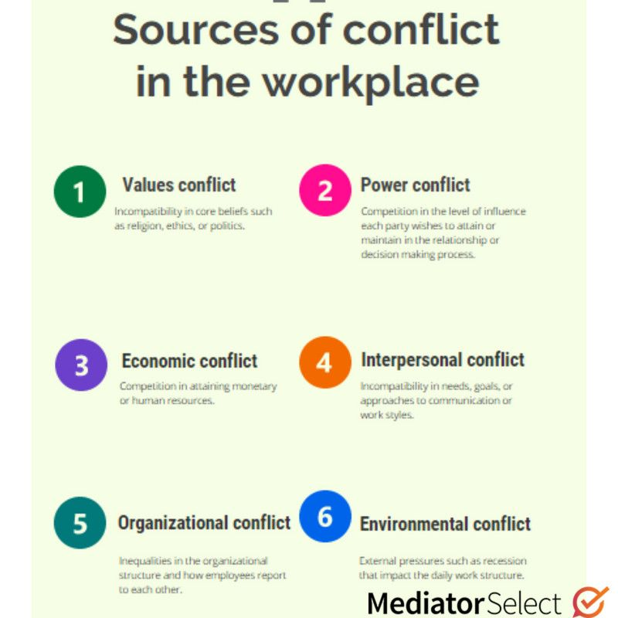
(Mediator,2023)
Going into any future field there are an abundance of skills that you need to have to not only be successful but to thrive in your working environment,some of these involve conflict management,critical thinking and negotiation.Mckibbens(2017)mentions an extremely important issue related to this,conflict,it is an on going and inevitable issue in work places and for it to be managed professionally and in a correct manner is implicit,it arises from problems with work relationships,change and little to no leadership.The impacts that this can have on a team are extreme and addressing them as soon as possible is imperative.
These issues can have a knock on effect with trust within the team, the efficiency of the teams but also it increases violence and lack of comfort between them all. Within any policing profession, conflict management is crucial and frequently used, not only within the teams themselves but also with the public. Lau et al(2003),discuss the effectiveness of conflict management programs for the traffic police in Hong Kong, they mention the day to day interactions with the public that can become tense and the tensions that can rise between team members and that with the management they are slowly being able to decrease the conflict themselves. The program increased the individuals self awareness, their communication skills and emotional behaviour.
Negotiation is a skill that is vital for moving forward into a workplace environment,it entails compromising with others to obtain a certain outcome.Firth(2014),talks about how negotiation is a linguistic aspect and shows how humans interact with each other and the beliefs,values and actions that come along with that.They include the fact that it is important to understand and identify the different variables of a negotiation.Zohar(2015)states that negotiation skill are required in a time of crisis to have a successful outcome,they are a vital part of business agreements and come through skills such as communication and critical thinking.Effective negotiation is a critical skills to have alongside conflict management as the two sit hand in hand,when put into place especially within the police or any emergency services,negotiating difficult conflicts or stressful situations.
Critical thinking falls into the category of skills that are needed to better further knowledge and intelligence.Making the right decision in any work environment is extremely difficult,especially in policing environments when faced with violence and crime.Barker(2011)summarises the importance of critical thinking as having the ability to intellectually carry out the skills of analysis,application and evaluation whilst reflecting and observing the experience.Being able to critically think about information eventually helps move to decision making,Champion(1995)completed a study regarding the relationship between critical thinking levels and police officers,they concluded that a police officers education level impacts their critical thinking levels and finished with the idea that officers with higher basic law enforcement training (Blet) scores have higher critical thinking levels than those with lower scores,coming to the idea that the higher educated they were and the more they understood of the law the more likely they were going to be able to think critically regarding different situations.

References-
Barker, B. (2010) Higher Order, Critical Thinking Skills in national police academy course development., ProQuest LLC. ProQuest LLC. 789 East Eisenhower Parkway, P.O. Box 1346, Ann Arbor, MI 48106. Tel: 800-521-0600; Web site: http://www.proquest.com/en-US/products/dissertations/individuals.shtml. Available at: https://eric.ed.gov/?id=ED534042 (Accessed: February 23, 2023).
Champon, D.H., SR., 1995. A study of the relationship between critical thinking levels and job performance of police officers in a medium size police department in North Carolina, North Carolina State University.
Firth, A. (2014) “Chapter 2,” in The discourse of negotiation: Studies of language in the Workplace. Kent: Elsevier Science. Available at:https://www.sciencedirect.com/science/article/pii/B978008042400250008X(Accessed:February 23,2023)
Jackson-Matthews,S(2018)How to solve problems in the workplace,”Mediator.Available at:https://mediatorselect.com/blog/articles/how-to-resolve-your-workplace-conflict-peacefully/#conflict-causes.(Accessed:February 22,2023)
Lau, E. , Li ,E. , Mac, C. ,Chung,I(2004) “Effectiveness of conflict management training for traffic police officers in Hong Kong,” International Journal of Police Science & Management, 6(2), pp. 97–109. Available at: https://journals.sagepub.com/doi/pdf/10.1350/ijps.6.2.97.34468(Accessed:February 23,2023)
McKibben, L (2017) “Conflict management: Importance and implications,” British Journal of Nursing, 26(2), pp. 100–103. Available at: Conflict management: importance and implications | British Journal of Nursing (magonlinelibrary.com)(Accessed:February 22,2023)
Mediator(2023)”Guide to workplace conflict-what causes conflict in the workplace.”Available at: https://mediatorselect.com/blog/articles/how-to-resolve-your-workplace-conflict-peacefully/#conflict-causes.(Accessed;February 22,2023)

Zohar, I (2015) "The art of negotiation" leadership skills required for negotiation in time of crisis, Procedia - Social and Behavioral Sciences. Elsevier. Available at: https://www.sciencedirect.com/science/article/pii/S1877042815056323 (Accessed: February 23, 2023).

Blog 3-

Can design thinking help in areas of policing?

Discuss the merits or shortcomings of design thinking to your chosen areas of study.
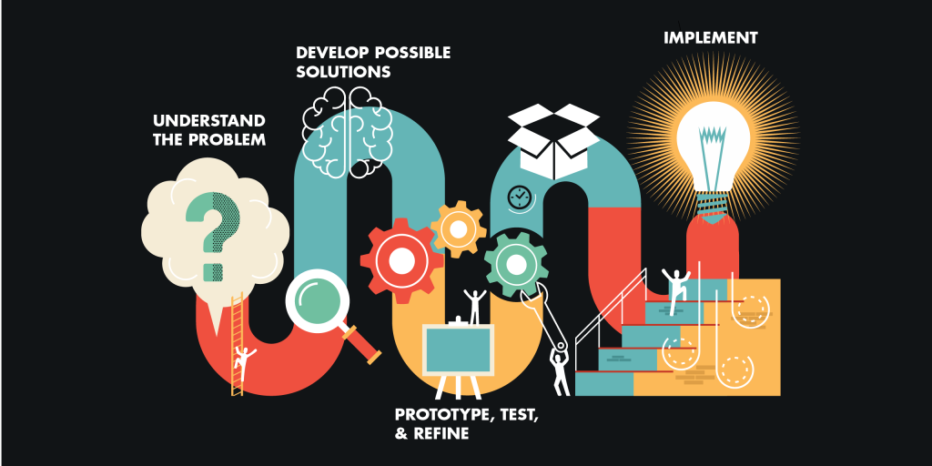
(Linke,2017)

Design thinking can be used in many aspects of policing,it can help solve crimes using different methods whilst moving away from the complex policies and procedures,allowing for a creative,yet,efficient way of finding evidence.Razzouk and Shute(2012) define design thinking as an analytic and creative process that engages a person in opportunities to investigate,produce and form prototypes,gain information on the design and redesign them. Panke(2019)talks about how design thinking can help to solve what he states to be wicked problems,they state that the problems do not have any right or wrong solutions and defy all scientific and engineering solutions.They are complex and unbound problems open to creative interpretation in a final aim of solving them with design thinking.This process can be used in many ways,ranging from being able to help prevent crimes to using creative ways of solving them,outside of the normal rules and regulations but using evidence to prove the offenders of being guilty.

Degnegaard et al(2015)completed a study regarding the police in Denmark and how they made a strategy to use and influence external stakeholders in efforts to prevent crime. The study began to explore the different roles of design thinking and was based on the ideate, develop and implication process within the Danish police, during this ,almost 100 professionals worked at designing a solution for crime prevention. The study explores and reviews how design thinking can be an imperative part in realising the potential in design thinking and creative interpretation. Inevitably, creating a source of clarity and potential for the productivity of eventually solving the targeted challenge.
Design thinking is an adverse process that can be used in many different fields of work to problem solve in a more intuitive and creative way in a study about the core and application of design thinking,Dorst(2011)stated that the paper demonstrates that many professions could benefit from the use of design thinking.From that, their application of professional designers, creating several different frames out of the investigation of themes,in the broader problem situation helps to understand the ease in which it could be used in many variations.
Ferreiro-Gonàlez et al(2019) created an escape room they are calling “CSI 1.0” which shows an educational view of how design thinking can be used in different professions,especially policing,they are provided with an analytical problem, an alleged crime and need to solve it,they play roles and only have their knowledge as student forensic scientists and their teamwork to solve it in the most analytical process possible,using design thinking to innovatively and creatively solve the crime.From the first experience,they have seen that this example of interactive education could be used for many more subjects,they quoted it to be “an innovative educational tool”.This shows that design thinking can be used not only in working fields but also for those training for many of these jobs,it is an extremely useful tool to have going into future positions,the capability to solve problems not only using rules and policies but thinking about the bigger picture.

References-
Degnegaard, R., Degnegaard, S. and Coughlan, P (2015) How to design for large-scale multi-stakeholder co-creation initiatives: Reframing crime prevention challenges with the police in Denmark, Latest TOC RSS. Intellect. Available at: https://www.ingentaconnect.com/content/intellect/DBS/2015/00000001/00000001/art00002 (Accessed: March 1, 2023).
Dorst, K (2011) “The core of ‘design thinking’ and its Application,” Design Studies, 32(6), pp. 521–532. Available at: https://doi.org/10.1016/j.destud.2011.07.006.
Ferreiro-González, M. et al.(2019) Escape classroom: Can you solve A crime using the analytical process?, ACSpublications201. Available at: https://pubs.acs.org/doi/10.1021/acs.jchemed.8b00601 (Accessed: March 1, 2023).
Linke, R (2017) Design thinking, explained, MIT Sloan. Available at: https://mitsloan.mit.edu/ideas-made-to-matter/design-thinking-explained (Accessed: February 28, 2023).
Panke, S (2019) “Design thinking in education: Perspectives, opportunities and challenges,” Open Education Studies, 1(1), pp. 281–306. Available at: https://www.degruyter.com/document/doi/10.1515/edu-2019-0022/html(Accessed:February 28,2023)
Razzouk, R. and Shute, V (2012) “What is design thinking and why is it important?,” Review of Educational Research, 82(3), pp. 330–348. Available at:https://journals.sagepub.com/doi/pdf/10.3102/0034654312457429?casa_token=55mCxh4KQ68AAAAA:bSiufJYsFzAX-OT9-yXgJquNSafoXB8AwObG9CG1aIsyccGWk_Xd3ZoGxR7YgZoycyaMh9uLemay(Accessed:February 28,2023)

