

BA (Hons) Business Management
Academic Year: 2024/2025
Student Name: Ileana Lupu
Student Number: 2231908
Supervisor Name: Dr Essa Bah
LCBB6000_BIRM
Dissertation title:
FROM RISK TO RESILIENCE: EXPLORING COST-EFFECTIVE STRATEGIES FOR ESTATE AGENTS IN THE UK FACING TENANT ARREARS

Abstract
This study explores cost-effective strategies to enhance resilience among UK estate agents facing tenant arrears, a persistent and structural challenge in the private rented sector. Using an interpretivist, inductive approach and qualitative documentary analysis, the research identifies systemic causes of arrears including income instability, welfare delays, and affordability pressures. It finds that arrears not only threaten estate agents’ revenue but also disrupt operations, strain landlord relationships, and damage reputations. The analysis highlights effective, low-cost interventions such as early tenant engagement, behavioural nudges (e.g. SMS reminders), and structured arrears protocols, which reduce evictions and improve rent compliance. The study concludes that proactive, supportive strategies are more sustainable than punitive approaches. It recommends standardising early intervention, improving on boarding processes, and using behavioural tools to encourage timely payment. These measures support operational continuity and strengthen agency resilience in a volatile market.
Table of Contents
Abstract 2
1.0 Introduction 5
1.1 Background and Relevance 5
1.2 Practical Experience 7
1.3 Problem Statement 7
1.4 Research Aim and Objectives 8
1.4.1 Aim 8
1.4.2 Objectives 8
1.5 Rationale 8
1.6 Outline of Dissertation 8
2.0 Literature Review 9
2.1 Tenant Arrears Concept 9
2.2 Operational and Financial Impact on Estate Agents 11
2.3 Risk, Resilience and the Role of Data in Rent Management 13
3.0 Methodology 16
3.1 Research Philosophy 17
3.2 Research Paradigms 17
3.3 Research Approach 17
3.4 Research Methodology 17
3.5 Research Strategy 17
3.6 Sampling Strategy 17
3.7 Data Collection 18
3.8 Data Interpretation 18
3.9 Ethical Considerations 18
4.0 Analysis of Findings and Discussion 19
4.1 Analysis of findings 19
4.2 Discussion 23
4.2.1 Structural and Behavioural Drivers of Rent Arrears. 23
4.2.2 Operational and Financial burden on Letting Agents and Landlords. 24
4.2.3 Resilience-Developing and Cost-Effective Mitigation Measures. 25
5.0 Conclusions and Recommendations 26
5.1 Conclusions 26
5.2 Recommendations 26
5.2.1. Standardise Early Arrears Intervention Procedures 26
5.2.2. Invest in On boarding and Preparation to be a tenant 27
5.2.3. Improve Tenant Engagement using Behavioural Tools 27
6.0 References 28
7.0 Appendices 34
7.1 APPENDIX A: Planning / Research Timeline Table 34
7.2 APPENDIX B: Literature Review Summary Table 35
Table B1. Summary of Key Literature Reviewed 35

1.0 Introduction

1.1 Background and Relevance
Tenant arrears represent one of the most persistent challenges within the United Kingdom private rented sector and the problem has become increasingly severe as structural legislation pressures on tenants intensify (McNally and Lally, 2024). The cost of living has risen significantly in recent years while wage growth has remained stagnant and household incomes have become more insecure. These trends have made it progressively harder for tenants to keep up with their rent obligations and arrears have become a regular feature of the sector rather than an exceptional circumstance. Hickman (2021) explains that rent payment behaviour is shaped by a combination of capability opportunity and motivation which means that even tenants who value housing security may fall into arrears when their financial circumstances are unstable.
The extent of the problem is clearly shown in national statistics. The English Private Landlord Survey indicates that ninety-four percent of landlords are private individuals as shown in Figure 1 below. In the second quarter of 2023 thirty-five percent of landlords reported tenants in arrears which has been a consistent pattern across nine consecutive quarters with rates fluctuating only between thirty-two and thirty-six percent (GOV.UK 2022). This long-term stability of high arrears rates demonstrates that the problem is not a temporary phenomenon caused by unusual external shocks but a structural and continuing feature of the rental market.
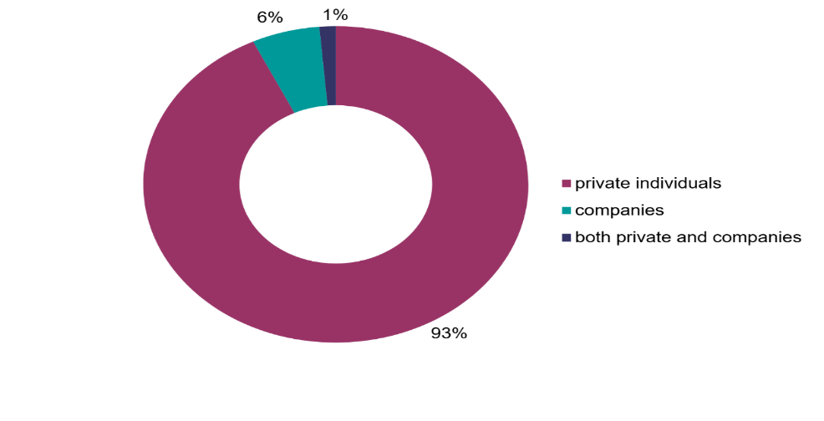
Figure 1: Category of landlords in the UK (GOV.UK, 2022)

The structural drivers of arrears include a wide range of interconnected factors. Many tenants are employed in precarious jobs that provide irregular or insufficient income and as a result their ability to pay rent consistently is undermined. Hardie (2024) emphasises the impact of Universal Credit which involves a five-week waiting period before the first payment is made and which has been consistently associated with the onset of arrears and increased demand for housing advice services. The unpredictability of welfare support combined with insecure employment produces a cycle of financial volatility that makes arrears almost inevitable for many households. Hickman (2021) also notes that these systemic flaws mean arrears are not simply a matter of individual irresponsibility but a predictable outcome of broader policy design and economic insecurity.
Another critical factor is the limited financial resilience of households in the lower income groups who are disproportionately represented in the private rented sector. McNally and Lally (2024) explain that these tenants are severely affected by the rise in essential living costs including food and utilities and that with very little disposable income and no savings buffer even a small disruption such as an unexpected bill or short-term job loss can quickly lead to arrears (McNally and Lally, 2024). This evidence underlines that arrears must be understood as an outcome of structural vulnerability rather than as a failure of tenant management.
Since the agents are intermediaries between landlords and tenants, they rely on timely rent payments to collect their management fees and commission (Hardie 2024). When tenants default on rent payments, the estate agents’ earnings are compromised since they derive their income from the collection of rent. Simultaneously, the landlords’ relationship with agents becomes strained as the former expect efficient rent collection and arrears management. According to McNally and Lally (2024), landlords increasingly evaluate agents' professionalism based on how well they manage tenant arrears. Thus, poorly handled arrears could cost the agent about lost landlord contracts.
The organization stands to lose on several fronts. Considerable effort and time must be devoted before the cases are taken to court (Hardie 2024). They also divert attention from core business activities such as property marketing, client acquisition and compliance oversight. For small and medium-sized agencies operating on tight budgets, this additional burden poses an existential threat (Hardie, 2024). As a result, arrears management is an unsustainable resource drain that threatens housing associations' business model.

The fact that the issue persists through various market cycles and years shows that the private rented sector lacks resilience (McNally and Lally 2024). In turn, this predicament threatens estate agencies’ profitability and business continuity through reputational loss and operational disruption. (McNally and Lally, 2024).

1.2 Practical Experience
During my work at an estate agency, I observed how tenant arrears negatively affected the business’s daily operations and relationships with landlords. I noticed that when tenants were in arrears, the commission was reduced which affected the financial performance of the branch. I realised how much staff time was wasted chasing unpaid rent, arranging meetings with tenants, drafting formal notices and letters to landlords to manage their expectations. This placed additional workload-related stress on the small team and restricted the time available to focus on growing the business, which would include marketing properties and acquiring new clients. I also noted that landlords would sometimes threaten to withdraw properties from management if arrears persisted which was a constant worry for agents as they depended on reputation and were careful not to lose business.

1.3 Problem Statement
Tenant arrears pose a serious threat to the operational resilience and long-term sustainability of estate agents because the continuity of tenant arrears negatively affects their reputation, stability and growth. Organisational resilience theory emphasises the ability to adapt and remain functional under shocks, which is continuously tested by arrears as a combined financial and operational threat (McNally and Lally, 2024). Behavioural economists also use the term “structural incentives” to describe patterns of behaviour which means that payment arrears are not random but systemic. Without efficient strategies to control arrears, agents face the threat of losing both financial and organisational stability.

1.4 Research Aim and Objectives

1.4.1 Aim
To explore and evaluate cost-effective strategies that can enhance resilience among UK estate agents facing tenant arrears.

1.4.2 Objectives
- To identify the key causes and patterns of tenant arrears affecting estate agents in the UK.
- To assess the financial and operational impact of tenant arrears on estate agents.
- To examine and evaluate cost-effective strategies used by estate agents to manage and recover from tenant arrears.

1.5 Rationale
The study is significant to both scholars and professionals. The study also targets the ways real estate agents respond to continuous financial threats in the private renting market (McNally and Lally, 2024). It expands theoretical discussions on organisational resilience and behavioural economics into the real estate markets. The study also seeks to address the practical issue of establishing affordable, credible and sustainable strategies for competitive survival in a volatile rental market by estate agents.

1.6 Outline of Dissertation
1.6.1 The dissertation is organised into several chapters to provide a clear and logical structure. The first chapter introduces the topic and establishes the research aims and objectives.
1.6.2 The second chapter presents a critical literature review that examines existing scholarship on tenant arrears risk management and resilience.
1.6.3 The third chapter outlines the research methodology including philosophy approach data sources and ethical considerations.
1.6.4 The fourth chapter presents and analyses the findings from documentary data focusing on the themes of arrears causes impacts and strategies.
1.6.5 The fifth chapter discusses the conclusions and recommendations highlighting implications for both theory and estate agency practice.

2.0 Literature Review
This chapter critically examines the themes on tenant arrears, provides the gap, conceptual framework and the hypothesis for the study.

2.1 Tenant Arrears Concept
Tenant arrears are those which have not been paid or paid late during a tenancy. This has become a major problem in the UK occasioned by various overlapping factors. According to Hickman (2021), structural causes may include the stagnant wages and high costs of living and affordable prices. He also points out the effect of Universal credit especially its five weeks’ delay making vulnerable tenants going into arrears at the beginning of their tenancy. With the help of the COM-B model (Capability Opportunity Motivation Behaviour), Hickman (2021) believes that rent payment behaviour is not simply a result of tenants’ choice but a product of outside influence, limiting financial capacity and opportunity. Figure 2 below illustrates Hickman’s COM-B model, which explains that rent arrears occur when capability or opportunity are limited, leading to reduced motivation and default behaviour.

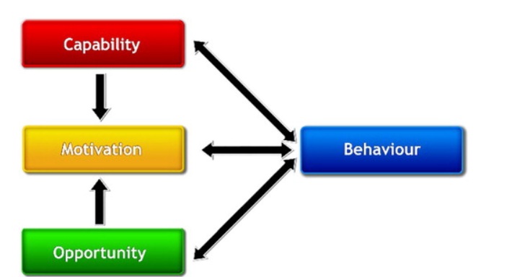
Figure 2. The COM-B behaviour system by Hickman (2021).

Bimpson and Manzi (2022) affirm this behavioural model and associate arrears with broader social disadvantage with the demonstration that poor mental health, lack of financial literacy and support networks increase the risk of arrears. Fitzhugh et al. (2018) expand on this with some practical knowledge that shows three tenant profiles, who find it hard to cope with being disorganised and strategic and testing behavioural nudges such as SMS reminders to have better rent compliance. But they agree that it is impossible to overcome structural economic hardship by messaging alone.
Another aspect that Glover and Jeyabraba (2022) refute is the stereotypical view of the irresponsible tenant who they argue is manifested through qualitative interviews by demonstrating that arrears are a result of unforeseen life shocks like illness or unemployment that are worsened by a financial safety net deficit. On the same note, Manzi Bramley and Ford (2022) suggest that a great number of tenants go into arrears because of temporary yet steep income interruptions aggravated by high rates of housing expenditures and bank borrowings. Hardie (2024) offers additional evidence based on a panel data to show that there is a causal relationship between the implementation of the Universal Credit and the demand of the arrears and homelessness advice in particular low-income regions. This substantiates the fact that welfare design defects especially payment lags play an active role in arrears. In the meantime, Wallace (2025) throws a dark veil over the idea of algorithmic risk profiling with a warning that digital screening systems will discriminate against tenants with poor socioeconomic backgrounds and enhance structural housing discrimination. Collectively these sources disclose the fact that tenant arrears are a result of a complicated combination of behavioural economic and policy factors. Although interventions such as messaging can work with some of the larger problems, the bigger problem is to deal with structural precarity welfare design and fairness in tenant assessment.

2.2 Operational and Financial Impact on Estate Agents

Tenant arrears impose a direct financial burden as well as an operational burden on the estate agents and the loss of income is just a tip of the iceberg. In general, rent gathers are charged on a percentage basis by the agents in the estate business attribute that any lateness or default by the tenants’ impact on their cash flows (KPMG, 2018). Although UK house prices rose 3.5% year-on-year, transactions grew just 1.3% in October 2018(see figure 3 below). For estate agents paid per sale, volume not value continues to constrain revenue and growth. Typically, estate agents earn a percentage-based management fee from rent collected meaning that any delay or default by tenants immediately affects their revenue streams (KPMG, 2018).

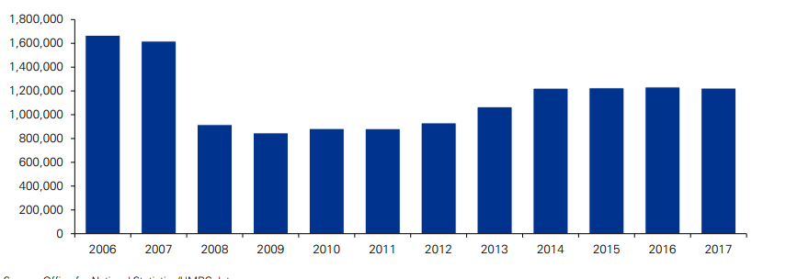
Figure 3. UK Residential Transactions, 2006-2017 (KPMG, 2018).

To the small and mid-sized firms where the profit margins are limited, such a loss may be particularly harmful. Worst still, the greater volatility in the housing market transaction volumes have flattened fees are becoming more and more competitive and regulatory demands are increasing. The accruing pressure puts estate agents in a vulnerable situation in which any small arrears will put business operations at risk (McNally and Lally, 2024). Arrears operationally management causes a huge burden of administration. The agents should make formal notices and negotiate payment schemes to resort to legal action and work in close communication with the landlords and tenants. This also consumes the staff time and resources that would otherwise serve in the core services like acquisition of property marketing clients and compliance monitoring. Cullen Key and Speed (2017) underscore that landlords now consider agent operation based on tenant placement, and arrears recovery as making this operation central to client retention. Consequently, arrears management will constitute both reputational and financial risk. It may result in termination of contracts, withdrawal of property and business loss when managed poorly (Reeve and Batty, 2011).
Recent studies by Manville (2022) further reinforce this point that in the situation of tenant non-payment property managers tend to cut expenditure on maintenance and services that set up a downward spiral on the quality of the property and the satisfaction of tenants. Although the paper is about landlord behaviour, the same is the case with letting agents whose resources are strained by cases of arrears. The research supports the concept that arrears have a significant influence on cash flow in addition to the overall quality of the service delivery which is a major element of the market reputation of an agent. In a comparative analysis of the commercial rental sector, Adetoro-Folorunso and Ogunbajo (2023) discovered that rental defaults led to poor relationship between property managers and landlords in terms of delays in payment of management services and erosion of trust in managerial competence. Although the context is different, the dynamics are reminiscent of the UK residential sector especially the conflict between the agency responsibilities to landlords and tenants. It is argued by the study that unresolved arrears can shift strategic focus of agencies towards generation of values to damage limitation. The operational burden might also encompass legal escalation in more complex cases. Leung (2021) points out that not only do certain agencies file eviction serials as a last resort enforcement measure, but they also do so as a revenue-saving measure. This shows a more underlying structural issue that estate agents can use legal mechanisms they can actually be able to administer financial predictability rather than to deal with arrears. Though such practices may be effective in short run they may also increase instability in relationships with tenants, and this may lead to housing insecurity.
According to McNally and Lally (2024) the estate agents are essentially trapped in a broken system that is expected to keep business afloat whilst negotiating between the structurally disadvantaged tenants and the financially motivated landlords. The fact that the estate agency industry is not officially regulated makes things even harder leaving many companies without a proper guideline or support system. As Ke et al. (2012) note that the mismatch of the expectations and the operational capacity is an indication of a structural weakness of the agency model. Altogether the literature indicates that tenant arrears are not just isolated financial losses but systemic risks that directly weaken the financial wellbeing and reputational position and strategic orientation of estate agents. The liens of arrears are much greater than the rent collection interfering with the normal running and viability of letting agencies throughout the UK.
According to The Telegraph (2024), local councils are losing more than £500 million annually from social tenants’ rent arrears, representing around 7.2% of the total rent roll (£7.7 billion).

2.3 Risk, Resilience and the Role of Data in Rent Management
The rising strain on estate agents to cope with rent arrears in a volatile market situation is getting heavier. The lack of economic stability among tenants and the rise of expectations among landlords has heightened the requirement of the agents to move past the reactive responses and apply the structured risk approaches. Lam (2014) states that Enterprise Risk Management (ERM) represents a wide-ranging approach to dealing with uncertainty through integrating risk analysis into the strategic planning and daily business. His model promotes prospective instruments like arrears forecasting scenario testing and resilience planning aspects which can be extended even to small estate agencies. Simpson (2021) provides the practical implementation of ERM by presenting the case study of Knight Frank that uses arrears tracking internal auditing and real-time data systems. As the case illustrates, reputational risk and financial volatility can be minimized through a well-designed strategy. Simpson, however, observes that there is big difference in the adoption of the sector. Smaller letting agencies that may not have adequate staff and digital infrastructure cannot take up strong risk models that would make them more vulnerable to disruption of their operations. Morris and Rose (2022) also believe that proactive data-based approaches can make the rental sector sustainable in the long run. However, even with this agreement, an ad hoc responsive approach is used by many letting agencies to address arrears. This disjointed reaction can be seen as a larger failure in incorporating risk thought into the centrepiece of letting agency activities and sustainable strategy.
Rent risk management has taken on a new direction that involves the use of technological solutions especially data platforms. Livingston et al. (2021) demonstrate that digital listings and tenant payment data can be utilized to track the pattern of arrears and signal an impending risk. But they warn that such datasets are oftentimes incomplete in terms of coverage and that they are not as accurate as they could be. Since such agents need to be critical of the reliability of third-party information before basing operational decisions on the information. Ferreri (2021) goes even more by criticising the concept of the platformisation of housing in which algorithmic systems are applied to mechanise payment tracking in terms of tenant screening, and even eviction activations. She contends that although such platforms are claimed to be efficient, they do allocate risk downwards on tenants and frontline agents without having a full consideration of their social implications. This indicates that the digital solutions can be helpful in determining the risk but not in allocating it equally. This concept is reflected in the ethical aspect of Byrne, McArdle and Wallace (2020) as they caution that algorithmic profiling tools to determine the risk posed by tenants are frequently socioeconomic biased. These devices can designate low-income or minority tenants as being in the high-risk category using proxies such as postcode or benefit status instead of real rent behaviour. Sitaraman (2023), also criticizes the obscurity of those types of systems by simply stating that they are not accountable and can be a cause of systemic exclusion.
Rogers, Bohland and Rechkemmer (2023) present a more general analysis since they focus on how algorithmic governance transforms the institutional resilience. According to them, resilience should now encompass more than the capacity to recover after disruption and involve critical interaction with the disrupted mediating technologies. In the case of estate agents, this implies that the resilience strategies should not focus solely on operational efficiency but also include fairness and transparency in the usage of data as well as ethical data usage. Overall, the literature indicates that there is an increasing number of opinions that effective arrears management requires not only technical solutions and data-based foresight but also deliberate approach to the ethical risk management strategy. This lack of estate agents will put both victims and carriers of systemic failure of the private rented sector.

2.5 Conceptual Framework and Hypothesis
This study is grounded in a risk and resilience conceptual framework which enables a multi-dimensional analysis of how estate agents in the UK private rented sector respond to tenant arrears. It draws from organisational resilience theory, behavioural economics and enterprise risk management (ERM), while incorporating recent developments in data analytics and algorithmic governance.
At its core the framework views estate agents as adaptive systems operating under chronic stress tasked with maintaining service delivery, client relationships, and profitability in the face of external shocks such as income volatility, welfare system delays and non-payment of rent. Behavioural insights (Hickman, 2021; Fitzhugh et al., 2018) are used to understand tenant payment patterns, while operational theories (Lam, 2014; Simpson, 2021) frame how agencies plan for and absorb risk. Digital tools such as tenant risk scores and arrears tracking software are explored both for their strategic value and their ethical complexity (Wallace, 2025; Byrne et al., 2020).
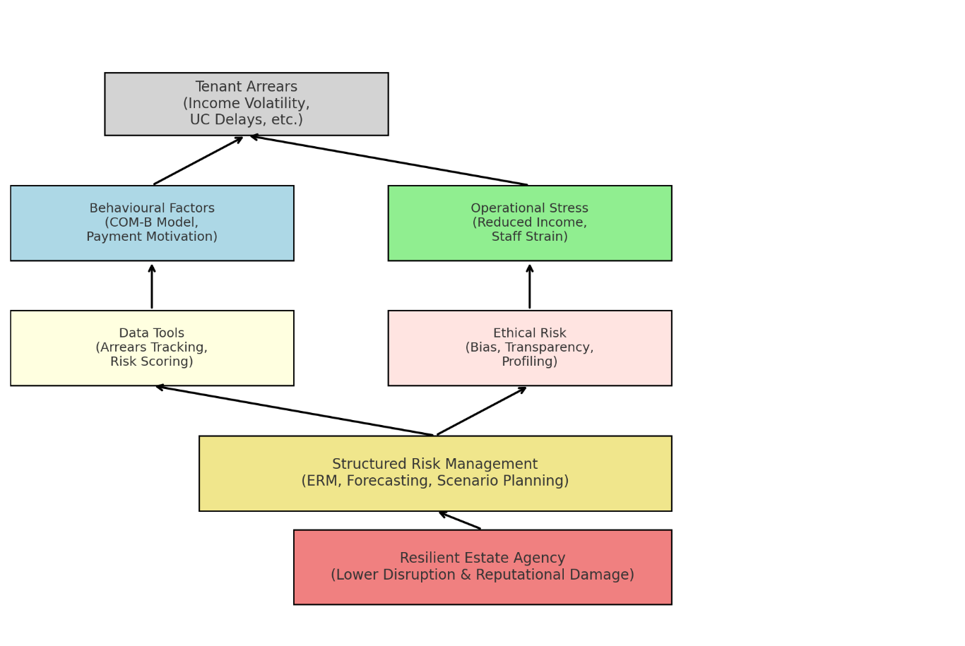

Figure 4: The Conceptual Framework (Own Creativity).

The study’s hypothesis is:
Estate agents that implement structured risk strategies and apply ethical data tools experience lower levels of operational disruption and reputational damage from tenant arrears in the private rental sector. Figure 4 illustrates that tenant arrears have multi-dimensional impact on tenants (behaviourally) and agencies (operationally). By using data tools responsibly and managing ethical risks, agencies can apply structured risk management strategies. This approach leads to greater resilience, helping agencies mitigate damage and disruption.
This framework as shown in Figure 4 above supports a holistic exploration of resilience in lettings, connecting practice to policy and technology.

2.6 Gap in the Literature
Although the antecedents and behavioural dynamics of tenant arrears are well known, little is known about operational resilience strategies that letting agents employ to counter persistent arrears. Most of the existing studies focus on tenants, landlords or policy but little attention is given to rental agency in the context of rental housing. Particularly, there is no research on how letting agents use or adapt digital risk tools (e.g., algorithmic tenant profiling and arrears tracking) and the implications of this for their effectiveness, ethics and sustainability. This study addresses the above-mentioned gap in knowledge by analysing how the use of data for managing arrears and risk governance in estate agency practice is undertaken.

3.0 Methodology
The methodology describes how the study will be conducted to investigate cost-effective methods UK estate agents can use to boost business resilience against tenant arrears. The research approach of this study is based on the Research Onion framework proposed by Saunders et al. (2007), as illustrated below.
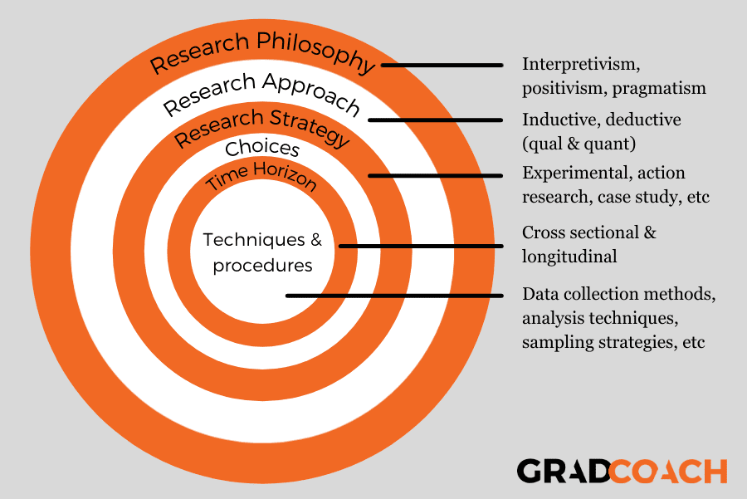
Diagram 1. Research Onion framework by Saunders et al. (2007).

3.1 Research Philosophy
The study is based on the interpretivist and constructivist research philosophy. Interpretivism helps understand the social practices within economic and political contexts, especially how estate agents respond to tenants’ arrears (Flick, 2022). Constructivism supports the idea that knowledge is acquired through one’s interactions and experiences. Together, these levels of interpretation enable the findings to focus on the strategic responses of estate agents rather than objective generalisations.

3.2 Research Paradigms
Interpretivist paradigm was adopted to prioritise contextual understanding and individual agency. This paradigm seeks to enable the exploration of estate agents’ practices and views in the dynamic rental market (Flick, 2022). Qualitative analysis views the researcher as a co-participant and interpreter rather than an impartial observer of social processes.

3.3 Research Approach
The study will use an inductive research approach. The analysis starts with specific data from the documentary reports and builds into broader levels of sustainability resilience adaptation strategies (Fitzhugh et al., 2018). Because the study seeks to build understanding as opposed to testing a hypothesis, it is appropriate to employ this form of reasoning.

3.4 Research Methodology
The study applied qualitative research methods as opposed to quantitative approach. This study will explore the behaviours and organisational meanings of estate agencies regarding decision making and strategic planning to curb tenant arrears. Qualitative techniques examine text-based data and fit a constructivist and interpretivist perspective (Fitzhugh et al., 2018).

3.5 Research Strategy
Documentary analysis is used as the main research method. This approach targets an in-depth analysis of existing materials like policy reports and publications by housing associations, as well as academic studies among others. And does not require direct interaction with the participants (Livingston et al., 2021).

3.6 Sampling Strategy
Purposive sampling helped to obtain documents that are relevant, authoritative and recent. The sources were selected based on their relevance to tenant arrears and estate agent operations, including think tanks, academic journals, government statistics and briefings.

3.7 Data Collection
Data were drawn from publicly accessible documents, including Shelter UK and GOV. UK datasets, housing journals and property sector publications. They also suggest ways in which organisations have managed to stay resilient despite the threat posed by tenant arrears.

3.8 Data Interpretation
Data will be analysed using thematic analysis. This is a flexible qualitative method that identifies and interprets patterns in the documents. And additionally enables the researcher to comprehensively engage with and understand the meanings that qualitatively emerge from the data (Flick, 2022). The analysis entailed reading and coding the data, clustering the codes into themes and interpreting them for meaning regarding organisational resilience. However, it necessitates a careful approach to minimise bias and maintain research quality:
Advantages include;
- Allows for depth and flexibility in exploring complex social issues (Flick, 2022).
- Suitable for analysing policy documents and professional discourse.
- Enables the researcher to link themes to theoretical concepts (e.g., resilience, organisational behaviour).
Disadvantages are;
- Subject to researcher bias in coding or theme interpretation (Flick, 2022).
- Requires careful and consistent documentation to maintain rigour.
- May miss nuanced quantitative patterns without numerical data.

3.9 Ethical Considerations
This study adheres to the ethical standards of the University of Wales Trinity Saint David. Since the study uses publicly accessible data and does not involve human participants, there are no issues related to consent or data protection. However, academic integrity was ensured by implementing appropriate citations in the tool and respecting data privacy and confidentiality requirements stipulated by GDPR. No sensitive or confidential information was accessed in the course of the study.

4.0 Analysis of Findings and Discussion
This section provides the findings and their analysis. From the selected sources, three themes were identified through thematic analysis namely:
- Structural and Behavioural Drivers of Rent Arrears,
- Operational and Financial burden on Letting Agents and Landlords,
- Resilience-Developing and Cost-Effective Mitigation Measures.
These themes will be the basis for analysis and discussions in the next subheadings.

4.1 Analysis of findings
4.1.1 Structural and Behavioural Drivers of Rent Arrears

Concerning the first theme, the result shows that the structural and behavioural factors have significant influence on the rent arrears. According to Figure 5, tenants indicated that they had problems with Housing Benefit (HB) work and life changes, increasing costs as the most common causes (Bimpson and Manzi, 2022). Affordability strain is emphasized by Figure 6 where median rents are more than 30 percent of income in places such as London and the South East (McNally and Lally, 2024). Other sources of evidence associate arrears with Universal Credit delays, reduction of benefits, and income unpredictability (Wilson and Keen, 2023; McNally and Lally, 2024). These aspects indicate macroeconomic stressors that are not directly related to personal failure in budgeting.

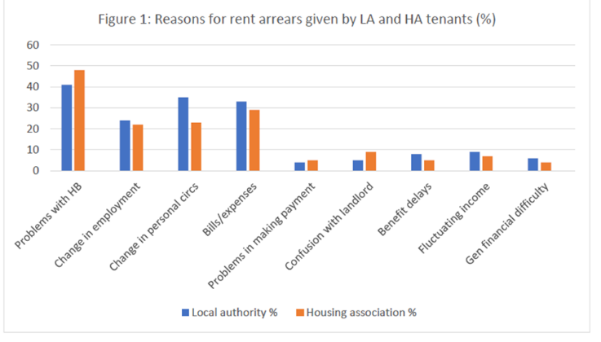
Figure 5: Reasons for rent arrears (Bimpson and Manzi, 2022).

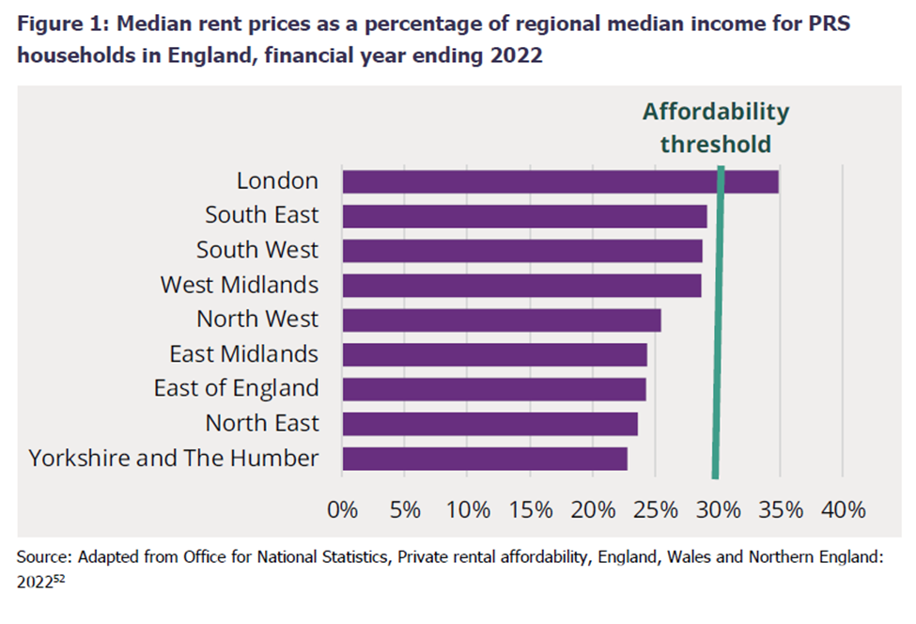
Figure 6: Median rent prices statistics (McNally and Lally, 2024).

4.1.2 Operational and Financial Burden on Letting Agents/Landlords
On the second theme, findings show that the rent due in arrears have resulted in accruing operational and financial strains among the estate agents and landlords. Most landlords, as Figure 7 shows that have financed their initial property with the help of a mortgage, which puts them in a very risky position when it comes to lost rental income (Department for Levelling Up, Housing and Communities, 2022). Figure 8 demonstrates that the arrears increased to their maximum point of £940 per tenancy in March 2021 (Centre for Housing Evidence, 2024). Further, Figure 9 shows that 11 percent of PRS tenants were behind, at most. The estate agents record the risk as absorbed in the course of eviction bans and some landlords are even considering becoming entirely out of the market.
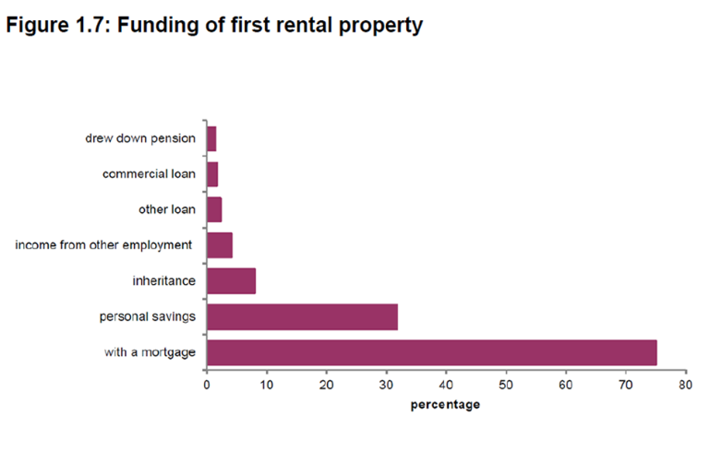
Figure 7: Funding of rental propoerty (Department for Levelling Up, Housing and Communities (2022).

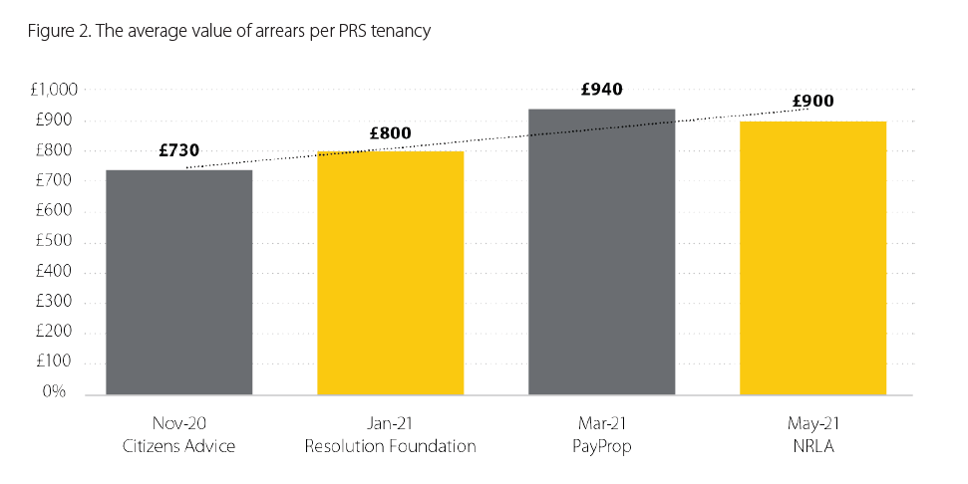
Figure 8: Rent arrears poer PRS tenancy by Centre for Housing Evidence (2024).
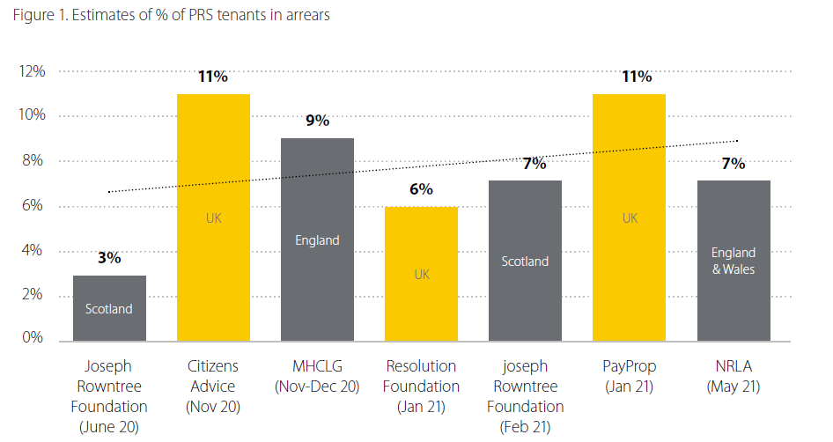
Figure 9: PRS tenants arrears estimates By Centre for Housing Evidence (2024).

4.1.3 Resilience-developing and cost-effective mitigation measures
On the last theme on the findings revealed that measures to develop resilience are behavioural nudges, protocols of arrears, and mechanisms of supporting tenants. As an illustration, Figure 10: Volume of cleared arrears shows that, although the behavioural intervention trial failed to significantly influence the number of arrears cleared, the behavioural intervention trail did increase the number of contacts with tenants by 17 per cent (Fitzhugh et al., 2018). Also, proactive measures such as SMS reminders have recorded a reduction in arrears by 14 percent (Fitzhugh et al., 2018). As Crisis (2017) and Propertymark (2024) report, agencies that implemented early support interventions had a lower number of evictions and a better response to payments, which show the effectiveness of non-punitive and cost-effective interventions.

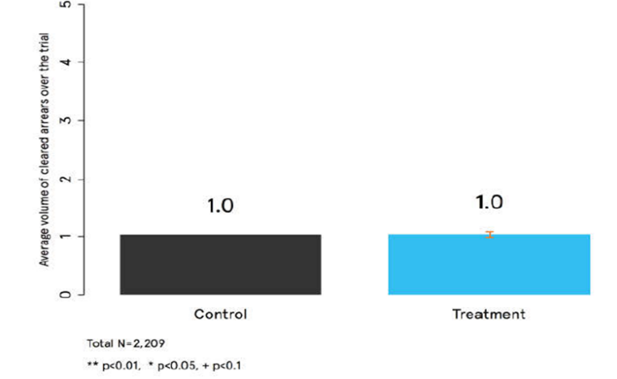
Figure 10: Volume of cleared arrears (Fitzhugh et al., 2018).

4.2 Discussion

4.2.1 Structural and Behavioural Drivers of Rent Arrears.
This theme responds to the second objective on finding out the underlying reasons about rent arrears. The results indicate that the effects of both structural and behavioural variables have a significant effect on rent arrears. Among the tenants shown in Figure 5, arrears were attributed to issues with Housing Benefit, employment or personal changes, and rising living costs at the first place (Bimpson and Manzi, 2022). These predicaments fit the broader-systemic limits that tenants have experienced especially unpredictability concerning wealth and benefit-related predicaments. To illustrate, Figure 6 shows that in regions with high demand, like London and South East, the median price of rental housing is higher than 30 percent of the income, which puts additional stress on low-to-moderate income tenants (McNally and Lally, 2024).
These stressors are supported in scholarly literature Hardie (2024) discovers a direct correlation between Universal Credit delays and increased arrears, especially in those whose earnings are not predictable. These delays, in turn, decrease the capacity of the tenants to pay their rents in time, which leads to debt and instability cycles. The same argument has been made by Hickman (2021) who states that most of the rent arrears demonstrate the nature of insecure employment and volatile income, but not poor financial behaviour. He emphasises that most social housing tenants spend their resources in an effective way, however, the outside shocks impair their capacity to maintain payments.
On a system level, Byrne and McArdle (2020) note that digital profiling and algorithmic risk assessment in the PRS marginalise tenants who are not truly high risk and minimise their chances of receiving support and inflate the possibility of arrears. This framing provides support to a culture of blame whilst tenants are making rational decisions given limited options. Glover and Jeyabraba (2022) further state that some of the tenants identified as the financially vulnerable were already on the periphery prior to COVID-19 and welfare reductions, and therefore arrears are connected to historical affordability gaps. Their report backs up the opinion that arrears are consequences of cumulative systematic failures and not an abrupt lapse of behaviour. It was also noted by Fitzhugh et al. (2018) that tenants react favourably to supportive communication, and therefore, behavioural interventions could be used to enhance engagement even when they fail to solve arrears directly. This underlines the importance of Cullen, Key and Speed (2017) on the tenancy management in the early stage as a procedure that can be used to prevent arrears due to proper support and setting expectations. In general, the facts justify Objective 1 because they show that rent arrears are not only caused by tenant’s mismanagement, but also through macroeconomic precarity, flaws in the benefit system, and tenancy management gaps (Hardie, 2024; Byrne and McArdle, 2020; Hickman, 2021).

4.2.2 Operational and Financial burden on Letting Agents and Landlords.
This theme responds to the second objective on Financial and operation impact. These results affirm that rent arrears pose a significant financial risk and burden of operation. As demonstrated by Figure 7, the vast majority of landlords finance their first house with the help of mortgages, which implies that lost rent causes them a straight threat to meet the repayments (Department for Levelling Up, Housing and Communities, 2022). In March 2021, arrears hit a high of £940 per tenancy (Figure 8) and at their highest points, up to 11% of tenants were in arrears (Figure 9) (Centre for Housing Evidence, 2024). Allowing agent to bear this cost in terms of lower revenue, increased workloads on arrears management and limited decision-making. Arrears compel lettings agencies to contact tenants more frequently, change the way things are done internally, and monitor missed payments more closely (Glover and Jeyabraba, 2022). It further aggravated the operational disruption during eviction bans, during which legal avenues to reclaim rent were shut over months at once (Simpson, 2021). The pressure of finances is changing long-term strategy.
Approximately 1 out of 10 landlords thought of selling part or all of their rental houses due to increased arrears and exposure to risk (Department for Levelling Up, Housing and Communities, 2022). This behaviour is consistent with the description of Lam where prolonged income destabilization leads to portfolio rebalancing and risk-reducing decisions (Lam, 2014). Most agents are embracing technology-based risk filters to deal with exposures. Increased screening of tenants by their landlords is being done more aggressively via digital platforms and algorithmic risk scores (Byrne and McArdle, 2020). It has become standard in online listings to have a tool to compute affordability, credit risk, or income history (Livingston et al., 2021). Such systems limit the exposure to arrears and, at the same time, increase the barrier to access among the renters with inconsistent revenue or previous incurred debt.
Other estate agents will lower arrears risk at an earlier stage in the tenancy process. The agencies that have organized pre-tenancy procedures have fewer instances of arrears or fewer instances of operational failures (Cullen et al., 2017). Understanding of rent expectation, affordability tests, and initial assistance minimize confusion and payment disputes in future of the tenancy. All in all, the evidence reveals that arrears hurt cash flow as well as agency capacity. There is more severe screening, risk-averse exits, and digital tools being used by agents. Though these plans guard income, they redefine access to tenants and flexibility, particularly in relation to low and erratic-income families.

4.2.3 Resilience-Developing and Cost-Effective Mitigation Measures.
This theme responds to the third objective. As information shows useful, affordable interventions that enhance resilience among agent agents to tenant arrears. Figure 10 demonstrates that despite the fact that the behavioural trial did not have a significant impact on arrears clearance, it resulted in an increase in the tenant contact, which is a crucial stage of the resolution process, by 17 percent (Fitzhugh et al., 2018). Even simple interventions like SMS payment reminders have been seen to eliminate arrears by 14 percent (Fitzhugh et al., 2018, p.11). These behavioural cues redirect the emphasis on law enforcement toward initial interaction. Glover and Jeyabraba (2022) discovered that proactive interventions, such as structured outreach and arrears support, minimized the conflict and increased payment outcomes.
Their results emphasize that the key to proper arrears management is not punishment but engagement. According to Isa et al. (2023) tenants experience higher chances of keeping pace with payments when they are upfront informed and advised on their budgets. Those agencies that incorporated support systems initially had enhanced flows of rent and reduction in disruptions. This implies that good on boarding rather than crisis response is the beginning of resilience. Hickman (2021) established that the condition of income shocks and sporadic incomes were the main causes of arrears - not an intentional non-payment. He says approaches of flexibility and contact, as opposed to enforcing are better in the long term. This supports the opinion that contact is not a tender approach but a strategic one. Cullen et al. (2017) contribute that the pre-tenancy processes can be well managed, which will decrease the arrears prior to beginning. The estate agencies with clear expectations, checking affordability and early contact recorded fewer cases of arrears. This implies that arrears prevention is not a financial only issue, but a procedure issue. According to McNally and Lally (2024), the capacity to adjust processes in a short time is also a determinant of resilience within agencies. The estate agencies that have created arrears procedures and escalation routes reacted more swiftly to external shocks. This shows that resilience has more to do with tenant support, but it has to do with internal systems and readiness. Altogether, there is evidence that attests to a transition to cost-effective engagement models. Organised communication, operational preparation and behavioural aids assist agents to handle arrears without the use of eviction. These plans lower the risks, maintain tenancies, and secure cash flows.

5.0 Conclusions and Recommendations

5.1 Conclusions
This research study explored the causes, effects and mitigation measures regarding the tenant arrears within the UK private rented sector. Using the thematic analysis, the results confirm that rent arrears are never due to tenant negligence mostly; on the contrary, structural factors such as benefit delays, volatile incomes, and affordability pressure are some of the significant contributors. Since estate agents and landlords are unable to increase their property rent to cover operational expenses, they have to endure aggravated financial and operational pressures, especially when there is a policy restriction, like an eviction ban. Nonetheless, cost-effective measures, such as behavioural nudges, structured communication, and early intervention, have proven to be effective in the control of the arrears without the use of the enforcement step. The information promotes the shift of the reactive and punitive strategies to proactive and resilience-oriented practice. Agents who operate on the basis of letting and invest in initial contact and tenant support have better chances of keeping their rents flowing and ensuring less stress on arrears. With mounting pressures in the sector particularly during economic unpredictability, the agents and property owners should implement viable systems that focus on prevention, flexibility, and involvement of tenants.

5.2 Recommendations

5.2.1. Standardise Early Arrears Intervention Procedures
Letting agents must incorporate early arrears identification and contact techniques into the regular functions. Activities like sending reminders well before the due date, calling when the payments are not made in 48 hours, and flexible payment rates can go a long way to preventing the accumulation of arrears (Fitzhugh et al., 2018). Experience demonstrates that tenants will be better responsive and cooperative in being approached in a positive manner at the beginning of the conversation. Organized communication is also associated with reduced eviction rates and enhanced payment agreements (Isa et al., 2023). Instead of letting arrears build up, regular early interaction has the effect of ensuring that agents are able to solve problems sooner and save tenancies.

5.2.2. Invest in On boarding and Preparation to be a tenant
Prevention of arrears is prior to the commencement of tenancy. During the on boarding, letting agents are expected to perform affordability checks, explain the expectations of rent, and provide advice on budgeting. It is essential because these steps allow to establish achievable promises and minimizing misunderstandings, particularly among the first-time tenants (Cullen et al., 2017). On boarding education has been linked to increased compliance in rent and reduction in conflict. The role of financial resilience in managing the finances of tenants with higher awareness of their rights and responsibilities is also outlined by McNally and Lally (2024). The financial literacy and communication at an early stage can help agents to mitigate risk of both sides.

5.2.3. Improve Tenant Engagement using Behavioural Tools
Insight on behaviour can be used to motivate prompt payment of rents without having to spend a lot of money. SMS reminders, encouraging letters, and fewer contacts channels have proven to have quantifiable effects on tenant responsiveness and a decrease in arrears (Fitzhugh et al., 2018). These measures particularly succeed where tenants are in temporary distress or disarray as opposed to non-payment purposefully. Glover and Jeyabraba (2022) have discovered that there were high arrears recovery rates and a reduced number of legal disputes among landlords who employed behavioural approaches. Low-cost nudges should be experimented by the agents as part of a wider arrears policy which emphasized engagement and support over enforcing.

6.0 References
Adetoro-Folorunso, Z. and Ogunbajo, O. (2023) ‘Assessing the effects of rental default by commercial property occupiers on property management in Minna, Niger State, Nigeria’, JABU International Journal of Social and Management Sciences, [online] Available at: https://jabu.edu.ng/wp-content/uploads/2024/04/Assessing-the-Effects-of-Rental-Default-by-Commercial-Property-Occupiers-on-Property-Management-in-Minna-Niger-State-Nigeria.pdf [Accessed 7 Oct. 2025].

Bimpson, E. and Manzi, T., 2022. Drivers of rent arrears in social housing: an evidence review.

Byrne, M. and McArdle, R. (2020) ‘Algorithmic tenancies and the ordinal tenant: digital risk-profiling in England’s private rented sector’, Housing Studies, 37(6), pp. 961–983. doi:10.1080/02673037.2020.1798343.

Byrne, M., McArdle, R. and Wallace, A. (2020) ‘Algorithmic tenancies and the ordinal tenant: digital risk-profiling in England’s private rented sector’, Housing Studies, 37(6), pp. 961–983. https://doi.org/10.1080/02673037.2020.1798343

Centre for Housing Evidence (2024) The Pandemic Rent Arrears Crisis. [online] UK Collaborative Centre for Housing Evidence. Available at:https://housingevidence.ac.uk/wp-content/uploads/2024/02/20211028_CaCHE_ThePandemicRentArrearsCrisis_FINAL.pdf

Crisis (2017) Local Lettings Agencies: A Good Practice Guide. [online] Available at: https://www.crisis.org.uk/media/236935/local_lettings_agency_guide.pdf

Cullen, D., Key, T. and Speed, L. (2017) Tenancy management: Tenant perceptions of the pre-tenancy and tenancy execution phases. London: HouseMark. Available at: https://www.housemark.co.uk [Accessed 7 Oct. 2025].
Cullen, D., Key, T. and Speed, L. (2017) Tenancy management: Tenant perceptions of the pre-tenancy and tenancy execution phases. London: HouseMark. Available at: https://www.housemark.co.uk (Accessed: 18 July 2025).

Department for Levelling Up, Housing and Communities (2022) English Private Landlord Survey 2021: Headline Report. [online] London: UK Government. Available at: https://assets.publishing.service.gov.uk/media/66ab81a4ab418ab0555931ac/EPLS_Headline_Report_2021_FINAL.pdf

Ferreri, M. (2021) ‘Rental housing, platforms, and the management of risk’, Housing Studies, 36(8), pp. 1249–1269. Available at: https://researchportal.northumbria.ac.uk/files/63567811/02673037.2021.pdf [Accessed 7 Oct. 2025].

Fitzhugh, E., Park, T., Nolan, D. and Gibbons, D., 2018. Reducing rent arrears at Metropolitan Housing. Final project report from The Behavioural Insights Team. Accessible.

Fitzhugh, H., O’Dell, C., Corbett, D. and Mathew, L. (2018) ‘Nudging in practice: Behavioural insights to reduce rent arrears’, Metropolitan Housing Trust Internal Report.

Flick, U. (2022) An Introduction to Qualitative Research. 7th edn. London: Sage Publications.

Glover, B. and Jeyabraba, M. (2022) The Bottom Line: An investigation of rent arrears in social housing. London: Demos. Available at: https://demos.co.uk/project/the-bottom-line/

GOV.UK (2022) English Private Landlord Survey 2021: Main Report. Available at: https://www.gov.uk/government/statistics/english-private-landlord-survey-2021-main-report/english-private-landlord-survey-2021-main-report--2

GOV.UK (2022) English Private Landlord Survey 2021: Main Report. [online] Available at: https://www.gov.uk/government/statistics/english-private-landlord-survey-2021-main-report/english-private-landlord-survey-2021-main-report--2 [Accessed 4 Jul. 2025].
Hardie, I. (2024) ‘Welfare reform and housing insecurity: the impact of Universal Credit rollout on demand for rent arrears and homelessness advice from Citizens Advice in England’, Social Policy and Society, 23(3), pp. 627–650. Available at: https://doi.org/10.1017/S1474746423000026

Hickman, P., 2021. Understanding social housing tenants' rent payment behavior: evidence from Great Britain. Housing Studies, 36(2), pp.235-257.

Isa, M., Salleh, K.M., Zainol, N.N., Nordin, M.S.A., Jibril, J.D., Idrus, M.S. and Sulaiman, M.A., 2023. Tenancy Management: Tenant perceptions of the pre-tenancy and tenancy execution phases. Asian Journal of Environment-Behaviour Studies, 8(26), pp.55-68.

Ke, Q., Loosemore, M. and Stewart, R. (2012) ‘Risk allocation in residential property management: the views of UK property professionals’, Property Management, 30(4), pp. 344–359. https://doi.org/10.1108/02637471211249513

KPMG LLP (2018) Property market disruption impacting estate agent profitability. KPMG. Available at: https://www.kpmg.com/uk (Accessed: 18 July 2025).

KPMG LLP (2018) Property market disruption impacting estate agent profitability. KPMG. Available at: https://www.kpmg.com/uk (Accessed: 18 July 2025).

Lam, J. (2014) Enterprise risk management: From incentives to controls. 2nd edn. Hoboken, NJ: John Wiley & Sons.

Lam, J. (2014) Enterprise risk management: From incentives to controls. 2nd edn. Hoboken, NJ: John Wiley & Sons.

Leung, L. (2021) ‘Serial eviction filing: Civil courts, property management, and the renters’ experience’, Social Forces, 100(1), pp. 316–339. [online] Available at: https://academic.oup.com/sf/article/100/1/316/5903878 [Accessed 7 Oct. 2025].
Livingston, M., Pannullo, F., Bowman, A., Scott, M. and Bailey, N. (2021) ‘Exploiting new forms of data to study the private rented sector: strengths and limitations of a database of rental listings’, Journal of the Royal Statistical Society: Series A (Statistics in Society), 184(2), pp. 663–682. Available at: https://academic.oup.com/jrsssa/article/184/2/663/7056340 [Accessed 7 Oct. 2025].

Livingston, M., Pannullo, F., Bowman, A.W., Scott, E.M. and Bailey, N., 2021. Exploiting new forms of data to study the private rented sector: Strengths and limitations of a database of rental listings. Journal of the Royal Statistical Society Series A: Statistics in Society, 184(2), pp.663-682.

Livingston, M., Pannullo, F., Bowman, A.W., Scott, E.M. and Bailey, N., 2021. Exploiting new forms of data to study the private rented sector: Strengths and limitations of a database of rental listings. Journal of the Royal Statistical Society Series A: Statistics in Society, 184(2), pp.663-682.

Manville, M. (2022) ‘Renter nonpayment and landlord response’, Housing Policy Debate, [online] Available at: https://www.ncbi.nlm.nih.gov/pmc/articles/PMC11160939/ [Accessed 7 Oct. 2025].

Manzi, T., Bramley, G. and Ford, J. (2022) Drivers of Rent Arrears in Social Housing: An Evidence Review. Sheffield: Holding On to Home. Available at: https://holdingontohome.org/wp-content/uploads/2022/08/Drivers-of-rent-areas-EV-Report.pdf

McNally, X. and Lally, C. (2024) Housing insecurity in the private rented sector in England: drivers and impacts. POSTnote 729. London: Parliamentary Office of Science and Technology. Available at: https://post.parliament.uk/research-briefings/post-pn-0729/

Morris, N. and Rose, M. (2022) ‘Risk management strategies for sustainable rental real estate’, Journal of Property Investment & Finance, 40(3), pp. 189–205. doi:10.1108/JPIF-12-2021-0098.
Morris, N. and Rose, M. (2022) ‘Risk management strategies for sustainable rental real estate’, Journal of Property Investment & Finance, 40(3), pp. 189–205. doi:10.1108/JPIF-12-2021-0098.

Propertymark (2024) Importance of Proactively Managing Arrears. [online] Available at: https://www.propertymark.co.uk/resource/importance-of-proactively-managing-arrears.html

Propertymark (2025) Handling Rent Arrears Disputes: What Letting Agents Need to Know in 2025. [online] Available at: https://www.propertymark.co.uk/resource/handling-rent-arrears-disputes-what-letting-agents-need-to-know-in-2025.html

Reeve, K. and Batty, E. (2011) The hidden truth about homelessness: Experiences of single homelessness in England. London: Crisis. Available at: https://www.crisis.org.uk (Accessed: 18 July 2025).

Rogers, P., Bohland, J.R. and Rechkemmer, A. (2023) ‘Risk and resilience in the age of algorithmic governance’, in Cutter, S.L., Burton, C.G. and Emrich, C.T. (eds.) The Oxford Handbook of Complex Disaster Risks and Resilience. Oxford: Oxford University Press, pp. 315–342. Available at: https://www.researchgate.net/publication/369459168_Risk_and_Resilience_in_the_Age_of_Algorithmic_Governance [Accessed 7 Oct. 2025].

Saunders, M., Lewis, P. and Thornhill, A. (2019) Research Methods for Business Students. 8th edn. Harlow: Pearson Education.

Simpson, O. (2021) ‘Risk management practices within the real estate sector: A case study of Knight Frank’, SSRN. Available at: https://ssrn.com/abstract=4641523 [Accessed 7 Oct. 2025].

Sitaraman, B. (2023) ‘Data-driven tenancy risk assessments and exclusion in rental housing’, Journal of Housing and the Built Environment, Advance online publication. https://doi.org/10.1007/s10901-023-09988-6

The Telegraph (2024) Taxpayers hit £500m council housing bill as rent goes unpaid. Available at: https://www.telegraph.co.uk/money/property/taxpayers-hit-500m-council-housing-bill-goes-unpaid/ (Accessed: 11 October 2025).

Wallace, A. (2025) ‘Algorithmic tenancies and the ordinal tenant: digital risk-profiling tools in England’s private rented sector’, Housing Studies, 40(1), pp. 35–58. https://doi.org/10.1080/02673037.2025.2453005

Wilson, W. and Keen, R. (2023) Housing and the Cost of Living. [online] House of Commons Library. Available at: https://researchbriefings.files.parliament.uk/documents/CBP-9622/CBP-9622.pdf

7.0 Appendices

7.1 APPENDIX A: Planning / Research Timeline Table

Task | Start Date | End Date | Duration (days) | Notes
Finalise literature review | 01/10/2025 | 07/10/2025 | 7 | Review and finalise academic sources
Methodology refinement | 01/10/2025 | 07/10/2025 | 7 | Final adjustments to research strategy
Data collection | 08/10/2025 | 21/10/2025 | 14 | Data gathering
Data analysis | 22/10/2025 | 04/11/2025 | 14 | Analyse and interpret collected data
Writing dissertation chapters | 22/10/2025 | 04/11/2025 | 14 | Write literature review, methodology, findings, discussion & conclusion
Proofreading & formatting | 05/11/2025 | 14/11/2025 | 10 | Final editing and formatting prior to submission

7.2 APPENDIX B: Literature Review Summary Table

Table B1. Summary of Key Literature Reviewed

Author(s) & Year | Focus of Study | Key Findings | Relevance to This Research
Hickman (2021) | Rent payment behaviour; structural causes of arrears; COM-B model | Arrears linked to low income, UC delays, limited capability/opportunity; behaviour shaped by structural factors. | Explains behavioural and structural causes of arrears affecting agents’ resilience.
Bimpson & Manzi (2022) | Drivers of arrears in social housing | Arrears linked to social disadvantage, low income, and lack of financial support. | Shows arrears originate from systemic vulnerabilities relevant to PRS.
Glover & Jeyabraba (2022) | Financial vulnerability among tenants | Arrears caused by life shocks (illness, job loss), not irresponsibility. | Supports the argument that arrears stem from structural pressures.
Hardie (2024) | Impact of Universal Credit on arrears | UC’s 5-week wait increases arrears and housing insecurity. | Reinforces systemic causes of arrears influencing estate agents.
Wallace (2025) | Algorithmic tenant screening | Warns of bias in digital risk profiling tools. | Highlights ethical considerations in data-driven arrears management.
Lam (2014) | Enterprise Risk Management (ERM) | Risk forecasting and structured planning improve resilience. | Provides theoretical basis for resilience strategies.
Simpson (2021) | Risk management in real estate (Knight Frank case) | Use of data tracking reduces arrears risk; but adoption uneven across agencies. | Shows practical examples of structured arrears management.
Livingston et al. (2021) | Data use in private renting | Rental data has limitations and potential bias. | Supports careful, ethical use of data tools.
Morris & Rose (2022) | Sustainable risk management in rental markets | Proactive, data-based approaches support long-term resilience. | Evidence supporting data-driven resilience strategies.
Fitzhugh et al. (2018) | Behavioural nudges for rent arrears | SMS reminders improved engagement by 17% and reduced arrears. | Evidence for low-cost behavioural strategies.
Cullen, Key & Speed (2017) | Pre-tenancy processes | Good on boarding reduces arrears and disputes. | Supports early-stage prevention strategies.
Isa et al. (2023) | Tenant support and communication | Early advice improves payment consistency. | Reinforces importance of proactive engagement.
McNally & Lally (2024) | PRS housing insecurity | Arrears reflect structural instability in PRS. | Supports problem statement and need for resilience.
Ferreri (2021); Byrne et al. (2020) | Platformisation and algorithmic governance | Digital systems can shift risk onto tenants and frontline agents. | Highlights ethical and operational risks of digital tools.

