Shbana Bilkis Begum
2120023
Academic & Employability skills
BMSW4001
Terkimbi Atonde
Reflective Report

Contents page

Introduction ………………………………………………………………. 3
Reflective writing …………………………………………….………….. 4
Models of reflection …………………………………………………….. 4/5
Reflection of Task1 ……………………………………………………… 6
Reflection of Task2 …………………………………………...…………. 7
Personal Development Plan (PDP) ………………………...…………. 8
Conclusion ………………………………………………………………… 9
Reference List ……………………………………………...…………….. 10

Introduction
In this report I will be writing about my reflection on my task 1 and task 2. In this report I will be writing about what is reflective writing and what different models of reflection there is. I will be choosing a model of reflection to write about my task 1 and task 2. In this report I will be writing about my experiences of writing my task 1 and doing the presentation of the job advert for task 2. I will also write about my targets that I have set for myself and how I will overcome these targets for future preferences.

Reflective writing is when we analyze or examine an occasion or event that has happened. Reflective writing gives us the insight to situations that have happened and makes us realise what we could have done to change this and how we can change this in future situations. Reflective writing is also a reflection of your thoughts and opinions on a situation.
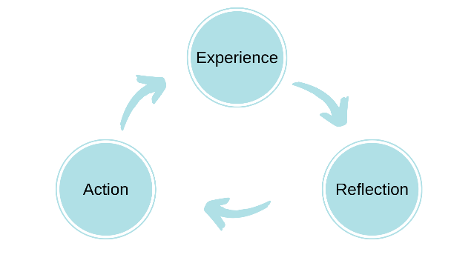
There are many different approaches to reflecting. These models of reflection are ERA cycle, Driscoll’s “WHAT” model, Kolb’s experiential learning cycle and Gibbs reflective cycle. The ERA was developed by Jasper in 2013. This cycle contains three stages and these stages are experience, reflection and action. This is one of the most simple cycles of reflection.

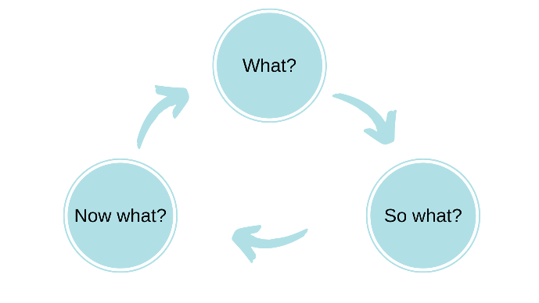
The Driscoll’s model is based on three stages which are what?, so what? and now what?. These questions were asked by Terry Borton in the 1970s. This is also another easy model of reflection.

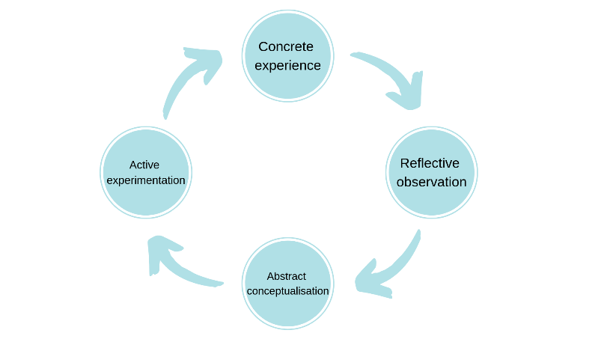
Kolb’s experiential learning cycle takes thing one step ahead of the other cycles. Kolb’s cycle mainly focusses on creating insight through actual experience. This cycle contains four stages which are concrete experience, reflective observation, abstract conceptualisation and active experimentation.

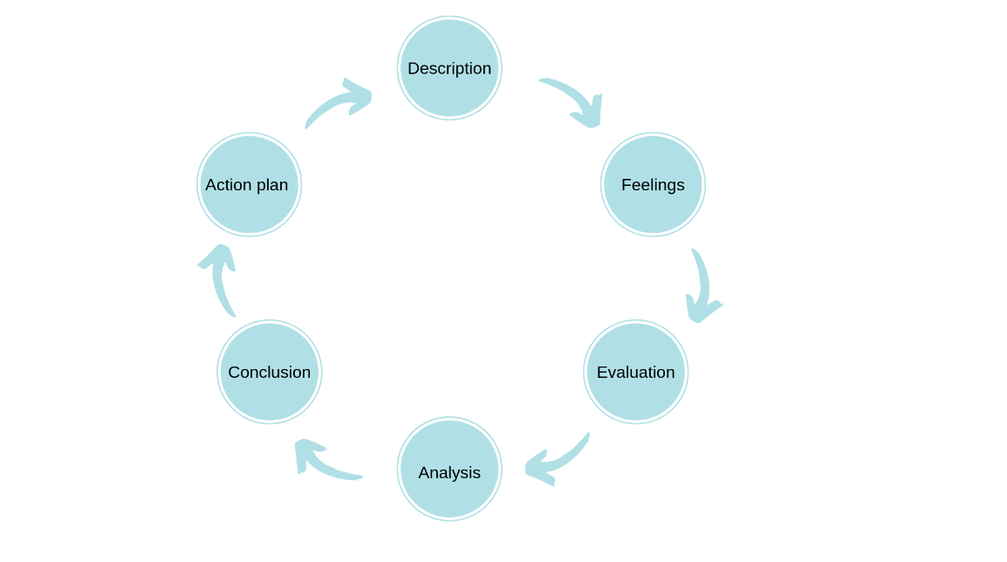
Gibb’s reflective cycle was developed by Graham Gibbs in 1988. This cycle has modified the learning cycle to acknowledge the importance of feeling and emotions in learning. This cycle builds on the other three cycles and adds more stages. This is the complex model of reflection. This cycle contains six stages. These stages are description, feeling, evaluation, analysis, conclusion and action plan.

As a professional it is very important to reflect on your work because through reflection you will learn more about yourself and this will help to improve yourself as a person and the job you are doing. When reflecting on your work you will acknowledge your strengths and weaknesses. When you find out your weaknesses you can try and find a solution on how you can better that weakness and what you need to do to improve this. “Reflecting helps you to develop your skills and review their effectiveness, rather than just carry on doing things as you have always done them. It is about questioning, in a positive way, what you do and why you do it and then deciding whether there is a better, or more efficient, way of doing it in the future.” (Self reflection | The Open University & Unison in Partnership).
I have chosen the Gibb’s reflective cycle to help me reflect on my work. This cycle was developed by Graham Gibbs in 1988. “It offers a framework for examining experiences, and given its cyclic nature lends itself particularly well to repeated experiences, allowing you to learn and plan from things that either went well or didn’t go well.” (Gibbs' Reflective Cycle | The University of Edinburgh).

During task1 I had to go through 5 stages in order for me to get my assignment done on time. These 5 stages include researching, note making, drafting, time management and final edit. When going through these stages I had to make sure that I knew what I was doing. Doing the researching was a little bit hard as I had to go through many websites and articles to find out which one I could use for my work. During this process it did make me feel a little exhausted and a little tired, as I haven’t done education in a long time. The good this was as I was researching it helped me learn how to do research again but the bad thing was it took me a bit longer than normal to find the right information. From this situation I realised that researching is very important, if you want to learn about things you don’t know, you will not find the information from one website, in order for you to get the correct information you will need to see many websites to get the right information. Another thing that I could have done was read some books, but I didn’t I got all my information from online. Next time when I will have to do an assignment, I will make sure I read books as well as get information from online.
I didn’t do any note making or drafting. These are targets that I have recognised, that I need to do in future assignment and in work. I have realised that if I made notes while researching I wouldn’t have had to go back to the same research many times. Drafting is very important, as I didn’t draft out any work and I went and did the assignment straight away, I hesitated a lot and at some points I thought I may not be able to the assignment. When drafting you can change you work. When you read and you think a sentence or a paragraph didn’t make sense, then you can change it or reword again without worrying that you may loose some of your work because this is a draft copy.
Time management was well maintained by myself. I gave myself 2 hours everyday to do my work. Some days I gave a little less time and some days a bit more time. When I did the work needed, it made me feel happy and confident that I have done some of my work. The time management was a good experience for me and it made me realise that with any sort of work you need to manage the time, it is very important. “Effective time management is the process of utilizing your time to plan your days so that you can do your work with less effort, and make the most out of your time. By controlling it, you can achieve greater and better outcomes in less time, with no stress.”( Importance of Time Management in the Workplace (timetracko.com).
When I finished typing up my assignment. I was so overjoyed that I had finished my work. Once completed I read through the whole assignment once again and made sure that everything that I had written made sense and that I was able meet the requirement that have been given by the lecturer.
During the second task, there was 3 of us in a group and we had to make a job advert. We made a decision to do a job ad on a bank manager role because I thought it was easy to find out the information because the other 2 member in my group had less knowledge on how to find out information online. I created the whole ad on Microsoft word because my group member were not good at using all the features on Microsoft word, so they asked me to make the job ad, while they saw me doing the ad. I gave my team members a list of job roles, that we could choose from and they picked a job role from the list. I was the group leader. Before finding out the information about the job role and requirements, we spoke and I told them who would find out which information. When speaking in a group, I made sure that I was asking questions to all group members and after the discussion I asked each one of them if they understood what they have to do. I reminded them 2 or 3 times if they had done the work they were supposed to do and if they had not done the work, I made them sit down and do the work in front of me straight away. I looked at other job adverts online and I chose the idea of how to do an advert from an image I found on google image. I started of with the advertising of what job role we were hiring for and I spoke about the responsibility of a bank manager and also what qualifications you need to become a bank manager. I went online to a bank website and got information about what responsibilities a bank manager has and what qualifications they need to become a manager. I felt confident and I made sure that when I was speaking that my voice was clear and loud so all my peers can hear me.
The feedback I got from my peers on the job advert was that they felt the slide was beautiful and the speaking was good. The skills which requires development they have said was better presentation, less writing, speaking should be more professional. I feel that what they have said about speaking should be more professional was not aimed at me, but another one of my team members. On the feedback form there was four skills listed on there, which are organisation of the job advert, working as a team, public speaking and professionalism. The score we got for organisation was 4 people gave 4 points, 1 person gave 3 point and 2 people gave 1 point. The score we got for working as a team was 1 person gave 5 points and 3 people gave 4 points. The score we got for public speaking was 3 people gave 4 points and 1 person gave 3 points. The score we got for professionalism was 3 people gave 4 points, 1 person gave 3 points and 2 people gave 1 point.
The two targets that I have realised from the feedback that I got was I should have used less writing as this was a job advert and in a job advert you need to be more precise in less words as people sometimes don’t have much time to read the whole advert, they look for the important information. The other target is that the job advert was too simple, I should have made it look more interesting and maybe should have given the ad a bit more colour, so it would have made the ad look more appealing.
Personal Target | How will I achieve this? | How will this improve my academic or employability prospects? | How will I know that I have achieved this? | When will I achieve this by?
1.  Note making | Next assignment I will make sure that I write notes while in reading the information. | By making notes this will improve my employability prospects as in all jobs, you will need to do note taking. | When I do my next assignment, I will see the notes that I have taken and work from these notes. | I will achieve this by my next assignment.
2.  Drafting | I will draft out my next assignment. | This will help my academic prospects as this will help me develop a skill, that I will need in future jobs. | I will show my lecturer my draft that I have done for the assignment and I will get feedback from them to see if it is right. | I will achieve this after my next modules.
3.  Using less writing when not needed | I will make sure I use less words when needed. | This will help my academic prospect as this is a important skill to have to use less words, when not needed. | When doing another presentation or work, I will go make sure I use important information. | I will achieve this in my next modules.
4.  Simplicity | Make work look more interesting and appealing. | This will help me improve both prospects as it’s an essential skill you need when working to make sure all work looks attractive. | I will know I have achieved this when I go on to do more assignment and presentations in class and we get feedback from peers. | By the end of my academic year.
Personal Development Plan

Conclusion
During this module I have learned about the different ways to present work and I have learned about the different academic and employability skills needed for jobs. I have learned about Harvard referencing, which will help me in future work. I have learned about the different models of reflection and how to use these models when reflecting. In the future I wish to develop more writing skills and I wish to develop a skill within technology as in most jobs now a days, everyone needs to know the computer.

REFERENCE
Gibbs' Reflective Cycle | The University of Edinburgh
Importance of Time Management in the Workplace (timetracko.com)
Models of reflection - Reflective Practice Toolkit - LibGuides at University of Cambridge Subject Libraries
Self reflection | The Open University & Unison in Partnership
What Is Reflective Writing? (yourdictionary.com)

