Smart Home Device Manager System for Bright Minds Academy

University of Wales Trinity Saint David
August13,2026
Module Name: Scripting and Programming Concepts
Module Code: ACCA 5036

Student Name: Robel Gebregziabher
Student ID:2427640

Lecturer’s Name: Koushik Modak

Code Link: https://github.com/Robel16-tech/Smart-Technology-Assesement-1-project.git

Table of Contents

Main Body 2
1. Analysis 3
2. Software Design and Development 3
Design: 8
Implementation Decisions 8
Source Code 22
3. Testing and Debugging Report 33
4. Evaluation 37
Conclusion 38
References 42
Appendices 43

Introduction
The rapid development of smart technologies has transformed how organizations manage facilities and resources. Smart lights, projectors, thermostats, sensors, and other connected devices are increasingly used in educational environments. As the number of devices grows, manual record-keeping can become inefficient and lead to inaccurate or outdated information. [5], [6]
.
Bright Minds Academy is a small private tutoring center that uses smart classroom devices in different rooms. Staff currently record device information manually, making it difficult to identify where a device is located, determine whether it is operational, or establish whether maintenance is required. The proposed system addresses this problem by replacing manual records with a simple computer-based management application. [2], [5]
This project aims to design and develop a Smart Home Device Management System using the Python programming language. The proposed system consists of a console-based application that enables staff to add new devices, update operational status, display all registered devices, and search for specific devices by name. Instead of employing a database management system, the application utilises Python dictionaries and lists, thereby emphasising the application of fundamental programming concepts such as data structures, functions, validation, conditional statements, and iteration.
The project follows the Software Development Life Cycle (SDLC), beginning with business requirements analysis and progressing through design, implementation, testing, evaluation, and documentation. The analysis phase uses abstraction and problem decomposition to define essential requirements. Design includes creating flowcharts and pseudocode to outline application logic. Implementation translates these designs into Python code with user-defined functions. The system is then tested with both standard and edge cases to ensure all validation rules and functional requirements are met.
The project demonstrates several software engineering principles, including modular programming, structured design, input validation, error handling, and code documentation. These principles contribute to the development of software that is reliable, maintainable, readable, and accessible to non-technical users. Although the application is intentionally designed as a simple prototype without database integration or real-time IoT communication, its modular architecture establishes a robust foundation for future enhancements such as persistent data storage, graphical user interfaces (GUIs), cloud connectivity, automated device monitoring, and user authentication.
In summary, this project illustrates the application of Python in developing a practical device management system that addresses a genuine business need. The proposed solution enhances the efficiency of recording and monitoring smart classroom devices while minimising the risk of human error. Additionally, the project facilitates the application of software engineering methodologies, programming techniques, and problem-solving skills within a realistic business context, resulting in a maintainable and scalable software solution appropriate for the operational requirements of Bright Minds Academy. The project develops a Python-based Smart Home Device Management System. The application allows staff to add devices, update device status, view all registered devices and search for a device by name. The project also demonstrates software development practices including requirements analysis, problem decomposition, modular programming, input validation, testing and evaluation. [1], [5], [7]

1. Analysis
Requirements analysis is an important stage of software development because it identifies the problem, users, required functionality and quality expectations before implementation begins. For Bright Minds Academy, the main problem is the difficulty of maintaining accurate information about smart classroom devices using manual records. The proposed solution therefore needs to provide a simple and reliable method for recording device names, locations and operational statuses. [2], [5]
The problem can be decomposed into several manageable modules. The first module adds a new device and records its room location. The second updates the status of an existing device. The third displays all registered devices, while the fourth searches for a particular device. A menu module provides access to these functions. Problem decomposition makes the system easier to design, implement and test because each part has a clear responsibility. [2], [5]
The first functional requirement is adding new devices. Staff must be able to enter a device name and room location, such as Smart Light A1 in Room 101 or Projector B2 in the Conference Room. Duplicate device names must be rejected so that each device can be identified uniquely. [2]
The second functional requirement is updating device status. Staff must be able to change an existing device to Online, Offline or Under Maintenance. The program validates the selected status before saving the change. The third requirement is viewing the complete device list, including device name, room and current status. [1], [2]
The fourth requirement is simple searching. Staff can enter a device name and receive its location and current status. If the device does not exist, the system provides an informative message rather than producing confusing output. A fifth requirement is a user-friendly numbered menu so that staff without advanced technical knowledge can operate the application. Input validation also prevents empty names, empty rooms, duplicate devices, invalid menu choices and invalid status values. [2], [5]
The non-functional requirements describe the quality expected from the system. Reliability requires accurate and consistent device information, while performance requires searching, displaying and updating information to respond quickly. Usability and accessibility require clear instructions and understandable messages. Maintainability is supported through meaningful variable names, comments and separate functions. Scalability is addressed by keeping the design modular so that databases, graphical interfaces or cloud services could be added later. Security is addressed within the scope of the prototype by protecting data integrity through validation. [5], [6], [8]
Overall, the analysis establishes a clear specification for the application. The system is intentionally simple because its purpose is to demonstrate a practical management solution while applying fundamental programming and software engineering concepts. The requirements identified here provide the basis for the subsequent design, implementation and testing stages. [2], [5]

1.2 Problem Decomposition
Problem decomposition is the process of breaking a large problem into smaller and more manageable tasks. Rather than attempting to build the entire system at once, the project is divided into individual components that can be designed, implemented, and tested independently.
The Smart Home Device Management System can be decomposed into the following modules:
Module 1 – Add New Device
This module allows staff members to register new smart devices by entering the device name and its physical location. Every new device is automatically assigned a default status of Offline until updated.
Module 2 – Update Device Status
This module enables users to change the status of an existing device. The available status values are:
• Online
• Offline
• Under MaintenanceInput validation ensures that only these predefined values are accepted.
Module 3 – View All Devices
This module displays all stored devices together with their room locations and current operational status. If no devices have been added, an appropriate message informs the user.
Module 4 – Search Device
Users can search for a device by entering its name. If the device exists, the system displays its location and status. If the device cannot be found, the user receives a suitable error message.
Module 5 – Exit Program
This module allows users to close the application safely after completing their tasks.
Breaking the system into these modules improves software organisation, simplifies debugging, and makes future maintenance significantly easier.

1.3 Abstraction
Abstraction is a computational thinking technique that focuses only on information relevant to solving the problem while ignoring unnecessary details.
In this project, only the information required to manage smart classroom devices is stored. Each device contains three important pieces of information:
• Device Name
• Room Location
• Current Status
The system deliberately ignores information that is outside the project scope, such as:
• IP addresses
• MAC addresses
• Network protocols
• Device manufacturers
• Battery levels
• Power consumption
• Real-time sensor readings
• User accounts
• Remote device control
Ignoring unnecessary complexity allows the application to remain simple, efficient, and suitable for the requirements of Bright Minds Academy.

1.4 Functional Requirements
Functional requirements describe what the software must do.
The Smart Home Device Management System includes the following functions.
FR1 – Add New Devices
The system shall allow staff members to add new smart devices by entering:
• Device Name
• Room Location
Sample include:
• Smart Light A1 – Room 101
• Projector B2 – Conference Room
• Device C3 – Lab 2
• Smart Light Parking A2 – Parking Basement 01
• Thermostat – Lab 01
The system should prevent duplicate device names from being added.
FR2 – Update Device Status
Users shall be able to modify the status of an existing device using one of the following options:
• Online
• Offline
• Under Maintenance
The program validates user input before saving any changes.
FR3 – View Device List
Users shall be able to display a complete list of registered devices showing:
• Device Name
• Room
• Current Status
The information should be displayed in an organised and readable format.
FR4 – Search for Devices
Users shall be able to search using a device name.
If the device exists, the system displays:
• Device Name
• Room
• Status
If no matching device exists, an informative message is displayed.
FR5 – User-Friendly Menu
The application shall provide a menu-driven interface allowing users to select functions easily using numbered options.
FR6 – Input Validation
The software shall validate all user inputs by ensuring:
• Device names cannot be empty.
• Room names cannot be empty.
• Duplicate device names are rejected.
• Invalid menu options are rejected.
• Invalid status values cannot be entered.

1.5 Non-Functional Requirements
Non-functional requirements describe the quality attributes of the system rather than its individual functions.
Reliability
The application must consistently store accurate information and prevent invalid data from being entered.
Performance
Searching, displaying, and updating device information should occur almost instantly because all information is stored in memory using Python data structures.
Usability
The menu interface should be straightforward enough for staff members with limited technical knowledge.
Maintainability
The source code should be modular and divided into reusable user-defined functions. Clear comments and meaningful variable names improve readability and simplify future maintenance.
Scalability
Although the current version stores information in memory, the design should allow future integration with databases, graphical user interfaces, or cloud services without major redesign.
Security
Although user authentication is outside the scope of this project, the application should protect data integrity by validating user input and preventing accidental corruption of stored information.
Accessibility
The console interface should provide clear instructions and informative messages so that users can operate the system with minimal training.
1.6 Summary of Analysis
The analysis phase identified the operational problems experienced by Bright Minds Academy and translated them into clear software requirements. Applying abstraction allowed unnecessary technical details to be removed, while problem decomposition divided the overall problem into manageable modules. Both the functional and non-functional requirements establish a clear specification that guides the design and implementation stages of the project. By completing a detailed analysis before development begins, the likelihood of producing reliable, maintainable, and user-friendly software is significantly increased.

2. Software Design and Development
2.1 System Design
The design phase converts the requirements identified during the analysis stage into a structured solution that can be implemented in Python. A well-designed system reduces programming errors, improves maintainability, and ensures that the software satisfies the business requirements. Before writing any code, the application’s logic is represented using flowcharts and pseudocode. This approach allows the developer to identify potential problems early and provides a clear blueprint for implementation.
The Smart Home Device Management System follows a modular design. Each major function of the system is implemented as an individual user-defined function, making the program easier to understand, test, debug, and maintain. The program uses a menu-driven interface that repeatedly displays available options until the user chooses to exit.
The design phase translates the requirements into a structured solution before code is written. The application uses a modular, menu-driven design. Each major operation is represented by a separate function, allowing individual components to be understood, tested and debugged independently. Flowcharts and pseudocode are used to represent the logic before implementation. [2], [5]
The main program begins by creating an empty dictionary, displays the main menu and waits for a user selection. The selected operation is executed and the menu is displayed again until the user chooses the exit option. This repeated structure is implemented using a loop and conditional selection. [1], [7]

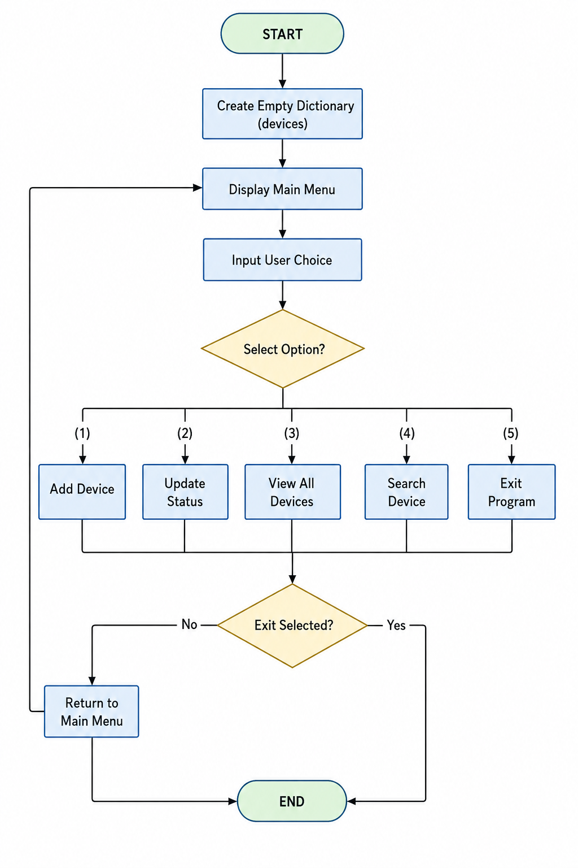

2.2 Flowchart
The overall program flow is shown in the system flowchart.
Main Program Flow
Start
│
▼
Create Empty Dictionary
│
▼
Display Main Menu
│
▼
┌─────────────────────┐
│User selects option? │
└─────────────────────┘
│ │ │
│ │ │
▼ ▼ ▼
Add Update Search
│
▼
View List
│
▼
Exit?
Yes / No
│
No ──┘
│
Yes
▼
End

https://lucid.app/lucidchart/44afa685-d4e1-4f31-a99d-99fa12fe9ba9/edit?viewport_loc=-1831%2C-163%2C4955%2C2440%2C0_0&invitationId=inv_12095b83-5a82-4031-98ab-30d705f8c4e8
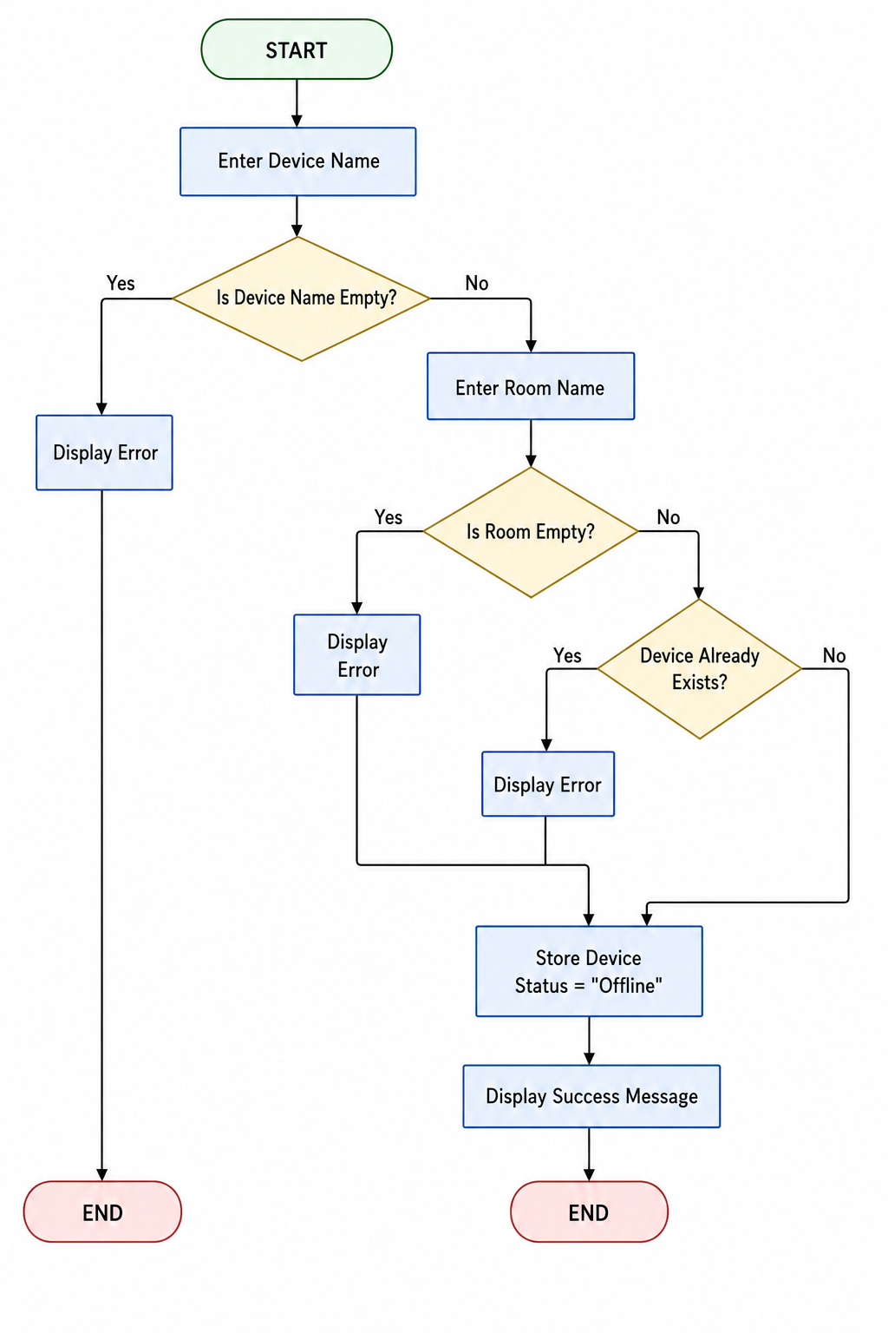

The following individual flowcharts should also be included in the report.
Flowchart 1 – Add Device
Start
│
Input Device Name
│
Is Name Empty?
│
Yes ─► Show Error
│
No
│
Input Room
│
Room Empty?
│
Yes ─► Show Error
│
No
│
Device Already Exists?
│
Yes ─► Show Error
│
No
│
Store Device
(Status = Offline)
│
Display Success Message
│
End
Flowchart 2 – Update Device Status
Start
│
Enter Device Name
│
Device Found?
│
No ─► Display Error
│
Yes
│
Choose Status
│
Status Valid?
│
No ─► Show Error
│
Yes
│
Update Status
│
Display Confirmation
│
End
Flowchart 3 – Search Device
Start
│
Enter Device Name
│
Device Found?
│
│
Yes No
│ │
▼ ▼
Show Display
Details Not Found
│ │
└──────┬───┘
▼
End

2.3 Pseudocode
The following pseudocode represents the core program logic and provides a blueprint for implementation. [2], [5]

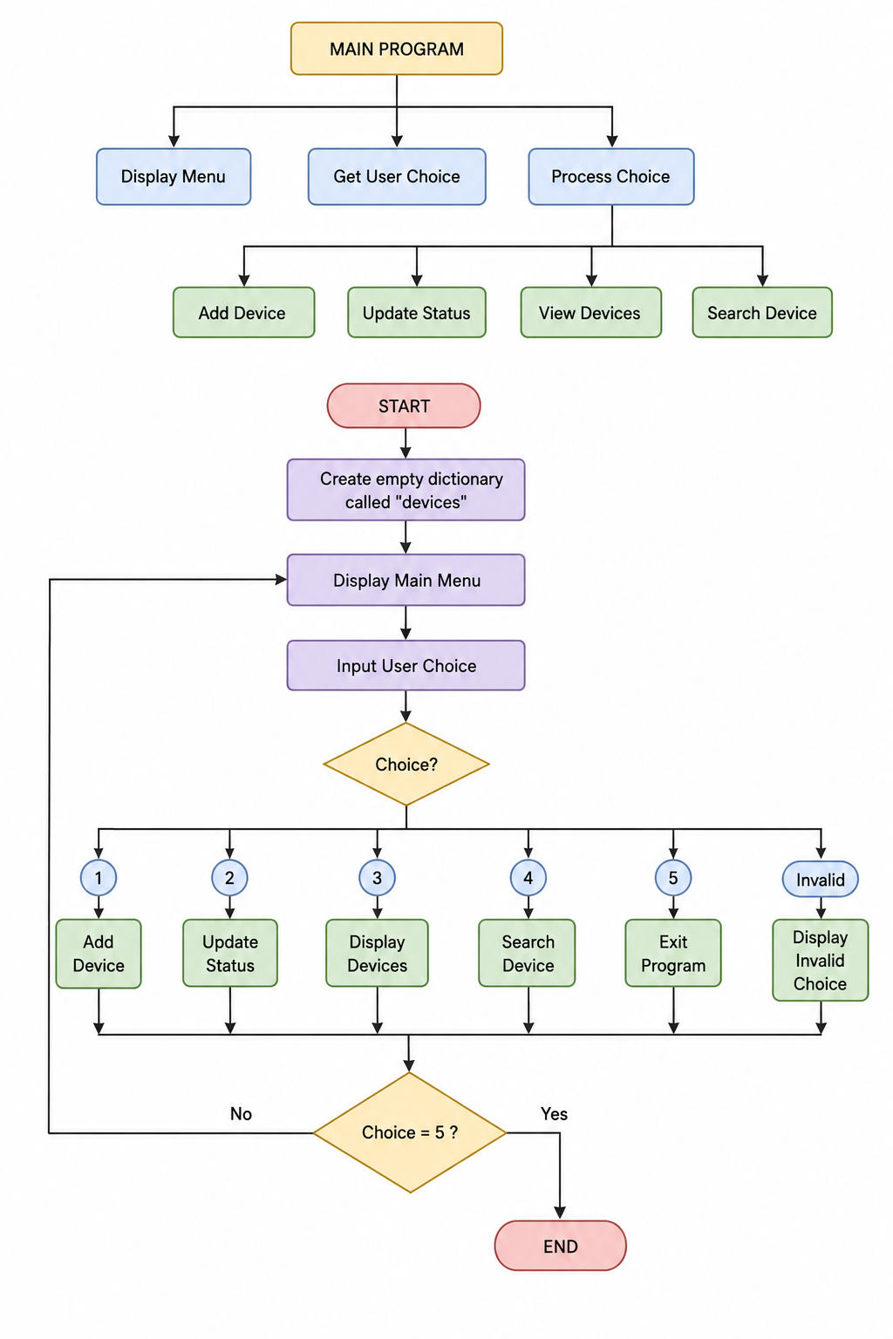
BEGIN
Create empty dictionary called devices
REPEAT
Display Menu
Input user choice
IF choice = 1 THEN
Add Device
ELSE IF choice = 2 THEN
Update Device Status
ELSE IF choice = 3 THEN
Display All Devices
ELSE IF choice = 4 THEN
Search Device
ELSE IF choice = 5 THEN
Exit Program
ELSE
Display Invalid Choice
UNTIL choice = 5
END
Add Device
FUNCTION Add Device
Input Device Name
IF Device Name is Empty
Display Error
RETURN
Input Room
IF Room is Empty
Display Error
RETURN
IF Device Already Exists
Display Error
ELSE
Store Device
Status = Offline

Display Success Message
END FUNCTION

┌──────────────┐
│ Add Device │
└──────┬───────┘
│
▼
Input Device Name
│
▼
Device Name Empty?
│ │
Yes No
│ │
▼ ▼
Display Error Input Room
RETURN │
▼
Room Empty?
│ │
Yes No
│ │
▼ ▼
Display Error Device Exists?
RETURN
│ │
Yes No
│ │
▼ ▼
Display Error Store Device
Status = Offline
Display Success
│
▼
END

Update Device Status
FUNCTION Update Status
Input Device Name
IF Device Exists
Display Status Options
Input New Status
IF Status Valid
Update Status
Display Success
ELSE
Display Error
ELSE
Display Device Not Found
END FUNCTION

┌──────────────────────┐
│ Update Device Status │
└─────────┬────────────┘
│
▼
Input Device Name
│
▼
Device Exists?
│ │
No Yes
│ │
▼ ▼
Display Device Display Status
Not Found Options
│
▼
Input New Status
│
▼
Status Valid?
│ │
No Yes
│ │
▼ ▼
Display Error Update Status
Display Success
│
▼
END
View Devices
FUNCTION View Devices
IF Dictionary Empty
Display No Devices
ELSE
FOR each Device
Display Name
Display Room
Display Status
NEXT
END FUNCTION
┌────────────────┐
│ View Devices │
└──────┬─────────┘
│
▼
Dictionary Empty?
│ │
Yes No
│ │
▼ ▼
Display No For Each Device
Devices │
▼
Display Name
Display Room
Display Status
│
▼
More Devices?
│ │
Yes No
│ │
└──────────┘
│
▼
END

Search Device
┌─────────────────┐
│ Search Device │
└──────┬──────────┘
│
▼
Input Device Name
│
▼
Device Exists?
│ │
No Yes
│ │
▼ ▼
Display Device Display Device
Not Found Details
│ │
└──────┬─────┘
▼
END

FUNCTION Search Device
Input Device Name
IF Device Exists
Display Device Details
ELSE
Display Device Not Found
END FUNCTION

2.4 Implementation Decisions
Data Structures
The most appropriate data structure for this project is a Python dictionary. A dictionary stores information using key-value pairs, allowing data to be accessed quickly through a unique key.
Each device name acts as the dictionary key, while the associated value stores the room location and operational status.
A Python dictionary was selected as the principal data structure. Each device name is used as a unique key and the associated value stores the room and status. This design provides direct access through the device name and makes searching and updating straightforward. It also prevents duplicate keys and can be extended with additional properties in future versions. [1], [3], [7]

devices = {
“Smart Light A1”: {
“room”: “Room 101”,
“status”: “Online”
},
“Projector B2”: {
“room”: “Conference Room”,
“status”: “Offline”
}
}
The dictionary was selected because it provides several advantages:
• Fast searching using device names.
• Prevents duplicate keys.
• Easy to update device information.
• Simple to extend with additional properties later.
Compared with a list, a dictionary performs searches more efficiently because it accesses data directly through the key rather than checking every item individually.
Variables Used
The main variables are devices, device_name, room, status, choice and valid_status. The devices dictionary stores registered devices; device_name stores the entered device name; room stores the location; status stores the operational state; choice stores the menu selection; and valid_status stores the acceptable status values. Descriptive variable names improve readability and maintainability. [7], [8]
The following variables are used throughout the program.
Variable Data Type Description
devices Dictionary Stores every registered smart device
device_name String Stores the device entered by the user
room String Stores the room location
status String Stores the device status
choice Integer Stores the user’s menu selection
valid_status List Stores the three acceptable status values
Each variable uses a descriptive name that improves code readability and maintainability.
Programming Constructs
Selection statements are used to make decisions, such as checking whether a device exists and validating menu choices. Iteration is used to repeatedly display the menu and to display multiple devices. User-defined functions separate the major tasks into add_device(), update_status(), view_devices(), search_device() and display_menu(). This modular approach reduces duplication and makes the program easier to maintain. [1], [7], [8]
Input validation is used to prevent incorrect information from being stored. Empty device names and rooms are rejected, duplicate device names are prevented, invalid menu selections are rejected and only the three permitted status values can be stored. Meaningful error messages are provided when invalid input is detected. [5], [6]
The solution uses several programming constructs available in Python.
Selection
Selection statements allow the program to make decisions.
device_name in devices:
print(“Device Found”)
else:
print(“Device Not Found”)
Selection is used for:
• Searching
• Validation
• Menu selection
• Updating status
Iteration
Iteration is used whenever the program must repeat a task.
:
for device in devices:
print(device)
Loops are also used to repeatedly display the main menu until the user exits.
Functions
The program follows a modular structure by separating each task into user-defined functions.
include:
• add_ device ()
• update_ status ()
• view_ devices ()
• search_ device ()
• display_ menu ()
Using functions reduces code duplication and improves readability.
Input Validation
Validation ensures only appropriate information is stored.
Examples include:
• Empty device names are rejected.
• Empty room names are rejected.
• Duplicate device names are prevented.
• Invalid menu choices are rejected.
• Invalid status values cannot be entered.
Validation improves software reliability by preventing incorrect data from entering the system.
Error Handling
Rather than allowing the program to crash, informative error messages are displayed whenever invalid input is entered.
For example:
• Device not found
• Invalid status
• Invalid menu option
• Duplicate device
Providing meaningful feedback improves usability and reduces user errors.
2.5 Python Modules and Libraries
The project deliberately uses Python's built-in functionality because the requirements are relatively simple. No external libraries are required. The implementation primarily uses dictionaries, lists, input(), print(), string methods, conditional statements, loops and user-defined functions. Avoiding unnecessary external dependencies keeps the application lightweight and portable. [1], [7], [9]
This project deliberately uses only Python’s built-in functionality because the system requirements are relatively simple.
No external libraries are required.
The project primarily relies on:
• Built-in dictionary data structure
• Built-in list data structure
• Input/output functions (input() and print())
• String methods such as .strip() and .title()
• Conditional statements
• Loops
• User-defined functions
Avoiding unnecessary external libraries keeps the application lightweight, portable, and easy to execute on any computer with Python installed.
2.6 Source Code and Implementation
The Smart Home Device Management System was implemented using Python 3. Python was selected because it is a high-level programming language that offers simple syntax, excellent readability, and a wide range of built-in data structures. These characteristics make Python particularly suitable for developing small management systems and for demonstrating core programming concepts such as functions, dictionaries, loops, conditional statements, and input validation.
The application follows a modular programming approach, where each major task is implemented as a separate user-defined function. This makes the program easier to understand, debug, test, and maintain. The system is menu-driven, allowing users to repeatedly perform operations until they choose to exit the application.
The system was implemented using Python 3. Python was selected because its syntax is readable and it provides built-in data structures that are suitable for demonstrating core programming concepts. The application is organised into separate functions so that each operation can be tested and maintained independently. [1], [7]
The code should follow recognised coding practices, including meaningful variable names, consistent indentation, comments, modular functions and input validation. These practices improve readability and maintainability and make future debugging easier. [8]

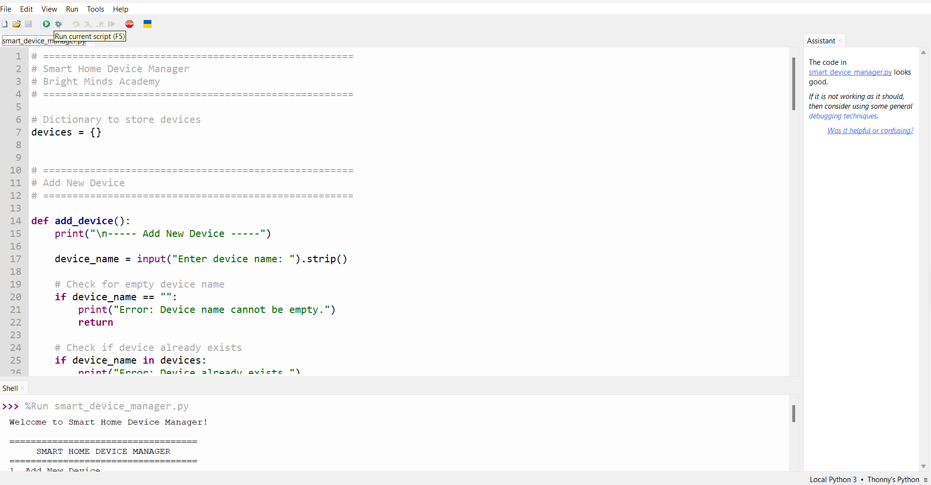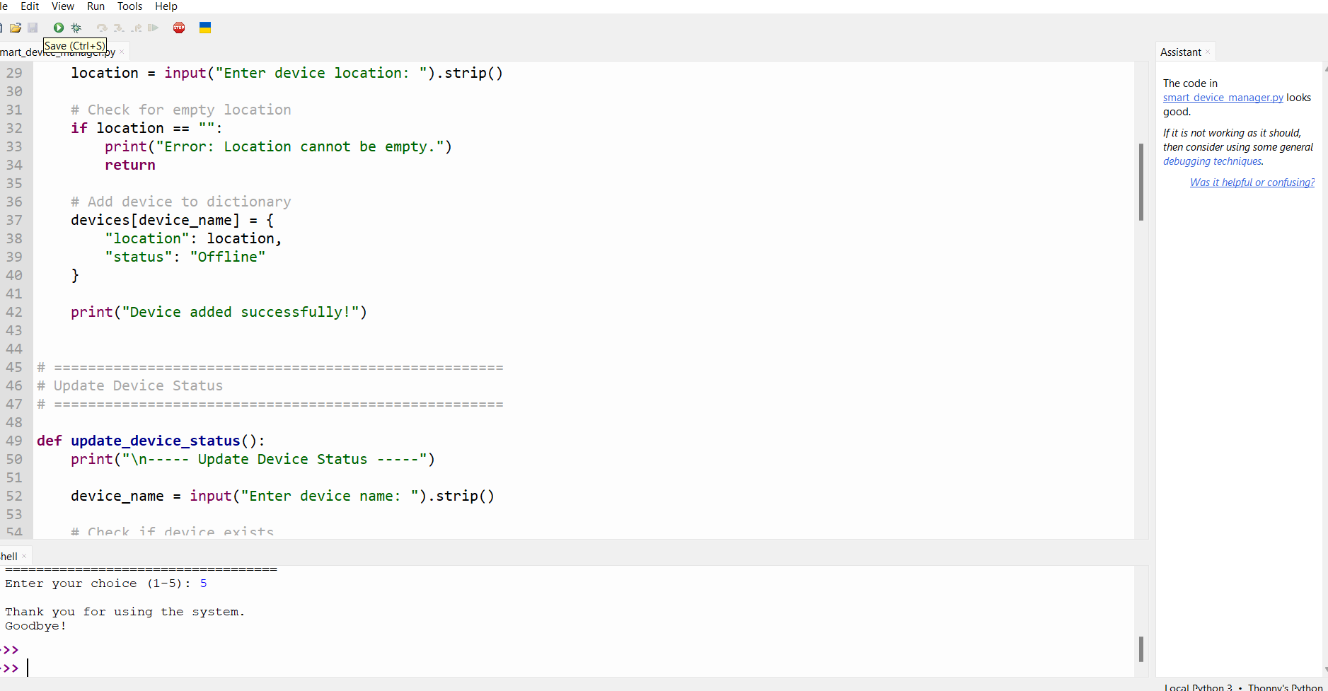

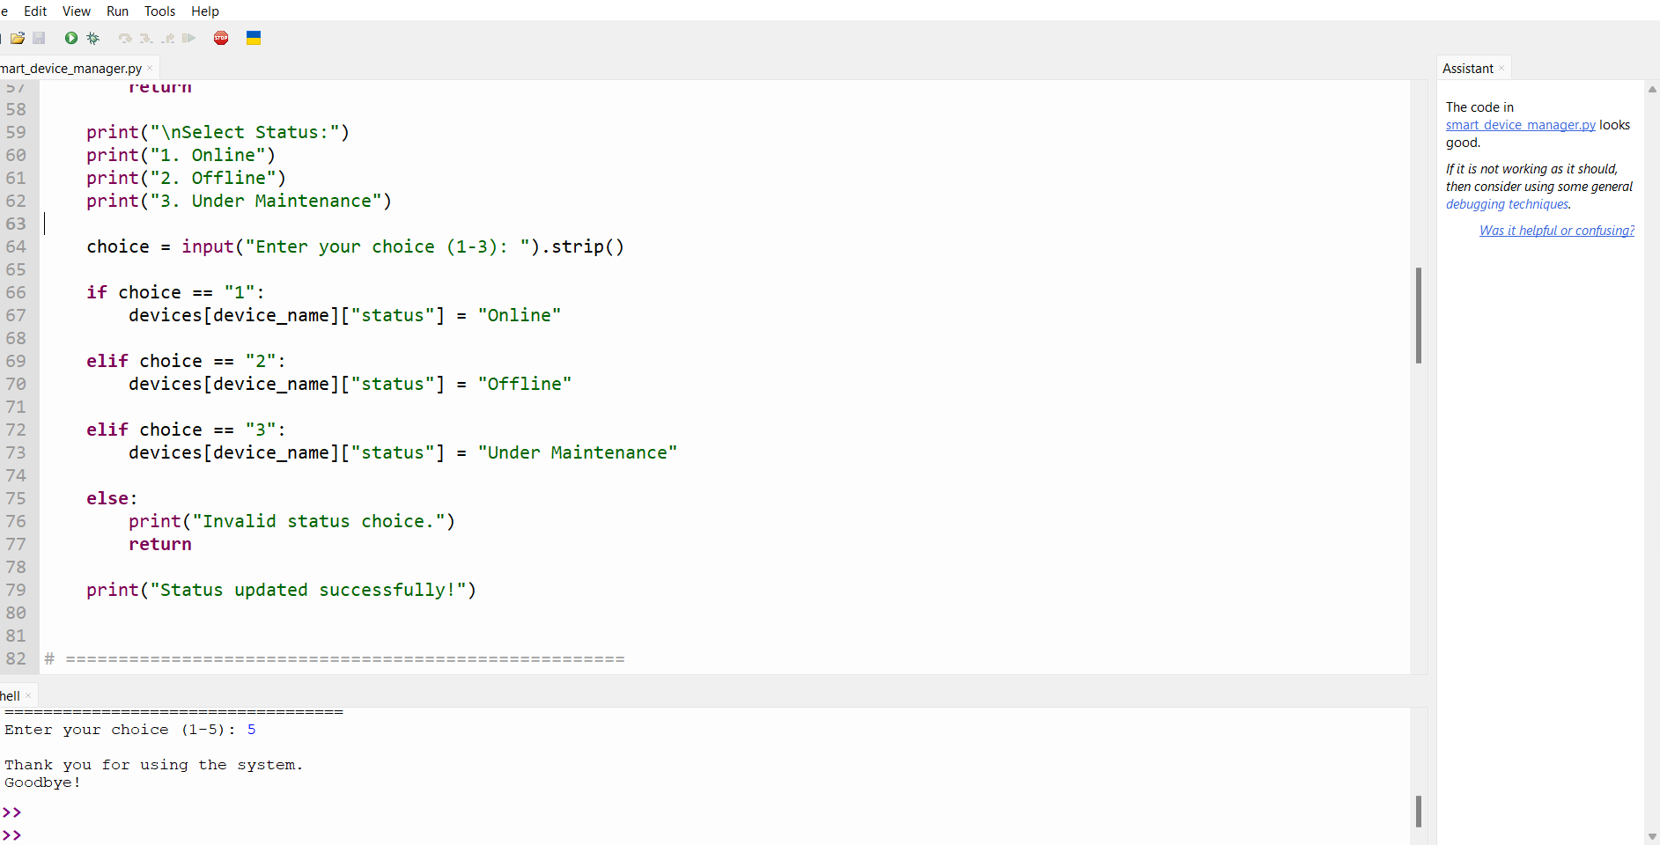

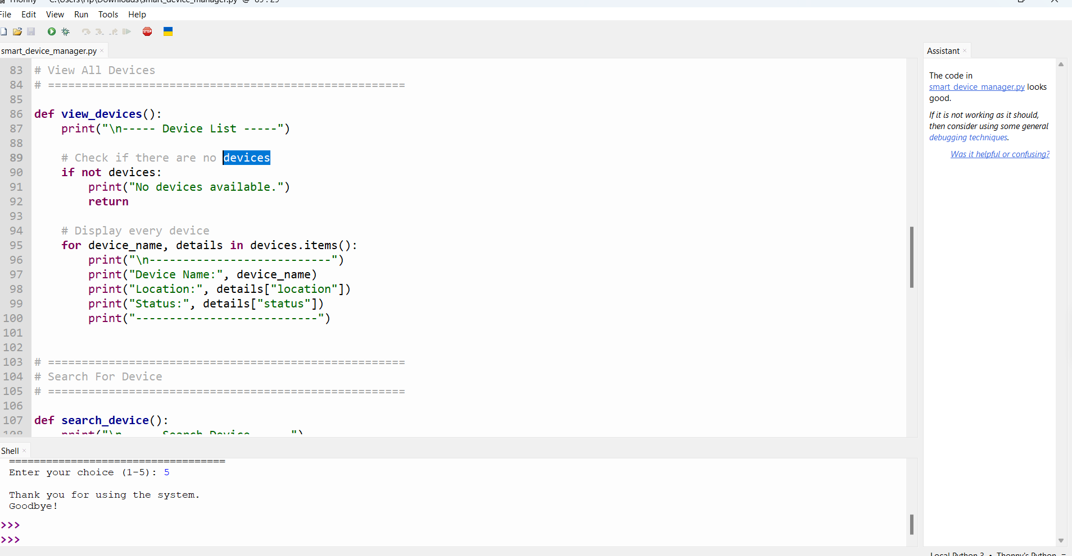

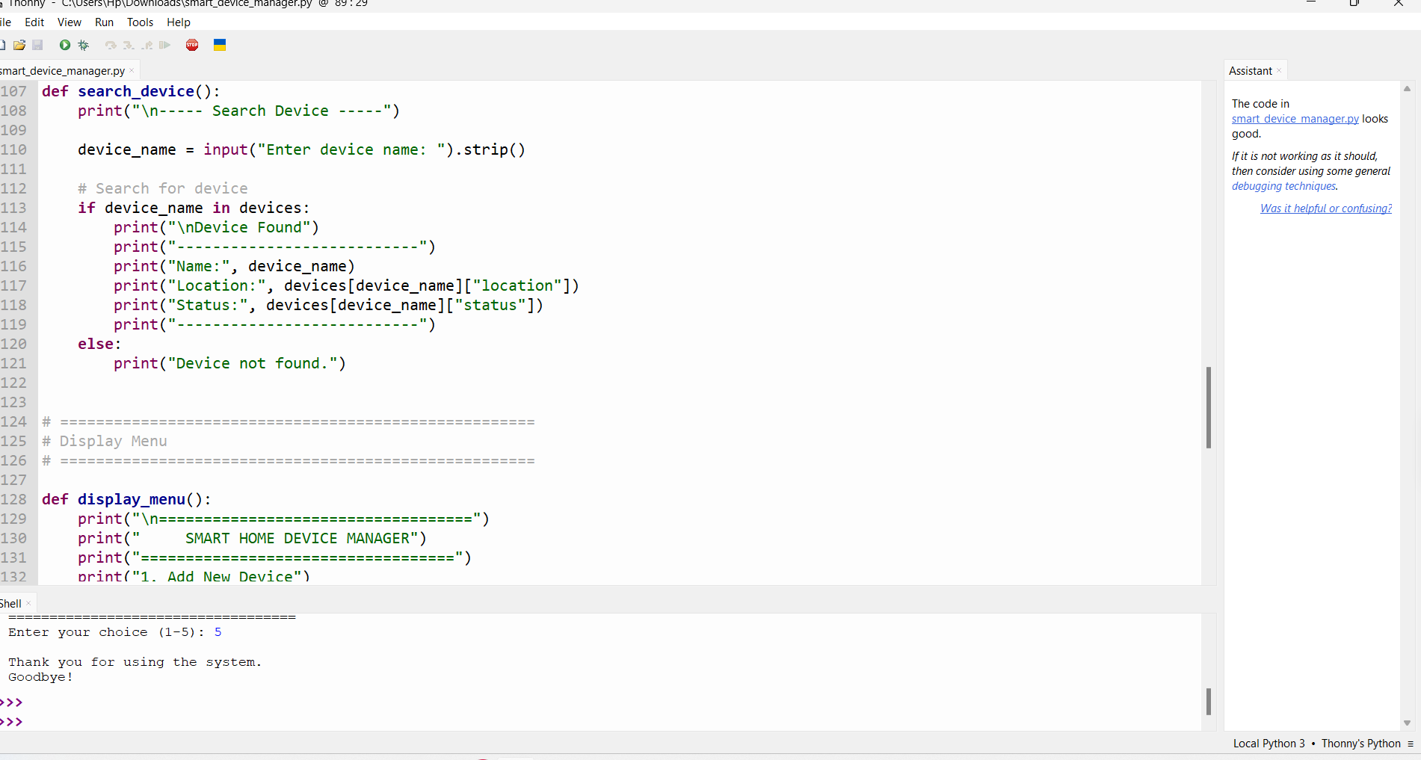

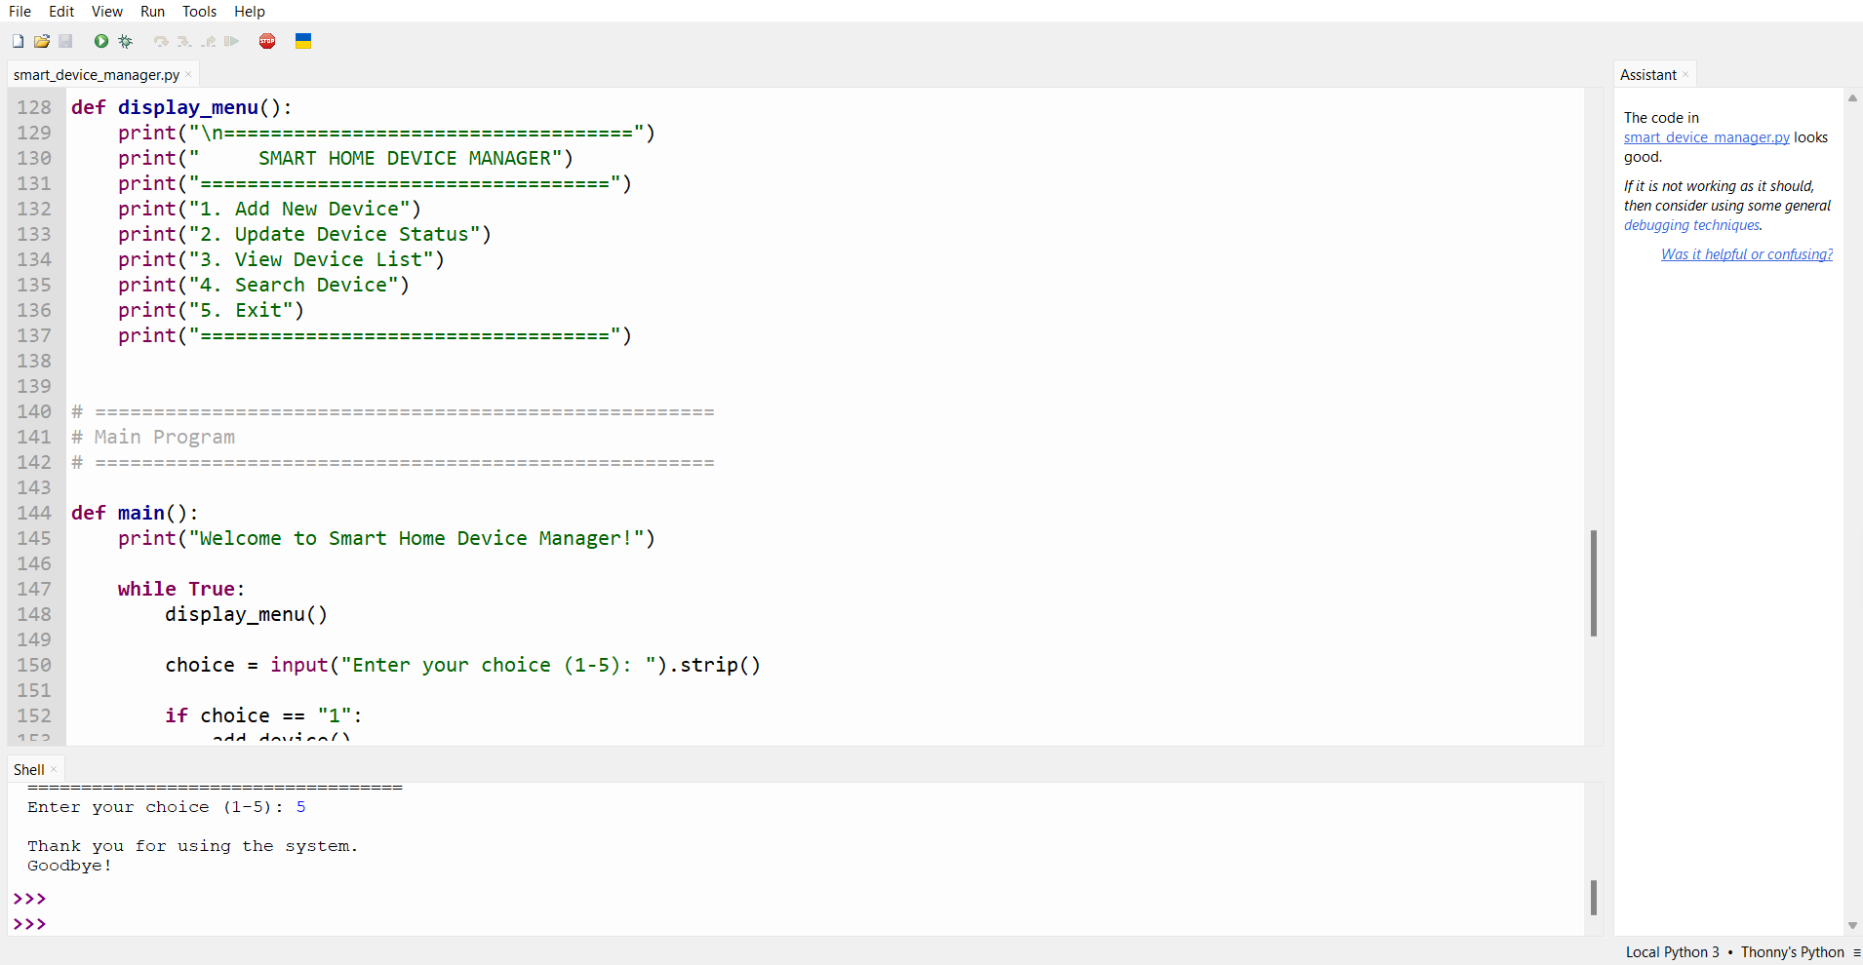

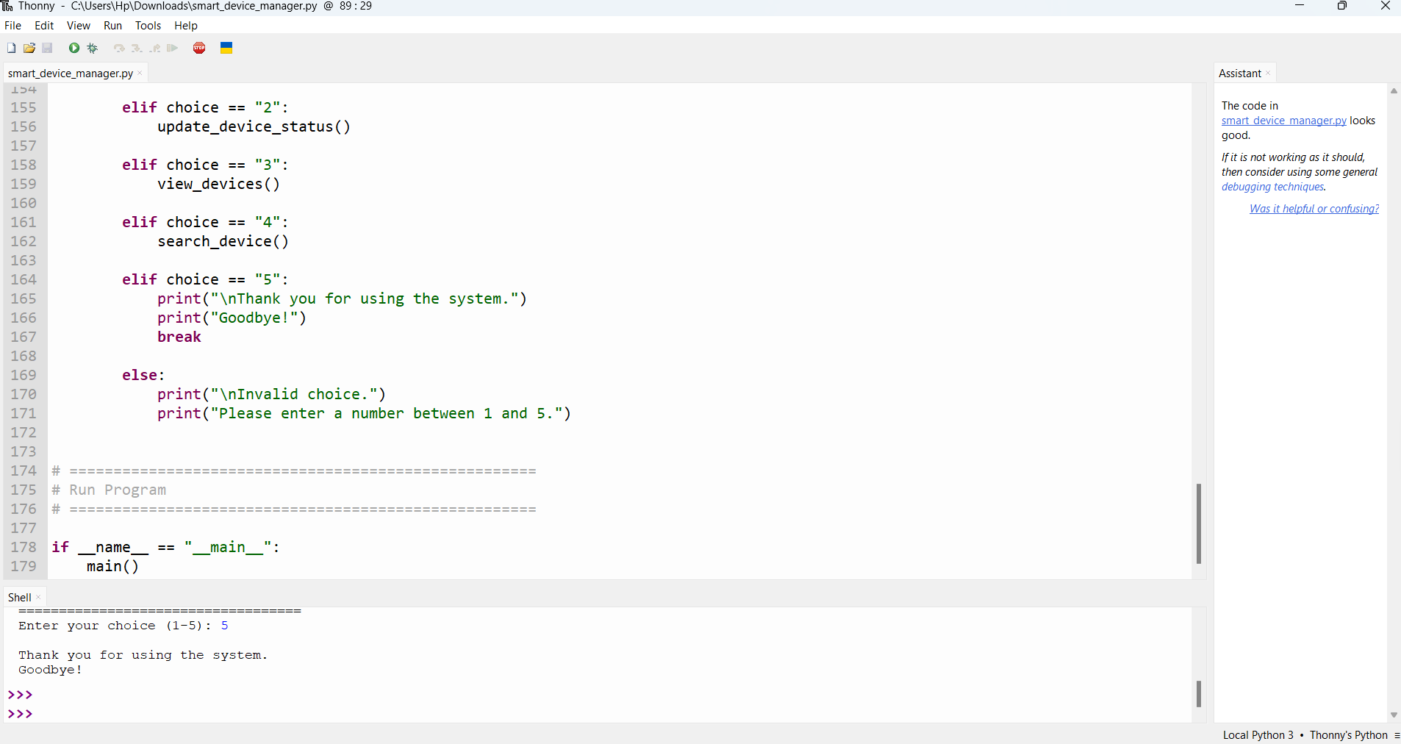

2.6.1 GitHub Repository(https://github.com/Robel16-tech/Smart-Technology-Assesement-1-project.git)
The completed project should be uploaded to a GitHub repository to provide version control, backup, and easy sharing of the source code.
Example Repository Link
https://github.com//SmartHomeDeviceManager
Suggested Repository Structure
GitHub Repository: [https://github.com/Robel16-tech/Smart-Technology-Assesement-1-project.git].[10]
Smart Home Device Manager/
│
├── main.py
├── README.md
├── LICENSE
├── screenshots/
│ ├── menu.png
│ ├── add_device.png
│ ├── search_device.png
│ ├── update_status.png
│ └── testing.png
├── flowcharts/
│ ├── main_flowchart.png
│ ├── add_device.png
│ ├── update_status.png
│ └── search_device.png
└── report/
└── SmartHomeDeviceManager_Report.docx

Screenshots
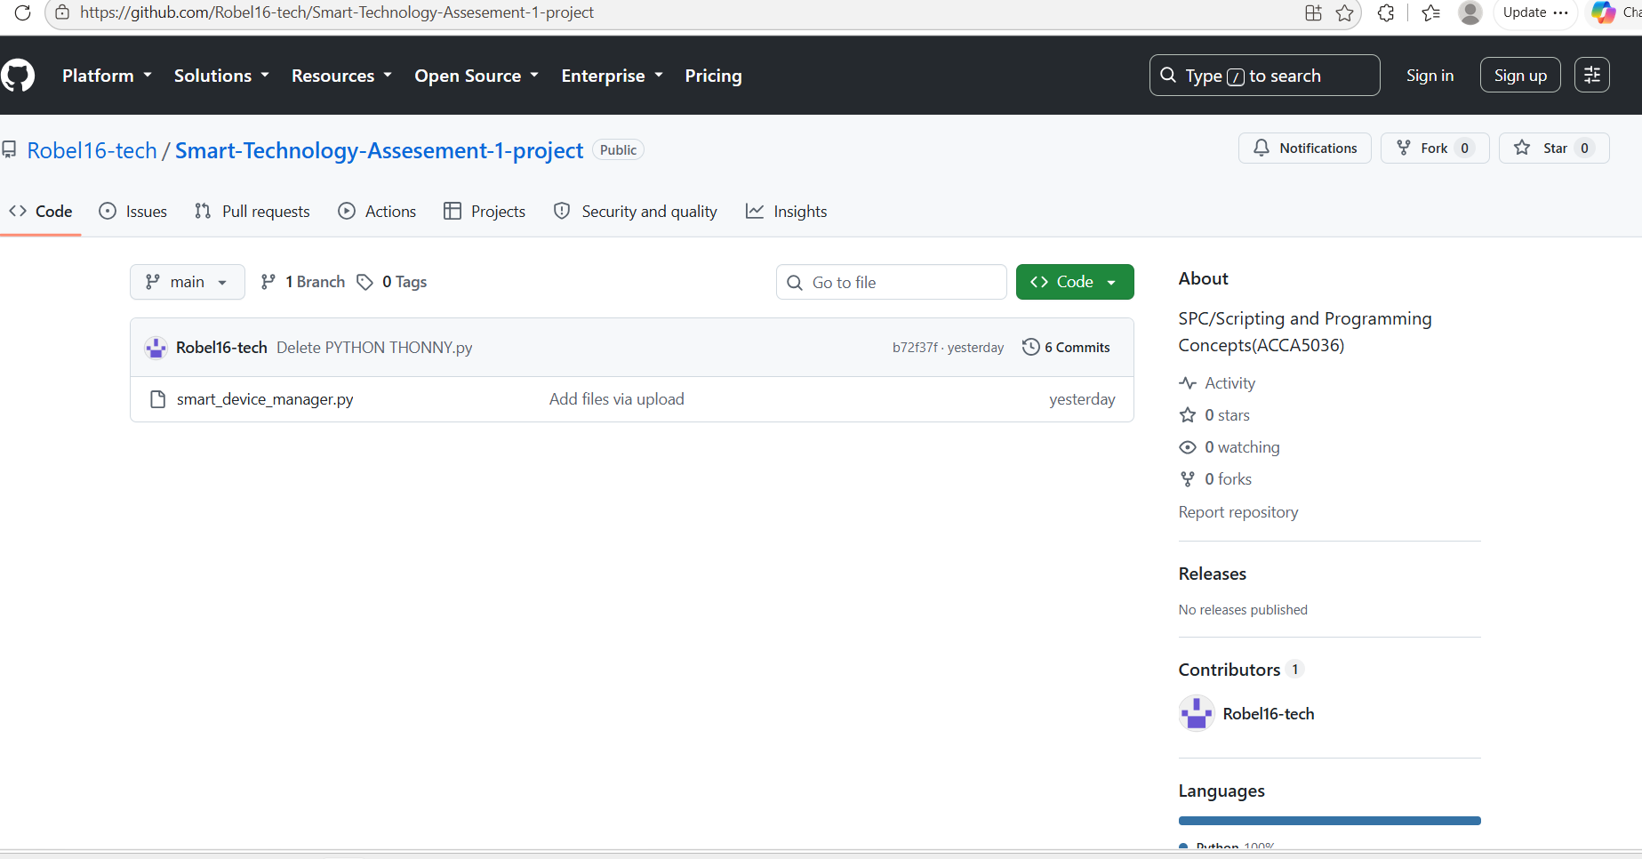

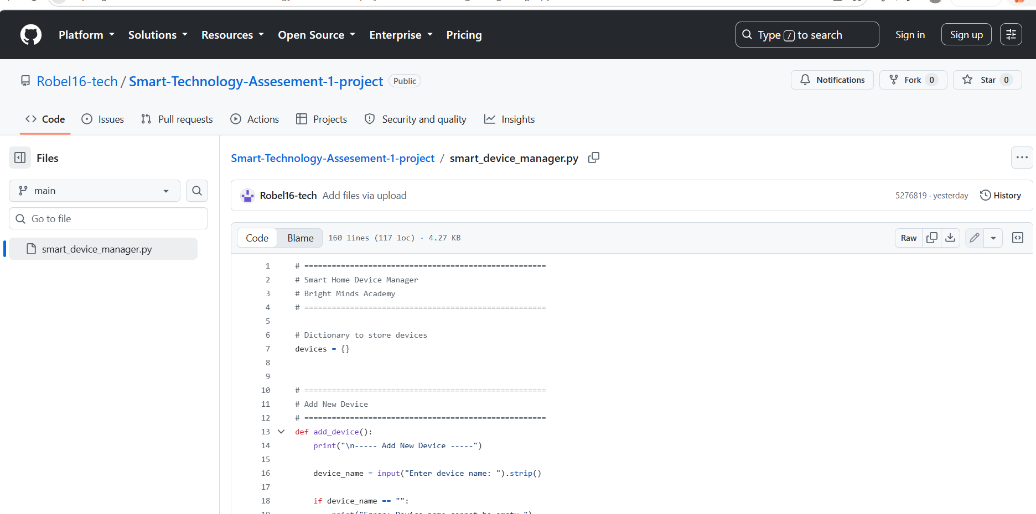

Using GitHub provides several advantages:
• Maintains a history of code changes.
• Allows projects to be backed up online.
• Supports collaboration.
• Demonstrates professional software development practices.
• Makes the project accessible to tutors and employers.

2.6.2 Complete Python Source Code
The following source code implements all of the functional requirements identified during the analysis stage.

Smart Home Device Management System

Bright Minds Academy

Dictionary used to store all devices
devices = {}
VALID_STATUS = [
“Online”,
“Offline”,
“Under Maintenance”
]
def. add device ():
“”" Add a new smart device.“”"
device_ name = input("Thermostat: ").strip()

if device_ name == "Thermostat":
print ("Error: Device name cannot be empty.\n")
return

if device_name in devices:
print ("Error: Device already exists.\n")
return

room = input ("Enter room location: "). strip ()

if room == "":
print ("Error: Room cannot be empty.\n")
return

devices [device name] = {
"room": room,
"status": "Offline"
}

print ("Device added successfully.\n")
def. update status ():
“”" Update device status.“”"
device_name = input ("Enter device name: "). strip ()

if device name not in devices:
print ("Device not found.\n")
return

print ("\ nChoose Status")

for index, status in enumerate (VALID_STATUS, start=1):
print(f"{index}. {status}")

choice = input("Enter option: ")

if not choiceisdigit():
print("Invalid selection.\n")
return

choice = int (choice)

if choice < 1 or choice > 3:
print("Invalid selection.\n")
return

devices [device _name]["status"] = VALID_STATUS[choice - 1]

print ("Status updated successfully.\n")
def view_ devices ():
“”“Display all registered devices.”“”
if len (devices) == 0:
print("No devices registered.\n")
return

print("\ nRegistered Devices")
print("-" * 60)

for device, details in devices .items ():

print (device: {device}")
print (f "Room : {details['room']}")
print (f" Status : {details['status']}")
print ("-" * 60)
def search_device ():
“”" Search for a device.“”"
device_ name = input("Enter device name: ").strip()

if device_ name not in devices:
print("Device not found.\n")
return

print ("\nDevice Information")

print (device: {device_ name}")
print (f" Room : {devices[device_ name]['room']}")
print (f" Status : {devices[device_ name]['status']}")
def display_ menu ():
print("\n")
print ("=" * 40)
print (" SMART HOME DEVICE MANAGER ")
print ("=" * 40)
print ("1. Add Device")
print ("2. Update Device Status")
print ("3. View Devices")
print ("4. Search Device")
print ("5. Exit")
def. main ():
while True:

display _menu()

choice = input ("1: ")

if choice == "1":
add_ device ()

elif choice == "2":
update_ status ()

elif choice == "3":
view_ devices ()

elif choice == "4":
search_ device ()

elif choice == "5":
print ("Program Closed.")
break

else:
print("Invalid menu option.\n")
main ()

2.6.3 Code Explanation
The source code has been organised into several user-defined functions to improve readability, modularity, and maintainability. Each function performs a single task, making the program easier to debug and update.
Main Function
The main() function controls the execution of the application. It repeatedly displays the menu using a while loop until the user selects the Exit option.
Purpose
• Controls program execution.
• Displays the menu.
• Calls the appropriate function.
• Prevents code duplication.
Insert Screenshot 2.1: Main menu displayed in Python.
Add Device Function
The add _device() function allows users to register a new smart device. Before storing the information, the function validates the device name and room location. Duplicate device names are rejected to maintain data integrity.
Validation Performed
• Device name cannot be empty.
• Room cannot be empty.
• Duplicate device names are not allowed.
Insert Screenshot 2.2: Adding “Smart Light A1” successfully.
Update Status Function
The update_ status() function allows staff members to change the operational status of a device. The function first checks whether the device exists before displaying the available status options.
Available status values include:
• Online
• Offline
• Under Maintenance
Only valid options are accepted.
Insert Screenshot 2.3: Updating a device status.
View Devices Function
The view_ devices() function displays every registered smart device stored in the dictionary.
The output includes:
• Device name
• Room location
• Current status
If no devices exist, an appropriate message is displayed.
Insert Screenshot 2.4: Displaying all registered devices.
Search Device Function
The search _device() function enables staff to search for a specific device by entering its name.
If the device exists, the following information is displayed:
• Device name
• Room
• Status
If the device cannot be found, an informative message is displayed.
Insert Screenshot 2.5: Searching for Projector B2.
2.6.4 Coding Standards
Several software engineering best practices were followed during implementation.
Meaningful Variable Names
Variables such as device_name, room, and status clearly describe the information they store, improving readability.
Modular Programming
Each function performs one specific task. This makes the program easier to maintain and supports code reuse.
Comments
Comments have been added throughout the program to explain important sections of the code. This improves maintainability and helps other developers understand the implementation.
Consistent Formatting
Indentation, spacing, and naming conventions follow Python best practices (PEP 8). Consistent formatting improves readability and reduces the likelihood of programming errors.
Input Validation
Validation is performed before any data is stored, preventing invalid or incomplete information from entering the system.
Overall, the implementation successfully satisfies all functional requirements identified during the analysis stage while following recognised software engineering principles. The modular design and comprehensive validation ensure that the application is reliable, maintainable, and easy for staff at Bright Minds Academy to use.
3. Testing and Debugging Report
Testing is an essential stage of the Software Development Life Cycle (SDLC). Its primary purpose is to verify that the software functions correctly and satisfies the requirements identified during the analysis phase. Effective testing helps identify defects before the software is released, reducing the risk of system failures and improving reliability.
For the Smart Home Device Management System, testing was performed throughout the development process. Each user-defined function was tested individually before the complete system was tested as a whole. This approach ensured that each feature operated correctly both independently and when integrated into the application.
Testing also confirmed that the validation implemented within the program successfully prevented invalid data from being stored. Both normal test cases and edge cases were executed to verify that the application behaved correctly under different conditions.

3.1 Importance of Program Testing
Program testing is an important part of software development because it helps developers detect and correct errors before users encounter them. Without testing, software may produce incorrect results, crash unexpectedly, or allow invalid information to be stored.
The main benefits of testing include:
• Ensuring that all functional requirements have been implemented correctly.
• Improving software reliability and stability.
• Detecting programming errors early, reducing maintenance costs.
• Verifying that validation rules prevent incorrect user input.
• Increasing user confidence in the software.
• Confirming that future modifications do not introduce new faults.
For this project, testing ensured that users could successfully add, update, search, and display smart devices while preventing invalid input from causing unexpected behaviour.
3.2 Types of Programming Errors
During software development, programmers commonly encounter syntax errors, runtime errors, and logical errors. Understanding these errors allows developers to identify problems quickly and implement suitable solutions.
Syntax Errors
Syntax errors occur when the programmer breaks the grammatical rules of the programming language. These errors prevent the program from executing.
Run
if choice == 1
print(“Hello”)
The example above is missing a colon (:), causing Python to generate a syntax error.
Solution
if choice == 1:
print(“Hello”)
Using a code editor such as Visual Studio Code or PyCharm helps identify syntax errors through highlighting and automatic error detection.
Runtime Errors
Runtime errors occur while the program is running. These errors usually result from invalid user input or unexpected situations.
Run
number = int(input("Enter number: "))
If the user enters:
A b c
Python raises a ValueError because “abc” cannot be converted into an integer.
Solution
The project prevents many runtime errors by validating user input before processing it. For example, menu choices are checked using isdigit() before converting them into numbers.

Logical Errors
Logical errors are the most difficult to identify because the program executes successfully but produces incorrect results.
Example
if choice > 5:
print(“Valid”)
The condition above is incorrect because menu options should only be valid between 1 and 5.
Correct Version
if 1 <= choice <= 5:
print(“Valid”)
Logical errors were identified by repeatedly testing each function with different inputs and comparing the results against the expected behaviour.

Test Cases
Test ID | Description / Input | Expected Result | Actual Result | Status
TC01 | Add Smart Light A1, Room 101 | Device added | Device added | Pass
TC02 | Add Projector B2, Conference Room | Device added | Device added | Pass
TC03 | View devices | All devices displayed | Correct list displayed | Pass
TC04 | Search Smart Light A1 | Device information displayed | Correct information shown | Pass
TC05 | Update device to Online | Status updated | Status updated | Pass
TC06 | Search Camera X1 | Device not found | Correct error displayed | Pass
TC07 | Enter menu option 9 | Invalid option message | Correct message displayed | Pass
TC08 | Exit using option 5 | Program closes | Program closed | Pass
The functional tests demonstrate that the principal operations work as expected, including adding, viewing, searching, updating and exiting. Invalid menu input is also rejected. [5], [6]

3.3 Test Cases
The following test cases were designed to verify both the functionality and validation of the Smart Home Device Management System.
Test ID Test Description Input Expected Result Actual Result Status
TC01 Add new device Smart Light A1, Room 101 Device added successfully Device added successfully Pass
TC02 Add second device Projector B2, Conference Room Device added Device added Pass
TC03 View devices Menu option 3 All devices displayed Correct list displayed Pass
TC04 Search existing device Smart Light A1 Device information displayed. Correct information shown Pass
TC05 Update device status Online Status updated Status updated Pass
TC06 Search non-existing device Camera X1 Device not found Correct error displayed Pass
TC07 Invalid menu option 9 Invalid option message Correct message displayed Pass
TC08 Exit program Option 5 Program closes Program closed Pass
3.4 Validation Test Cases (Edge Cases)
The system was also tested using invalid inputs to verify that validation worked correctly.
Test ID Invalid Input Expected Behaviour Actual Result Status
V01 Empty device name Display error Error shown Pass
V02 Empty room name Display error Error shown Pass
V03 Duplicate device name Reject duplicate Duplicate rejected Pass
V04 Invalid status option (7) Reject input Error displayed Pass
V05 Menu option “abc” Reject input Error displayed Pass
V06 Search blank device Device not found Error displayed Pass
V07 Update unknown device Device not found Correct message Pass
V08 View devices when empty “No devices registered” Correct message Pass
The validation tests confirm that the application prevents invalid information from being stored while providing clear feedback to the user.
Test ID | Invalid Input | Expected Behaviour | Status
V01 | Empty device name | Display error | Pass
V02 | Empty room name | Display error | Pass
V03 | Duplicate device name | Reject duplicate | Pass
V04 | Invalid status option 7 | Reject input | Pass
V05 | Menu option abc | Reject input | Pass
V06 | Search blank/unknown device | Display error | Pass
V07 | Update unknown device | Device not found | Pass
V08 | View devices when empty | No devices registered | Pass

3.5 Debugging Process
During development, several issues were identified and corrected through systematic debugging.
Issue 1: Duplicate Devices
Initially, the program allowed users to add multiple devices with the same name. This confused when searching for devices.
Solution: Before adding a device, the program checks whether the device name already exists in the dictionary. If it does, an error message is displayed and the device is not added.
During development, duplicate devices were initially possible. This was corrected by checking whether the device name already exists before adding it. Invalid menu choices were also initially accepted, so validation was added to allow only valid options. [5]
Blank device names and room names were another problem because they could create incomplete records. Validation was added to reject empty fields. Searching for an unknown device was also improved by checking whether the device exists and displaying a clear error message when it does not. [5], [6]
Overall, testing and debugging demonstrated that the application satisfies the identified functional requirements and that the validation rules operate as intended. The process improved the reliability and usability of the final prototype. [5], [6]

Issue 2: Invalid Menu Choices
Early versions of the program accepted any input for the menu, including letters and symbols. This caused incorrect program behaviour.
Solution: Validation was added to ensure that only valid menu options (1–5) are accepted. Invalid inputs display an error message without causing the program to terminate.
Issue 3: Blank Inputs
Users could initially press Enter without typing a device name or room location, resulting in incomplete records.
Solution: Input validation checks that both the device name and room fields contain data before the device is added to the system.
Issue 4: Searching for Unknown Devices
Attempting to search for a device that had not been registered previously caused confusing output.
Solution: A check was added to verify that the device exists before displaying its information. If the device is not found, the user receives a clear error message
3.6 Summary of Testing
The testing process demonstrated that the Smart Home Device Management System satisfies all functional requirements identified during the analysis stage. Every feature was tested using both valid and invalid inputs, and all validation rules operated as expected. The debugging process improved the reliability and usability of the application by correcting errors before the final version was completed. As a result, the software provides accurate device management while preventing incorrect data from being entered into the system.
4. Evaluation
The evaluation stage is the final phase of the Software Development Life Cycle (SDLC). It provides an opportunity to assess whether the software achieved its objectives, identify the strengths and limitations of the solution, and reflect on the knowledge and skills gained throughout the development process. Evaluating the project also helps identify possible improvements that could be implemented in future versions of the application.

4.1 Project Outcomes
The Smart Home Device Management System was successfully developed to meet the requirements of Bright Minds Academy. The completed application enables staff members to manage smart classroom devices using a simple menu-driven interface. Users can add new devices, update their operational status, search for devices by name, and display all registered devices.
All functional requirements identified during the analysis phase were implemented successfully. Input validation ensures that users cannot enter empty values, duplicate device names, or invalid menu options. This improves the accuracy and reliability of the stored information while providing a user-friendly experience.
The use of Python dictionaries proved to be an effective solution for storing device information because they provide fast access to data and simplify searching and updating operations. Furthermore, the modular design of the application makes the code easier to maintain and extend in future versions.
Overall, the project demonstrates that a relatively simple Python application can provide an effective solution for managing smart classroom devices without requiring a complex database or networking infrastructure.

4.2 Challenges Faced
Several challenges were encountered during the design and implementation of the project.
Designing an Efficient Data Structure
One of the first challenges was deciding how to store device information efficiently. Initially, using multiple lists was considered, but this approach would have required searching several lists simultaneously to retrieve information about a single device.
This challenge was addressed by using a Python dictionary. Each device name acts as a unique key, while the associated value stores the room location and current status. This approach simplifies searching, updating, and displaying information.
Implementing Input Validation
Ensuring that users entered valid information required careful planning. Without validation, users could enter blank device names, duplicate records, or invalid menu selections.
To solve this issue, validation checks were implemented throughout the application. These checks prevent incorrect data from being stored and provide informative error messages whenever invalid input is detected.
Developing Modular Functions
Another challenge involved organising the source code into logical functions rather than writing all instructions within one large program.
The problem was solved by creating separate user-defined functions for each major task, including adding devices, updating statuses, viewing devices, and searching. This modular approach improved readability, simplified debugging, and reduced code duplication.
Testing Different User Inputs
Testing the application required considering many different user scenarios, including both valid and invalid inputs. Some errors only became apparent when unusual or unexpected values were entered.
Systematic testing using predefined test cases helped identify these issues early in development. Corrective changes were made before the final version of the software was completed.
4.3 Future Improvements
Although the current version successfully satisfies the project requirements, several enhancements could improve the system further.
Database Integration
Currently, all device information is stored in memory using a Python dictionary. As a result, all data is lost when the program is closed.
A future version could use an SQLite or MySQL database to store information permanently, allowing devices to remain available after the application is restarted.
Graphical User Interface (GUI)
The existing application uses a command-line interface. While this is suitable for demonstrating programming concepts, a graphical interface would provide a more intuitive user experience.
A future version could be developed using libraries such as Tkinter or PyQt to provide buttons, forms, and tables for easier interaction.
User Authentication
The current system allows any user to access and modify device information.
Future versions could include user accounts with usernames and passwords. Different access levels could also be introduced, allowing administrators to manage devices while restricting standard users to viewing information only.
Additional Device Information
Only the device name, location, and status are currently stored.
Future versions could include additional fields such as:
• Device serial number
• Installation date
• Manufacturer
• Warranty expiry date
• Last maintenance date
• IP address
• MAC address
• Energy consumption
• Assigned technician
Adding these fields would improve asset management and maintenance planning.
Reporting Features
The system could automatically generate reports showing:
• Total number of devices
• Online devices
• Offline devices
• Devices requiring maintenance
• Devices grouped by room
These reports would assist management in monitoring equipment more effectively.
Cloud Connectivity
A future version could integrate cloud-based services to allow device information to be accessed remotely from different locations. Cloud storage would also improve data backup and enable multiple authorised users to manage devices simultaneously.
4.4 Self-Reflection
This project provided valuable practical experience in applying software development principles to solve a realistic business problem. Throughout the project, I developed a deeper understanding of the Software Development Life Cycle and recognised the importance of completing thorough analysis and design before beginning implementation.
One of the most significant lessons learned was the importance of planning the program structure before writing code. Producing flowcharts and pseudocode helped organise the solution logically and reduced programming errors during implementation.
The project also strengthened my understanding of Python programming concepts, including dictionaries, loops, conditional statements, user-defined functions, input validation, and modular programming. Before completing this project, I had limited experience designing software that involved multiple interacting functions. Developing the Smart Home Device Management System improved my confidence in creating structured and maintainable programs.
Testing the application highlighted the importance of identifying edge cases rather than focusing only on normal user behaviour. By considering invalid inputs, duplicate records, and unexpected menu selections, I gained a better appreciation of software reliability and quality assurance.
Furthermore, using GitHub encouraged good software engineering practices by supporting version control and organised project management. I also improved my technical documentation skills by explaining design decisions, implementation choices, and testing procedures using appropriate academic language.
Overall, this project has enhanced both my programming ability and my understanding of professional software development practices. The knowledge gained during this assignment will provide a strong foundation for future projects involving larger systems, databases, graphical interfaces, and networked applications.

5. Conclusion
The Smart Home Device Management System provides a practical solution to Bright Minds Academy's need for more efficient management of smart classroom devices. The proposed Python application replaces manual recording with a structured system for adding devices, updating status, viewing records and searching for devices. [2], [5]
The project demonstrates the application of software engineering principles including requirements analysis, modular design, appropriate data structures, input validation, testing, debugging and evaluation. Although the current prototype does not provide persistent storage, authentication or a graphical interface, its modular structure provides a suitable foundation for future development. [5], [6]
The Smart Home Device Management System successfully achieves the objectives defined during the requirements analysis stage. The application provides a reliable and user-friendly method for managing smart classroom devices while demonstrating the effective use of fundamental programming concepts and software engineering principles.
The project follows a logical Software Development Life Cycle, beginning with requirements analysis, progressing through system design and implementation, and concluding with testing and evaluation. The use of modular programming, input validation, dictionaries, and user-defined functions contributes to a solution that is maintainable, scalable, and suitable for future development.
Although improvements such as database integration, graphical interfaces, and user authentication could enhance future versions, the current implementation satisfies all specified functional requirements. It provides an effective prototype for Bright Minds Academy’s smart classroom environment.

References
The following references are formatted using the IEEE referencing style.
[1] G. van Rossum and F. L. Drake Jr., The Python Language Reference Manual. Bristol, UK: Network Theory Ltd., 2003.
[2] K. E. Kendall and J. E. Kendall, Systems Analysis and Design, 10th ed. Harlow, England: Pearson Education, 2019.
[3] T. Budd, Exploring Python, 3rd ed. New York, NY, USA: McGraw-Hill Education, 2021.
[4] B. W. Kernighan and R. Pike, The Practice of Programming. Boston, MA, USA: Addison-Wesley, 1999.
[5] I. Sommerville, Software Engineering, 10th ed. Harlow, England: Pearson Education, 2016.
[6] R. S. Pressman and B. Maxim, Software Engineering: A Practitioner’s Approach, 9th ed. New York, NY, USA: McGraw-Hill Education, 2019.
[7] E. Matthes, Python Crash Course, 3rd ed. San Francisco, CA, USA: No Starch Press, 2023.
[8] C. R. Martin, Clean Code: A Handbook of Agile Software Craftsmanship. Upper Saddle River, NJ, USA: Prentice Hall, 2008.
[9] Python Software Foundation, “Python 3 Documentation,” Available: https://docs.python.org/3/. [Accessed: 28-Jul-2026].
[10] GitHub, “GitHub Documentation,” Available: https://docs.github.com/. [Accessed: 28-Jul-2026].

Appendices
Appendix A – Complete Python Source Code
Include the complete Python source code (main.py) used to develop the Smart Home Device Management System. The code should be fully commented and formatted according to Python coding standards (PEP 8). This appendix enables the lecturer to review and execute the program if required
Appendix B – Flowcharts
Include the flowcharts developed during the design phase.
Suggested flowcharts include:
• Main Program Flowchart
• Add Device Flowchart
• Update Device Status Flowchart
• View Devices Flowchart
• Search Device Flowchart
Each flowchart should be numbered (e.g., Figure B1, Figure B2) and include a brief explanation describing its purpose.
Flowcharts
Appendix
C – Pseudocode
Include the pseudocode for all major functions within the application.
Examples include:
• Main Program
• Add Device
• Update Device Status
• View Devices
• Search Device
Each algorithm should correspond to the implemented Python function.
Appendix D – Test Evidence
Insert screenshots demonstrating the successful execution of the application.
Suggested screenshots include:
Figure D1 – Main menu displayed.
Figure D2 – Adding “Smart Light A1”.
Figure D3 – Adding “Projector B2”.
Figure D4 – Updating a device status.
Figure D5 – Viewing all registered devices.
Figure D6 – Searching for an existing device.
Figure D7 – Searching for a device that does not exist.
Figure D8 – Attempting to add a duplicate device.
Figure D9 – Entering an invalid menu option.
Figure D10 – Attempting to enter blank input.
Each screenshot should include a short explanation confirming whether the observed behaviour matches the expected result.
Appendix E – GitHub Repository
Include evidence that the project has been uploaded to GitHub.
Suggested screenshots include:
• GitHub repository homepage.
• Repository file structure.
• main.py displayed on GitHub.
• Commit history showing version control.
• README.md file.
Example repository structure:
Smart Home Device Manager/
│
├── main.py
├── README.md
├── screenshots/
├── flowcharts/
├── report/
└── LICENSE
Appendix F – Additional Documentation
This appendix may include any supplementary material that supports the project, such as:
• Program execution logs.
• Additional validation examples.
• Extra testing results.
• Alternative algorithm designs.
• Development notes.
• Future enhancement sketches.
Including supporting evidence demonstrates the complete software development process and provides additional information for assessment.

