

The Role of Penetration Testing in Enhancing the Cybersecurity Posture of Small, and Medium Enterprises (SMEs) in the UK.
by
Talwinder Kaur (2227879)

Supervisor: Munyaradzi Nicholas Murira

Project submitted as part of the requirements for the award of MSc Cyber Security and Digital Forensics

July, 2024

Table of Contents
ABSTRACT 7
Chapter 1: 8
Introduction 8
1.2 Rationale 10
1.3 Aims and Objectives 11
1.4 Significance of study 12
1.6 Structure of the project 12
Chapter 1 12
Chapter 2- Literature Review 12
Chapter 3- Research Methodology 12
Chapter 4- Testing and Implementation 12
Chapter 5- Testing and Results 13
Chapter 6- Conclusion and Recommendation 13
Chapter 2: Literature Review 14
2.1 Introduction 14
2.2 Overview of the current Cybersecurity Landscape in SMEs 14
2.3 Benefits and Effectiveness of Penetration Testing in Identifying Vulnerabilities Towards Enhancing Cybersecurity Posture in SMLEs 23
2.4 Approaches to Penetration Testing 25
2.5 Types of Penetration Testing 26
2.6 Role of Ethical Hacking in Strengthening the UK Cyber Security 29
2.6.1 The Role of the UK Cyber Security Group 29
2.6.1 Integration of Penetration in the UK's Cybersecurity Practice 31
2.7 Challenges and Limitations in Penetration Testing 32
2.8 Methodologies and Framework in Penetration Testing 34
2.8.1 Penetration Testing Tools 38
2.9 Common Cybersecurity Breaches Faced by SMES 41
Chapter 3: Research Methodology 44
3.1 Introduction 44
3.2 Research Method 45
3.3 Research Philosophy 45
3.4 Research Approach 45
3.5 Research Strategy 46
3.7 Time Horizon 47
3.8 Data Collection and Analysis 47
3.8.1 Data Collection 47
3.8.2 Data Analysis 47
3.9.1 Project Plan 48
3.9.3 Contingency Plan 50
3.9.4 System Specification 51
Chapter 4 53
4.5 Logical Topology 55
4.6 Virtual Network Setup 56
4.7 Adopted Testing Methodology 57
4.8 Flowchart Diagram 61
Chapter 5 62
Testing and Results 62
Chapter 6 81
Evaluation and Conclusion 81
6.2 Evaluation 81
6.2 Recommendations for Improvement 81
6.3 Conclusion 82
Chapter 7 83
References 83

Table 1 Percentage of organisations that have identified breaches or attacks in the last 12 months [12] 17
Table 2. Percentage of businesses identified different attacks in the last 12 months [12] 18
Table 3. percentage of organisations took action following a cyber security incident [12] 19
Table 4. percentage of organisations that have done any of the following since their most disruptive attack [12] 20

Figure 1.Graph showing the percentage of organisations that experienced attacks 15
Figure 2. Ethical hacking modes [22] 24
Figure 3. pros and cons [33] 30
Figure 4 penetration testing pattern [22] 34
Figure 5 research onion structure [45] [52] 40
Figure 6. Gantt Chart 45
Figure 7. Logical topology 51
Figure 8. Host IP address discovery 59
Figure 9. Nmap hosts scan 60
Figure 10. Nmap service discovery for Windows machine 61
Figure 11. Nmap service discovery for metasploitable 62
Figure 12. Nmap ports discovery 63
Figure 13. Eternalblue vulnerability 64
Figure 14. Vsftcp vulnerability discovery 65
Figure 15.vsftcp exploit 66
Figure 16. Backdoor exploit attack 67
Figure 17. Backdoor Exploit initiated 67
Figure 18. Privilege root access 68
Figure 19. Privilege Escalation 68
Figure 20. Escalate Privilege 69
Figure 21.Email draft 71
Figure 22. Cloned login page 71
Figure 23. Campaign Analysis 72
Figure 24. Targeted website 74
Figure 25. Captured packets with a Wireshark 75
Figure 26.Analysed packets 75

ABSTRACT
Small and Medium Enterprises (SMEs) are a vital component of the global economy, contributing significantly to economic growth, innovation, and employment. However, the increasing reliance on digital technologies exposes SMEs to a wide range of cyber threats, making cybersecurity a critical concern. This dissertation investigates the role of penetration testing in enhancing the cybersecurity posture of SMEs in the UK. The study begins with a comprehensive review of the current cybersecurity landscape in SMEs, highlighting their unique challenges and vulnerabilities. It then evaluates the benefits and effectiveness of penetration testing as a proactive measure to identify and mitigate vulnerabilities. By adopting a suitable methodology, the research designs and sets up a virtual network environment to simulate cyber-attacks, ensuring adherence to ethical guidelines. The findings from the penetration tests inform the development of effective mitigation techniques and recommendations tailored to SMEs. This project aims to demonstrate how penetration testing can significantly improve the security measures of SMEs, ensuring compliance with industry standards and enhancing overall cybersecurity resilience.

Chapter 1:

Introduction
Small and Medium-sized Enterprises (SMEs) are a crucial and varied segment of the global economy, characterized by their smaller scale, lower annual revenue, limited assets, and fewer employees compared to larger corporations. Despite their modest size, SMEs significantly impact economic growth, innovation, and employment. They often drive the creation of new technologies, products, and services, contributing to economic vitality and industry diversification. As SMEs increasingly depend on digital technologies for core operations, their exposure to cyber threats grows, making cybersecurity essential. Protecting customer data, financial information, and intellectual property is vital for regulatory compliance, business continuity, and maintaining customer trust. Thus, prioritizing cybersecurity is crucial for SMEs to ensure resilience and growth in the digital era [1].
As the world is moving towards the digitalization of new technology there is a need for cybersecurity for the safe protection of personal and official data and the protection of its infrastructure from cyber threats [2]. Penetration testing commonly referred to as ethical hacking is a technique that involves the legal attempt at breaking into a computer system in an organisation to establish the loopholes that exist within the system. This practice is critical when it comes to the enhancement of the security posture within a particular network since it achieves the assessment of the network from the perspective of a potential attacker. Whitehat or ethical hackers are those individuals who use the same methods and tools that black hat hackers use, but they intend to locate these vulnerabilities and report them to the relevant authorities to be rectified [3].
It became necessary to possess knowledge in the area of ethical hacking because, with the rising complexity of threats and no perfect security solution, there is always a weak link. The security measures commonly employ tools like firewalls and antivirus software that focus on the known threat. Ethical hacking on the other hand seeks to be more aggressive in its approach by seeking to prevent the threat from occurring in the first place [4]. Given the long evolution of threats, such an approach is necessary, for the emergence of new types of criminal activity in cyberspace. Ethical hacking comprises vulnerability assessment, social engineering, network/information application attack, and security review. These activities are designed to address different components of an organisation’s security environment and collectively give an all-around assessment of vulnerabilities. For example, vulnerability scanning is the identification of well-known security holes using automated tools, while in penetration testing, a real or practical attack is conducted to identify vulnerabilities or weaknesses that may not be easily picked by the automated tools.
Another advantage of ethical hacking is that it can show an organisation’s management the type of possible threats its organisation is facing, and how severe these threats are. As such, an organisation can acquire knowledge about its weak points before they are exploited by attackers and therefore come up with safety measures to mitigate them. Besides improving security measures, it also leads to meeting compliance with the norms and standards of the regulatory world [5].
Furthermore, penetration testing can be also used for assessing the efficiency of existing security measures and identifying the areas for improving such measures. Ethical hacking is now well understood in different tiers in the United Kingdom, including governmental organisations, private sectors as well as in universities. The UK’s National Cyber Security Centre (NCSC) [6] encourages ethical hacking as a way forward in strengthening the UK cyber security system. Besides, most organisations in the UK adapt to incorporate ethical hacking as a key approach to ensuring data security and structures in their jurisdictions.
However, it is also crucial to acknowledge the fact that ethical hacking has several challenges. These challenges could be Legal and ethical challenges, lack of specialised knowledge and skills, and the evolutionary nature of cyber threats. Legal and ethical questions surrounding the application of hacking tools and methods are likely to arise, which is why there is a need to regulate and standardise every hacking tool in the market [7].
Ethical hacking is a specialty that can only be conducted by professionals with adequate training, and knowledge of the most recent threats, and hacking methods. Besides, the threat environment is dynamic, and therefore ethical hacking techniques should also be updated all the time.

Vulnerability is typically viewed as a weakness or flaw within a network, making it susceptible to unauthorized access and data breaches. These vulnerabilities can be present in software, hardware, and even in procedural steps. In software, vulnerabilities often manifest as bugs in the code, including issues like SQL injections and cross-site scripting. Hardware vulnerabilities may involve flaws in routers, connections, and IoT devices. To protect against these vulnerabilities, it is essential to conduct comprehensive vulnerability scans on networks, hosts, and websites. Identifying these weaknesses allows for the implementation of effective security measures to safeguard the network

1.2 Rationale
The rise of cyber threats in the recent past has continued to endanger both organisations and individuals highlighting the need for improved network security. A string of more sophisticated attacks on organisations from the public and private sectors have shown the scale of the loss in terms of money and operations, as well as the reputational cost. Specifically, the modern ones have exposed personal data, affected essential business networks, and incurred significant costs. Such acts call for preventive measures for the security of organisations, which raises the capacity to predict threats [8].
Penetration has become one of the most important and effective approaches used to detect and prevent threats that may be exploited by threat actors. As earlier mentioned, traditional security measures are generally more or less of an ‘umbrella’ type, which guards and is ready with a response once threats are identified, whereas ethical hacking is more proactive in its approach [9]. That is why it is necessary to use such strategic actions as the attack simulation with the support of ethical hackers to reveal existing weak points in a system and give further recommendations to enhance security measures. This is particularly important since a new attack technique is being developed almost daily today.
The present research was informed by the need for a better grasp of the part that ethical hacking needs to play in the UK’s cybersecurity system. Nevertheless, it has been acknowledged that ethical hacking is of enormous significance, but there is a lack of extensive research that assesses the success of the method and understanding of the most effective application of the technique [10]. It is, therefore, hoped that the findings of the current study, based on the common practices, emerging issues, and results of cybersecurity research and implementation, will be useful for establishing a better strategy regarding cybersecurity measures.
The justification for carrying out this work is to establish the importance of ethical hacking and its influence on protecting the network. It focuses on proposing improvements for ethical hacking based on the evident strengths and weaknesses of the existing practices. This, in turn, will assist organisations in safeguarding against potential cyber threats, and increase the security of the UK’s cyberspace. Besides benefiting cybersecurity practitioners, the findings of this study will be useful for policymakers and other stakeholders who contribute to the overall advancement of cybersecurity in the UK.

1.3 Aims and Objectives
This project aims to investigate how penetration testing can enhance the cybersecurity posture of small, medium, and large enterprises (SMEs) by identifying vulnerabilities, improving security measures, and ensuring compliance with industry standards.
The objectives include:
- Review the current cybersecurity landscape in SMEs
- Evaluate the benefits and effectiveness of Penetration Testing in Identifying Vulnerabilities towards enhancing cybersecurity posture in SMLEs
- Adopt a suitable methodology to meet the aim of this project.
- Design and set up a virtual network environment to simulate attacks while complying with every ethical rule.
- Propose effective mitigation techniques and recommendations based on the outcome of the penetration test.

1.4 Significance of study
The significance of this project lies in its potential to improve cybersecurity resilience, provide practical guidance, enhance compliance and risk management practices, offer practical examples and best practices, contribute to academic research, and ultimately reduce cybersecurity risks for small, medium, and large enterprises.

1.6 Structure of the project

Chapter 1
This chapter gives an overview of the project, outlining its aim and objectives necessary for its completion. It serves as a roadmap, delineating how the project will be approached and structured.

Chapter 2- Literature Review
This chapter will focus on reviewing the necessary pieces of literature needed to support the aims and objectives of this work.

Chapter 3- Research Methodology
Chapter three constitutes the research methodology section, which comprehensively outlines the research philosophy, approach, time horizons, design, strategy, choices, techniques, and procedures essential for completing the project. The research onion methodology.

Chapter 4- Testing and Implementation
This chapter discusses the design and implementation phase of this project, detailing the proposed design and execution plan. It begins with problem formulation, solution design, and subsequent implementation steps. In this project, a prototype of the proposed SME network infrastructure will be developed to facilitate attacks. This includes specifying various network servers, network security devices, and their configurations. The testing environment will be established using a virtualization platform such as VirtualBox or Azure, utilizing multiple virtual machines to simulate a penetration test.

Chapter 5- Testing and Results
Chapter 5 focuses on documenting the testing and evaluation details. It presents the results and outcomes of the experiments conducted based on the design and implementation outlined in Chapter 4.

Chapter 6- Conclusion and Recommendation
This chapter gives a general conclusion of the entire dissertation. From chapter one to chapter 5.

Chapter 2: Literature Review

2.1 Introduction
To satisfy the objectives of this project, it is crucial to carefully review several works of literature that are crucial to the entire process, from the formulation of research questions and hypotheses to the analysis and interpretation of results. A thorough and critical review of the literature ensures that the research is grounded in existing knowledge.

2.2 Overview of the current Cybersecurity Landscape in SMEs
Understanding the current cybersecurity landscape in SMEs involves examining several components like the current cyber threats and risks, security practices and measures, regulatory and compliance requirements, challenges, and cybersecurity awareness culture, to get a comprehensive view of how well-prepared and resilient an SME is against cyber threats. It also involves identifying areas where improvements can be made to enhance their overall cybersecurity posture.
According to [1], Cybersecurity for Small and Medium-sized Enterprises (SMEs)" explores the critical importance of cybersecurity for SMEs. It emphasizes creating a cybersecurity-aware culture within these enterprises, highlighting the significance of treating cybersecurity as a top business priority and integrating it into daily operations. The document underscores the role of ongoing employee training and engagement in recognizing and mitigating cyber threats. SMEs are a crucial part of the global economy, characterized by smaller scale, lower annual revenue, limited assets, and a reduced workforce compared to larger corporations. Despite their size, SMEs have significant economic influence and are vital for economic growth. The researcher outlines several challenges SMEs face in cybersecurity, which include [1];
- Awareness and Knowledge Gaps: Many SME owners and employees lack comprehensive cybersecurity knowledge, leading to risky behaviors and inadequate security practices.
- Financial and Operational Impacts: Cyberattacks can cause severe financial losses, operational disruptions, and damage to reputation and customer trust.
- Legal and Regulatory Consequences: SMEs may face legal actions and regulatory penalties in the aftermath of a cyberattack, adding to their challenges.
- Best Practices for Cybersecurity: most SMEs are not adopting the best cybersecurity practices for ensuring the safety of their networks and resources.
- Cybersecurity Strategy: Developing a well-defined cybersecurity strategy is essential for identifying, mitigating, and responding to cyber threats.
- Employee Training and Engagement: Continuous training and awareness programs for employees are crucial in fostering a cybersecurity-conscious culture.
- Network Security Measures: Implementing robust network security measures like firewalls and intrusion detection systems is necessary to protect sensitive data.
- Data Protection and Encryption: Utilizing data protection and encryption technologies to safeguard information.
- Incident Response and Recovery Plans: Establishing clear incident response and recovery plans to minimize the impact of cyber incidents.
[1] concludes that cultivating a cybersecurity-aware culture within SMEs is a strategic imperative. It ensures the protection of digital assets, enhances customer trust, and contributes to the long-term resilience and success of SMEs in the digital landscape​. However, to further support the researcher's point of view, it is important to note that if an SME can employ the services of a pentester, 90% of the listed cybersecurity challenges can be resolved by just conducting penetration testing. The result from the penetration test will guide the business owner on the right security measures to put in place.

Another researcher [11] examines the cybersecurity practices and challenges faced by small and medium enterprises (SMEs) in developing countries, focusing on South Africa. The research provides a thorough review of the cybersecurity landscape in developing countries, highlighting unique challenges faced by SMEs. The study emphasizes the need for context-specific solutions and collaboration among practitioners and government institutions to improve cybersecurity practices among SMEs in developing countries. By focusing on South Africa, the study offers a detailed understanding of how specific local factors influence cybersecurity practices.

The key points of the document are summarized and critically analyzed as follows:
Despite lower internet penetration rates, developing countries have become significant internet users, with 2.5 billion users compared to 1 billion in developed countries.
SMEs in developing countries are increasingly using IT systems, which exposes them to cybersecurity threats. These enterprises often lack the resources and dedicated IT departments to manage cybersecurity effectively. The researchers categorize the Cybersecurity Challenges for SMEs into Internal Factors (SMEs’ perceptions of cybersecurity are influenced by budget constraints, management support, and attitudes toward cybersecurity) and External Factors (The broader cybersecurity landscape and institutional pressures also shape SMEs' cybersecurity practices.)
They further state that Key issues to cybersecurity include poor "security hygiene," reliance on mobile technology, novice internet users, use of pirated software, and limited understanding of cyber threats. Issues such as phishing attacks, Sim-swap fraud, ID theft, lack of IT education, and the absence of standardized procedures are prevalent in Africa, and the various approaches to tackling cybersecurity include intrusion detection systems, anomaly detection, signature detection, hybrid methods, honeypots, and web server logging.
The researchers adopted a qualitative approach to understand SMEs' cybersecurity practices from their perspective. This method is suitable for developing countries where contextual factors differ significantly from developed economies.
The Key Findings include Factors Influencing Cybersecurity Practices (Financial resources, management support, expertise availability, and awareness of cybersecurity threats significantly affect cybersecurity implementation) and cybersecurity Implementation (SMEs in South Africa adopt various cybersecurity practices, but they face challenges due to limited resources and institutional support).
They concluded by stating that the exploration of various cybersecurity methods provides a broad perspective on potential solutions for SMEs.

The Weaknesses in the research are;
- Limited Sample Size: The study's findings are based on a qualitative inquiry of only three South African SMEs, which may not be representative of the broader SME landscape in developing countries.
- Generalization Issues: The specific focus on South Africa might limit the generalizability of the findings to other developing countries with different socio-economic conditions.
Recommendations
- Broader Research: Future research should include larger sample size and cover SMEs from various developing countries to provide more generalizable insights.
- Enhanced Support: Governments and institutions in developing countries should provide more resources and support to SMEs for implementing effective cybersecurity measures.
- Awareness Programs: Increased efforts are needed to raise cybersecurity awareness among SMEs to ensure they understand the importance of protecting their IT systems.
According to the cyber breaches report from the UK Department for Science, Innovation & Technology, an Official Statistics of Cyber security breaches survey 2023 released on 19 April 2023 reported different cyber breaches each organisation encountered and how they approached the attack [12]. The Cyber Security Breaches Survey is a research initiative focused on assessing the cyber resilience of the UK, in alignment with the National Cyber Strategy. Its primary purpose is to guide government policy on cyber security, ensuring that UK cyberspace remains a secure environment for business activities. The study examines the policies, processes, and approaches to cyber security adopted by businesses, charities, and educational institutions [12]. It also looks into the various cyber-attacks and cybercrimes these organizations encounter, the impact of these incidents, and the organizations' responses.
In the past 12 months, 11% of businesses and 8% of charities have experienced cybercrime. This figure increases to 26% for medium-sized companies, 37% for large corporations, and 25% for high-income charities. Among the 32% of businesses and 24% of charities that identified any cyber security breaches or attacks, about one-third (34% for businesses and 32% for charities) fell victim to cybercrime [12].
Additionally, 3% of businesses and 1% of charities have been victims of fraud due to cybercrime, representing 9% of the businesses and 6% of the charities that identified any breaches or attacks [12].
It is estimated that across all UK businesses, there were approximately 2.39 million instances of cybercrime and around 49,000 instances of fraud resulting from cybercrime in the last year. For charities, there were an estimated 785,000 instances of cybercrime. Due to sample size limitations, it is not possible to estimate the scale of fraud from cybercrime among charities.
The average annual cost of cybercrime for businesses is estimated to be around £15,300 per victim. The sample sizes do not allow for a similar cost calculation for charities.
The tables below are a representation of the data collected and analysed from the effects of cyber breaches in the UK [12], and how each organisation responded to these breaches. This result will further prove why it is important for organisations to incorporate ethical hacking as part of their cyber security measures.

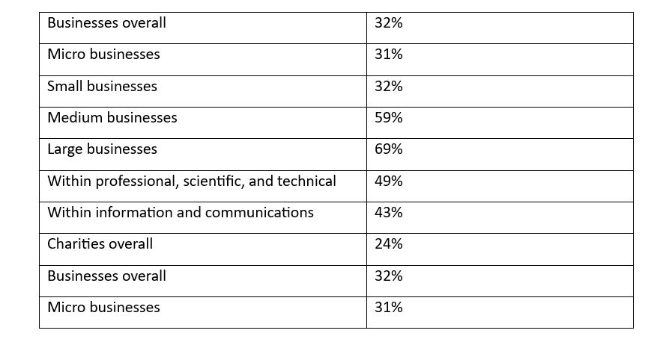
The table below is a Percentage of organisations that have identified breaches or attacks in the last 12 months.

Table 1 Percentage of organisations that have identified breaches or attacks in the last 12 months [12]
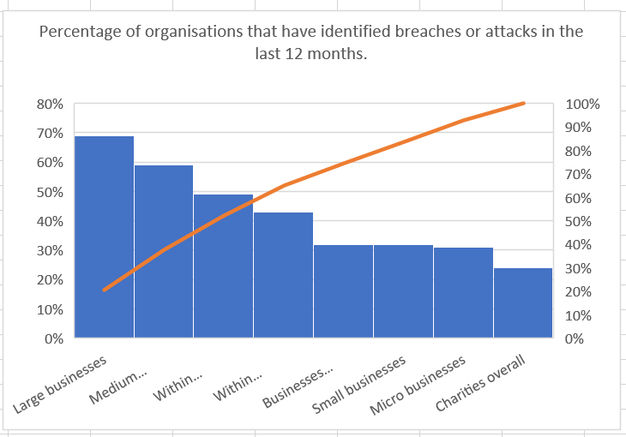

Figure 1.Graph showing the percentage of organisations that experienced attacks

The graph above, indicates that over 60% of organisations that experienced cyber breaches were large organisations, over 50% were medium organisations, and 40% were small organisations.

The table below shows the Percentage of these businesses that have identified the following types of breaches or attacks in the last 12 months
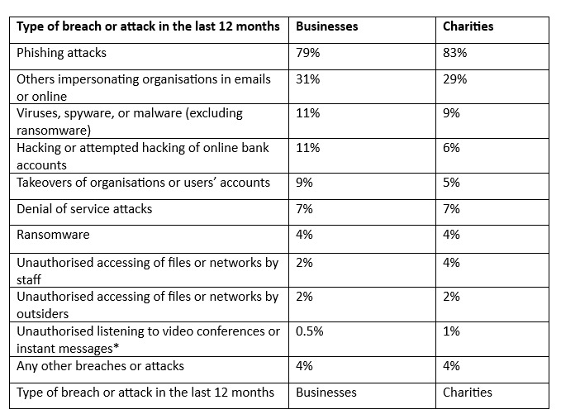
Table 2. Percentage of businesses identified different attacks in the last 12 months [12]

The table shows the percentage of organisations that say they took, or would take, the following actions following a cyber security incident.
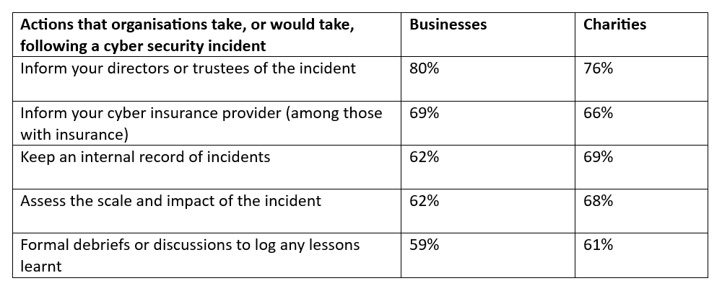
Table 3. percentage of organisations took action following a cyber security incident [12]

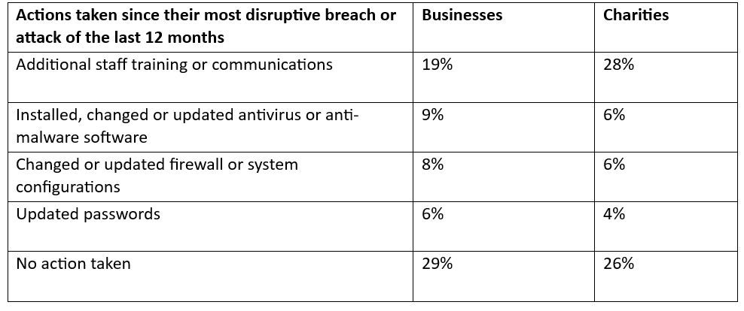
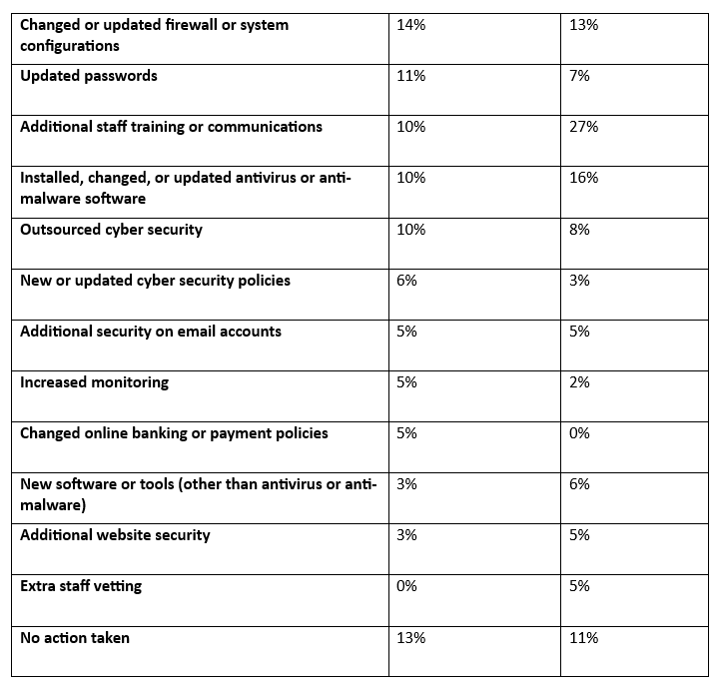
The table below shows the percentage of organisations that have done any of the following since their most disruptive breach or attack of the last 12 months.

Table 4. percentage of organisations that have done any of the following since their most disruptive attack [12]

Summary of the report
From the above report, only 10% of businesses and 8% of charities decided to outsource their cyber security which means that an external agency would possibly have an ethical hacker or a penetration tester that will likely perform a penetration test on the organisation's network to check for vulnerabilities. Ethical hacking is an effective security technique for detecting weaknesses or vulnerabilities in a network, the results gathered from this exercise provide business owners with the right approach to securing their network from cyber-attacks. Any organisation without proper security architecture is prone to several cyber-attacks which can lead to loss of sensitive data or even loss of service.
This is why this work promotes the need for organisations to incorporate ethical hacking in enhancing the security of their network.

2.3 Benefits and Effectiveness of Penetration Testing in Identifying Vulnerabilities Towards Enhancing Cybersecurity Posture in SMLEs
Penetration testing has its origins in the history of computing and information technology, especially in the period of phone phreaking, which started in the 1960s. However, it was not until the 1970s that the term ‘hacking’ started to form and it originally simply meant any effective or technologically savvy programmer [13]. In that period, hacking was more of a beneficial activity with people interested in the mechanisms of systems and determination to alter them for the better. Although phone phreaking was composed of traditional prank calls and curiosity, there have been cases of notable figures such as John Draper, popularly known as “Captain Crunch” a phone phreak, and Steve Wozniak, co-founder of Apple involved hence illustrating the fine line between manipulating the infrastructure for fun or with ill intent [14].
The term penetration testing originated in the early 90s and was used by IBM to define the process of system security testing. Cognizant that conventional security processes have mainly centered on threats known in advance, IBM realised that a different strategy was required – one that was more anticipative and insinuated itself into the role of an aggressor [15]. Currently, senior executives engage professional hackers in efforts to gain unauthorised access to their networks in the hope of finding relative weaknesses before they are exploited. This was a definite departure from a mainly conservative strategy that only sought to resist attacks to one that also sought to launch some attacks. With the increase in the use of the internet in late 1999 and early 2000, there was a corresponding rise in Cyber threats. For instance, the high-profile virus “I Love You” in 2000, infected a huge number of computers throughout the world proving the complexity of the threats that were emerging. In turn, the process and power of ethical hacking were realised by the organisations [16]. The International Council of Electronic Commerce Consultants initiated the Certified Ethical Hacker (CEH) program in 1999, which offered structured training. This shift was important to establish ethical hacking as relevant and professional by nature.
According to [17], contemporary ethical hacking can be described as the legal attempt to penetrate system security to identify vulnerabilities that can be exploited by hackers. Unlike black hackers who hack to make a profit, causing harm or for any other unlawful reason, ethical hackers use the same methods but comply with every ethical law and with permission from the CEO or business owner. It aims to prevent malicious attacks on an organisation since it identifies and communicates these flaws to the business owner and also recommends mitigation techniques on how to prevent future attacks.
For ethical reasons, penetration testers must follow certain principles to demonstrate that the activity is highly professional. Penetration testers are required by law to have express; preferably written consent of the owner of the system in question before launching an attack [18]. This removes the legal distinction between them and malicious hackers, and that is why it is so important. Second, there is also the principle of minimal damage – ethical hackers intend to carry out tests without negatively affecting the organisation’s processes or services. Another main principle is the principle of confidence. Ethical hackers can get access to so much data in the course of their work; they work under very strict legal and professional rules concerning the disclosure of the data they gather. Additionally, they adhere to the principles of reporting every discovered vulnerability and the corresponding report even if the penetration test was unsuccessful. This transparency enables organisations to gain a complete view of their risk exposure [19].
Penetration testers must respect the principle of integrity as well. They must give their results as they are without overemphasised or underemphasized, to assist organisations in focusing on their security needs adequately.
A penetration test identifies potential risks that may arise if an attacker gains access to an organization's computing systems and networks. By performing a PEN test, SMLEs can estimate the mitigation measures needed to close security gaps before an actual attack occurs. This proactive approach helps reduce financial and information losses that could damage customer trust due to security breaches. Additionally, it protects organizations from financial failure, ensures compliance with industry regulations, and enhances trust and corporate image. Penetration testing also provides essential information to meet auditing and compliance requirements. Regardless of the size of the organisation either small, medium, or large enterprises, pentest can be adopted to check for possible vulnerable points of entry that a hacker can use to exploit an enterprise network system for malicious gains [20].
Some of the primary objectives of penetration testing are to promote IT security awareness at all organizational levels through structured training and awareness programs, aiming to prevent security incidents that could harm confidentiality, integrity, and availability of services which can damage relationships and customer trust. It also helps SMLEs to assess the security awareness of their employees, the effectiveness of existing security policies and processes, and the efficiency of their products. It aids in decision-making by evaluating the organization's security posture, thereby informing security investments and IT strategy planning.

2.4 Approaches to Penetration Testing
Penetration testing has three different approaches or strategies, they include Black box, White box, and Gray box.
2.4.1 In black box penetration testing, the testing team operates with no prior knowledge about the target system. They approach the test as an external attacker would, starting from scratch to identify potential security breaches. This method mimics real-world attack scenarios where the attacker has no inside information. For example, if a company wants to test the security of its public-facing web application, the black box testers would only use publicly available information and their skills to uncover vulnerabilities.
2.4.2 In white box penetration testing, the testers are provided with comprehensive information about the target system, including network diagrams, source code, and access credentials. This thorough insight allows testers to perform a more in-depth analysis, pinpointing vulnerabilities that might not be easily detectable from an external perspective. For instance, if a software company wants to ensure the security of its application, white box testing would allow the testers to examine the source code for potential flaws and test internal functionalities that aren't exposed to the public [20].
2.3.3 Gray box penetration testing falls between black box and white box testing. The testers receive partial information about the target system, with the remainder left for discovery. This approach combines the advantages of both black and white box testing, providing a balanced view of the system's security. For example, a company might give testers limited access credentials and a high-level network diagram but not detailed information on the system's internal workings. This allows testers to identify vulnerabilities from both an external and internal perspective, simulating the scenario where an attacker has some insider information or has already breached a low-level security barrier.
Each strategy of penetration testing offers unique insights into an organization's security posture and helps in identifying different types of vulnerabilities that might be missed if only one method were used.
[20]

2.5 Types of Penetration Testing
- Network Tests: This test is often conducted on a network, to check for vulnerabilities.
External Network Tests: Assess vulnerabilities in publicly accessible assets.
Internal Network Tests: Simulate insider threats to test internal defenses.
Common Techniques: Bypassing firewalls, testing routers, evading IPS/IDS, port scanning, and probing for vulnerabilities [21].

- Social Engineering Tests:
Method: Attackers deceive employees to gain sensitive information.
Techniques: Phishing, smishing, and social engineering tools.
Purpose: Evaluate employee awareness and the organization's response to social engineering attacks [21].
- Web Application Tests:
Scope: Includes web apps, browsers, plugins, APIs, and various coding languages.
Goal: Identify vulnerabilities in web applications and assess potential impacts.
Challenges: Evolving threats, open-source code, and complex testing environments [21].
- Wireless Networks and Websites:
Focus: Test wireless encryption, access points, hotspots, and potential misconfigurations.
Methods: Brute force attacks, MAC address spoofing, and DoS attack prevention.
Significance: Ensures robust security for wireless networks and connected devices [21].

- Physical and Edge Computing Tests:
Objective: Test the physical security of data centers and edge computing devices.
Approach: Assess security systems, and access controls, and impersonate personnel.
Relevance: Important for protecting critical assets from physical attacks [21].
- Cloud Security Tests:
Importance: Evaluate the security of private and public cloud environments.
Requirements: Advance notice and adherence to specific cloud provider rules.
Areas Tested: Security, applications, APIs, storage, encryption, VMs, OSs, and misconfigurations.
- Red Team vs. Blue Team:
Concept: Red teams simulate attackers, and blue teams defend.
Benefits: Realistic attack simulations, improved response times, and enhanced security team skills [21].
This comprehensive overview covers various types of penetration tests, each designed to assess and improve different aspects of an organization's cybersecurity posture. By employing these tests, organizations can identify vulnerabilities, enhance employee awareness, and strengthen their overall security defenses [21].
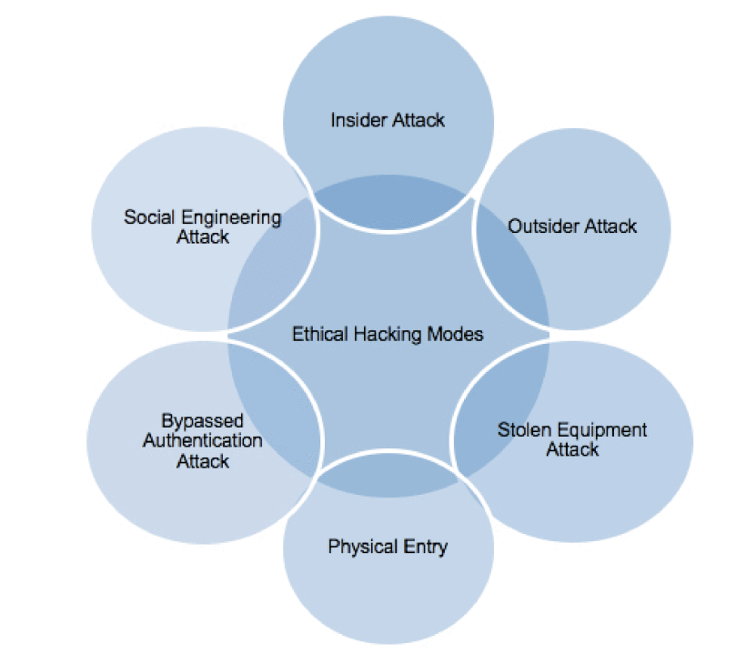
Figure 2. Ethical hacking modes [22]

2.6 Role of Ethical Hacking in Strengthening the UK Cyber Security

In today’s digital world, cybersecurity is a critical concern for businesses of all sizes.
As cyber threats become increasingly sophisticated, companies must proactively protect their sensitive data and ensure customer safety.
A press release was published on 31 August 2021 by the UK government's official website [23] stating that the Ministry of Defence (MOD) has collaborated with HackerOne to involve 26 ethical hackers in a Bug Bounty programme. The 30-day challenge aimed to identify and fix vulnerabilities in Defence’s cyber systems, enhancing security and resilience. The programme rewards ethical hackers for finding real vulnerabilities, which MOD cyber teams then address, improving the security of Defence networks and devices.
This initiative aligns with the UK government's commitment to robust security and resilience, as stated in the Integrated Review. The MOD plans to continue using Bug Bounty expertise alongside other capabilities to bolster cyber security and share lessons learned with partners [23].
Minister for the Armed Forces, James Heappey, and MOD Chief Information Security Officer, Christine Maxwell, highlighted the importance of collaboration with the ethical hacking community. They emphasized the need for transparency and innovative approaches to attract skilled personnel and improve cyber resilience.
HackerOne CEO, Marten Mickos, praised the MOD's forward-thinking approach, noting that governments worldwide are adopting similar practices to enhance their cyber defenses [23].

2.6.1 The Role of the UK Cyber Security Group
The United Kingdom’s Cyber Security Group plays a pivotal role in defending organizations against cyber-attacks and promoting best practices in cybersecurity. One key strategy they advocate is hiring “ethical hackers” to test an organization’s security [24].
The UK Cyber Security Group is a leading Managed Security Service Provider (MSSP) in the UK. Their mission is to equip organizations with robust security solutions and support them in complying with the government’s Cyber Essentials scheme. Cyber Essentials is a certification program designed to help businesses attain a basic level of cybersecurity to protect against common cyber threats [24].
In today's evolving cyber threat landscape, traditional security measures alone are inadequate. The existence of potential security vulnerabilities exposes businesses to substantial risks, including data breaches, financial harm, and reputational damage [24].
Engaging ethical hackers to perform comprehensive security assessments offers numerous advantages:
- Proactive Vulnerability Discovery
Ethical hackers can uncover vulnerabilities in an organization’s systems and networks before they can be exploited by malicious actors. This proactive approach enables companies to address security weaknesses before they escalate into serious issues [24].
- Meeting Cyber Essentials Standards:
The Cyber Essentials certification mandates that companies adhere to stringent cybersecurity practices. Regular penetration testing, facilitated by ethical hackers, is crucial for meeting these standards, ensuring compliance and robust security measures [24].
- Building Customer Confidence:
Customers entrust businesses with sensitive data, expecting it to be safeguarded. Employing ethical hackers to bolster security measures can reinforce this confidence, signaling a strong commitment to cybersecurity and customer protection [24].
- Cost-Effective Security Strengthening:
Dealing with security breaches and recovering from cyber-attacks can impose significant financial burdens on organizations. Ethical hacking presents a cost-effective method to enhance security, pre-empting potential breaches and their associated costs [24].

2.6.1 Integration of Penetration in the UK's Cybersecurity Practice
The United Kingdom is relatively advanced when it comes to cybersecurity, as it understood the importance of ethical hacking to enhance the nation’s cyber defences from the very beginning. This proactive approach can be observed in the frameworks of cybersecurity in the country where more institutions embraced ethical hacking strategies at both the national and organisational levels. The integration can be said to be anchored on the National Cyber Security Centre which is part of GCHQ set up in 2016 to enhance the cyber security of the United Kingdom. The NCSC has openly endorsed ethical hacking citing it as a powerful asset in its fight against cyber criminals [25].
The NCSC’s endorsement is not just a recommendation but an approval of IG’s policies. The NCSC which runs a government-backed certification programme called Cyber Essentials wants organisations to conduct regular vulnerability scans and penetration tests. Currently, more than 30,000 UK organisations have Cyber Essentials accreditation, proving that ethical hacking is common. Moreover, specifically for the industries classified under high risk, such as finance and energy, the NCSC’s Cyber Assessment Framework requires more serious penetration testing to keep the critical infrastructure safe [26]. It is rather interesting how ethical hacking is being adopted in the public sector. In the wake of the 2017 WannaCry ransomware attack that paralyzed the operations of some National Health Service facilities in England, the UK’s Department of Health and Social Care purchased several mocks cyberattacks to assess how secure the health service was. [27] From these tests carried out by NCC Group, several vulnerabilities were realised thus improving the firm’s security a lot. Similarly, the Ministry of Defence of the UK has been operating the so-called “Bug Bounty” since the year 2021, inviting all the ethical hackers of the world to test its networks for vulnerabilities. The program has already detected more than 300 threats in the first year of operation, including critical ones. It has been realised that ethical hacking is more popular in the private sector, particularly in financial firms. The CBEST framework that was developed by the Bank of England in 2014 was among the earliest programs in the world that incorporated threat intelligence penetration testing. CBEST hires ethical hackers aiming to mimic the threats and attempts to perform an attack on the bank and its structures, and on this basis, CBEST delivers accurate information about the potential threat to the banks [28]. In research conducted by the University of Oxford, it was revealed that institutions that participated in CBEST had achieved 35% fewer cybersecurity breaches compared to institutions that did not participate in the scheme.
Telecommunication giants such as BT and Vodafone in Britain have incorporated ethical hacking in their security systems [29]. For instance, BT has its “Red Team” employees who are in principle ethical hackers who continuously audit the company’s global network. The same year, BT said that such maneuvers enabled them to avert more than 6,500 possible assaults in a report. Vodafone, for instance, has an annual event called Bug Bounty Cup in which computer experts are invited to crack down on the firm and identify the weak points on its networks [30]. The event in 2022 was able to recognize over 150 critical issues, which again underlined the importance of cooperative Ethical Hacking. Enterprises in the UK, even start-ups and those within the small-medium enterprise category are employing ethical hacking, frequently through MSSPs. Some organisations such as the Rapid7 and NCC Group provide penetration testing as a service which means that even SMEs can hire the services of excellent ethical hackers. FSB’s poll showed that 42 percent of small businesses in the UK had employed such service by 2021, up from only 15 percent in 2018 [31]. Such widespread adoption of ethical hacking as a part of the frameworks embraced by UK cybersecurity reflects a very high level of proactivity in the protection of cyberspace. Starting from the government structures and security of important infrastructure objects through the banking and telecommunications systems to small companies, modern organisations use the services of ethical hackers. This is not an example of merely paying lip service to the inclusion of minorities; it is well established within guidelines and best practices, indicating the United Kingdom’s determination to remain competitive in the constantly changing terrain of cyber threats.

2.7 Challenges and Limitations in Penetration Testing
Penetration testing is now considered an important aspect of modern cybersecurity, but it has several drawbacks and drawbacks. These constraints vary from legal/ethical issues to technical challenges, which all raise pertinent questions for the state and development of ethical hacking paradigms. Thus, one of the most significant challenges relates to what is legal and ethical [32]. Ethical hackers perform functions that, if executed by other people, will be seen as unlawful activities. On one hand, this can create legal structures, on the other hand, it can complicate the legal processes as well. In England, ‘The Computer Misuse Act 1990’ makes hacking without permission unlawful, nevertheless, the authorization in ethical hacking is rather ambiguous. Such a contract may allow a network to be tested, but as soon the pentester stumbles across a weakness that was not a part of the contract and tries to exploit it, the pentester is doing something unethical. It is not the first time that ethical hackers have ended up receiving legal threats even with a good purpose. In one of the occurrences that took place in 2018, a security researcher was arrested for a while after he reported the weakness in Budapest’s transit system.
Pentesting exposes all kinds of information that is away from the gaze of its owner: identifiers, confidential data, business secrets, or proof of violations. In this case, all constituents of the EC-Council’s Code of Ethics conflict, especially the confidentiality clause, but what if the discovered information is criminal? According to a survey conducted by the SANS Institute in 2019, 22% of ethical hackers had to encounter legal violations during their engagements, which puts them between the rock and the hard place of client confidentiality and one’s sense of morality [33]. The second and highly demanding challenge is the scarcity of skilled personnel. Viable pentesting entails knowledge of networks, operating systems, languages, and recent hacking techniques. The constantly changing characteristics of threats aggravate the situation significantly. For ethical hackers, fresh attack methods appear like a new day, let alone a week or a month which makes it hard to keep up. The emergence of threat activity such as AI-based attacks is a real example. Cybersecurity firm Darktrace revealed in 2021 the first cases of using machine learning to devise very specific phishing emails that adjust the wording of the message to the specific manner of writing and speaking of the target [31]As we have witnessed in the sophistication of things such as the supply chain attack of 2020’s SolarWinds, existing strategies that entail network protection of an organisation have shortcomings since they do not necessarily analyse the entire supply.

The image below summarises the Pros and Cons of ethical hacking
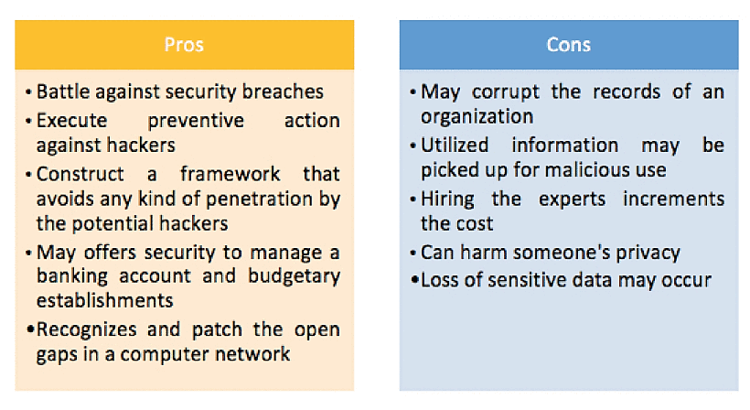
Figure 3. pros and cons [33]

2.8 Methodologies and Framework in Penetration Testing
Penetration testing (pentest) is the attempt to assess information security measures from the perspective of a potential hacker, testing the effectiveness of security controls [34].
A pentester conducting a penetration test will perform a series of security assessments to gain access to a system and exploit existing security flaws. He uses the same tools and techniques as a malicious hacker but does so in a controlled and authorized manner [34].
For a pentest to be successful, it must adopt a methodology and framework.
Several pentesting methodologies and frameworks exist currently.
For this work, only five will be discussed [34]:
- Information Systems Security Assessment Framework (ISSAF)
- Open-Source Security Testing Methodology Manual (OSSTMM)
- Open Web Application Security Project (OWASP)
- Penetration Testing Execution Standard (PTES)
- NIST Technical Guide to Information Security Testing and Assessment 800-115
- Each of these methodologies has its unique features

- The Information Systems Security Assessment Framework (ISSAF)
The ISSAF was developed by the Open Information Systems Security Group (OISSG), a non-profit organization in London, that offers a comprehensive methodology for penetration testing. This framework comprises three primary phases: planning and preparation, assessment, and reporting and clean-up. A key benefit of ISSAF is its clear mapping of tasks to the specific tools required for each task, ensuring a structured and systematic approach to penetration testing [34].
The ISSAF methodology proposes a strict sequence of steps when simulating an attack:
They include:
- Gathering Information
- Mapping the network
- Identifying vulnerabilities
- Penetrating
- Getting basic access privileges and elevating them
- Further enumeration
- Remote users/sites compromise
- Maintaining access
- Covering your tracks
- Reporting
- Clean and destroy evidence

- OSSTMM – Open-Source Security Testing Methodology Manual
The OSSTMM is a security testing framework that ISECOM (Institute for Security and Open Methodologies) developed. It is primarily used as a security auditing methodology, OSSTMM is not as detailed in the selection of tools and methods. However, it is highly effective in evaluating organizational controls to ensure compliance with regulatory standards. Access to its latest version requires a paid membership, but previous versions are available for free. [34]
OSSTMM Testing phases
- Human Security
- Physical security
- Wireless communications
- Telecommunications
- Data networks

- OWASP – Open Web Application Security Project
OWASP is a widely known and acceptable methodology used by security professionals. The non-profit organization behind it focuses on advancing software security. OWASP (Open Web Application Security Project) offers a variety of tools, guides, and testing methodologies, including the OWASP Testing Guide (OTG). The OTG is divided into three main sections: the OWASP testing framework for web application development, the web application testing methodology, and reporting [34].
Stages of the OWASP framework:
- Reconnaissance
- Scanning
- Exploitation
- Maintaining access
- Reporting

- The Penetration Testing Execution Standard (PTES)
PTES is a methodology designed to cover the essential aspects of a penetration test. It starts with the initial contact phase and proceeds through the stages of the cyber kill chain (such as vulnerability analysis, exploitation, and post-exploitation), concluding with the reporting phase. While PTES outlines the steps typically followed in a penetration test, it does not provide exact instructions on how to perform each step. Instead, it offers a general framework. Technical guidelines accompany PTES, but they are intended as approximations rather than precise instructions, recognizing that actual penetration tests will vary from client to client. The PTES also integrates other resources and frameworks, such as OWASP for web application penetration testing [34].
PTES Methodology steps
- Intelligence gathering
- Threat modeling
- Vulnerability analysis
- Exploitation and post-exploitation
- Reporting

- The National Institute of Standards and Technology (NIST)
NIST offers a manual aimed at enhancing an organization's overall cybersecurity.
This framework is designed to ensure information security across various industries, including banking, communications, and energy. Organizations of all sizes can adapt these standards to fit their unique requirements. To comply with NIST standards, companies must conduct penetration tests on their applications and networks according to predefined guidelines [34].
The methodology proposed by NIST includes
- Planning
- Discovery
- Attack
- Reporting

In summary, there are various methodologies for penetration testing, each with its unique characteristics and approaches. Security professionals should explore different frameworks and guides to gain valuable insights beyond penetration testing techniques. This knowledge will enhance their overall approach to organizational security, making it a worthwhile investment of time.
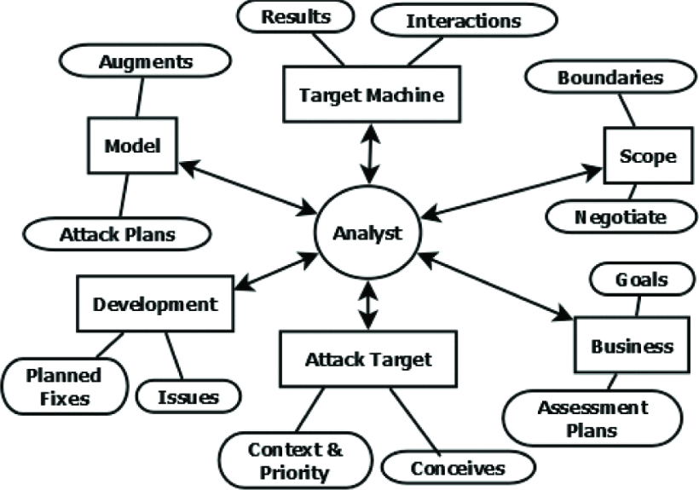
Figure 4 penetration testing pattern [22]

2.8.1 Penetration Testing Tools
Pen testers have a wide range of tools and approaches to examine network weaknesses from all angles. These resources are invaluable in evaluating potential vulnerabilities that might be overlooked in the battle against cyber threats. This is why ethical hacking is considered a crucial aspect of contemporary security and network protection [35].
- Nmap
Nmap is an open-source tool for the discovery of networks and doing some security auditing on it. Nmap was developed by Gordon Lyon, as a security auditing and network discovery tool. Nmap can quickly and easily scan networks to determine which hosts are up, what services they offer, and what OS they are running. This makes Nmap excellent for discovering open ports and services that could provide entry points for attackers. For instance, an open port with an outdated service could act as a soft target [36]. Nmap has been shown to identify more than 95% of network services in a protected environment, making it highly credible in determining network topology [37].
Discovery of the network includes the discovery of Hosts and services and once this is done, we will have a scan on the ports (Scan types include TCP SYN scan, TCP connect Scan, UDP scan, and Intense Scan). Below is my approach to it.
- Metasploit
Metasploit is a free penetration testing software used for developing, testing, and executing exploit code [38]. Developed by H.D. Moore and managed by Rapid7, Metasploit hosts a vast number of known exploits and demonstrates the effectiveness of various attacks. For example, if Nmap identifies a host running an older version of Apache, Metasploit can exploit known vulnerabilities in that version [39]. Tools like Metasploit can reduce successful attacks by up to 90% if used in penetration testing, as they help identify critical vulnerabilities before they are exploited.
- Wireshark
Wireshark is the most effective tool for network traffic analysis. Developed independently by Gerald Combs, Wireshark is a packet analyzer that facilitates the detailed examination of network traffic [40]. It can capture and display packets, revealing unencrypted channels, passwords, or signs of malware activity [41]. Wireshark has been used to identify data exfiltration attempts by detecting abnormally high traffic out of the network, showcasing its effectiveness in detecting subtle changes in network traffic patterns.
- Vulnerability Scanners (Nessus, OpenVAS)
Vulnerability scanning is a basic method in ethical hacking, conducted with programs that search for known weaknesses in a network. Tools like Nessus and OpenVAS operate against databases of known vulnerabilities and generate reports [42]. Using multiple vulnerability scanners can detect approximately 60% more vulnerabilities than using a single tool. This method goes beyond vulnerability assessment by targeting known vulnerabilities and attempting to penetrate deeper into the network.

- Social Engineering Tools (Social-Engineer Toolkit)
Social engineering exploits the human element of security. Tools like the Social-Engineer Toolkit help create phishing emails and fake web pages to test an organization's susceptibility to social engineering attacks. Social engineering is considered an art, that relies on psychological manipulation. A famous example involves Kevin Mitnick, who hacked Motorola by convincing an employee to grant him access. Ethical hackers must test human vulnerabilities to ensure comprehensive security [43].
- Burp Suite
Burp Suite, developed by PortSwigger, is a benchmark tool for web application security assessment. It can alter HTTP connections, making it easy for testers to check for vulnerabilities like SQL injection or cross-site scripting. A 2019 study by Whitehat Security found that more than a third of web apps examined had such issues, many detected using tools like Burp Suite [44].
Studies have shown the effectiveness of these tools in discovering vulnerabilities and enhancing the security of a network. IBM X-Force researcher analyzed data from over 13,000 penetration tests performed between 2018 and 2020 [45], revealing that in 26% of cases, the above-mentioned tools achieved the objectives of a penetration test, with web application and network-related issues being the most reported. Another study by FireEye in 2020 showed that organizations adopting penetration testing experienced 53% fewer security incidents than those that did not [46]. These tools and methodologies are essential for identifying and mitigating vulnerabilities, making penetration testing a vital practice in contemporary cybersecurity.

2.9 Common Cybersecurity Breaches Faced by SMES
  - Phishing Attacks
Phishing attacks involve tricking individuals into providing sensitive information by posing as a trustworthy entity. This often involves emails, fake websites, or messages that appear legitimate but are designed to steal credentials or distribute malware.
Mode of attack: This attack is perpetuated by a threat actor who creates fake but realistic phishing emails and sends them to users’ clients or employees of a company to trick them into clicking a phishing link to steal their private data. Tools like GoPhish or PhishMe can be used to design and manage phishing campaigns. [47]
Prevention:
- Implementing robust email filtering solutions.
- Educating users about identifying phishing attempts.
- Enforcing multi-factor authentication (MFA).

  - Privilege Escalation
Privilege escalation occurs when an attacker exploits vulnerabilities in a system to gain elevated access to resources that are normally protected. This can be achieved through exploiting software bugs, misconfigurations, or taking advantage of system design flaws
Mode of attack: gaining access to a vulnerable system with known bugs or misconfigurations that allow for privilege escalation. Tools like Metasploit can be used to test various privilege escalation techniques [48].
Prevention:
- Regularly patching and updating systems.
- Implementing the principle of least privilege (PoLP).
- Using security controls like SELinux or AppArmor to restrict capabilities.

  - Social Engineering Attacks
Social engineering attacks occur when a threat actor attempts to manipulate people into divulging confidential information. This can include tactics like pretexting, baiting, or tailgating, relying heavily on human interaction and psychological manipulation [49].
Mode of attack: This attack involves creating realistic scenarios that test the human element of security. This usually involves phone-based vishing attempts, in-person impersonation, or baiting with infected USB drives.
Prevention:
- Training employees to recognize and respond to social engineering tactics.
- Establishing clear protocols for verifying identities and requests.
- Limiting the amount of publicly available information about the organization and its employees [50].

  - Denial of Service (DoS) Attacks
DoS attacks aim to make a service unavailable by overwhelming it with traffic or exploiting vulnerabilities to crash the service. Distributed Denial of Service (DDoS) attacks involve multiple systems targeting a single service [51].
Mode of attack: Simulating DoS attacks can be done using tools like LOIC (Low Orbit Ion Cannon) or Hping to generate traffic that overwhelms the network or service. It’s important to conduct these simulations in a controlled and isolated environment to prevent unintended disruptions.
Prevention:
- Deploying rate limiting and traffic filtering.
- Using anti-DDoS services and solutions.
- Implementing redundant and scalable infrastructure.

Chapter 3: Research Methodology

3.1 Introduction
This chapter outlines the research methodology used to investigate the role of penetration testing in enhancing the cybersecurity posture of small, medium, and large enterprises (SMEs) in the UK. The research is conducted using the research onion framework, which provides a structured approach to the research process [52]
The article "Research Onion: A Systematic Approach for Designing Research Methodology" by [52] discusses the Research Onion model, a framework created by [53]. to aid researchers in systematically designing and executing research. The model comprises six layers: philosophies (research paradigms like positivism and interpretivism), approaches (deductive and inductive), strategies (methods like experiments and case studies), choices (mono-method, mixed-method, multi-method), time horizons (cross-sectional and longitudinal), and techniques and procedures (specific data collection and analysis methods). By following these layers from the outermost to the innermost, researchers can ensure their methodology is coherent, rigorous, and well-aligned with their research objectives, thereby enhancing the overall quality and validity of their studies. [52]
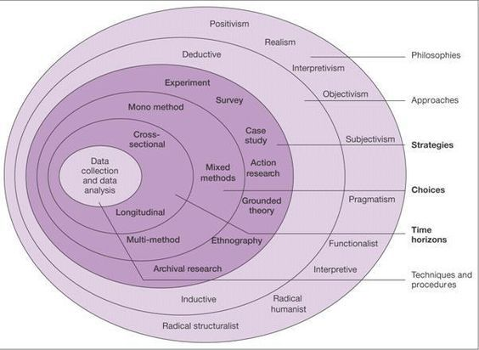

Figure 5 research onion structure [45] [52]

3.2 Research Method
Qualitative Research Method: The work utilizes a qualitative method to collect and analyze secondary data. This method is appropriate for exploring the depth and richness of experiences and practices related to penetration testing in SMEs.
The rationale for choosing a qualitative research method is rooted in the need for deep, contextual, and flexible exploration of the role of penetration testing in enhancing SMEs' cybersecurity posture. The implications and rationale of this choice highlight the potential for comprehensive insights, practical recommendations, informed policies, and future research directions, all of which can significantly contribute to the cybersecurity landscape for SMEs in the UK.

3.3 Research Philosophy
Interpretivism: This work adopts an interpretivist philosophy, focusing on understanding the subjective experiences and contexts of SMEs about penetration testing. Interpretivism is suitable for qualitative research, as it allows for an in-depth exploration of complex social phenomena and the meanings individuals or organizations attach to them.
Rationale: Interpretivism is suitable for understanding the complexities of cybersecurity and penetration testing within SMEs. It allows for a deep exploration of subjective experiences, insights, and practices related to penetration testing in enhancing cybersecurity.
Implications: This philosophy focuses on understanding the context and meaning of cybersecurity practices and how they vary across different organizations.

3.4 Research Approach
Inductive Approach: An inductive approach is employed for this work, allowing theories and insights to emerge from the analysis of qualitative data. This approach is beneficial for exploring new or under-researched areas, such as the specific impact of penetration testing on SMEs' cybersecurity posture.
Rationale: The inductive approach is fitting as it allows for the development of theories based on the observed patterns and findings from secondary qualitative data.
Implications: This approach will enable you to generate insights and hypotheses about the impact of penetration testing on SMEs’ cybersecurity posture, which can be further explored or tested in future research.

3.5 Research Strategy
Case Study: The research strategy adopted for this work is a case study. This strategy facilitates an in-depth examination of the role of penetration testing in specific SMEs. Case studies are particularly useful for gaining a comprehensive understanding of a particular phenomenon within its real-life context.
Rationale: A case study strategy is appropriate for an in-depth investigation of how penetration testing enhances cybersecurity within SMEs. It allows for detailed exploration of specific instances or examples.
Implications: This strategy will help in understanding the particularities of each case and drawing meaningful conclusions about the broader context.

3.6 Research Choice
Mono Method: This work employs a mono method, using qualitative data exclusively.
This choice ensures a focused and detailed exploration of the research topic, allowing for a nuanced understanding of the impact of penetration testing on SMEs.
Rationale: Given that the data is secondary and qualitative, a mono-method qualitative choice is appropriate. This choice focuses on collecting and analyzing qualitative data to explore the research questions.
Implications: This choice will streamline your research process and ensure a thorough analysis of the qualitative data available.

3.7 Time Horizon
Cross-Sectional: A cross-sectional time horizon is adopted, analyzing data at a single point in time. This approach is suitable for capturing the current state of cybersecurity posture among SMEs and understanding how penetration testing is impacting them at present.
Rationale: A cross-sectional time horizon is suitable for this research as it involves analyzing data at a single point in time to understand the current state of cybersecurity and penetration testing practices in SMEs.
Implications: This time horizon will provide a snapshot of the current cybersecurity posture and practices among SMEs in the UK.

3.8 Data Collection and Analysis

3.8.1 Data Collection
Secondary Data: The data for this research is collected from existing sources, including academic journals, industry reports, case studies, and other relevant documents. These sources provide comprehensive insights into how penetration testing affects the cybersecurity measures, vulnerabilities, and compliance standards of SMEs in the UK.
Rationale: Secondary data will be collected from existing research studies, industry reports, cybersecurity assessments, case studies, and other relevant documents.
Implications: This method leverages existing knowledge and data, providing a cost-effective and time-efficient way to gather information relevant to your research questions.

3.8.2 Data Analysis
Thematic Analysis: Thematic analysis is used to analyze the qualitative secondary data. This method involves identifying, analyzing, and reporting patterns or themes within the data. Thematic analysis allows for a systematic examination of the data to uncover key themes related to the role of penetration testing in enhancing the cybersecurity posture of SMEs.
Rationale: Thematic analysis is a qualitative data analysis method that is appropriate for identifying, analyzing, and reporting patterns (themes) within the data.
Implications: This analysis will help in organizing and interpreting the qualitative data to understand the role of penetration testing in enhancing cybersecurity posture. Themes related to vulnerabilities, security improvements, and compliance will be particularly important.

In summary, this methodology framework provides a structured approach to investigating how penetration testing can enhance the cybersecurity posture of SMEs in the UK by identifying vulnerabilities, improving security measures, and ensuring compliance with industry standards.

3.9 Project Plan, Contingency Plan, and System Specification
This project plan and contingency plan, along with the Gantt chart, provide a structured approach to completing this work.

3.9.1 Project Plan
- Chapter One (March-April 2024)
- Define Objectives: Clarifying research goals and objectives.
- Literature Review: (April – June 2024)
- Conducting a preliminary literature review to identify key sources.
- Chapter 3: Methodology Planning (May 2024)
- Finalizing the research methodology, including the interpretivist philosophy, inductive approach, case study strategy, mono method, cross-sectional time horizon, qualitative research method, and thematic analysis.
- Data Collection and Analysis (May 2024)
- Identify Secondary Data Sources: Identifying and gathering relevant secondary data from academic journals, industry reports, case studies, etc.

- Data Analysis
- Conduct Thematic Analysis: Analyze the qualitative data to identify key themes and patterns related to penetration testing and cybersecurity posture.
- Interpret Results: Interpret the results within the context of the research questions and objectives.
- Chapter 4 (Design and Implementation) (May - June 2024)
- Discuss the proposed experiment, including the design and implementation phase
- Chapter 5: Testing and Results
- Final Submission Preparation: Format the dissertation according to the university guidelines and prepare it for submission.
- Chapter 5: Conclusion, Review, and Submission (June - 4th July 2024)
- Final Review: Conduct a final review of the dissertation. Review the dissertation chapters including the Introduction, Literature Review, Methodology, Data Analysis, Results, and Conclusion.
- Submit Dissertation: Submit the completed dissertation on or before 4th July 2024.

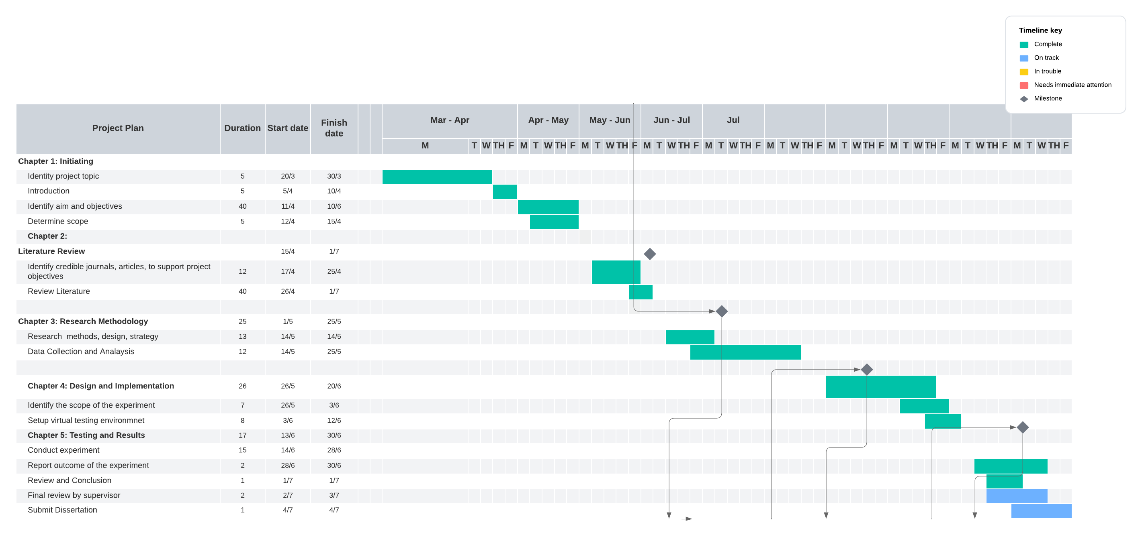
3.9.2 GANTT CHART
Figure 6. Gantt Chart

3.9.3 Contingency Plan
- Delays in Data Collection:
Alternative Sources: a list of alternative sources ready if primary data sources are inaccessible.
- Extended Deadlines: Allow for additional time in the schedule for data collection if needed.
Issues with Data Analysis:
Additional Training: Allocate time for additional training or consultation on thematic analysis if challenges arise.
Software Backup: Use reliable qualitative analysis software and have a backup option in case of technical issues.
- Writing Delays:
Set Milestones: Break down writing tasks into smaller milestones with specific deadlines to ensure steady progress.
Seek Feedback Early: Get feedback on draft sections from supervisors early to avoid major revisions later.
- Technical Issues:
Backup Data Regularly: Ensure that all data and drafts are regularly backed up on multiple platforms (cloud storage, external hard drives, etc.).
Access to Resources: Ensure continuous access to necessary software and databases through contingency plans like remote access or alternate logins.
- Health and Personal Issues:
Health Measures: Maintain a healthy work-life balance to prevent burnout.
Flexible Schedule: Allow for some flexibility in the schedule to accommodate unforeseen personal issues.

3.9.4 System Specification
Host System Specifications
The host system is the physical machine that will run the virtual environment. It should have sufficient resources to support multiple VMs running concurrently.
Processor (CPU):
Quad-core CPU (Intel i5/i7 ) or better
Virtualization support (VT-x for Intel)
Memory (RAM):
Minimum: 16 GB
Recommended: 32 GB or more
Storage: SSD with at least 512 GB of available space
Windows 7 and 10, macOS, and a Linux distribution (metasploitable2 Ubuntu, Fedora, etc.)
Virtual Machine Specifications
Each VM will represent different systems in the simulated network, including target machines and the attacker's machine.
Attacker's Machine (Kali Linux VM):
Processor: 2 virtual CPUs
Memory: 4 GB RAM (minimum), 8 GB RAM (recommended)
Storage: 50 GB virtual hard disk (VHD)
Network: Bridged adapter or NAT

Target Machines (Windows/Linux Servers and Clients)
Processor: 1-2 virtual CPUs per VM
Memory: 2-4 GB RAM per VM
Storage: 30-50 GB VHD per VM

Network: NAT Network
Virtualization Software: VirtualBox (latest version)
Additional Tools: VirtualBox Extension Pack (for USB 2.0/3.0 support, etc.)

Attacker's Machine:
Operating System: Kali Linux (latest version)
Penetration Testing Tools:
Metasploit
Nmap
Nessus/OpenVAS
Burp Suite
John the Ripper/Hashcat
Social Engineering Toolkit (SET)
Target Machines:
Operating System: Ubuntu Server (Metasploitable2)
Software: Nessus or OpenVAS
Network Configuration
Network Topology:

Chapter 4
Design and Implementation
4.1 Introduction
This chapter discusses the design and implementation phase of this work, it outlines the design phase of how the experiment will be performed, what type of devices to use for the setup, and how testing methodology to use for the experiment.

4.2 Problem Formulation
To help in achieving the aim of this chapter, this work has formulated a case study that describes a certain company that suspects its network system might be vulnerable to possible cyber breaches.

4.3 CASE STUDY: Cyber Security Concerns at Tech Solutions Inc.
4.3.1 Background
Tech Solutions Inc. is a small-sized production company specializing in creating custom enterprise solutions. Over the past few months, the company has grown significantly, adding more clients and employees, which has increased the complexity of its network infrastructure. The IT department has noticed unusual activity, and the management is concerned that the network might be vulnerable to cyber-attacks. To ensure their network's security, they decide to hire an ethical hacker to perform a comprehensive penetration test.

4.3.2 Objective
The objective is to identify potential vulnerabilities in the network, including susceptibility to phishing attacks, privilege escalation, social engineering attacks, and Denial of service attacks.
To achieve this, a virtual network environment will be set and configured to represent Tech Solutions Limited, using a virtual box and virtual machines.

4.4 Setting up the virtual environment
In setting up this virtual environment, numerous factors were taken into account, including the scope of the attacks, legal and ethical considerations, and the safety and security of data, tools, and resources. The simulation was configured on a VirtualBox, using four virtual machines, each with an ISO operating system installed, all connected through a NAT Network to facilitate communication between the virtual machines. All virtual machines were assigned IP addresses using the IP range 10.10.10.0/24.

4.4 Configuration Settings
- Kali Linux machine: This will act as the attacker machine. It will be used to exploit other machines on the network. IP Address: 10.10.10.4
- Metasploitable2: This machine will be the victim machine with an IP address 10.10.10.5
- Windows 10: This machine is more vulnerable than metasploitable2. It assigned an IP address of 10.10.10.6
- Windows 7: This machine is set up to be a client machine, and is assigned an IP address of 10.10.10.7
These IP addresses were dynamically assigned by the virtual box network adapter

This configuration setting is represented in the logical topology network, as seen in figure 7.

4.5 Logical Topology
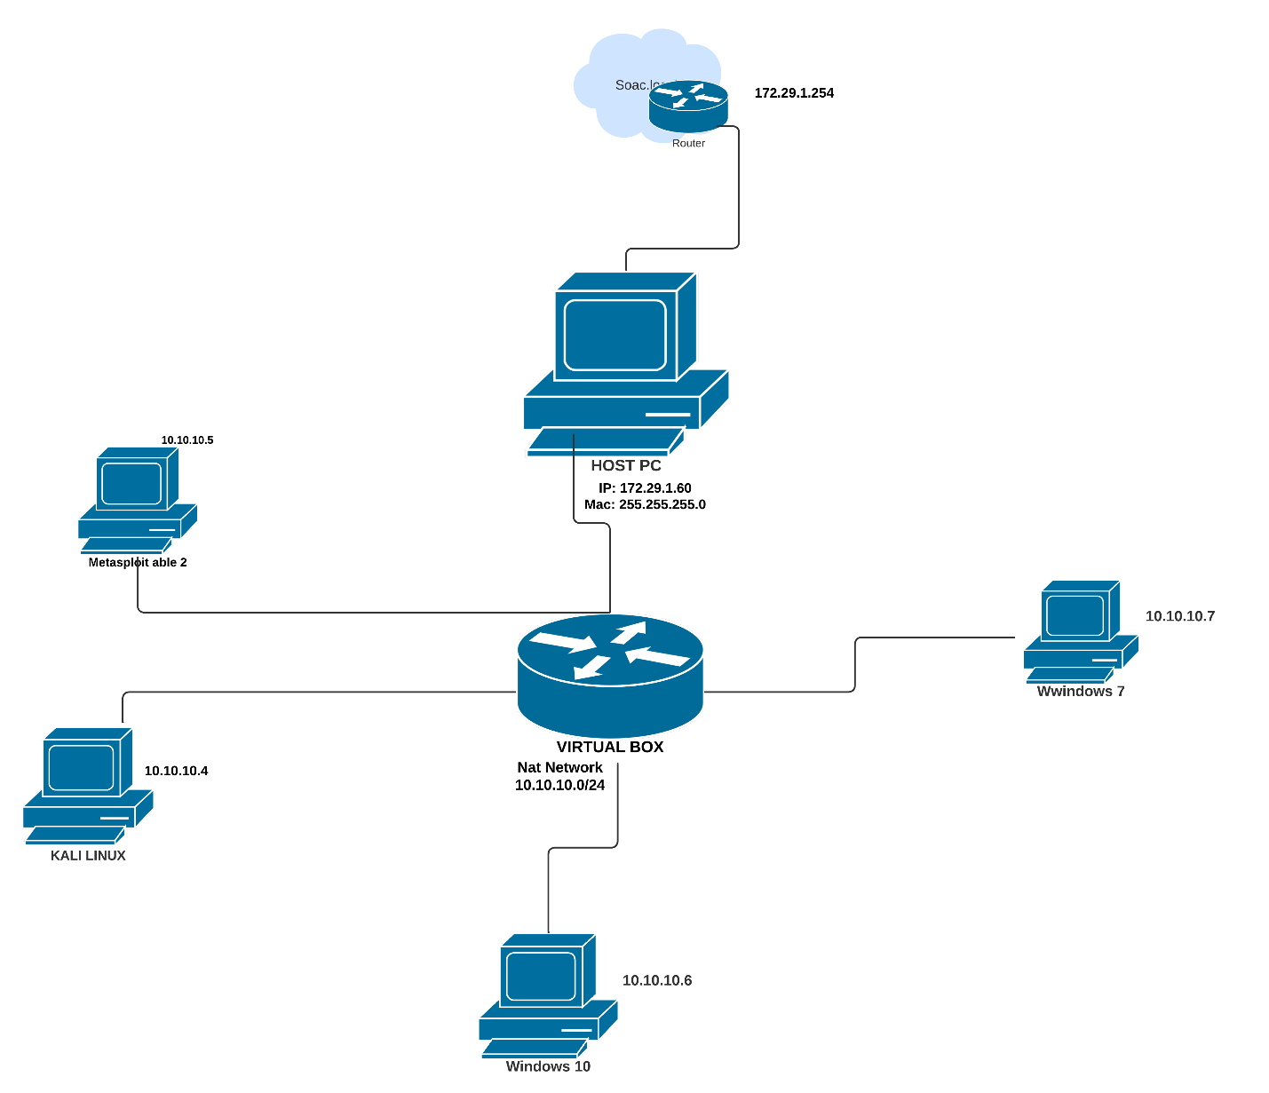
Figure 7. Logical topology

This logical network topology represents the network setup for Tech Solutions Limited

4.6 Virtual Network Setup

Below is a screenshot of the virtual network setup representing the Tech Solutions Inc. network. This setup has four virtual machines; Kali linux, Metasploitable 2, Windows 7, and Windows 10.
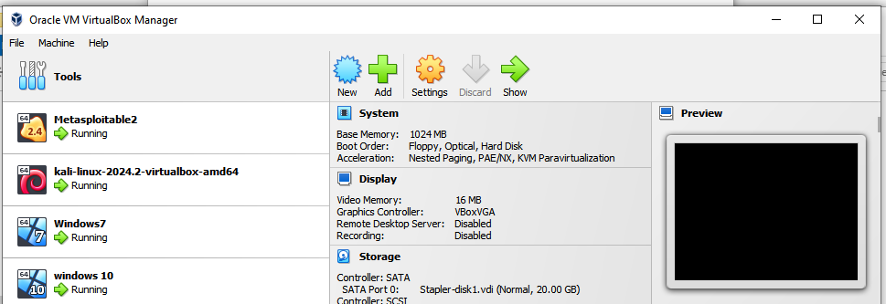

This network setup is just a testing environment to determine

4.7 Adopted Testing Methodology
Based on the different penetration methodologies discussed in chapter two of this work, the Penetration Testing Execution Standard (PTES) is adopted as the methodology designed to cover the essential aspects of this penetration test simulation. [34].
PTES Methodology steps include:
- Intelligence gathering
- Threat modeling
- Vulnerability analysis
- Exploitation and post-exploitation
- Reporting

Using the PTES standard, this is the flow of the penetration testing simulation phases.
1. Pre-engagement Interactions
Objective: Establish the scope, objectives, and logistics of the penetration test.
Activities:
Scope: Assess the network security of the company, including the cybersecurity awareness level of the employees.
Objectives: Determine the risk level of the network and propose adequate mitigations and recommendations.
Legal Considerations: Ensure all legal and compliance requirements are addressed, including obtaining proper authorizations.
Logistics: Schedule testing times and identify key contacts within the company.

2. Intelligence Gathering (Reconnaissance)
Objective: Collect information about the target network and systems to identify potential attack vectors.
Activities:
Passive Reconnaissance: Gather publicly available information about Tech Solutions Inc., including domain names, IP addresses, and employee details.
Active Reconnaissance: Use tools like Nmap to map the network, and identify active devices, open ports, and running services.

3. Threat Modeling
Objective: Develop a strategy to prioritize and approach potential vulnerabilities based on the gathered intelligence.
Activities:
Identify Assets: List critical assets that could be targeted, such as customer data, financial records, and intellectual property.
Identify Threats: Consider possible threats like phishing, malware, network exploitation, and privilege escalation.
Prioritize Risks: Assess the likelihood and potential impact of each threat to prioritize testing efforts.

4. Vulnerability Analysis
Objective: Identify vulnerabilities in the network, systems, and applications.
Activities:
Automated Scanning: Use tools like Nessus, OpenVAS, and Burp Suite to scan for known vulnerabilities.
Manual Analysis: Manually verify scan results and conduct in-depth analysis of specific systems and applications.
Phishing Simulation: Craft and send phishing emails to employees to test their susceptibility to social engineering attacks.

5. Exploitation
Objective: Attempt to exploit identified vulnerabilities to gain unauthorized access and demonstrate potential risks.
Activities:
Network Exploitation: Use tools like Metasploit to exploit network service vulnerabilities.
Web Application Attacks: Perform SQL injection, cross-site scripting (XSS), and other web application attacks.
Phishing Exploitation: Capture credentials from employees who fall for phishing emails.
Privilege Escalation: Use local exploits and weak password attacks to gain higher privileges on compromised systems.
6. Post-Exploitation
Objective: Assess the extent of access gained and potential damage that could be inflicted.
Activities:
Persistence Mechanisms: Install backdoors or scheduled tasks to maintain access to compromised systems.
Data Exfiltration: Simulate data theft by extracting sensitive information to demonstrate potential data loss.
Network Pivoting: Use compromised systems to access other parts of the network and expand the attack.

7. Reporting
Objective: Document findings, provide evidence, and offer recommendations to improve security.
Activities:
Detailed Report: Compile a comprehensive report that includes an executive summary, methodology, detailed findings, exploitation steps, and the impact of successful attacks.
Evidence Documentation: Include screenshots, logs, and other evidence to support findings.
Recommendations: Offer actionable steps to remediate identified vulnerabilities and enhance overall security posture.

8. Post-Engagement
Objective: Ensure that the company can remediate vulnerabilities and improve security based on the findings.
Activities:
Debriefing: Conduct a debriefing session with Tech Solutions Inc.'s management and IT team to discuss findings and recommendations.
Remediation Support: Provide guidance and support for implementing recommended security measures.
Follow-Up Testing: Schedule follow-up tests to verify that vulnerabilities have been successfully remediated and that security improvements are effective.
For this simulation, at least 4 attacks will be conducted, including phishing, privilege escalation, Denial of service attack, and social engineering, etc.

4.8 Flowchart Diagram

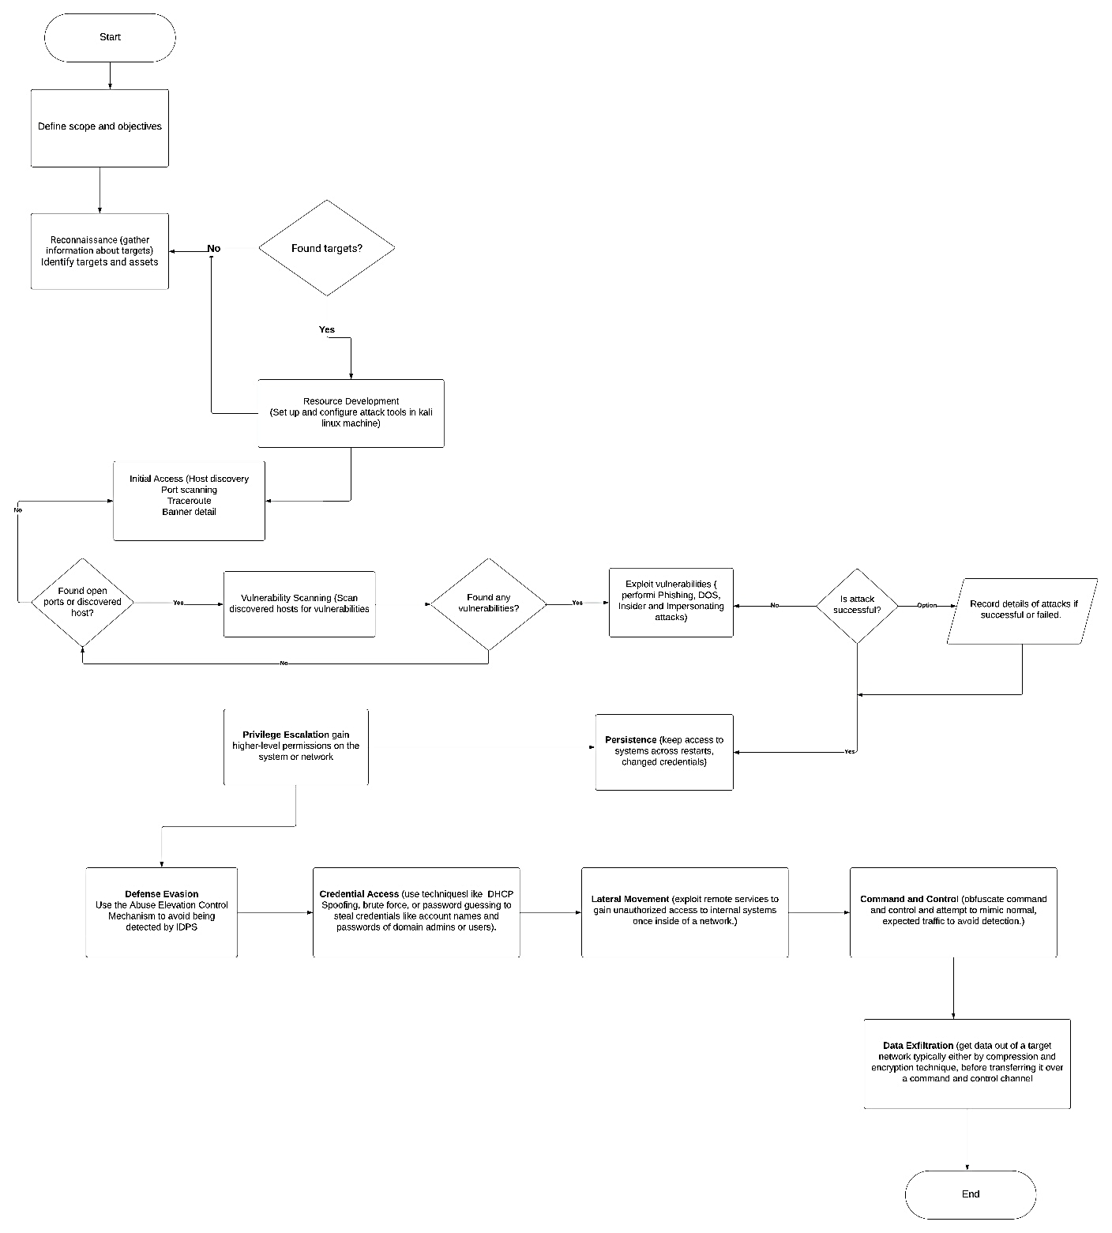
This flowchart represents the flow of the proposed penetration testing simulation.

Chapter 5

Testing and Results

5.1 Introduction
This chapter discusses the experiment simulation and outcomes. Each attack discussed and proposed in chapters two and four will be executed and analyzed.

By adopting the Penetration Testing Execution Standard (PTES) methodology, the first thing to do is to gather information about the network, including types of operating systems, IP addresses, open ports, and configuration settings.

5.2 Privilege Escalation
- Reconnaissance
Performed a network scan using an IP range of 10.10.10.0/24, to discover hosts that are up and running address (sudo net discover -I eth0 -r 10.10.10.0/24)

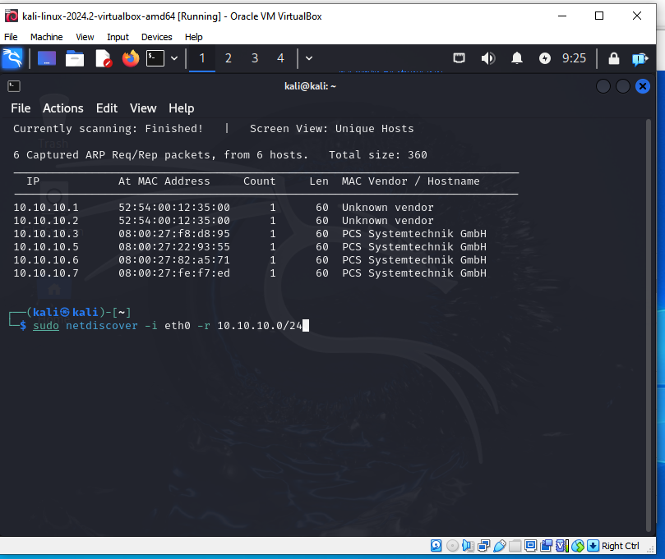

Figure 8. Host IP address discovery

From this screenshot, 6 hosts were discovered. Two hosts are from unknown vendors, while 4 hosts are known, indicating that they are computer devices. From our network topology in Chapter 4, these known IP addresses match those in the topology.
The next phase is to further identify more details about the hosts on the network, so a ping sweep command was executed using the nmap command “nmap -sn 10.10.10.0/24”

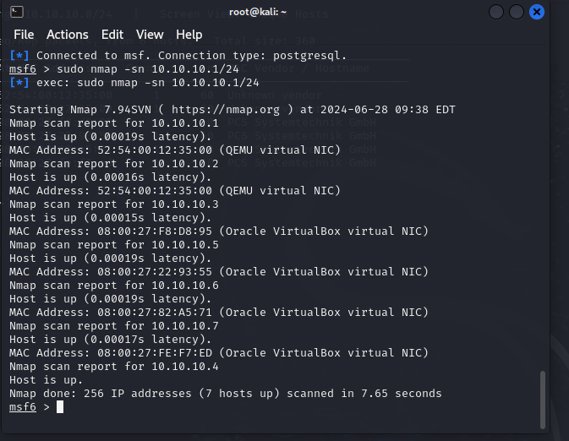
Figure 9. Nmap hosts scan
From the above screenshot, we discovered more hosts that are running, but our focus will be on those hosts running on Oracle VirtualBox which are 10.10.10.5 (Metasploaitable2), 10.10.10.6 (Windows10, 10.10.10.7(Windows7), and 10.10.10.4 (Kali machine).

A further scan to discover what operating system is running on the devices using the nmap command “nmap -A -TA 10.10.10.7” (windows7)
The screenshot below shows the Nmap scan for Windows, unfortunately, it didn't show the operating system, and all ports are in ignored states. This means that the patch has been fixed. This same scan was performed for Windows 10 and the result is the same.

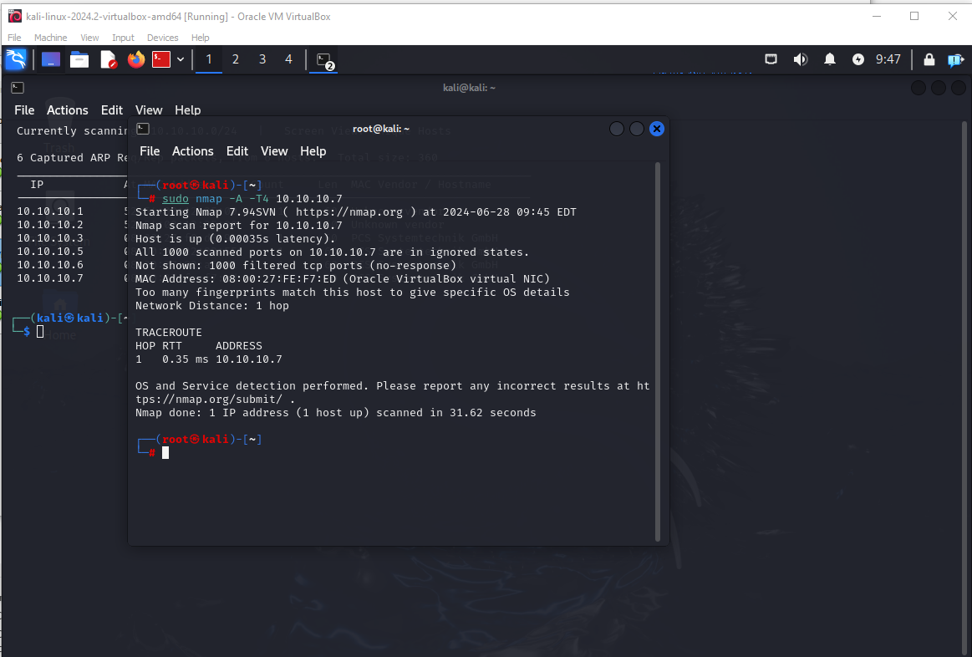

Figure 10. Nmap service discovery for Windows machine
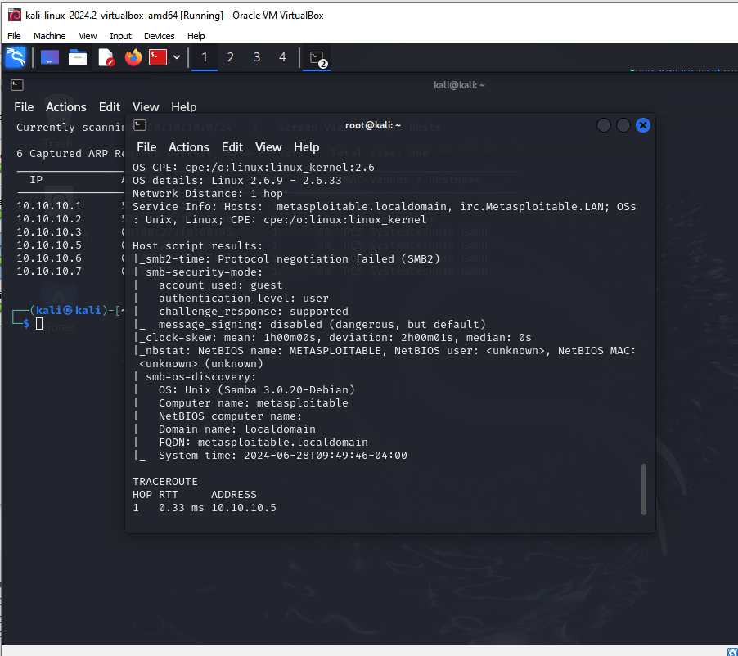

Figure 11. Nmap service discovery for metasploitable
The command “nmap -A -TA 10.10.10.5” performs a comprehensive scan of the target network or hosts, including OS detection, version detection, script scanning, and traceroute, at an aggressive speed to quickly gather detailed information. From the picture above, we can see almost all information about the computer, the type of OS(Unix, Linux) running on the device, the computer name (metasploitable), traceroute, system time and date, etc. With this information at our disposal, we can exploit the system.

The Nmap command “nmap -sV 10. 10.10.5” scans the specified IP address and attempts to detect the versions of the services running on the open ports. This can help identify the software and its versions for further analysis or vulnerability assessment.
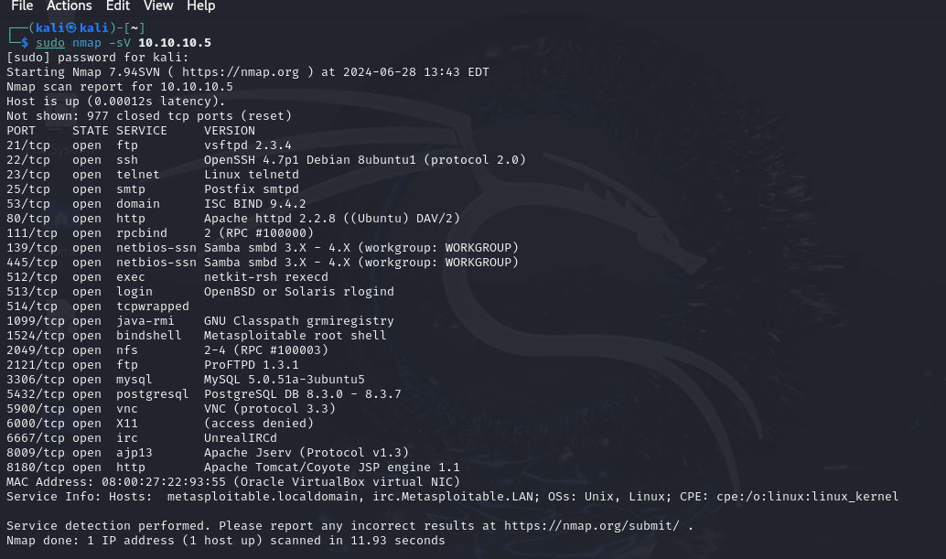
As seen below, all services running on this computer can identified. Ports 21, 22, 23, etc are all open.

Figure 12. Nmap ports discovery
- Threat Modelling
Doing quick research on different threats in Windows 7, the most well-known Windows threat is Eternalblue. Eternal Blue is an exploit that targets vulnerabilities in the SMBv1 protocol of older Microsoft operating systems. SMBv1, developed in 1983, allows Windows machines to share files, printers, and ports. EternalBlue takes advantage of flaws in how Windows handles specially crafted data packets, allowing attackers to send malicious packets that propagate malware across the network. The exploit, identified as CVE-2017-0144, can be fully mitigated by applying Microsoft's patch, which closes the security gap. However, protection is only ensured if the patch is installed on all vulnerable systems [54].

- Gaining Access / Exploitation
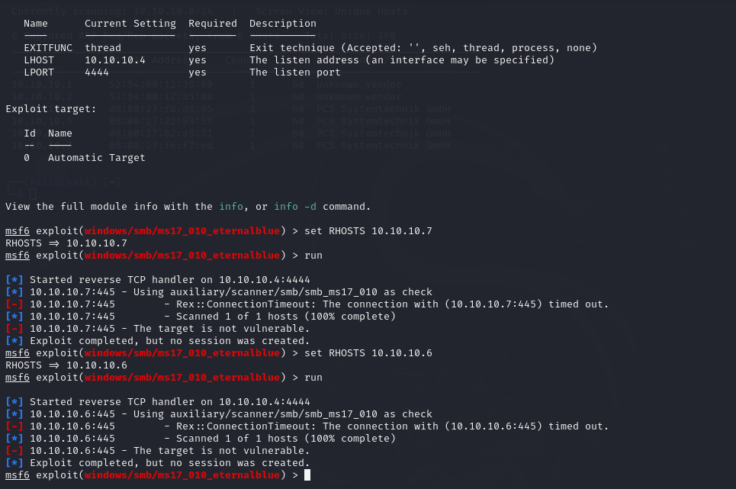
Utilizing the eternalble vulnerability to try to gain access to the Windows machine using the eternalblue exploit in Metasploit “windows/smb/ms17_010_eternalblue” with a reverse TCP handler on on the IP addresses “10.10.10.6 and 10.10.10.7”, it shows that these targets are not vulnerable to eternalblue vulnerability. Hence the attack was unsuccessful.

Figure 13. Eternalblue vulnerability
Since we were able to discover open ports and services on the metasploitable device with IP 10.10.10.5, we will attempt to gain remote access to the device.
A quick Nmap host discovery scan to detect the service version of TCP port 21, which is a file transfer protocol with the command “nmap -A -T4 10.10.10.5” showed Vsftcp 2.3.4 as the version of the port, and the status is open, as seen below.

- Vulnerability Analysis
Searching for exploits using the search exploit command with the TCP version “searchsploit vsftpd 2.3.4”, we discovered a Backdoor command Execution vulnerability, as seen below.
The vsftpd 2.3.4 vulnerability related to the ALPACA TLS protocol content confusion attack allows remote attackers to redirect traffic between subdomains, leading to potential security breaches. The key to preventing exploitation is to ensure that software updates and patches are applied promptly and that security configurations are properly managed.

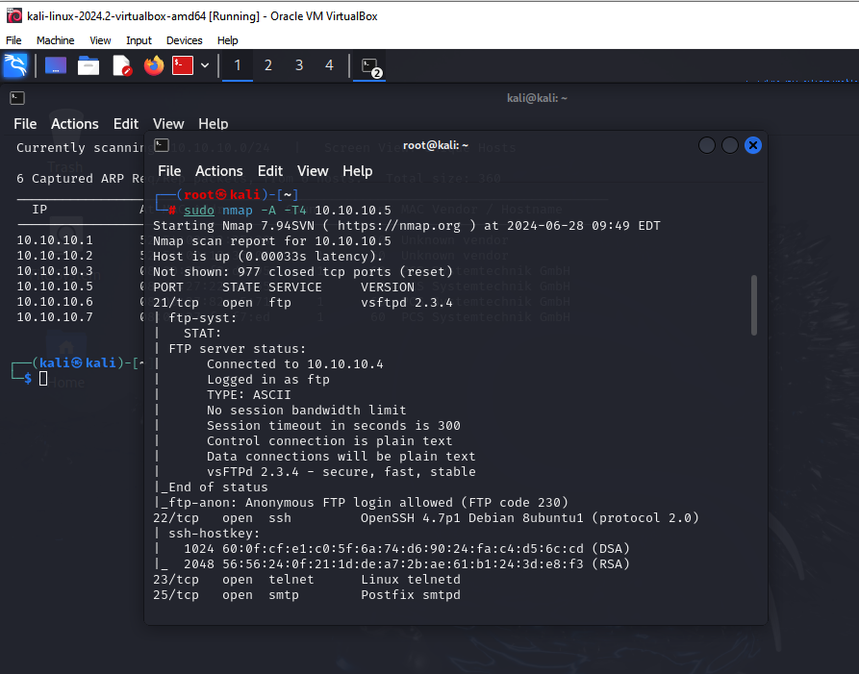

Figure 14. Vsftcp vulnerability discovery

- Exploitation and Post-exploitation
To exploit this vulnerability, the Metasploit framework is used to exploit this vulnerability. Metasploit is a powerful penetration testing framework widely used by security professionals to identify and exploit vulnerabilities in systems. The latest version of Metasploit is v6.4.9-dev. It contains 2420 exploits and 1468 payloads.
Msf6> search vsftpd 2.3.4
msf > use exploit/unix/ftp/vsftpd_234_backdoor
“Show info or show options” display information about the exploit, as seen in the screenshot

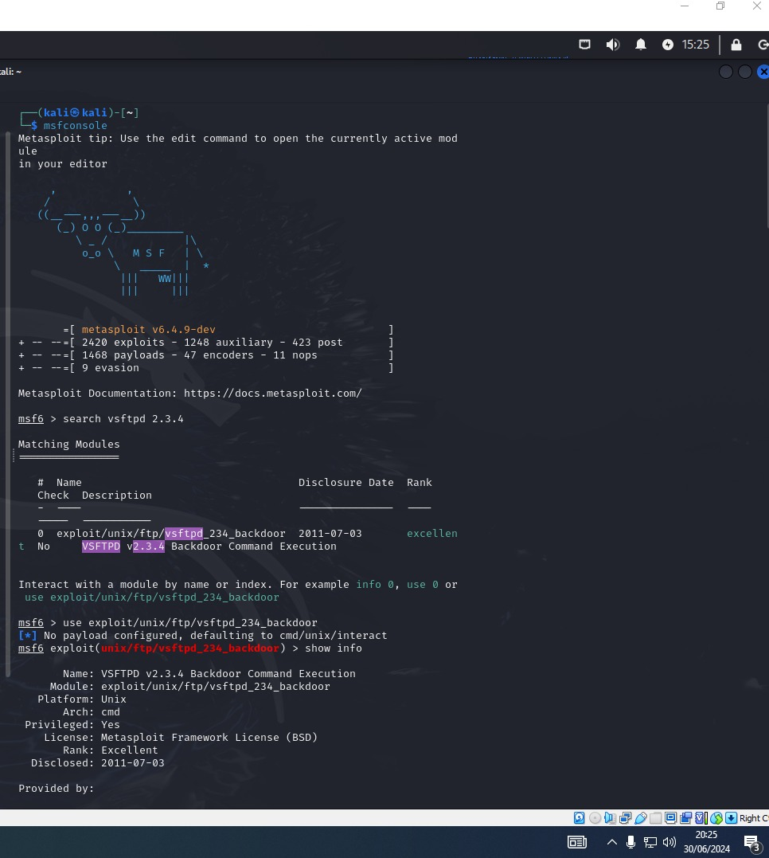

Figure 15.vsftcp exploit

- Show Available Targets:
msf exploit(vsftpd_234_backdoor) > show targets
Lists the potential targets that the exploit can be used against. From the screenshot below, details about the backdoor exploit are seen, as the potential target.
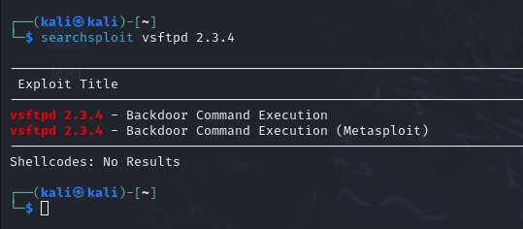

Figure 16. Backdoor exploit attack
- Set Target:
msf exploit(vsftpd_234_backdoor) > set RHOSTS 10.10.10.5
Specifies the target system to be exploited.
Displays the required options (e.g., target IP) and allows you to configure them.
Execute Exploit:
msf exploit(vsftpd_234_backdoor) > exploit
Runs the exploit with the configured options to attempt to compromise the target.
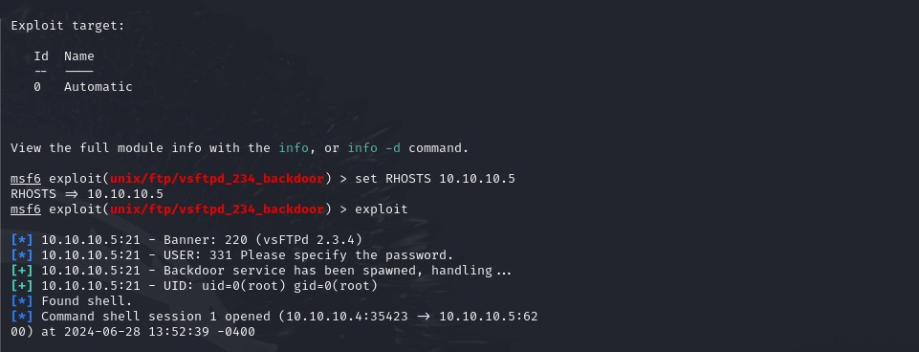
Figure 17. Backdoor Exploit initiated
As the exploit is executed, we can see that the command shell session is opened and the attacker UID has been elevated to a root privilege user.

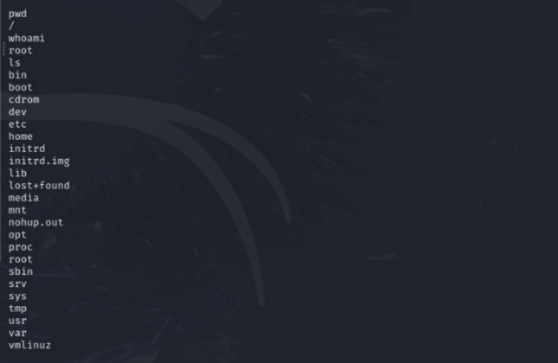
To check the attacker's privilege, the “whoami” command is executed, and it shows that the attacker has a root privilege, and can see all the directories on the computer.
Figure 18. Privilege root access
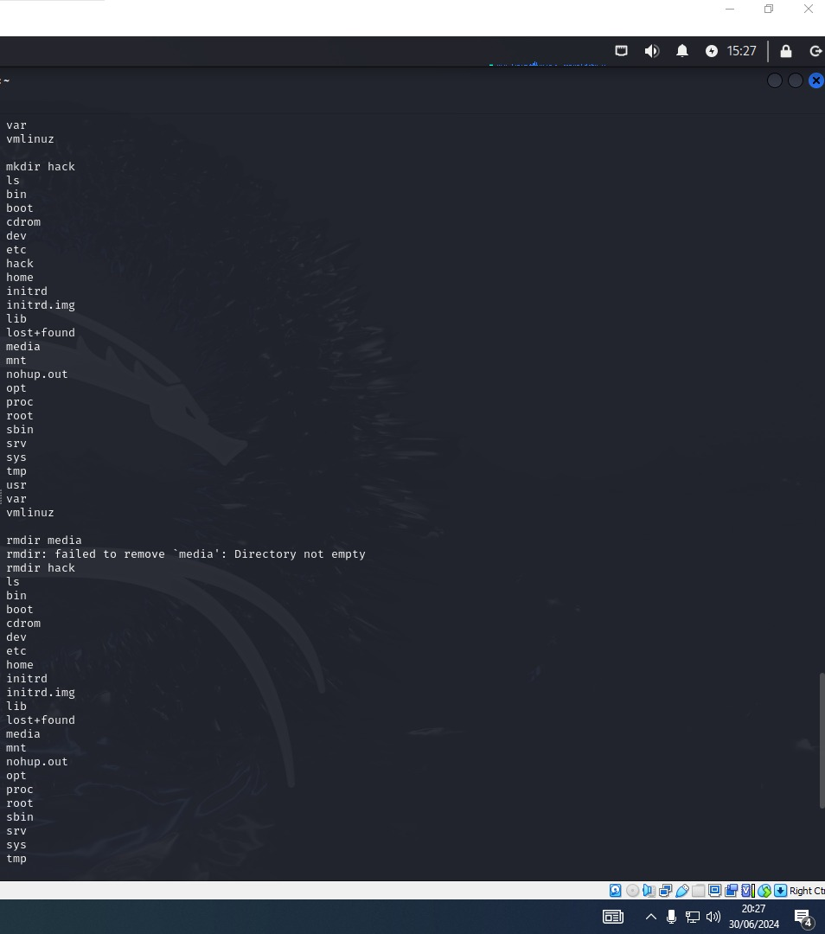

Figure 19. Privilege Escalation
Now that the attacker is a root privilege user, the attacker was able to escalate his privilege by making a new directory (mkdir) called hack. The attacker can also delete the directory as seen in the screenshot below, using the “rmdir hack” command, by typing ls, the hack directory is no longer visible.
Figure 20. Escalate Privilege
From the above results, it is clear that this particular system is vulnerable to a backdoor attack.
- Mitigation and Recommendation
To mitigate this vulnerability [55]:
- Disable FTP if not needed: Some server setups have FTP enabled by default. Only enable it if necessary.
- Use FTPS or SFTP: Disable standard FTP and use FTPS or SFTP instead for secure file transfers.
- Update SSH Software: Ensure your SSH software uses strong ciphers and the latest version of TLS (avoid SSL).
- Disable Anonymous FTP: If possible, disable anonymous FTP to enhance security.
- Isolate Your FTP Server: Avoid storing anything on the FTP server that you do not intend to share.
- Restrict Access with Firewall: Use firewall rules to limit access to trusted IP addresses or MAC addresses.
- Manage File Permissions Carefully: Be cautious with the file permissions of shared files to prevent unauthorized access.
- Validate Uploaded Data: If customers upload data to your FTP server, implement extra validation when reading it to ensure security.
- Recommendation
To prevent similar attacks, regularly update all software to the latest versions to patch known vulnerabilities, ensuring updates come from official and trusted sources. Utilize network monitoring tools to detect unusual network traffic that may indicate a breach. Implement antivirus software along with host-based and network firewalls. Enhance protection by adding an IDS or IPS to block unauthorized access attempts. Lastly, conduct security audits and penetration tests to identify and mitigate vulnerabilities, and educate users about safe software downloading practices.

5.3 Phishing Attack
- Phishing Campaign Description for Tech Solutions Inc.
Objective:
The primary goal of the phishing campaign is to evaluate the security awareness of employees at Tech Solutions Inc. and to identify vulnerabilities in the company's defenses against phishing attacks. This simulation will help in educating employees about the importance of cybersecurity and how to recognize and avoid phishing attempts.

- Campaign Details:
Target Audience:
A selected group of employees across various departments within Tech Solutions Inc.
Approximately 10-20 employees to ensure a broad assessment.

- Phishing Scenario:
The phishing email will impersonate an IT Support Technician from Tech Solutions Inc.
The email will inform the employee of suspicious activity on their account and urge them to change their password immediately to protect their information.
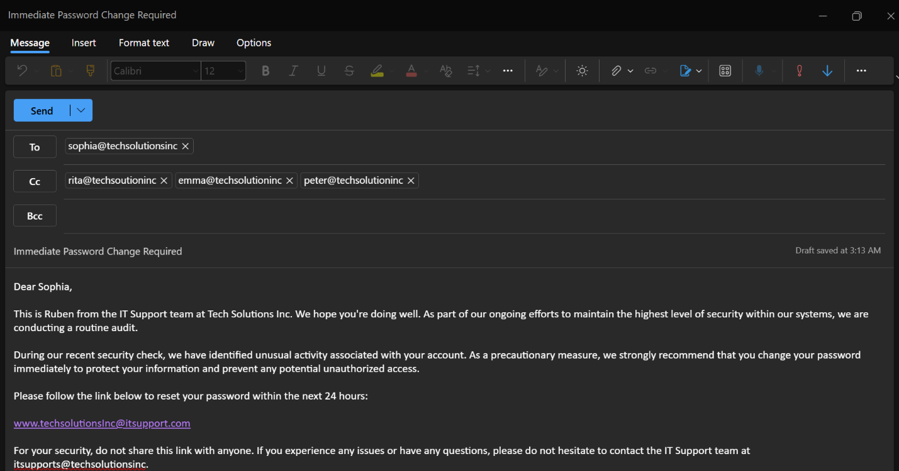
- Email Content:
Figure 21.Email draft
Domain: A domain similar to the company's official domain techsolutionsinc.com was set up.
Hosting: A web hosting service was used to host the phishing page. (for ethical reasons, the identity of that hosting service is kept secret)
Phishing Page: A cloned version of the company's actual login page was created to capture the username and password.

Figure 22. Cloned login page
- Email Service: A reputable email service provider that allows for email spoofing or the company's internal email system is used to send out phishing emails.
- Timing: Emails were sent out during working hours to increase the likelihood of them being seen and acted upon promptly.

- Monitoring and Data Collection:
Click Tracking: Monitor who clicks on the phishing link.
Credential Capture: Log any credentials submitted on the phishing page.
Data Analysis: Analyze the collected data to identify patterns and common vulnerabilities.

- Post-Campaign Actions:
The outcome of the phishing campaign was unsuccessful as the emails were not delivered to the targeted audience. This is because the company has an Email Security system that filters and blocks phishing emails. Microsoft Defender for Office 365 and Mimecast to filter fake emails.

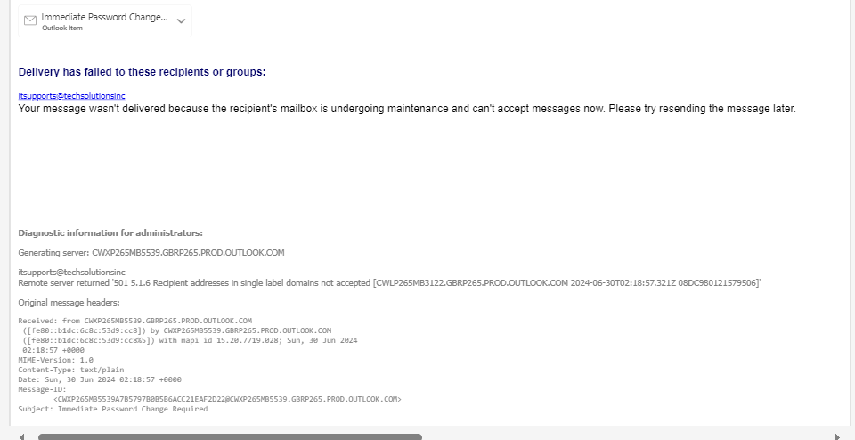
Figure 23. Campaign Analysis

- Results Analysis: Since this is a penetration test, every security Intrusion detection and prevention system in the company’s network was still active and running, hence the phishing email campaign was unsuccessful.
- Report and Recommendation:
- Training Sessions: To maintain the security level, the company should organise mandatory training sessions for all employees to educate them on how to identify and avoid phishing attempts in the future.
- Policy Review: Review and update the company’s cybersecurity policies and procedures based on the findings from the phishing campaign.
- Ethical Considerations:
- Permission: I obtained written consent from senior management or relevant authorities within Tech Solutions Inc. before conducting the campaign.
- Data Privacy: Securely store and handle any data collected during the simulation, ensuring it is only used for improving security awareness and measures.
- Transparency: After the simulation, transparently communicate with all participants about the purpose and outcomes of the campaign, emphasizing the importance of cybersecurity

5.5 Man-In-The-Middle
A Man-In-The-Middle (MITM) attack is a type of cybersecurity breach where a malicious actor intercepts and potentially alters the communication between two parties who believe they are directly communicating with each other. The attacker can eavesdrop on the communication, steal sensitive information, or inject false information without the knowledge of the legitimate parties involved.
The attacker intercepts the communication between two parties. This can be done through various means such as IP spoofing, ARP poisoning, or compromising routers and switches.
For this attack, HTTPS Spoofing will be demonstrated. This attack aims to capture and analyze Traffic: It Uses Wireshark to capture traffic and analyse the intercepted data.
Look for sensitive information being transmitted in plaintext due to the SSLstrip downgrade.
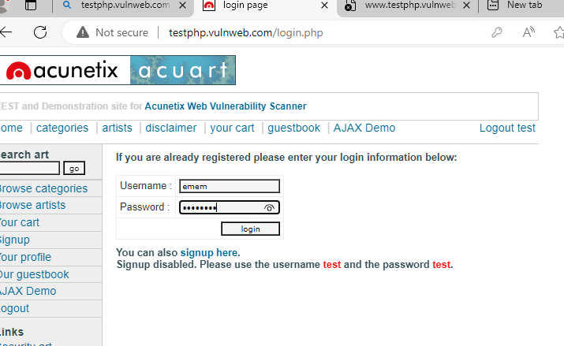
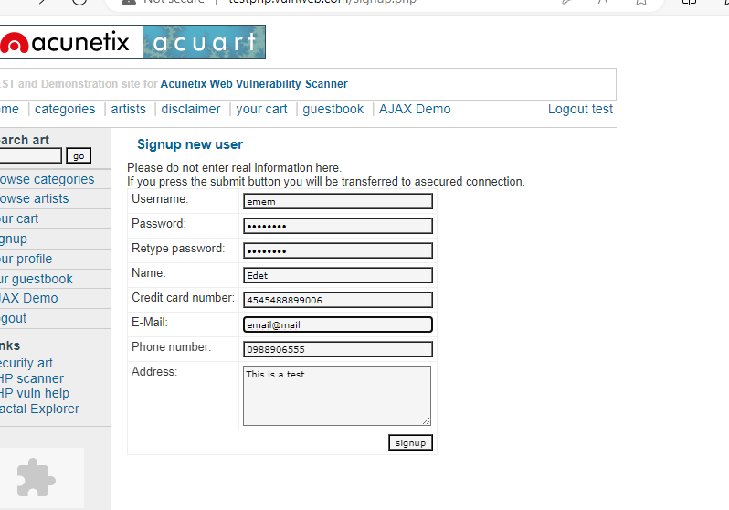
To simulate this attack, a user attempts to login to a website through a computer targeted for MITM attack with IP 10.10.10.7. Below is a screenshot of the website.
The user attempts to login to the website, and the attacker intercepts, captures, and analyses the packets for sensitive information using Wireshark.
Figure 24. Targeted website

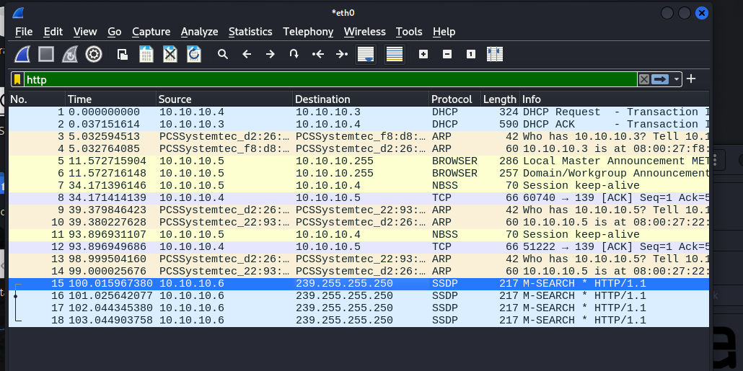
Figure 25. Captured packets with a Wireshark
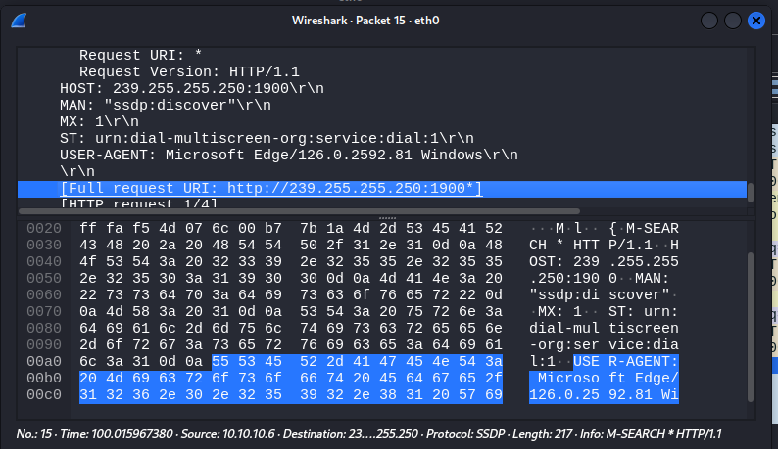
This is a screenshot of the intercepted and captured packets, the IP address of the target is 10.10.10.6 as sent above. The packets were captured on eth0, but to see the login credentials, we need to analyze the HTTP protocol through the spoofed IP address header.

Figure 26.Analysed packets
- Report
For some reason, this attack was not successful, possibly because the company uses secure networks and VPNs to protect against man-in-the-middle attacks that can facilitate HTTPS spoofing. The HTTP protocol for 10.10.10.6 was not visible on the captured packets.

- Recommendation
- Strict HTTPS Usage: Ensure all sites use HTTPS and implement HTTP Strict Transport Security (HSTS) to prevent downgrades to HTTP.
- Certificate Pinning: To prevent impersonation, use certificate pinning to bind a service to a specific certificate or public key.
- DNS Security: Implement DNSSEC to protect against DNS spoofing and ensure the integrity of DNS responses.
- User Education: Educate users on verifying website URLs and certificates.
- Network Security: Use secure networks and VPNs to protect against man-in-the-middle attacks that can facilitate HTTPS spoofing.
- Regular Monitoring: Monitor for suspicious activity and unauthorized certificates using tools like Certificate Transparency logs.

Final Report
The objective of this penetration testing highlight the mechanisms of various cybersecurity breaches, their simulation in controlled environments, preventive measures, and recommendations for improvement.
There’s a need for regular training to be conducted as often as possible, new staff must be trained before being added to the computer network, and updated security practices, and continuous monitoring are critical in mitigating the risks associated with these attacks. Effective cybersecurity strategies require a combination of technical defences, user education, and proactive security policies to build resilient and secure systems.

Chapter 6

Evaluation and Conclusion

6.2 Evaluation
Based on the conducted pentesting exercise, the current state of the company’s cybersecurity level is not so good, but it is not so bad either. The pentest shows that the network is vulnerable to a backdoor attack, this is due to an unpatched security feature on the operating system. I recommend a frequent update of outdated software.
To continually maintain a healthy security network, the following must be implemented;

6.2 Recommendations for Improvement
- Regularly update and patch software to fix known vulnerabilities.
- Implement the principle of least privilege (PoLP) to limit user access rights.
- Use intrusion detection and prevention systems to monitor and block suspicious activities.
- Comprehensive user education and awareness programs.
- Establishing and enforcing strict security policies.
- Using technical controls such as caller ID verification and restricting physical access to sensitive areas.
- Regular training and simulated social engineering exercises.
- Creating a culture of security awareness within the organization.
- Implementing strict verification procedures for sensitive information requests.
- Regular security audits and vulnerability assessments.
- Implement robust access control mechanisms and policies.
- Continuous monitoring and anomaly detection to identify and respond to privilege escalation attempts.

:

6.3 Conclusion

This dissertation has demonstrated the critical role of penetration testing in enhancing the cybersecurity posture of SMEs in the UK. Through a detailed examination of the current cybersecurity landscape, the research has identified the unique challenges faced by SMEs, including limited resources and expertise in cybersecurity. The study has shown that penetration testing is an effective tool for identifying vulnerabilities within SME network infrastructures. The virtual network environment set up for this research provided valuable insights into the types of attacks SMEs might face and the potential weaknesses in their defenses. The findings underscore the importance of regular penetration testing as part of a comprehensive cybersecurity strategy. Effective mitigation techniques and tailored recommendations based on the outcomes of the penetration tests can help SMEs strengthen their security measures, ensuring compliance with industry standards and safeguarding their critical assets. Ultimately, this research highlights the necessity for SMEs to adopt proactive cybersecurity practices to maintain business continuity, protect sensitive information, and build customer trust in an increasingly digital landscape.

Chapter 7

References

[1] | V. ARYA, “"Cybersecurity for Small and Medium-sized Enterprises (SMEs).",” Cyber Security Insights Magazine, , 2022.
[2] | A. M. A. e. a. Hawamleh, “"Cyber security and ethical hacking: The importance of protecting user data.",” Solid State Technology , vol. 63.5 , pp. 7894-7899., (2020).
[3] | C. Beretas, “Analysis of White and Black Hat Hacker Roles, Practices and Techniques, Considering Ethical and Legal Issues, Including Bug Bounty Programs,” 2023. [Online]. Available: https://suntextreviews.org/uploads/journals/pdfs/1700148397.pdf.
[4] | J. N. H. S. O. a. C. A. 2. Yaacoub, “A survey on ethical hacking: issues and challenges. .,” arXiv preprint arXiv:2103.15072, 2021.
[5] | S. a. A. D. Sinha, “Ethical hacking: the story of a white hat hacker. ISSN,,” International Journal of Innovative Research in Computer Science & Technology (IJIRCST),, pp. pp.2347-5552. , 2020.
[6] | NCSC, “Active cyber defence (ACD) - the second year, Active cyber defence report.,” 2019.
[7] | F. Jimmy, “Cyber security Vulnerabilities and Remediation Through Cloud Security Tools.,” Journal of Artificial Intelligence General science (JAIGS) ISSN: 3006-4023, 2(1),, pp. pp.129-171., 2024.
[8] | Y. A. S. D. J. A. N. a. J. A. Perwej, “A systematic literature review on the cyber security,” International Journal of scientific research and management, 9(12),, pp. pp.669-710., 2021.
[9] | J. N. H. S. O. a. C. A. Yaacoub, “Ethical hacking for IoT: Security issues, challenges, solutions and recommendations,” Internet of Things and Cyber-Physical Systems,, vol. 3, pp. pp.280-308, 2023.
[10] | K. a. V. d. H. J. Macnish, “Ethics in cybersecurity research and practice,” Technology in society, 63, p. p.101382, 2020.
[11] | S. T. M. &. K. C. Kabanda, “Exploring SME cybersecurity practices in developing countries.,” Journal of Organizational Computing and Electronic Commerce, 28(3),, p. 269–282., 2018.
[12] | D. f. S. I. a. Technology, “Cyber security breaches survey 2023,” GOV.UK, 2023,” 2023. [Online]. Available: https://www.gov.uk/government/statistics/cyber-security-breaches-survey-2023/cyber-security-breaches-survey-2023#chapter-4-prevalence-and-impact-of-breaches-or-attacks.
[13] | R. Arnone, “Hackers Cybercrime-Computer Security: Ethical Hacking: Learn the attack for better defence.,” ARIS2-Advanced Research on Information Systems Security, 1(1), pp. pp.50-61, 2021.
[14] | W. 2. S. J. S. a. S. Isaacson, 2021. [Online]. Available: https://www.academia.edu/download/48940221/prem-chap-steve-jobs.pdf.
[15] | D. 2. Wright, “ Business Hacking: A Case Study of Business Information Systems.”.
[16] | L. Pilli, “Analysis of Artificial Intelligence Techniques to Detect, Prevent, Analyze and Respond to Malware.,” 2023. [Online]. Available: https://era.library.ualberta.ca/items/b1fa2cd1-ebe0-47dc-b4d1-14b98e78fba8/download/5afbe07a-9beb-424f-9128-772aca230ed6.
[17] | E. D. A. G. S. M. B. M. R. a. F. M. Onyema, “Cyber threats, attack strategy, and ethical hacking in telecommunications systems,” in In Security and privacy in cyberspace (pp. 25-45), Singapore, 2022.
[18] | J. Chew, “A Study on Ethical Hacking in Cybersecurity Education Within the United States,” 2024. [Online]. Available: https://digitalcommons.calpoly.edu/cgi/viewcontent.cgi?article=4429&context=theses.
[19] | S. Hamra, “Ethical hacking: Threat modeling and penetration testing a remote terminal unit,” 2020.
[20] | H. M. Z. A. Shebli and B. D. Beheshti, “A study on penetration testing process and tools,” in IEEE Long Island Systems Applications and Technology Conference, (LISAT), 2018.
[21] | R. Fernandez, ““7 Types of Penetration Testing: Guide to Pentest Methods & Types,”,” eSecurity Planet, 28 Jun 2023. [Online]. Available: https://www.esecurityplanet.com/networks/types-of-penetration-testing/#1-Network-tests .
[22] | M. P. a. M. A. Shaik, “ "Review on Penetration Testing Techniques in Cyber security,",” in Second International Conference on Augmented Intelligence and Sustainable Systems (ICAISS), Trichy, India,, 2023.
[23] | GOV.UK, “Ethical hackers collaborate with Defence to strengthen cyber security,”,” 03 August 2021. [Online]. Available: https://www.gov.uk/government/news/ethical-hackers-collaborate-with-defence-to-strengthen-cyber-security.
[24] | ukcybersecuritygroupltd, “The Ethics of Hacking: Should Companies Hire ‘Ethical Hackers’ to Test their Security?,”,” 2024.
[25] | L. Gjesvik, “Comparing Cyber Security. Critical Infrastructure protection in Norway, the UK and Finland,” NUPI Report., 2019.
[26] | A. Renvall, “Improving cybersecurity through ISO/IEC 27001 information security standard in the context of SMEs.,” 2018.
[27] | M. Ryan, “Ransomware Revolution: the rise of a prodigious cyber threat Berlin/Heidelberg, Germany:,” Springer, p. (p. 164). , 2021.
[28] | D. M. C. a. F. D. Bodeau, “Cyber threat modeling: Survey, assessment, and representative framework,” Mitre Corp, Mclean, 2018.
[29] | E. Sutherland, “Trends in regulating the global digital economy,” Available at SSRN 3216772., 2018.
[30] | C. a. C. C. Chindrus, “Securing the Network: A Red and Blue Cybersecurity Competition Case Study,” Information 14(11), p. p.587., 2023.
[31] | N. J. A. a. P. E. Rawindaran, “Awareness of Machine Learning techniques used by (SME) for their cyber security,” in In 4 Conference 2021 Best Student Paper Prize Winner Towards The Decarbonisation Of Tourism, 2021.
[32] | L. C. M. a. L. S. Smith, “Ethical hacking: Skills to fight cybersecurity threats.,” EPiC Series in Computing, 82(5),, pp. pp.102-111., 2022.
[33] | D. Levine, “Confidentiality creep and opportunistic privacy,” In Research Handbook on Information Law and Governance (pp. 28-47), 2021.
[34] | D. Gkoutzamanis, “Five penetration testing frameworks and methodologies",,” 2020.
[35] | V. A. I. R. S. A. S. R. V. a. R. S. Saraswathi, “Automation of recon process for ethical hackers,” in 2022 International Conference for Advancement in Technology (ICONAT), 2022.
[36] | H. B. D. B. E. S. A. T. C. A. R. a. B. X. Hindy, “A taxonomy of network threats and the effect of current datasets on intrusion detection systems,” in IEEE Access, 8, 2020.
[37] | M. M. S. a. S. T. Tabassum, “Ethical Hacking and Penetrate Testing using Kali and Metasploit Framework,” International Journal of Innovation in Computational Science and Engineering, 2(4), pp. pp.9-22., 2021.
[38] | A. a. S. V. Aibekova, “Offensive security: Study on penetration testing attacks, methods, and their types,” in In 2022 IEEE International Conference on Distributed Computing and Electrical Circuits and Electronics (ICDCECE), 2022.
[39] | S. a. W. N. Raj, “A study on metasploit framework: A pen-testing tool,” in International Conference on Computational Performance Evaluation (ComPE) IEEE, 2020.
[40] | I. S. A. a. A.-S. N. Diyeb, “Ethical network surveillance using packet sniffing tools: A comparative study,” International Journal of Computer Network and Information Security, 11(7),, p. p.12., 2018.
[41] | V. B. A. J. S. P. A. K. M. a. A. M. 2. Vasani, “Comprehensive analysis of advanced techniques and vital tools for detecting malware intrusion.,” Electronics, 12(20), p. p.4299.
[42] | P. T. L. a. B. S. Lachkov, “Vulnerability Assessment for Applications Security Through Penetration Simulation and Testing,” Journal of Web Engineering, 21(7), pp. pp.2187-2208, 2022.
[43] | Z. Z. H. a. S. L. Wang, “Social engineering in cybersecurity: Effect mechanisms, human vulnerabilities and attack methods.,” Ieee Access, 9, , pp. pp.11895-11910. , 2021.
[44] | U. a. P. R. Ravindran, “A Review on Web Application Vulnerability Assessment and Penetration Testing,” in Review of Computer Engineering Studies, , 2020.
[45] | P. B. P. J. G. a. V. H. Mvula, “Discover Data. https://d-nb.info/129993479X/34,” 2023.
[46] | T. Le, “Towards an improved understanding of software vulnerability assessment using data-driven approaches,” arXiv preprint arXiv:2207.11708, 2022.
[47] | J. Abawajy, “User preference of cybersecurity awareness delivery methods.,” in Behaviour & Information Technology, , 2014.
[48] | ENISA., “ Cyber Threat Landscape Report 2018,” European Union Agency for Cybersecurity..
[49] | A. &. S. R. Gupta, “Phishing in enterprises: Context, consequences, and countermeasures.,” Computers & Security, pp. 94, , 2020.
[50] | J. &. M. A. Kong, “Simulation-based security training: A case study for social engineering attacks.,” Computers & Security,, pp. 60, 1-12, 2016.
[51] | W. Stallings, “Effective Cybersecurity: A Guide to Using Best Practices and Standards.,” Addison-Wesley Professional., 2019.
[52] | E. V. A. Dissanayake, Research Onion: A Systematic Approach for Designing Research Methodology, vol. Part one, 2023, p. 02.
[53] | P. L. a. A. T. M. N. K. Saunders, “Saunders, Research Methods for Business Students, 8/E,” Pearson,,” 2019. [Online]. Available: https://www.pearson.com/nl/en_NL/higher-education/subject-catalogue/business-and-management/Research-methods-for-business-students-8e-saunders.html.
[54] | C. Burdova, ““What Is EternalBlue and Why Is the MS17-010 Exploit Still Relevant?,,” Avast, 2020. [Online]. Available: https://www.avast.com/c-eternalblue.
[55] | cyrisk.com., “Mitigation Instructions for vsftpd,”,” [Online]. Available: https://cyrisk.com/security/vsftpd.
[56] | N. J. A. P. E. a. H. C. Rawindaran, “Perspective of small and medium enterprise (SME's) and their relationship with government in overcoming cybersecurity challenges and barriers in Wales.,” in International Journal of Information Management Data Insights, 3(2), , 2023.
[57] | A. B. J. S. J. C. A. a. J. S. Reid, “Ethical dilemmas and reflexivity in qualitative research.,” Perspectives on medical education, 7, pp. pp.69-75., 2018..
[58] | N. a. P. T. Ruggiano, “Conducting secondary analysis of qualitative data: Should we, can we, and how?.,” Qualitative Social Work, 18(1), , pp. pp.81-97. , 2019. .
[59] | E. Sferrazza Papa, “What is a wall? Towards an ontology of political artefacts.,” Rivista di estetica, (67), , pp. pp.80-96. , 2018.
[60] | I. R. S. a. Z. N. Shah, “Using ML and Data-Mining Techniques in Automatic Vulnerability Software DiscoveryUsing ML and Data-Mining Techniques in Automatic Vulnerability Software Discovery,” in International Journal of Advanced Trends in Computer Science and Engineering, 10(3), 2021.
[61] | F. B.-H. E. N. N. W. A. a. G. N. Shaikh, “Internet of malicious things: Correlating active and passive measurements for inferring and characterizing internet-scale unsolicited iot devices.,” in IEEE Communications Magazine, 56(9), 2018.
[62] | V. Sherif, “Evaluating preexisting qualitative research data for secondary analysis,” in In Forum qualitative sozialforschung/forum: Qualitative social research , 2018.
[63] | K. a. H. K. 2. Sol, “Understanding epistemology and its key approaches in research.,” Cambodian Journal of Educational Research, 2(2),, pp. pp.80-99., 2022.
[64] | G. a. H. N. 2. (. 4.-4. Terry, Reflexive thematic analysis. In Handbook of qualitative research in education, Edward Elgar Publishing., 2020.
[65] | E. Turyahikayo, “Philosophical Paradigms as the Bases for Knowledge Management Research and Practice.,” Knowledge Management & E-Learning, 13(2),, pp. pp.209-224, 2021.
[66] | C. S. A. W. M. a. K. K. Ullrich, “Qualitative research methods in medical dissertations: an observational methodological study on prevalence and reporting quality of dissertation abstracts in a German university,” BMC Medical Research Methodology, 20,, pp. pp.1-9., 2020.
[67] | R. Vishnu, “Analysis of Current Machine Learning and AI Techniques to Perform Automated Hacking.,” 2021.
[68] | S. A. E. B. Z. a. K. I. Zeadally, “Harnessing artificial intelligence capabilities to improve cybersecurity.,” Ieee Access, 8, , pp. pp.23817-23837. , 2020.
[69] | D. Passey, “Theories, theoretical and conceptual frameworks, models and constructs: Limiting research outcomes through misconceptions and misunderstandings,” in Studies in Technology Enhanced Learning, 1(1)., 2020.
[70] | F. a. N. L. Nyimbili, “Types of Purposive Sampling Techniques with Their Examples and Application in Qualitative Research Studies,” British Journal of Multidisciplinary and Advanced Studies, 5(1), pp. pp.90-99., 2024.
[71] | J. H. K. M. G. R. R. a. S. M. Malmqvist, “Conducting the pilot study: A neglected part of the research process? Methodological findings supporting the importance of piloting in qualitative research studies,” International journal of qualitative methods, 18,, p. p.1609406919878341., 2019.
[72] | R. R. W. a. G. A. Joyner, Writing the winning thesis or dissertation: A step-by-step guide, Corwin press, 2018.
[73] | M. a. A. F. Islam, “Justification for adopting qualitative research method, research approaches, sampling strategy, sample size, interview method, saturation, and data analysis,” Journal of International Business and Management, 5(1),, pp. pp.01-11, 2022.
[74] | J. Crawford, “The computer misuse act and hackers: A review of those convicted under the Act.,” Inf. Secur. Group, Roy, 2021.
[75] | C. a. S. C. Collins, “The central role of theory in qualitative research,” International journal of qualitative methods, 17(1), p. p.1609406918797475., 2018.
[76] | H. L. A. H. R. a. M. A. Cheong, “Secondary qualitative research methodology using online data within the context of social sciences,” International Journal of Qualitative Methods, 22.
[77] | S. Chatfield, “Recommendations for secondary analysis of qualitative data,” 2020.
[78] | T. A. J. A. S. B. E. B. P. B. A. B. E. C. S. C. P. C. D. a. C. A. Ahumada, “Establishing the Infrastructure for a Collaborative Multi-messenger Ecosystem,” Windows on the Universe, 2024.
[79] | PricewaterhouseCoopers, “Ethical hacking,” PwC,” 2024. [Online]. Available: https://www.pwc.co.uk/issues/cyber-security-services/design-and-delivery/ethical-hacking.html.
[80] | N. C. Agency, “Cybercrime,” Nationalcrimeagency.gov.uk,,” 2019. [Online]. Available: https://www.nationalcrimeagency.gov.uk/what-we-do/crime-threats/cyber-crime.
[81] | D. GOV.UK, “Cyber security breaches survey 2024: technical report,,” 2024. [Online]. Available: https://www.gov.uk/government/statistics/cyber-security-breaches-survey-2024/cyber-security-breaches-survey-2024-technical-report#chapter-3-qualitative-approach-technical-details.
[82] | N. &. K. D. &. K. Y. &. S. &. J. P. Garg, “TOWARDS THE IMPACT OF HACKING ON CYBER SECURITY,” IIOAB Journal. 9. , pp. 61-77, 2018.
[83] | A. Z. M. A. M. B. A. a. S. Z. af, “"Ethical Hacking Methodologies: A Comparative Analysis,",” in Mohammad Ali Jinnah University International Conference on Computing (MAJICC), Karachi, Pakistan, 2021, 2021.
[84] | A. Melnikovas, “Towards an Explicit Research Methodology: Adapting Research Onion Model for Futures Studies,” Journal of Futures Studies, p. 23.2, 2018.

