Kathy’s Cakes
Business plan
July 2020

Table of Contents
Table of Contents 1
Executive Summary 2
Business Overview 3
Markets and Competition 4
Target Markets 4
Competition 4
Sales and Marketing 5
Product Positioning 5
Marketing 5
Sales 5
Management 6
Key Personnel 6
Advisors and support services 6
Operations 7
Premises and Equipment 7
Employees 7
Suppliers 7
Financial Forecast 8
Sales 8
Cashflow 8
Profitability 8
Financing 9
Appendix 1……………………………………………………………………………………….10
Appendix 2…………...…………………………………………………………………………..11
Appendix 3………………………………………………………………………………………..12

Executive Summary

I am in the process of starting my own part-time home cake baking and decorating business, I do already have a full-time job as an admin assistant in a very large office.

I will mainly run the business at weekends and evenings, I aim to make the minimum of two cakes per week depending on the design of the cakes.

I will be catering for birthdays, anniversaries and any celebration that calls for a cake or cakes, I already have a few customers that I have made for in the past and they have been very happy with the results of their cakes, I have often been advised to start a business baking and decorating cakes.

In the past I have made sales by word of mouth and customers have approached me mostly for birthday cakes and the odd anniversary and leaving cake, only now I feel I have the experience and funds to do this and I am feeling positive in my approach to the business, I expect my target market will be local customers within a ten mile radius I also expect to get quite a large custom from my full-time job as it is a large organization.

I shall be the sole proprietor and will take on the roll of baking, decorating, delivering the cakes, I will also do the stock control and financing, when the business is more established and I am able to take on more orders only then will I consider looking for premises and staff.

The benefits of working from home means I will be able to work at any hour that suits me and as I have no rent to pay I have more funds to buy stock and the equipment I need to start and also can pass that saving onto the customer.

I do not need any financial help as I have the necessary funds to get the business up and running.

Business Overview
Kathy’s Cakes, which will be located in Swansea will be a
celebration cake decorating business.
birthdays, anniversaries, baby shower and any other kind of
celebration cake will be baked and decorated by myself.

Products

I will start off with two flavours of cake, vanilla and chocolate
and gradually progress to other flavours as the business
progresses with either a buttercream covering or fondant.
Any cake toppers and lettering to be arranged with the customer, the cake will either be delivered within a ten-mile radius or the customer has the option to collect.

As I am in full time employment it makes sense to start this business part time, It has often been suggested by friends and family to start my own business when cakes have been made for them and I have been asked for cakes quite often but due to work commitments it has been unachievable.
I would start marketing by word of mouth and social media, and
progress from there depending on the demand.
The only person in the business would be myself as I have no plans
to employ any staff at the moment.
The business will be run from home and therefore no need for any
premises, which will be practical and a financial saving.
I shall need to purchase some extra equipment although very
little as I already possess a large amount.

Markets and Competition

Target Markets

My target market will be friends and work colleagues to start with, as I work in a very large office I have confidence there will be quite a lot of work there as I have often received enquiries to make cakes for them.

I will agree with the customer what sort of cake they would like, mainly birthday and anniversary cakes I have made in the past, also a few children’s birthday cakes which I have always been told they were very good, I have also made a wedding cake which everyone was very pleased with. Before the design of the cake is decided I always ask the customer if they have any allergies, dairy, wheat and peanuts which there could be traces of in some flavouring. I asked a few of my previous customers for feedback and the results can be seen in appendix 3.

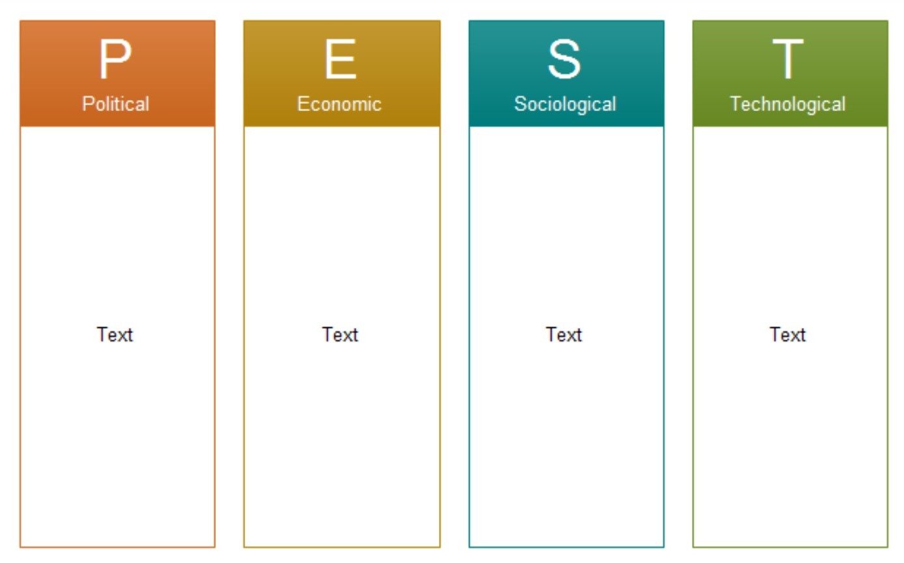
Photographs on icing sheets is very popular with customers usually children’s birthday cake so essential to have an edible printer and computer
Personalised and unique designs individually
pre-planned by the customer.
Economy is low at the moment hopefully pick up in the next few months, and a lot of job losses due to the pandemic.
Direct government grant given to new businesses to cover start-up costs, with owner providing 50% of the grant.

Competition

I have found just over 30 celebration cake businesses within the Swansea area. I have made the assumption that with this amount there will be a portion of the market I could capture with competitive prices.

My main competitors will be the home bakers that are already established and advertise mainly on social media, I am confident that I can make a profitable business from this venture and aim to progress from doing it part time into a full time business.

Sales and Marketing

Product Positioning

I offer a service to customers which will be unique to their specifications, some of my competitors only offer a limited selection, especially the larger businesses, Marks and spencer cakes and Jenkins bakery. I found that the larger bakeries have a limited selection, but the smaller bakers have a closer relationship with the customers in deciding on the finished cake.

As a home baker I have no premises cost and so the saving could go to the end result and onto the customer.

Marketing

I will advertise my products on social media and by word of mouth to begin with, as the business progresses, I will consider other means of advertising and will be decided on depending on the cost.

Sales

I have plans to distribute some samples to customers where I have my full time job, as there are over five thousand employees I am confident I shall get some business as I have already been asked for my produce.

I already have some existing customers which have enquired about future sales.

Management

Key Personnel

This will be a sole business I will be undertaking all aspects of work; the baking and decorating will be done by myself also the stock control and financial records.

I have been baking and decorating cakes for friends and family for quite a few years now and have always wanted to make a business from it, I have no recognized qualifications just experience but I am looking to enrol in a cake decorating class to add to my skills. Some of my work can be viewed in appendix 2.

I will be registering a new food business with my local authority at least twenty eight days before I start trading, I will also take a food hygiene and safety course which is a cost of twenty five pounds and will receive a certificate on completion.

There might be an inspection of my kitchen to confirm the conditions meet all the criteria for my business to proceed.

I have no mortgage so will not need permission to use my home for this business, I will be taking out insurance which is advisable by the government website.

I enjoy doing this and always put one hundred per cent into every cake I make, if I am not happy with what I make I will start it again.

I have previously purchased a large amount of equipment but feel I will need another food mixer and be able to have two working at the same time. This will be my most expensive purchase; I will be working from home so no need for premises which will be a massive saving.

Advisors and support services

As this will be a small home run business, I feel I so not need any business advisers, I am confident I will be able to manage the accounts myself.

Operations

Premises and Equipment

The business will be run from home; therefore, I will not be spending any money on premises unless the business progresses and I then need to expand.

Over the years I have acquired a large amount of equipment for baking and decorating, I already have a food mixer which is only a few months old, I will purchase another mixer and will be able to have the two working together.

Another large purchase will be a fridge freezer to keep all the ingredients separate from my personal food, butter, cream and any buttercream that needs to be stored.

I will also need more cake tins and storage containers as I do not have enough at the moment if I was to make multiple cakes, I have all the tools and have also invested in an edible printer to print pictures and designs onto icing paper or rice paper and have found this is very popular with birthday cakes and small cupcakes.

Employees

I shall be the sole proprietor of the business but if it does progress and demand is high, I shall consider taking on staff.

Suppliers

As this will be a small business there are so many suppliers that I can get my ingredients from, the only item I would be buying in bulk is fondant icing which I buy in ten kilo packs from an online supplier who is reasonably priced. This is enough fondant to cover two large cakes and boards.

This fondant will also be used to make any figures or decorations the customer requires.

The other fresh items, eggs flour and sugar can be bought at any supermarket and is competitively priced and will be purchased when needed, therefore they will be as fresh as possible.

Financial Forecast

Sales

I have a few orders for future business at the moment and have estimated that I can fulfil two orders per week, three at the most with a basic twelve-inch buttercream cake costing forty-five pounds. Any decorations will be decided with the customer, flowers, figures and delivery if needed.

This is the lowest estimate of sales, as the business gets more established and more orders are taken hopefully the sales will improve.

Cashflow

Payment will be taken as cash on delivery or collection.

Profitability

I am starting a small part time business; I will see how the sales progress in the future and if there is a lot of demand, I shall consider making it a full-time venture with premises and staff.

Financing
I will not need a large amount of money to fund this business as I have no premises to rent and own a large amount of equipment.
However, I will need to buy a few items as detailed in appendix 1.

I have calculated the start-up cost would be around £650.00, the amount of ingredients would be enough to bake three twelve inch buttercream cakes, any decorations that the customer wants will be purchased as and when needed to be as fresh as possible.
The total does not include fuel and delivery charges if it’s to be delivered, I have these funds available so will not need any financial help to start the business.
I intend to begin by advertising on social media, I will be able to take orders for future dates for birthdays and anniversaries etc. I would be able to accommodate the minimum of two customers per week, three is possible depending on the cake design the customer wants.

Appendix 1.

Start-up costs assumptions

Equipment

Food mixer £298.00
Fridge freezer £200.00
Cake tins £35.00
Storage containers £27.00

Ingredients

Flour 3kg £10.00
Caster sugar 3kg £5.00
Eggs 3 dozen £3.75
Butter 1kg £4.80
Icing sugar 3kg £6.00
Raspberry jam 860g £3.60
Food colouring various colours £12.00
Flavouring £3.00

Cake boards and boxes

Twelve-inch board with box x3 £10.00

Total £618.15

Food hygiene and safety certificate £25.00

I have been quoted a monthly insurance cost of £10.00

Appendix 2.

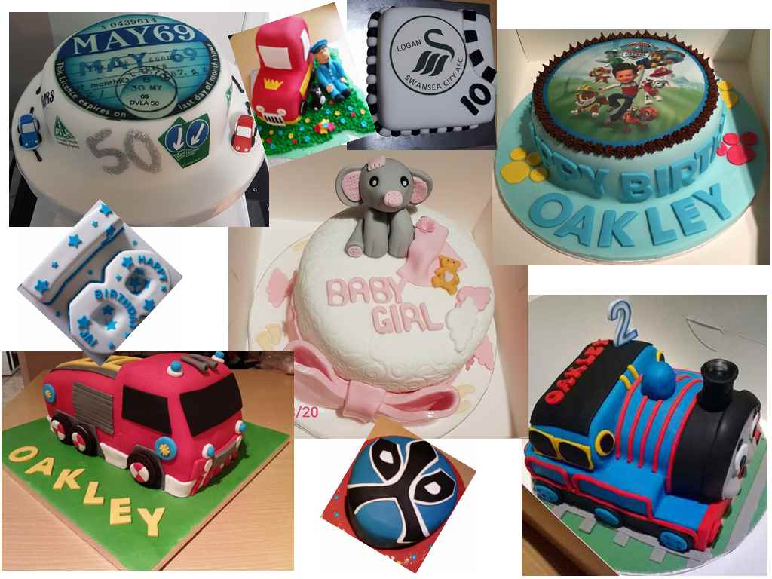
Here are a few of the celebration cakes I have made in the past.

Appendix 3.

I asked five previous customers for their feedback about the quality of the cakes I had made them, I was pleased with the results and will continue to ask for feedback from future customers.

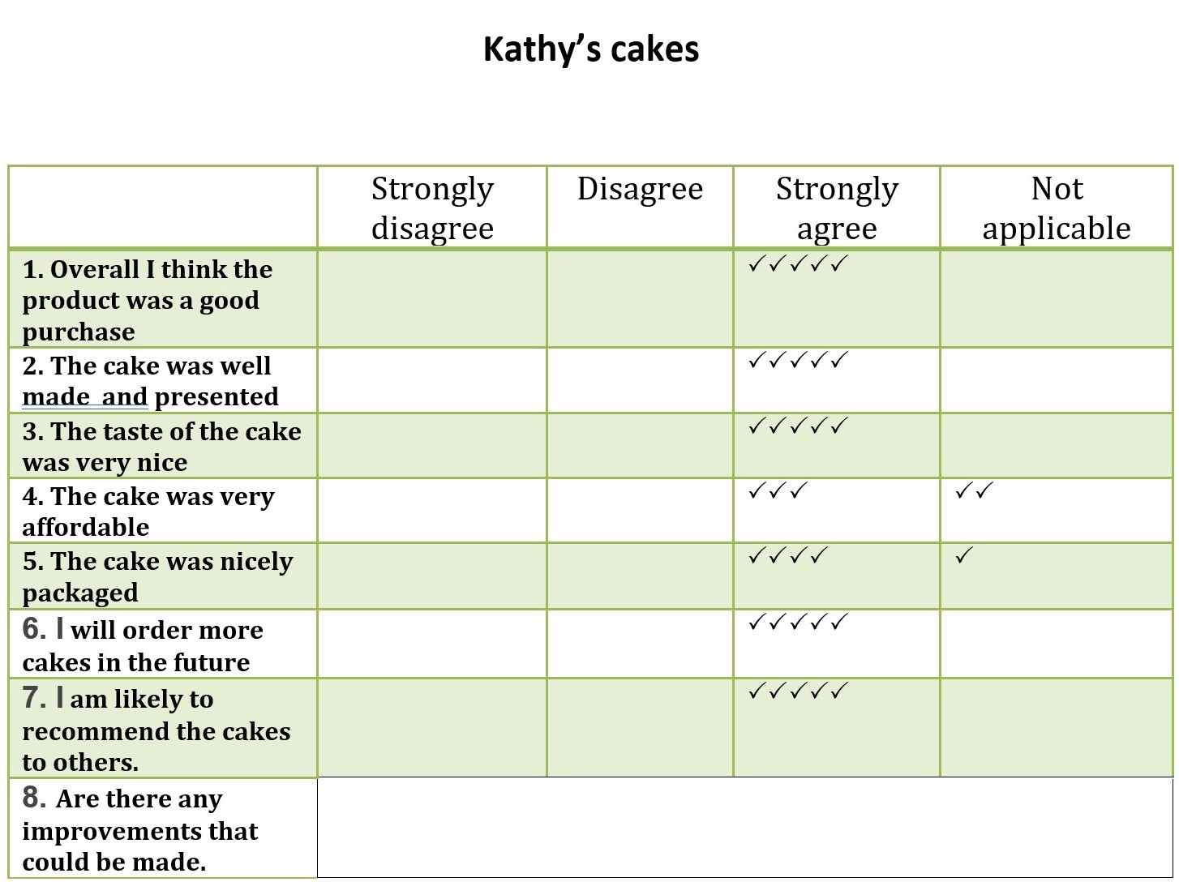

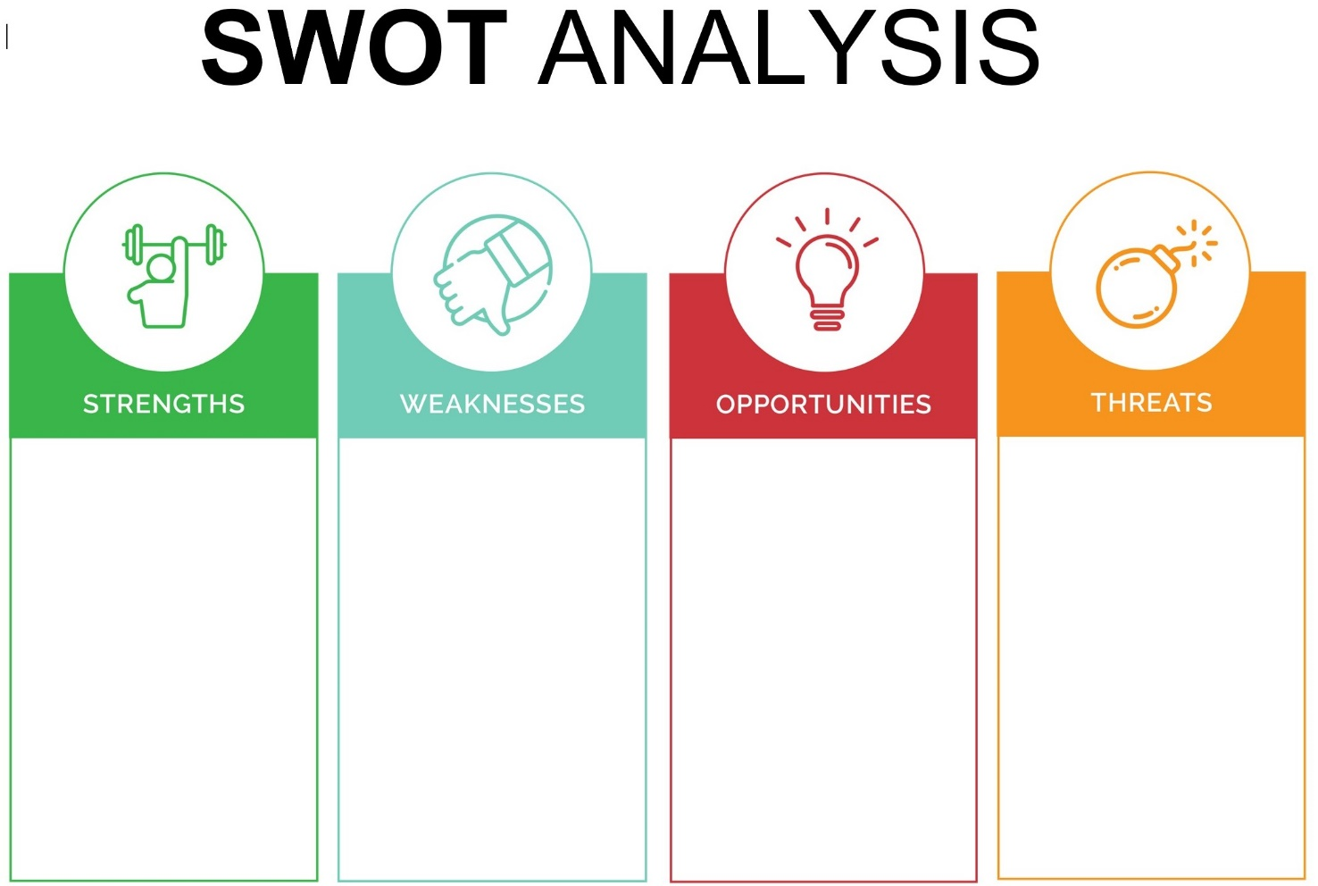
With a second job if orders multiply, I will have to consider putting more time into the business.
A chance to make a profitable and reputable business, it is an opportunity to fulfil an ambition that is long overdue.
Can only work at weekends and evenings, must make sufficient time for orders.
Determination to fulfil customers’ orders professionally and on time.

