CHANGEMAKERS: CREATIVITY AND
VALUE CREATION PROFESSIONS
BMHP5014
Component 1: Online Portfolio of Set Exercises

Student name
Student number
Lecturer’s name
Submission date
Word count | 2,168 words (excluding cover page, contents, mind-map labels and reference list)

Contents
Introduction 2
Task 1 – Defining Key Concepts in Practice 3
Task 2 – Mind Map 4
Task 3 – Self-Reflection of Group Activity 4
Task 4 – Case Study Analysis of a UK Innovation 5
Task 5 – Research Task 5
Task 6 – Exploring Digital Innovation in Health and Social Care 6
Benefit of Wearable Health Technologies 6
Electronic Health Records and Communication 6
Digital Technology in Preventative Care 7
Task 7 – Understanding the NHS Leadership Framework 7
Task 8 – Self-Reflection Journal Entry 8
Reference List 9

Introduction
The portfolio presents a series of set exercises completed throughout the module, providing evidence of engagement with creativity, innovation, leadership, value creation and contemporary technology within health and social care. It links recognised theories to current challenges within the sector and focuses on how creative thinking can improve services, experiences and outcomes. The tasks involve critical understanding, problem solving and reflecting on learning, and it illustrates an enterprising mindset that can support responsible change and contribute to the common good across health and social care sectors.

Task 1 – Defining Key Concepts in Practice
When ideas are implemented and meaningfully applied, they become innovations. Factors like perceived benefit, compatibility, complexity, trialability and visibility are explained by the Diffusion of Innovations theory, which can be linked to adoption (Dearing and Cox, 2018). Innovation is important in health and social care as it is a requirement for services to adapt to the needs of a changing population, pressures on the workforce and limited resources. For example, digital triage can provide earlier assessment for the clinical urgency of a person presenting to the emergency department and identify a pathway that suits their healthcare needs.
Creativity refers to the process of generating ideas that are both novel and useful. Amabile’s Componential Theory of Creativity suggests that creativity develops when domain knowledge, creativity-related skills, motivation and a supportive environment combine. This is vital because there is no single solution to complex care needs, and person-centred practice must be adapted to individual circumstances.
Value creation extends beyond generating new services; it also involves improving existing approaches to achieve outcomes that matter to patients and service users. Importantly, value-based healthcare begins by identifying the population served and determining whether care should focus on activity or meaningful outcomes (Teisberg et al., 2020). This is particularly important when services face limited funding, staff time and operational capacity.
Change is not simply a transition from current practice to future practice; it requires structured planning and management. There are various ways of summarising Lewin's model, and one that is frequently used is unfreezing the old assumptions, moving to the new behaviours and refreezing the new practice (Burnes, 2017). If innovation is to improve care, then it is important to engage in change, whereby staff need to keep an open mind to innovation and help to sustain the innovation.

Task 2 – Mind Map
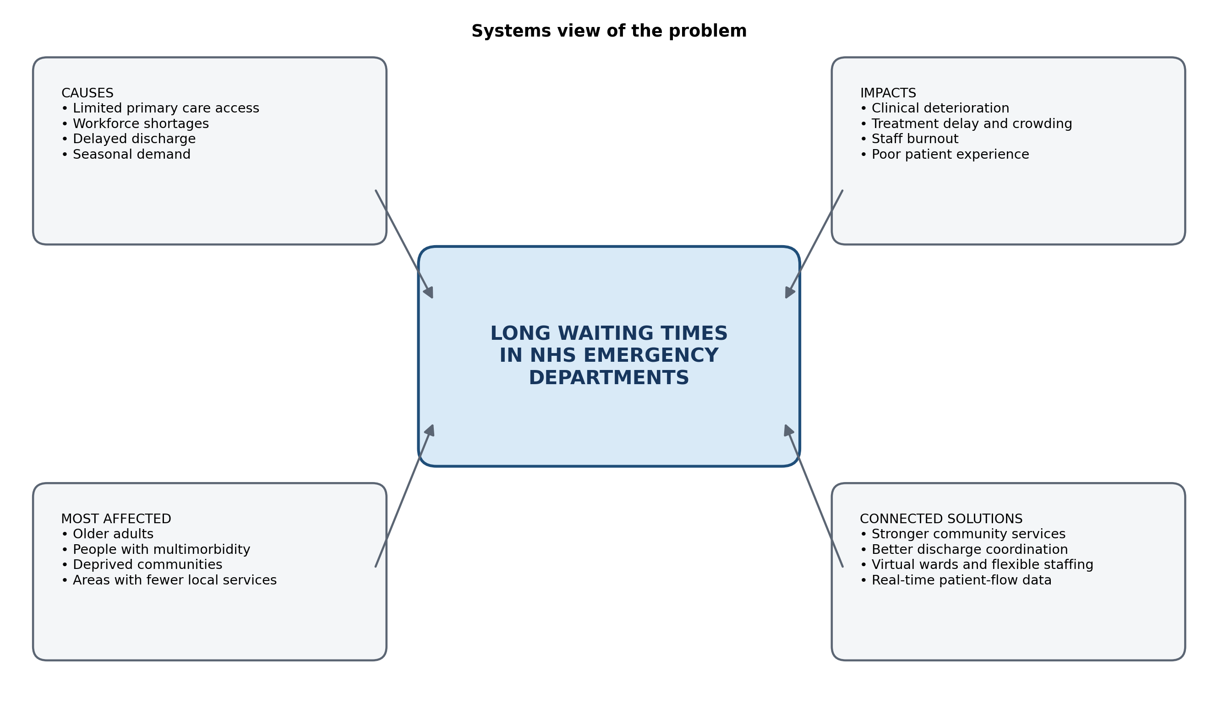
Figure 1. Systems mind map of long waiting times in NHS emergency departments.
Long waiting times in NHS emergency departments increase risks for patients, negatively affect patient experience and increase pressure on staff. The mind map connects four causes that could be impacted by the workforce shortage. For example, delayed discharge reduces bed capacity and impacts patient movement in and out of the emergency department, leading to crowding. These issues may be particularly pronounced for older individuals, those with multiple health issues and communities with fewer local services. Systems thinking can demonstrate that the problem is not a problem to be solved stand-alone in one department (Reynolds and Holwell, 2020).

Task 3 – Self-Reflection of Group Activity
I used Gibbs’ Reflective Cycle to structure my reflection on a group activity focused on reducing hospital readmissions. The reflective model supports progression from description to analysis of feelings, evaluation, meaning and future actions (Bassot, 2020).
Choosing the best option was considered convergent thinking, while generating many options during the activity with no premature judgment of the options was considered divergent thinking.At the beginning, I preferred convergent thinking because structured evaluation felt more natural. Ideas suggested within the group included telehealth follow-up, medication reviews, community volunteer support and clearer discharge information.
The discussion became repetitive as group members considered different solutions without reaching agreement. I made the suggestion to create a list of each option and then list the cost, feasibility, patient benefit and time it will take to implement each option. This helped to build a sense of agreement within the group that the most pragmatic suggestion was a follow-up call and checking of medicines. This provided support in decision-making, but I thought I was jumping a little too quickly towards evaluation, and perhaps my skill was so limited in terms of idea generation.
What I have found is that in my own role within the group I am offering organisational input and analysis, but if a group is not able to tolerate not knowing, listen and be patient, then a group won't work. The next time would definitely be a fixed 5-minute different phase wherein all members can only give 1 concept each, before any idea is thrown out. After this stage, I would evaluate the final decision using previously agreed criteria for convergence and allow those who weren't as vocal to have their say.

Task 4 – Case Study Analysis of a UK Innovation
Virtual wards provide NHS patients with hospital-level care either remotely or within their own homes through coordinated clinical support. This innovation challenges traditional assumptions about where and how acute care can be delivered. Multidisciplinary teams are able to intervene quickly when things are getting worse through remote monitoring, phone checks, online appointments and community visits.
The COPD virtual ward pathway in South and West Hertfordshire was found to be safe and effective, demonstrating positive outcomes in areas including length of stay, repeat admissions, patient experience and costs. Although the evaluation involved a small intervention cohort and the findings should therefore be interpreted with caution, the pathway demonstrated a positive benefit-cost ratio alongside favourable feedback from both staff and patients (NHS England, 2023).
Patients' treatment values have been enhanced by the fact that they have recovered in a familiar environment and have gone home more confident. Reduced bed pressure and improved utilisation of hospital resources were key benefits of this system. Wider uptake is explained by diffusion theory, which leads staff to be more likely to use these services if there are obvious benefits, the services are easy to try out, and the outcomes appear credible (Dearing and Cox, 2018).

Task 5 – Research Task
Staff stress and burnout can be observed through emotional exhaustion, reduced motivation and difficulties maintaining compassionate care, as they become emotionally exhausted, show low levels of motivation, experience sickness absence, quit their job or struggle to maintain caring and compassionate attitudes to patient care. As de Hert (2020) mentions, excessive workload, excessive working hours, lack of control and work-life balance and lack of organisational support are reported. This can build up over time due to the stressful nature of the work and can affect staff health and safety and care quality.
According to Montgomery et al. (2019), to address the issues of burnout in healthcare, there must be a restructuring of the implementation of the organisation itself. When interventions are focused just on the individual and thus reducing the responsibility back onto the employee, they warn that workplace culture, relationships, ineffective systems, a lack of autonomy and a lack of support from senior leaders will be emphasised.
Both articles highlight that high workload demands and organisational conditions are significant contributors to staff burnout. De Hert (2020) discusses the prevalence, impacts and prevention of burnout, while Montgomery et al. (2019) emphasise the need for organisational redesign to address workplace factors. Both sources support the use of psychological support alongside improvements in working conditions.

Task 6 – Exploring Digital Innovation in Health and Social Care

Benefit of Wearable Health Technologies
Wearable health technologies can be used as a tool to assist in the management of chronic conditions, to capture information 'between' appointments and to help the patient identify patterns in their own health. The levels the CGM measures can reflect elevated glucose levels for a person with diabetes, and tell them how different foods, activities, stress, or medications affect those levels. Depending on the disease, an activity monitor might track oxygen saturation, activity, or sleep; wearables can take readings of all these. According to Topol (2019), connected sensors and personalised digital information can help in the early identification and individualised care. Using wearables as a way to facilitate a professional assessment should not be confused with or in place of a professional assessment.

Electronic Health Records and Communication
Electronic health records enhance communication by providing a consensus, up-to-date patient record, with access to patient history, medications prescribed, pharmacist alerts for drug allergies, lab results, care plans, and any prior communications that have occurred. This reduces the need to scribble things down on paper or for other people to explain themselves to the patient again. The same basic information can be shared by a GP, a hospital clinician, a pharmacist and a community nurse within a multidisciplinary care setting, to allow decisions and recording of change to be coordinated. As discussed in the article by Wager et al. (2021), integrated information systems can aid decision-making in clinical environments and facilitate interoperability and continuity in healthcare organisations. However, four key points are essential for the effective use of EHRs: documentation, systems, governance and staff development. The clinically implemented data storage should be based on the clinical workflows and needs rather than just one's perception of it being a repository of administrative data that results in unnecessary duplication of effort and information overload.

Digital Technology in Preventative Care
More effective prevention, as digital technology can help to detect risk earlier, inform them in ways and ways that suit their context, and context-sensitively encourage them to change their behaviour before they become ill. It could be integrated as part of an NHS strategy, with this clever app offering people individual targets, reminders and direct links to local support networks to get them out to take more exercise, improve their diet and get a better night's sleep. With consent, data could help a practitioner identify when activity is decreasing or glucose levels are escalating and provide timely guidance. Topol (2019) states that digital data and prediction can enable proactive, personalised care with clinical oversight. Technology Acceptance Model is applicable, as patients and professionals are likely to adopt a system depending on the perceived usefulness and ease of use. Preventative tools should be accessible, simple to use and practical for users.

Task 7 – Understanding the NHS Leadership Framework
The NHS Leadership Competency Framework for Board Members contains six domains designed to support quality improvement and sustainable outcomes. It links leadership behaviours to the NHS values, and expects leaders to show how evidence and resources can drive improvements in care; to make the most of staff capability and partnership working. It is designed to be used by the board, chief executives and chairs, as well as by those aspiring to become senior leaders. These domains support practical activities including recruitment, evaluation, self-assessment and continuous professional development (NHS England, 2024).
The framework is crucial as health and social care leadership is not merely a matter of operational control. Leaders must balance multiple responsibilities, including quality, safety, staff wellbeing, financial sustainability, equity, public accountability and long-term change. The domains provide a structure to review and reflect on the decision-making behaviour of leaders and the consequences of this on the organisational culture together. They also build and reinforce a common sense of responsibility because, crucially, only boards that are co-ordinated, responsive to staff and service users, evidence-based, creative and challenging in their approach can succeed.
One way to encourage creativity is to build a culture that is compassionate, just, and positive. One such action is for a ward leader to ask staff to explore why medicines are often late to students and experiment with minor adjustments. The leader can establish a quick, weekly improvement huddle, communicate safety considerations with the team and ensure that all of the roles attend. Although part of the appreciation of creativity is dependent on the motivation and social factors, a nurturing environment counts (Amabile, 2018). Staff members will more readily share concerns, push back on procedures, and enact reasonable changes when they feel heard and are psychologically safe.

Task 8 – Self-Reflection Journal Entry
This module has brought my understanding of the perception of creativity from Associate Perception and Art form to a perception and Process for improving care. The system of delivering care could be the subject of innovation in the virtual-ward case, in addition to technology. It also emphasised the need for appreciating it from the patient's side, nurses' satisfaction and making use of the resource in an accountable way.
In the group activity, it had a great influence on my practice. Reflection allowed me to realise that I often quickly get to a structured evaluation and dismiss ideas before the team has fully researched enough possibilities (Bassot, 2020). For future placements, I will break out idea building and selection and accept multiple professional perspectives, and will have clear criteria for testing out ideas.
Digital innovation will be carried forward based on the principle that digital innovation will be used when users believe that it is useful and easy to use (Rahimi et al., 2018). My future is to be more of a change facilitator that is evidence-based, while listening to and learning from those who use the service.

Reference List
Amabile, T.M. (2018) Creativity in context: Update to the social psychology of creativity. Reprint edn. New York: Routledge. Available at: Google Books (Accessed: 29 July 2026).
Bassot, B. (2020) The reflective journal. 3rd edn. London: Bloomsbury Academic. Available at: Google Books (Accessed: 29 July 2026).
Burnes, B. (2017) Managing change. 7th edn. Harlow: Pearson. Available at: Google Books (Accessed: 29 July 2026).
Dearing, J.W. and Cox, J.G. (2018) ‘Diffusion of innovations theory, principles, and practice’, Health Affairs, 37(2), pp. 183–190. Available at: https://doi.org/10.1377/hlthaff.2017.1104.
De Hert, S. (2020) ‘Burnout in healthcare workers: Prevalence, impact and preventative strategies’, Local and Regional Anaesthesia, 13, pp. 171–183. Available at: https://doi.org/10.2147/LRA.S240564.
Montgomery, A., Panagopoulou, E., Esmail, A., Richards, T. and Maslach, C. (2019) ‘Burnout in healthcare: The case for organisational change’, BMJ, 366, l4774. Available at: https://doi.org/10.1136/bmj.l4774.
NHS England (2023) Rapid evaluation report: Chronic obstructive pulmonary disease virtual ward enabled by technology – South and West Hertfordshire Health and Care Partnership. Available at: NHS England (Accessed: 29 July 2026).
NHS England (2024) NHS leadership competency framework for board members. Available at: NHS England (Accessed: 29 July 2026).
Rahimi, B., Nadri, H., Lotfnezhad Afshar, H. and Timpka, T. (2018) ‘A systematic review of the Technology Acceptance Model in health informatics’, Applied Clinical Informatics, 9(3), pp. 604–634. Available at: https://doi.org/10.1055/s-0038-1668091.
Reynolds, M. and Holwell, S. (eds.) (2020) Systems approaches to making change: A practical guide. 2nd edn. London: Springer. Available at: Google Books (Accessed: 29 July 2026).
Teisberg, E., Wallace, S. and O’Hara, S. (2020) ‘Defining and implementing value-based health care: A strategic framework’, Academic Medicine, 95(5), pp. 682–685. Available at: https://doi.org/10.1097/ACM.0000000000003122.
Topol, E. (2019) Deep medicine: How artificial intelligence can make healthcare human again. London: Hachette UK. Available at: Google Books (Accessed: 29 July 2026).
Wager, K.A., Lee, F.W. and Glaser, J.P. (2021) Health care information systems: A practical approach for health care management. 5th edn. Hoboken, NJ: Wiley. Available at: Google Books (Accessed: 29 July 2026).

