Daniel Lewis
1702173

MA Contemporary Dialogues (Fine Art)
Confirmative Praxis (ADAA7002)

Contextualising Report

Word count: 5,295

Anatomy of a Performance
The Structure of Domestic Perfection

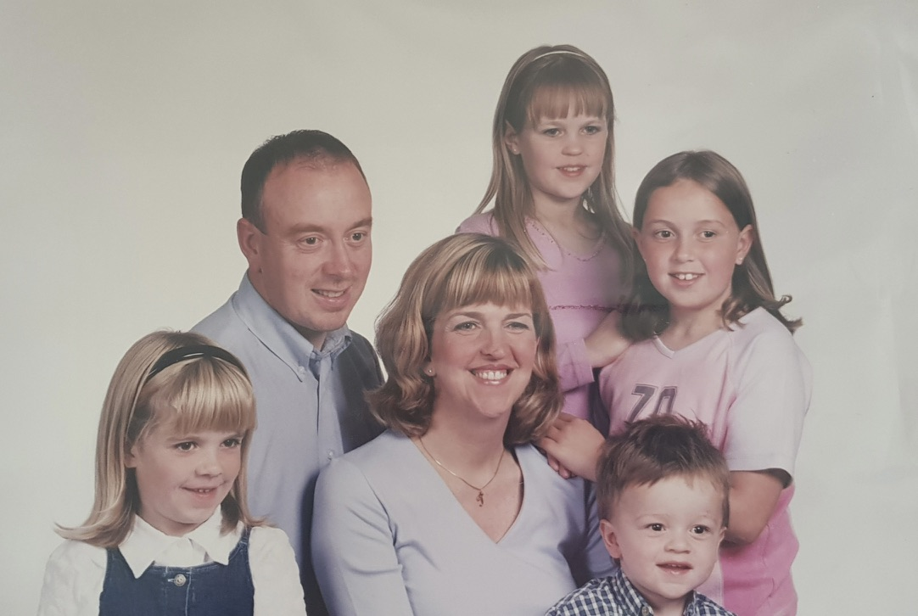
Fig. 1: Lewis, D. (2025) Lewis Family Portrait [Reappropriated photograph]. Original source: Family Archive (2002).

TABLE OF CONTENTS |  | Page
 | List of figures | 4
 | Introduction | 5
Chapter 1 | Theoretical framework | 7
1.1: | Representation | 7
1.2 | Enactment | 8
1.3 | Regulation | 10
Chapter 2 | Activating Theory through Praxis | 12
2.1 | Re-presenting the Domestic Archive | 13
2.2: | The Domestic Space as Structure | 16
2.3 | Encounter and Rupture | 20
 | Conclusion | 25
 | References | 28
 | Bibliography | 30

List of figures

Fig. 1: Lewis, D. (2025). Lewis Family Portrait. [Reappropriated photograph]. Original source: family archive (2002)

Fig. 2: Lewis, D. (2025). The Birth of the Firstborn Son. [Reappropriated photograph]. Original source: family archive (1999)

Fig. 3: Gane, H. (2023) Man Hands On. [Photograph]. Available at: https://axisweb.org/artwork/man-hands-on

Fig. 4: Lewis, D. (2025). The Living Room. [Reappropriated photograph]. Original source: family archive (2005)

Fig. 5: Williams, D. (2018) Settling to a Still Pool [Installation shot]. Available at: https://www.elysiumgallery.com/dafydd-williams-settling-still-pool/)

Fig. 6: Lewis, D. (2025) [Christmas Dinner pre-rupture]. [Installation Shot]. Photographed by the author.

Fig. 7: Lewis, D. (2025) Christmas Dinner, 2000. [Reappropriated photograph]. Original source: family archive (2000)

Fig. 8: Lewis, D. (2025) [Christmas Dinner installation]. [Installation detail Shot]. Photographed by the author.

Fig. 9: Lewis, D. (2025) Christmas Dinner. [Performance Still]. Recorded by Paris Naik-Neenan.

Fig. 10: Lewis, D. (2025) Christmas Dinner, 1999. [Reappropriated photograph]. Original source: family archive (1999)
Anatomy of a Performance
The Structure of Domestic Perfection

Introduction

This contextualising report examines the fine art praxis focused on the inherent tension between the curated domestic archive and the regulated reality of lived experience. The work investigates the family unit not as a neutral site of intimacy, but as a primary field of family politics where domestic ideology is enforced through rigid behavioural expectations. Centrally, the research questions how a household marked by trauma successfully projects an identity of ‘perfection’ through the strategic management of representation and the stylised repetition of idealised familial roles.

The foundation of this inquiry lies in the domestic archive – the collection of family photographs that historically have been positioned as apolitical, benign documents of togetherness. However, as the report will attest, these images function as ideological constructions that prioritise the appearance of harmony while omitting moments of tension from the visual field. The praxis moves beyond a passive engagement with nostalgia, instead treating the archive as a regulatory system. By revisiting these images, the work seeks to expose the unresolved truths that exist in the margins of the archive, transforming the archive from a site of memory into a site of contested structures.

To interrogate these dynamics, the report is structured around three key conceptual pillars. The interrogation utilises Marianne Hirsch’s (1997) theory of the ‘familial gaze’ to understand how images organise expectations within the family unit, uncovering the patterns where the family performs for the camera to validate its own existence. The application of Judith Butler’s theory of performativity to examine how familial roles, such as the father, mother, or child, are not innate but are enacted through the “stylised repetition of acts” (Butler, 1990, p. 140) under social and domestic constraint. Michel Foucault’s (1977/) concepts of panopticism and surveillance provide a framework to analyse the power structures that compel these performances. Here, the home is reimaged as a space of permanent visibility, where the gaze of authority is internalised by the subjects, leading to a state of constant self-regulation (Foucault, 1980).

A significant portion of this research focuses on the dining table as a central motif. As a site of communication, the table is often romanticised; however, in this praxis, it is interrogated as a stage for the performance of the ‘perfect family’. This interrogation considers the table as a site of Invisible ideologies (Lord, 2018), acting as a physical barrier that masks the “tense legs” within the archival record. The methodology of this project reflects a necessary shift from the two-dimensional still image to the three-dimensional representation of spatial order through installation. While the archive captures the static performance, it often fails to convey the sensory atmosphere of real-time surveillance that structures behaviour beyond the camera’s lens.

By utilising the medium of installation and performance, specifically through a reconstructed depiction of a family Christmas dinner setting, the work seeks to manifest the psychological weight of the domestic space. This intervention aims to uncover the dissonance between the curated archive and a constructed domestic reality. Ultimately, this praxis aims to destabilise the projection of domestic perfection, forcing an encounter with the structural fractures and generational patterns of authority that define the private sphere. Through this lens, the act of re-presentation becomes an act of unmasking, reclaiming agency from a curated and regulated past.

Chapter 1: Theoretical Framework

This chapter establishes the theoretical grounding that informs my practice, focusing on how domestic life is represented, enacted, and regulated. Through an examination of the family archive, familial roles, and mechanisms of control, the chapter outlines the conceptual frameworks that underpin my investigation of the ‘perfect family’ as a constructed and sustained ideal. These perspectives provide the foundation for the practice-based decisions explored throughout the report.

1.1 Representation
Family photographs are often understood as informal records of private life, preserving moments of intimacy and togetherness. Within both personal and cultural contexts, these images are commonly understood as benign documents that capture family life as it unfolds, contributing to shared memory and continuity. This apparent ordinariness has historically positioned family photography as apolitical and emotionally transparent, shielding it from critical scrutiny. However, Marianne Hirsch challenges this notion, arguing that family photographs function not as neutral records but as ideological constructions that actively shape domestic reality. In Family Frames: Photography, Narrative, and Postmemory (1997), Hirsch notes that the family photo serves to confirm the family’s ideology of itself, prioritising the appearance of unity over the complexities of individual experience.

Central to this argument is the ‘familial gaze’, a term which Hirsch uses to describe how images organise expectations of roles and relationships within the unit She suggested that the camera does not simply capture a pre-existing bond but rather “situates human subjects in the ideology, the mythology, of the family as institution and projects a screen of familial myths between camera and subject” (1997, p. 11). This gaze operates through a rigid process of selection and omission, while images uphold ideals of harmony are preserved, moments of tension or discomfort are pushed outside the visual field of the archive. In this sense, the archive functions as a medium that effectively forgets what it cannot represent, ensuring that any evidence of discord is rendered invisible within the curated narrative. What is absent from the image becomes as significant as what is shown, as these omissions contribute to a ‘perfect family’ narrative that appears natural and uncontested (1997, pp.7-12).

The ideological function of the photograph is further reinforced by Roland Barthes’ assertion that photography does not preserve memory but actively displaces it. In Camera Lucida, Barthes states that “not only is the photograph never, in essence, a memory … but it actually blocks memory, quickly becomes a counter-memory” (Barthes, 1981, p. 91). Barthes’ distinction is crucial in positioning the photograph not as an act of remembering but as a fixed, uncontested statement of the past, operating in what he describes as the aorist tense. Within the domestic archive, this allows the image to displace lived experience, replacing the instability of memory with a stabilised visual account that resists contradiction.

Furthermore, Hirsch posits that the repetition and circulation of these photographs stabilise familial norms retrospectively. Viewed through this framework, the archive acts as a screen through which specific interpretations of the past are reinforced, often favouring idealised representations over personal recollection. In this sense, the family archive can be understood not simply as a collection of images, but as a system that determines what is visually permissible within the family narrative; the archive establishes the boundaries of what can be represented within the domestic context.

Over time, this process contributes to the naturalisation of behavioural norms. As a result, the archive ceases to function as a passive record of memory and is instead revealed as a mechanism through which family identity is managed and sustained. For contemporary analysis, this reframing is essential; it transforms the archive from a site of nostalgia into a contested structure, allowing for a critical interrogation of the omissions of tension concealed beneath polished representations of the family photo.

1.2 Enactment
While the domestic archive foregrounds how family life is represented and retrospectively stabilised through images, Judith Butler’s theory of performativity provides a framework of understanding how familial roles are enacted and sustained through behaviour. Butler challenges the assumption that social roles emerge organically from identity, instead framing them as effects of repeated actions that conform to established norms. In Gender Trouble (1990), Butler introduces performativity as a means of questioning the stability of gender identity, suggesting that identity is not something one is, but something one does. What appears to be a natural expression is, in fact, produced through a “stylised repetition of acts” (Butler, 1990, p. 140). Within the domestic sphere, this repetition becomes central to the maintenance of the ‘perfect family’, where coherence is achieved through consistency of behaviour.

Butler distinguishes between ‘performance’, which implies a pre-existing subject choosing to act a role, and ‘performativity’, which is the process through which the subject itself is formed. Erving Goffman’s The Presentation of Self in Everyday Life (1959) further supports the concept of social roles as situational behaviours enacted in response to context rather than expressions of an essential self. In this sense, the family operates as a primary stage on which these roles are rehearsed and naturalised through routine interaction. The apparent stability of the family unit, where roles and relations are inherited, is therefore dependent on the continuous enactment of familiar roles.

In Bodies That Matter (1993), Butler extends this concept by clarifying that performativity is not a voluntary theatrical choice, but a repetition under constraint. She argues that “constraint is not necessarily that which sets a limit to performativity; constraint is, rather, that which impels and sustains performativity” (Butler, 1993, p. 95). Within the domestic environment, behavioural conformity carries social currency; actions only function as acceptable when they align with dominant ideals. Over time, these repeated acts become sedimented, creating the illusion of a stable and natural family structure that conceals the effort required to sustain it.

When applied to familial roles, performativity suggests that these positions function as inherited scripts rather than personal expressions. Butler refers to this process as citerationality – the idea that every action is a citation of a pre-existing social norm. These norms are learned early and repeated subconsciously, becoming embedded through routine domestic practice. In an environment characterised by rigid self-monitoring behaviours, this formation of subjectivity can be understood as a means of maintaining stability. The behaviour observed within the home can be understood as a compulsory citation of a culturally approved script. Butler notes that this “reiteration is necessary is a sign that materialisation is never quite complete, that bodies never quite comply with the norms by which their materialisation is impelled” (1993, p. 2), indicating that the endless restaging of familial roles is driven by an underlying instability that must be continually managed.

By framing family identity as a performative construct, the tension between lived experience and outward appearance becomes theoretically visible. Moments where behaviour deviates from expectation reveal the fragility of the familial ideal. Rather than signalling failure, these disruptions expose the labour required to maintain the appearance of the unit, highlighting how normative behaviour functions not only as a condition of recognisability and security, but as a means of survival within the domestic sphere (Butler, 2004). In this way, performativity provides a critical lens through which an abusive or highly regulated household can successfully project an image of normality, relying on repetition of expected behaviours to sustain the illusion of domestic stability.

If performativity explains how familial roles are enacted and maintained through repetition, it becomes necessary to examine the conditions that compel these behaviours.

1.3 Regulation

While performativity accounts for how familial roles are enacted and sustained through repetition, Michel Foucault’s analysis of disciplinary power provides a framework for understanding how such repetition becomes compulsory within the domestic sphere. In Discipline and Punish: The Birth of the Prison (1995), Foucault argues that disciplinary power operates most effectively through subtle mechanisms that encourage individuals to regulate their own behaviour rather than through overt force. Power, in this sense, is not continuously imposed from the outside, but internalised, producing subjects who monitor themselves in anticipation of correction.

Foucault’s metaphor for this is the Panopticon, a condition of permanent visibility where the subject, aware that they may be observed, begins to regulate their own behaviour as if the authority figure were always present, as Foucault notes, the subject enters “a state of conscious and permanent visibility assures the automatic functioning of power” (Foucault, 1995, p. 201). Within this framework, the domestic space can be understood as a panoptic site in which behaviour is shaped through anticipation. Foucault’s concept of ‘normalising judgement’ is particularly relevant here, as it describes a process that “compares, differentiates, hierarchises, homogenises, excludes. In short, it normalises” (1995, p. 183). In the domestic context, everyday conduct is assessed against an unspoken concept of how family roles should be enacted, allowing certain behavioural patterns to become routine while concealing the regulatory work that sustains them. Althusser’s concept of interpellation helps to explain how individuals come to recognise themselves within these familial roles, allowing hierarchical positions to be perceived as natural rather than imposed (Althusser, 1971).

As discipline becomes internalised, regulation increasingly operates at the physical level. Foucault’s concept of the ‘docile body’, a body that can be “subjected, used, transformed and improved” describes how bodies are trained to be compliant through discipline (Foucault, 1995, p. 136). Within the domestic sphere, this manifests as a controlled presence, such as moderated speech and the suppression of authentic emotional response, as a learned response to an environment shaped by authority; the effectiveness of domestic power lies in this automation. Nikolas Rose’s analysis of governance further supports this understanding, describing how modern power operates through self-governance, where individuals are encouraged to regulate their own conduct in accordance with normative ideals (Rose, 1999).

The family archive sits within these disciplinary conditions, recording moments where behaviour has already been adjusted and where conduct aligns with the expected domestic order. In this sense, what the archive accumulates is evidence of control as a lived condition, where restraint and compliance are normalised through repetition of expected behaviour.

Chapter Two: Activating Theory through Praxis

Prior to engaging directly with the domestic archive, my praxis was concerned with the regulation of queer identity and the enforcement of (hetero)normative behaviour by dominant structures. The work was informed by theoretical frameworks addressing how authority and regulation operate across varying contexts. This theoretical lens gradually directed my attention towards the domestic sphere, where I recognised the home as an initial site where these regulatory expectations of identity and behaviour are established and sustained. This realisation repositioned the familial unit as a primary site of enquiry, within which the archive emerged as a compelling medium.

2.1: Re-presenting the Domestic Archive

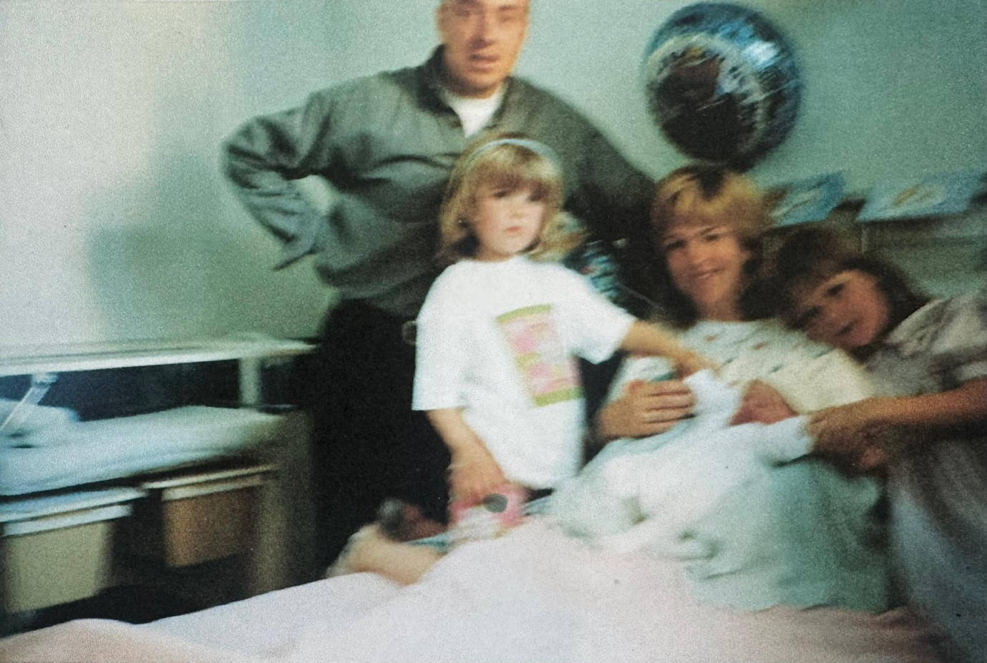
Fig. 2: Lewis, D. (2025). The Birth of the Firstborn Son [Reappropriated photograph]. Original source: Family Archive (1999).

Turning to the domestic archive as a site for analytical research marked a significant turning point within my praxis. Rather than engaging with the archive as a passive record of memory, my focus shifted toward the tension between lived experience and what is represented within the image. The domestic everyday reality I experienced was structured by a rigid regulatory system, in which the pursuit of the ‘perfect family’, enforced through the paternal figure, functioned as a mechanism of control.

While this lived experience was not directly visible within the archive, it shaped the conditions under which the archive was produced; the act of posing for the camera paralleled the behavioural norms that were embedded within everyday life. The family photograph operates as a form of performance in which power is enforced through correction in lived reality. Subtle details such as posture, proximity, and gesture become an internalised learned behaviour from a young age to align with the expected image, to the point where such behaviours appear natural, mirroring the ‘automatic functioning of power’ described by Foucault (1995).

These behaviours are not incidental but structured by pre-existing social and political norms. As alluded to by Butler (1990), familial roles are pre-determined by an inherited identity formed through the intersections of age, gender, and relation – the father, the mother, the daughter, the son. The appearance of the ‘perfect family’ is sustained through this repetition, allowing stability to be produced through performance.

Within the family archive, patterns of enacted roles become apparent through repetition, where stability is measured through coherence and consistency of behaviour. In this way, the archive functions as a metric of success within the regulatory domestic space, confirming alignment with an idealised family order.

This presents the central concern of the archive: when no apparent tension is represented, the archive fails to serve as an evidential representation of the true lived experience. This concern became central within the development of my praxis and prompted a turn towards recontextualisation to bypass the ‘familial gaze’ (Hirsch, 1997). What happens when the archive, typically a private record circulated within the immediate family, is subjected to public intervention? Re-presenting these private images as public artworks opens them up to scrutiny, transforming them from benign memories into ‘counter-memories’ (Barthes, 1980) that destabilise the sustained projection of perfection without overt measures taken to direct judgment. With no direct line of judgment, the very metrics that quantified the success of the domestic order, such as body language and proximity, are put to question.


Fig. 3: Gane, H. (2023) Man Hands On. [Photograph].

The public dissemination of the family archive proved to be an effective strategy for addressing power dynamics within the family, reinforced through engagement with Hamish Gane’s Man Hands On (2023). While Gane employs physical cropping of the image to expose power dynamics through visual omission, the work reinforced an instinct that meaning could be generated not through overt manipulation, but through directing attention to what is already visible yet rarely questioned. This influence affirmed the effectiveness of allowing observers to infer authority and regulation through subtle visual cues (Gane, 2025).

Despite this critical engagement, a limitation emerged in working solely with archival images. While the recontextualisation of family photographs succeeded in calling the familial ideal into question, the still image remained bound to the moment of representation. The archive could foreground the appearance of regulation, but it struggled to convey the atmosphere of surveillance and self-monitoring in anticipation of correction that structured behaviours beyond the photograph. The images revealed the performance, but not the conditions that demanded it.

Recognising this limitation marked a further turning point in the practice. While the archive remained foundational, it became clear that this domestic power could not be fully addressed through representation alone. The conditions that compelled performance – surveillance and real-time regulation – existed beyond the archive and were embedded within the lived environment of the home itself. To engage more directly with these dynamics, my practice shifted toward the domestic environment as the site in which these behaviours were actively formed and reinforced through what Althusser (1971) defines as the ‘ideological state apparatus’ of the family unit.

2.2: The Domestic Space as Structure

Recognising the limits of the archive prompted me to look beyond what was represented and towards what is omitted: the regulated domestic environment that worked to sustain the appearance of perfection. This realisation directed my practice toward installation as a medium of engaging with space itself as an active force in shaping behaviour.

In this shift, Pierre Bourdieu’s concept of habitus emerged as an appropriate theoretical grounding, where environments do not merely contain behaviour but actively produce it, generating “systems of durable, transposable dispositions” that structure both practices and perceptions (1977, p. 72). Approaching the domestic interior through this framework positioned the home not as a neutral site, but as a structuring structure through which regulation is normalised and internalised. Behaviour within the domestic space is activated through anticipation, producing self-regulation even in the absence of direct authority.

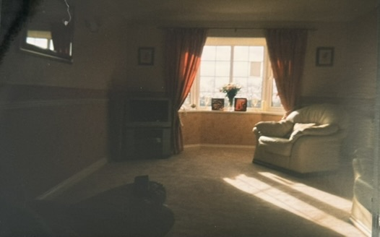
Fig. 4: Lewis, D. (2025) . The Living Room [Reappropriated photograph]. Original source: Family Archive (2005).

Installation provides a vessel to allow the observer – the very subject that representations of the ‘perfect family’ were meant to deceive – into the space itself, enabling them to grasp the highly charged structure that sustains the illusion. This strategy thematically resembled the construction of illusions that are theatrical sets, in which the environment and the act are pre-positioned. Through this concept, the spatial arrangement functions as a domestic panopticon; the viewer enters a site of permanent visibility in which the gaze of authority becomes internalised by the subjects (Foucault, 1995). I built on this by introducing strategic lighting that bridged the archive and theatrical registers, turning the domestic space into a stage upon which the performance of familial ideals could unfold. This lighting choice serves to highlight the ‘front region’ of the domestic performance (Goffman, 1956), where the family must maintain a façade of harmony for the observer.

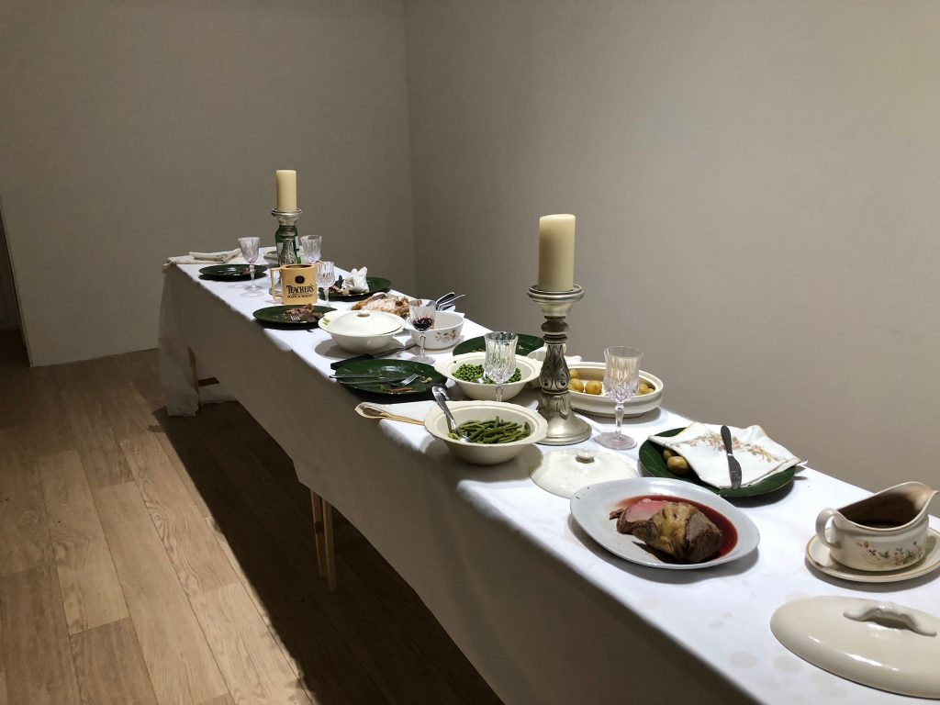
Fig. 5: Williams, D. (2018) Settling to a Still Pool [Installation shot].

During this development, an encounter with Dafydd Williams’ installation, Settling to a Still Pool (2018), prompted a significant methodological shift. Williams’ interrogation of the domestic sphere through the symbolic remnants of a family dinner, focusing on the deterioration of ritual and the ‘horrific’ potential of the home, repositioned my thinking around the medium (Williams in Elysium Gallery, 2018). Rather than a re-presentation of the regulatory space, I began to reconsider how installation might actively manifest the psychological regulations that structure behaviour around the archive. This encounter directed me to recount the loaded memories that the selective family archive omits, shifting my practice toward the use of signifiers of memory, rather than literal archival imagery. This allows objects to function as what Rose (1999) describes as technologies of the self – items that regulate our conduct and identity through their mere presence in our private lives.

This methodological shift allowed a particular charged memory tied to a domestic site to emerge, foregrounding the themes of masking through instability: the dining table. Drawing on Foucault’s conception of power as operating through everyday practices and ritualised behaviour (1980), the family dining table can be understood as a domestic site in which socio-political norms are reproduced. As Lord (2018) observes, the rectilinear dining table is an expression of domestic ideology that “reinforces traditional domestic roles”, providing a material framework for the performance of the functioning family unit (DeVault, 1991). The memory attached to this site reveals the fragility of the construct. During a family meal, my sister’s chair collapsed beneath her, interrupting the everyday ritual and escalating into an eruption of tensions, with my father holding a large kitchen knife towards her before leaving the room. My sisters, mother, and I remained in position in near silence. This silence, produced by shock, functioned as a state of heightened anticipation. It was a physical manifestation of habitus (Bourdieu, 1977), where authority is reasserted through the subjects of the unit following the outburst. This compliance in anticipation of what might follow demonstrates how the domestic gaze becomes internalised, creating what Foucault (1995) describes as docile bodies – subjects who regulate their own behaviour through the anticipation of authority.

This break in the script of the family order became foundational to my thinking around installation. Rather than approaching the dining table as a static symbol of the domestic, I began to understand it as a structure where narrative is in motion and can be manipulated. Working within this framework, I turned towards performance as a means of representing what the archive omits, allowing for the dismantlement of the idealised family structure and ritual to be encountered rather than resolved. By introducing the performing body into the space, the anatomy of the domestic perfection is laid bare; the tension is no longer held as a hidden archival trace but an active, physical encounter. This performative intervention temporarily fractures the Bourdieusian habitus, forcing a confrontation with the instability that the dining table was designed to mask (Lord, 2018).

2.3: Encounter and Rupture

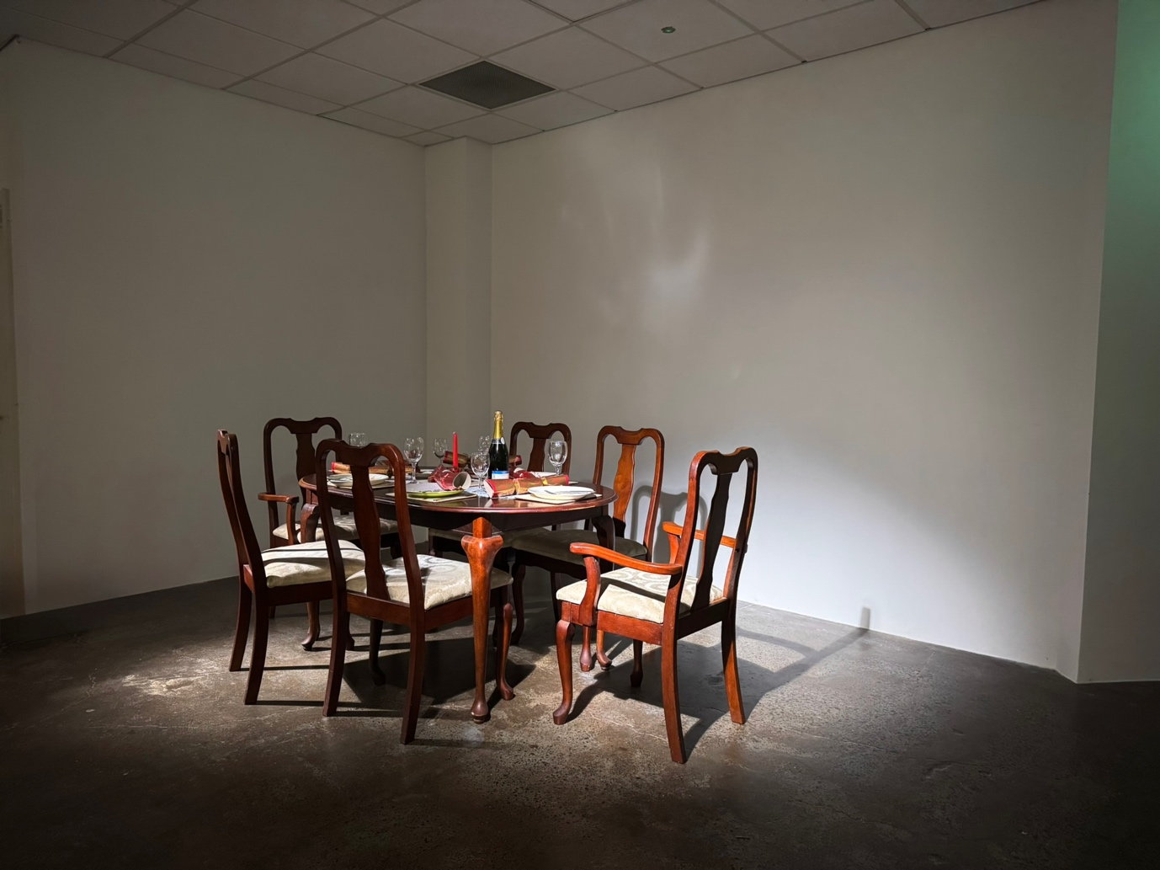
Fig. 6: Lewis, D. (2025) Christmas Dinner (pre-rupture) [Installation shot].

From the outset, the installation was structured to narrate a heightened sense of visibility where behaviour is regulated within the home, aligning with what Hirsch describes as the familial gaze (1999). Before disruption can be introduced, the work first needs to convincingly perform domestic order. Modelled after specific archival photographs, the installation is directed through the intensified context of the Christmas dinner, a period where the ideal of the perfect family is often at its most aggressively rehearsed, and therefore most vulnerable to destabilisation. It is here that the stylised repetition of acts (Butler, 1990) is most visible, as the pressure to perform the ’perfect’ holiday ritual exposes the fragility of the underlying structure.

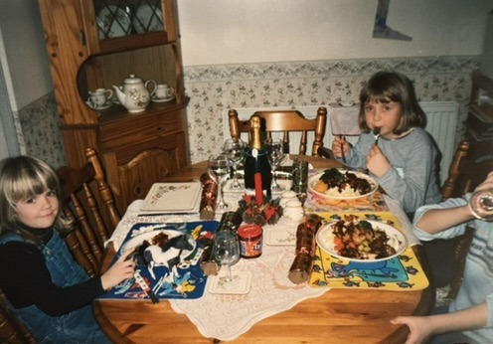
Fig. 7: Lewis, D. (2025). Christmas Dinner, 2000 [Reappropriated photograph]. Original source: Family Archive (2000).


Fig. 8: Lewis, D. (2025) Christmas Dinner [Installation detail shot].

This sense of control was materially reinforced most through a considered lighting strategy, which functioned as the first subtle indication that the scene was not entirely neutral. Operating across three conceptual registers, the lighting referenced the artificiality of theatrical sets, foregrounding the constructed nature of the scene. It also mimicked the flash of the film cameras that captured these years within the archive, actively placing the observer within the site. Finally, the focused illumination implied a condition of surveillance, isolating the table and intensifying the sense of behavioural exposure. This lighting strategy effectively transforms the gallery into a field of visibility (Foucault, 1995), where the audience assumes the role of the invisible surveillance.

Seating was equally deliberate; the arrangement mirrored the hierarchy of the family unit, positioning the father at the head of the table, subsequently dictating the arrangement of bodies and objects within the scene. The selection of props further reinforced this sense of order and familiarity. Wherever possible, original objects still present in the family home were used or supplemented by era-accurate counterparts to evoke a sense of nostalgia. The inclusion of food became an unexpectedly significant sensory component of the installation, acting as a lure that reinforced reassuring associations of the domestic routine and establishing a foundation of security prior to any overt act of disruption.

Once the static presentation of the installation had established the perception of the domestic ideal, achieving the desired stable structure, the work gained conceptual momentum in the lead-up to the disruption. Rather than the immediate break of the normative structure, tension was sustained through delayed activation, allowing control and idealised behaviour to remain outwardly intact. The conditions of the disruption were further shaped by the intentional withholding of information surrounding the performance, where very few had the knowledge to anticipate it, yet were unaware of when the performance would commence, serving as an intentional mirroring of the application of power present within the domestic. By withholding the ‘script’ of the performance, the work subjects the viewer to the same unpredictable ‘regime of control’ (Rose, 1999) that governs the domestic space. This was a key component to the performance; in attempts to parallel the representations of lived experience of the family that are omitted from the archive, the performance was unannounced and received minimal documentation.

Although the performance of breaking the chair was inevitable, its activation remained contingent on the presence of the original authority figure within the family structure. Rather than suspending this hierarchy, the performance demonstrated how power continued to operate through the maintenance of restraint and idealised behaviour up to the point of rupture, confirming the persistence of domestic authority even in the moment of exposure.

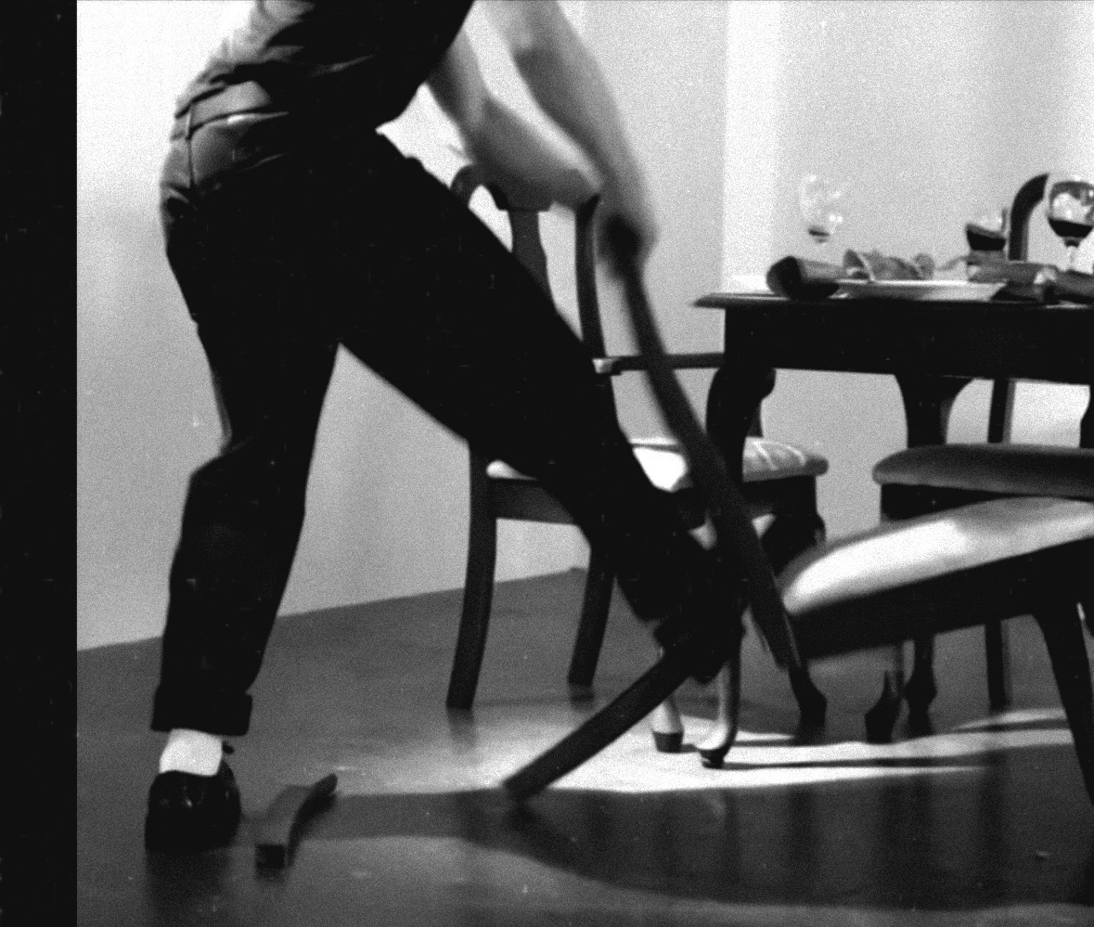
Fig. 9: Lewis, D. (2025) Christmas Dinner [Performance still]. Recorded by Paris Naik-Neenan.

The breaking of the chair catalysed the breakage of the stable structure. The imposed traces of a curated harmony within the spatial order of familial gaze are fractured through the manifestation of evidence rather than a projection of representations. From the catalytic moment, audiences are forced to now encounter the aftermath of the imposed façade of constructed stability.

Beyond the catalytic moment of the spectacle of performance lay the presence of the prolonged decay of representation. The food presented, thought of as the sensory lure of evoking security, becomes the narrating metaphor for the impending unsustainable act of constrained self-regulation in the domestic sphere. Once the tone is set by the spectacle of the chair, the food that remained throughout the duration of the exhibition would inevitably deteriorate. Mould brought hesitancy to engage, declaring the site as a space where distance is necessary. This deterioration functions as a manifestation of abjection (Kristeva, 1982); by allowing the ‘proper’ domestic ritual of the family meal to descend into decay, the work forces a confrontation with the ‘grossness’ of the underlying power structure that is exposed. The work operates through prolonged consequences rather than a singular event, indicating the disruption would persist regardless of interference.

Following the immediate act of rupture, the work began to gesture toward the trajectory of familial structure beyond the original, informing incident. While the chair itself marked the site of disruption, it was not the breaking of the chair that became the enduring imprint of the memory, but my father’s reactive state in its aftermath. Over the decades that have followed, the inquiry of generational patterns shaping how authority and behavioural expectations are reconfigured rather than resolved across generations. This temporal shift was enacted through the performance, through my repositioning behind the head of the table following the breaking of the chair, extending the performance beyond metaphorical reenactment toward implication. In doing so, the work foregrounded the inheritance of role and structure, indicating how power persists through patterns of behaviour that continue to shape life beyond moments of rupture.

Conclusion
This project set out to examine how the ideal of the ‘perfect family’ is constructed and sustained within the domestic sphere. While family photographs initially appeared as benign records of memory and continuity, critical engagement with the archive revealed its role in stabilising a carefully managed version of domestic life. Rather than functioning as transparent documents, these images operate through selection and omission, producing a visual coherence that conceals the regulatory conditions underpinning it. The archive does not misrepresent lived experience; it performs its function by excluding it.

Working through the archive made these mechanisms visible, but it also exposed the limits of representation. While photographs could register the appearance of conformity, they remained bound to the moment of capture and were unable to account for the anticipatory regulation and self-monitoring that structured the behaviours beyond the image. The archive revealed performance, but not the conditions that demanded it. This limitation became a critical turning point within practice, prompting a move away from re-presentation and toward methods capable of engaging with space, embodiment, and lived experience more directly.

This shift to installation allowed the domestic environment itself to be treated as material. By reconstructing the space, the work moved beyond the image and into the conditions of its production. The home was no longer approached as a neutral setting, but as an active structure that shapes behaviour through anticipation, repetition, and internalised authority. Installation made it possible for regulation to be encountered physically rather than inferred visually, exposing how compliance is produced through everyday spatial arrangements and ritualised domestic practices.

Performance further intensified this encounter. By introducing the performing body into the reconstructed environment, the work disrupted the stability of the familial script and revealed the labour required to maintain the appearance of domestic normality. These disruptions did not function as moments of resolution, but as points of exposure, where the instability became visible. Performance operated not as a spectacle, but as a means of accessing what the archive suppresses, allowing the conditions of regulation to be experienced rather than explained.

Central to this investigation was the persistence of authority within the family structure, particularly its inheritance rather than its presence alone. By repositioning myself within the space, the work addressed how authority continues to operate through internalisation and repetition. Rather than dismantling the structure, the work revealed its endurance, highlighting how familial roles are reproduced and maintained through the repetition of acts.

Ultimately, the project insists that domestic perfection is not an image to be dismantled, but a structure to be examined. While the archive served as an entry point, installation and performance enabled deeper engagement with the lived conditions of regulation. Rather than resolving the tensions it exposes, the work holds them in place, insisting on their continued visibility and inviting reflection on the cost of upholding the representation of the ‘perfect family’.

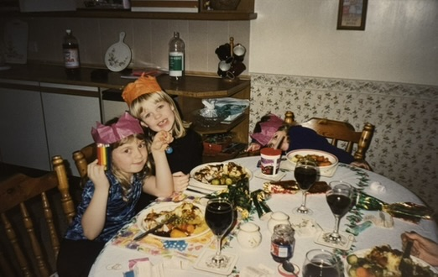
Fig. 10: Lewis, D. (2025). Christmas Dinner, 1999 [Reappropriated photograph]. Original source: Family Archive (1999).

References

Althusser, L. (1971). ‘Ideology and ideological state apparatuses (notes towards an investigation)’, in Lenin and Philosophy and Other Essays. Available at: https://www.marxists.org/reference/archive/althusser/1970/ideology.htm (Accessed 10 January 2026).

Barthes, R. (1981). Camera Lucida: Reflections on Photography. Translated by Howard. R. New York. Hill and Wang.

Bourdieu, P. (1977) Outline of a Theory of Practice. Translated by Nice, R. Cambridge: Cambridge University Press, p. 72

Butler, J. (1993) Bodies That Matter: On the Discursive Limits of “Sex”. New York. Routledge. Available at: https://monoskop.org/images/d/df/Butler_Judith_Bodies_That_Matter_On_the_Discursive_Limits_of_Sex_1993.pdf (Accessed: 22 December 2025)

Butler, J. (1990). Gender Trouble: Feminism and the Subversion of Identity. New York. Routledge. Available at: https://monoskop.org/images/e/ee/Butler_Judith_Gender_trouble_feminism_and_the_subversion_of_identity_1990.pdf (Accessed: 22 December 2025)

Butler, J. (2004) Undoing Gender. London: Routledge.

Devault, M (1991). Feeding the Family: The Social Organization of Caring as Gendered Work. Chicago. The University of Chicago Press. Available at: https://archive.org/details/feedingfamilysoc0000deva/page/n6/mode/1up (Accessed 05 January 2026)

Foucault, M. (1995). Discipline and Punish: The Birth of the Prison. Translated by A. Sheridan. New York. Random House Inc. Available at: https://monoskop.org/images/4/43/Foucault_Michel_Discipline_and_Punish_The_Birth_of_the_Prison_1977_1995.pdf (Accessed: 22 December 2025)

Foucault, M. (1980). Power/Knowledge: Selected interviews and other writings, 1972-1977. Edited and translated by Gordon, C. New York. Pantheon Books. Available at: https://monoskop.org/images/5/5d/Foucault_Michel_Power_Knowledge_Selected_Interviews_and_Other_Writings_1972-1977.pdf (Accessed 05 January 2026).

Gane, H. (2025) Hamish Gane – Praxis Presentation [Lecture]. Swansea, 10 October

Goffman, E. (1956). The Presentation of Self in Everyday Life. Edinburgh. University of Edinburgh. (Available at: https://monoskop.org/images/1/19/Goffman_Erving_The_Presentation_of_Self_in_Everyday_Life.pdf (Accessed 10 January 2026).

Hirsch, M. (1999). The Familial Gaze. Hanover. University Press of New England. Available at: https://openlibrary.org/works/OL18253720W/The_familial_gaze (Accessed: 07 January 2026)

Hirsch, M. (1997) Family Frames: Photograph, Narrative and Postmemory. Cambridge, Massachusetts. Harvard University Press. Available at: https://archive.org/details/familyframesphot0000hirs/page/n6/mode/1up (Accessed: 17 December 2025)

Kristeva, J. (1982). Powers of Horror: An Essay on Abjection. New York. Columbia University Press. Available at: https://archive.org/details/powersofhorrores00kris (Accessed: 11 January 2026).

Lord, E. (2018) . The invisible ideologies behind the dining table. Assemble Papers. Available at: https://assemblepapers.com.au/2018/05/17/on-dining-tables-and-divorce/ (Accessed: 5 January 2026).

Rose, N. (1999). Powers of Freedom: Reframing Political Thought. Cambridge. Cambridge University Press. Available at: https://archive.org/details/powersoffreedomr0000rose/mode/1up (Accessed: 11 January 2026).

Williams, D. (2018) Dafydd Williams: Settling to a Still Pool [Video]. Elysium Gallery, Swansea. 21 May. Available at: https://youtu.be/QYjVhQTM5yI?si=--ng7wFmFSbGUzHl (Accessed 09 January 2026).

Bibliography

Big Think (2011) Judith Butler: Your Behaviour Creates Your Gender. [Online video] Available at: https://www.youtube.com/watch?v=Bo7o2LYATDc (Accessed: 22 December 2025)

