Innovative Marketing Strategies for Nike
LECTURER: TUSHARA BALENDRAN
Student Name: RAJPUT SAMVEER
Student ID: 2132184
MODULE:- LCMB70011
COURSE:- Master in business administration
TITLE:- Marketing Assessment 1
SUBMISSION DATE:- 07/09/2022

Table of Contents
1.0. Introduction 3
2.0. Brief background information 3
3.0. Communication 5
4.0. Briefly Shannon and Warren Weaver Model 5
5.0. Integrated Marketing Communications (IMC) 6
6.0. New promotional strategies 7
7.0. Branding and brand equity 8
8.0. Keller’s Brand Equity model 10
9.0. Discuss the customer journey and customer touchpoints 11
10.0. Diagram and explanation of a customer journey map for your organisation 13
11.0. Total Engagement Model 14
12.0. Conclusion 15
Reference List 16

1.0. Introduction
In terms of a recent study by a global management consultancy firm, it is found that in order to enhance the satisfaction of level of the pivotal consumers, in most cases, business organisations are putting more emphasis on the touchpoints, which diverted the attention from the more crucial issue of the "end to end journey" of the consumers. Furthermore, more touchpoints are responsible for creating more complexity, which most cases, is challenging to spot in the long run (Neher et al., 2022).
The purpose of the assignment is to examine the critical evaluation regarding in which way Nike can develop innovative marketing strategies for increasing awareness of the brand as well as evaluating the overall “customer journey” across a wide range of communication channels to fulfil the expectation of the future and present stakeholders of the famous American multinational organisation.
This report will provide a brief idea on the chosen shoe manufacturing USA based multinational firm and a brief idea of communication and aligned communication model in the chosen firm. A brief idea on Integrated marketing communication will explain in which way Nike can use the new promotional strategies to increase awareness in the chosen management domain will also be highlighted. In the end of the report, the brand equity mode of Keller will be implemented to understand the brand performance of Nike.

2.0. Brief background information
In the global business domain, Nike is an American-based multinational firm established itself as the largest manufacturer and supplier in the world, which was established by Phill Knight and Bill Bowerman in the year 1965 (Tighe, 2018). The first store of the brand opened in the year 1966 as well as launched the first shoe from the brand Nike in the year 1972 (Statista, 2021).

Figure 1: Nike Logo
Source: (Nike, 2022)
A proper rebranding happened from the Nike to Nike, Inc, and after the 1980s, the brand rapidly expanded the business along with diversification of its line of products through the following acquisitions. At present, in more than 170 countries, Nike has its retail distributors as well as outlets which effectively managed by around 79,100 worldwide workers. At present, around the world, 1000 retail stores exist, and the success of the brand can be considered to the worldwide marketing campaign such as professional sports team, agreement, celebrity athletes and various others. The mission statement of the brand is to bring innovation as well as inspiration to each and every athlete around the globe; this motto motivated the brand to do each and every possible thing to motivate the human potential in the business domain (Statista, 2021).
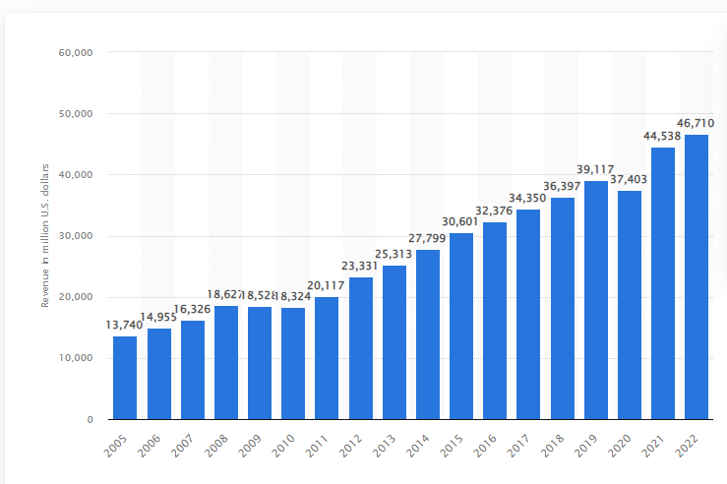
Figure 2: Year wise financial performance of the shoe brand
Source: (Statista, 2021)
As of 2022, the global revenue of the Nike has amounted to around 46.71 billion US dollars, which has been increased at a rapid rate in the last few years at a rapid rate from the 13740 billion US dollars that assisted the brand in establishing itself as the 80 000 employees (Statista, 2021).

3.0. Communication
As per definition, the communication term originated from the Latin word “communication”, which means imparting or sharing. It is the method of the process by which information is basically interchange with individuals through a common system of behaviour, signs or symbols through which messages communicate (Kupec et al., 2020). In accordance with the views of Li et al. (2021), marketing communication is the mode through which firms attempt to remind, persuade as well as inform their consumers in a direct as well as indirect manner. In the marketing domain, communication term is used to explain in which way business organisations attempt to remind, persuade as well as inform their consumers in a direct as well as indirect manner.

4.0. Briefly Shannon and Warren Weaver Model
The eminent united-based industrial specialist Warren Weaver, as well as applied mathematician Claude Shannon, developed a mathematical theory of communication, which is also known as the "Shannon-Weaver model of communication” (Adanlawo et al., 2021). This model is mainly designed to create an effective communication framework between the sender as well as a receiver, where the sender is the main originator or source of the communication while the receiver is the destination of the message sender. As opined by Kovalevskaya and Kratenok (2019), this two-communication model first highlighted the noise aspect, which mainly assists in making the communication effective and efficient by disconnecting the issue causing the noise. On the contrary, Cañón Prieto et al (2019) criticised the model by stating that effective human communication cannot be explained through a “mathematical theory” as it ignored some crucial aspects of communication, such as feedback.

Figure 3: Shannon Weaver Model of Communication
Source: (Mitra et al., 2020)
In the conversation between the employer and employees, the sender can be the employer who makes calls or send email as the encoder in the way or mode which could be easily encoded. Now, satellites, cables or the internet are the channels which used to transmit information to the destination and act as a decoder (Adanlawo et al., 2021). Now, noise can easily create through the information moves and ultimately reach the receiver or employee or worker, who is capable of interpreting the message in an easy manner as well as can provide feedback to the sender (Mitra et al., 2020).

5.0. Integrated Marketing Communications (IMC)
In the year 1998. eminent authors Schultz and his collaborators defined the term IMC as a strategic business method which mainly used for the purpose of evaluating, executing, coordinating, measurable, innovative communication programs over time with consumers to attract the attention of the relevant people (Duralia, 2018). By emphasising more the requirement to the IMC approach, renowned American author Phillip Kotler defined the concept IMC by stating that under which an organisation effectively coordinates as well as integrates its effective communication channel to deliver a consistent as well as a clear message about an organisation as well as its services or products to its pivotal consumers (Laurie and Mortimer, 2019). Furthermore, Phillip Kotler against came back in 2003 with a new definition of IMC and argued that the complete marketing approach of an organisation must be considered as a way of looking at the whole marketing process from the perspective of the pivotal consumer (Porcu et al., 2019). For Instance, pivotal IMC tools are advertising: helps to reaches geographically diverse consumers within a short span of time; sales promotion: which helps to attract the attention of the targeted consumers to effectively connect in the process of communication; personal selling: face to face interaction to meet the need of the consumers, social media marketing: through Facebook, Instagram are the modern method of communication which develop by using the above media platform. As opined by Porcu et al. (2019), most business organisations like Nike uses various IMC tool such as online marketing, press release as well as television to attract the attention of the consumers in an easy and speedy manner (Kushwaha et al., 2020).

6.0. New promotional strategies
In the most current fiscal year, overall sales of Nike has been declined due to the economic instability created due to global circumstances, but digital sales of the brand have maintained their momentum (). As per definition, marketing strategy is the method that permits a business to centralise its limited resources to acquire a higher level of opportunities to achieve a sustainable competitive and create a higher level of sales (Pafitis, 2020). Furthermore, along with the digital sales, Nike must focus on the offline promotional mode as a huge gap created between the online and offline modes of shopping requires to be resolved in a speedy manner. Therefore, in order to grow through an e-commerce platform or increase digital sales, it is highly crucial for the brand to enhance its brand awareness by following the below-mentioned new promotional strategies.
The digitalisation of the manufacturing process
Nike can digitalise its whole production process with the help of 3D printing robotics as well as technology at any technical factory. For example, one of the pivotal competitors of Nike, Adidas, by using this strategy, has developed "future craft 4D shoes" that developed with oxygen as well as light, and by using this digital marketing strategy, the brand has successfully reached the new generation consumers who preferred to buy a customised product as per their terms as well as condition (Retail Dive, 2022).
Run a social media contest:
In spite of being a pro in digital marketing. Nike can run social media contests as it is one of the easy and fun ways to connect with potential consumers and enhance the higher level of the prospect of the business. Nike is basically intelligently selling emotional benefits through products which can be enhanced by arranging such contests, and it helps to attract the attention of the consumers through their effective strategies. For example, as per the new survey data, Facebook contests have the potential to attract an average of 34% of a new types of consumers by increasing the organic reach of the brand (Retail Dive, 2022).
Offline promotional strategies
Now, as a global brand and as per the requirement of the consumers, it will be crucial to focus on offline marketing strategies to connect with the all-age group consumers as well as stay productive with the strong competitors.
Offline Influencer Marketing Campaign:
Nike can use billboards, one of the pivotal tools of offline marketing, in significant areas such as Los angles or busy areas to boost reaction on social media. As opined by Wang et al. (2019), for the purpose of broadcasting as well as building brand awareness, billboard advertising is still popular to reach the maximum number of people within a short span of time. Basically, in comparison to the other type of marketing methods, a billboard has the potential to acquire the highest number of impressions; for that purpose, Adidas, one of its pivotal competitors, Nike, has put the billboard in 16 busy and high-traffic areas such as eight in Los angles and eight others areas and calling out influencers to promote the billboard advertising through creating personalised outdoor ads. This promoting strategy is quite innovative by creating an influencer marketing campaign offline (Howland, 2022).
Nike can provide an innovative in-store experience by installing communicative kiosks in its pivotal store to reduce the gap between the offline as well as inline experience. As a result of that, a consumer can easily copy any type of social media option, permitting consumers to photograph those holding or wearing shoes or an item in the store (Gebreselassie and Bougie, 2019). Therefore, consumers can easily post the photo, which indirectly helped Nike to get easy exposure of the brand to attract the attention of the consumer by submitting real-time feedback from the users. It could be a unique way to attract consumers in-store and create an experience which encourages them to promote the brand instead of the company, as word-of-mouth marketing promotions have always been found to be the best approach to create loyal consumers or the brand.

7.0. Branding and brand equity
Branding
Branding terms are used to explain the method of creating a positive as well as the strong perception of an organisation, its services as well a product in the mind of consumers by togethering the elements of a statement, consistent theme, design as well as logo throughout the overall marketing process of communication (Gebreselassie and Bougie, 2019). In terms of the “American Marketing Association", a brand is a symbol, design, term, name or any type of character tics that addresses one seller's service or good as a different from the other type of seller (Theurer et al., 2018). Therefore, branding is the idea which used to attract people in both emotional as well as practical ways triggered when revealing the name, visual identity or logo, which is understood from the above section (Keller and Swaminathan, 2019).
Brand Equity
In the marketing domain, brand equity is used to explain added value provided to services as well as products, which may be reviewed in the way consumers act, feel as well as think with respect to the brand and its profitability, market share and brand value (Keller and Brexendorf, 2019). In the high valued brand name, brand equity term is included, which steamed from the perception of the consumer’s superiority. Theurer et al. (2018) defined the term brand equity as a set of brand liabilities as well as assets connected to the brand symbol and name that are used to subtract or add from the value offered by service o product to the organisation or the customer of the organisation (Tasci, 2020).
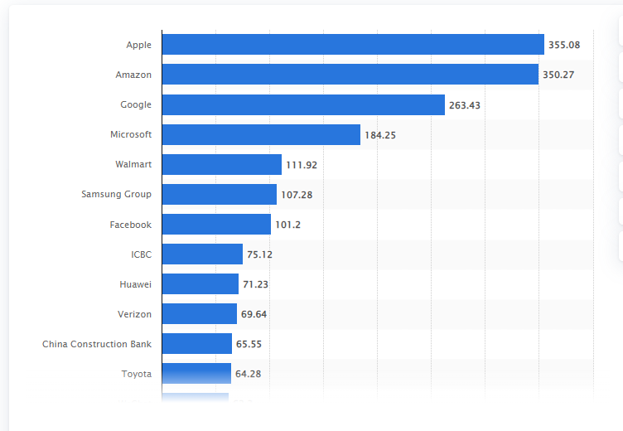
Figure 4: Brand equity
Source:(Statista, 2022)
As per the recent data, Apple is one of the most valuable brands with an estimated brand value of around 55.1 billion US dollars, while Amazon has acquired the second position and Google achieved the third position (Statista, 2022). All the enlisted brands have acquired equity through creating loyalty, boosting talent, attracting talent and lowering the overall costs of the business.

8.0. Keller’s Brand Equity model
In the book on strategic brand management (1993), Marketing professor Kevin Lane Keller developed the Customer-Based Brand Equity Model (CBBE), also called the brand equity model, to highlight the journey of consumer's connection with brands from the recognition of the bottom to the peak of the model (Keller and Swaminathan, 2019). For example. Over the years, Nike has developed branding through years of targeting by focusing on the stages of salience, response as well as relationship. The advantage of the CBBE model is the use of physical design, distribution, as well as image, which can help to create a strong competitive advantage in the domain of product categories, while the series of disadvantages of developing brand equity is the higher level of costs as the branding reputation, does not come free (Tasci, 2020).
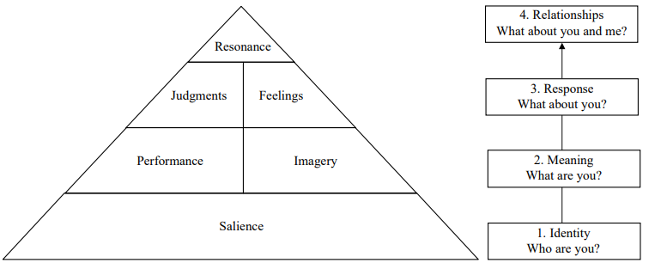
Figure 5: Keller’s Brand Equity model
Source:( Tasci, 2020)

Keller brand equity model of the Nike
Now, Brand salience was developed by Nike in 1971; the logo was originally designed by Davidson, which made on the idea of a swoosh, the wing of a goddess, which signifies the power, motivation as well as the sound of speed (Nike, 2022). This strong logo has helped to brand to develop an emotional connection with its wide range of geographically diverse people. The Brand performance or meaning is the function, durability, as well as satisfaction offered by the product (Tasci, 2020). Nike's product's unique quality and satisfaction have been maintained through a higher level of standard, which management committed to providing, while brand imagery maintained the Nike over the years through meeting style and a higher level of need, which assisted consumers to feel unique. The brand response is the feeling and judgement of a brand, which is quite personal and important to stay active in the business domain (Keller and Swaminathan, 2019). In terms of a recent study, 56% of the respondents are satisfied with Nike products in comparison to its competitor and respond to it by providing positive feedback and demand that assisted in achieving unchallenged success in the retail space. A brand relationship is a connection with the consumers, which developed Nike by offering high-quality premium products at affordable prices through 3rd party retail position. In addition, a strong connection has been developed with Nike through an innovative social media campaign, incentives and support that boosts the connection.

9.0. Discuss the customer journey and customer touchpoints
Consumer journey is the path of communication of an individual with the brand, service as well as product, described both indirect as well as through direct actions such as hearing or contacting about the brand (Kranzbühler et al., 2019).

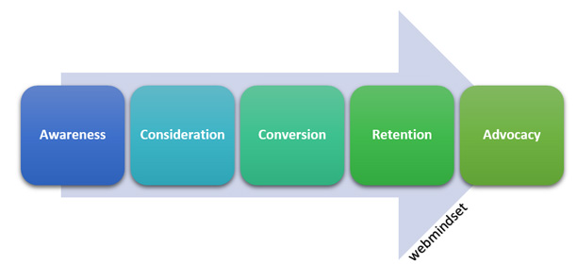

Figure 6: consumer Journey
Source:( Tueanrat et al., 2021)
Stages of the consumer Journey of the Nike
Stage 1: Awareness: In this stage, consumers of the brand are aware of their need and start to search for the product or services. In the present time period, as per a study, before purchase, around 81% of the shoppers research their products while 41% of the random shoppers are made less researched rather open to large purchases with deals and offers (Saleslion, n.d.). Stage 2: Consideration. after being aware of a brand, potential consumers of the products are started to consider the brand by evaluating the quality and price of the products from the reviews made by the public in the various domain. Stage 3: Conversion was the third stage when the potential consumers of a brand assumed to have relevant information regarding the brand, and Stage 4: Retention is the most crucial stage for a brand to retain the trust by maintaining quality, effective customer service. Advocacy is stage 5 or the last stage; when onboarded, consumers can become vocal support of the brand and can help to create word of marketing. Influenced to attract a new set of consumers, who might be difficult to target by the brand.
Consumer Touchpoints
It is a direct or indirect connection between the brand and consumer that occurs within as well as outside control of the brand, during or after the purchase of a brand's product or service.
- Pre-Purchase Touch Points:
In this stage, Nike is continually trying to create more touchpoints with the consumers to effectively trigger the consumer's wants and needs through innovative online and offline marketing tools (Herhausen et al., 2019). For example, SEO optimised website of Nike is always trying to answer all pre-purchase queries along with developed personal contracts through mails (Nike, 2022)
- Purchase Touchpoints:
At this stage, two types of touchpoints are normally encountered due to the online and offline services of the brand (Tueanrat et al., 2021). Now, if consumers visit Nike's nearby store, sales assistants help them through effective communication and helping to provide the best products and create touchpoints. In a similar manner, an online dashboard and virtual executive help the consumer to select the best product, created touchpoint. End of the purchase, the offer of a discount card of 25% off on purchase within 5 months created another touchpoint (Herhausen et al., 2019).
- Post Purchase Touch Points
In this stage, a consumer has already used the Nike brand, but every week receives a newsletter regarding in which way the consumer can clean product or use product, which creates a touchpoint. Furthermore, Nike virtual assistant can call the consumer to explain in which way redeem the points through the purchase within the time span, created psychological trust through building touchpoints Herhausen et al., 2019).

10.0. Diagram and explanation of a customer journey map for your organisation
Triggering needs
Discover
Purchase
Use
Bond
website
Insta Post and Reviews
Postsposr=
Need for high-quality, durable shoes
Customer Executive
Newsletter and discounts
Customer review and create word of mouth promoting

Figure 7: customer journey of Nike
Source: (created by the learner)
Hence, based on the above figure, it can be concluded that the customer journey of Nike consumers started with the website search to gather information to meet their needs. Good reviews from the online channels finally motivate consumers to purchase the product and develop a good image of the brand from the assistance acquired from the customer service executive, loyal program card and future discounts coupons on the purchase. In the pose purchase stage, satisfied consumers started to refer products to her friends and relatives and promote his online page, which made her loyal consumers, and it happened due to the perfect satisfaction at each touchpoint. Now, the strength of the Nike’s customer journey map is its pre purchase touch points as the SEO optimised websites, unique and innovative content has wonder for the brands by effectively attracting the attention of the consumers (Batidzirai et al., 2021). On the other hand, the major weakness of the customer Journey map is the lack of strategy to apply the touchpoints in the post purchase stage. For example, an effective executed newsletter has the potential to become the best consumer touch points as per the value they provided to the consumers. However, in the case of the Nike, poor executed newsletter failed to keep informed as well as engaged consumer with the brand rather worked as bad reviews which most of the cased influenced consumers to unsubscribe newsletter that broke the connection and end the customer journey with the brand, Nike (Duralia. 2018).

11.0. Total Engagement Model
The objective behind this model is to put each and everything together into an effective as well as efficient system domain that assists in focusing on connecting activities of the organisation on a unified plan for engaging consumers through effective promotion, service as well as an advertisement (Grover and Kar, 2020),
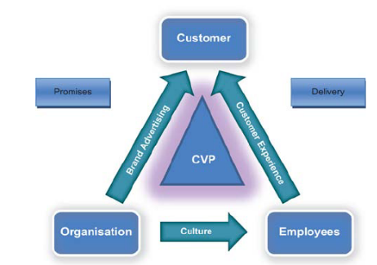
Figure 8: Total Engagement Model
Source: (Batidzirai et al., 2021)
In the case of Nike, the value of the brand has been recognised as it successfully provided quality products to a large number of consumers without making issues or defects. It has assisted in creating an engaged consumer, such as 55% of the consumers of Nike associated with the brand for more than 15 years, while the left 58% of the consumer are satisfied with the quality of the brand offered through its loyalty program that attracted consumers (Saleslion, n.d.). In spite of the profit, a huge gap exists in its promotional marketing domain, which requires focusing on increasing the percentage of loyal or engaged consumers by focusing on the aspect of the culture and value proposition (Batidzirai et al., 2021).

12.0. Conclusion
Hence, based on the above scenario, it can be concluded IMC concept by stated that simultaneously running the marketing is not only quite extensive but also challenging to manage the creation and distribution in the proper manner; otherwise, it has a huge potential to overloaded with information, which could distract instead of attracting the consumers towards the brand. Furthermore, from the above scenario, it can be concluded that promotional strategies of the brand are the new way for a business organisation to carefully coordinates as well as integrates its various communication channels to deliver a compelling, consistent as well as a clear message. Now, the third stage is when the potential consumers of a brand are assumed to behave relevant information regarding the brand, such as Nike products are very long lasting, affordable, and good designed, and some big celebrities and athletics are constant endorses and used it. In spite of the application of the innovative strategies, the Nike brand has a wide scope to increase more engaged consumers by using the below-mentioned strategies, which are elaborated on in the following section.
Recommendation
- Nike should focus on employee engagement along with a consumer engagement program as it will help to improve the brand confidence value among the consumer in a psychological way.
- Nike should introduce a greater number of successful loyalty programs to boost consumers to purchase more products.
- Nike should maintain offline and online marketing programs to connect with the old-age consumers section as this percentage of people in the global domain has been increasing at a rapid rate.

Reference List
Adanlawo, E.F., Reddy, M.M. and Rugbeer, H., 2021. Intercultural business communication: The implications of language barriers. Psychology and Education Journal, 58(5), pp.6281-6290.
Batidzirai, B., Trotter, P.A., Brophy, A., Stritzke, S., Moyo, A., Twesigye, P., Puranasamriddhi, A. and Madhlopa, A., 2021. Towards people-private-public partnerships: An integrated community engagement model for capturing energy access needs. Energy Research & Social Science, 74, p.101975.
Cañón Prieto, C.D., Romero-Gelvez, J.I. and Herrera-Cuartas, J.A., 2019. Using social network analysis to improve enterprise communication.
Duralia, O., 2018. Integrated marketing communication and its impact on consumer behavior. Studies in Business and Economics, 13(2), pp.92-102.
Gebreselassie, A. and Bougie, R., 2019. The meaning and effectiveness of billboard advertising in least developed countries: The Case of Ethiopia. Journal of Promotion Management, 25(6), pp.827-860.
Grover, P. and Kar, A.K., 2020. User engagement for mobile payment service providers–introducing the social media engagement model. Journal of Retailing and Consumer Services, 53, p.101718.
Herhausen, D., Kleinlercher, K., Verhoef, P.C., Emrich, O. and Rudolph, T., 2019. Loyalty formation for different customer journey segments. Journal of Retailing, 95(3), pp.9-29.
Howland, D., 2022. Adidas goes offline for influencer campaign. [online] Retail Dive. Available at: <https://www.retaildive.com/news/adidas-goes-offline-for-influencer-campaign/526943/> [Accessed 18 August 2022].
Keller, K.L. and Brexendorf, T.O., 2019. Measuring brand equity. Handbuch Markenführung, pp.1409-1439.
Keller, K.L. and Swaminathan, V., 2019. Strategic brand management: Building, measuring, and managing brand equity. London: Pearson.
Kovalevskaya, I.I. and Kratenok, I.V., 2019. Communication Design: programme of study for specialty 1-26 80 05 Marketing.
Kranzbühler, A.M., Kleijnen, M.H. and Verlegh, P.W., 2019. Outsourcing the pain, keeping the pleasure: effects of outsourced touchpoints in the customer journey. Journal of the Academy of Marketing Science, 47(2), pp.308-327.
Kupec, V., Lukáč, M., Štarchoň, P. and Pajtinková Bartáková, G., 2020. Audit of museum marketing communication in the modern management context. International Journal of Financial Studies, 8(3), p.39.
Kushwaha, B.P., Singh, R.K., Varghese, N. and Singh, V.N., 2020. Integrating social media and digital media as new elements of integrated marketing communication for creating brand equity. Journal of Content, Community & Communication, 11(6), pp.52-64.
Laurie, S. and Mortimer, K., 2019. How to achieve true integration: the impact of integrated marketing communication on the client/agency relationship. Journal of Marketing Management, 35(3-4), pp.231-252.
Li, F., Larimo, J. and Leonidou, L.C., 2021. Social media marketing strategy: definition, conceptualization, taxonomy, validation, and future agenda. Journal of the Academy of Marketing Science, 49(1), pp.51-70.
Mitra, A., Ahmed, N., Pramanik, P. and Nandi, S., 2020. Language Studies and Communication Models. International Journal of English Learning & Teaching Skills, 3(1), pp.1776-1794.
Neher, K., Park, R. and Maechler, N. 2022. From touchpoints to journeys: Seeing the world as customers do | McKinsey. [online] www.mckinsey.com. Available at: https://www.mckinsey.com/business-functions/growth-marketing-and-sales/our-insights/from-touchpoints-to-journeys-seeing-the-world-as-customers-do [Accessed 18 Aug. 2022].
Nike.com. 2022. Nike. Just Do It. Nike.com. [online] Available at: https://www.nike.com/in/?cp=76060516106_aff_FE4O7wtxe6g&ranMID=41134&ranEAID=FE4O7wtxe6g&ranSiteID=FE4O7wtxe6g-6MZRWlAyLwxmDs.gUhKm.Q [Accessed 18 Aug. 2022].
Pafitis, E. 2020. Nike’s Marketing Strategy: What Can We Learn? | SB. [online] www.startingbusiness.com. Available at: https://www.startingbusiness.com/blog/marketing-strategy-nike.
Porcu, L., del Barrio-Garcia, S., Alcántara-Pilar, J.M. and Crespo-Almendros, E., 2019. Analyzing the influence of firm-wide integrated marketing communication on market performance in the hospitality industry. International Journal of Hospitality Management, 80, pp.13-24.
Retail Dive. 2022. Adidas goes offline for influencer campaign. [online] Available at: https://www.retaildive.com/news/adidas-goes-offline-for-influencer-campaign/526943/ [Accessed 18 Aug. 2022].
Saleslion. n.d.. 81% of Shoppers Research their Product Online before Purchasing. [online] Available at: https://saleslion.io/ecommerce-statistics/81-of-shoppers-research-their-product-online-before-purchasing/ [Accessed 19 Aug. 2022].
Statista 2021. Nike’s revenue 2018 | Statista. [online] Statista. Available at: https://www.statista.com/statistics/241683/nikes-sales-worldwide-since-2004/.
Tasci, A.D., 2020. A critical review and reconstruction of perceptual brand equity. International Journal of Contemporary Hospitality Management.
Theurer, C.P., Tumasjan, A., Welpe, I.M. and Lievens, F., 2018. Employer branding: a brand equity‐based literature review and research agenda. International Journal of Management Reviews, 20(1), pp.155-179.
Tighe, D. 2018. Nike: employees worldwide 2018 | Statista. [online] Statista. Available at: https://www.statista.com/statistics/243199/number-of-employees-of-nike-worldwide/.
Tueanrat, Y., Papagiannidis, S. and Alamanos, E., 2021. Going on a journey: A review of the customer journey literature. Journal of Business Research, 125, pp.336-353.
Wang, L., Yu, Z., Yang, D., Ma, H. and Sheng, H., 2019. Efficiently targeted billboard advertising using crowdsensing vehicle trajectory data. IEEE transactions on industrial informatics, 16(2), pp.1058-1066.

