Research Project

Assignment Title: Eco Bike Hub Case Study.

Student name: Shasha Xiong
Student ID number: 2106355
Lecturer: Beverley Holland
Internal Verifier: Dr. T Bashford
Submission date: 14/01/2022
University/Programme: University of Wales Trinity Saint David/ MSc Computing Portfolio
Word count: 2510

Table
1 Abstract 2
2 SQL vs. NoSQL 2
2.1 Concept 2
2.2 Storage method 2
2.3 Storage structure 2
2.4 Storage Specifications 3
2.5 Storage expansion 3
2.6 Inquiry method 4
2.7 Transactions 4
2.8 Performance 5
2.9 Authorization method 5
3 Database Creation 5
3.1 Database Design Principles 5
3.2 Database Logic Design 7
3.3 Design of Data Table 7
4 Transaction 14
5 Distributed Database Solution 17
References 19

1 Abstract
The article first discusses and compares SQL database and NoSQL database, and then creates a database according to the needs of Eco Bike Hub. In addition, the article investigates the company's most important transactions to improve query performance. Finally, a distributed database design is proposed to provide a suitable fragmentation mode for the system.

2 SQL vs. NoSQL

2.1 Storage method
SQL databases exist in the form of tables, and the rows and columns of the table represent the data, so it is easy to extract the data. However, Nosql databases are big chunks of integration. Often stored in datasets, making it difficult to extract data(Choi, Lee and Jeong2021).

2.2 Storage structure
Bai (2020) stated that SQL databases correspond to structured data. A data table has a predefined structure (definition of columns) that describes the form and content of the data. Although the predefined structure means reliability and stability, it is very difficult to modify the data. Nosql database based on dynamic structure can easily handle unstructured data.

2.3 Storage Specifications
To avoid duplication and simplify space utilization, SQL databases divide data into the smallest relational tables, which facilitates table management. But when doing multi-table queries, data management becomes a bit of a hassle. Nosql datasets are stored flat, which makes it easier to read and write entire blocks of data, although this makes data potentially repetitive.

2.4 Storage expansion
The biggest difference between the two is the data expansion part expansion. SQL can increase processing power by increasing computer performance. But if the number of tables designed for an operation is too many, the vertical expansion will also reach the upper limit. Since Nosql database is horizontally scalable, its storage is naturally distributed, and more common database servers can be added to the resource pool to share the load.

Horizontal scaling is the expansion of the number of servers for high concurrent processing (enhancing the ability to process business).

According to the reverse proxy configuration of nginx, the forwarding server (configured ip) performs rotation processing services (the load balancer can be added to distribute requests).

Vertical expansion is to increase the processing power of a single machine, generally increasing the processing power of the CPU.

2.5 Inquiry method
Relational databases operate databases through structured query language (that is, what we usually call SQL). SQL is very powerful in supporting database CURD operations and is the standard usage in the industry. Nosql queries operate data in blocks, using Unstructured Query Language (UnQl), which is not standardized. The concept of a primary key in a relational database table corresponds to the ID of a document stored in (Nosql Gyorodi, et al. 2019). Relational databases use predefined optimizations (such as indexes) to speed up query operations, while Nosql has simpler and more precise data access patterns.

3 Database Creation
From an overall point of view, the importance of database design work is self-evident, and it must be viewed in a crucial position to clarify its importance in data security, processing efficiency, and scalability. effect.

3.1 Database Design Principles
1. Consistency principle Conduct systematic and unified analysis and design of rental information, coordinate data sources with different structures, and ensure the validity and consistency of system data.

2. Integrity principle In order to prevent users from adding illegal instructions or data under the premise of legal access, a corresponding data audit mechanism should be formulated on this basis to ensure the correctness and compatibility of data.

3. Security Principles Authentication and authorization mechanisms should be designed to avoid problems such as data destruction, leakage or alteration due to any reason.

4. Scalability principle Considering the future development of the system, the following three aspects should be taken into account in the database design process, namely: moderate redundancy, scalability and scalability.

5. Normalization In the process of database design, the normalization theory must be regarded as a principled requirement to avoid the occurrence of data redundancy, modification or deletion exceptions, etc., on the basis of merging or decomposing relational models to convert it into an advanced paradigm. In general, it is sufficient to be in third normal form (3NF).

3.2 Database Logic Design
According to the needs of Eco Bike Hubs, through the detailed and in-depth exploration of information management, the design of the data structure and data items has been completed. The entity relationship diagram of the system database is shown in Figure 3-1.

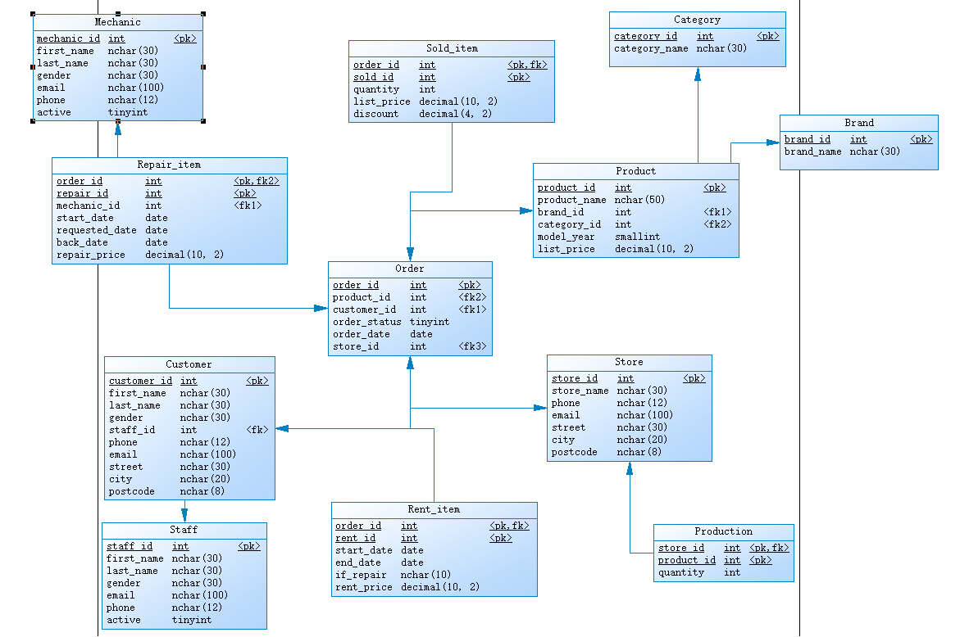
Fig. 3-1 EDR

3.3 Design of Data Table
The following is the design of the database table of the bicycle rental management system, that is, the entity described in Section 2.2 is refined, the entity is refined into a specific database table, and the field name, field type, main attribute and field description of the table are described in detail.

The Tables
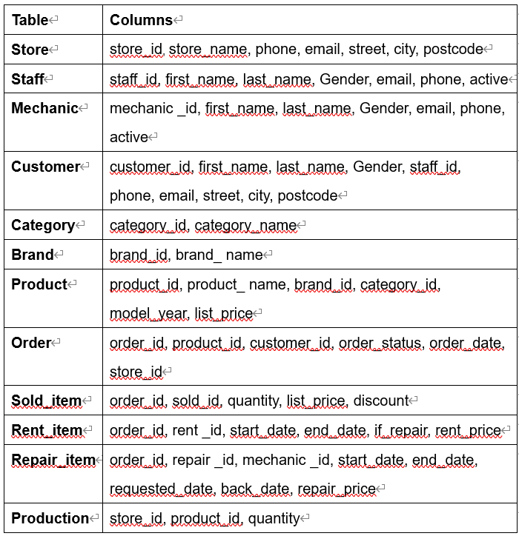

The Stores table includes the store’s information. Each store has a store name, contact information such as phone and email, and an address including street, city, and postcode.
Store
Column | Attribute Domain Requirements
store_id | Auto increment field use SQL Server’s Identity Property: IDENTITY(1,1), PK
store_name | Character String, Size: 30, Required
phone | Character String, Size: 12, Required
email | Character String, Size: 100, Required
street | Character String, Size: 30, Required
city | Character String, Size: 20, Required
postcode | Character String, Size 8, Required, Limit values to min length 6

The employee information table is mainly used for the management of employee information data and the realization of function settings in the car rental management system. The structure of the employee information table is shown in Staff Table, where staff_id is the primary key of the table. In addition, if a staff no longer works for any stores, the value in the active column is set to zero.
Staff
Column | Attribute Domain Requirements
staff_id | Auto increment field use SQL Server’s Identity Property: IDENTITY(1,1), PK
first_name | Character String, Size: 30, Required
last_name | Character String, Size: 30, Required
gender | Character String, Size: 30, Required, male or female
email | Character String, Size: 100, Required
phone | Character String, Size: 12, Required
active | tinyint

The mechanic information table is mainly used for the management of mechanic information data and the realization of function settings in the car rental management system. The structure of the employee information table is shown in Mechanic Table, where mechanic_id is the primary key of the table. In addition, if a mechanic no longer works for any stores, the value in the active column is set to zero.
Mechanic
Column | Attribute Domain Requirements
mechanic_id | Auto increment field use SQL Server’s Identity Property: IDENTITY(1,1), PK
first_name | Character String, Size: 30, Required
last_name | Character String, Size: 30, Required
gender | Character String, Size: 30, Required, male or female
email | Character String, Size: 100, Required
phone | Character String, Size: 12, Required
active | tinyint

The basic customer table is used to store the customer information of Eco Bike Hub. The table includes the customer number of the bicycle rental, the member name of the bicycle rental, and the member phone number of the bicycle rent, bicycle rent customer address and other fields, in which customer_id is the primary key of the table, and the specific table structure is shown in Customer Table.
Customer
Column | Attribute Domain Requirements
customer_id | Auto increment field use SQL Server’s Identity Property: IDENTITY(1,1), PK
first_name | Character String, Size: 30, Required
last_name | Character String, Size: 30, Required
gender | Character String, Size: 30, Required, male or female
staff_id | Integer, Required, FK
phone | Character String, Size: 12, Required
email | Character String, Size: 100, Required
street | Character String, Size: 30, Required
city | Character String, Size: 20, Required
postcode | Character String, Size 8, Required, Limit values to min length 6

The Category table stores the categories of bicycles, such as tandem bikes, covered bikes, and electric bikes.
Category
Column | Attribute Domain Requirements
category_id | Auto increment field use SQL Server’s Identity Property: IDENTITY(1,1), PK
category_name | Character String, Size: 30, Required

The Brand table stores the brand’s information of bikes, for example, Electra, Haro, and Heller.
Brand
Column | Attribute Domain Requirements
brand_id | Auto increment field use SQL Server’s Identity Property: IDENTITY(1,1), PK
brand_name | Character String, Size: 30, Required

The Product table stores the product’s information such as product name, product brand, product category, product’s model year, and product’s list price. Each product belongs to a brand specified by the brand_id column. Hence, a brand may have zero or many products. Each product also belongs a category specified by the category_id column. Also, each category may have zero or many products.
Product
Column | Attribute Domain Requirements
product_id | Auto increment field use SQL Server’s Identity Property: IDENTITY(1,1), PK
product_name | Character String, Size: 50, Required
brand_id | Integer, Required, FK
category_id | Integer, Required, FK
model_year | Smallint, Required
list_price | Decimal(10,2), Required, Number (should be able to accept monetary values)

The Order table stores the sales order’s information, including customer, order status, order date. It also stores the information on where the sales transaction was created (store). Each order has a row in the Orders table.
Order
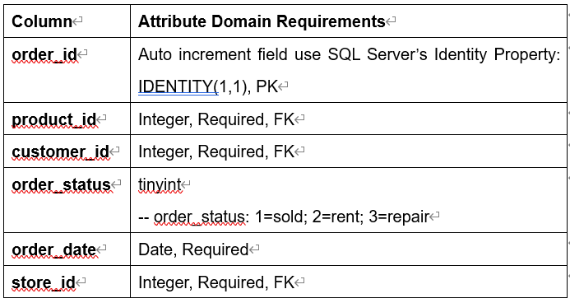

The Sold_item table stores the line items of a sales order. Each line item belongs to a sales order specified by the order_id column.
Sold_item
Column | Attribute Domain Requirements
order_id | Integer, Required, PK, FK
sold_id | Integer, Required, PK
quantity | Integer, Required
list_price | DECIMAL(10,2), Required, Number (should be able to accept monetary values)
discount | DECIMAL(4,2), Required, Percentage value e.g. 0.1 for 10%, Limit to min 0% and max 50% (0.5)

The Rent_item table stores the line items of a rent order. Each line item belongs to a rent order specified by the order_id column.
Rent_item
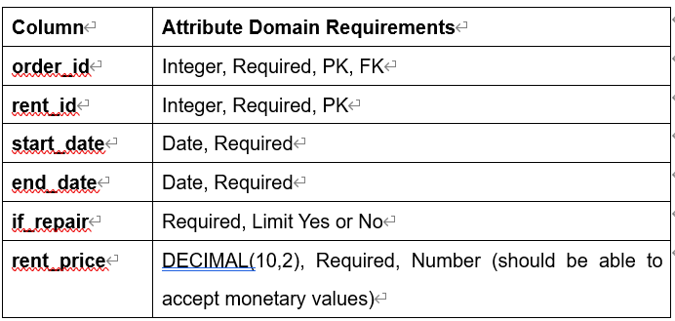
The Repair_item table stores the line items of a epair order. Each line item belongs to a repair order specified by the order_id column.
Repair_item
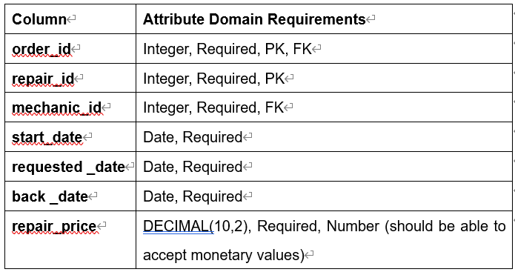

The Production table stores the inventory information i.e. the quantity of a particular product in a specific store.
Production
Column | Attribute Domain Requirements
store_id | Integer, Required, PK, FK
product_id | Integer, Required, PK
quantity | Integer, Required, limit quantity>=0

4 Transaction
begin tran
The beginning of a transaction is probably the easiest concept to understand in the course of things. Its sole purpose is to indicate the beginning of a unit. If for some reason the transaction cannot or does not want to be committed, then this is the point from which all database activity will be rolled back (Mukherjee, 2019). That is, the database ignores all statements after this starting point that are not finally committed.

commit tran
When a commit tran command is issued, the transaction can be considered complete. That is, after all Sql statements contained in the transaction are executed, the impact of the transaction is now persistent and will continue, even in the event of a system failure (as long as there are backups or the database files are not physically damaged).

rollback tran
A rollback is to perform a transaction rollback. Anything that has happened since the associated begin statement will be forgotten, that is, all operations contained in the transaction will be undone (Mundy, Thornthwaite, and Kimball, 2011). The syntax for rollback looks the same as a begin or commit statement, except that savepoints are allowed:

save tran
Saving a transaction is essentially creating a bookmark. Create a name for the bookmark, which can be referenced in rollbacks after creating a "bookmark". The nice thing about bookmarking is that you can roll back to a specific point in your code - just name the savepoint you want to roll back to.

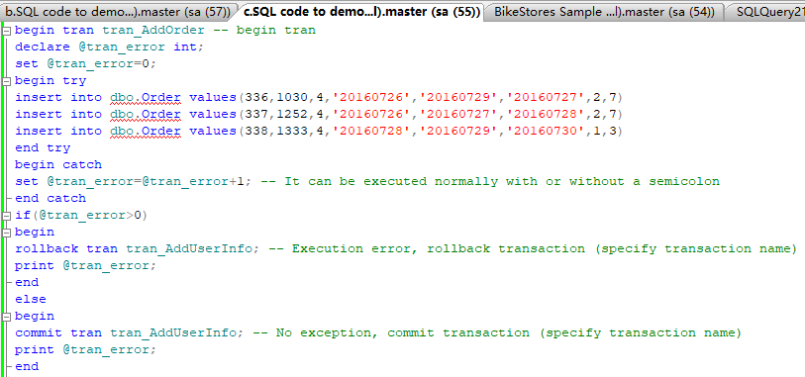

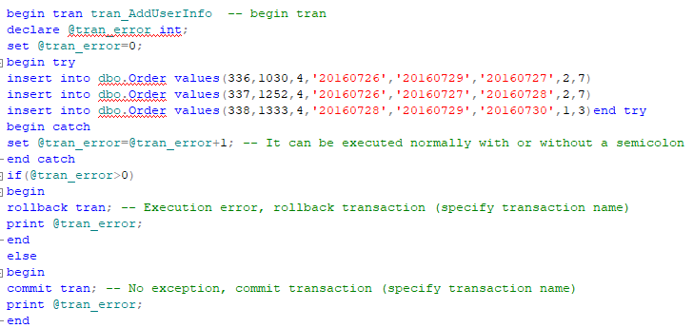

As can be seen from the above operation, after the transaction is opened, the database is operated, and the operation is checked immediately, and it can be seen that the record is in the modified state. But as the transaction rollback operation progresses, the data is rolled back to the state it was in before the transaction started.

Whether the commit of the transaction demonstrated last time is modified or the data operation is rolled back after the rollback demonstrated above, it is the normal application of the transaction. After the transaction is opened, all operations performed on the database are cached. When the transaction is committed, the actual operation is performed and written to the database. If you choose not to commit but to roll back, the transaction will not be stored. The defined operations are applied to the database.

In program design, if you are not sure that the operation on the database will be successful, for example, you need to perform multiple database operations to complete a certain function. If the previous operations are successful, but a certain step of the following operation fails for some reason, you need to perform Re-operation, at this time, we hope that the database is in the state before the operation, and the transaction can help us complete such a design. Before this set of operations, open a transaction, and verify the operation for each operation to ensure that the operation is carried out effectively. If all operations are performed correctly, submit the transaction. If any operation is abnormal, perform the transaction. rollback.

5 Distributed Database Solution
Using distributed partition view to achieve horizontal sharding, to partition a table is to divide the table into two or more smaller segments according to the partition key.

Antonopoulos, et al (2017) claimed that he stored procedure is used to place the operations on the vertical sharding table of multiple sites in a distributed transaction, either all commit or all rollback, which ensures the data consistency of the distributed database system.

Use stored procedures to achieve vertical sharding. Set the table Customer to store all the customer information of the company. After vertical sharding, two tables are generated. Customer1 (cno, cname, address) is stored in the database DB1 of the A server, and Customer2 (cno, gender, age) is stored in the database of the B server. DB2 On A and B, the stored procedure add_customer is established, and database links are established with each other.

References
[1] Antonopoulos, P. et al. (2017) ‘Resumable online index rebuild in SQL server’, Proceedings of the VLDB Endowment, 10(12), pp. 1742–1753. doi:10.14778/3137765.3137779.

[2] Bai, Y. (2020) SQL server database programming with visual basic.net : concepts, designs and implementations. First edition. Hoboken, New Jersey: John Wiley & Sons, Inc. doi:10.1002/9781119608493.

[3] Choi, H., Lee, S. and Jeong, D. (2021) ‘Forensic Recovery of SQL Server Database: Practical Approach’, IEEE access, 9, pp. 14564–14575. doi:10.1109/ACCESS.2021.3052505.

[4] Gyorodi, R. et al. (2019) ‘Performance of OnPrem Versus Azure SQL Server: A Case Study’, IEEE access, 7, pp. 15894–15902. doi:10.1109/ACCESS.2019.2893333.

[5] Mukherjee, S. (2019) ‘Popular SQL Server Database Encryption Choices’. doi:10.14445/22312803/IJCTT-V66P103.

[6] Mundy, J., Thornthwaite, W. and Kimball, R. (2011) The Microsoft data warehouse toolkit : with SQL Server 2008 R2 and the Microsoft Business Intelligence toolset. 2nd ed. Indianapolis, IN: Wiley.

