Problem Solving and Decision Making BMSW4004_LON

Student Name: Calin Andrei Buica
Student ID: 2112409

Lecturer`s Name: Akinseye Aluko

Contents
Introduction 3
Why is problem solving important 3
How to solve problems 4
Identifying the problem 4
Verifying the problem 5
Defining the problem 6
Root-cause analysis 6
Alternative generation 7
Evaluation of alternatives 8
Implementation 8
Post-implementation review 9
Institutalisaion and control 9
Conclusion 9
References 10
Part 1 Role-Play……………………………………………………………………………………………...........11

Introduction
Problems will inevitably occur in all businesses, whether they are large corporations with various divisions or small, newly established businesses. What matters is how we handle these problems, not just that they exist. In this report, the term "problem" refers to the discrepancy between a given company's present state and its desired future state. Depending on the company, the difficulties' nature may differ tremendously. The development of a new, more environmentally friendly method of doing things, for instance, could upset the corporate strategy of an energy firm that relies on cause harmful effects. Other businesses' issues might only involve a drop in sales or a difficulty hiring qualified personnel. In that sense, the method of evaluating the current circumstance and subsequently coming up with a solution to close the aforementioned gap could be described as problem solving. This report aims to clarify the significance of taking appropriate action and the steps required for successfully resolving issues.

Why is problem solving important
It's without question that any company' ability to solve problems will play a crucial role in its growth. And even if a problem isn't immediately harmful to the company's ability to continue operating, it still has a significant impact over time. It is crucial to solve all issues and give them the focus they require because of this. A business can only succeed against its rivals by following this strategy. (Williams, Steve, 2001). Solving problems is of critical importance for every company, because each problem lead to increasing the expenses and decreasing the profit for the company and the increasing the number of unsolved issues can significantly damage the company sustainability and profit.

How to solve problems

Identifying the problem
- Regardless of the obvious problems that companies frequently encounter, such as equipment failure or unsatisfied clients, occasionally difficulties may have hidden causes. For instance, it might be challenging to recognize a problem, let alone identify the cause of it, when sales of the company are rising but its market share proportion is steadily decreasing. It is essential that the company take this action seriously because of this. To achieve the best results, a company must address three common identifying deficits. Keeping a close eye out for new issues. Since most problems grow worse over time, the company should be alert to any red flags in order to avoid situations where it is already too late and there is no way to respond in a sufficient or effective manner.
- Appropriating properly
- Even when a company recognizes a problem, it may fail to recognize its importance and fail to take the necessary action. Problems could only get worse if they were underestimated. Identifying the problem in details is critical step for then moving to find solutions which can solve the problem and prevent future complications from it.
- Not overreacting
In the same way that underrating issues is bad, overestimating them is also bad because it could result in increased assets being thrown away on difficulties that are essentially nonexistent.
Methods that prove to work most effectively in various situations. To name but two:
- Statistical process control
This program's job is to alert management teams when their service operations are running smoothly and when an unforeseen variable is causing variations in the work products. In order to reduce the presupposed factors for worse effectiveness and optimize the ones that result in improved performance, the concept is to examine deviations in effectiveness and determine the true reason for such outcomes.
- Benchmarking
This approach entails contrasting a business with its rivals in order to assess its performance and adopt strategies that have a successful track record. Of course, there are a lot more techniques, like actively seeking out consumer feedback and carefully monitoring each stage of every procedure carried out by the company. (Hicks, Michael J, 2013)

Verifying the problem
To get a different viewpoint from the ones who are identifying the issue, it's critical to consider introducing it to others. Not to recognize the possibility that, once the problem was discovered, there might be elements they were unaware of that, when taken into account, could have a substantial impact on the circumstance. By skipping this step, you run the risk of wasting a lot of time and energy looking for the incorrect answer.
Figure 1

(Pereira, Leandro, 2021)

Defining the problem
This is the negotiated agreement among those tasked with solving the issue and those in responsible for supervising their tasks. They must come to an understanding regarding the broad guidelines for the original problem resolution. In order to give each element the proper attention, difficult issues are now divided into reciprocally exclusive observes and measures constituents. Determining the deadline for the problem's resolution is also important. Companies occasionally necessitate a quick response, which necessitates the creation of a stopgap measure while the true underlying problems of the issue are carefully investigated. (Mann, Darrell, 2001).

Root-cause analysis
Finding the circumstance that, if treated, would make the issue go away is the goal at this process. The causation chart, which illustrates how the evolving considerations, such as the external surroundings, management methods, devices, etc., have the possibility of causing the issue, is a frequently employed technique for locating underlying causes. Various hypotheses are created after that. For instance, a branch of the chart might show that low pay leads to high employee attrition, which in tends to result in the hiring of unskilled people to continue operating the machinery, which probably resulted in more losses and greater cost of materials. In light of this evaluation' findings, it is recommended that the underlying cause of lower wages be addressed in order to address the issue of high manufacturing costs. The objective is to discover connections between the issue and the input parameters, so finding trends in the data could be very helpful. After identifying the most likely causative factors, the proof at hand should be scrutinized in order to weed out any actual causative factors that may exist. This might entail modifying the circumstances in a trial to see if the issue is affected by the modifications made while controlling the prospective causative factors. (Aarikka-Stenroos, Leena, and Elina Jaakkola, 2012).
Figure 2

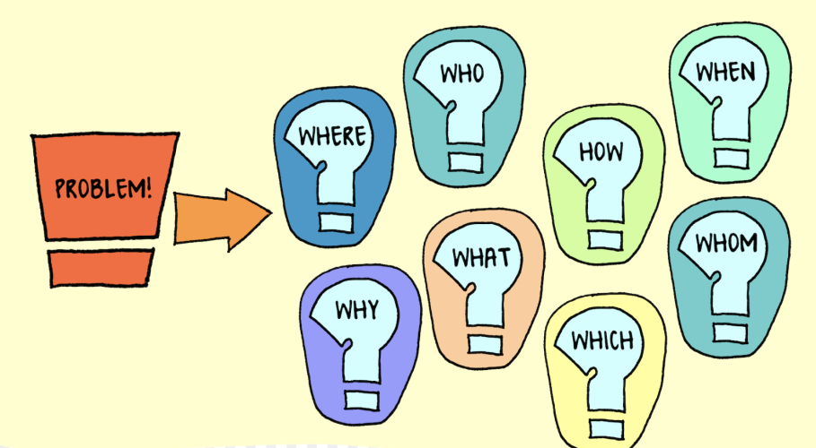
(Pereira, Leandro, 2021)

Alternative generation
It's time to develop a strategy for controlling the underlying causes once they have been recognized. Since this is primarily a collaborative activity, preconceived notions about how the company was run in the past shouldn't stifle original thought. Even if an appropriate solution has been discovered trying to come up with additional ones could be very advantageous because it might lead to the discovery of more efficient and affordable alternatives to the same issue. (Orser, Barbara J., 2000).
Figure 3

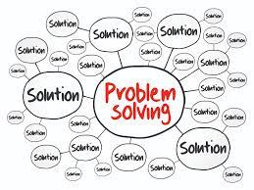
(Pereira, Leandro,2021)

Evaluation of alternatives
It is essential to establish the performance indicators, with cycle time, manufacturing costs, customer base, waste levels, and warranty claims being the most crucial in this specific situation. This allows for comparison of the various options. But it's also important to take into account the assets required to put each alternative into practice. Ultimately, we must keep in mind that institutions are managed to make up of real individuals, and some solutions might call for abilities or connect directly to scarce resources that are not within the company. The political stances held by the individual involved should also be taken into account because they may influence the decision to favor one option over another. Having said that, it is crucial to take into account the advantages of each workaround, both concrete and abstract. (Mann, Darrell, 2001).

Implementation
No regardless of how effective a plan is, if it is not put into action, it is utterly worthless. It's typical for organizations to stop giving a plan the sufficient attention once it's developed, but doing so will prevent the plan from being successful. To make the work simple to understand and useful in practice, it should be divided up and assigned. To keep track of your progress, particular time restrictions should be set for each breakthrough.
Figure 4


(Paula Carroll 2020)

Post-implementation review
Contradictory to what many businesses think, the procedure is not complete once the remedy is put into place, so it is not generally a good idea to just keep moving on. To ascertain whether the issue has been effectively solved, a comment assessment should be carried out. The assessment should address the issues of whether the anticipated results were achieved and whether the extra initiatives were substantiated. A further thing to think about at this stage is dissecting the issue procedure in order to learn from it and have a foundational knowledge of what has so far started working when a new problem occurs. (Pereira, Leandro, 2021).

Institutionalization and control
The last stage is to establish the outcome and secure all the modifications made as a result of the original problem solution. This might entail modifying some initiatives, implementing new control performance measures, or revising the job descriptions for some positions. Additionally, it should be thought about whether the issue at hand is a singular instance or if the solution can be applied to other parts of the company. Lots of issues frequently arise in other divisions of the same business, and if this is the case, recently designed procedures could be applied to these other configurations. (Paula Carroll 2020).

Conclusion
In summary, it is obvious why a company needs a suitable problem-solving approach if it were ever to keep developing. We should be able to guarantee that difficulties are entirely removed because they often persist and are challenging to eradicate permanently. That could only be accomplished through a lengthy, multi-step process that involved trying to identify the original problem existence, verifying it with new people, figuring out the assets that could be used to address it, figuring out the cause of its event occurring, and developing a strategy to address it, choosing the most effective strategy and putting it into action, assessing the results, and applying the already founded solution to other difficulties. Only by doing this could a trouble be completely settled rather than just partially or completely avoided. (Fahey, Will, Paul Jeffers, and Paula Carroll, 2020)

References
Aarikka-Stenroos, Leena, and Elina Jaakkola. "Value co-creation in knowledge intensive business services: A dyadic perspective on the joint problem solving process." Industrial marketing management 41.1 (2012): 15-26.
Fahey, Will, Paul Jeffers, and Paula Carroll. "A business analytics approach to augment six sigma problem solving: A biopharmaceutical manufacturing case study." Computers in Industry 116 (2020): 103153.
Graesser, A.C., Fiore, S.M., Greiff, S., Andrews-Todd, J., Foltz, P.W. and Hesse, F.W., 2018. Advancing the science of collaborative problem solving. Psychological Science in the Public Interest, 19(2), pp.59-92.
Hicks, Michael J. Problem solving in business and management: hard, soft and creative approaches. Springer, 2013.
Junker, N.M., Baumeister, R.F., Straub, K. and Greenhaus, J.H., 2021. When forgetting what happened at work matters: The role of affective rumination, problem-solving pondering, and self-control in work–family conflict and enrichment. Journal of Applied Psychology, 106(11), p.1750.
Mann, Darrell. "Systematic win-win problem solving in a business environment." growth 88 (2001): 95.
Okwechime, E., 2018. The impact of big data on organisational problem solving: evidence from two UK smart cities initiatives (Doctoral dissertation, Glasgow Caledonian University).
Orser, Barbara J., Sandy Hogarth-Scott, and Allan L. Riding. "Performance, firm size, and management problem-solving." Journal of Small Business Management 38.4 (2000): 42-58.
Pereira, Leandro, et al. "Pereira problem solving: Business research methodology to explore open innovation." Journal of Open Innovation: Technology, Market, and Complexity 7.1 (2021): 84.
Snyder, Lisa Gueldenzoph, and Mark J. Snyder. "Teaching critical thinking and problem solving skills." The Journal of Research in Business Education 50.2 (2008): 90.
Williams, Steve. Making better business decisions: Understanding and improving critical thinking and problem solving skills. Sage Publications, 2001.

Andrei(employee): Good morning, Sir and thank you for your quick reply to my email regarding the situation I had in the previous day with one of my colleagues when I tried to resolve a customer complain.
Mustan(manager): Can you please describe and explain to me the problem and all information about it so we can find solution?
Andrei: There were complain from a regular customer linked to an online order placed three days ago and no one from the team members completed on time. So, I did ask the responsible team member on shift for the online orders, but he rudely explained to me that this is not my job and i should just avoid the customer and forget about the problem. I cannot accept this kind of behavior as our customers are important for the company and we need to make sure they are happy.
Mustan: Can you tell me the day and time when this happened, and the name of the team member involved so I can review the CCTV please? Did anyone witness the situation and the conversation?
Andrei: It happened yesterday around 2 o’clock. It was only me, my colleague John who was in charge of dealing with online orders at that time and no one else, as the other member of the team were in a break.
Mustan: OK I will review the CCTV, will brief the team member that there should be high level of positive customer service for every customer. I also will review in general how many orders are with delay for over 8 hours and we will make sure this issue is solved and prevent. Any new occasions with that team member please do let me know so I can investigate future.
Andrei: Thank you, and hopefully it’s not going to happen again and if I’m not asking for too much, can you please speak with the staff member to correct his attitude when there is a customer problem as this is not acceptable? That will be much appreciated.
Mustan: Yes, this will be done when I arrange one to one meeting with him in order to investigate and solve the matter. This should completely solve the problem so everyone can continue with proper daily tasks.
Andrei: Thank you so much for doing this meeting and trying to resolve this incident so quickly. Have a good day Sir.

