Iestyn Green
Web Development Report
2420522

Table of Contents
Introduction 3
Client-Side and Server-Side Scripting 4
Node.js framework evaluation 7
Overview of the Code Design 8
User Manual 15
Conclusion 17
Works Cited 18

Introduction
This report will explore several key aspects of modern web development, beginning with a detailed comparison of client-side and server-side scripting. It examines their differences, including execution environments, database connectivity, and typical use cases. Following this, the report will conduct a critical investigation of the Node.js framework, assessing its advantages and limitations in developing scalable and efficient web applications. Finally, the report will document the Node.js and AJAX code developed as part of the assignment, providing a comprehensive overview of its architecture and functionality, along with a user manual. Testing is also covered to demonstrate the application’s reliability and performance. Combined, this report should provide a thorough understanding of scripting techniques and practical application development.

Client-Side and Server-Side Scripting
Client-side scripting refers to code, mostly written in JavaScript, which runs in the user’s web browser rather than on a server. Its main role is to enable dynamic and responsive interactions in modern web applications. This type of scripting enables the DOM (Document Object Model), which represents the structure and content of the webpage, to be incrementally updated in real-time without requiring the entire page to be reloaded or a new URL to be navigated to. Client-side JavaScript operates in an event-based style, responding to user interactions such as clicks or form inputs. These interactions typically do not reload the page but rather update only parts of it, providing a smoother and faster experience for the user rather than the traditional full-page reloads. Common use cases include updating page content, such as news feeds, form validation without server requests, interactive menus, and AJAX-based data loading. [1]
JavaScript is a versatile, general-purpose scripting language that is essential for client-side web applications, capable of executing numerical algorithms and supporting interacting applications. HTML5 and CSS provide the structural and stylistic foundations for web applications, enabling the creation of rich user interfaces. These technologies, combined, allow developers to create dynamic, interactive, and accessible web-based applications. Modern browsers optimise JavaScript performance, enhancing computational tasks and visual capabilities. Additionally, web standards such as web storage and file APIs complement these languages by enabling local data management within the browser. [2]
A browser’s runtime environment enables client-side scripting by executing code directly on a user’s device, handling dynamic web content. In mobile computing, browsers such as RocketBrowser, allow the integration of lightweight interpreters like TinyScheme to support interactive behaviour. These environments manage asynchronous actions, user interface updates and runtime memory constraints, especially for devices that are resource-limited. Despite limitations such as static memory usage and restricted update mechanisms, embedding script engines within browsers enables the development of dynamic, script-driven applications, even on constrained platforms, thereby enhancing responsiveness and reducing development overhead for client-side functionality. [3]
Server-side scripting refers to a technique that involves using scripts on a web server to create dynamic content. These scripts handle backend processes, interact with databases and generate dynamic content. Technologies like PHP, Django, Ruby on Rails, and Node.js are prominent examples. These technologies integrate with major databases, such as MySQL and PostgreSQL, and are commonly used in web development to manage user authentication, store data, and generate content. They differ in performance and extensibility, but all share the primary goal of streamlining backend development for websites and applications. [4]

Server-side scripts run in a web server environment, not in the client’s browser. These scripts execute in response to incoming HTTP requests, enabling the generation of dynamic content based on server-side logic. Unlike client-side scripts, which depend on a browser to run, they operate directly on the server. The server is responsible for handling incoming HTTP requests, executing appropriate server-side logic, and returning a response, unlike scripts in the browser. The runtime environment must be capable of executing the server-side language and interfacing with other services, such as databases or APIs, to fulfil the request and deliver the output. [5]
Various server-side scripting languages can be used to build dynamic and interactive web applications. An example language is PHP, which is a mature language widely used for creating server-side scripts that dynamically generate HTML content. It integrates easily with databases such as MySQL and powers numerous content management systems, including WordPress. Node.js enables developers to run JavaScript on the server, utilising an event-driven, non-blocking I/O model that’s excellent at handling multiple concurrent connections efficiently, making it ideal for real-time applications. Python is popular due to its readability and simplicity; it offers a powerful web framework named Django that helps developers build secure, scalable, and maintainable web applications quickly. Ruby, especially with Ruby on Rails, promotes convention over configuration, allowing rapid development and clean code architecture, which is well-suited for startups and projects requiring fast iteration cycles. These languages all interact over IP-based networks and use protocols such as HTTP and TCP to communicate between clients and servers. [6] [4]

Client-side scripting and server-side scripting are two fundamental approaches in web development, differing primarily in where the code is executed and how interactions are managed. Server-side scripting runs on the server, processing the user requests by executing business logic, accessing databases and generating responses before sending data back to the client. This method typically uses languages such as PHP, which is valued for its open-source nature, platform independence and strong database connectivity, making it suitable for both small and large organisations. Server-side scripts handle tasks such as form validation, authentication, and data manipulation centrally, ensuring consistent behaviour regardless of the client device. [7] [8]

In contrast, client-side scripting occurs within the user’s browser, relying heavily on JavaScript to handle logic, user interactions, and dynamic content updates locally. This approach sends minimal initial data from the server, allowing the client device to perform much of the processing. It often communicates with the server via APIs using methods like GET and POST to exchange data asynchronously. Client-side scripting provides more responsiveness, particularly for supporting dynamic interactions, without requiring a full request to the server for every action. However, it depends on the client’s processing power and availability of JavaScript, meaning that performance can really vary between different devices. [7] [8]

While client-side scripting improves the user experience by reducing server load and allowing real-time interface updates, it may face limitations if JavaScript is disabled or encounters errors. Server-side scripting, by contrast, is generally more secure as it controls sensitive operations on the server and maintains central management of data and logic. [7] [8]

Security is a big concern for client-side scripting. Research indicates that client-side web applications are vulnerable due to inadequate JavaScript security, a lack of network access control, and risks associated with cross-domain communication. New security models propose browser-enforced, fine-grained policies that block unauthorised requests and prevent common attacks, such as cross-site scripting and cross-site tracing, thereby improving security [9]. Server-side scripting handles security by centralising sensitive operations on the server, reducing exposure to many client-side risks, but it requires secure coding and server configuration. Both of these approaches play different roles, and modern applications often combine them to gain the benefits of each. For example, server-side scripting is used for core operations and security, while client-side scripting is utilised for interactivity and an enhanced user experience.

When it comes to scalability, server-side applications can scale effectively by utilising load balancers, cloud platforms, and distributed databases. However, increasing traffic also increases the demand for server resources and raises security concerns. Modern server-side environments like Node.js benefit from tools that enforce least-privilege and web-hardening techniques, which help manage growth securely without reducing performance [10]. Client-side scripting supports scalability by shifting processing to the user’s device, reducing server load. Frameworks like React and Vue.js use modular architecture and virtual DOMs to manage increasing complexity more efficiently. [11]
In summary, both client-side and server-side scripting play important and complementary roles in web development. Client-side scripting is crucial for building a responsive and interactive interface, while server-side scripting handles core logic, data management and security.

Node.js framework evaluation

Node.js is a fast, lightweight, and cross-platform JavaScript runtime environment that is primarily used for building web servers and desktop applications. Originally released in 2009, Node.js was created to offer a scalable alternative to traditional web servers. Unlike a traditional web server, which creates new threads or processes for each incoming request, consuming significant memory and CPU resources, Node.js utilises a single-threaded event loop to manage connections efficiently. This event-driven, non-blocking approach enables Node.js to handle numerous requests with minimal resource utilisation, resulting in low latency and high throughput. When necessary, Node.js can spawn additional threads from a pool to handle CPU-intensive tasks, enabling effective load balancing across multiple CPU cores. As a result, this reduces memory and CPU overhead compared to traditional multithreaded servers, leading to faster server response times and improved scalability. Compared to languages like PHP, which use synchronous models, Node.js is faster and better suited for multi-user applications. Node.js also incorporates Google Chrome’s v8 JavaScript engine, supporting modern JavaScript syntax. It isn’t limited to plain JavaScript and also supports languages that compile JavaScript, such as TypeScript. Node.js also benefits from a vast package ecosystem accessible through npm, its package manager, which simplifies the process of adding libraries and tools. [12]

Node.js offers many benefits for its use, making it very popular among developers for web application development. One major advantage is its use of a single programming language, JavaScript, for both client-side and server-side coding. This simplifies development by removing the need to learn multiple languages, making it easier to become a full-stack developer. Additionally, the large and active community supporting Node.js, which is supported by major companies such as Google and Netflix, ensures that there are continuous improvements and a lot of resources for developers. [13]

Despite its increasing popularity, Node.js does still have several significant drawbacks. Its asynchronous, callback-based programming model often leads to ‘callback hell’, where deeply nested functions can create complicated, hard-to-read, and difficult-to-maintain code, especially when dealing with multiple external APIs. The ecosystem surrounding Node.js can be immature, and many APIs and modules are unstable or not yet production-ready, which limits reliability for large-scale applications. Although Node.js integrates well with NoSQL databases, its support for relational databases remains immature and weak, posing challenges in environments that rely heavily on traditional SQL-based systems. Also, Node.js is built on JavaScript, a language originally designed for client-side scripting, which introduces security vulnerabilities and limits in server-side capabilities. Certain tasks, for example, XML schema validation and transformations, are poorly supported or very difficult to implement compared to other mature platforms such as Java or .NET. These issues, combined, highlight that while Node.js offers advantages in scalability and speed, it still faces difficulties in code complexity, ecosystem stability, database integration, and advanced server-side functionality. [14] [15]

Overview of the Code Design
Next, this report will delve into the documentation and creation of the licence plate application, providing an overview of the code design, covering the code documentation, including a user manual, discussing its main and most outstanding features and lastly, covering the testing used. The application follows a standard client-server architecture, with React being used to build the front end and Java, along with the Spring Boot framework, being used to build the back end. The front end’s primary objective is to render the user interface and handle interactions such as searching, adding and purchasing licence plates. It communicates with the backend by using AJAX requests using the Axios library, resulting in seamless data transfer without needing to reload the page. The backend exposes a RESTful API that handles incoming HTTP requests, validates the input, and applies business rules to them, such as banning bad words. It then interacts with a relational database to retrieve and update plate records. Spring Boot provides built-in features for dependency injection, REST API handling, and database integration through Spring Data JPA. Meanwhile, the front end leverages React’s component-based structure for real-time UI updates. Combined, this architecture creates a clean separation of concerns, scalability, and maintainability across both the client and server code.
The front end of the licence plate application is built using React and uses AJAX requests to communicate with the backend. One key function implemented is the handleSubmit() method in AddPlate.js; this is used to handle the form submission and sends a POST request to add a new licence plate, not only sending the request to the backend but at the same time updating the user interface to reflect whether it has been a success or if there is an error. It is also worth noting that the application utilises environment variables, such as REACT_APP_URL, to direct frontend requests to the backend. Making it more easily portable across environments without requiring code changes.

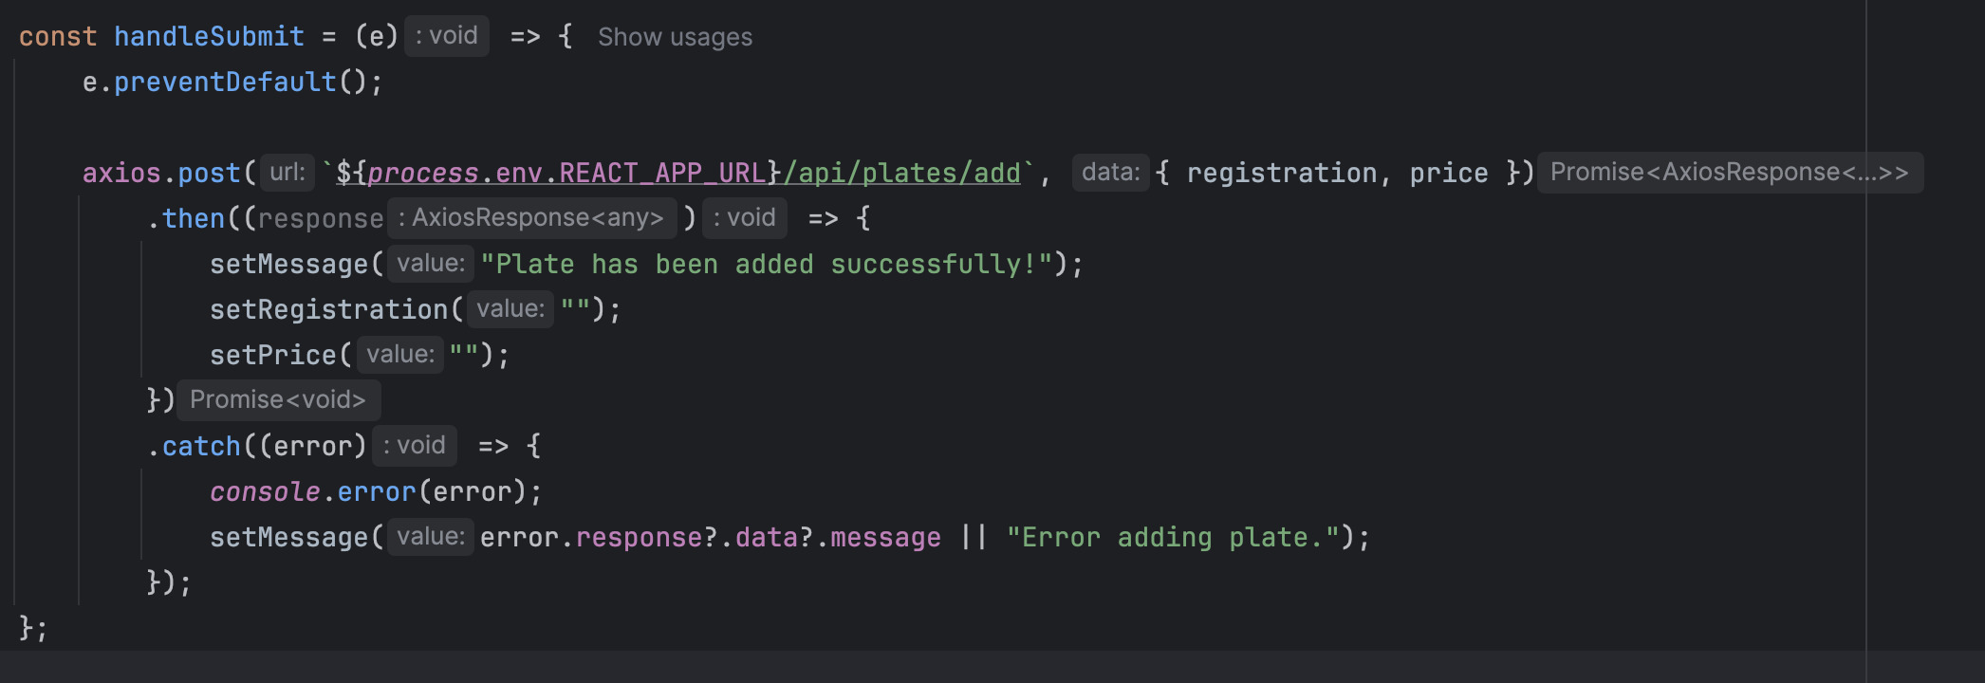
Similarly, the SearchPage.js file contains a performSearch() function that sends a GET request with the search term as a parameter.
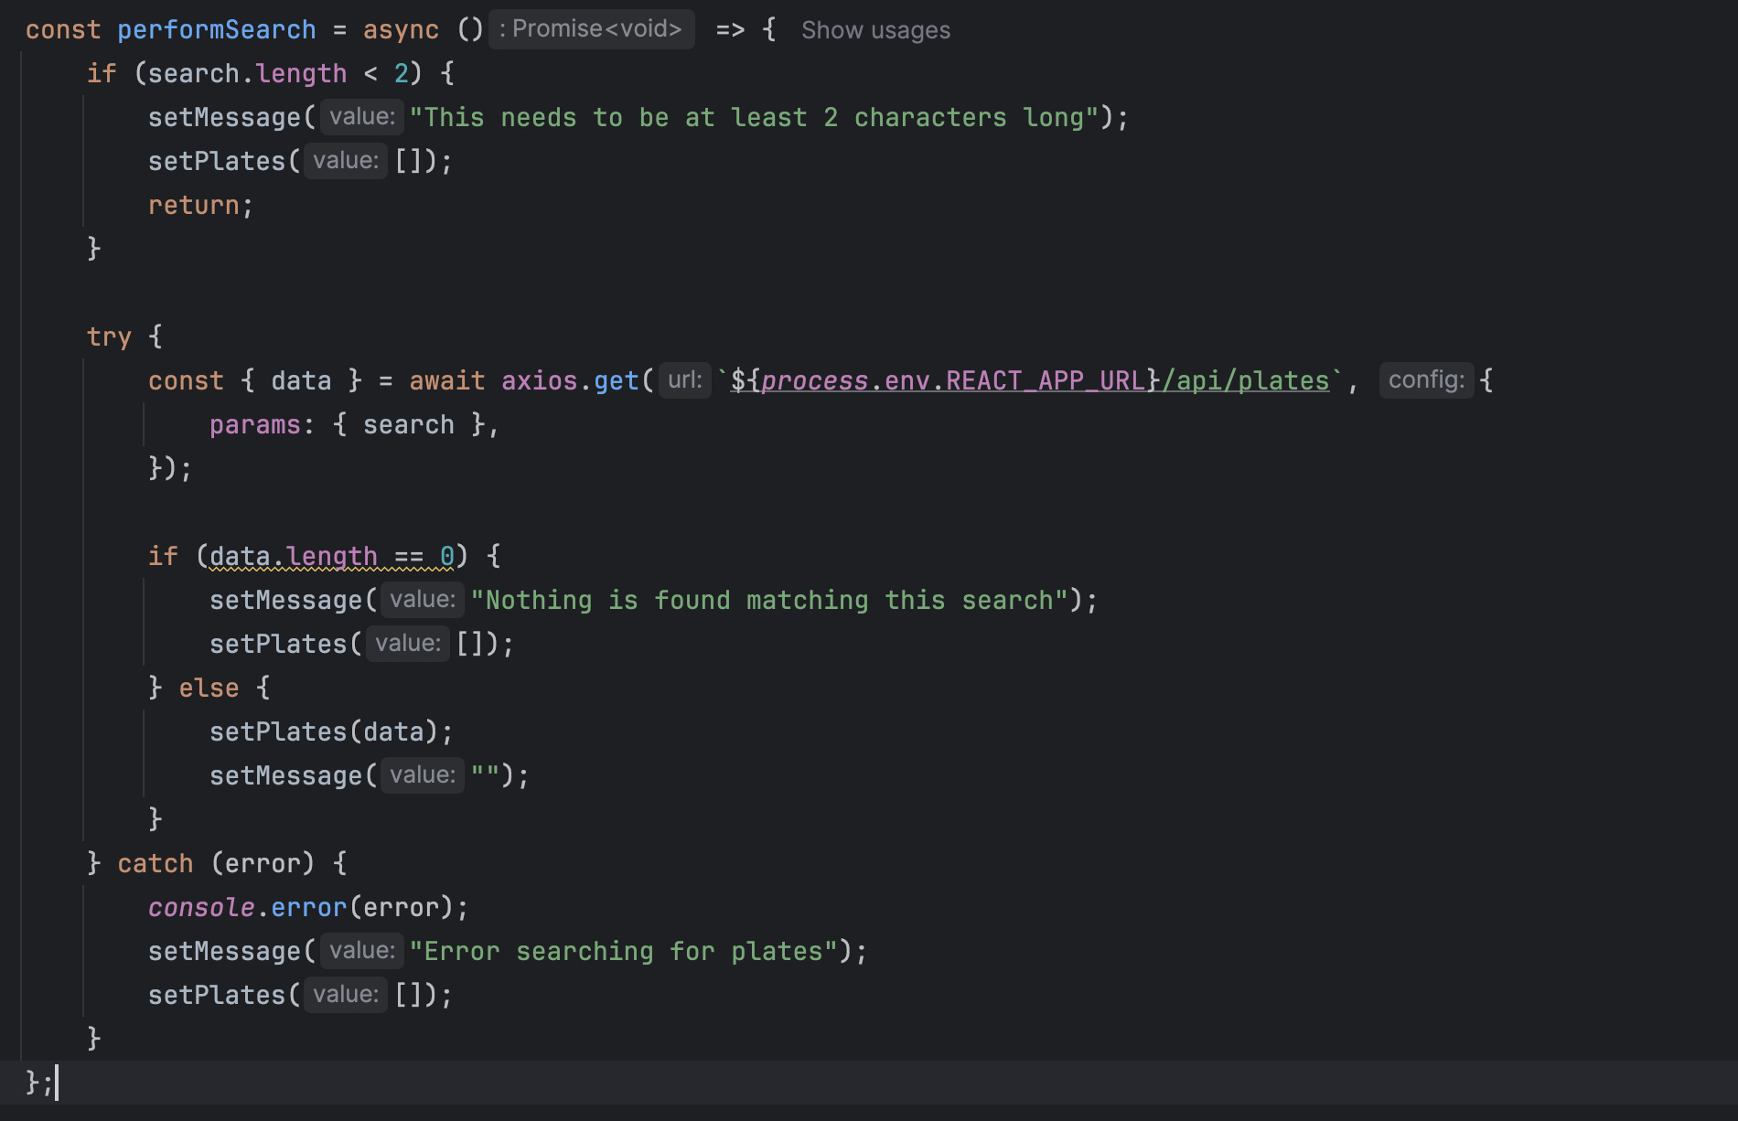
Here, you can also see the inclusion of a validation check to assert that the search is at least two characters long. As mentioned earlier, the backend of the application is built using Java and Spring Boot that exposes a RESTful API that handles the search, adding and purchasing of plate requests. The controller class PlateController.java maps endpoints like /api/plates/add and interacts with the database by using PlateService and PlateRepository, using JPA for persistence. Spring Data JPA handles the database connectivity, which is used to abstract the SQL interactions through interfaces like:
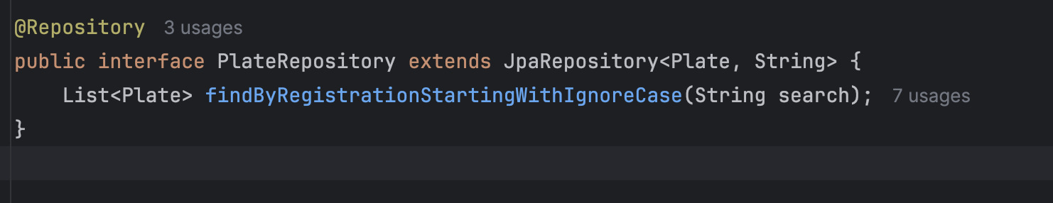
The seamless connection between the front end and back end can also be seen in the purchase functionality. The handleThePurchase method sends a purchase request and also refreshes the displayed results to ensure the user sees the current status without needing to do a manual page reload.
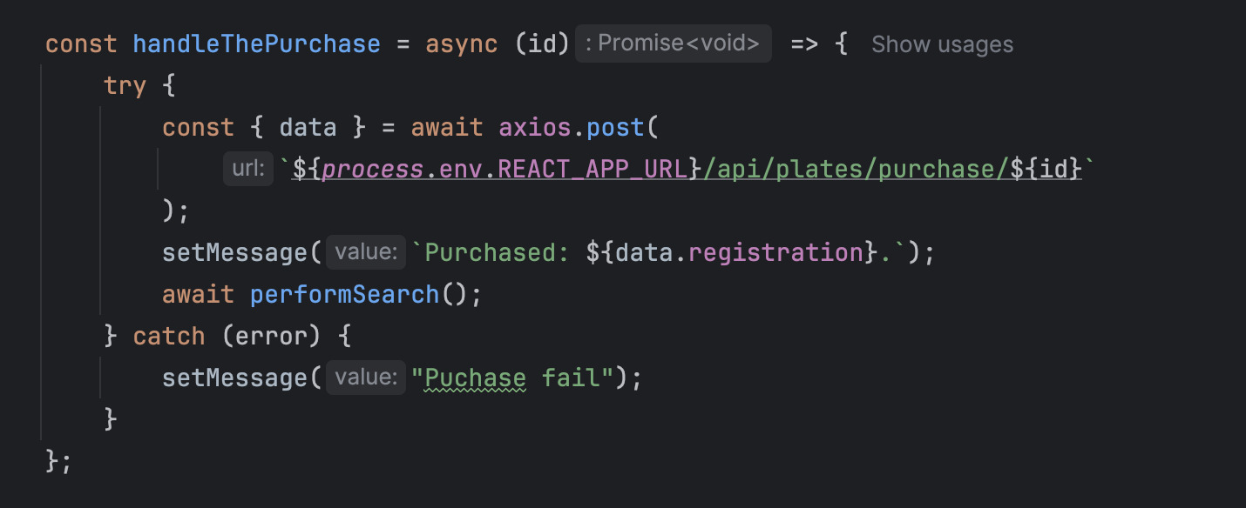
Another notable implementation in the code is the inclusion of business logic within the service layer. The PlateService class handles this logic, ensuring data integrity and proper application behaviour. For example, the purchasePlate method first checks whether the plate has been purchased already before continuing the operation, thus preventing duplicate purchases and maintaining consistency in the system.
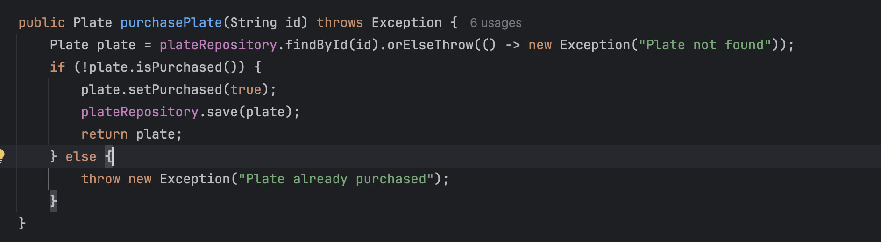
Similar to this, the addPlate method includes input validation by implementing a filter to prevent a list of banned words, protecting the application from inappropriate or rude words being added as licence plate registrations.
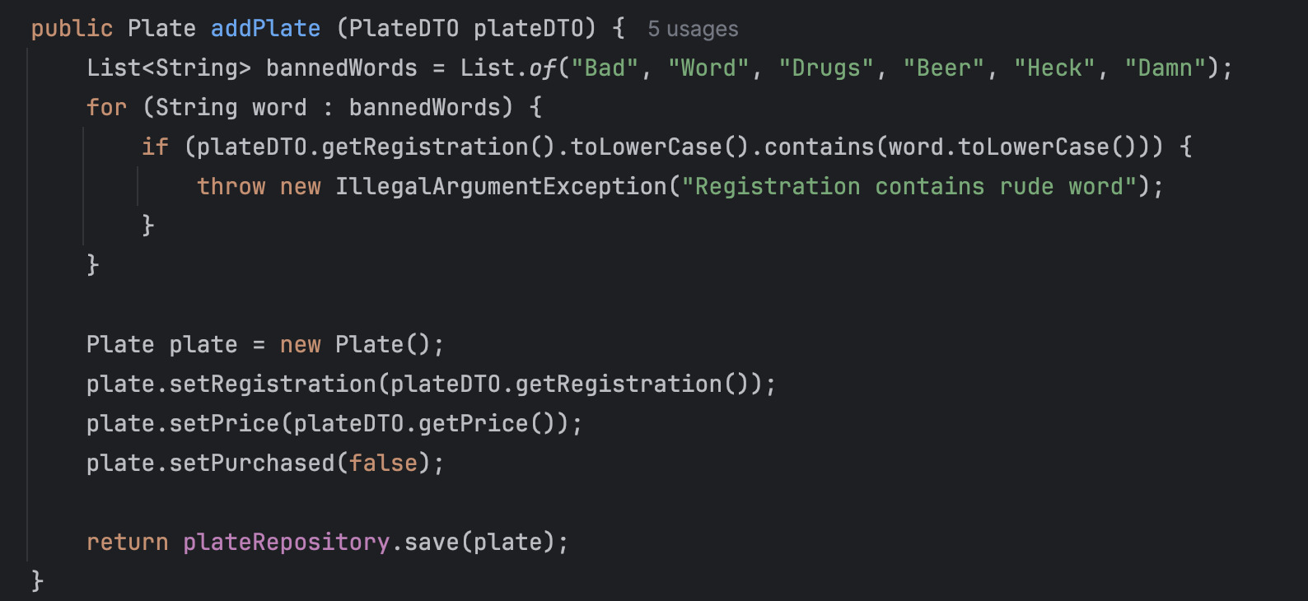
This whole application is containerised by using Docker to improve the deployment. The frontend React app uses a multi-stage dockerfile. Initially, it starts from a Node.js base image to install the dependencies and build the React app; this process then compiles and bundles the React code into a static asset. In the second stage, these assets are then copied into a lightweight Nginx image.
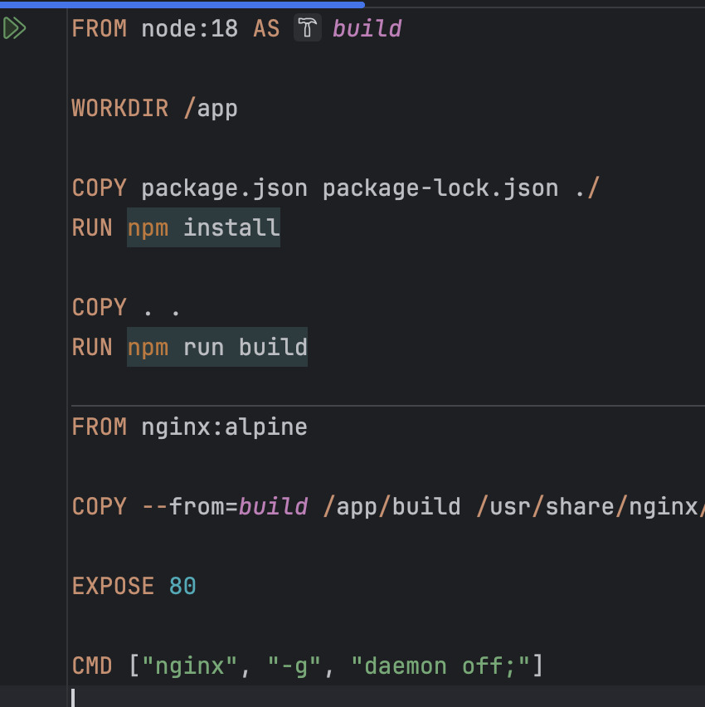

The backend Dockerfile uses an OpenJDK 17 image container, and the database uses PostgreSQL. These services are orchestrated using Docker Compose, which ensures correct startup order and container networking.
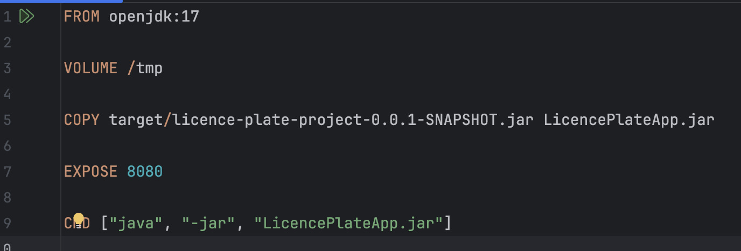
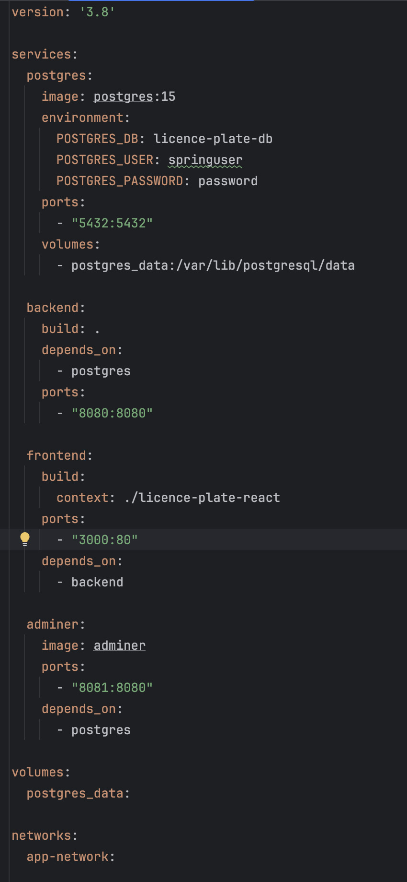

Key design choices made in this application include real-time UI updates upon form submission or purchase actions, which are supported by asynchronous AJAX calls using Axios. Backend operations are designed to be efficiently managed through Spring Boot’s layered architecture, separating concerns into controller, service and repository layers. The controller layer controls the entry point for HTTP requests, mapping RESTful endpoints and delegating processing to the service layer. Core business logic is then handled in the service layer, which handles logic such as purchase validation and input filtering, resulting in cleaner, more maintainable code. The repository layer utilises Spring Data JPA to manage database access, handling CRUD operations and custom queries while keeping SQL details hidden from higher layers.
Additionally, DTOs are used to encapsulate data passed between layers and across the network. They help decouple internal entity models from API contracts, making the application more flexible and secure by exposing only necessary data fields. The choice of developing the application with a layered approach paired with the DTO makes the code more maintainable and testable and helps create a clear separation between web, business and data.
The application also includes comprehensive testing at multiple levels to ensure reliability and correct functionality. To thoroughly test it, 23 unit tests were created, which were designed to cover various edge cases across the application. This following segment will highlight the most important tests added to the application.
Unit tests for the service layer verify core business logic, such as searching, adding, and validating licence plates against banned words, as well as purchasing functionality with proper error handling for edge cases (i.e., already purchased plates or missing entries). To create these tests, Mockito is used to mock dependencies and validate expected behaviours and exceptions.
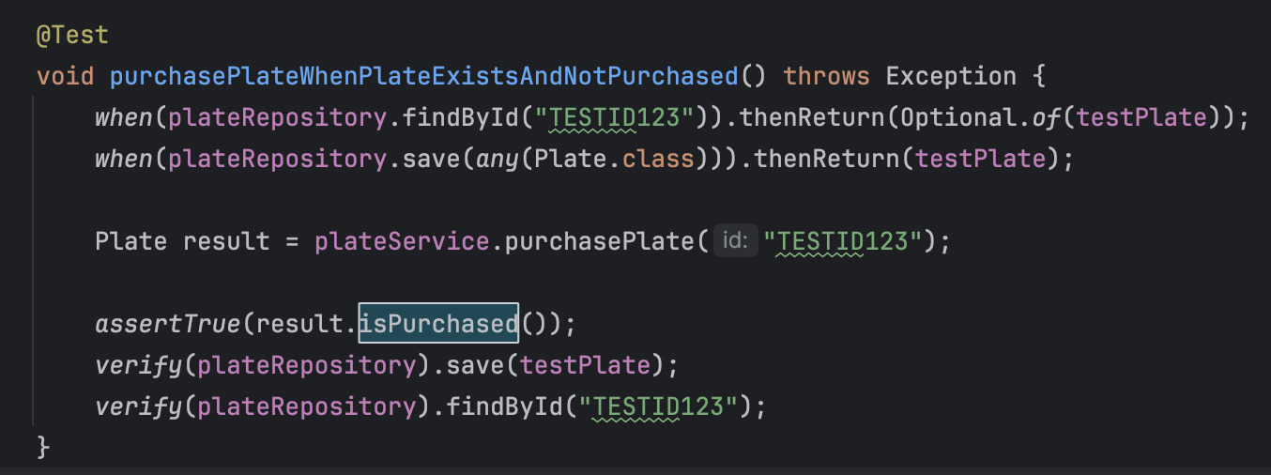
Integration tests focus on the controller layer, using Spring’s MockMVC to simulate HTTP requests and verify that the API endpoints correctly process requests and responses. For example, the test for adding a plate verifies that invalid input results in a Bad Request status.
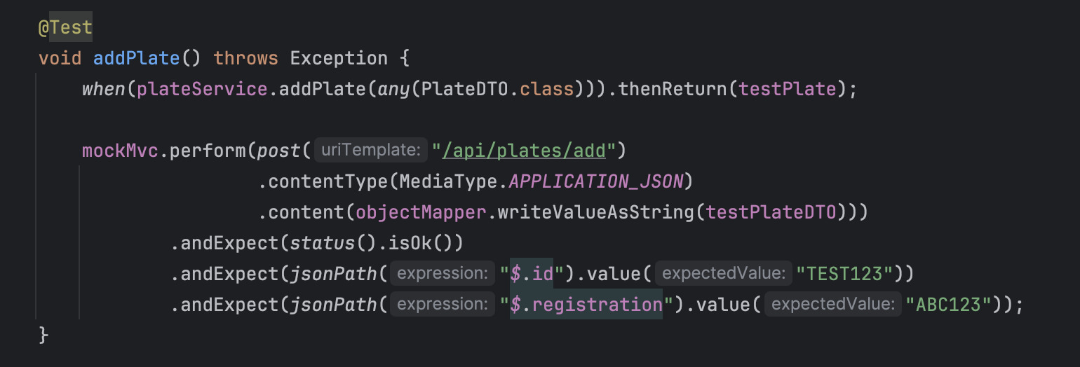
Entity validation tests are implemented to confirm that the domain model enforces constraints, such as registration patterns, using Jakarta Bean Validation.
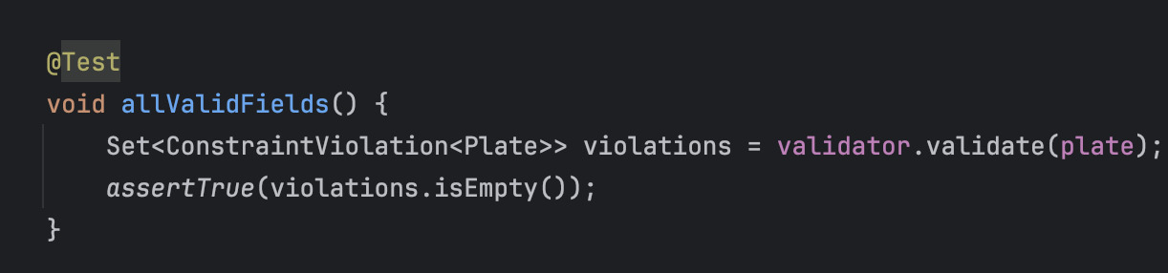
All tests pass successfully, confirming the robustness of the application logic and validation.

User Manual
This segment will cover the steps required in order to run the application. Covering installation and execution as well as interactions and expected outputs.
How to install and Run:
Before running the application, you will need to have Docker installed as well as a modern web browser. Next, you will need to copy the project folder to your machine. Then you will need to navigate to the project root directory and run:
`docker-compose up --build`
This command should run the frontend and backend and start a PostgreSQL database. Once this is successfully running, you will need to navigate to:
`http://localhost:3000`
In your local browser.

User interactions and expected outputs
To search for a plate, enter a plate reference number into the input box (minimum of 2 characters) on the homepage. Then, click Search. The application will display stored plates from the backend. If no plates are found, a message will be displayed indicating this.

To add a plate, navigate to the “Add Plate” page. Next, you will need to enter a valid plate registration that is between 2 and 10 alphanumeric characters and assign it a minimum price of £0.05. Next, click Submit, and a confirmation message will display stating that the plate has been added. If validation fails (for example, if a banned word is added), an error message will be displayed.
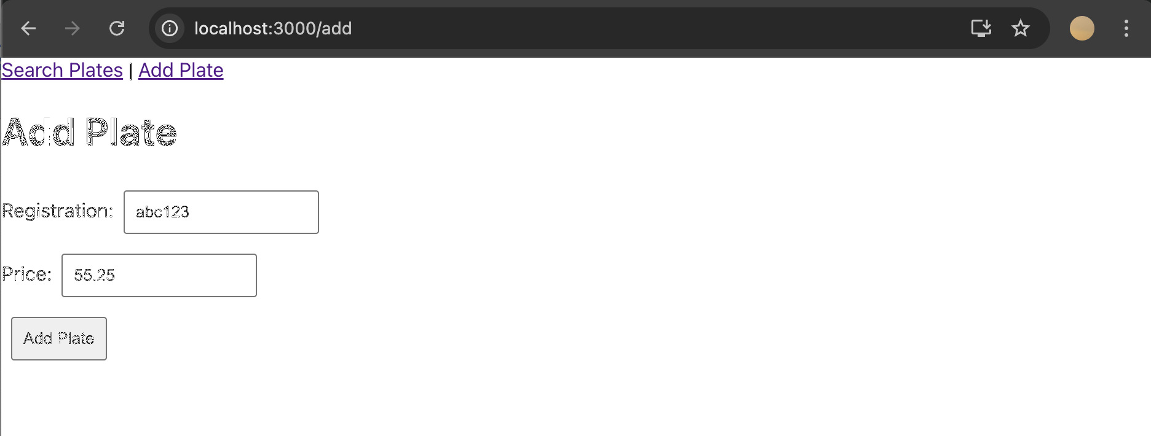

To purchase a plate, when searching for a plate, the licence plate will display the word “Available” next to it; you can then click “Purchase”. Once clicked, the status will update to display “Purchased”


Conclusion
To conclude, this report has highlighted the fundamental differences between client-side and server-side scripting, emphasising the distinct roles they play. Client-side scripting enhances responsiveness and interactivity, while server-side scripting ensures data management and security. The investigation into Node.js revealed some of its benefits in scalability and performance, alongside challenges like callback complexity and database limitations. Documentation of the licence plate application code demonstrated a practical implementation and testing, showing the roles of these technologies in modern web development.

Works Cited

[1] | Z. Behfarshad and A. Mesbah, “Hidden-Web Induced by Client-Side Scripting: An Empirical Study,” Springer-Verlag Berlin Heidelberg, Vancouver, 2013.
[2] | J. Walker and S. Chapra, “A client-side web application for interactive environmental simulation modeling,” Elsevier, 2014.
[3] | R. Rischpater, “Scheme for Client-Side Scripting in Mobile Web Browsing or AJAX-Like Behavior Without Javascript,” Scheme and Functional Programming, Chicago, 2006.
[4] | T. Crawford and T. Hussain, “A Comparison of Server Side Scripting Technologies,” in Proceedings of the International Conference on Software Engineering Research and Practice (SERP), pp. 69-76, 2017, 2017.
[5] | P. Thiemann, “An embedded domain-specific language for type-safe server-side web scripting,” Association for Computing Machinery, New York, 2005.
[6] | A. Singh and A. Patra, “Internet Protocol with Internet Programming (IP with IP): Architecture and Design,” International Journal of Scientific Research in Computer Science and Engineering, vol. 12, no. 4, pp. 66-76, 2024.
[7] | J. D. Haney and C. A. VanLengen, “Server-Side Scripting in JavaScript/JScript and VBScript,” Information Systems Education Conference (ISECON), Philadelphia, 2000.
[8] | T. F. Iskandar, M. Lubis, T. F. Kusumasari and A. R. Lubis, “Comparison between client-side and server-side rendering in the web development,” IOP Conference Series: Materials Science and Engineering, vol. 801, no. 1, 2020.
[9] | D. Prabhakara, “Web Applications Security A security model for client-side web applications,” Institutt for telematikk, Trondheim, 2009.
[10] | W. De Groef, “Client- and Server-Side Security Technologies for JavaScript Web Applications Beveiligingstechnologiën voor webapplicaties in JavaScript,” Ku Leuven, Heverlee, 2016.
[11] | A. Shukla, “Modern JavaScript Frameworks and JavaScript's Future as a Full-Stack Programming Language,” Journal of Artificial Intelligence & Cloud Computing, vol. 2, no. 4, pp. 1-5, 2023.
[12] | M. Heller, “What is Node.js? The JavaScript runtime explained,” InfoWorld, San Francisco, 2020.
[13] | B. Basumatary and N. Agnihotri, “Benefits and Challenges of Using NodeJS,” International Journal of Innovative Research in Computer Science & Technology (IJIRCST), vol. 10, no. 3, p. 67–70, 2022.
[14] | H. Shah and T. R. Soomro, “Node.js Challenges in Implementation,” Global Journals Inc., Framingham, 2017.
[15] | N. Chhetri, “A Comparative Analysis of Node.js (Server-Side JavaScript),” St. Cloud State University, St. Cloud, 2016.

