Morgan_Fiona_2501925-BMDS7009-CW2.docx
Assignement Title: Programme improvement Project.
I confirm this essay is my own original work and does not include text created by a genterated artificial intelligence tool.

Title:
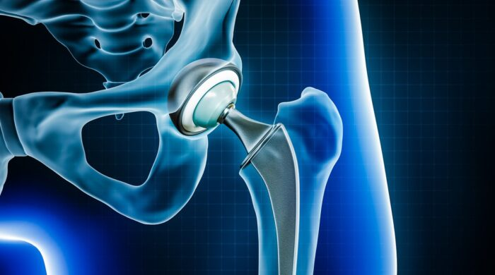

(Understanding the Process of Hip Replacement Surgery - WWMG, no date)

Introduction
The Occupational therapy (OT) preadmission service for elective orthopaedics service at Aneurin Bevan University Heath Board (ABUHB) was established in 2002, providing a service to patients awaiting total hip replacement surgery. Since Covid-19 elective orthopaedic surgery waiting list times have increased dramatically. The total waiting list times grew by 5.6% in the period February 2023 to November 2024 in Wales (Welsh Government, 2025). ABUHB has announced the wait to have hip and knee surgery is approximately 129 weeks from the GP referral to having surgery (Aneurin Bevan University Health Board, 2026).
OT plays an important role in the pre-rehabilitation of the patient awaiting Total hip replacement surgery, preparing them for their surgery and allowing the patient to discuss their goals (College of Occupational Therapists, 2012). OT at ABUHB provides a telephone service prior to their surgery assessing the patient’s needs, providing education, provision of equipment and enabling patients to manage their own daily tasks prior to and post their surgery.
Figure 1 demonstrates the process of how the Occupational therapy service run their preadmission OT service.

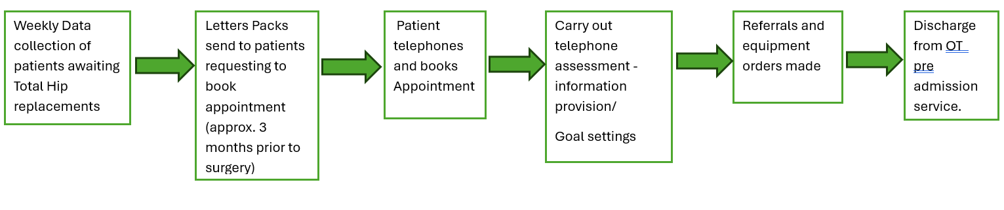
Figure 1 OT preadmission service for Elective orthopaedics.
In November 2024 Welsh government has had an Initiative drive to increase the through put of patients who are awaiting Elective Orthopaedic surgery (Welsh Government, 2025). Therefore, ABUHB has had to increase their capacity with weekend surgery lists and extending theatre sessions into the evenings. This has impacted the OT service greatly as the number of patients coming into the service has increased.
The double diamond model was used to demonstrates the problems that has occurred in the occupational therapy service since ABUHB increased patient capacity. The approach (figure 2) is divided into four parts focusing on discovering the problem and defining the challenges it occurs and looking at developing and delivering the solutions. (Rian, Agung Triayudi and Ira Diana Sholihati, 2024).

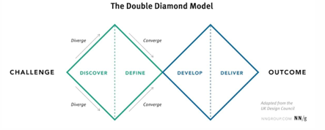
Figure 2 Double Diamond Model (Rian, Agung Triayudi and Ira Diana Sholihati, 2024).
In the first phase of this model (discovery and define), the topic of focus should be on the impact of the OT preadmission service due to the increase of patents capacity having surgery. Discovery helps the health professionals understand what the problem is. It involves speaking to the team who are affected by the increase capacity. The Define stage is the insight gathered from the discovery which helps outline the challenges that has occurred (The Double Diamond - Design Council, no date). Figure 3 highlights the analysis of the problems that has occurred since November 2024 on the OT preadmission service.
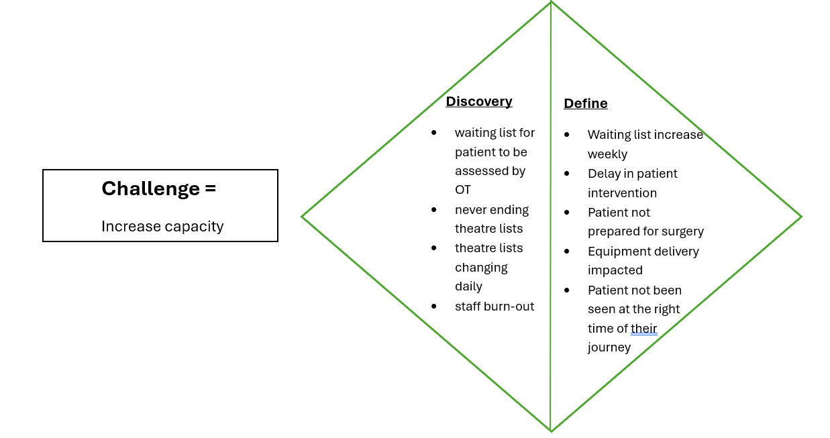(The Double Diamond - Design Council, no date)Figure 3 First phrase of double diamond model – adapted from (The Double Diamond - Design Council, no date)
From this analysis it has shown that patients are being impacted from the increase capacity and the waiting lists that have been formed. Using the Double diamond model has allowed the formulation of the aim and objectives for this improvement project

Aim
For patients to able to access the right OT intervention at the most appropriate time for them in their surgical journey.
Objectives
- For patients to be as independent as possible whilst waiting for surgery
- For patients to be prepared for their surgery and recovery afterwards
- Referrals and equipment provision to be completed in a timely manner
- To shorten the patients wait time for OT intervention
- To empower staff to be able to make decisions regarding preadmission intervention processes.
Method
To improve the efficiency of the service a new approach is needed to determine when a patient should be seen. The second phase of the double diamond model would be best placed at this point to look at the development and delivery of the implementation of the project. Develop should encourage the team to give answers to the problems and look at the design of the project. The delivery stage will test the solutions on a small-scale pilot study to ensure the solutions are right for the services, improvements can take place and reject the things that are not working (Surveys, Polls, and Quizzes | Microsoft Forms, no date).
Figure 3 looks at the possible solutions to improve the preadmission OT service delivery and shorten the waiting lists. It highlights which solution project to trial and what would need to be implemented to be able to deliver this project.
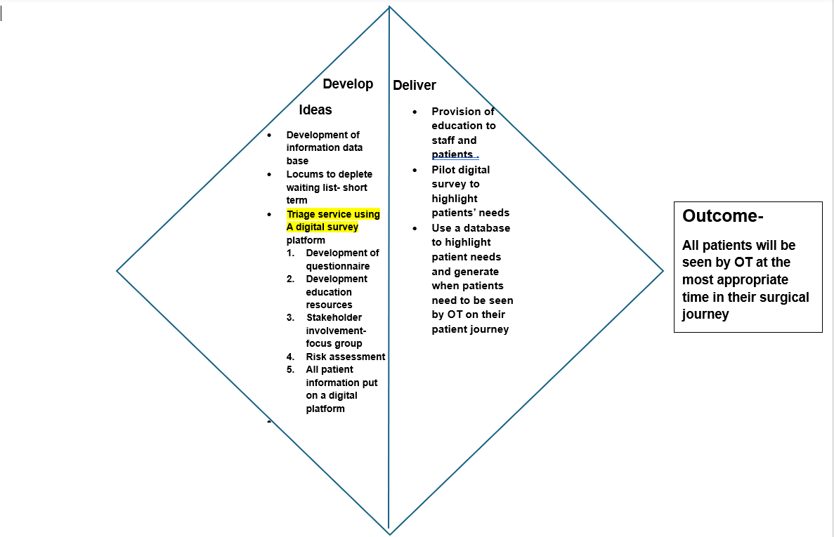
Figure 3 Phase 2 Double diamond Model for the OT service delivery, adapted from-(The Double Diamond - Design Council, no date)
Triage service using a digital survey
Digital survey could play a part in collecting data regarding the patient’s abilities and need for OT intervention. Microsoft forms is easily accessed as ABUHB uses the software Microsoft 356. It allows the users to create different types of forms (a questionnaire in this case) which provides information for the health professional regarding the patient and will also provide data collection to evaluate the project improvement. Its user friendly for patients as it can be accessed from any Information technology devise. It allows the patient to complete the questionnaire in their own time and the health professional to have access to the questionnaire in a timely manner (Surveys, Polls, and Quizzes | Microsoft Forms, no date).
Patients who are on the waiting list will have access the to the questionnaire through a Quick Response (QR) code (A QR code is a barcode which stores information, and when scanned it opens a link. They are easy to use and a fast way to obtain information (Free QR tools Team, 2025)) and will answer several triage questions. Once submitted to OT for screening, the data can be used to determine what action is needed to be taken by the OT service and what intervention the patient requires -1, send patient information to prepare patient for surgery 2, an assessment is needed straight away as patient is having difficulties 3, an assessment needed when surgery date is given.
Discussion
When setting up a new project it is vital to engage all stakeholders who will be impacted by the service change. Stakeholder analysis is key to highlight those who need to be involved. It shows how stakeholders are importance within the decision making of the project (Brugha, 2000). Communicating with stakeholders early is necessary to ensure they fully understand the project and understand the benefits of it. By using a Power Interest matrix (Figure 4), allows analysis of who the stakeholders are, it helps priories the stakeholders and establish their power and interest in the project(Thamma-reddi Latha, 2023).
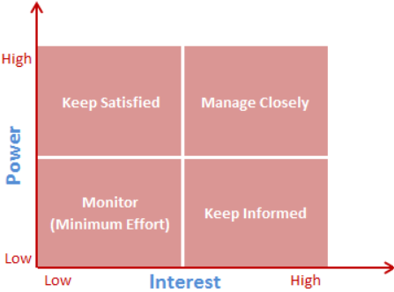

Figure 4 Power- interest matrix (Thamma-reddi Latha, 2023)
Figure 4 illustrates that high power and high interest stakeholders need to be managed closely, low power and high interest stakeholders need to be kept informed, whereas the high power and low interested stakeholders need to be satisfied and lower powered and low interest stake holders need to be monitored.
When looking at this project Figure 5 highlights which stakeholders would be involved and where they would be placed on the Power interest matrix.
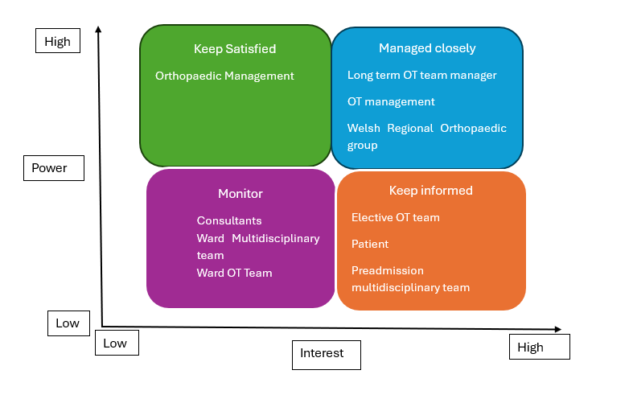
Figure 5 Power Interest matrix showing stakeholders for OT triage project. Adapted from (Thamma-reddi Latha, 2023)
Completion of this matrix highlights, how the stakeholders need to be engaged within in the project and at what level. The OT management team and the regional orthopaedic group will have a large influence into how /if the project will go ahead. The elective OT team, patient and the preadmission team will need to be kept informed as these are the people who need to be involved and be hands on with the project.
Consideration into which digital platforms available needed to take place, to ensure the right software would be appropriate to assist in the delivery of the project. Alternatives to Microsoft Forms could be google forms, survey monkey, jot form or Typeforms (Top 10 Microsoft Forms Alternatives for 2025 | ChecklistGuro, 2025). They all had pros and cons, but Microsoft forms would be more appropriate to use due to the easy accessibility to ABUHB therefore would not be any financial costs to use it. The Microsoft forms can be accessed by any device from a mobile phone, laptop or a desktop device. It does not need a separate app therefore both the creator of the form or the responder can easily access it. Microsoft forms can also be linked to a QR code therefore can be easily accessible by the user.(Surveys, Polls, and Quizzes | Microsoft Forms, no date). Microsoft forms have been used effectively in the healthcare settings assisting with data and audit collections however there is always a concern if the intended users will comply with this. Causton et al., (2023) when carrying out an auditing process with doctors, found that between 75-77% of the doctors filled in the Microsoft forms. However, this demonstrates there was still compliance issues. When carrying out this project, steps must be taken to ensure all patients complete a questionnaire and they are not forgotten. Therefore, reminders will need to be put in place for completion or alternative ways to complete the questionnaire if there is an issue with using Microsoft forms.
ABUHB have a large population of elderly people, in 2023 there was 122,366 people over the aged of 65 in their coverage area (Welsh Government, 2023). Hip replacement surgery is usually performed on 60 to 80 year olds due to age related conditions that effect the hip (Hip replacement | NHS inform, no date) Age UK, (2025) found that one in five older people have limited access to the internet and often using it less than once a month. With these demographics in mind the use of digital software with this population needs to be considered and measures would need to be put in place to ensure their ability to participant in this initiative.
This project’s main aims and objectives are looking at the best patient care within an OT service. Healthcare professionals often focus on improving services, quality and patient’s outcomes but lacks in identifying the benefits through the change or implementation of an initiative project (Vas et al., 2023) Therefore it is important to look at the benefits from delivering this service using Microsoft forms and QR codes. By using The Benefit Realisation Framework would allow the identification of the benefits of trialling this initiative. This framework is used to gain evidence for reporting and tracking the success of the initiative. It will give information for reporting the outcomes and developing a case for the future. It will also help with obtaining further funding and support and indicate project improvements (Vas et al., 2023). Figure 6 indicates there are four stages of the framework starting with Benefit indication. This identifies the objective and the benefits; it pinpoints the stakeholders involved and the benefit categories. The second stage helps putting the data collection methods in place to measure the benefits by creating targets and establishing baselines. The third stage is realisation which data collection is taking place, ensuring the initiative is on track and advising the stakeholders. Lastly is the transition, it helps with the identifying where the improvements need to take place (Maya G, 2023).
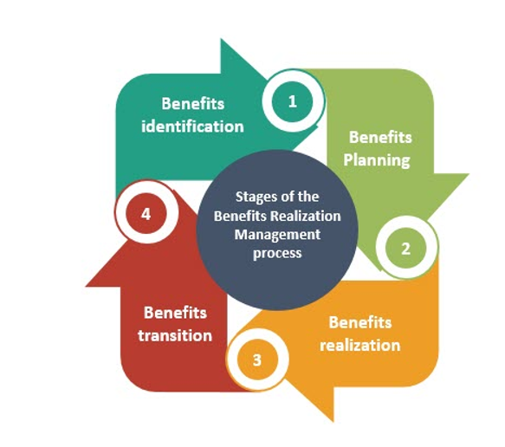
Figure 6 stages of the Benefit Realisation Framework (Maya G, 2023).
By using this framework for the initiative. It has identified the organisational benefits of the planned service improvement. Figure 7 highlights the key benefits of using Microsoft forms and QR forms to improve the organisation, staff and patient care.

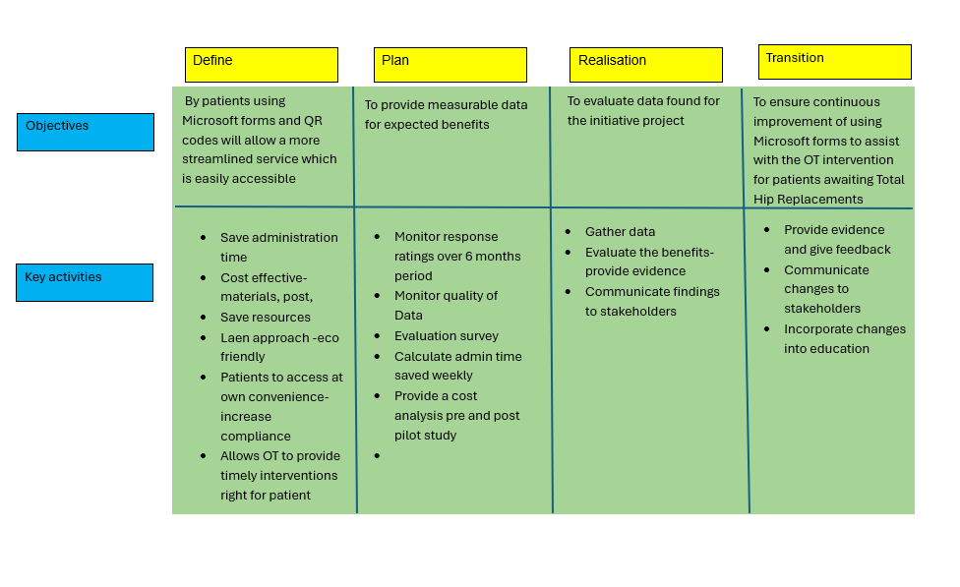
Figure 7 Benefit Realisation analysis of the OT service improvement adapted from the Benefit Realisation framework (Maya G, 2023).
The Benefit Realisation framework has highlighted this initiative could save time, cost and resources, through not having to send letters and information out to patients. This would alleviate the administration time, and would allow staff to do other things. Resources from paper, ink or postage would same the department money. This would need to be monitored throughout the project and data gathered to validate the success of the project and further improvements that need to be put in place.
References
Age UK (2025) Age UK warns 2.4 million digitally excluded older people are at risk of being left behind in an increasingly digital world. Available at: https://www.ageuk.org.uk/latest-press/articles/age-uk-warns-22.4-million-digitally-excluded-older-people-are-at-risk-of-being-left-behind-in-an-increasingly-digital-world/ (Accessed: February 22, 2026).
Aneurin Bevan University Health Board (2026) Trauma and Orthopaedics RTT Waiting Times - Aneurin Bevan University Health Board. Available at: https://abuhb.nhs.wales/hospitals/a-z-of-services/trauma-and-orthopaedics/trauma-and-orthopaedics-rtt-waiting-times/ (Accessed: February 6, 2026).
Brugha, R. (2000) “Stakeholder analysis: a review,” Health Policy and Planning, 15(3), pp. 239–246. Available at: https://doi.org/10.1093/heapol/15.3.239.
Causton, J. et al. (2023) “P-100 To what extent does the use of Microsoft forms improve compliance when auditing medical on-call activity?,” To what extent does the use of Microsoft forms improve compliance when auditing medical on-call activity?. British Medical Journal Publishing Group, p. A46.3-A47. Available at: https://doi.org/10.1136/spcare-2023-HUNC.121.
College of Occupational Therapists (2012) “Specialist Section Trauma and Orthopaedics Occupational therapy for adults undergoing total hip replacement.” Available at: www.COT.org.uk (Accessed: February 6, 2026).
Free QR tools Team (2025) What Is a QR Code and How It Works | Complete Guide 2025. Available at: https://freeqrtools.com/what-is-a-qr-code-and-how-it-works/ (Accessed: February 10, 2026).
Hip replacement | NHS inform (no date). Available at: https://www.nhsinform.scot/tests-and-treatments/surgical-procedures/hip-replacement/ (Accessed: February 22, 2026).
Maya G (2023) Benefit Realization Management Process – Techno PM - Project Management Templates Download. Available at: https://www.techno-pm.com/blogs/benefits-realisation-management/benefit-realization-management-process (Accessed: February 22, 2026).
Rian, R.H., Agung Triayudi and Ira Diana Sholihati (2024) “Implementation of the Double Diamond Method in User Experience Design of Health Service Application (Homecare),” SaNa: Journal of Blockchain, NFTs and Metaverse Technology, 2(1). Available at: https://doi.org/10.58905/sana.v2i1.272.
Surveys, Polls, and Quizzes | Microsoft Forms (no date). Available at: https://www.microsoft.com/en-gb/microsoft-365/online-surveys-polls-quizzes?msockid=343fb534374b64c23a27a39a36d86541 (Accessed: February 10, 2026).
Thamma-reddi Latha (2023) ProjectManagement.com - Stakeholder Analysis using the Power Interest Grid. Available at: https://www.projectmanagement.com/wikis/368897/stakeholder-analysis--using-the-power-interest-grid#_ (Accessed: February 10, 2026).
The Double Diamond - Design Council (no date). Available at: https://www.designcouncil.org.uk/our-resources/the-double-diamond/ (Accessed: February 9, 2026).
Top 10 Microsoft Forms Alternatives for 2025 | ChecklistGuro (2025). Available at: https://checklistguro.com/blog/top-10-microsoft-forms-alternatives-for-2025 (Accessed: February 20, 2026).
Vas, V. et al. (2023) “Identifying value in healthcare transformation initiatives: an evaluation of an approach to benefits realisation,” BMJ Open Quality, 12(4), p. 2349. Available at: https://doi.org/10.1136/bmjoq-2023-002349.
Welsh Government (2023) Population estimates by local health boards and age. Available at: https://statswales.gov.wales/Catalogue/Population-and-Migration/Population/Estimates/Local-Health-Boards/populationestimates-by-lhb-age (Accessed: February 21, 2026).
Welsh Government (2025) Orthopaedic summit: 9 December 2024 [HTML] | GOV.WALES. Available at: https://www.gov.wales/orthopaedic-summit-9-december-2024-html (Accessed: February 6, 2026).

