University of Wales Trinity Saint David London
Programme: BSc Cloud Computing
Module: ACCC5000 Cloud Computing Technologies
Lecturer: Anupam Mazumdar
Name: Celdwan Bandeira
ID:1812407

Executive Summary
Cloud computing offers SMEs with an opportunity to compete internationally through a systematic and efficient commuting system. It leads to comprehensive management of customers and staff related information enabling businesses to improve their productivity significantly. The report aims to provide an overview of key concepts, types and deployment models of cloud computing to London Bikes Ltd. In this study, main migration strategies for cloud computing has also been discussed. Similarly, concerns regarding adoption of cloud computing have been addressed. Considering case of London Bikes Ltd., the implementation process of SaaS has been described.

Table of Contents
Introduction 3
Background and terminology of Cloud Computing 3
Essential characteristics and expected from implementation of potential solutions 5
Service models and available real-world services 7
Deployment models and recommendation for London Bikes Ltd. 9
Virtualisation and its link to Cloud Computing 11
Migration strategies of Cloud Computing 12
Concerns of security 14
Implementation process of SaaS for London Bikes 15
Conclusion 15
Reference List 17

Introduction
Gaining a comprehensive undertaking of critical components of cloud computing has become essential in the era of digitalisation. It has become increasingly necessary for businesses to incorporate cloud computing services for SMEs as it aids in reduction of operational costs. It is advantageous for increasing speed and accuracy of business activities performed by an organisation. Vital organisational requirements for enhancing London Bikes' IT capabilities include a confidential and secure cloud data backup to prevent loss of essential data and solutions to improve management of staff and customers. This report aims to provide a comprehensive understanding of critical concepts related to cloud computing for the SME London Bikes Ltd. It further aims to identify and recommend cloud computing technologies that would be effective for SMEs to meet its organisational requirements.

Background and terminology of Cloud Computing
Cloud computing involves performance of different business activities such as management of client data and security through the aid of Internet. It requires resources like data storage, databases, servers, networking along with software to systematically performance business services online. In 2019, 99% of all private businesses were accounted for by SMEs (Merchantsavvy.co.uk, 2020). This indicates increasing contribution and significant role played by SMEs for development of UK economy. In this context, businesses like London Bikes must ensure that they use latest available technologies for enhancing their IT capabilities. Consequently, it would lead to an improvement in their management of business activities and reduce operational costs for increasing their profitability. Key concepts and principles associated with cloud computing have been elaborated below.
Cloud computing concepts
Concept of cloud computing revolves around selection of a suitable model of providing IT services that serve a significant purpose in business. Varghese and Buyya (2018) ascertained that cloud computing emphasises on use of IT services and not products for performing key management and storage stacks. In this context, cloud computing includes services wherein a common infrastructure is shared by multiple clients to activate their business goals. Lu and Xu (2019) identified that services of cloud computing are accessed on-demand based on the type of service businesses require. For instance, requirements of an SME like London Bikes for managing its client base of 150 along with its employees would differ from a more significant business. This is determined based on the transaction, capacity and user needs of the company. Another vital aspect of cloud computing is that its services are scalable. Mikkonen and Khan (2016) stated that cloud computing offers scalable and flexible services for the convenience of its users. It enhances the ability of an SME to scale its services for meeting a growing business's needs.
Principles
Gaining an understanding of the principles associated with cloud computing is crucial for businesses to prevent risks related to data breaches and transfer issues due to lack of knowledge. Fundamental principles governing practical cloud computing that London Bikes Ltd. is required to be aware of have been discussed below.

Figure 1: Principles of Cloud Computing
(Source: Inspired by Gillam and Antonopoulos, 2017)
Cost and benefit
By evaluating the costs along with the benefits of incorporating cloud computing, businesses can make well-informed decisions. According to Gillam and Antonopoulos (2017), understanding the costs associated with each cloud computing service and organisation requirement is crucial for making the right decision. This is essential for SEMEs to prevent over expenditure and select the cloud services that it requires the most.
Capability
Businesses must understand the capabilities of cloud computing services and integrate them to the optimal extent. This can be attained through the integration of cloud providers with internal resources for gaining holistic support along with a delivery solution.
Enablement
Principle of enablement emphasises on the need for planning cloud computing as a strategic enabler. Lu and Xu (2019) identified that by utilising cloud computing services for enabling the strategic growth of a business, it could avoid unprecedented risks. Instead of utilising cloud computing as a technical platform or outsourcing arrangement, companies are required to use it for enabling the attainment of strategic goals.
Enterprise risk
An enterprise risk management perspective must be undertaken by businesses while choosing an appropriate cloud computing service. This is essential to ensure that selected service leads to proper adoption and usage of cloud services for increasing operational efficiency.
Accountability
Lack of accountability is a significant issue that can increase the risks faced by organisations while managing their cloud computing services. In this context, accountabilities must be clearly defined for internal along with service provider responsibilities.
Trust
Trust is an essential principle of cloud solutions. This is because it is vital to building trust within business processes that are dependent on computing solutions to overcome issues of uncertainty. Chiregi and Navimipour (2018) observed that many IT experts lack confidence in cloud computing as a secure and safe platform. Although it has an increased risk of privacy threats, IT security experts must take proper emails for securing cloud computing services offered to enterprises to gain a bond of trust and confidence in its services.

Essential characteristics and expected from implementation of potential solutions
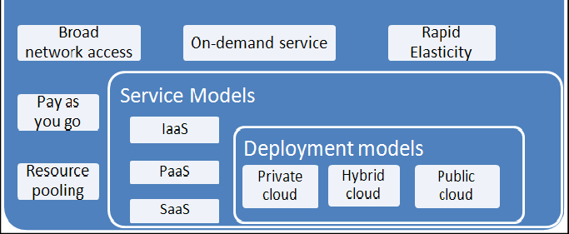
Figure 2: Characteristics of cloud computing
(Source: Inspired by Adams, 2017)
Successful identification and implementation of cloud computing services enable SMEs to find solutions for their business process issues. This can be obtained through process of instantaneous resource provision. Rad (2017) noted that resource provisioning involves selection and deployment of software and hardware resources based on business needs. Utilisation of a cloud computing model empowers fitting and “on-demand network access” to a public pool of computing resources. These resources include “servers, applications, networks and services” that are speedily released and provisioned. Essential characteristics and probable aids of using cloud computing model due to which it is recommended to London Bikes have been discussed below.
Protection from cyber threats
Adams (2017) observed that cloud computing maximises potential benefits gained by companies. It enables them to solve issues of cyber threats like league, theft and loss of private data stored online. This is obtained through cloud computing platforms that include penetration testing, virtual private networks, obfuscation, firewalls and tokenisation. London Bikes would benefit from investing in cybersecurity services of cloud computing to safeguard confidential data from potential loss.
Synchronisation
Cloud computing provides an ability to access and manage stored data systematically. Diaby and Rad (2017) noted that cloud computing resources could be provisioned without human interaction from service providers. This enables organisations to provide additional computing resources based on their needs to synchronise and manage data. Through the aid of online storage solutions like Google Drive and OneDrive, London Bikes would be able to retrieve data stored previously in an effective manner. Synchronisation of data is hugely beneficial for SMEs to increase efficiency of database management.
Accessibility
Cloud computing services have ease of accessibility over one network by verse customer platforms. This enables customers and employees to access and use services offered by London Bikes efficiently. Network bandwidth and latency of cloud computing are integral to quality of services (QoS) of network.
Reduced complexity
Ease of using cloud computing resources makes it hugely beneficial for SMEs to improve operational accuracy. London Bikes is recommended to use a cloud computing model for complexity of managing its expanding customer wrong employee base. It would enable the organisation to easily track and manage their orders and essential information of customers and employees alike systemically.

Service models and available real-world services
Cloud computing services are categorised into three groups. These include “software-as-a-service (SaaS), infrastructure-as-a-service (IaaS) and platform-as-a-service (PaaS)”. These service models have been discussed below.
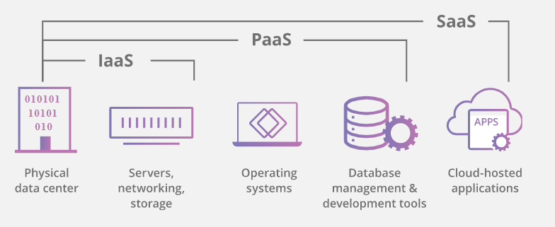
Figure 3: Service models
(Source: Influenced by Dong, 2017)
Software as a Service (SaaS)
SaaS is one of the most popular cloud computing forms. Purwani et al. (2017) noted that SaaS is a software distribution model that enables a service to host applications for its customers. These applications are made available to customers through Internet. Low initial expenses and ease of integration into existing software used by business make SaaS highly convenient. In London Bikes’ case, SaaS optimisation would produce a centralised platform to increase visibility of operations and consequently, productivity. Dong (2017) observed that by discovering essential applications for a company, SaaS optimisation leads to selection of better licences which improve employee productivity. It leads to a reduction of costs faced by London Bikes along with security risks due to increased visibility. Use of SaaS leads to streamlining of workflows within an enterprise. SaaS workflows reduce need for hiring IT personnel due to ease of using its cloud computing model. This would be hugely beneficial for an SME like London Bikes, which has a small workforce. It requires fewer backups and storage making it convenient for London Bikes to use it for its database management purposes. Collaboration with appropriate productivity tools like Dropbox, Slack, Google Apps, Hubspot and ZenDesk becomes increasingly easy for organisations using SaaS. This would be advantageous for London Bikes to save time and enhance productivity. London Bikes would be recommended to use SaaS platforms that can be used over Internet with minimal monthly subscription fees.
Platform as a Service (PaaS)
PaaS provides a mix of hardware along with software tools through Internet. These tools are beneficial for developing applications. Krancher et al. (2018) identified that PaaS helps build apps and software for consumers. Critical examples of PaaS include OpenShift, Windows Azure and Apache Stratos. Component analysis, including log analysis, can be done through PaaS, making it useful to solve software development challenges by businesses. Architecture evaluation is another significant advantage that PaaS provides enabling businesses to choose infrastructure and platforms based on their needs. PaaS offers an opportunity to change user interfaces as well as use service platform tools for increased efficiency. Its increased flexibility makes it useful for organisations aiming to expand their business operations.
Infrastructure as a Service (IaaS)
IaaS is practical for businesses of all sizes as it offers complete control over infrastructure and a pay-as-you-use model, making it feasible for business budgets. Shahzadi et al. (2017) noted that IaaS provides a safer alternative to physical hardware and IT infrastructure. Real-life-examples of IaaS includes Magento 1 Enterprise Edition, Google Computer Engine (GCE) and AWS EC2, among others. It provides an option for scalable clustering, making it easier to scale up or down based on business’ needs solving issues of complex structures.
Platform-level virtualisation is another aspect of IaaS that aims to virtualise hardware components of operating system. This leads to saving of space and resources, thereby enhancing efficiency of used platform. On-demand provisioning enables customers to pay for services and infrastructure needs based on their budget and needs. This is effective for companies who have limited financial resources enabling them to use essential computing services online.

Deployment models and recommendation for London Bikes Ltd.
Public
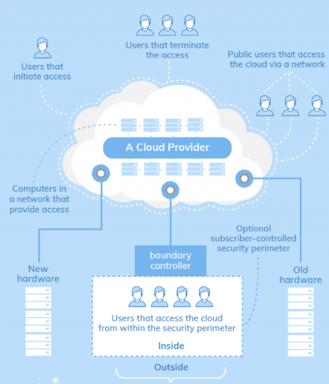
Figure 4: Public model
(Source: Opencirrus.org, 2019)
Public cloud deployment model is available for access by all public. It utilises a third-party server wherein data is created and stored. Odun-Ayo et al. (2019) noted that server infrastructure belongs to its service providers of public deployment models. Resources are offered by these providers based on company's budget and requirements.
Private
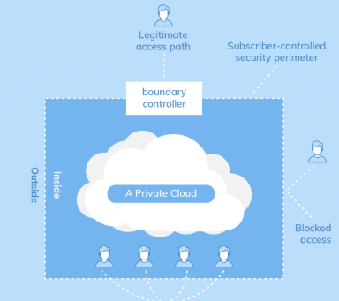
Figure 5: Private model
(Source: Opencirrus.org, 2019)
Private cloud deployment provides increased flexibility and high scalability leading to customisation of infrastructures. It further offers increased privacy, security and reliability to businesses due to access to authorised personnel. However, it is expensive and requires extensive employee training.
Community
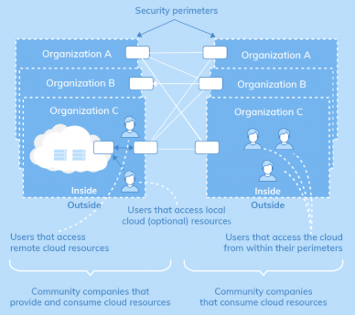
Figure 6: Community model
(Source: Opencirrus.org, 2019)
A community cloud enables several companies to use server by sharing its infrastructure and other resources. It follows a similar deployment model as a private network, but its set of users extends to include related companies. Diaby and Rad (2017) observed that community deployment model reduces costs and increases ease of sharing data and collaboration. It is a reliable and secure model. However, businesses are needed to share a fixed storage and bandwidth capacity that may affect their overall productivity.
Hybrid
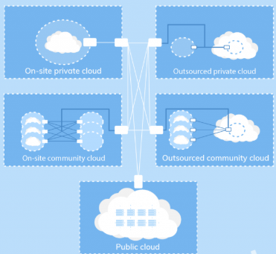
Figure 7: Hybrid model
(Source: Opencirrus.org, 2019)
Hybrid deployment model utilises best features available of other deployment models. Helmi et al. (2018) noted that a hybrid cloud deployment model offers increased security and privacy when compared to public model. It further provides enhanced scalability and flexibility than that of a private model, making it financially reasonable and highly effective.

Virtualisation and its link to Cloud Computing
Virtualisation is considered to be an essential component of cloud computing that enables creation of virtual networks and services to be uploaded on the cloud. Toosi et al. (2019) noted that virtualisation separates computer environments from its physical infrastructure to enable running of multiple operating systems simultaneously. It leads to a reduction in IT costs while enhancing effectiveness of existing hardware.
Type 2 hypervisor
Type 2 hypervisor runs within an operating system of a host machine. Vojtesek and Pipis (2016) noted that Type 2 hypervisor has an additional software layer over the hardware that may be Windows, Linux or Mac OS. This is common for environments with a small number of servers making it convenient to manage. For instance, VirtualBox by Oracle is a typical Type 2 hypervisor vendor that can be run with ease over existing software.
Type 1 hypervisor
Type 1 hypervisor includes installation of a software layer directly on top of a physical server and its underlying software. It is called a "bare metal hypervisor" as it provides increased stability and performance as it does not depend on an operating system. Pousa and Rufino (2017) noted that type 1 hypervisors are most suitable for business. This is because it leads to virilisation of hardware components and running multiples softwares developed from different environments simultaneously. These include Oracle and Microsoft Hyper-V among others. It enables organisations to move virtual machines between physical services either automatically or virtually based on business needs.
Based on needs of London Bikes, the SME would be recommended to install Type 1 hypervisor as it would provide increased ease and optimal performance of existing hardware. Moreover, since the organisation wants to use SaaS, integration of type 1 hypervisor would be suitable for meaning its operations systematically and at reduced costs.

Migration strategies of Cloud Computing
A cloud migration strategy is a plan made by an organisation for moving its data and applications from on-premises architecture to cloud computation. Migrating to cloud is a digital transformation for most businesses as it involves a massive organisational change and support. Acquiring engagement of people and support before migration leads to a smoother and faster process of cloud migration enabling in meeting goals of businesses (azure.microsoft.com, 2020). As of particular, "resource pooling" and "virtualisation" that results in processing along with lower networks has been addressed in a significant way. A process of cloud migration is a series of events carried out in the sustenance of ultimate cloud migration (Gholami et al. 2016). These processes underline a comprehensive perspective in capturing the business as well as technical concerns. Therefore process involved in migrating to a cloud involves the following:-
Re-hosting:- Re-hosting includes re-deployment of apps in an environment that is cloud-based, through which changes are made for the host configuration of the app. Such a type of migration assists in quick and seamless technology. Enterprises would be able to make savings on cost by 30% without a need for any involvement in cloud optimisation.
Re-Platforming:- Re-Platforming is a process where applications and their components are migrated to a cloud-managed platform without having to change much of their infrastructure. By this way, applications are operated on cloud platforms, through replacement of the configuration in the app's architecture.
Re-Architecting:- This method involves existing applications to function smoothly in cloud platforms through leverage of features and services generated by the cloud provider. Such a feature comes into forefront for the development of software within cloud. It happens as a response to cater to software needs and designating into newer ventures.
Re-Purchasing:- In this process, old forms of application are discarded with an aim for purchasing new ones or upgrading to newer versions. Enterprises can make deployment for SaaS platforms in an efficient manner by use of this method.
Retiring:- During the process of migration, enterprises would require diving into apps for deriving an understanding of uses and cost incurred to the company. In case the app is obsolete or unworthy of application to the cloud, it would be removed from kit leading to simplification of cost and translation into savings to promote efficiency and scalability.
Retaining:- In this process, applications from migrations would lead to a significant amount of time to be spent in re-architecting or running of cloud and might turn out to be costly in case migration is made. Through this manner, old apps would be saved unconventionally.
In recent times cloud has evolved into an attractive environment for HPC workloads. As of particular, "resource pooling" and "virtualisation" that results in processing along with lower networks has been addressed in a significant way (Kehrer and Blochinger, 2019). London Bikes Ltd. needs to make use of such processes to generate successful migration of Cloud Computing. In the first stage, it is essential for doing proper planning by assessing the environment and determining the factors necessary for determining the governance of migration (Samarati et al. 2016). Once the background is assessed, a need for execution is crucial. Fundamental challenge involved is in the ability to put nominal disturbance to regular operation at lesser cost and for a limited time. After data is migrated to cloud, it is significant for investigation of real-time variations for critical infrastructure and prediction of conflicts in workload for London Bikes Ltd. In doing so, aspect of meeting on-going performance and benchmarks to ensure RPO and RTO objectives needs to be met.

Concerns of security
Migration of application or services to the cloud, without putting a check on security calls for a need for careful preparation. Understanding of cloud-based deployment and building upon new forms of infrastructure necessitates the significance of communication between the businesses and IT teams. A significant contribution is in the determination of a suitable system of cloud deployment (Rana and Rahman, 2018). In some cases, the components of the application are difficult to be shifted, and a public cloud would be a significant option for cost, scalability and maintenance. In the absence of a clear line of communication and denial-of-service includes attacks targeting cloud resources, cloud-API attacks as well as hi-jacking of services.
Plan for Bandwidth Requirements: -Gaining an understanding for the data-flows and requirements of bandwidth makes assurance for security solutions to meet up with the performance requirements.
Comprehending issues of Compliance: - It is crucial for meeting the requirements of data that is processed and data that moves alongside different clouds in the networking environments. Essential consultation with the legal system has to be dealt with before adoption of any sort of cloud program.
Provision of greater resource accessibility and disaster recovery:- Terror faced by establishments in beholding cloud solutions for addressing the trepidations related to security includes the availability of the cloud-based resources. Recognition of scaling and adapting to security solutions to encounter the performance necessities is of crucial importance.
Usage of right security at the right place:- An "next-generation firewall tool" is a commonly used tool that is to be applied, along with other solutions like "web application firewall (WAF)" "intrusion protection or detection service (IPF)" and "cloud access security broker (CASB)". Therefore, a wide range of solutions is required relying on the services that are used.
Establishment of a Lifecycle Management Framework: - Safeguarding constancy between the explanations of security and rule enforcement is essential. Such security tools need to be selected for operating in a specific cloud platform through seamless solutions in the policy life cycle deployed in other kinds of environments.
In the implementation of the security for cloud migration, London Bikes Ltd needs to take into account such business and technical considerations to run cloud-based platforms securely. Primary business considerations would involve understanding and set up of significant goals and objectives. Identification of customers and their competitors is of fundamental importance in providing a suitable track for business growth (Zeng et al. 2017). Similarly, technical considerations as a form of protection, integrity, safety and continuity would help in adapting towards a newer set of protection methods. The way customers can gain access to the services and Compliance with the standards of the business is of crucial concern.

Implementation process of SaaS for London Bikes
SaaS refers to tasks that need to be completed for successfully enabling an environment of cloud computing. Restraints on resource constraints can be overcome from the application of computing services in the form of SaaS. SaaS helps a claim to be used by many tenants at same time, and as each tenant is protected the development cost on its application would be reduced (Fithri et al. 2020). A SaaS implementation needs to be complicated, depending upon the scope of elements that are to be included in a configuration such as, workflows, processes, meta-data and error messages. Therefore, creation of configuration templates helps in arrangement of common elements in multiple implementations. Critical steps needed for proper application of SaaS include:-
- Understanding attributes of the application
- Constitution of a right team
- Setting up of an ideal infrastructure.
- Consideration of bandwidth and hosting solutions.
- Generating quality performance
- Planning for disaster recovery and continuity of business plans
- Customer Support
- SLA’s and documentation process
SaaS would, therefore, be implemented through application of different technologies and models at London Bikes Ltd. In order to do this, proper clarity of information is required in understanding business goals and objectives at primary stages of development of the application (Rodrigues et al. 2016). SaaS needs to enhance accessibility of data through Internet so that monitoring of data usages would be done effectively at London Bikes Ltd.

Conclusion
Cloud-computing is the obtainability of resources like data storing and computing power that is available for many users on the Internet. London Bikes Ltd is an SME located in the heart of the city, London. Recently, it has begun to host a website internally to enable smooth processing of its data management and accessibility. Having plans for securing a Cloud-data solution, London Bikes ensures that the confidential data is free from potential loss. In this study, background and study of terminology for assisting staff at London Bikes have been discussed. Essential characteristics and potential benefits for implementation of possible solutions have been identified. A recommended service model for London Bikes Ltd. has been made. An explanation of virtualisation and how it links to Cloud Computing has been provided to understand its importance. Along with that, migration strategies for Cloud Computing and concerns for security have been taken into consideration. Similarly, process of implementation of SaaS for London Bikes has been entailed in this study.

Reference List
Merchantsavvy.co.uk (2020). UK SME Data, Stats & Charts. Available at: https://www.merchantsavvy.co.uk/uk-sme-data-stats-charts/#:~:text=By%20the%20start%20of%202019,in%20the%20UK%20are%20SMEs.&text=0.6%25%20are%20medium%2Dsized%20businesses%20(50%2D259%20employees) [Accessed on: 05 July 2020]

Varghese, B. and Buyya, R., (2018). Next generation cloud computing: New trends and research directions. Future Generation Computer Systems, 79, pp.849-861.

Lu, Y. and Xu, X., (2019). Cloud-based manufacturing equipment and big data analytics to enable on-demand manufacturing services. Robotics and Computer-Integrated Manufacturing, 57, pp.92-102.

Mikkonen, I. and Khan, I., (2016). Cloud computing: SME company point of view. Management Challenges in the 21st Century: Digitalization of Society, Economy and Market: Current Issues and Challenges, 12(4), pp. 176-199.

Gillam, L. and Antonopoulos, N. eds., (2017). Cloud computing: principles, systems and applications. Eds. 6. California: Springer.

Chiregi, M. and Navimipour, N.J., (2018). Cloud computing and trust evaluation: A systematic literature review of the state-of-the-art mechanisms. Journal of Electrical Systems and Information Technology, 5(3), pp.608-622.

Adams, M., (2017). Big data and individual privacy in the age of the internet of things. Technology Innovation Management Review, 7(4), pp. 99-143.

Diaby, T. and Rad, B.B., (2017). Cloud computing: a review of the concepts and deployment models. International Journal of Information Technology and Computer Science, 9(6), pp.50-58.
Purwani, F. and Rukun, K., (2017). A review of cloud learning management system (CLMS) based on software as a service (SaaS). In 2017 International Conference on Electrical Engineering and Informatics (ICELTICs) (pp. 205-210). IEEE.

Dong, H., (2019). IaaS Reservation Optimization for Multi-QoS Level based SaaS Provisioning. Aust. J. Intell. Inf. Process. Syst., 16(1), pp.65-72.

Krancher, O., Luther, P. and Jost, M., (2018). Key affordances of platform-as-a-service: self-organization and continuous feedback. Journal of Management Information Systems, 35(3), pp.776-812.

Shahzadi, S., Iqbal, M., Qayyum, Z.U. and Dagiuklas, T., (2017). Infrastructure as a service (IaaS): A comparative performance analysis of open-source cloud platforms. In 2017 IEEE 22nd International Workshop on Computer Aided Modeling and Design of Communication Links and Networks (CAMAD) (pp. 1-6). IEEE.

Opencirrus.org (2019). Cloud Deployment Models. Available at: https://opencirrus.org/cloud-deployment-models/ [Accessed on: 08 July 2020]

Odun-Ayo, I., Goddy-Worlu, R., Samuel, V. and Geteloma, V., (2019). Cloud designs and deployment models: a systematic mapping study. BMC research notes, 12(1), p.436.

Helmi, A.M., Farhan, M.S. and Nasr, M.M., (2018). A framework for integrating geospatial information systems and hybrid cloud computing. Computers & Electrical Engineering, 67, pp.145-158.

Toosi, A.N., Son, J., Chi, Q. and Buyya, R., (2019). ElasticSFC: Auto-scaling techniques for elastic service function chaining in network functions virtualization-based clouds. Journal of Systems and Software, 152, pp.108-119.

Vojtesek, J. and Pipis, M., (2016). Virtualization of operating system using type-2 Hypervisor. In Computer Science On-line Conference (pp. 239-247). Springer, Cham.

Pousa, D. and Rufino, J., (2017). Evaluation of type-1 hypervisors on desktop-class virtualization hosts. IADIS-journal On Computer Science And Information Systems, 12(2), pp.86-101.

azure.microsoft.com, (2020). About Microsoft azure. Available at: https://azure.microsoft.com/is-is/migration/migration-journey/ [Accessed on 04 July 2020]

Gholami, M.F., Daneshgar, F., Low, G. and Beydoun, G., (2016). Cloud migration process—A survey, evaluation framework, and open challenges. Journal of Systems and Software, 120, pp.31-69.

Kehrer, S. and Blochinger, W., (2019). A survey on cloud migration strategies for high performance computing.

Samarati, P., di Vimercati, S.D.C., Murugesan, S. and Bojanova, I., (2016). Cloud security: Issues and concerns. Encyclopedia on cloud computing, pp.1-14.

Rana, M.E. and Rahman, W.N.W.A., (2018). A Review of Cloud Migration Techniques and Models for Legacy Applications: Key Considerations and Potential Concerns. Advanced Science Letters, 24(3), pp.1708-1711.

Zeng, E., Mare, S. and Roesner, F., (2017). End user security and privacy concerns with smart homes. In Thirteenth Symposium on Usable Privacy and Security ({SOUPS} 2017) (pp. 65-80).

Fithri, D.L., Utomo, A.P. and Nugraha, F., (2020), January. Implementation of SaaS cloud computing services on E-learning applications (case study: PGRI foundation school). In Journal of Physics: Conference Series (Vol. 1430, No. 1, p. 012049). IOP Publishing.

Rodrigues, J., Ruivo, P., Johansson, B. and Oliveira, T., (2016). Factors for adopting ERP as SaaS amongst SMEs: The customers vs. Vendor point of view. Information Resources Management Journal (IRMJ), 29(4), pp.1-16.

