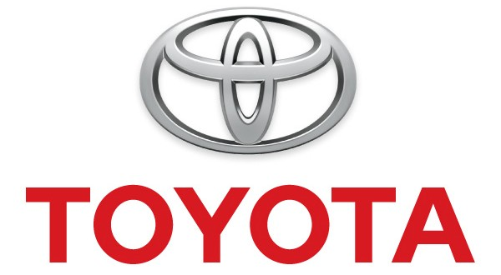
ASSESSMENT 1: ENVIRONMENTAL ANALYSIS OF TOYOTA MOTOR CORPORATION

by <Name>

Course
Professor
Institution of Learning
City/State
Date

Table of Contents
1.0 Introduction 4
2.0 Company Background 4
3.0 Business Environment Analysis 5
3.1 External Environment Analysis 6
3.1.1 Macro-environment Forces: PESTEL Analysis 6
3.1.1.1 Political Factor 6
3.1.1.2 Economic Factor 6
3.1.1.3 Social Factor 7
3.1.1.4 Technological Factor 7
3.1.1.5 Legal Factor 8
3.1.1.6 Ecological Factor 8
3.1.2 Micro-Environmental Forces: Porter’s Five Forces Analysis 9
3.1.2.1 Power of Buyers 9
3.1.2.2 Power of Suppliers 9
3.1.2.3 Competitive Rivalry 10
3.1.2.4 Threat of substitutes 10
3.1.2.5 New Entrants Threat 11
3.2 External Environment Analysis: Value Chain Analysis 11
3.3 SWOT Analysis 13
4.0 Conclusion 15
5.0 Bibliography 16

1.0 Introduction
The environmental analysis represents a procedure that supports market analysts in gathering and scrutinising environmental conditions and factors affecting a business. Factors, issues, and trends addressed through the strategic approach indirectly and directly impact a business organisation. Today, environmental analysis enables organisations to handle dynamic and complex issues associated with market globalisation. For instance, management teams must consider that technological dynamism and competition pressure inhibits organisational profitability. Therefore, understanding the business environment enables organisations to create effective strategies for environmental forces. In this paper, SWOT, Porter’s Five Forces, PESTLE, and Value Chain analyses provide details for the internal and external environments of the Toyota Motor Corporation.

2.0 Company Background
Kiichiro Toyoda established Toyota Motor Corporation in 1937 to exploit the rapidly growing automotive industry. The company operated in Japan in its early stages but eventually established international outlets in the 1950s. Today, the Aichi-based automobile manufacturing corporation is categorised among the world’s largest players in the global automotive industry. The company offers diverse products to its global clients, including sports utility vehicles, trucks, buses, minivans, sedans, and 2box. The company manufactures and markets its motor vehicles under different brand names, namely Hino, Toyota, Ranz, Lexus, and Daihatsu (Nkomo, 2019). Toyota also manufactures and sells automobile-related products like electronic components, car air-conditioning compressors, batteries, and engines. The company has relied on product diversification and quality maximisation tactic in maintaining competitiveness and profitability in the automobile market. The company currently employs 366,300 people and has a market capitalisation of approximately $254 billion (Carlier 2021). Utilising environmental analysis strategies in creating evidence-based operations has enabled the company to maintain consistent success in the market.

3.0 Business Environment Analysis
The business environment represents external and internal forces that affect business organisations negatively or positively. The internal environment represents internal resources and conditions that affect business organisations’ operations (Craig & Campbell 2012). The Value Chain Analysis is common used in analysing internal activities affecting organisational performance, including service, sales and marketing, outbound logistics, operations, and inbound logistics. The external environment represents controllable (micro-environment) and uncontrollable (macro-environmental) external forces affecting organisational performance. Porter’s Five Forces supports the analysis of organisational micro-environmental forces (controllable market forces), including the power of buyers, competitive rivalry, the threat of substitutes, new entrants threat, and power of suppliers. On the other hand, the PESTLE tool supports the analysis of organisational macro-environmental forces (controllable market forces), including legal (L), social (S), political (P), economical (E), technological (T), and ecological (E) (Çitilci & Akbalık 2020). Generally, the SWOT analysis tool provides information about an organisation’s opportunities (O), strengths (S), weaknesses (W), and threats (T).

3.1 External Environment Analysis

3.1.1 Macro-environment Forces: PESTEL Analysis

Figure 1: PESTEL Framework
(https://www.business-to-you.com/scanning-the-environment-pestel-analysis/)

3.1.1.1 Political Factor
The political factor allows multinational corporations like Toyota to understand policies restrictions, security measures, and specific requirements for specific nations. The political factor hugely affects operation cost and consumer expenditure in nations. For instance, Euro Standards has increased the demand for small engine or hybrid cars in the European region due to their associated low carbon tax levels. The political factor further encompasses legal responsibilities for cost regulations, intellectual property possessions, and contracts.

3.1.1.2 Economic Factor
Economic factors in local and international markets influence consumer demand and an organisation’s growth. For instance, individuals focus on purchasing hybrid cars to gain fuel saving benefits during tough economic times. Choosing cars with small and efficient engines allows people to reduce fuel consumption rates and save money. Governments also support fuel saving ideas since high fuel prices can reduce productivity and gross domestic product. Toyota’s management team observe that high demand for its energy-efficient Toyota Prius may occur in oil-importing nations (Halbright & Dunn 2010). On the contrary, fuel-guzzling Toyota models like the Land Cruiser, Toyota Lexus, and the Sequoia.

3.1.1.3 Social Factor
The social factor represents different consumer needs, cultures, and ideologies that affect business operations in societies. For instance, Toyota experiences a challenge in addressing the challenge in dealing with the cultural difference between European and Japanese customers. The company’s management team may consider that Europeans have a better social-work life balance than Japanese citizens (Tan et al. 2012). In this regard, imputing social value in vehicle designs supports Toyota in satisfying the needs of European clients.

3.1.1.4 Technological Factor
Technology serves as a crucial driver for competitiveness and globalisation in the automobile industry. Particularly, investing in technology allows automobile manufacturing companies to overcome competition pressure existing in the industry. Toyota relies on a cutting edge in producing high quality and energy efficient vehicles in a cost effective manner. For example, the Toyota Prius car has a 1.8-litre engine displacement that generates high torque and capacity (Ewing 2019). Additionally, integrating Cool-EGR with the Toyota Prius engine facilitates system recirculation and exhaust temperature recalculation.

3.1.1.5 Legal Factor
Various legislations existing in domestic and international markets generate different effects on business organisations. Toyota is affected by different laws, including competition, environmental protection, intellectual property, consumer protection, and taxation laws. Toyota’s Plug-In Hybrid Electronic Vehicles are equipped with special technologies that promote compliance with environmental protection policies and regulations. Toyota’s management team understands that compliance with employment laws in its different nations of operation promotes brand image protection. Compliance with taxation and consumer protection allows Toyota to operate smoothly in different nations.

3.1.1.6 Ecological Factor
Environmental sustainability serves as a sensitive topic in the globalised business world. Investing in environmentally sustainable initiatives allow automobile manufacturers to minimise greenhouse gases emission in their vehicles. The companies understand that vehicle exhaust gases negatively impact human health and climate change (Simão & Lisboa, 2017). Toyota has addressed the GHGs emission problem by producing Hybrid (green) cars with highly efficient engines. Still, the company has lagged behind in regards to the production of engines that use alternative energy sources like biofuels, electricity, natural gas, and hydrogen.

3.1.2 Micro-Environmental Forces: Porter’s Five Forces Analysis
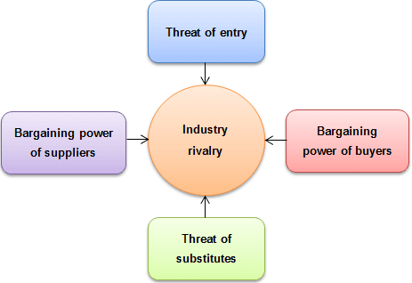
Figure 2: Porter’s Five Forces
(https://strategicmanagementinsight.com/tools/porters-five-forces/)

3.1.2.1 Power of Buyers
Business organisations should realise that buyers serve as crucial stakeholders in any market. High buyers’ bargaining power represents their capacity to demand quality maximising and cost minimisation for services and goods. High buyers’ bargaining power in the automobile industry exposes the Toyota company to immense pressure. Notably, the automobile industry has numerous individual buyers requiring a single car compared to governments and corporations demanding multiple vehicles. Numerous vehicle manufacturers in the industry mean that buyers can select alternative automobile brands easily. Toyota addresses the high buyers’ bargaining power through quality maximisation and cost reduction processes.

3.1.2.2 Power of Suppliers
The power of suppliers represents the pressure suppliers can exert on a company through quality reduction, price increase, and availability reduction. Automobile companies like Toyota experience low suppliers’ bargaining power. Substitute vehicle manufacturing products availability means that Toyota can pressure suppliers to increase materials’ quality and reduce their costs (Nkomo 2019). As a result, the corporation considers that suppliers do not threaten Toyota’s forward integration strategy. The forward integration strategy allows Toyota to improve operational efficiency and lower production costs.

3.1.2.3 Competitive Rivalry
Competition pressure represents the huge need for change to deal with competitors’ activities. For instance, Toyota experiences very strong competitive pressure in the global automobile industry. Various factors increasing competitive pressure in the automobile industry are the high automobile manufacturer population, the industry’s maturity and vastness, huge competitor sizes, and customers’ brand loyalty. Toyota implements cost reduction and quality maximisation tactics in addressing stiff pressure from its competitors (Taneja et al. 2012). The management team understands that failure to address the competition problem can expose the corporation to huge financial losses.

3.1.2.4 Threat of substitutes
The substitute threat represents clients’ capacity to access alternative products for the ones offered by a company. The substitutes’ threat in the automobile industry appears in three major areas, namely green car, public transportation, and alternative car brands. Toyota experiences a weak substitution threat for its products due to competitors’ challenges in matching its products’ convenience and price.

3.1.2.5 New Entrants Threat
New entrants may pose immense competition pressure to existing companies in various industries. However, established companies like Toyota experience weak competition pressure due to huge entry capital requirements and a strong brand image. The huge capital requirement means that small entrants in the automobile industry may experience challenges in accomplishing economies of scale. Furthermore, Toyota relies on high engineering quality and differentiated product design in addressing new entrants’ competition.

3.2 External Environment Analysis: Value Chain Analysis
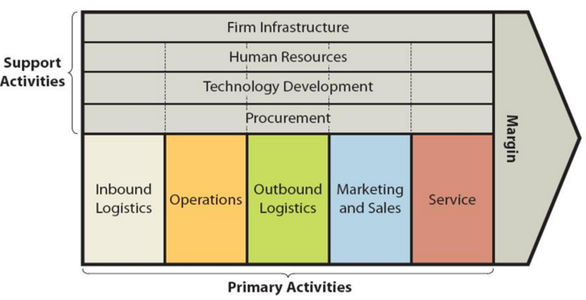
Figure 3: Value Chain Analysis (Dudovski 2016)
The value chain system addresses support and primary activities from an organisation’s internal environment. Primary activities forming Toyota’s internal environment are inbound logistics, operations, outbound logistics, marketing and sales, and service delivery. First, inbound logistics take a central role in the Toyota company’s value chain analysis process. Markedly, the Just-in-Time (JIT) production serves as a crucial element of the corporation’s inbound logistics. The JIT system supports Toyota in optimising supply, reducing inventory costs, and increasing production efficiency. Secondly, Toyota’s operations represent activities like motor vehicles assembly and manufacturing process, final engine tuning, and motor parts configuration (Osono et al. 2008). Toyota Production System (TPS) refers to an operation structure developed by Toyota Corporation by combining JIT and lean production concept. Thirdly, outbound logistics represent the distribution and storage of finished goods to dealers or distributors. Fourth, Toyota uses direct marketing, media advertising, public relations, and sales promotion in popularising its automobile brands. Finally, the corporation offers different services to customers, including repair services, training, maintenance, final checking, and delivery.
Various support activities for the Toyota Motor Corporation are infrastructure, technology, human resource, and procurement. First, the Management Information System refers to a crucial infrastructure that supports Toyota in controlling, organising, and handling its diverse departments. The corporation further utilises robotic systems in increasing production efficiency and speed. Secondly, Toyota recognises the critical role employees play in boosting its competitiveness in the market. As a result, the corporation focuses on strengthening its workforce through continuous development and compensation efforts. Creating training programs allows employees to gain important skills that improve their workplace performance. Third, the corporation relies on its effective procurement strategies in obtaining high-quality raw materials at low costs. Finally, Toyota relies on cutting edge technology in reducing operating costs and increasing product quality. The company collaborates with different organisations in creating technologically advanced automobiles.
The core values that allows Toyota to gain a competitive advantage in the global automobile market are customer orientation, product quality, innovation, globalisation, professional excellence, and teamwork. Today, Toyota experiences intense competition from established corporations like Ford, General Motors, and Volkswagen. Creating effective staff compensation programs allow the corporation to accomplish its innovation and quality maximisation goals. Offering high-quality products at relatively low prices enables the corporation to achieve a competitive advantage in the market (McPhee & Wheeler, 2006). Generally, different strategies that offer the corporation a competitive advantage are low prices, environmental sustainability, and social awareness. The company relies on innovation in generating vehicles with high fuel efficiency and low emission rates. The company further protects its brand image through its social responsibility program, which comprises activities like charities, running awareness campaigns, and ethical business practices.

3.3 SWOT Analysis
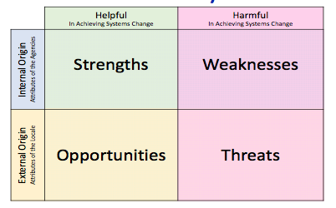
Figure 4: SWOT Analysis
https://ohioemploymentfirst.org/view.php?nav_id=405
The SWOT explores weaknesses, threats, and opportunities that the Toyota Motor Corporation should handle through its strengths. Various strengths (internal factors) possessed by Toyota are brand recognition, focus on R&D, strong market position, and strong supply chain. The corporation relies on its strong brands in dominating automobile markets in Oceania, Africa, North America, Asia, and Europe. Focusing on R&D enables Toyota to improve product functionality, safety, and quality. The R&D effort has allowed Toyota to create environmentally sustainable products. Maintaining extensive distribution and production network enables the corporation to address the huge demand for its products internationally (Nkomo 2019). However, the corporation has weaknesses (internal factors) like product recalls, organisational culture secrecy, and hierarchical organisational structure. The product recall problem has tainted the company’s brand image while hierarchical management structures inhibit its performance in Western nations, which emphasise the adoption of teamwork-based and flat management structures.
Threats and opportunities exist as external strategic factors for the Toyota Motor Corporation. Various threats Toyota faces in the market are intense competition, natural disasters, and unfavourable foreign exchange rates. The corporation relies on excellent customer service, fuel economy, product safety, development and innovation, and pricing in addressing competition pressure. The company is also highly sensitive to foreign currency exchange fluctuation (Jurevicius 2013). The weakening Yen against the Euro and the US dollar has negatively affected the corporation’s global operation. The company further experiences huge disruptions from natural disasters like floods and earthquakes. Still, the corporation can exploit existing opportunities in the global automobile market, including the expanding automotive industry and partnerships. The moderately growing automobile market since 2008 offers Toyota an opportunity for boosting its profitability and competitiveness.

4.0 Conclusion
SWOT, Porter’s Five Forces, PESTLE, and Value Chain analyses offer crucial details about Toyota Motor Corporation’s internal and external environment. Porter’s Five Forces explores the corporation micro-environmental forces like the power of buyers, competitive rivalry, the threat of substitutes, new entrants threat, and power of suppliers. The PESTLE analysis explores the corporation’s macro-environmental forces, including legal, social, political, economic, technological, and ecological. The Value Chain Analysis explores the internal environment, while the SWOT analysis explores the corporation’s opportunities, strengths, weaknesses, and threats.

5.0 Bibliography
Carlier, M., 2021. Consolidated number of Toyota Motor Corporation employees from FY 2012
to FY 2021. Statista. https://www.statista.com/statistics/294192/number-of-toyota-employees/
Carlier, M., 2021. Toyota's market capitalization between March 31, 2019 and 2021. Statista.
https://www.statista.com/statistics/279650/market-capitalization-of-toyota/
Çitilci, T. and Akbalık, M., 2020. The Importance of PESTEL Analysis for Environmental
Scanning Process. In Handbook of Research on Decision-Making Techniques in Financial Marketing (pp. 336-357). IGI Global.
Craig, T. and Campbell, D., 2012. Organisations and the business environment. Abingdon:
Routledge.
Ewing, S., 2019. 2020 Toyota Prius: Model overview, pricing, tech and specs. Road Show.
https://www.cnet.com/roadshow/news/2020-toyota-prius-buyers-guide-price-specs/
Halbright, R. and Dunn, M., 2010. Case Study: The Toyota Prius. Managerial Marketing.
Jurevicius, O., 2013. Toyota Motor Corporation SWOT analysis. Strategic Management Insight,
16.
Nkomo, T., 2019. Analysis of Toyota Motor Corporation.
http://dspace.vnbrims.org:13000/jspui/bitstream/123456789/2458/1/Toyota%20Case%20study.pdf
McPhee, W. and Wheeler, D., 2006. Making the case for the added‐value chain. Strategy &
Leadership.
Osono, E., Shimizu, N. and Takeuchi, H., 2008. Extreme Toyota: Radical contradictions that
drive success at the world's best manufacturer. Hoboken: John Wiley & Sons.
Simão, L. and Lisboa, A., 2017. Green marketing and green brand–The Toyota Case. Procedia
manufacturing, 12, pp.183-194.
Taneja, S., Pryor, M.G. and Sewell, S.M., 2012. Toyota recalls: A strategic leadership
perspective. International Journal of Business and Public Administration, 9(2), pp.125-141.
Tan, J.H., Chua, W.L., Chow, C.K., Chong, M.C. and Chew, B.C., 2012. PESTLE Analysis on
Toyota Hybrid Vehicles. In Proceedings of the International Conference on Technology Management and Technopreneurship.

