Name: Paul Richards

Student No: 0251968

Course: Applied Computer Networks and Cybersecurity

Module: Network Operating Systems and Services
(ACCA5023)

Date:30/04/2021

Contents

Introduction 3

Task 1: Understanding NTFS and Share Permissions. 4
NTFS 4
Share Permissions 15

Task 2: Utilising Group Policy Management Console to better facilitate network object management 28
GP0 1: Moderating Access to the Control Panel 28
GPO 2 : Removing Access to the Command Prompt 41
GPO3: Restricting Access to Removable Media Drives 47
GPO 4: Restricting Software Installs 54
GPO 5: Enforcing Password Policy in the ‘nwtraders.msft’ domain 64

Task 3:Observational Task 74
3 a) Difference between local permissions and file shares. 74
3 b) Role of Group Policy 77
3 c) Examples of Password Policies 79

Introduction

The worksheet covers the following:

- Modifying NTFS and Share Permissions.

- Creating shares and mapping a network drive.

- Creating Group Policies and applying them to an OU (Organisational Unit) to restrict user access.

- Modifying the Password Policy for users.

- The difference between Local and Network Permissions.

- The Role of Group Policy.

- Examples of good password policies.

Task 1: Understanding NTFS and Share Permissions.

NTFS

Step 1: Logged into Client1 or WS1-NWT using the NWTRADERS\administrator user account
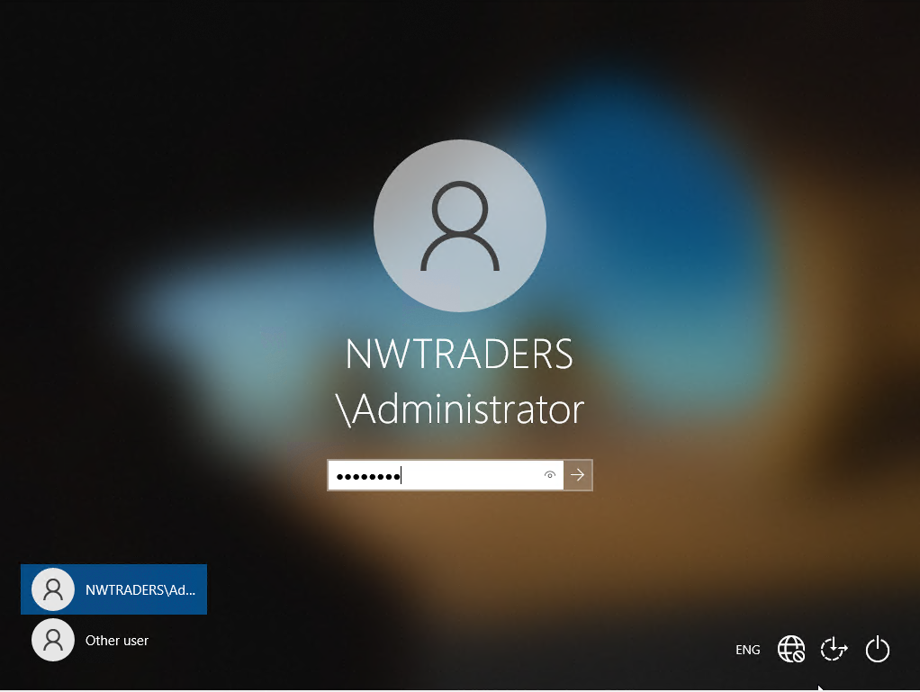

Step 2 : In the search box, search for My PC and click on search result.
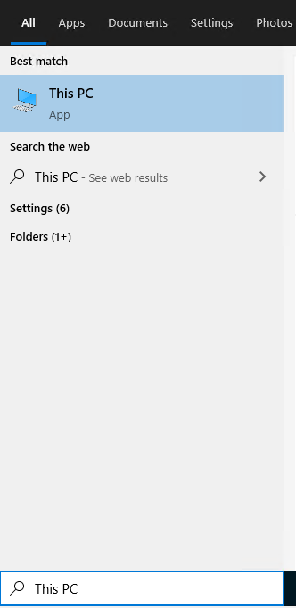
Step 3: Under My PC and in the Local Disk (C:), create a new folder by right clicking on empty space on the C drive and selecting new and folder.
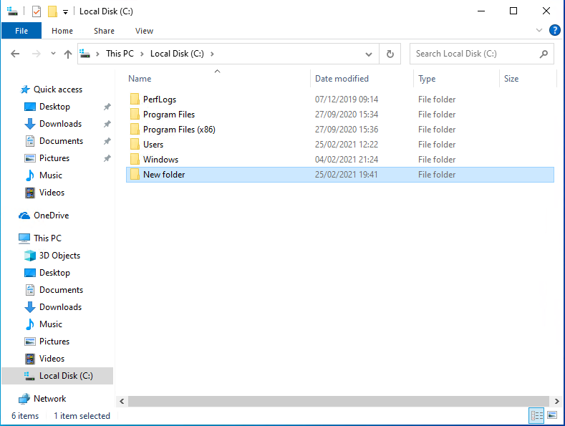

Step 4: Rename the folder to ‘Dept_Important_Docs’ by right clicking on the folder and selecting rename.
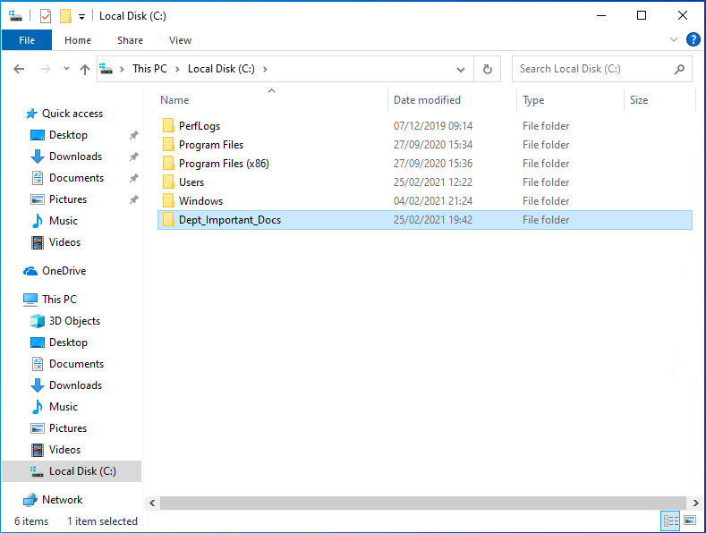

Step 5: Opened up the ‘Dept_Important_Docs’, and created a new file by right clicking on blank white space and selecting new and file.
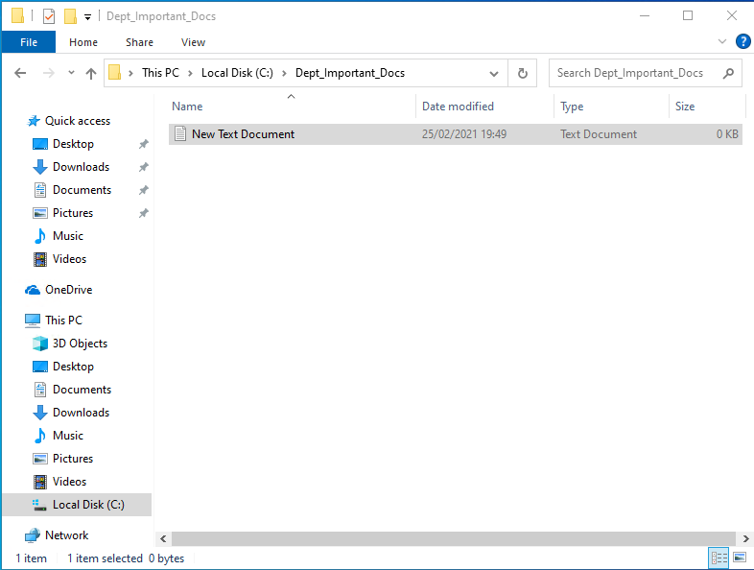

Step 6: Rename the file to ‘Important File’, by right clicking on the file and selecting rename.
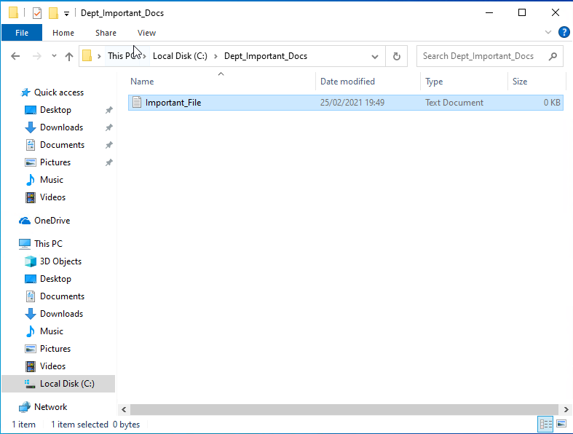
Step 7: After renaming the file in the ‘New_Important_Docs’ folder, navigated back to the C drive to change the security permissions by right click on the ‘New_Important_Docs’ and selecting properties and security.
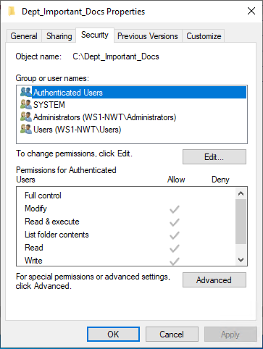

Step 8: Tried removing the Authenticated Users group, clicked on edit button. On the permissions screen, selected the Authenticated Users group and clicked on the remove button.
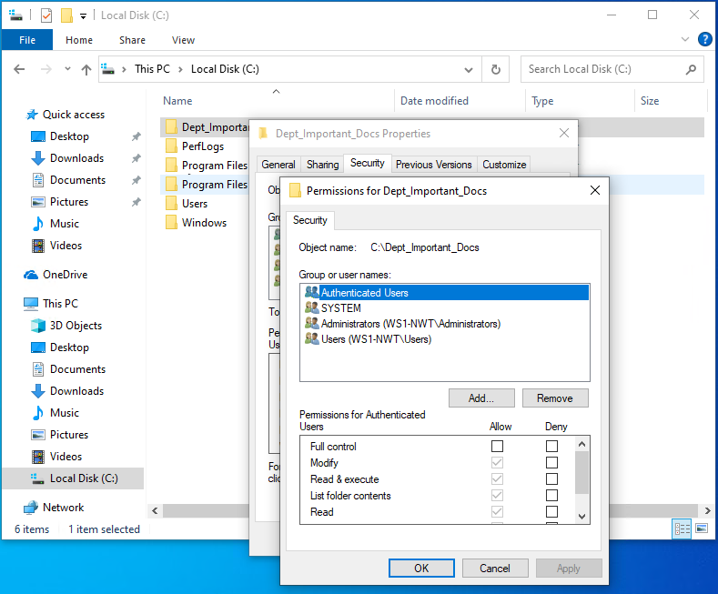
Step 9: Got a windows security error that I could not remove the Authenticated users group, because of inherited permissions.
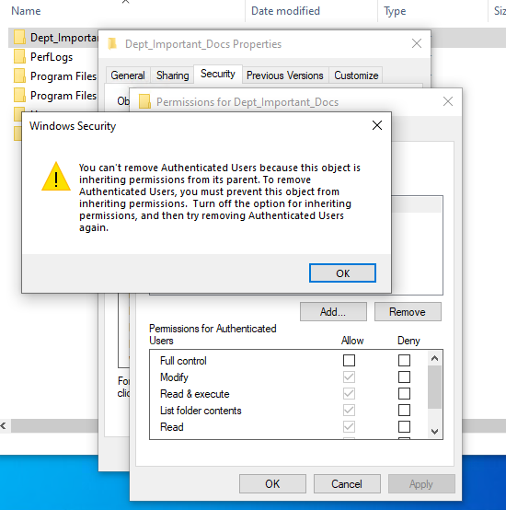

Step 10: To overcome this error, clicked ok and cancel on the permissions screen. Clicked on the advanced button. In the advanced security settings screen for the ‘Dept_Important_Docs’, selected the authenticated users group and clicked the remove button.
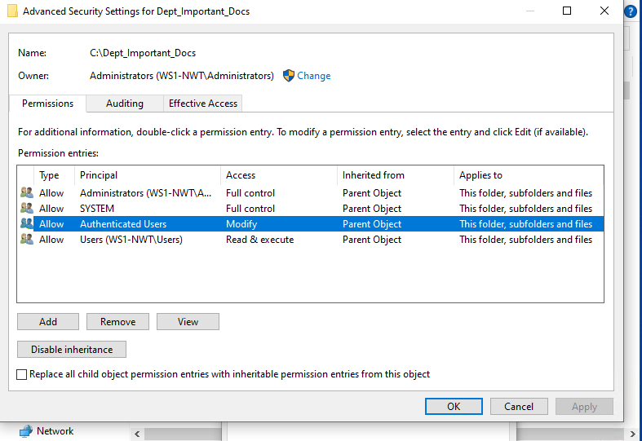
Step 11: When trying to remove the user groups from the ‘Dept_Important_Docs’ folder, I got a windows security error, indicating that I cannot remove authenticated users because of inherit permissions, and to disable inherit permission if I wish to remove the authenticated users. Click ok to close the error message.
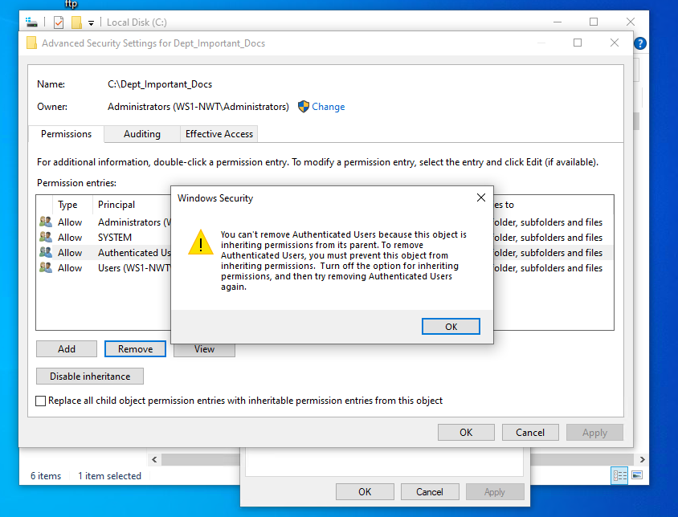

Step 12: Click on the disable inheritance button, a block inheritance screen pop up which presents me with two options. Selected the second option to remove all inherited permissions from this object.
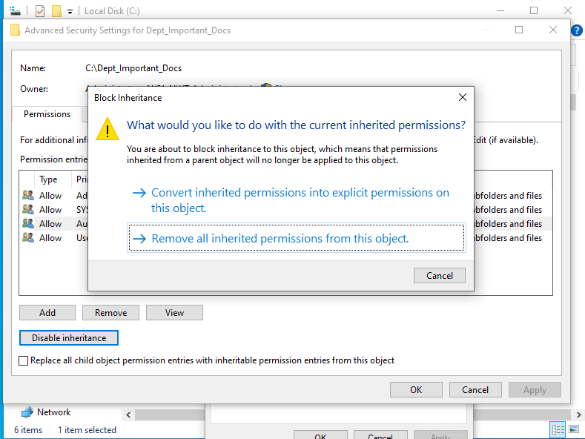
Step 13: After removing all inherited permissions, all user groups in Advanced Security Setting for ‘Dept_Important_Docs’ were removed.
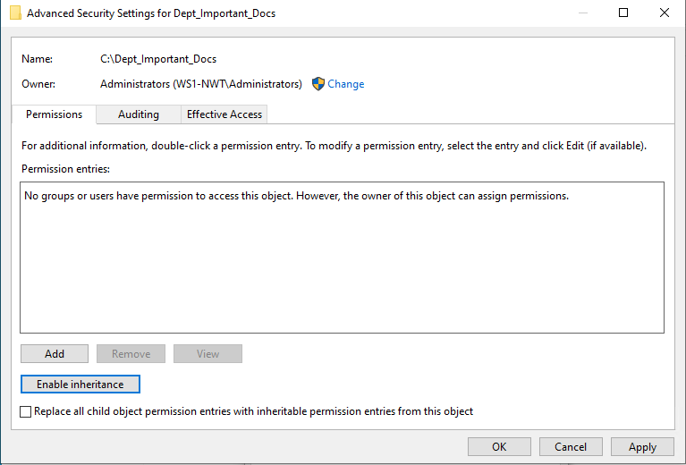

Step 14: Clicked on apply to confirm changes. A Windows Security warning that all users have been denied access to the folder ‘Dept_Important_Docs’ and did I wish to continue with the changes. Clicked on yes to confirm and continue with changes, then clicked ok to exit the advanced security settings screen.
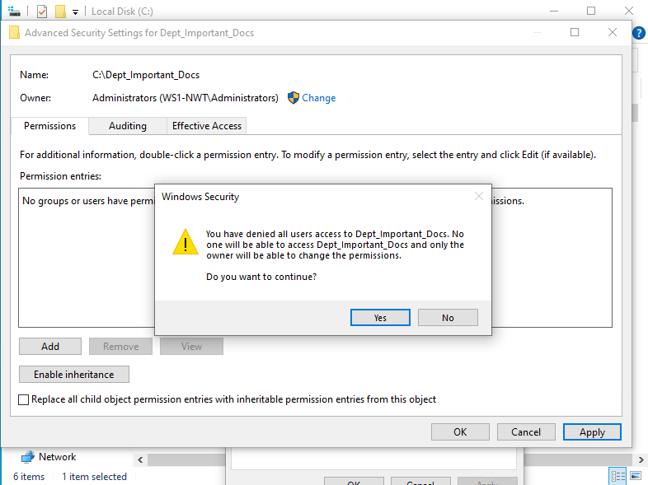

Step 15: To grant another user access to the ‘Dept_Important_Docs’ folders, clicked on Edit and added. In the select users, computers, services accounts and groups screen, entered the nwtraders\administrator user account, clicked check names and ok to add the user group to the permission screen.
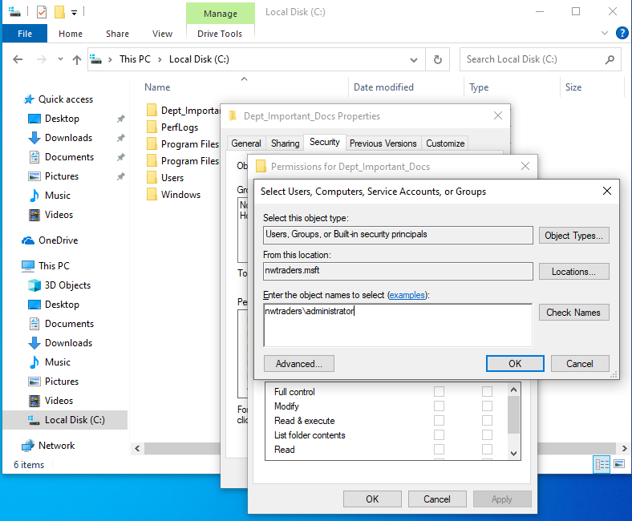

Step 16: In the permission screen, increase the nwtraders\administrator user account permissions by clicking on allow full control, then apply. By default, the nwtraders\administrators user account was only granted read and execute, list folder contents, and read permission.
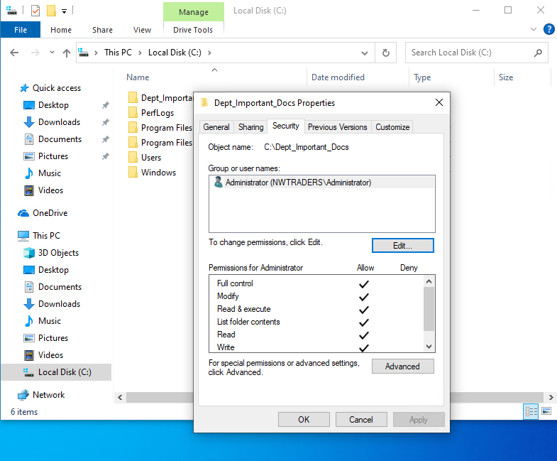
Step 17: To check that ‘Important_File’ has inherited the permissions granted to the nwtraders\administrator user account. Clicked ok to exit the properties of the ‘Dept_Important_Docs’ Properties screen. Open up the ‘Dept_Important_Docs’ folder and right clicked on the ‘Important_File’. Clicked on properties and security tab and could see that the nwtraders\administrator account had full access to the ‘Important_File’. Once finished, exit all screens and return to the C drive.
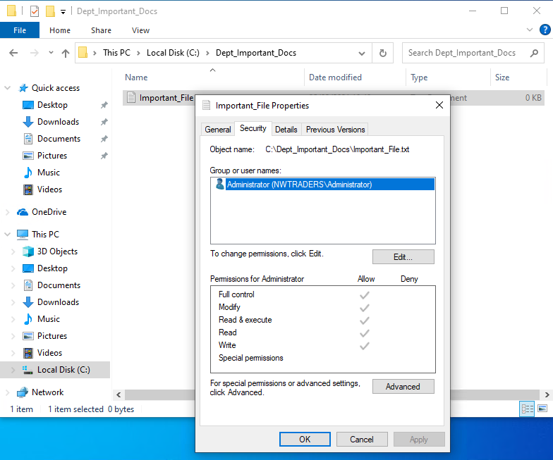

Step 18: Added another user to the ‘Dept_Important_Docs’ folder by right clicking on the ‘Dept_Important_Docs’ folder, selecting properties, security, edit and add. In the select users, computers, services accounts and groups screen, entered Kelly Meloni, clicked on check name and ok to add the user to the permission screen. Left the user with the default permissions of read and execute, list folder contents and read. Click on apply and ok to commit changes. Then on ok on the security tab screen to exit the ‘Dept_Important_Docs’ properties screen.
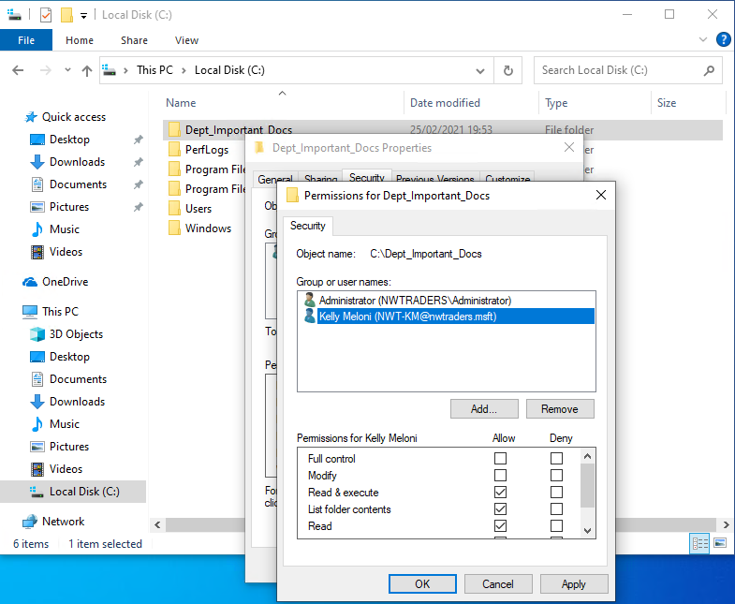
Step 19: Did a simply test to see if I could save changes to the ‘Important_File’, using the nwtraders\administrator user account by opening the file and saving the text ‘Test’, which saved successfully.
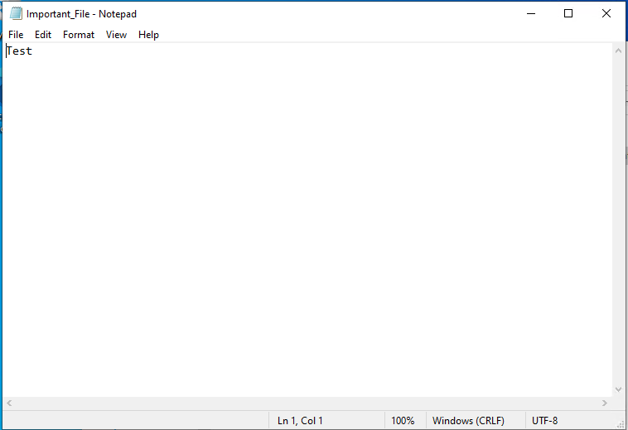

Step 20: Logged out Client 1 and logged back into client 1 as NWT-KM or Kelly Meloni.
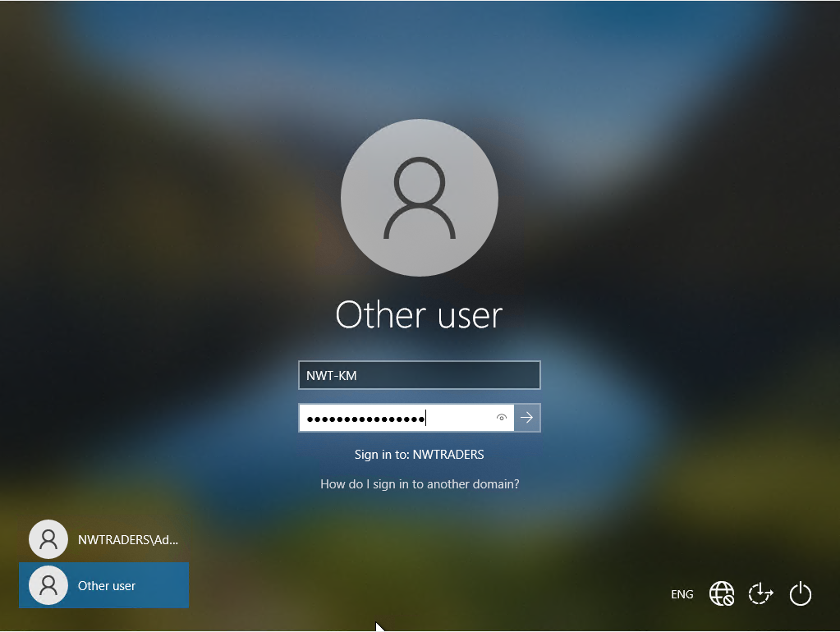
Step 21: Navigated to the ‘Important_File’ and tried saving the text ‘Hello’. Got an error stating that I do not have permissions to save to the file.
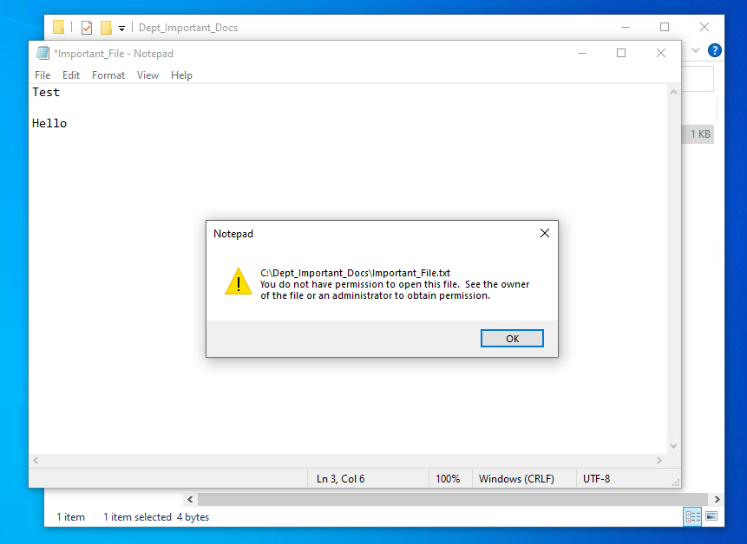

Share Permissions

Step 1: Logged into Server 1, as nwtraders\administrator.
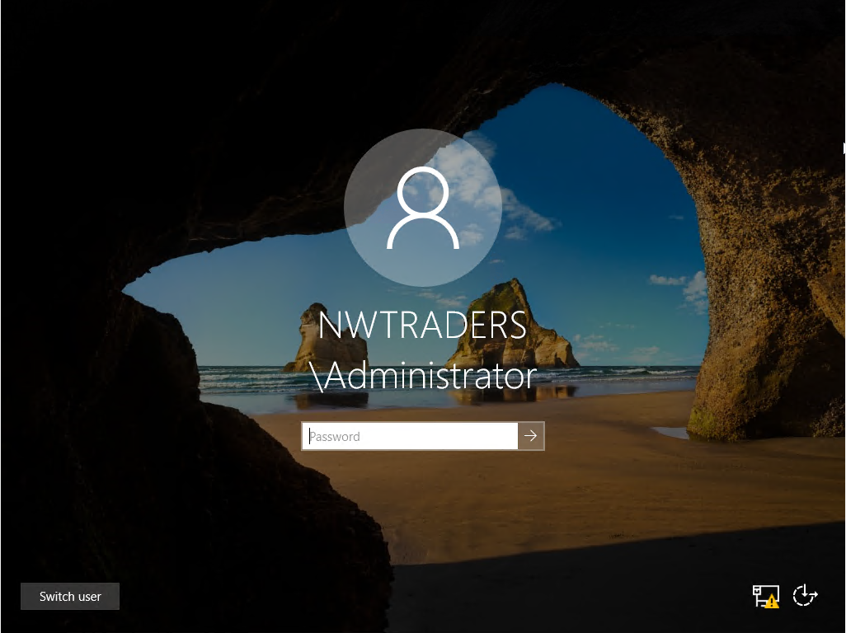

Step 2: In the search box, entered server manager and click on the result of the search.

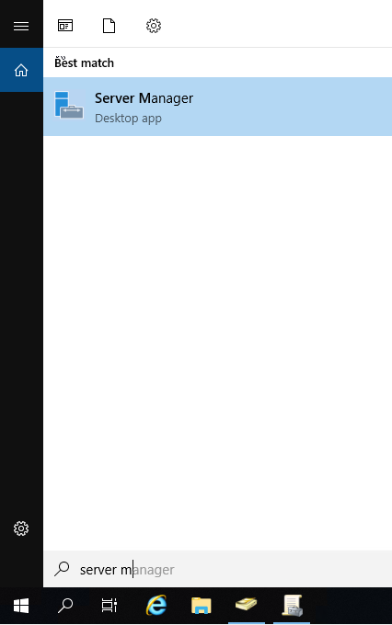
Step 3:Opened up Server Manager, clicked on file and storage services.
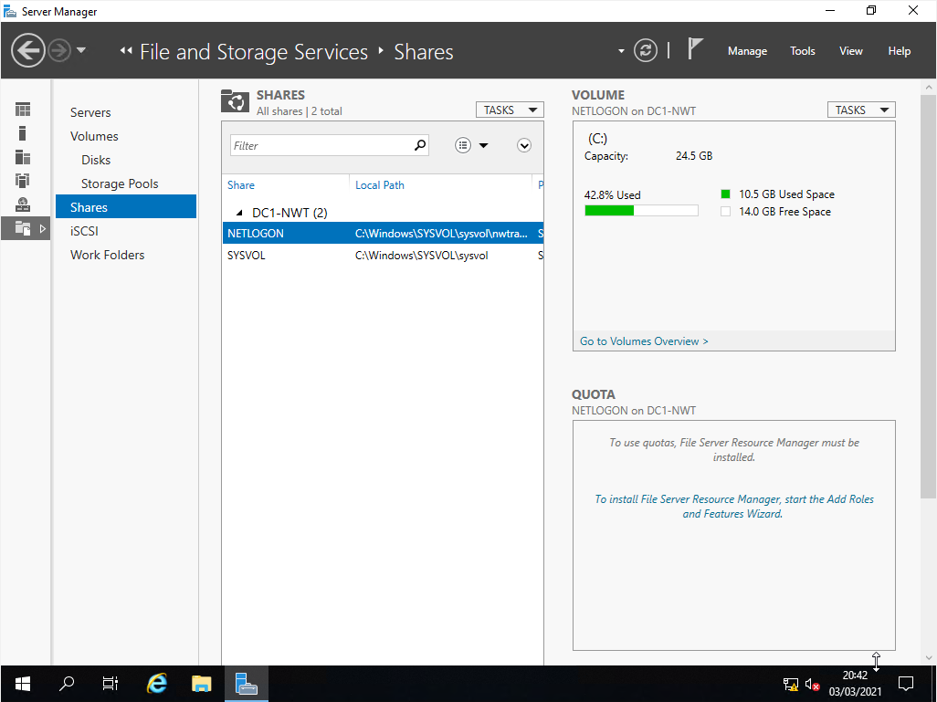

Step 4: Clicked on tasks next to shares, selected ‘New share’.
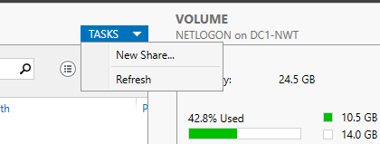

Step 5: On the select profile screen in the new share wizard, select ‘SMB Share – Quick’ and click next.
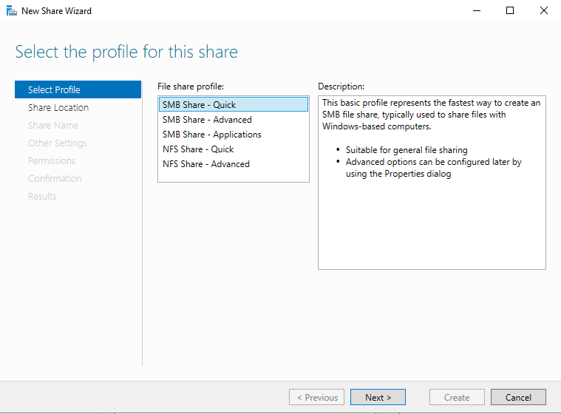

Step 6: In the share location screen, select the C: drive under select by volume and click on next.
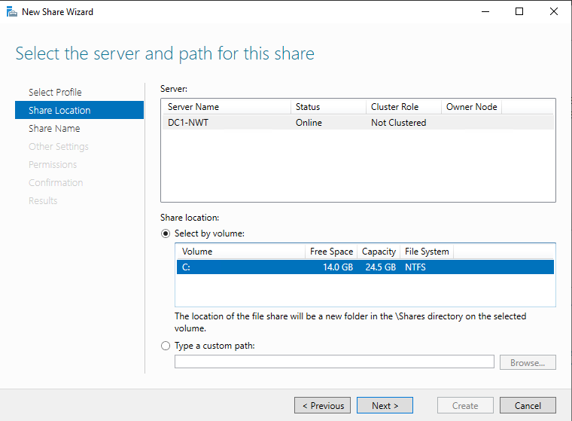
Step 7: In the share name screen, named the share DeptNetShare$. Left the local share as c:\shares\DeptNetShare$ and the remote path to share as \\DC1-NWT\DeptNetShare$. Clicked next.
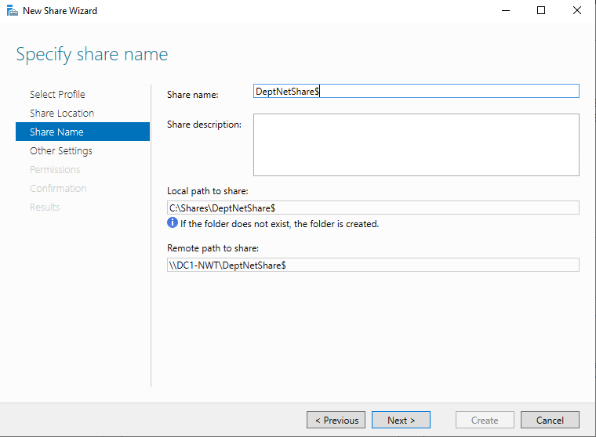

Step 8: In the other settings screen, select enable access-based enumeration and allow caching of share, and then clicked next.
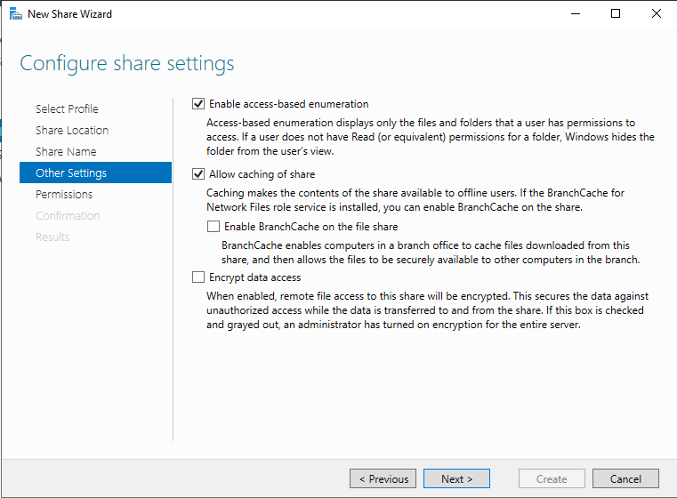
Step 9: In the Permissions screen, click on customize permissions.
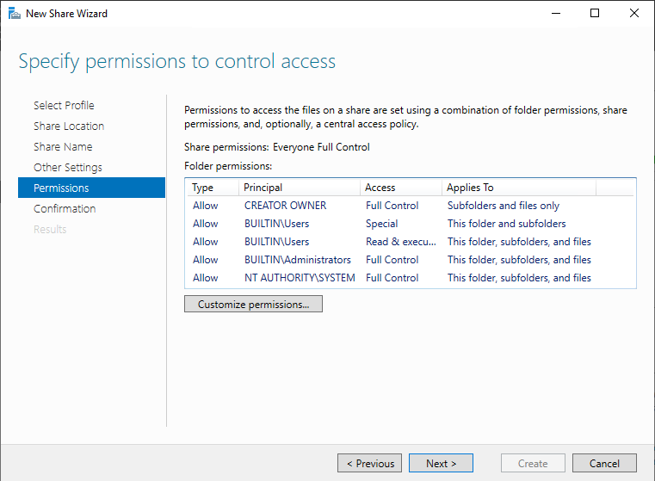

Step 10: In the advanced security settings screen, click on add.
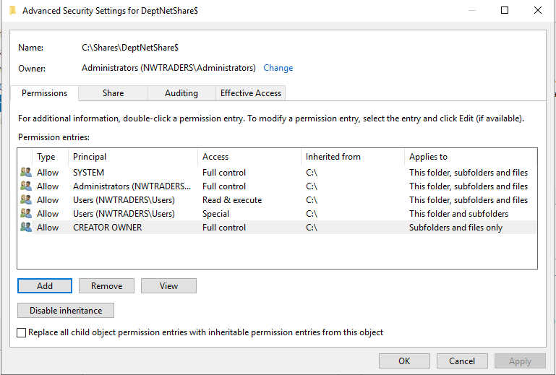
Step 11 In the permission screen, click on ‘Select a Principal’.

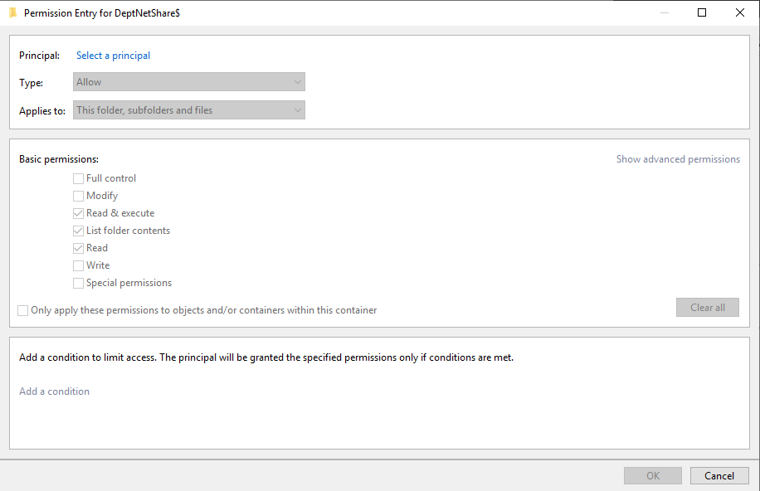

Step 12: Entered the user name Kelly Meloni, clicked the check name button and ok.

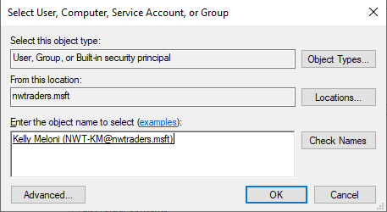

Step 13: Left Kelly’s user account on the default permission, read and execute, list folder contents and read. Clicked ok to confirm changes.
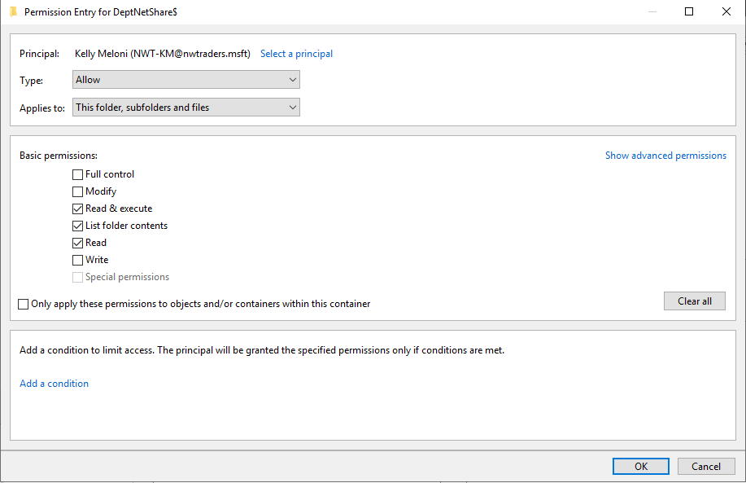

Step 14: Clicked add again to add another user and click on ‘Select a Principal’.

Step 15:Entered the user name Paul Richards, clicked on check names and ok to add user.
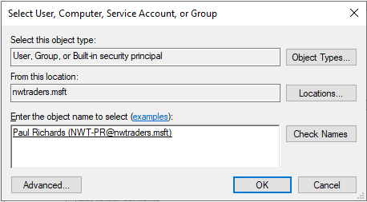

Step 16: Increased the user Paul Richards’ permissions, by granting them full control. Clicked ok.
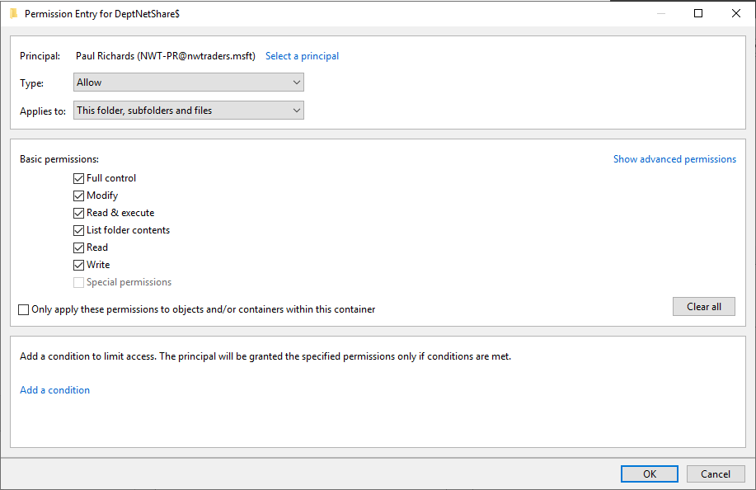

Step 17: In the advanced security screen, click on apply and then ok to confirm changes.
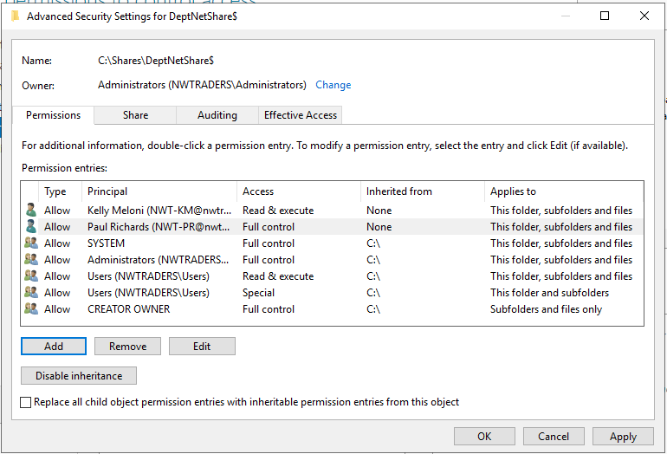

Step 18: On the permission screen, click on next.
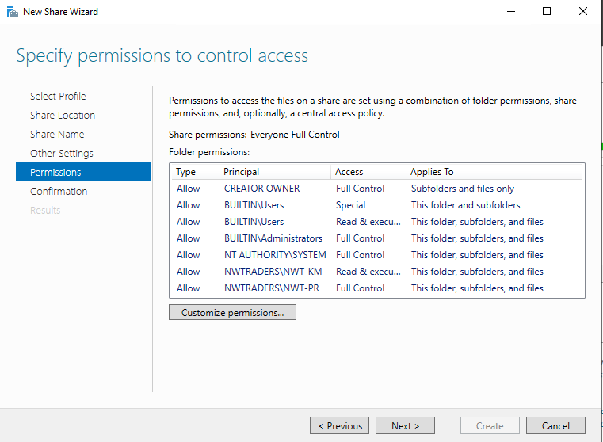
Step 19: On the confirmation screen, click on create.
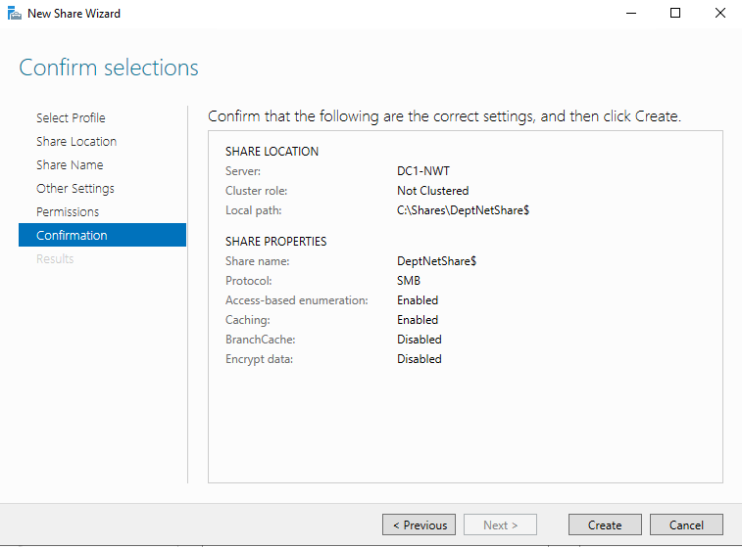

Step 20: Once the share had been created, click close.
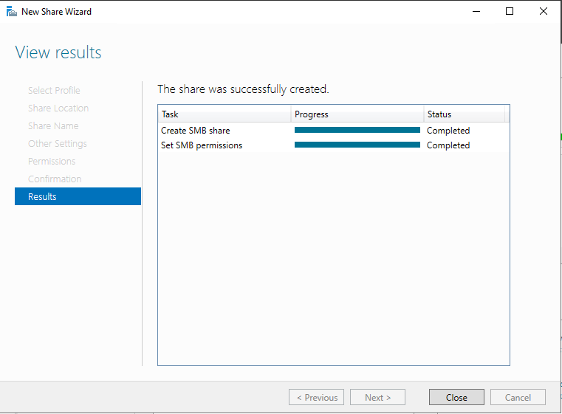
Step 21: Logged into client 1 as Paul Richards
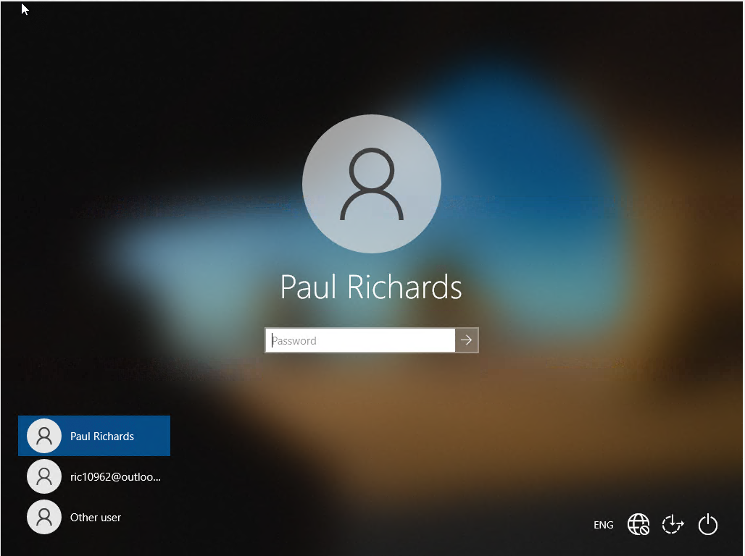

Step 22: In the search box, enter ‘This PC’
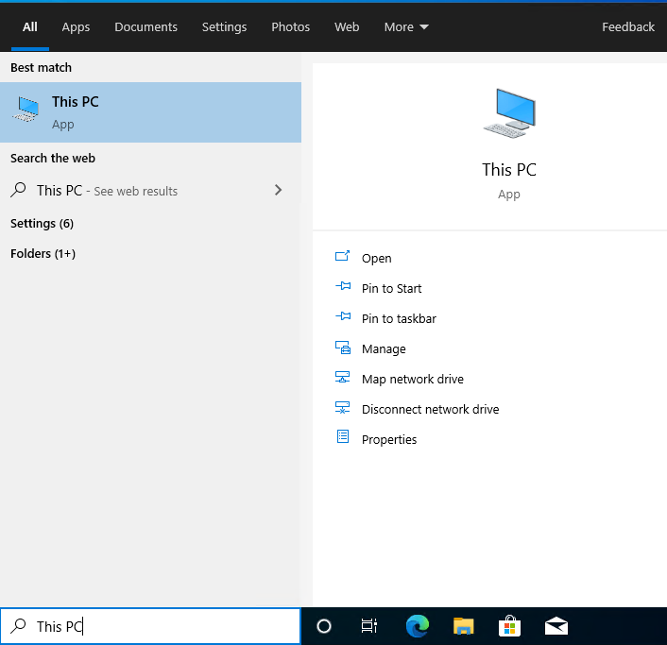
Step 23: Right click on ‘This PC’ and select ‘Map network drive’.
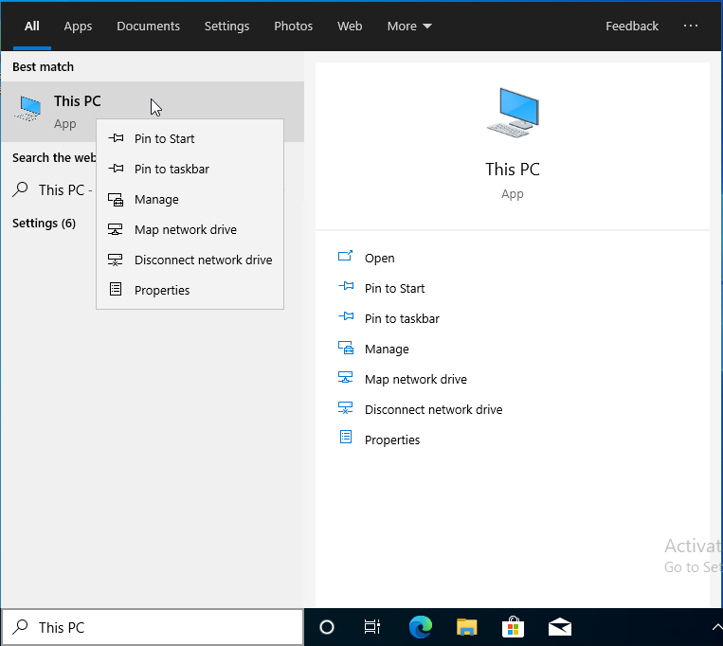

Step 24: In the ‘Map network drive’ screen, left the drive on z, enter the UNC path \\DC1-NWT\DeptNetShare$. Left the reconnect options checked and clicked finish.
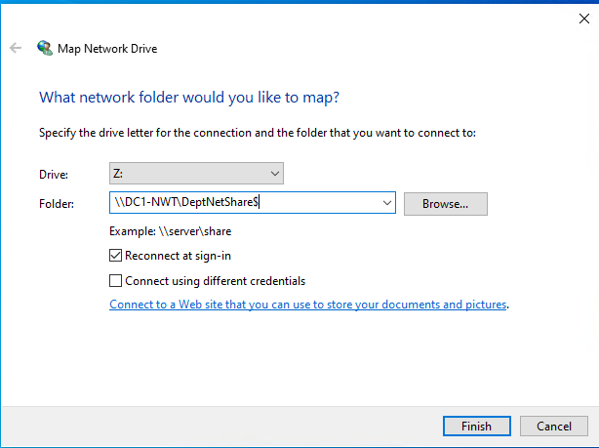

Step 25: The network share appeared in file explorer on client 1.
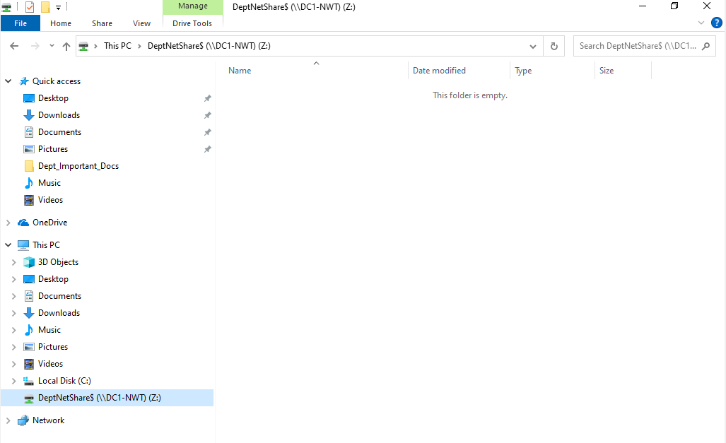

Task 2: Utilising Group Policy Management Console to better facilitate network object management

GP0 1: Moderating Access to the Control Panel

Step1: Logged into Server 1 as nwtraders\administrator.

Step 2: Did a search for active directory users and computers. Clicked on the search result.
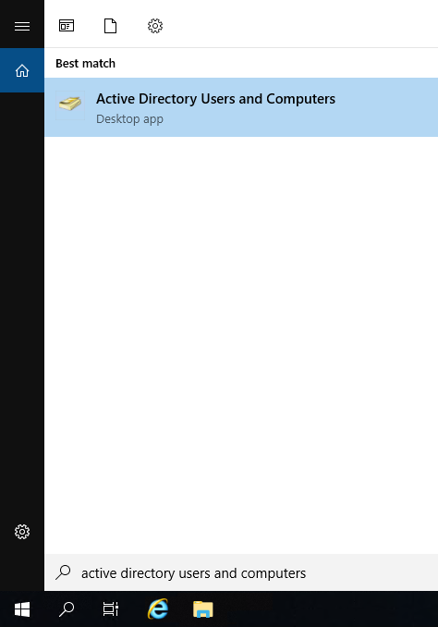

Step 3: Open up ‘Active Directory User and Computers’. Created a new Organisational Unit (OU), by right clicking on the nwtraders.msft domain and selecting ‘New’ and ‘Organisational Unit’.
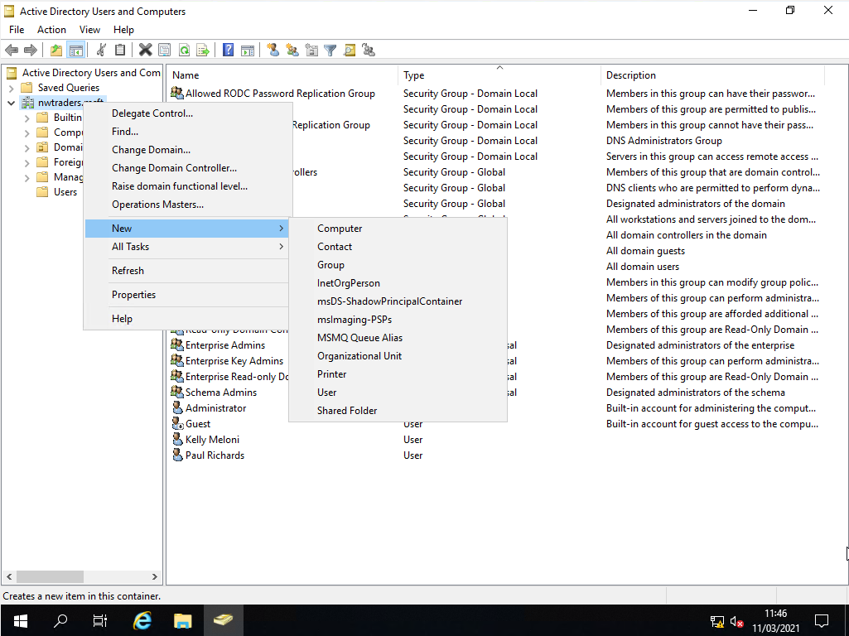

Step 4: In the new object wizard, called the OU Non Admin Users. Click on ok to confirm the changes.
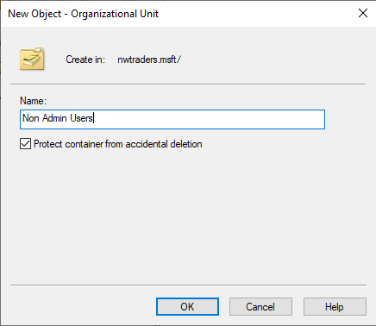

Step 5: Created a new user in the Non-Admins Users OU, by right clicking on the OU, selecting new and user.
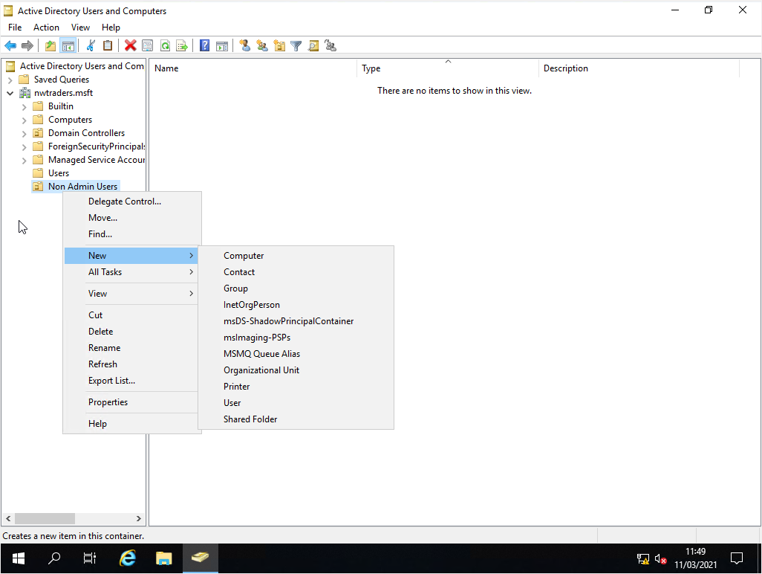

Step 6: Name the user Howell Rees and set the user id to NWT-HR. Clicked next.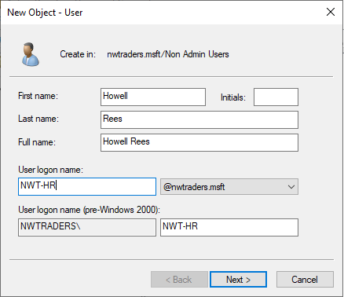

Step 7: Set a password for the user, and leave it on the default option user must change password at next logon. Clicked next.
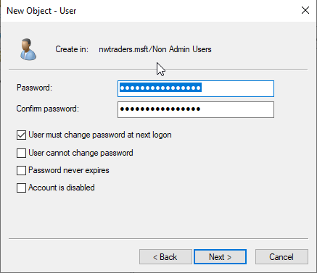

Step 8: Click on ‘Finish’ to complete the user account creation process.
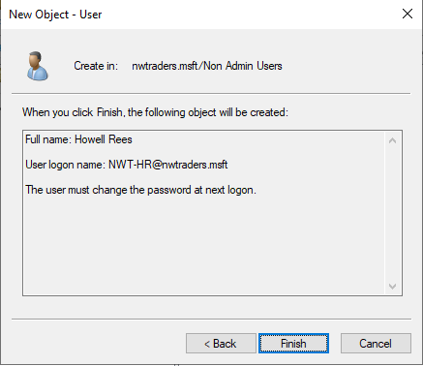
Step 9: Right clicked on the user account and selected ‘Properties’.
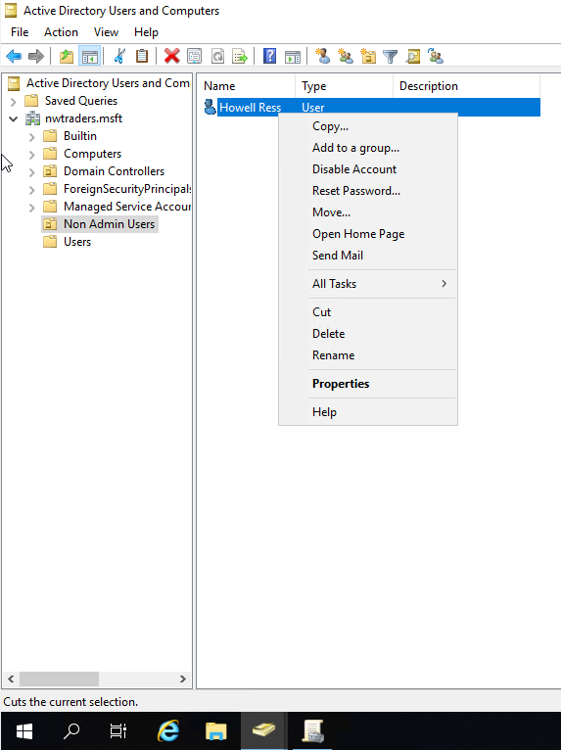

Step 10: Clicked on ‘Account’ tab and ‘Logon Hours’, to alter the logon hours to match the previous non domain user account NWT-KM.
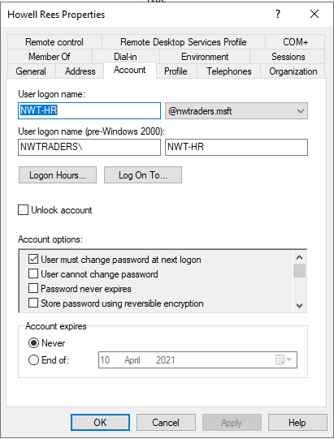
Step 11: Clicked the ‘Logon Denied’ radio button, and specified that the user cannot log into the domain between 1 to 2 pm from Monday to Friday. Clicked ‘Ok’ to confirm changes.

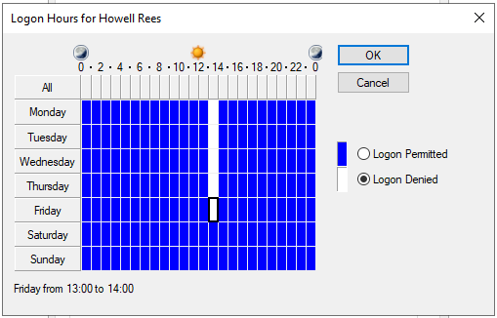

Step 12: Change the option to user must change password at next logon to user cannot change password. Clicked on ‘Apply’ and ‘Ok’ to complete changes.
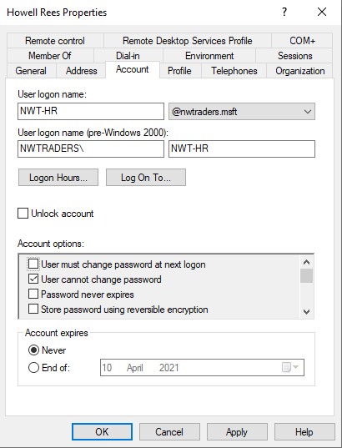

Step 13: Right clicked on the ‘Domain users’ account and selected ‘Properties’.

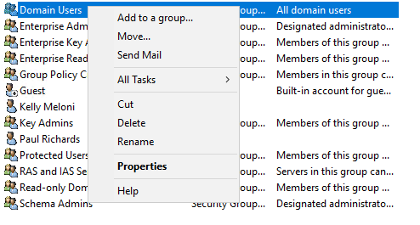

Step 14: Clicked on the ‘Members’ tab, to ensure that the new user Howell Rees had been added to the domain group.
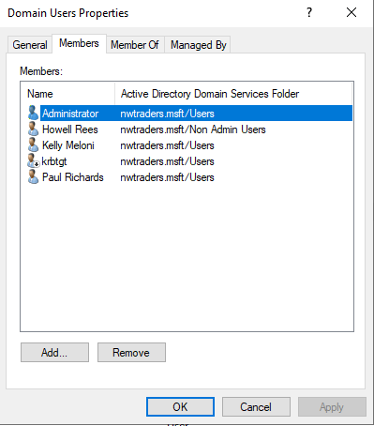
Step 15: In the search box, enter Group Policy Management and click on the search result.
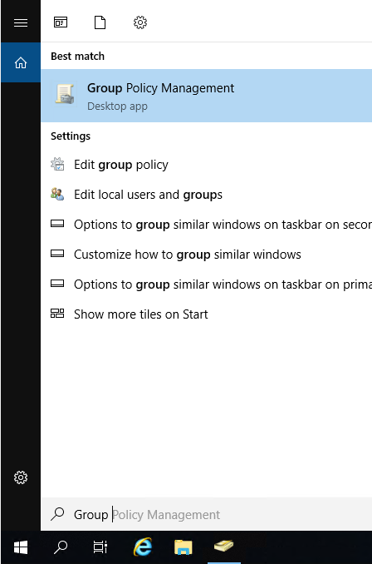

Step 16: In ‘Group Policy Management’, applied a new group policy to Non-Admin User OU. In group policy management, expanded Forest: nwtraders.msft, domain and nwtraders.msft. Right clicked on ‘Non Admin OU’ and selected ‘Create a new GPO in this domain and link it here’.
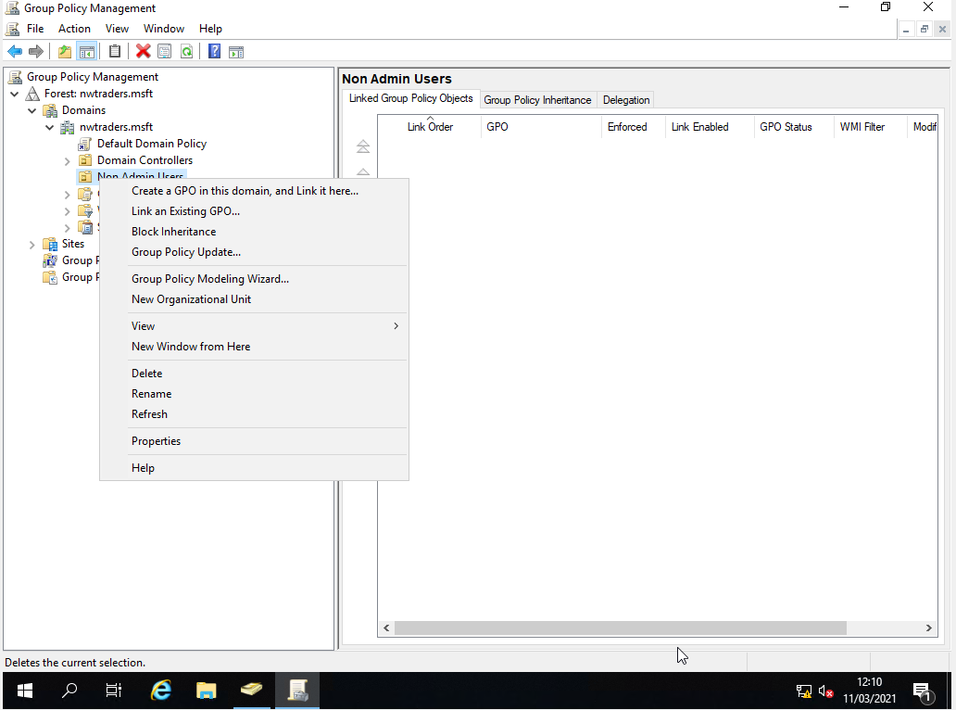
Step 17: Named the New GPO (Group Policy Object) NoCtrlPanAccess and clicked ok.

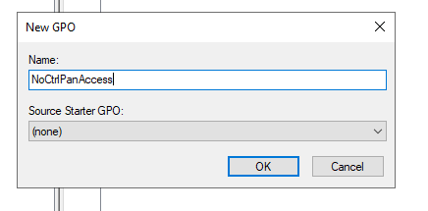

Step 18: Opened up the properties of the GPO. Right click on the ‘NoCtrlPanAccess’, and selected ‘Edit’.
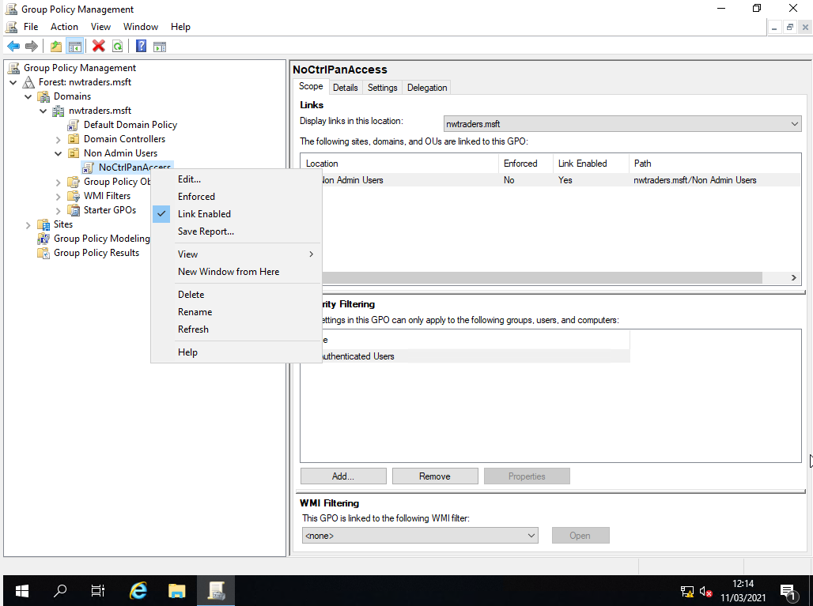

Step 19: Expanding user configuration, policies, administrative templates.
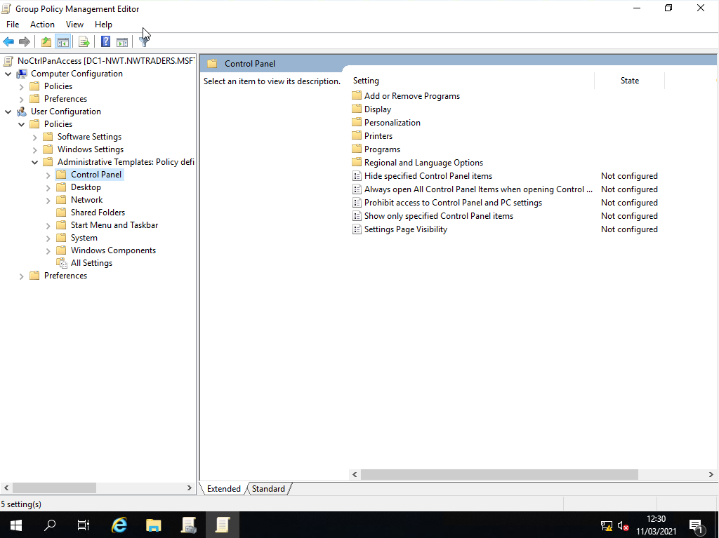

Step 20: Double clicked on ‘Prohibit access to control panel and PC settings’ option. Enabled the group policy setting. Clicked on apply and ok to commit change.
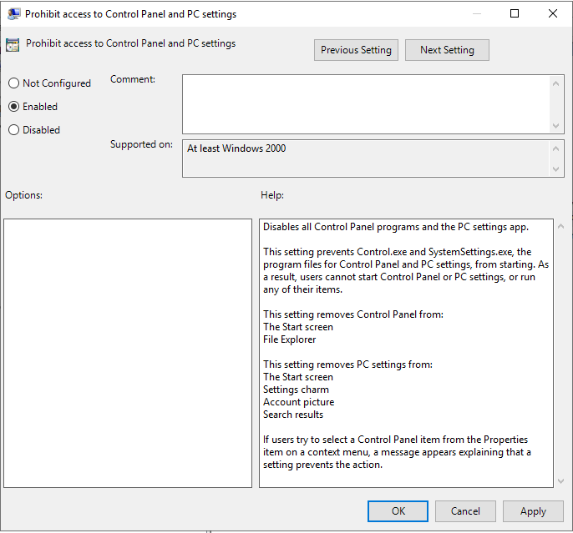
Step 21: On the Group Policy Editor screen, could see that ‘Prohibit access to control panel and PC settings’ was enabled.
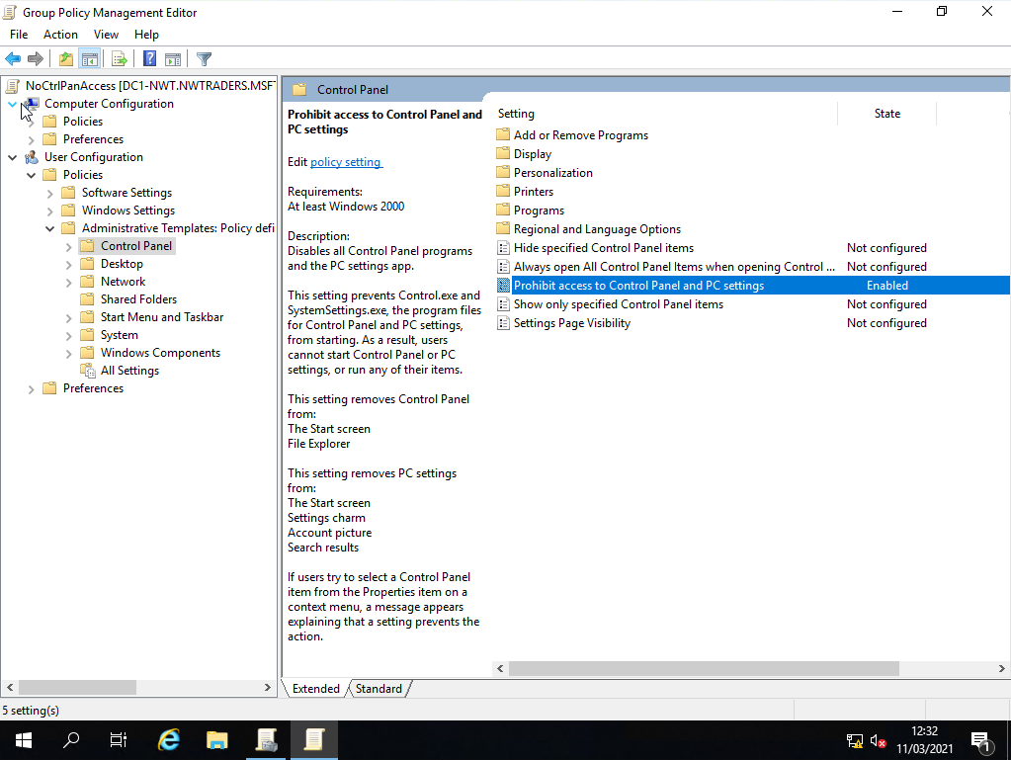

Step 22: Closed group policy management. Did a search for command prompt, right clicked on the search result and selected run as administrator.
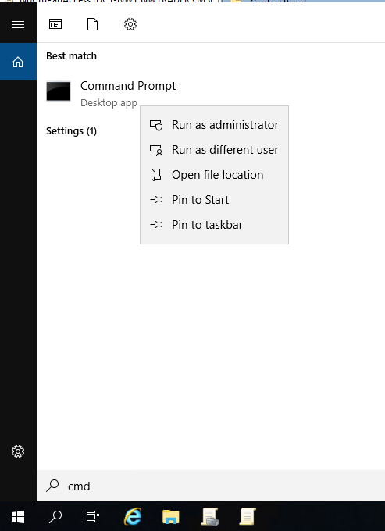

Step 23: Opened up command prompt and entered the command gpupdate /force to apply the group policy on the domain.
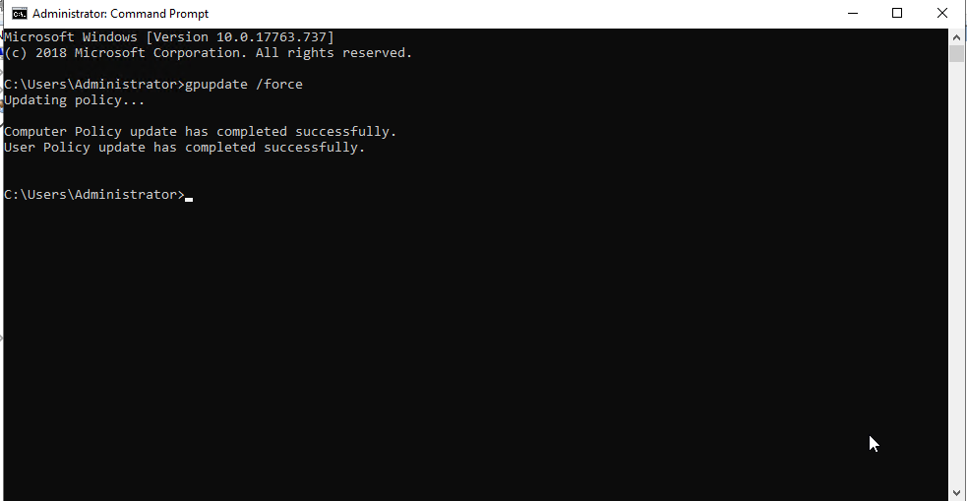

Step 24: Logged into client 1 using the new user account, NWT-HR.
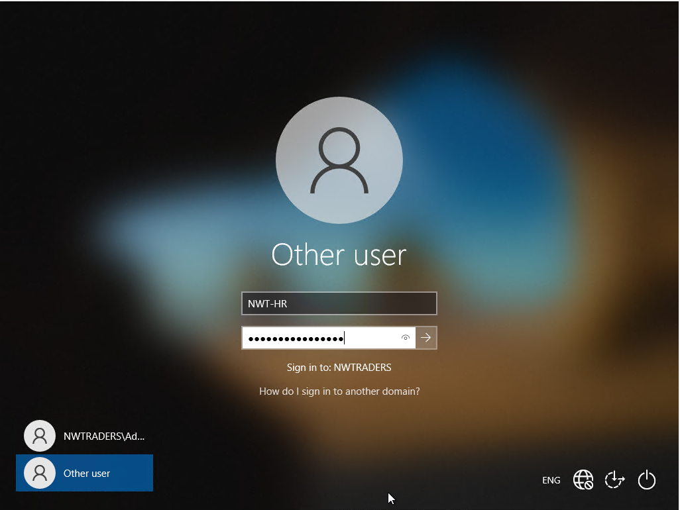

Step 25: Searched for control panel. Clicked on the search result.
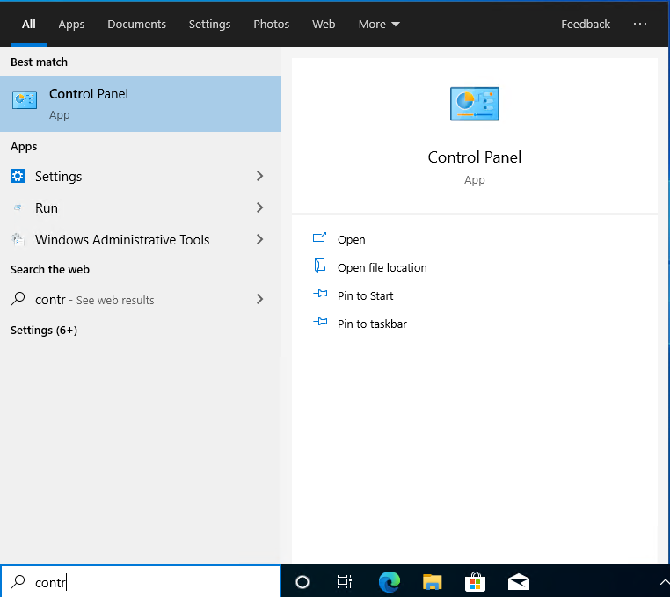

Step 26: Got an error message stating that “This operation has been cancelled due to restrictions in effect on this computer. Please contact your system administrator”. Clicked ok to close the message.

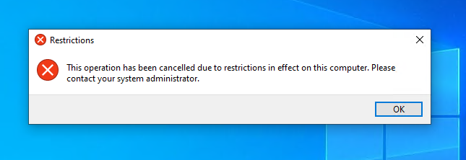

GPO 2 : Removing Access to the Command Prompt

Step 1: Opened up group policy management on Server 1. Right click on Non Admin Users OU, selected create a GPO in this domain, and link it here..
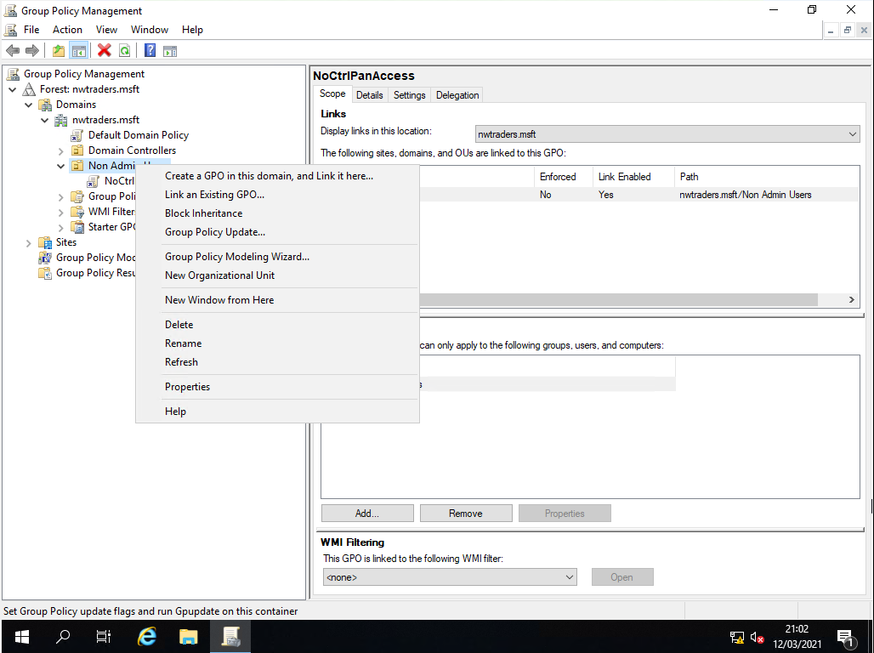

Step 2: Named the New GPO (Group Policy Object) NoCmdPrmptAccess and clicked ok.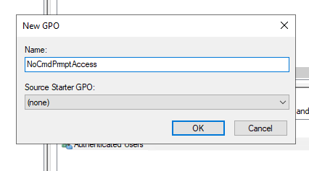

Step 3: Open up the properties of the GPO. Right click on the NoCmdPrmptAccess, and select edit.
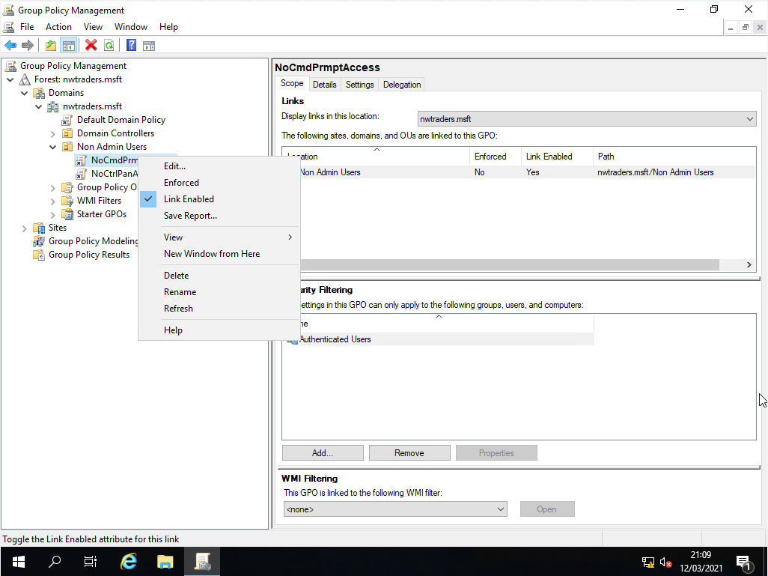

Step 4: Expanded user configuration, policies, administrative templates and system.
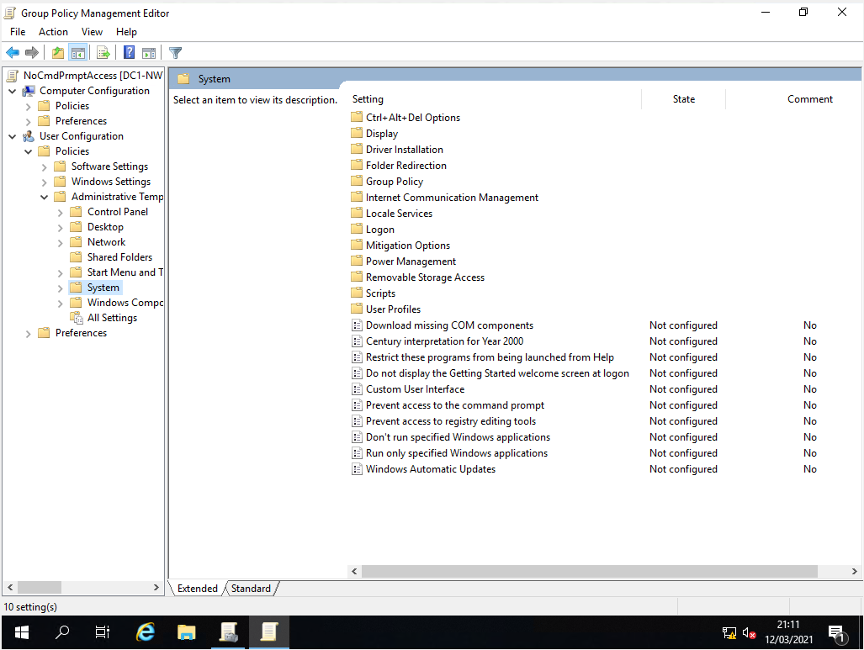
Step 5: Double clicked on the ‘Prevent access to the command prompt’ setting. Enabled the group policy setting. Clicked on apply and ok to commit change.
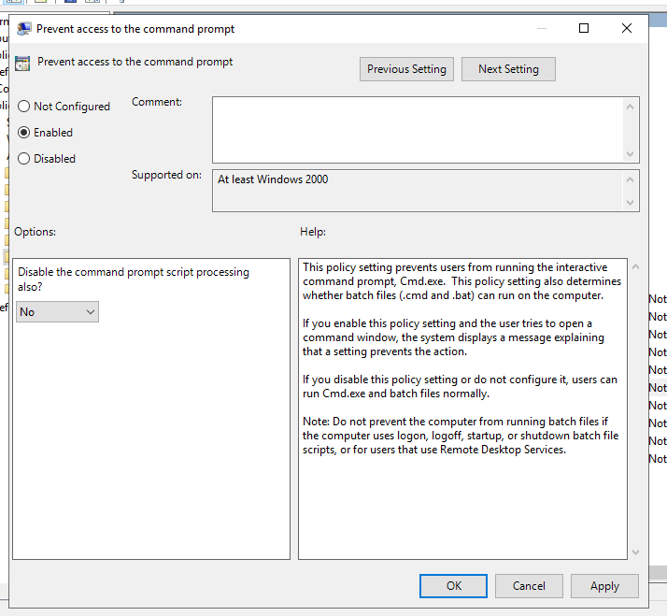

Step 6: On the Group Policy Editor screen, I could see that the ‘Prevent access to the command prompt’ setting was enabled.
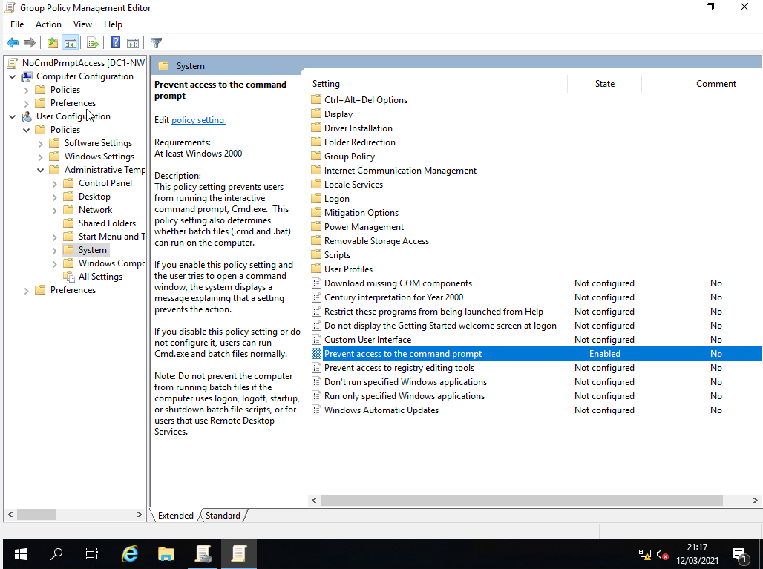
Step 7 : Closed group policy management. Did a search for command prompt, right clicked on the search result and selected run as administrator.

Step 8: Opened up the command prompt and entered the command gpupdate /force to apply the group policy on the domain.
Step 9: Logged back into Client 1 as Howell Rees
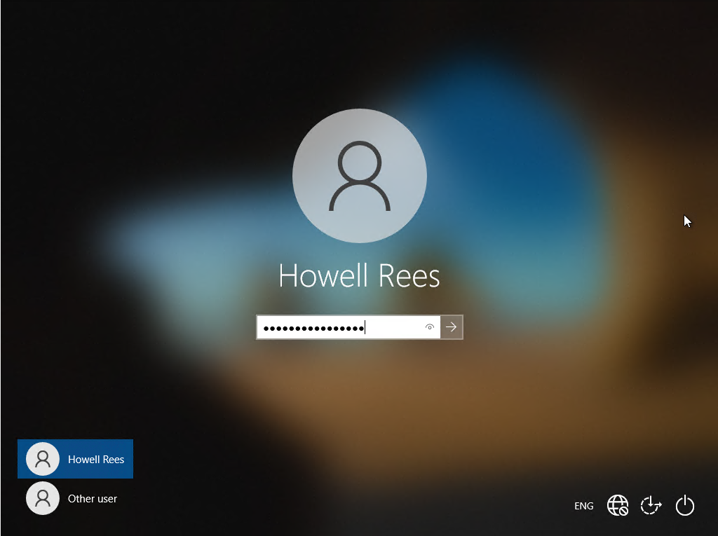

Step 10: Searched for command prompt. Clicked on the search result.
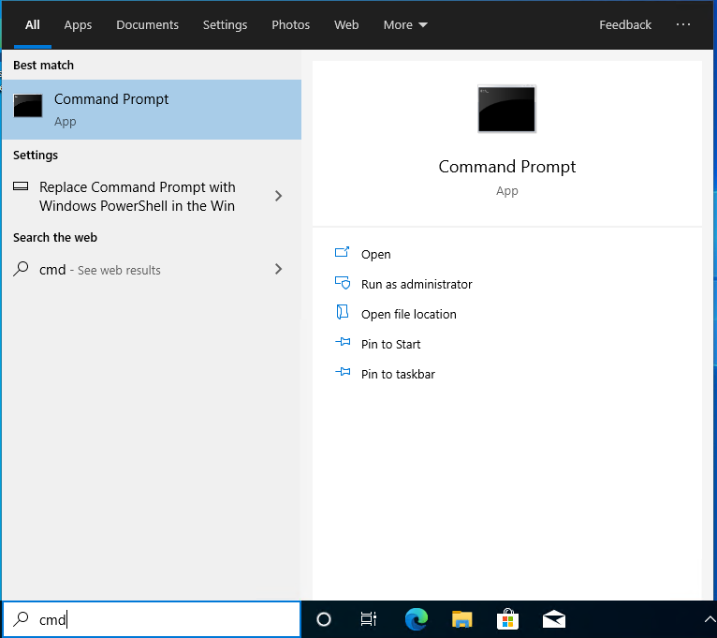
Step 11: Command prompt, opened, but the following message appeared ‘The command prompt has been disabled by your administrator’. Press any Key and command prompt closed down.
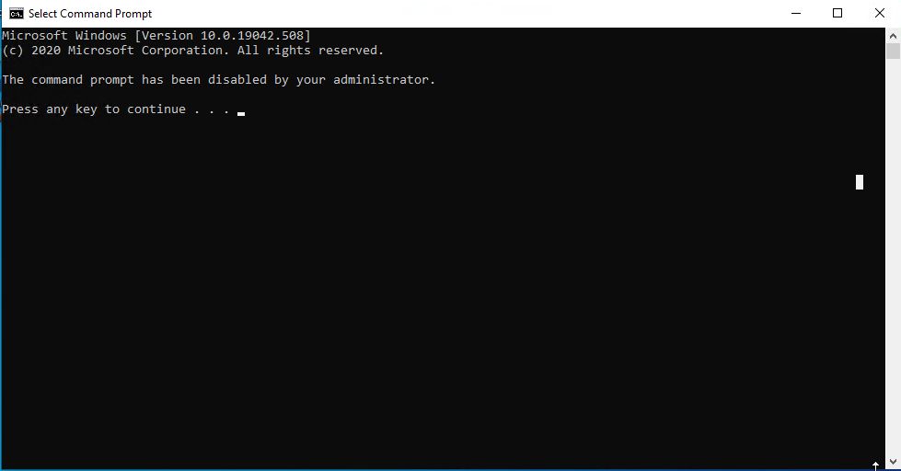

GPO3: Restricting Access to Removable Media Drives

Step 1: Opened up group policy management on Server 1. Right click on Non Admin Users OU, select ‘Create a GPO in this domain, and link it here’.
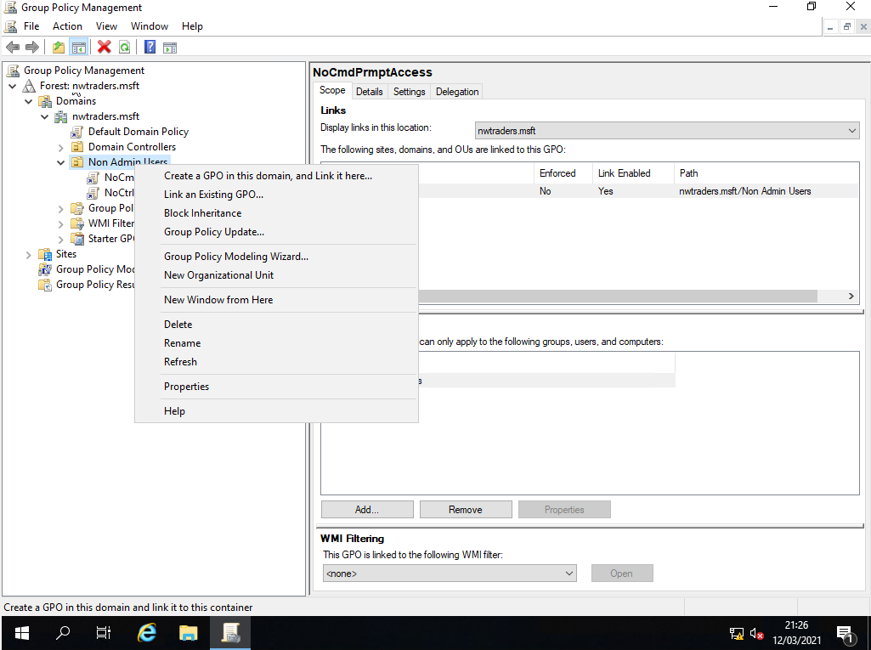

Step 2: Named the New GPO (Group Policy Object) NoRemDriveAccess and clicked ok.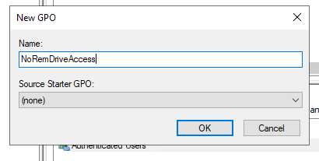

Step 3: Open up the properties of the GPO. Right click on the NoRemDriveAccess, and select edit.
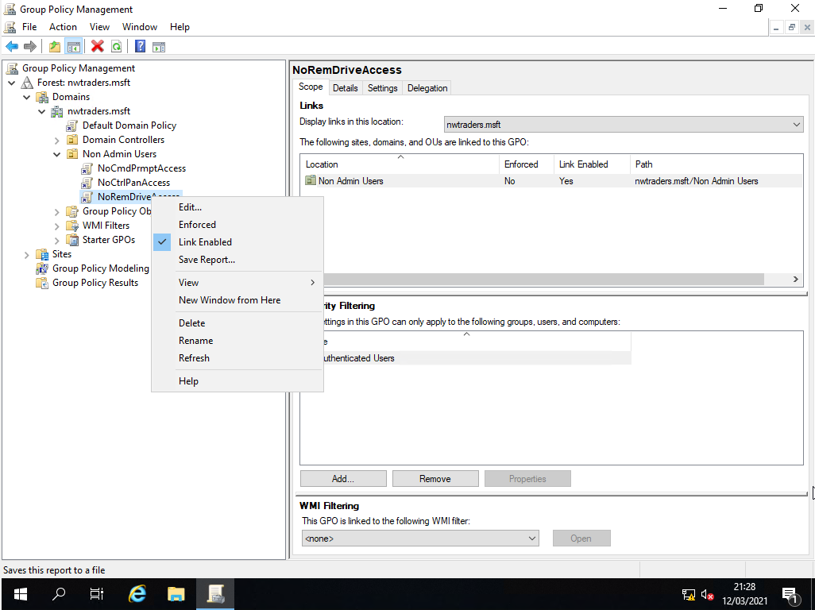

Step 4: Expanded user configuration, policies, administrative templates and system.

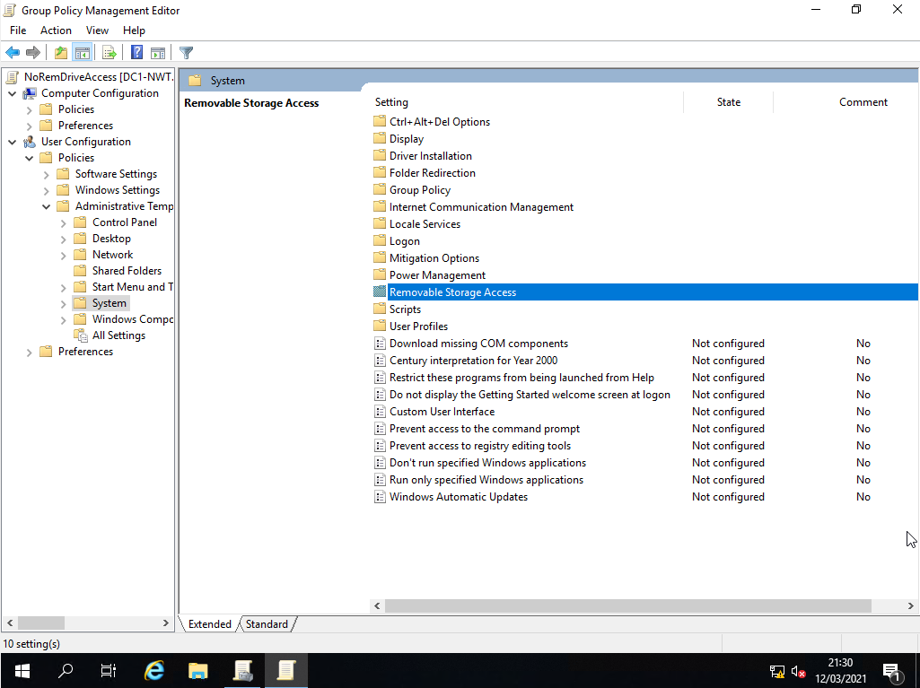
Step 5: Double clicked on removable storage access.
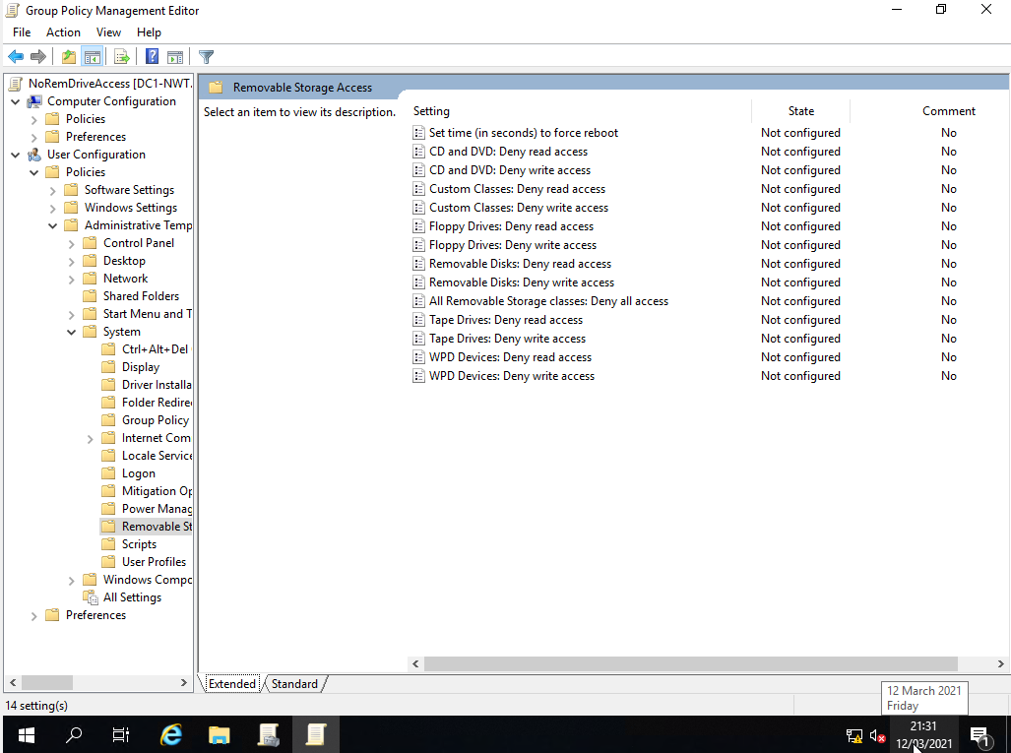

Step 6: Double clicked on ‘All removable storage classes: Deny all accesses’ setting. Enabled the group policy setting. Clicked on apply and ok to commit change.
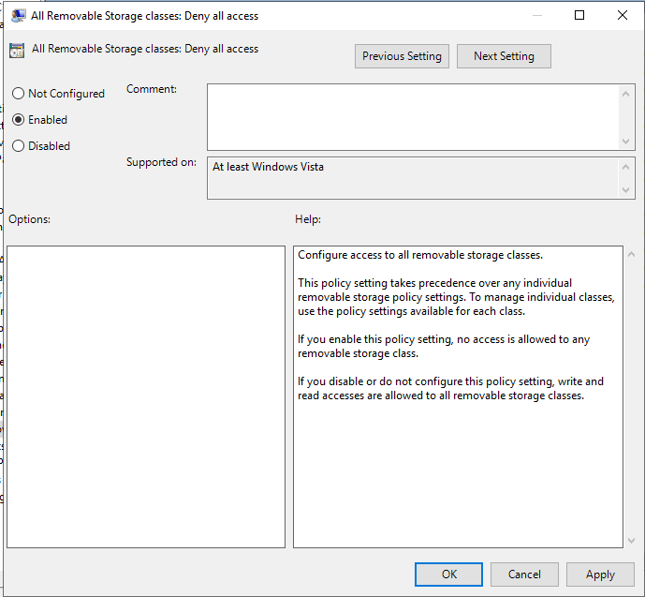

Step 7: On the Group Policy Editor screen, I could see that the ‘All removable storage classes: Deny all accesses” setting was enabled.

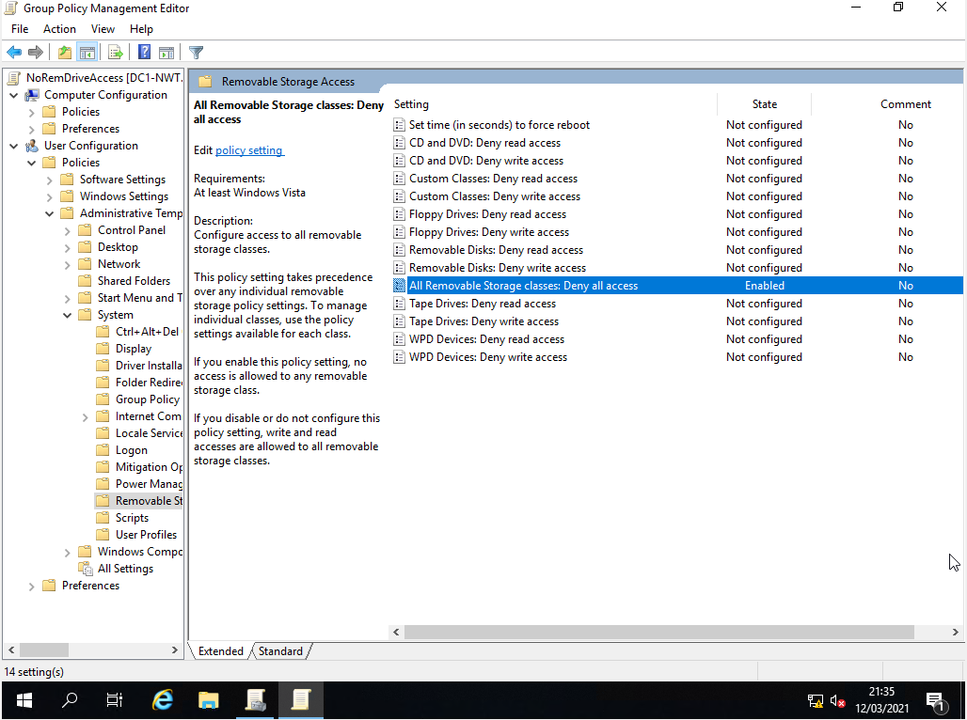

Step 8 : Closed group policy management. Did a search for command prompt, and right clicked on the search result and selected run as administrator.

Step 9: Opened up command prompt and entered the command gpupdate /force to apply the group policy on the domain.

Step 10: Logged back into Client 1 as Howell Rees

Step 11: In the search box, searched for My PC and clicked on the search result.

Step 12: Double click on the DVD RW Drive (D:)
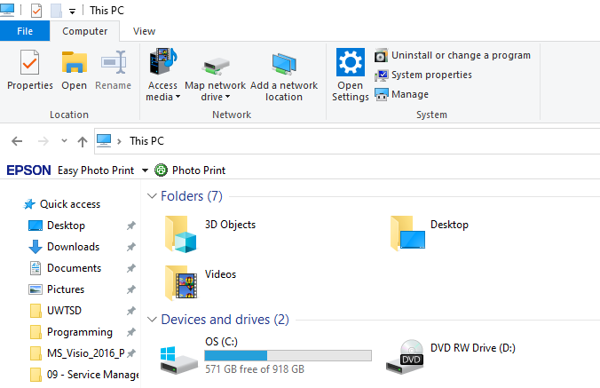

Step 13: Received the error that the location is not available. D:\ is not accessible. Access is denied. Click ok to close the message.
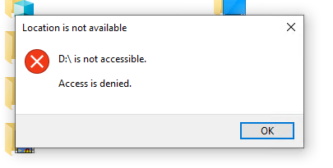

GPO 4: Restricting Software Installs

Step 1: Did a search for active directory users and computers. Clicked on the search result.

Step 2: Open up Active Directory Users and Computers. Created a new Organisational Unit (OU), by right clicking on the nwtraders.msft domain and selecting new and Organisational Unit.
Step 3: In the new object wizard, called the OU NWClientComputers, click on ok to confirm the changes.
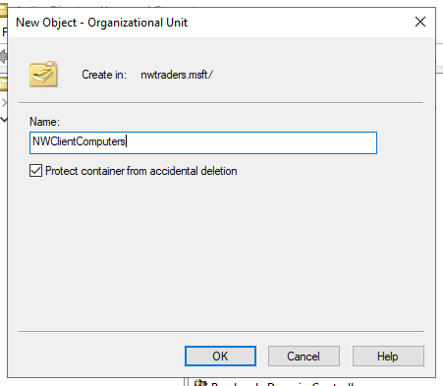

Step 4: After creating the new OU, clicked on the ‘Computers’ container and right clicked on WS1-NWT and selected move.
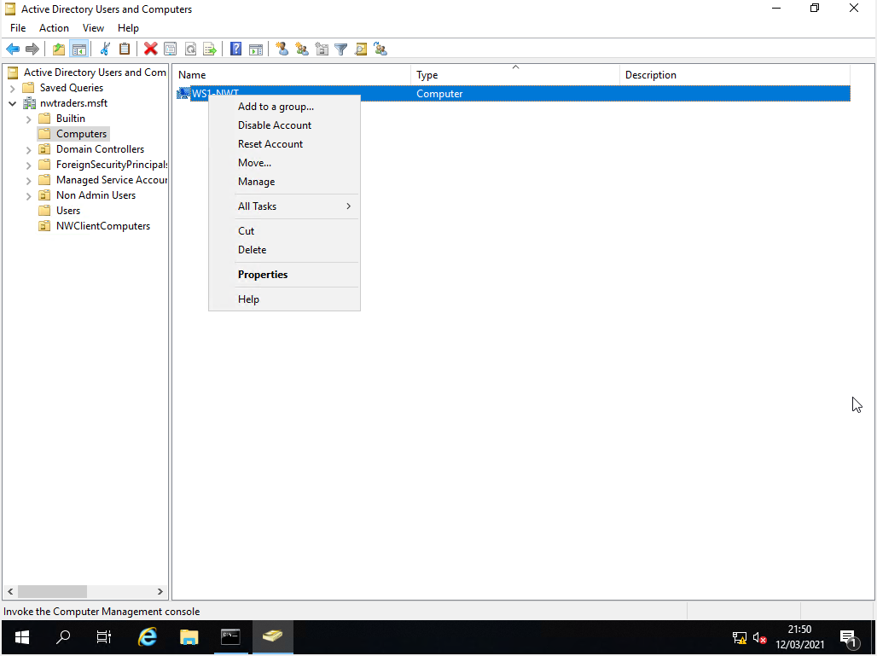
Step 5: Selected the NWClientComputers OU and clicked ok.
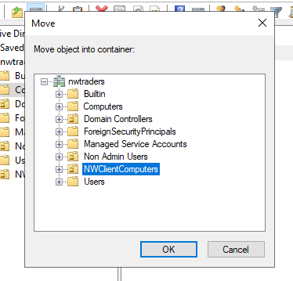

Step 6: Double clicked on NWClientComputers OU to confirm that WS1-NWT had moved.
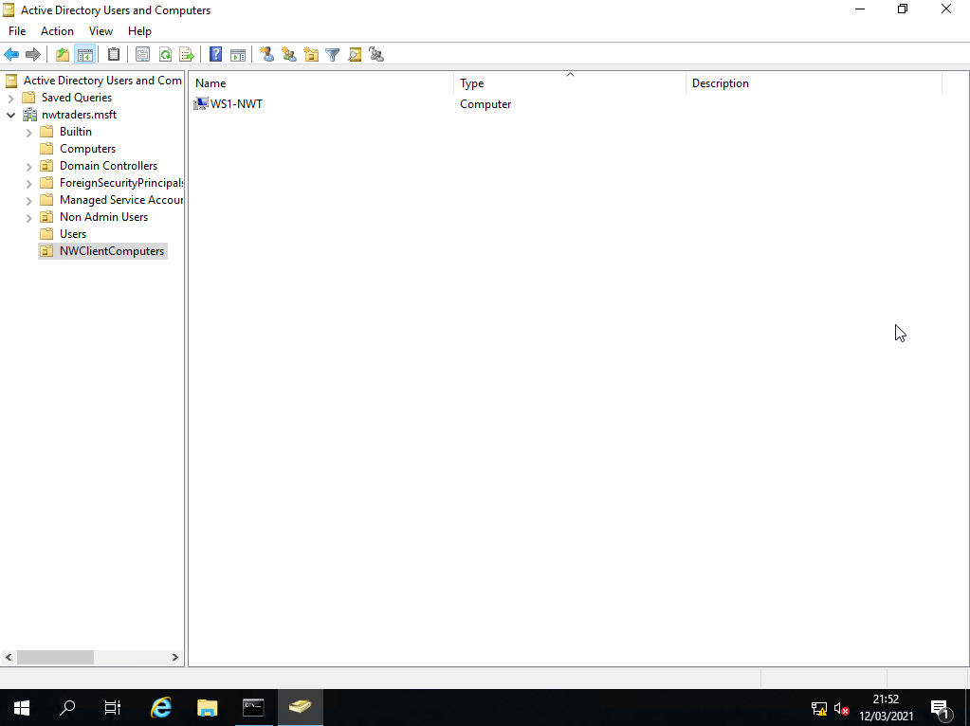
Step 7: Open ‘Group Policy Management’ console. Created a new group policy by right clicking on NWClientComputer OU and selecting ‘Create a GPO in this domain and link it here’.
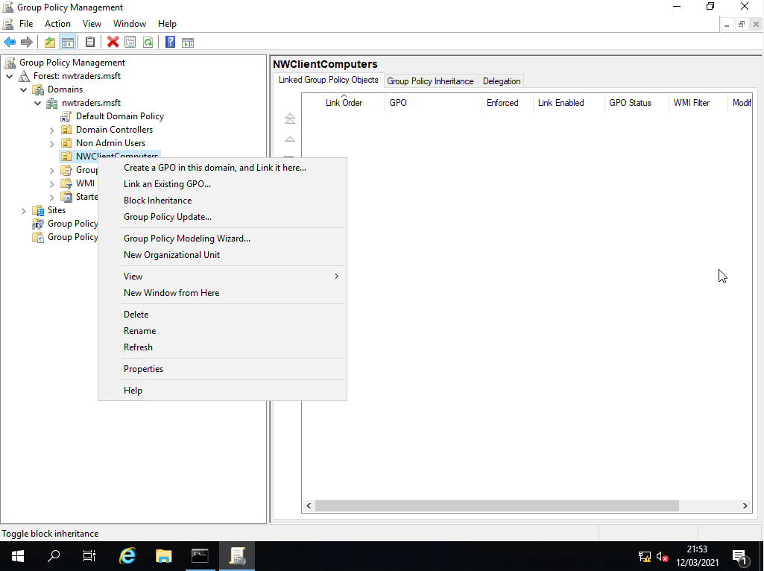

Step 8: Named the GPO NounauthSoftInstallS and clicked ok.
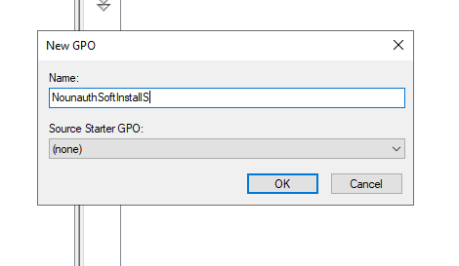

Step 9: Open up the properties of the GPO. Right clicked on the NoRemDriveAccess, and select ‘Edit’.
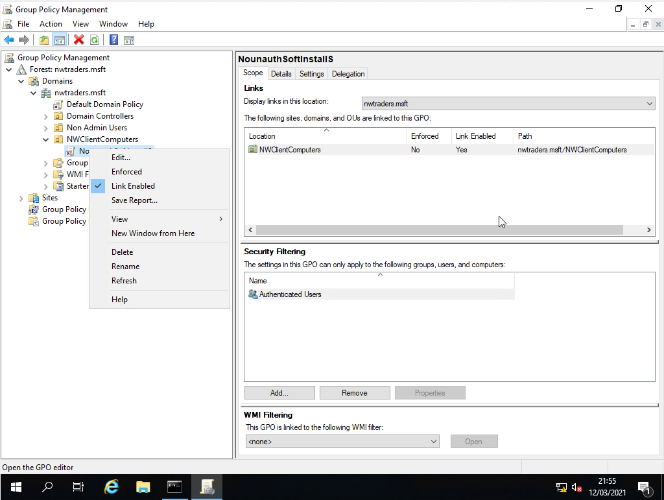

Step 10: Expanded computer configuration, policies, administrative templates and double click on windows components.
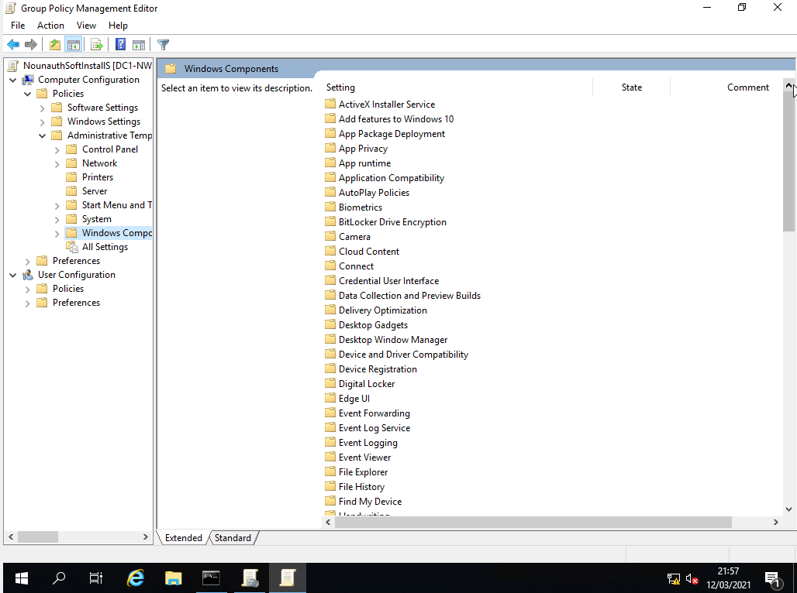
Step 11: Scroll down to windows installer.
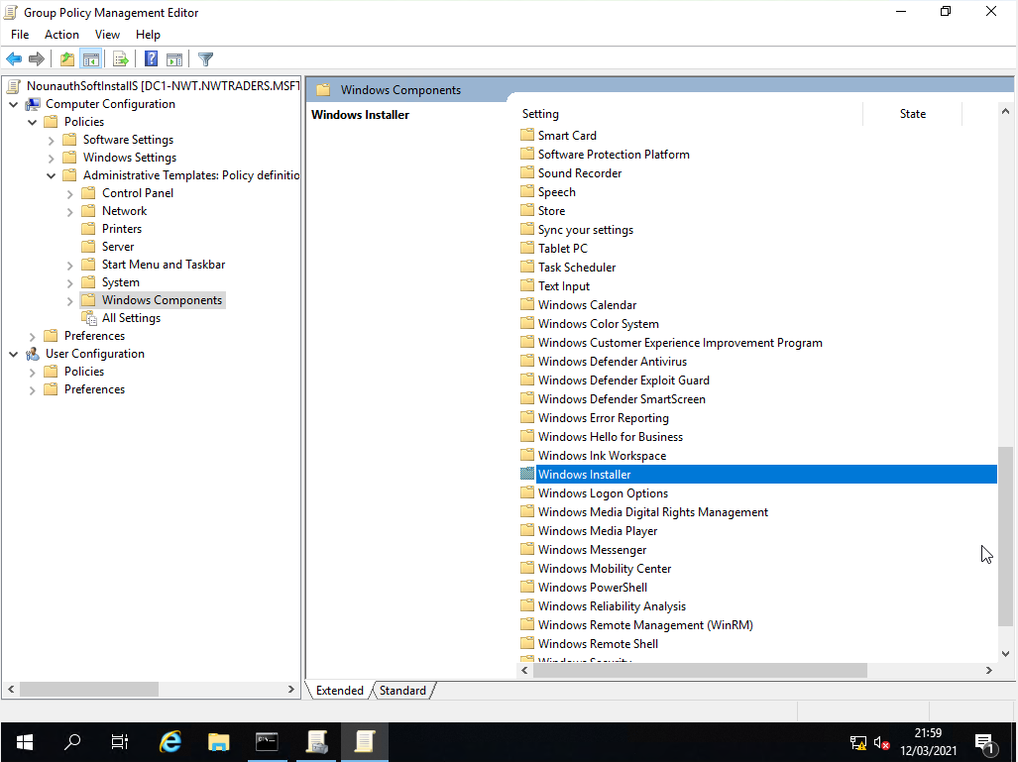

Step 12: Double clicked on windows installer.
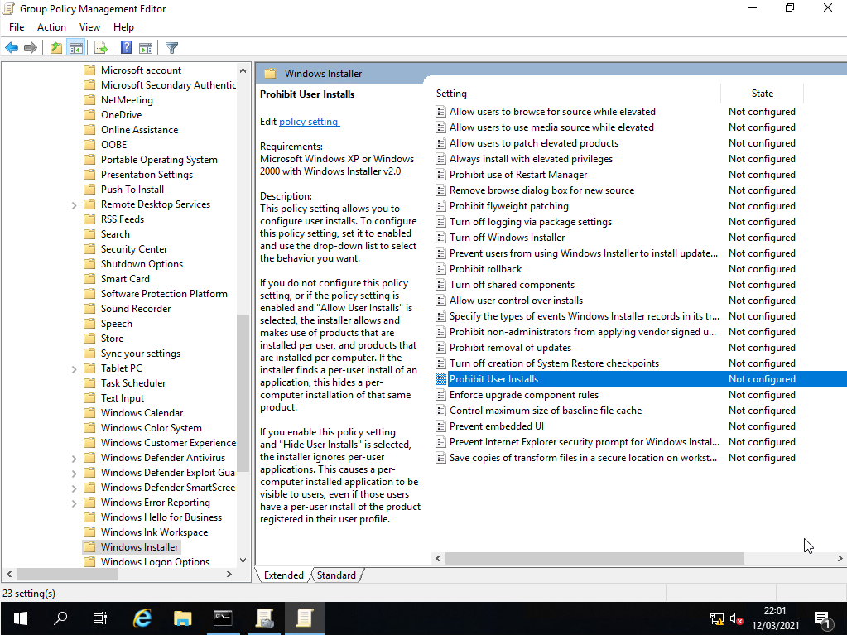

Step 13: Double clicked on ‘Prohibit user installs’. Enable group policy setting. Clicked on apply and ok to confirm changes.
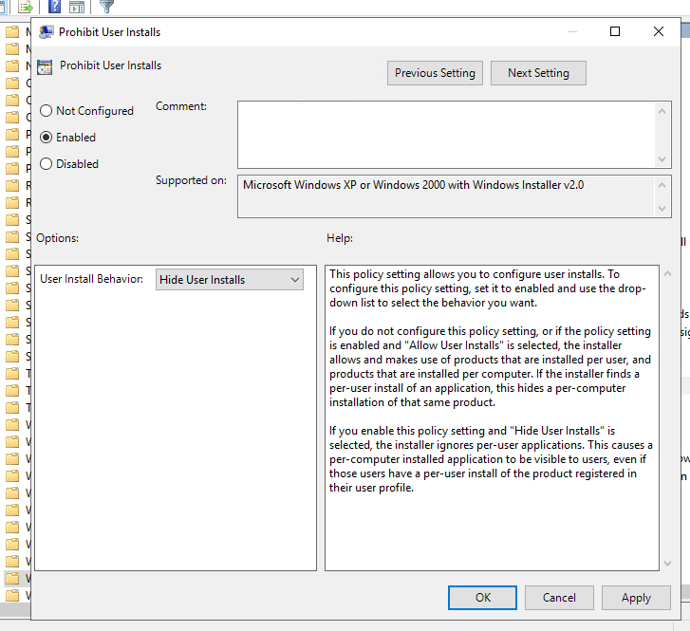

Step 14: On the Group Policy Editor screen, I could see that the ‘Prohibit user install” setting was enabled.
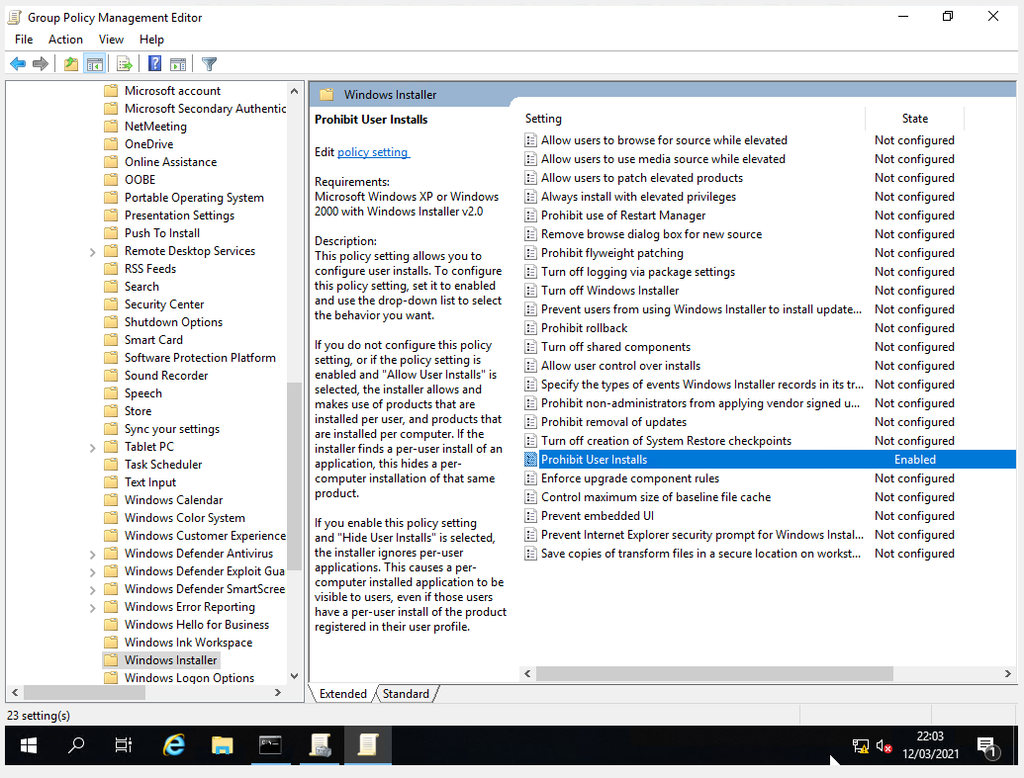

Step 15 : Closed group policy management. Did a search for command prompt, right clicked on the search result and selected run as administrator.

Step 16: Opened up command prompt and entered the command gpupdate /force to apply the group policy on the domain.

Step 17: Logged back into Client 1 as Howell Rees

Step 18: Copied a software program called 7zip onto client1 and double clicked on the software. Was prompted to enter user credentials to install the software.
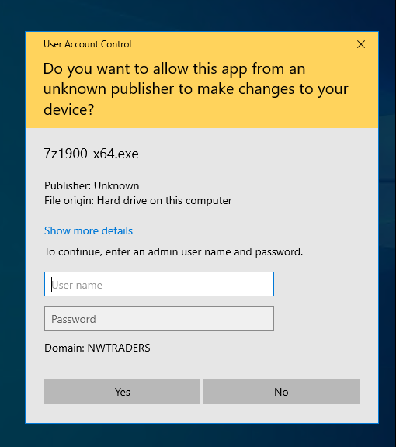
Step 19: Enter the user credentials of Howell Rees, receive a windows installer error. The system administrator has set policies to prevent this installation. Click ok to close the error message.

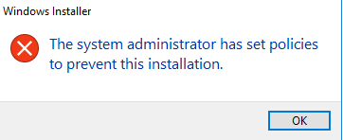

GPO 5: Enforcing Password Policy in the ‘nwtraders.msft’ domain

Step 1: Opened up ‘Group Policy Manager’. Expanded forest nwtraders.msft, domains, nwtraders.msft, right click on default domain policy and selected ‘Edit’.
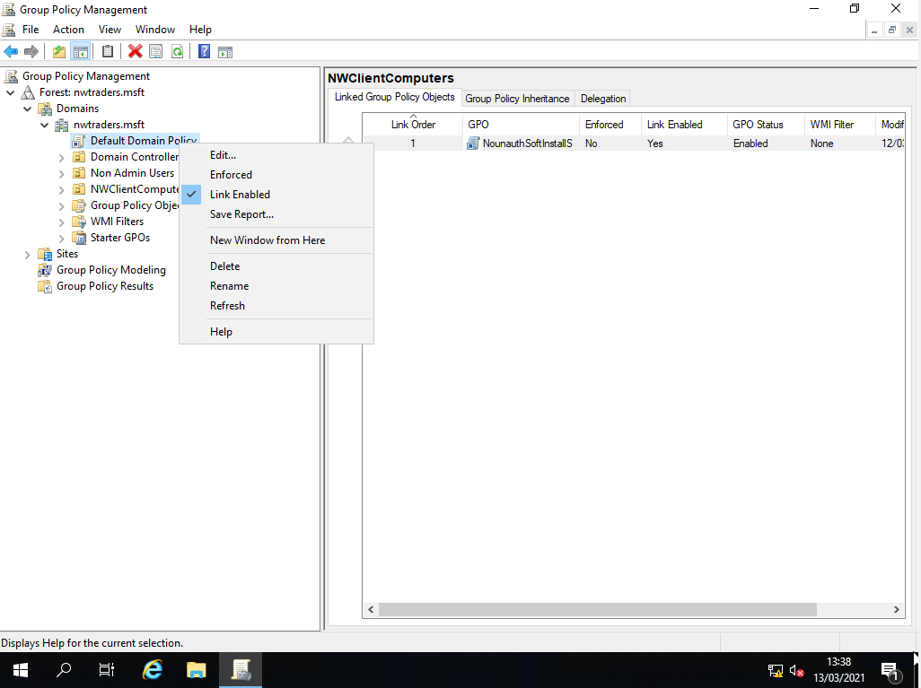

Step 2: Expanded computer configuration, policies, windows setting, security settings and expanded account policies.
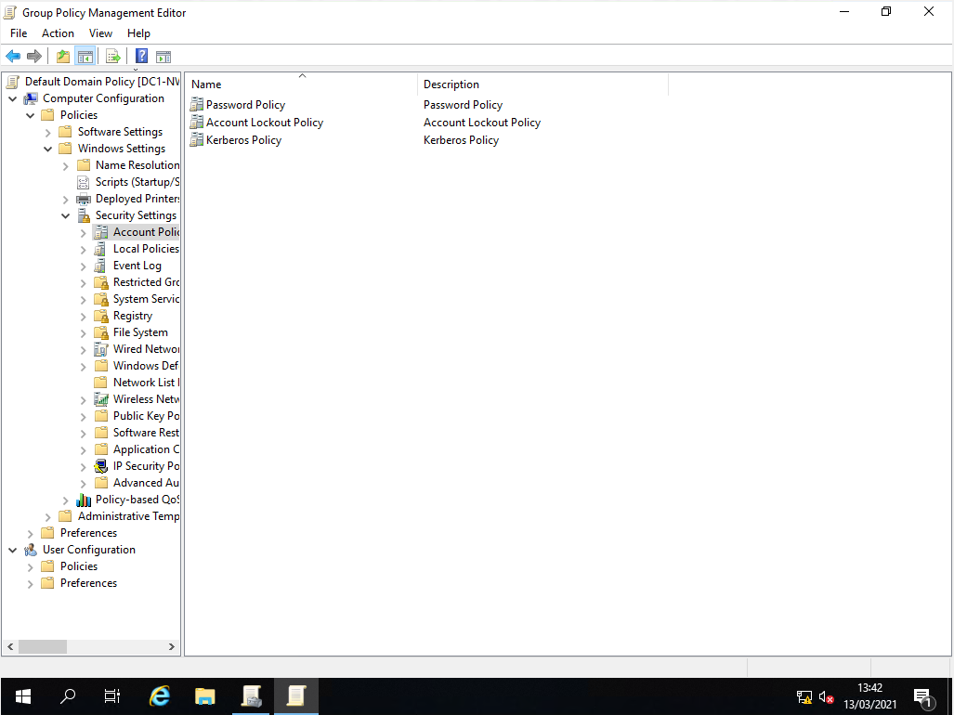
Step 3: Double clicked on ‘Password Policy’.
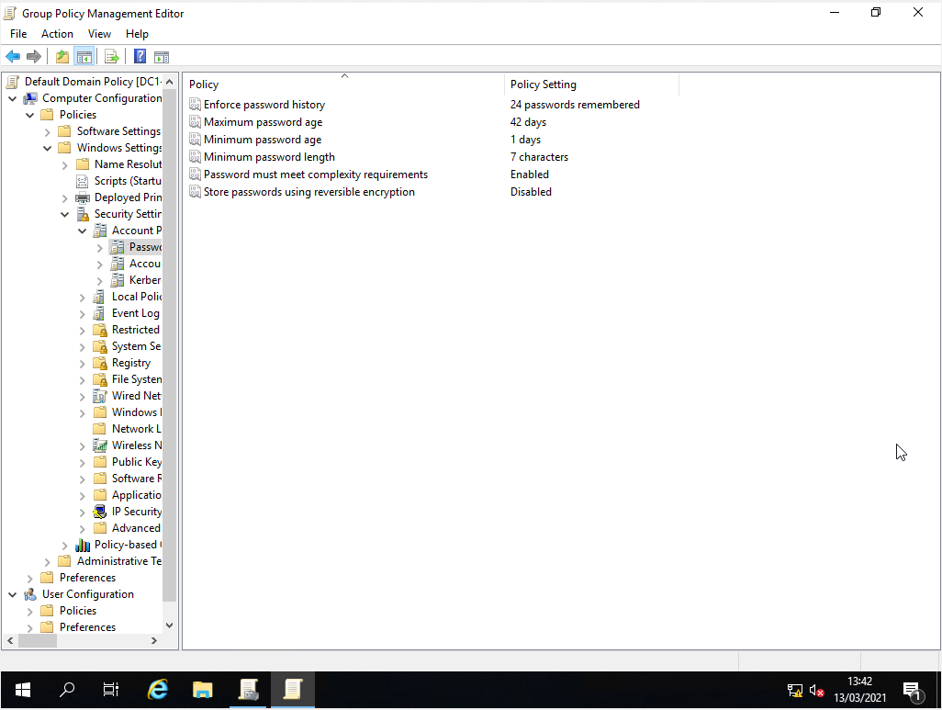

Step 4: Double click on ‘Enforce password history’. Changed the number of days in the ‘Keep password history for’ drop down box from 42 days to 8 days. Clicked on apply and ok to confirm changes.
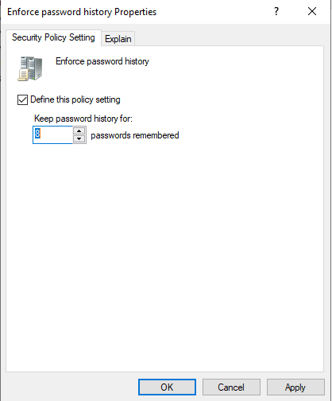
Step 5: Double clicked on maximum password age. Changed the number of days in the ‘Password will expire in’ drop down box from 42 days to 31 days. Clicked on apply and ok to confirm changes.
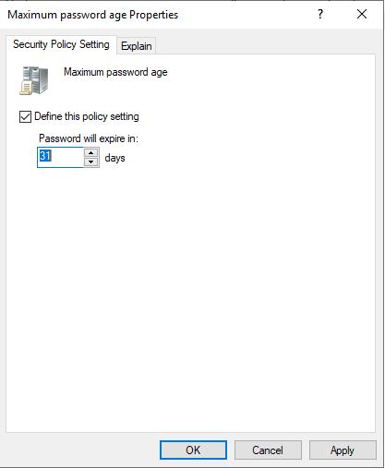

Step 6: Double clicked on minimum password age, and left it on the default of 1 day and clicked cancel.
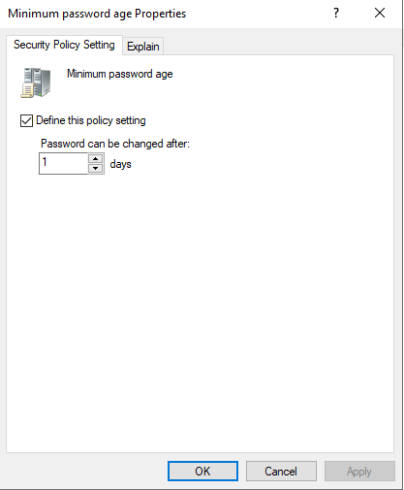
Step 7: Double clicked on minimum password length policy. Changed the number of characters in the ‘Password must be at least’ from 7 characters to 10 characters. Clicked on apply and ok to confirm changes.
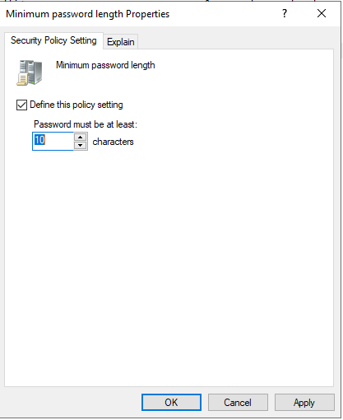

Step 8: Double clicked on Password must meet complexity requirements. The security setting was already enabled, so I clicked cancel.

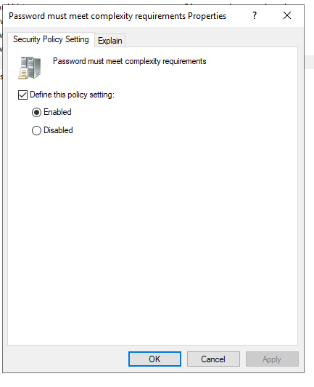
Step 9: Double click on ‘Store passwords using reversible encryption’. The security setting was already disabled. Clicked on cancel.

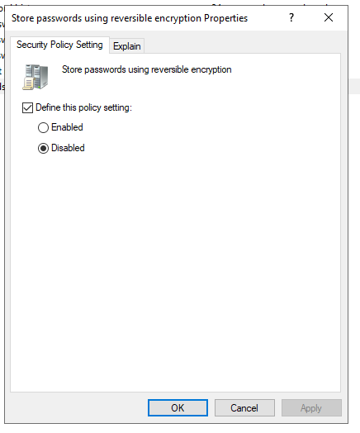

Step 10: Closed down ‘Group policy management’ console, and did a search for command prompt, right clicked on the search result and selected run as administrator.
Step 11: Opened up command prompt and entered the command gpupdate /force to apply the group policy on the domain.

Step 12: Opened up active directory users and computers. Right clicked on the users container and selected new and user.
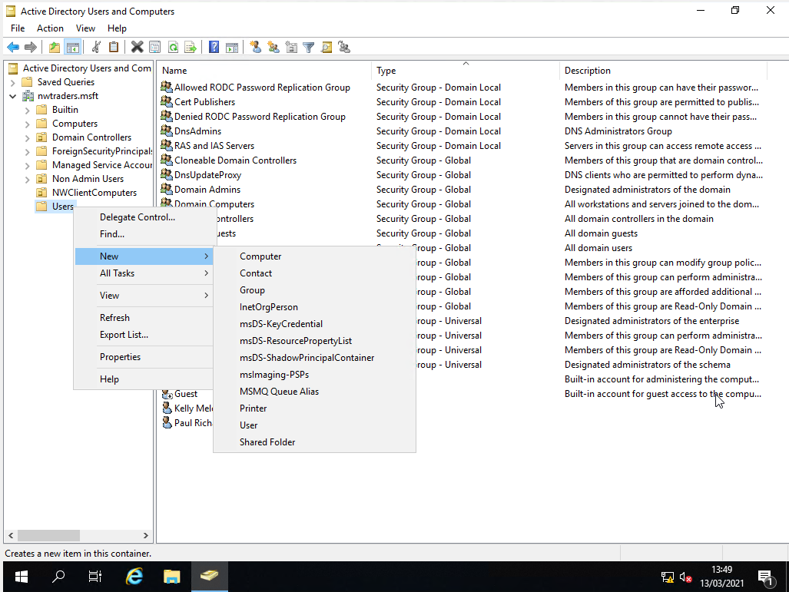

Step 13: In the ‘New Object’ wizard, named the user Mal Rees and gave him the user id NWT-MR. Clicked on Next
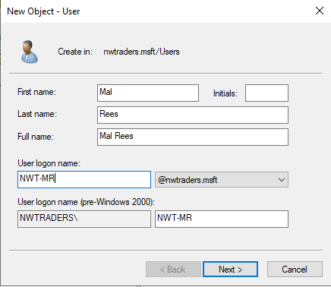

Step 14: Entered a password of 8 characters in length. Clicked on next.
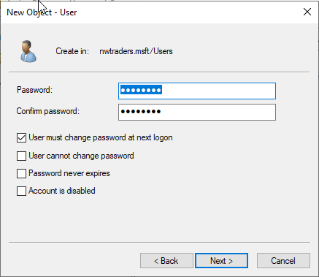
Step 15: Clicked on Finish.
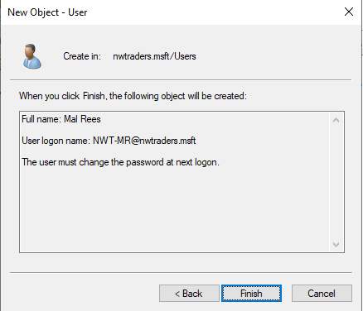

Step 16: Got a windows Active Directory Domain Services. Got an error message, that the password did not meet the minimum password length. Clicked ok to close the message
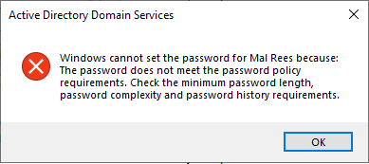

Step 17: Went back to the password screen, recreated a password of 10 characters in length for the user. Clicked next.

Step 18: Clicked on finished. Got no error message.
Step 19: User account created successfully in the users container.
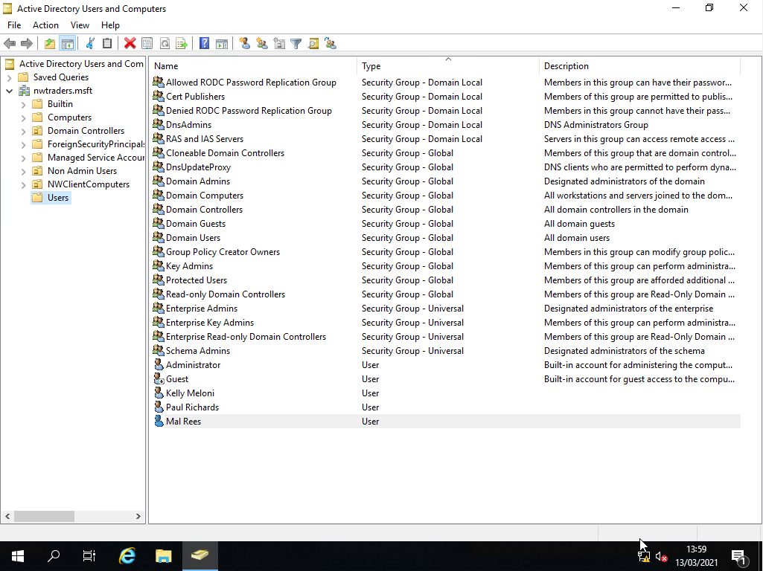

Task 3:Observational Task

3 a) Difference between local permissions and file shares.

Local permissions

According to Microsoft [1], local permissions are the permissions a user obtains when logging into a machine. Local permissions are the access levels that user has been granted to the local machine e.g. to open files and run software. Local permissions are controlled by the user's local user accounts on a machine. If a user is a local administrator, they will have full control on the local machine. They will be able to create files and install programs. If the user has a basic local user account, they will be limited in what actions they can take on a machine e.g. to install software. Local user accounts are controlled through the membership of local groups. If a user is a member of an administrator group, they will have local administrator permissions. This means that they will have full control over the local machine. If a user is a member of the user group, the user will have limited permissions. They may be limited to creating files locally, and deny from installing software. There are a number of local built in groups which are contained in local users and groups section in computer manager, which are used to manage local users permissions on a local computer. A screenshot of local users and computers taken from client 1, is shown below:

Figure 3.0

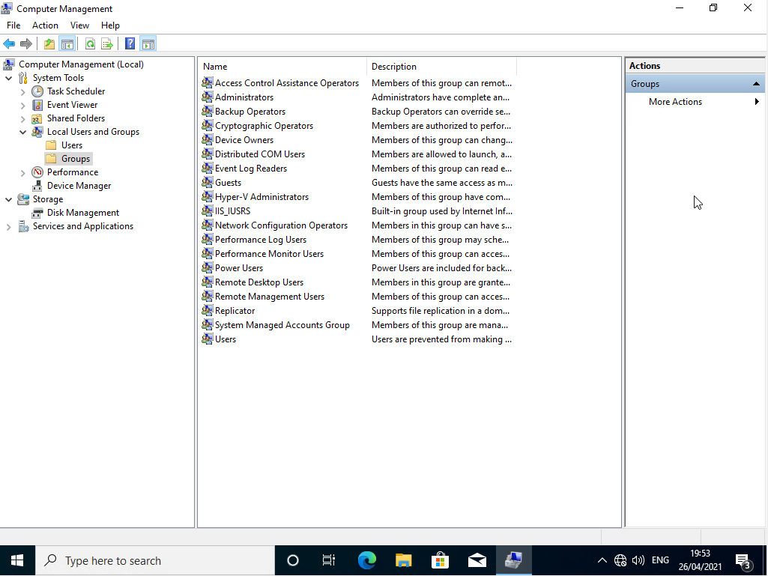

Network share permissions

According to Microsoft [2], a network share refers to a folder that has been shared on a network and is typically stored on a server. The network shared is not stored on a local computer, and is not affected by local permissions. Permissions to the shared folder are controlled through share permissions and NTFS (New Technology File System) permissions. The permissions are not totally controlled through user accounts or groups like Local permissions. For example, if a user needs to be able to open and read a document on a network share, they will need to be granted read permission at the share permission and NTFS permission levels.

There are three types of share permissions; full control, change and read. Full control, allows you full control over the folder. The change permission allows read, write, execute and delete permissions to be performed. Read only allows you read access to the folder. A screenshot of Share permissions taken from Server 1, is shown below:

Figure 3.1
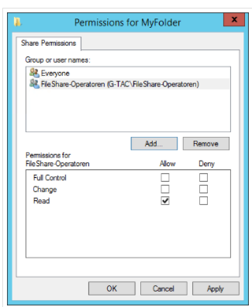

There are five types of NTFS permissions. Full control, provides full control to the file. Modify is the same as the change permission in share permission. It grants a user read, write, execute and delete permissions. Read allows you to read files. Write allows you to create files. Read and execute, allows you to perform read and execute functions. A screenshot of NTFS permissions taken from Server1, is shown below:

Figure 3.2
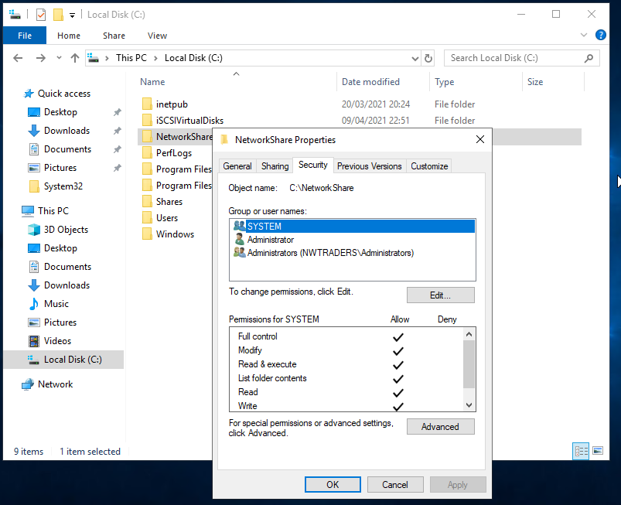

Difference between local and NTFS permissions

To sum up, local permissions only affect local access and not network access. Local permissions are only applied when a user logs into a computer locally. Local permission will affect access to the local machine and not access to a network resource. Network share permissions are applied to a network share, which affects anyone trying to access the network share on the network, regardless of which machine the user is logged into.
Local permissions are controlled through local groups, whereas network share permissions are controlled through share permissions and NTFS permission. E.g. if the user or their membership to a group has not been granted share and NTFS permission to a network share. They will not be able to access the network share. Network share access is not determined by or group membership, like local permissions.

3 b) Role of Group Policy

According to Don Poulton [3], Group Policy allows a system administrator to have centralized control over users and computers on a network. Group Policy can be applied to a user or computer. Group Policy can provide a system administrator with the following control over a network.
- Group Policy can be used to control the installation and deployment of software.
- Group Policy can be used to control user access. For example, in lab 3, we set a group policy to block a user’s access to the control panel.
- Group Policy can be used to configure client settings. For example, you can use group policy to assign all users the same desktop background.

The steps below explain how group policy is deployed on a network:
- An administrator creates a group policy in an active directory. The administrator can configure a group policy to target either a user or computer.
- Once the group policy is configured, it will be downloaded and applied to the computer or user.
- Any changes made to the group policy, will automatically be downloaded and applied to the users and computers.
Group Policy is client driven. Group Policy settings are configured on clients by Client Side Extensions (CSE). What CSE is installed on the clients depends on the version of the operating system running on the computer.
The steps explain how client side extensions work in group policy:
- Group policy is stored on a domain controller and is replicated to all other domain controllers.
- The client will download a copy of the group policies that apply to the client. These group policies are processed by client side extension.
- If there is no client side extension or the client side extension does not understand the setting, the setting will simply be ignored.

Group policies are managed through the group policy management console and group policy management editor. The group management console allows you to link a OU to a group policy. OU or organisation units are containers which you create in an active directory to store user and computer accounts. A screenshot of group policy management console taken from server 1 is shown below:

Figure 3.3

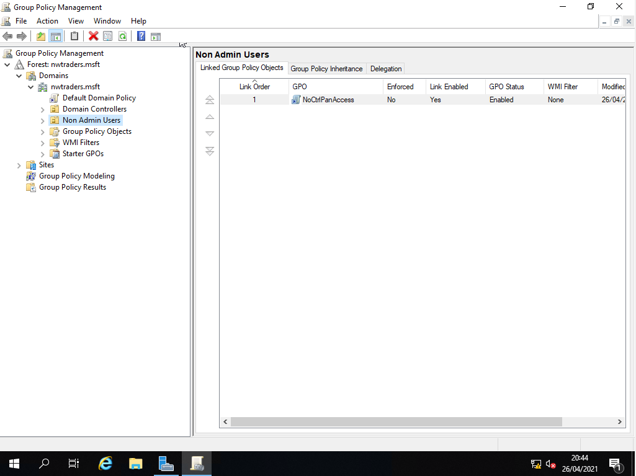

This can be used to help administrators separate users and computers from other parts of the network. Administrators can use OUs to restrict who to apply group policies too. Applying a group policy to everyone on the network is not a good idea, because not all users and computers will require the same settings.
The group policy editor allows you to configure the group policy. When creating or editing group policy you have two sections, computer configuration which applies to computer accounts, and user configuration which applies to user accounts.
This is further broken down into policies and preferences. Any settings applied through policies, the user is forced to have, the user has no choice. Any settings applied under preferences the user has a choice if they want the setting or not.
Policies are split into 3 sections. Software settings are used to control the deployment and management of software. Windows settings - any changes to windows settings, has an effect on the computer as a whole. Administrative templates contain the bulk of the group policy settings.
Preferences are split into 2 sections. Windows setting, which has an effect on the computer as a show. Control panel settings, which controls the control panel.

A screenshot of the group policy editor from server 1 is shown below:

Figure 3.4
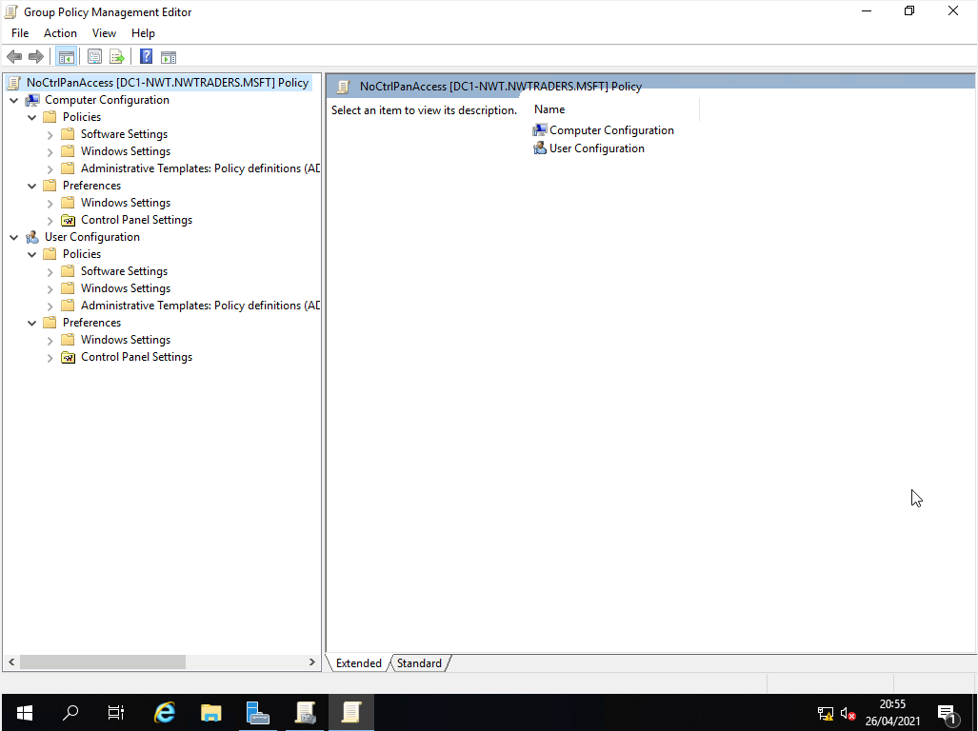

3 c) Examples of Password Policies

Password policy

According to Don Poulton [4], below are the best practises for setting a password policy for a windows domain.

- Minimum password length policy. A minimum password length policy determines the minimum number of characters needed for a password. The longer the password, the harder it is for a hacker to crack the password. The recommended minimum length for a password is 8 characters, however a lot of organisations prefer to use a minimum length of 10 characters. E.g. Using a password like Cardiff1, would be harder to crack than a password like Barry1.
- Password history policy. A password history policy sets how often an old password can be reused. It is recommended to set the password history policy to remember a minimum of 10 user’s passwords. By restricting a user from using a previous password, makes it harder for a hacker to crack a password, because they are not using the same password repetitively. If a user continues to use the same password repeatedly, this gives the hacker more time to break a password. Reducing the amount of time a hacker has to break a password, makes it harder for a hacker to work out a user’s password.
- Minimum password age policy. A minimum password age policy determines how long a user can keep a password before they can change it. The minimum password policy prevents a user dodging the password system. The policy stops the user using a new password and then changing it back to an old one. It is recommended to set the minimum password age policy between the values of 3 to 7 days. Just like the password history policy, a minimum password gives a hacker less time to crack a password, making it harder for a hacker to work out a user’s password.
- Maximum password age policy. A maximum password age policy determines how long a user can keep a password, before they are required to change it. This policy forces a user to change their passwords regularly. It is recommended to set to the maximum password age policy to 90 days. The purpose of a maximum password age policy, like the previous password policies, is to give hackers less time to crack a password.
- Complex password policy. This policy requires that users cannot use basic words and numbers to create a password e.g. password01. The user is required to create a password that contains symbols, letters, numbers, upper and lower case characters e.g. P@ssw0rd This makes it harder for a hacker to crack the password. Using common words when creating a password, exposes the password to dictionary attacks, which can reveal to the hacker what is the user’s password.
- Reversible encryption password policy. The reversible password encryption setting, allows you to decrypt a password and view it in plain text on a database. All user credentials are stored on the database. A user’s password is encrypted on a database to prevent a hacker from finding out the user’s password. It is recommended that reversible password encryption should be disabled. If a user has forgotten their password, it is recommended to reset the user’s password, and get the user to create a new password. It is not recommended to enable reverse password encryption to help a user find out what their password was previously.
- Email Reminders. It is recommended to remind users to change their password to ensure user’s change their password before it expires. This gives user’s plenty of time to create a new password, and minimise disruption to the user.
- Reset password policy. It is recommended that the local administrator password is reset every 180 days and service account password every year during a maintenance period.

Bibliography

[1] | Microsoft Official Academic Course, 70–410 Installing and Configuring Windows Server 2012 R2: Exam 70-410, Wiley, 2014, pp. 402-428.
[2] | Microsoft Official Academic Course, 70–410 Installing and Configuring Windows Server 2012 R2: Exam 70-410, Wiley, 2014, pp. 89-119.
[3] | D. Poulton, MCSA 70-410 Cert Guide R2: Installing and Configuring Windows Server 2012, Pearson IT Certification, 2014, pp. 708-750.
[4] | D. Poulton, MCSA 70-410 Cert Guide R2: Installing and Configuring Windows Server 2012, Pearson IT Certification, 2014, pp. 752-782.

